

**Faculty of engineering - Shoubra Benha University**

*Mobile computing report*

**Name:** ziad ali Mustafa ali ismail

**B.N:** *371*

**Date:** 31/5/2020

**Topic:** mobile computing

# GitHub link:

**GitHub pages:**

**Application brief:**

The application is talking about mobile computing, its history and its applications. Mobile computing is the set of IT technologies, products, services, and operational strategies and procedures that enable end users to gain access to computation, information, and related resources and capabilities while mobile. There are a lot of applications of mobile computing in a lot of fields like business, consumer, industrial, entertainment and many specialized vertical-market activities. Mobile hardware includes mobile devices or device components that receive or access the service of mobility but mobile software is the actual program that runs on the mobile hardware.

Screen shots:

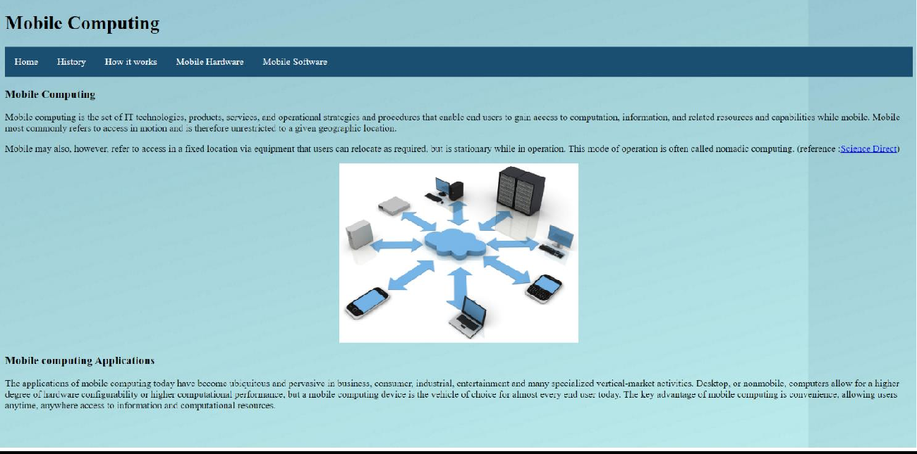

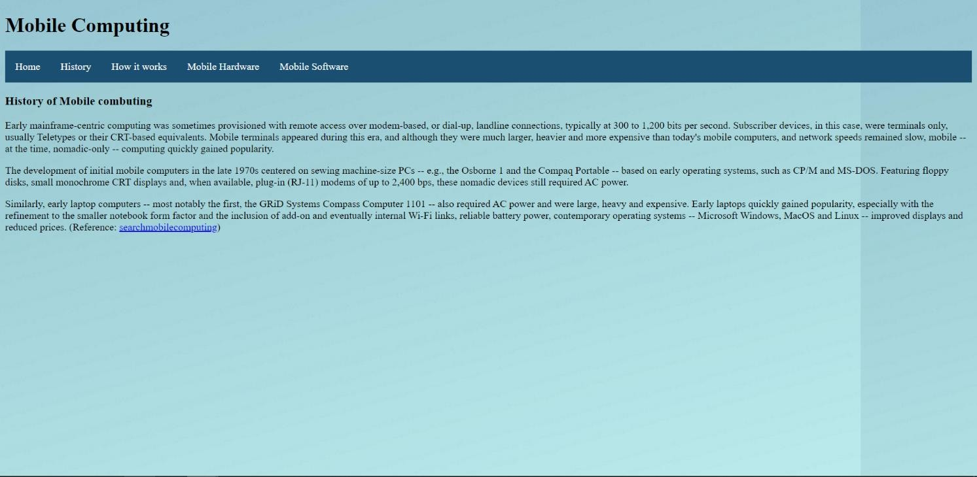

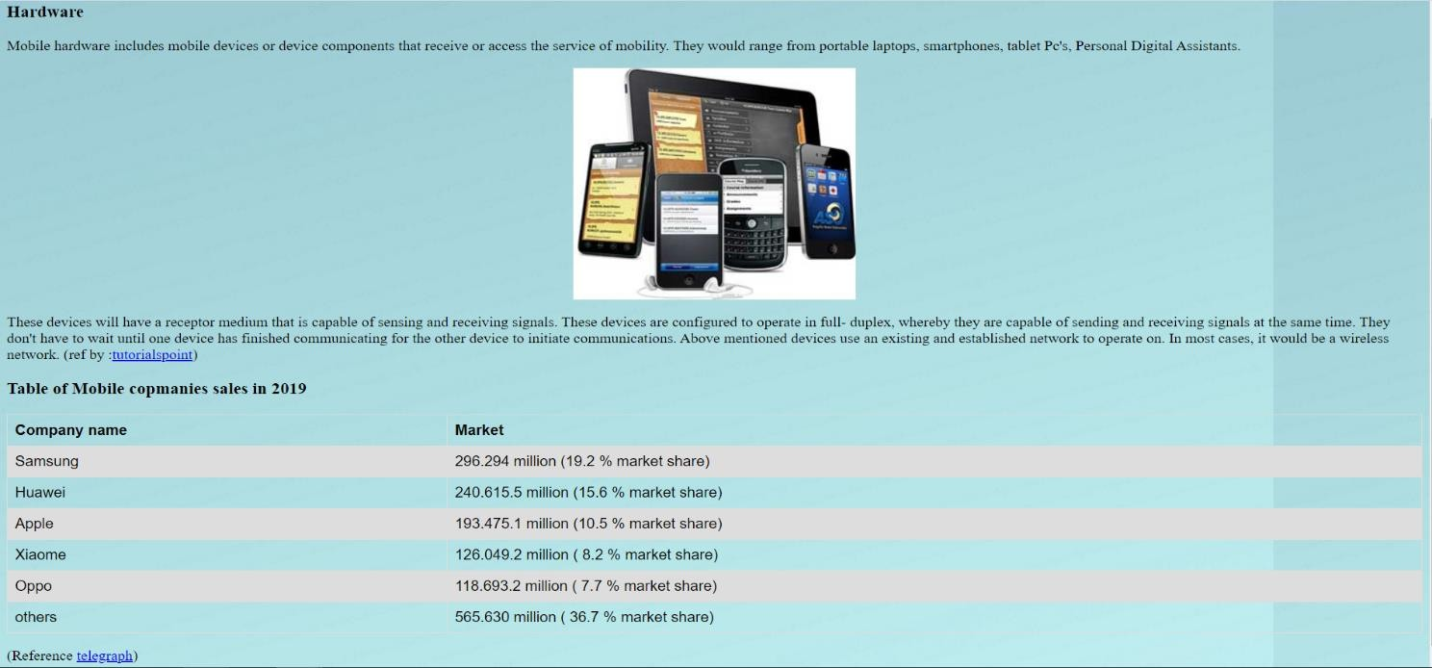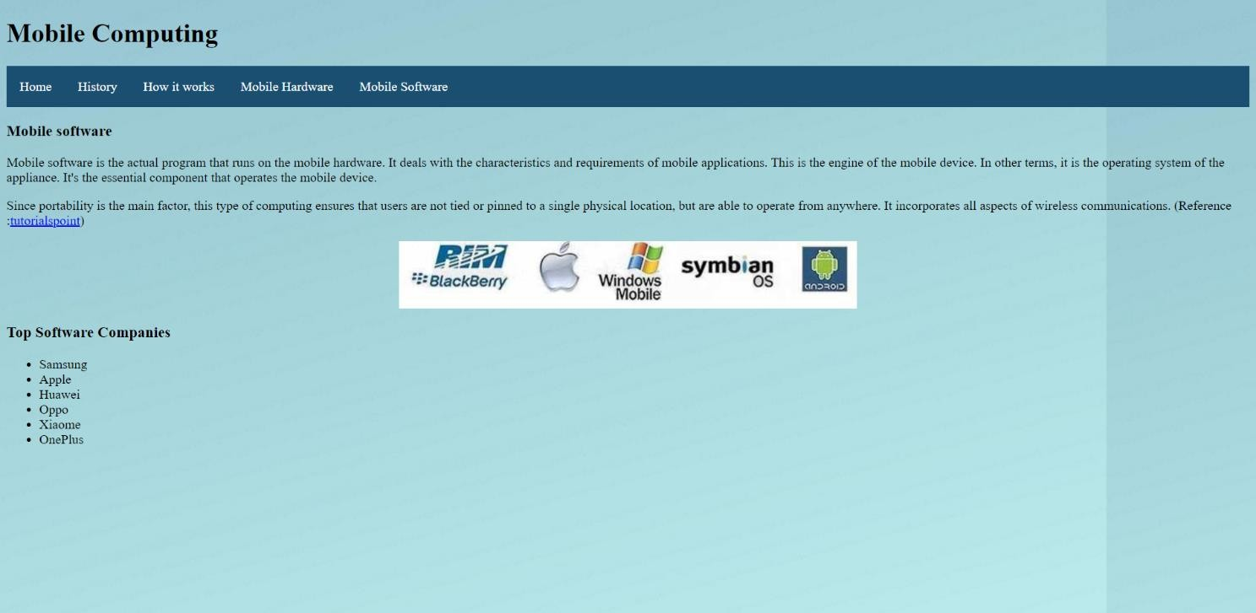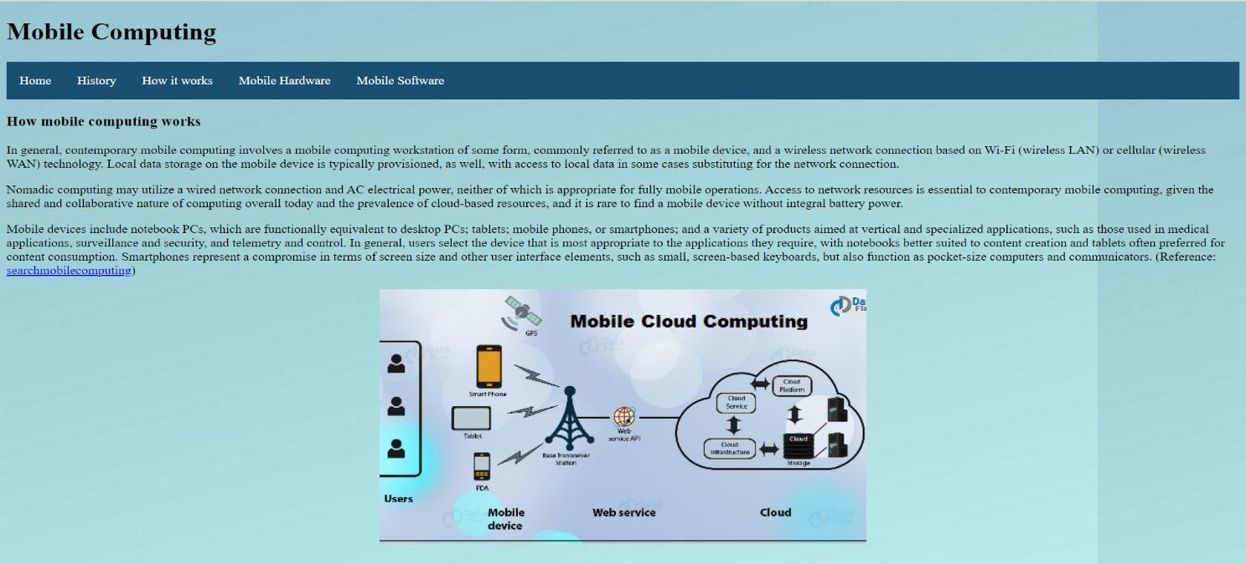

Screen shots of source code:

