DARFUS ERP
End-User Manual
A practical guide to inventory, sales, and finance
Language: English
Version: Stage F runtime handover
23 August 2026
Important
This guide describes the current release. Buttons may differ by role, branch, and record status.

Contents
1. Where do I start?
2. Application basics
3. Dashboard
4. Inventory and receiving
5. Inventory profiles
6. Asset, Barcode and RFID
7. Transfers, Workshop and Count
8. Suppliers and purchases
9. Customers
10. Point of Sale
11. Invoices, returns and reservations
12. Gold Center
13. Customer Gold Purchase
14. Accounting, Treasury and Reports
15. Users and Settings
16. Troubleshooting and safety
17. Status glossary and task finder
18. Handover and training checklist
How to use this guide
Start with the persona that matches your work, then use the quick task recipes before reading the detailed chapters.

Where do I start?
Choose the description closest to your work. You may see fewer screens or buttons than the examples when your role does not include the required permission.
Persona | Main screens | Daily use
Cashier | POS, Customers, Invoices | Sell, search by Barcode, review totals, and print the receipt.
Inventory / Warehouse | Inventory, Receive, Transfer, Workshop, Count | Track pieces, locations, status, and Barcode.
Purchasing | Suppliers, Receive, Supplier balance | Receive supplier stock and follow purchase history.
Accountant | Accounting, Statements, Treasury | Review journals, balances, and treasury.
Branch Manager | Dashboard, Reports, Approvals | Monitor performance, approvals, and branch status.
Administrator | Users, Permissions, Settings | Manage access, master data, and sensitive settings.

Permission note
A missing button does not necessarily mean the screen is broken; check your role, branch, and record status.

Application basics
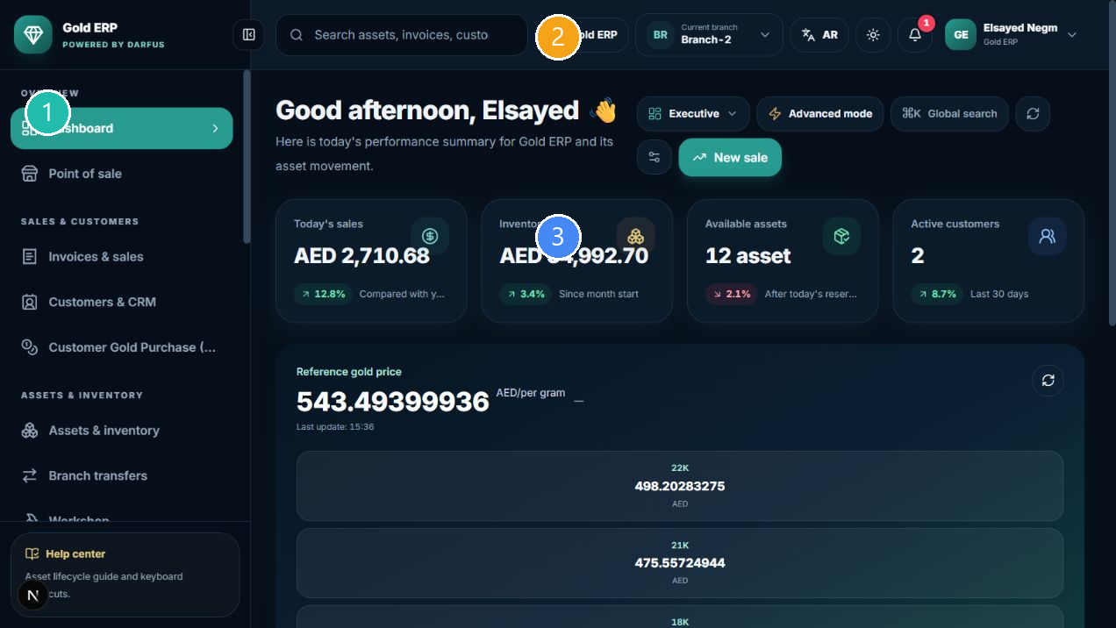
Dashboard and branch context
① Navigation ② Company/Branch and language context ③ Current workspace

Login, language, and branch
- Open the login page and enter the account details provided by your administrator.
- After signing in, check the company and branch shown in the header before starting any action.
- Use the language control to switch between Arabic and English. The page direction changes automatically.
- Use the branch control to choose a branch available to your account; changing the branch does not move an Asset.

What you see on most screens
- Sidebar: move between modules.
- Top bar: global search, company, branch, language, notifications, and user account.
- Headings and badges: show the screen, result count, status, or action availability.
- Tables: use search, filters, and pagination; the current page may not contain every record.

Inventory and receiving
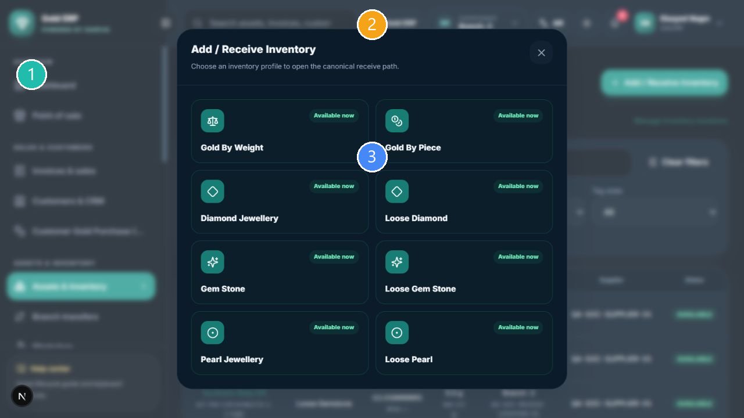
Choosing a profile from the unified intake path
① Navigation ② Company/Branch and language context ③ Current workspace
The canonical path is: Inventory -> Add / Receive Inventory -> choose the profile -> complete the form -> review the preview -> Receive Inventory.

What receiving means
- Each physical piece is recorded as its own Asset, with its identity and Barcode preserved.
- The Asset appears in Inventory and Asset Details according to company, branch, and location.
- Purchase, supplier, date, and historical value are recorded when the workflow requires them.
- The receive may affect supplier balance and accounting according to the transaction type and settings.
- Do not use an old supplier shortcut to create a receive when the unified Inventory path is available.

Receiving steps
- Confirm the branch, location, supplier, and purchase date.
- Choose the correct inventory profile; do not mix piece, weight, loose-stone, and jewellery meanings.
- Enter the required fields with the actual values, then review the preview, prices, and tax.
- Press Receive Inventory once after reviewing the form.
What happens after completion
A success result appears, and you can find the Asset in Inventory, Asset Details, supplier history, and accounting when applicable. Do not repeat the action when the result is uncertain; contact the administrator.

Inventory profiles

Gold By Weight
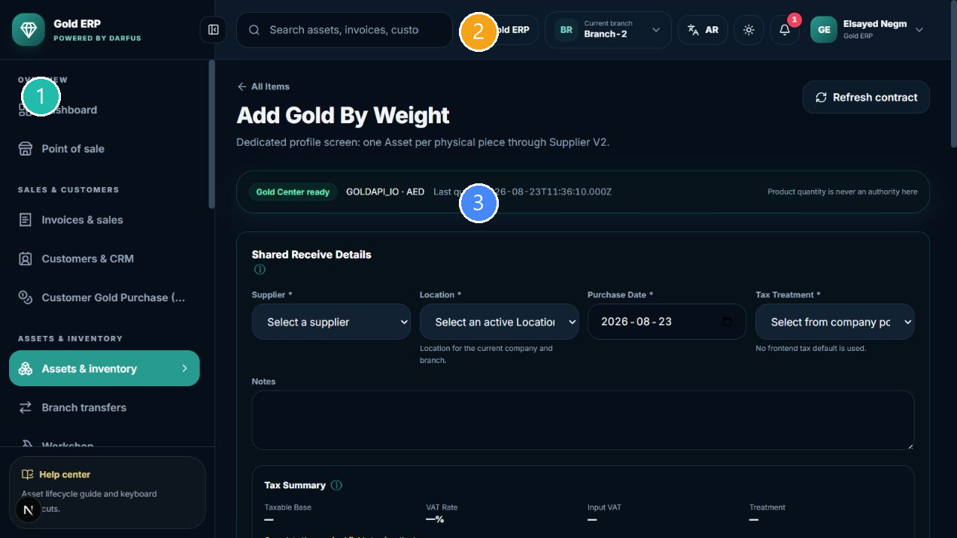
Gold By Weight
① Navigation ② Company/Branch and language context ③ Current workspace
Use it when the gold value is driven by weight and karat.
- Review the shared supplier, location, date, and tax information at the top of the form.
- Enter the profile fields shown on the screen; do not invent a value for a field that is not shown or required.
- Review the historical and current preview and selling price before opening confirmation.
- After receiving, find the Asset from Inventory or by Barcode.
Profile effect
The Asset, Barcode, and purchase history remain linked to the same physical piece. Calculated values and tax are shown according to company settings.

Gold By Piece
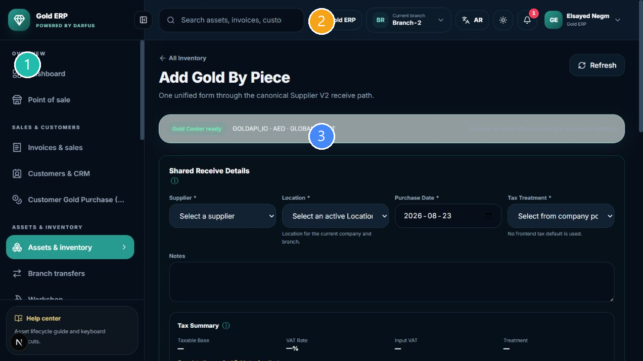
Gold By Piece
① Navigation ② Company/Branch and language context ③ Current workspace
Use it when each gold piece is a separate physical unit with piece-specific data.
- Review the shared supplier, location, date, and tax information at the top of the form.
- Enter the profile fields shown on the screen; do not invent a value for a field that is not shown or required.
- Review the historical and current preview and selling price before opening confirmation.
- After receiving, find the Asset from Inventory or by Barcode.
Profile effect
The Asset, Barcode, and purchase history remain linked to the same physical piece. Calculated values and tax are shown according to company settings.

Diamond Jewellery
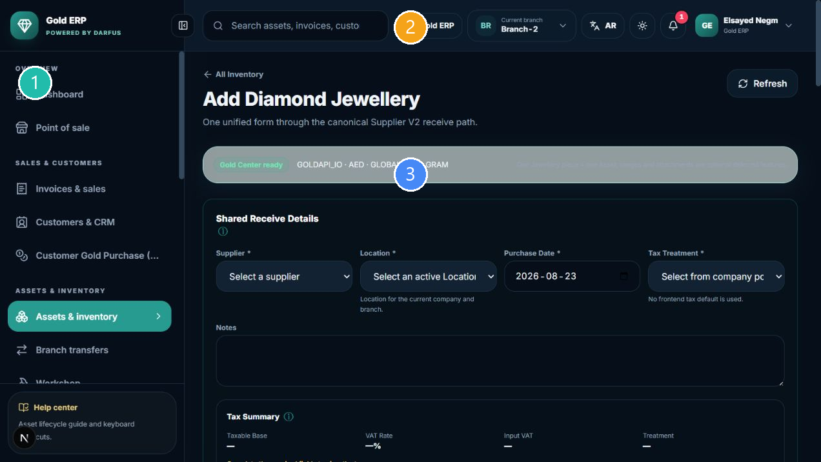
Diamond Jewellery
① Navigation ② Company/Branch and language context ③ Current workspace
Use it for jewellery that contains mounted diamonds.
- Review the shared supplier, location, date, and tax information at the top of the form.
- Enter the profile fields shown on the screen; do not invent a value for a field that is not shown or required.
- Review the historical and current preview and selling price before opening confirmation.
- After receiving, find the Asset from Inventory or by Barcode.
Profile effect
The Asset, Barcode, and purchase history remain linked to the same physical piece. Calculated values and tax are shown according to company settings.

Loose Diamond
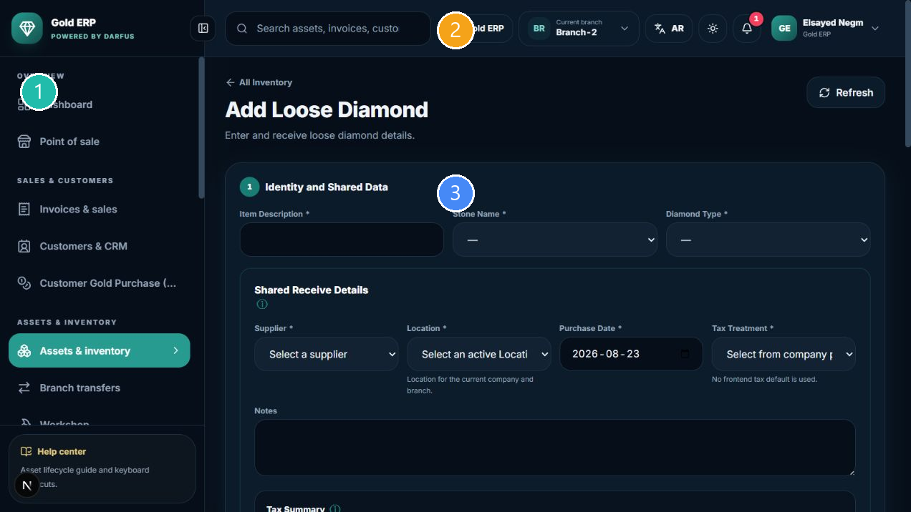
Loose Diamond
① Navigation ② Company/Branch and language context ③ Current workspace
Each loose stone is recorded as an individual piece with its own Barcode.
- Review the shared supplier, location, date, and tax information at the top of the form.
- Enter the profile fields shown on the screen; do not invent a value for a field that is not shown or required.
- Review the historical and current preview and selling price before opening confirmation.
- After receiving, find the Asset from Inventory or by Barcode.
Profile effect
The Asset, Barcode, and purchase history remain linked to the same physical piece. Calculated values and tax are shown according to company settings.

Gem Stone Jewellery
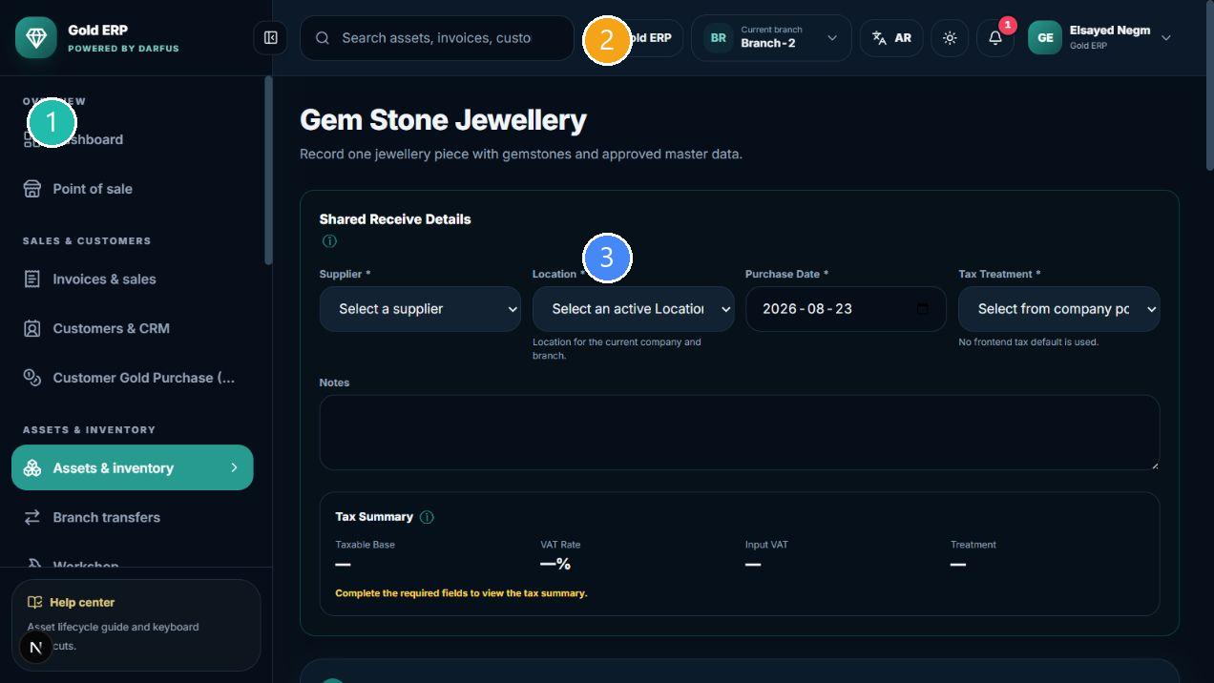
Gem Stone Jewellery
① Navigation ② Company/Branch and language context ③ Current workspace
Use it for jewellery with mounted gemstones.
- Review the shared supplier, location, date, and tax information at the top of the form.
- Enter the profile fields shown on the screen; do not invent a value for a field that is not shown or required.
- Review the historical and current preview and selling price before opening confirmation.
- After receiving, find the Asset from Inventory or by Barcode.
Profile effect
The Asset, Barcode, and purchase history remain linked to the same physical piece. Calculated values and tax are shown according to company settings.

Loose Gem Stone
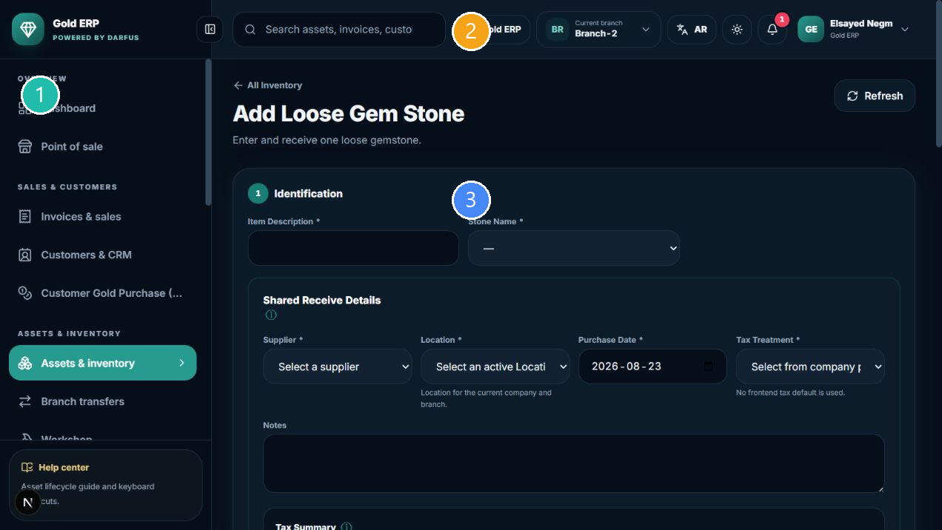
Loose Gem Stone
① Navigation ② Company/Branch and language context ③ Current workspace
Use it for a loose gemstone tracked separately.
- Review the shared supplier, location, date, and tax information at the top of the form.
- Enter the profile fields shown on the screen; do not invent a value for a field that is not shown or required.
- Review the historical and current preview and selling price before opening confirmation.
- After receiving, find the Asset from Inventory or by Barcode.
Profile effect
The Asset, Barcode, and purchase history remain linked to the same physical piece. Calculated values and tax are shown according to company settings.

Pearl Jewellery
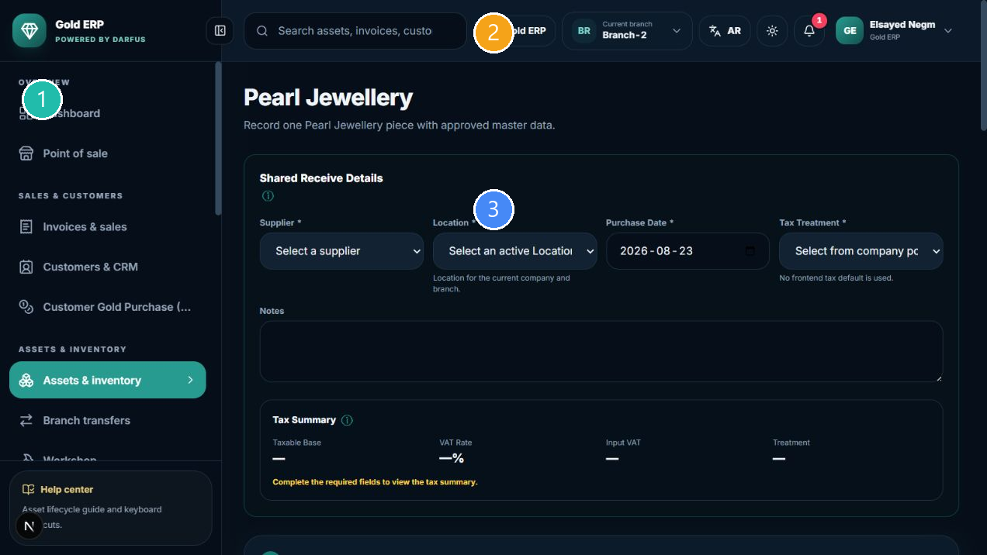
Pearl Jewellery
① Navigation ② Company/Branch and language context ③ Current workspace
Use it for jewellery containing mounted pearls.
- Review the shared supplier, location, date, and tax information at the top of the form.
- Enter the profile fields shown on the screen; do not invent a value for a field that is not shown or required.
- Review the historical and current preview and selling price before opening confirmation.
- After receiving, find the Asset from Inventory or by Barcode.
Profile effect
The Asset, Barcode, and purchase history remain linked to the same physical piece. Calculated values and tax are shown according to company settings.

Loose Pearl
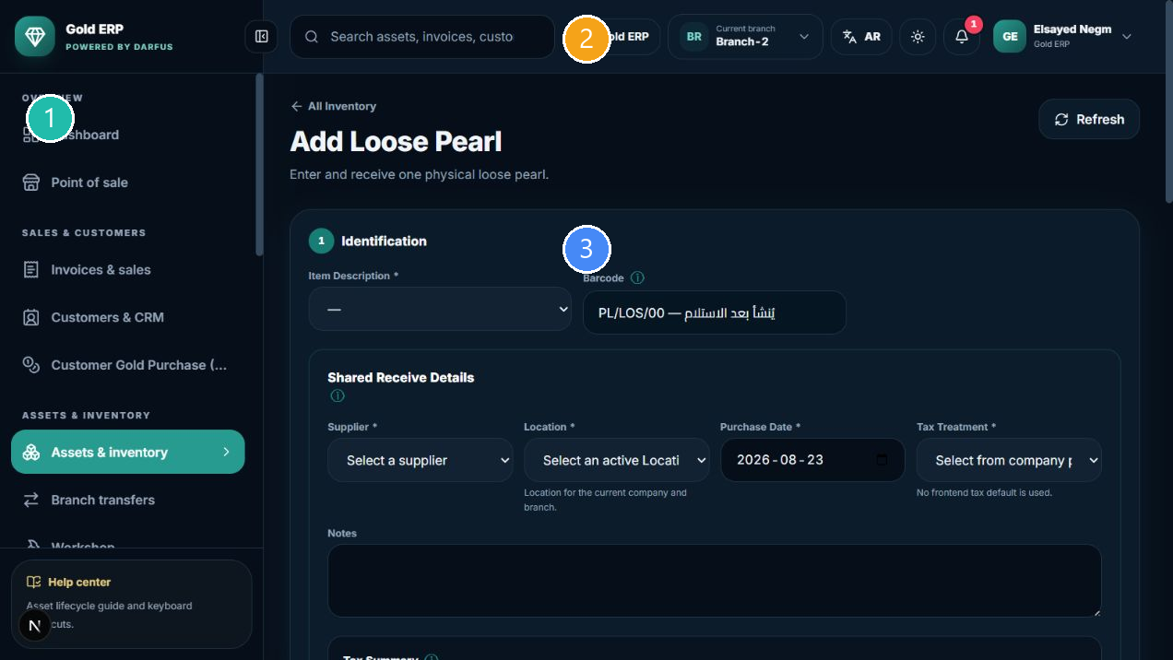
Loose Pearl
① Navigation ② Company/Branch and language context ③ Current workspace
Use it for an individual pearl that needs its own Asset and Barcode.
- Review the shared supplier, location, date, and tax information at the top of the form.
- Enter the profile fields shown on the screen; do not invent a value for a field that is not shown or required.
- Review the historical and current preview and selling price before opening confirmation.
- After receiving, find the Asset from Inventory or by Barcode.
Profile effect
The Asset, Barcode, and purchase history remain linked to the same physical piece. Calculated values and tax are shown according to company settings.

Asset, Barcode, and RFID
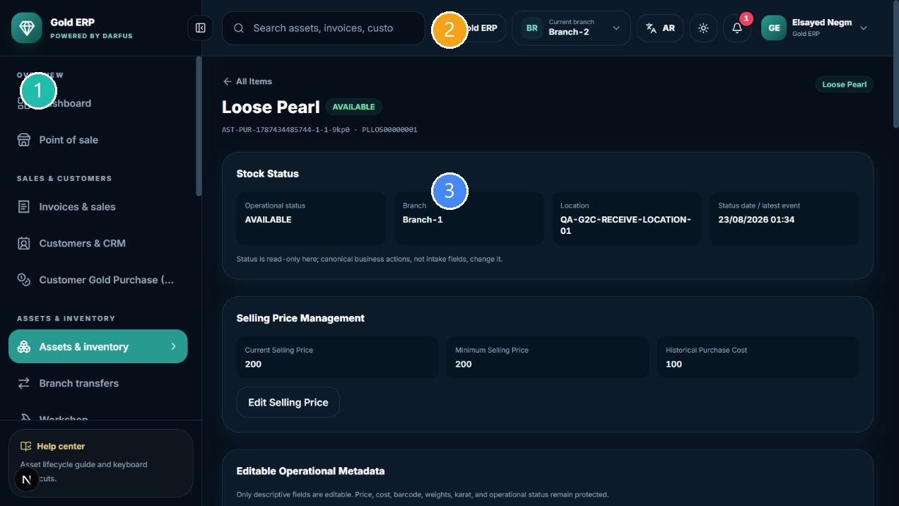
Asset details and traceability
① Navigation ② Company/Branch and language context ③ Current workspace
Asset Details is the business traceability card for a physical piece. Use it to review identity, branch, location, status, supplier, history, values, and events.

Barcode
- Barcode search returns the matching physical item.
- Reprint uses the same identity; it does not create a new piece.
- Barcode replacement - when exposed and permitted - changes the active Barcode for the same Asset and keeps the previous history for traceability.

RFID
Use RFID only when the RFID control is visible to your account. Assigning or replacing a tag does not change the Asset or Barcode unless the screen explicitly says so.
Do not edit status by imitation
Status changes belong to the correct workflow such as Sale, Transfer, or Workshop, not arbitrary editing in Asset Details.

Transfers, Workshop, and Count

Branch Transfers
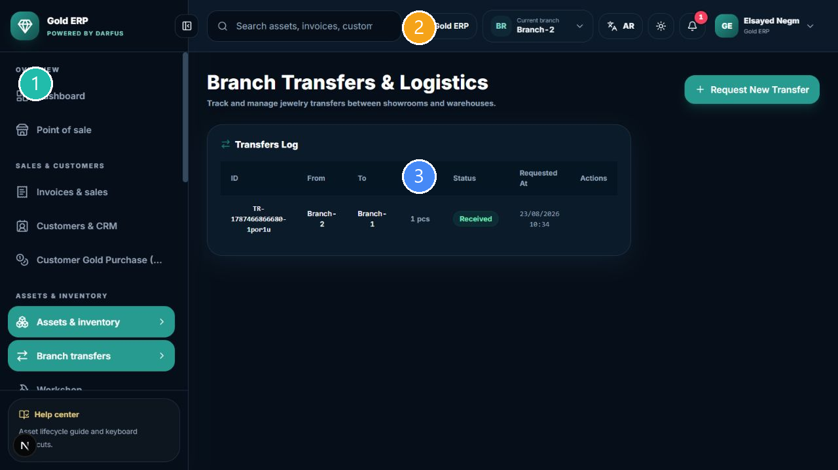
Transfer register and states
① Navigation ② Company/Branch and language context ③ Current workspace
- Inventory -> Transfers -> Create Transfer.
- Choose source and destination branch/location, then select available Assets.
- Submit the request, then complete Approve, Dispatch, and Receive according to the role.
- Open the same transfer record to review its state.
What changes?
The physical piece, Asset, and Barcode remain the same; branch/location custody changes through the transfer. A transfer does not create a sales invoice or supplier payment.

Workshop
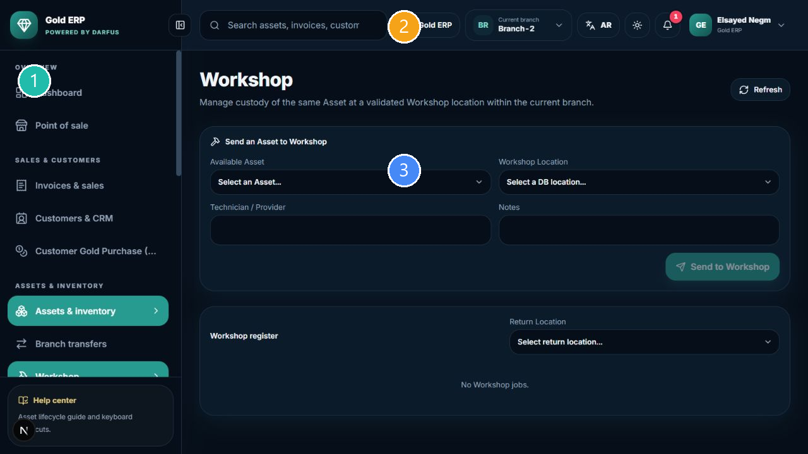
Workshop register
① Navigation ② Company/Branch and language context ③ Current workspace
- Inventory -> Workshop -> choose the piece and destination.
- Confirm Send, then follow the same record when it is returned.
- Do not sell the piece while it is in Workshop when its status prevents sale.
What happens?
The Asset and Barcode stay the same while operational custody/status changes through Workshop. Workshop is not a sale.

Inventory Count
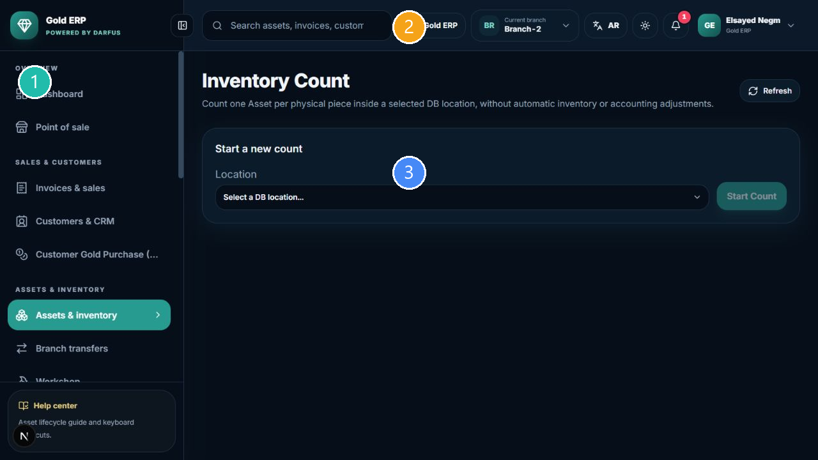
Count and compare expected with counted
① Navigation ② Company/Branch and language context ③ Current workspace
- Inventory -> Inventory Count -> choose the location and start a count.
- Review Expected, Counted, Missing, Unexpected, and Variance.
- Complete and close the same count when the workflow requires it.
Count effect
A count records evidence of what was observed. Do not assume it changes Asset status automatically; review the count result and audit history.

Suppliers and purchases
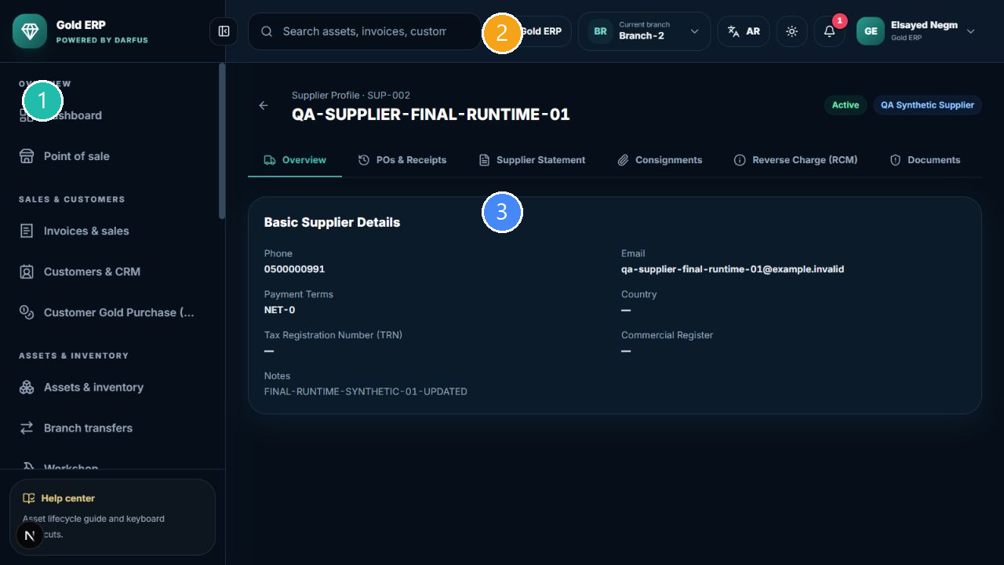
Supplier details, balance, and history
① Navigation ② Company/Branch and language context ③ Current workspace
- Open Suppliers & purchases and search by name, category, or phone.
- Open View to review supplier details, purchase history, and balance.
- For create or edit, use the button visible to your account and complete the fields shown.
- Do not overwrite the balance manually; the system-derived balance comes from recorded transactions.

Receiving supplier purchases
Start receiving from Inventory through the unified path. Supplier Details is for information, history, and balance; it is not a second receive source when Inventory is available.
After receiving or paying
After a receive, review the Asset in Inventory, supplier history, and Accounting when applicable. After a successful supplier payment, review the balance, Treasury, and journal.

Customers
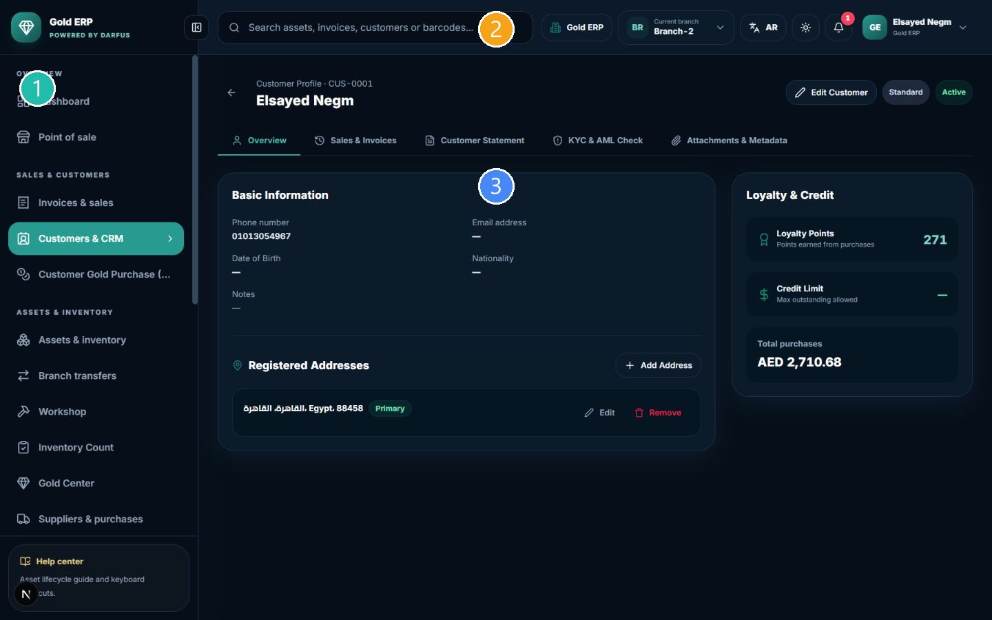
Customer details
① Navigation ② Company/Branch and language context ③ Current workspace
- Customers & CRM -> Add Customer.
- Complete the required fields shown, then save.
- Search by name or phone and open details when needed.
- In POS, search by phone and select the customer; POS does not silently create an unknown customer.
Customer effect
Creating or editing a customer does not create an invoice or payment. Sales or deposits may appear in the customer summary according to the workflow.

Point of Sale
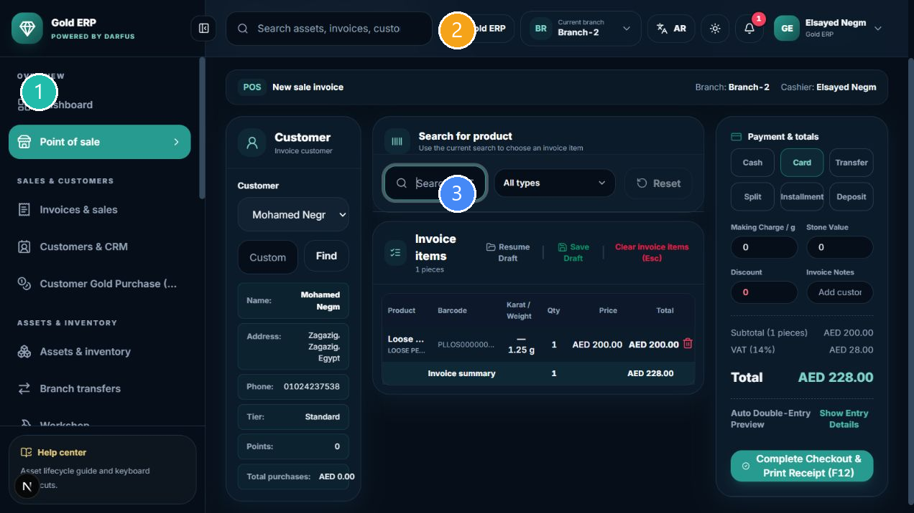
Cart and totals before completion
① Navigation ② Company/Branch and language context ③ Current workspace

Making a sale
- Confirm the branch and customer shown.
- Search by Barcode or supported item identifier, then select an available Asset.
- Review the cart, price, availability, VAT, and total.
- Review Journal Preview when it is shown.
- Choose a displayed payment method, open confirmation, and complete Checkout once.
- Open or print the receipt after success.

Journal Preview
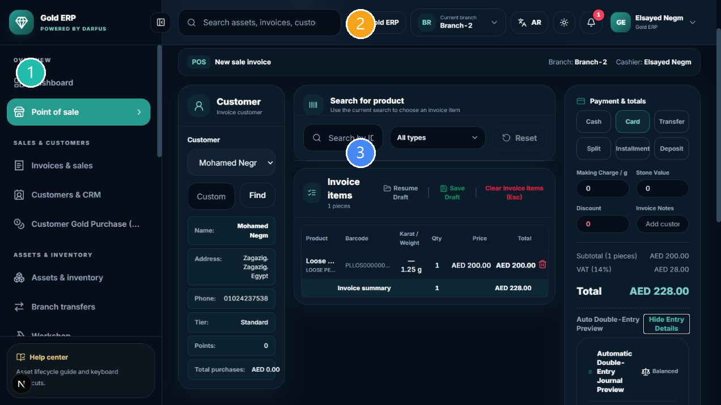
Financial preview details
① Navigation ② Company/Branch and language context ③ Current workspace
Journal Preview shows the expected financial effect before completion. The example shows cash, revenue, VAT, cost of goods sold, and inventory; a balanced preview means the preview balances, not that the sale is complete.
What happens after Checkout
The sale document and receipt are created, payment is recorded, cash or the relevant account is affected, the journal is posted, and the Asset becomes Sold while its Barcode remains linked to the same Asset.

Uncertain result
If an error or uncertain result appears, do not repeat Checkout or payment blindly; ask a supervisor to verify the invoice and payment.

Invoices, returns, and reservations
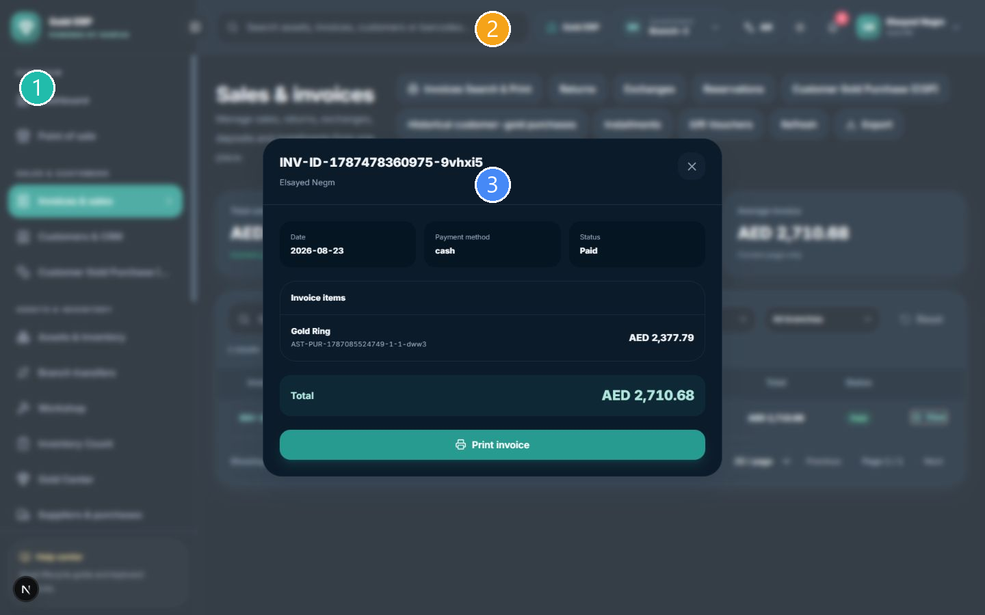
Existing invoice details
① Navigation ② Company/Branch and language context ③ Current workspace

Invoices and print
- Invoices & sales -> Invoices Search & Print.
- Search by invoice, customer, or payment method.
- Open View to review customer, item, VAT, total, and payment status.
- Use Print invoice when the button is shown.
Customer information in an invoice represents the sale-time snapshot and may differ later from the current customer profile.

Returns and exchanges
Start from Returns or Exchanges, locate the original invoice, and follow the validations and state allowed by the screen. Do not imitate the workflow by editing status manually.

Reservations and deposits
- Sales -> Reservations -> choose the customer and Asset.
- Record a deposit only when the button is shown and the permission is available.
- Follow deposit, refund, or complete sale from the same reservation record.
Deposit effect
A deposit remains a customer advance until refund or completion and affects Treasury and Accounting according to the action.

Gold Center and Customer Gold Purchase
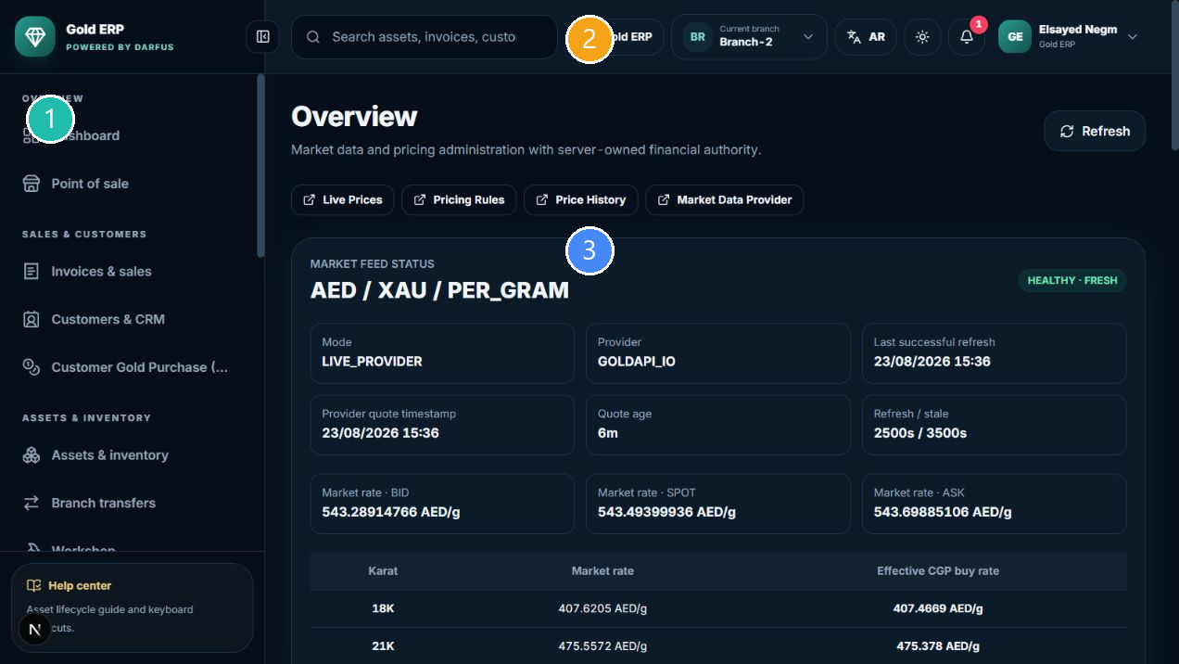
Price status and update state
① Navigation ② Company/Branch and language context ③ Current workspace

Gold Center
Gold Center shows current reference prices, karats, and freshness state. Supported pricing workflows use this reference; do not bypass a stale or unavailable state.

Customer Gold Purchase
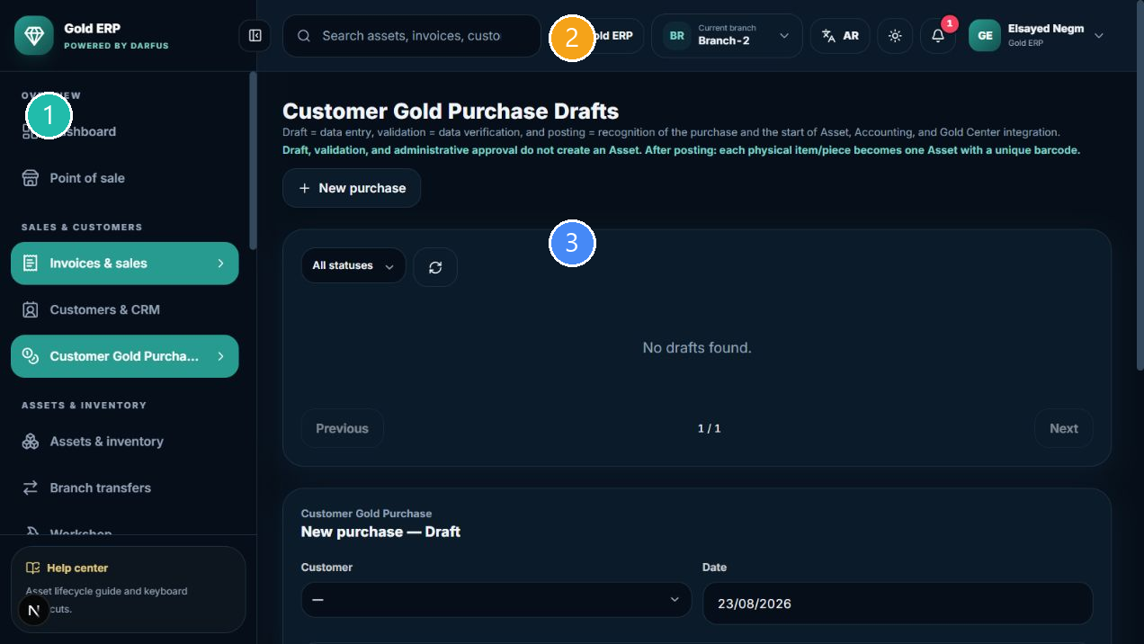
Customer Gold Purchase drafts
① Navigation ② Company/Branch and language context ③ Current workspace
- Open Customer Gold Purchase and create a draft when the button is shown.
- Enter customer and gold details, then review validation, price, and snapshot.
- Post only after validation, then review Settlement when available.
Not a supplier receive
Customer Gold Purchase is separate from supplier stock receiving. Do not mix the two documents.

Accounting, Treasury, and Reports
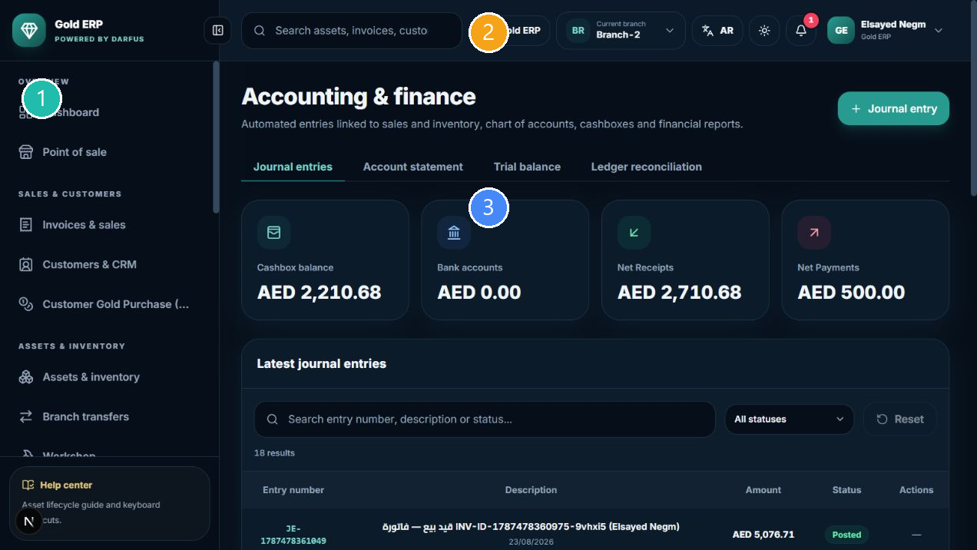
Accounting screen
① Navigation ② Company/Branch and language context ③ Current workspace
- Accounting: review journals, source, date, debit, credit, and status.
- Chart of Accounts: review accounts and branch mappings when permitted.
- Statements and Reports: use date and branch filters; do not treat an empty screen as a final zero before checking filters.
- Treasury: review cash session, movements, and payment results shown to your account.
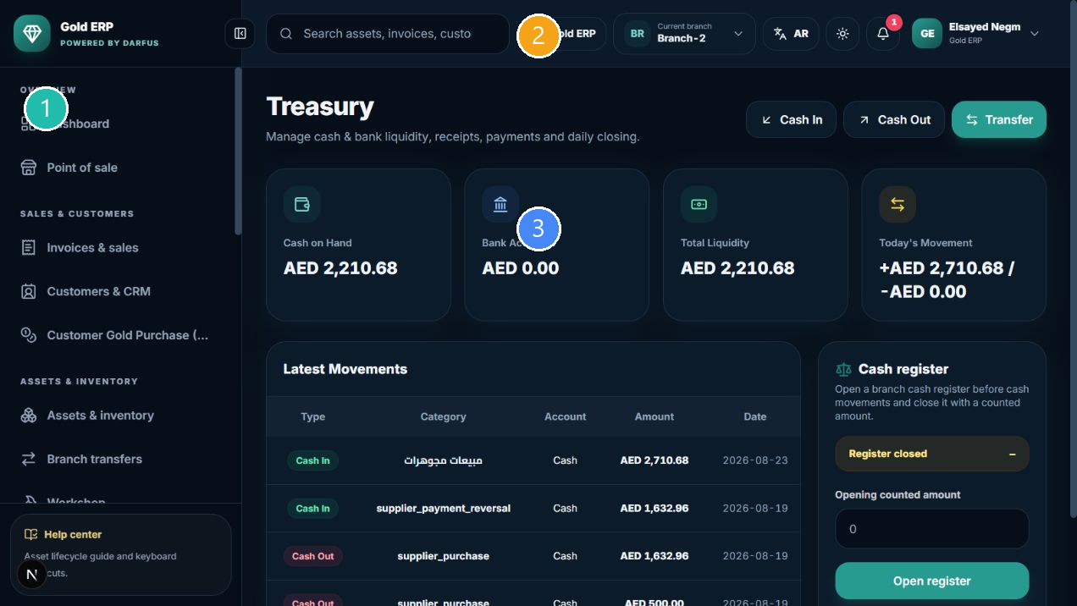
Treasury and movements
① Navigation ② Company/Branch and language context ③ Current workspace
Journal safety
Do not manually rewrite a posted journal. If a journal or payment is uncertain, keep the reference and ask the finance administrator to review it.

Users and Settings
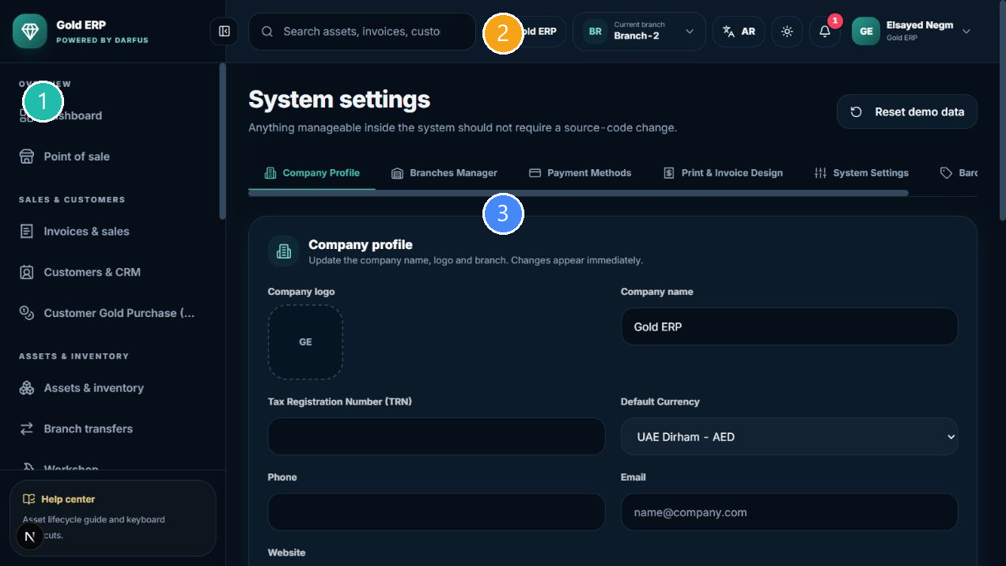
Company settings
① Navigation ② Company/Branch and language context ③ Current workspace
- Users and Employees: create, deactivate, and assign role/branch when permitted.
- Tax & VAT: review company policy and rate; only the authorized administrator should change them.
- Locations: add or disable a location when permitted; do not delete a value used by historical records.
- Barcode codes: review codes in the dedicated screen; do not create codes outside the supported workflow.
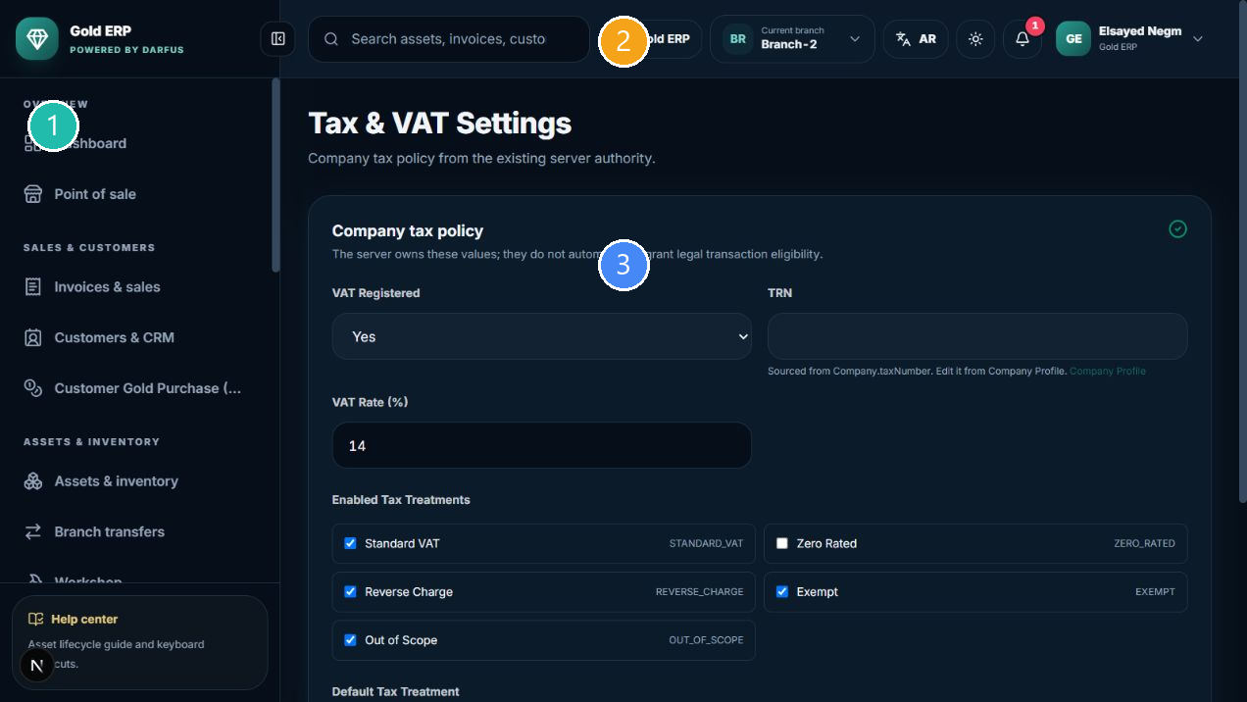
Tax policy
① Navigation ② Company/Branch and language context ③ Current workspace
Money settings
Settings that affect price, tax, or accounting should be changed only by the authorized administrator, with a documented reason.

Troubleshooting and safety
What you see | What to do
الزر غير ظاهر | Check role, branch, and record status.
Permission denied | Ask the administrator to review the permission.
الباركود غير موجود | Check spelling, branch, and item status.
العنصر غير متاح للبيع | It may be Sold, Reserved, in Workshop, or in Transfer.
السعر غير متاح أو قديم | Do not bypass price protection; check Gold Center or contact the administrator.
المعاينة غير متاحة | Complete required fields and check branch, location, and settings.
نتيجة دفع أو Checkout غير واضحة | Do not repeat it; ask for invoice and payment verification.
الجلسة انتهت | Sign in again and verify any financial action before repeating it.

Do not do this
- Do not sell the same physical piece twice.
- Do not move an item between branches outside Transfer.
- Do not create a fake supplier or customer to bypass a required field.
- Do not repeat payment or Checkout without knowing the result of the first attempt.
- Do not delete historical master data when Disable is available.

Status glossary and quick task finder
Status | Meaning
Available | Normally available for the allowed workflow.
Reserved | Reserved and not available for ordinary sale.
Workshop | In the Workshop workflow.
Sold | Sold with its financial effect recorded.
Pending / Approved / In Transit / Received | Transfer lifecycle states.
Missing / Unexpected / Variance | Inventory Count results.
Draft / Validated / Posted | Customer Gold Purchase lifecycle.

Quick recipes
- Receive stock: Inventory -> Add / Receive Inventory -> choose type -> enter data -> review -> Receive.
- Find a piece: Inventory -> search by Barcode or open Asset Details.
- Transfer: Inventory -> Transfers -> Create -> Approve -> Dispatch -> Receive.
- Count: Inventory -> Inventory Count -> location -> Start -> scan/count -> Complete/Close.
- Create a customer: Customers -> Add Customer -> save -> use it in POS.
- Sell: POS -> customer -> Barcode -> cart -> totals -> payment -> Checkout once -> receipt.
- Review a journal: Accounting -> find the source/reference -> review debit, credit, and status.

Handover and training checklist
- ☐ I know how to sign in and select the correct branch.
- ☐ I know how to search for customers, suppliers, and pieces by Barcode.
- ☐ I know how to receive, transfer, send to Workshop, and count inventory.
- ☐ I know how to review totals, VAT, and Journal Preview before a sale.
- ☐ I know when I need administrator permission.
- ☐ I will not repeat an uncertain financial action without verification.
Quick User Training Checklist
Start with sign-in and branch context, then take a read-only tour of Inventory, POS, and Accounting. Do not use real customer data in the first training session.

Current release notes
External e-invoicing integration is not part of this release scope. Do not bypass price or tax protection when a stale or unavailable state appears.

