Videos likes project

**1-preprocessing: -**

In this phase We made preprocessing with three techniques: -

1. Feature selection: -

We choose the wrapper method with forward selection to get the best features to work with and the result was the three features as the figure shown below.



1. Feature scaling: -

We set the fixed ranges from 0 to 50.

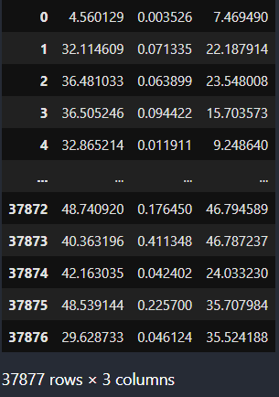

**2-Classification techniques: -**

1. **Logistic regression: -**





1. **Svm-poly: -**





* **Hyperparameter tuning: -**

1. We increased the degree and regularization parameter (c) was fixed.
2. We increased the regularization parameter and the degree was fixed.

From 1,2 we got the below table.

1. **Svm-linear: -**





* **Hyperparameter** **tuning**: -

1. We increase the regularization parameter and the result was shown in the table below.

1. **Svm-rbf: -**





* **Hyperparameter tuning: -**

1. We increased variance (gamma) while the regularization parameter was fixed and gets the result shown in the table below.

1. **Decision tree: -**





**2-Conclusion: -**

1. **Bar graphs: -**

1. **Models used: -**
2. Logistic regression.
3. Svm with polynomial kernel.
4. Svm with linear kernel.
5. Svm with rbf kernel.
6. Decision tree.

The best model to use was the **Decision tree**  as it gets the highest accuracy (89%).