**The <head> tag in HTML is used to define the metadata and other non-visible elements of a web page. It is placed between the <html> tag and the <body> tag. The <head> section contains information such as the page title, character encoding, links to stylesheets, scripts, and other resources that are not directly displayed on the web page but are essential for its functionality and presentation.**

**Here’s how you can use the <head> tag in HTML:**

**Basic Structure of an HTML Document with <head>**

html

<!DOCTYPE html>

<html lang="en">

<head>

    <!-- Metadata and other non-visible elements go here -->

    <meta charset="UTF-8">

    <meta name="viewport" content="width=device-width, initial-scale=1.0">

    <title>My Web Page</title>

    <link rel="stylesheet" href="styles.css">

    <script src="script.js"></script>

</head>

<body>

    <!-- Visible content of the web page goes here -->

    <h1>Welcome to My Web Page</h1>

    <p>This is a sample paragraph.</p>

</body>

</html>

**Common Elements Inside the <head> Tag**

**<title>:**

**Defines the title of the web page, which appears in the browser tab or window title bar.**

**Example:**

1. <title>My Web Page</title>

**<meta>:**

**Provides metadata about the HTML document, such as character encoding, author, description, and keywords.**

**Examples:**

1. <meta charset="UTF-8"> <!-- Character encoding -->
2. <meta name="description" content="This is a sample web page"> <!-- Page description -->
3. <meta name="keywords" content="HTML, CSS, JavaScript"> <!-- Keywords for SEO -->
4. <meta name="author" content="John Doe"> <!-- Author of the page -->
5. <meta name="viewport" content="width=device-width, initial-scale=1.0"> <!-- Responsive design -->

**<link>:**

**Used to link external resources, such as stylesheets (CSS), icons, or fonts.**

**Example:**

1. <link rel="stylesheet" href="styles.css"> <!-- Link to a CSS file -->
2. <link rel="icon" href="favicon.ico"> <!-- Link to a favicon -->

**<script>:**

**Used to embed or link to JavaScript files.**

**Example:**

1. <script src="script.js"></script> <!-- Link to an external JavaScript file -->
2. <script>
3. console.log("Hello, World!"); <!-- Inline JavaScript -->
4. </script>

**<style>:**

**Used to define internal CSS styles for the page.**

**Example:**

1. <style>
2. body {
3. font-family: Arial, sans-serif;
4. background-color: #f0f0f0;
5. }
6. </style>

**<base>:**

**Specifies the base URL for all relative URLs in the document.**

**Example:**

<base href="https://www.example.com/">

**Example of a Complete <head> Section**

<!DOCTYPE html>

<html lang="en">

<head>

    <meta charset="UTF-8">

    <meta name="viewport" content="width=device-width, initial-scale=1.0">

    <title>My Awesome Web Page</title>

    <meta name="description" content="This is an example of a well-structured HTML document.">

    <meta name="keywords" content="HTML, CSS, JavaScript">

    <meta name="author" content="Jane Doe">

    <link rel="stylesheet" href="styles.css">

    <link rel="icon" href="favicon.ico">

    <script src="script.js"></script>

    <style>

        h1 {

            color: blue;

        }

    </style>

</head>

<body>

    <h1>Welcome to My Awesome Web Page</h1>

    <p>This is a sample paragraph.</p>

</body>

</html>

**Key Points to Remember**

* **The <head> tag is not visible on the web page itself but contains essential information for the browser and search engines.**
* **Always include a <title> tag in the <head> section, as it is required for valid HTML and improves SEO.**
* **Use <meta> tags to provide metadata, such as character encoding and viewport settings for responsive design.**

**Link external resources like CSS and JavaScript files using <link> and <script> tags.**

**By properly using the <head> tag, you can ensure that your web page is well-structured, optimized for search engines, and functions correctly across different devices and browsers.**

**Common Special Characters and Their HTML Entities**

| **Character** | **Description** | **HTML Entity** |
| --- | --- | --- |
| **<** | **Less-than sign** | **&lt;** |
| **>** | **Greater-than sign** | **&gt;** |
| **&** | **Ampersand** | **&amp;** |
| **"** | **Double quotation mark** | **&quot;** |
| **'** | **Single quotation mark (apostrophe)** | **&apos; (or &#39;)** |
| **©** | **Copyright symbol** | **&copy;** |
| **®** | **Registered trademark symbol** | **&reg;** |
| **™** | **Trademark symbol** | **&trade;** |
|  | **Non-breaking space** | **&nbsp;** |
| **€** | **Euro symbol** | **&euro;** |
| **£** | **Pound symbol** | **&pound;** |
| **¥** | **Yen symbol** | **&yen;** |
| **¢** | **Cent symbol** | **&cent;** |
| **§** | **Section symbol** | **&sect;** |
| **°** | **Degree symbol** | **&deg;** |

**HTML Comments**

<!-- This is a comment. It will not be displayed in the browser. -->

**HTML Links**

**Absolute vs. Relative References**

**Absolute Reference:**

**Uses the full URL to link to a page on another website.**

**Example:**

<a href="http://www.dr-chuck.com/page2.htm">Second Page</a>

**Relative Reference:**

**Links to a file in the same folder or directory as the current document.**

**Example:**

<a href="page1.htm">First Page</a>

**Opening Links in a New Tab:**

**Use the target="_blank" attribute to open a link in a new tab.**

**Example:**

<a href="http://www.dr-chuck.com/page2.htm" target="_blank">Second Page</a>

**Images in HTML**

**Images can be embedded directly into HTML using the <img> tag. They can also be made clickable by wrapping them in an <a> tag.**

**Example 1: Embedding an Image**

<p>

    Images can be <img src="tiny.png"> right in the middle of text like a character.

</p>

**Example 2: Making an Image a Clickable Link**

<p>

    We can even make an image a clickable

    <a href="lists.htm">

        <img style="height:60px; width:60px" src="tiny.png">

    </a>

    link to another page.

</p>

**Image Attributes:**

**The <img> tag has important attributes:**

**src: Specifies the image file path.**

**alt: Provides alternative text for screen readers or if the image fails to load.**

**width and height: Define the dimensions of the image.**

**Example:**

<img src="tiny.png" alt="A small icon" width="60" height="60">

**HTML Lists**

**HTML provides two main types of lists:**

1. **Unordered Lists (<ul>): Used for items that do not need to be in a specific order. Items are typically displayed with bullet points.**
2. **Ordered Lists (<ol>): Used for items that need to be in a specific order. Items are displayed with numbers or letters.**

**In your example, an unordered list (<ul>) is used.**

<ul>

    <li>

        <p>This page shows us how lists work</p>

    </li>

    <li>

        <p>We need to encode <a href="special.htm">certain characters</a> to show them in HTML</p>

    </li>

    <li>

        <p>We should learn more about <a href="links.htm">Links</a></p>

    </li>

    <li>

        <p>We should learn about <a href="images.htm">Images</a></p>

    </li>

</ul>

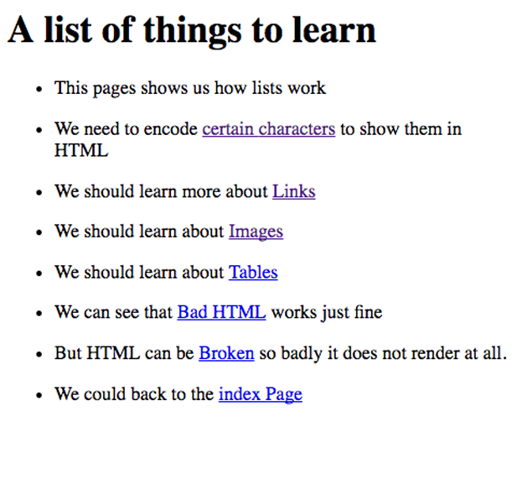

**Nested Lists:** You can nest lists inside other lists to create sub-items

<ul>

    <li>Item 1</li>

    <li>Item 2

        <ul>

            <li>Sub-item 1</li>

            <li>Sub-item 2</li>

        </ul>

    </li>

    <li>Item 3</li>

</ul>

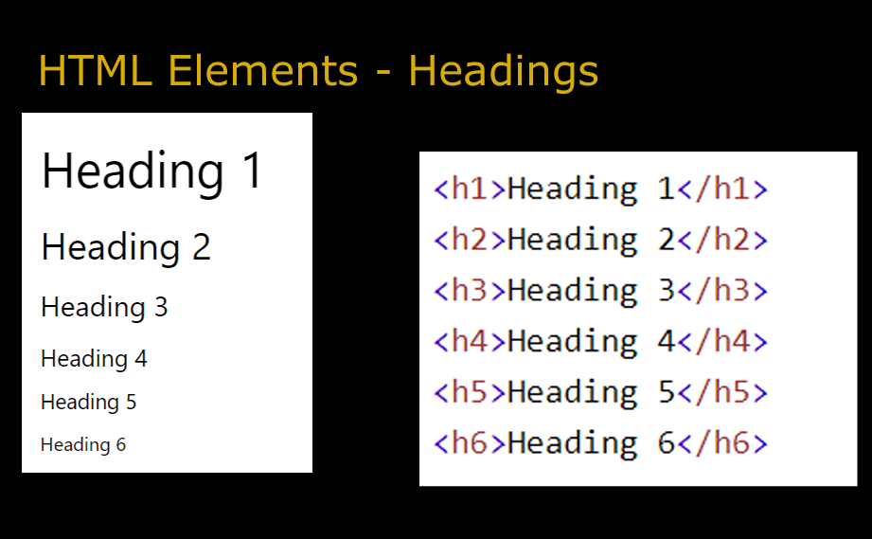

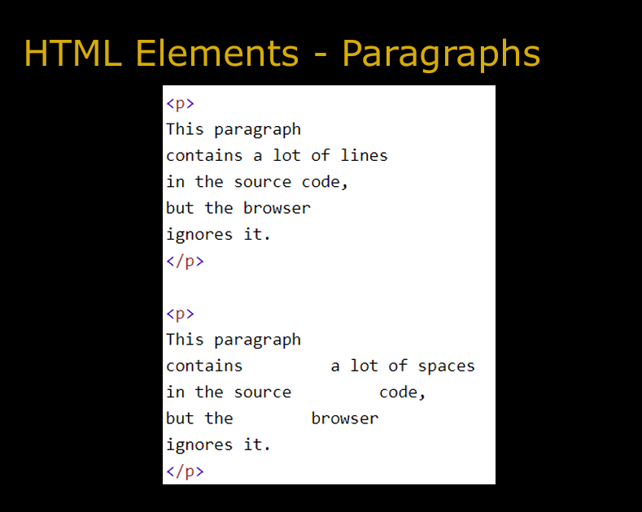

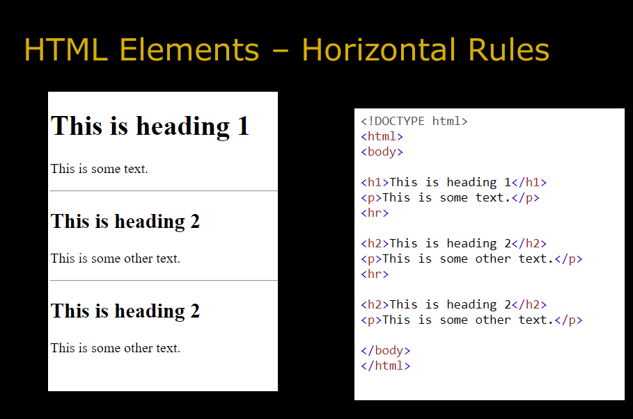

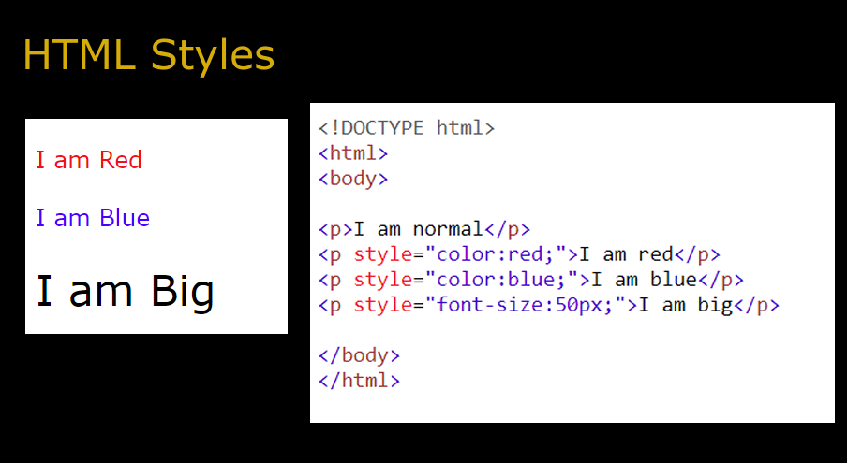

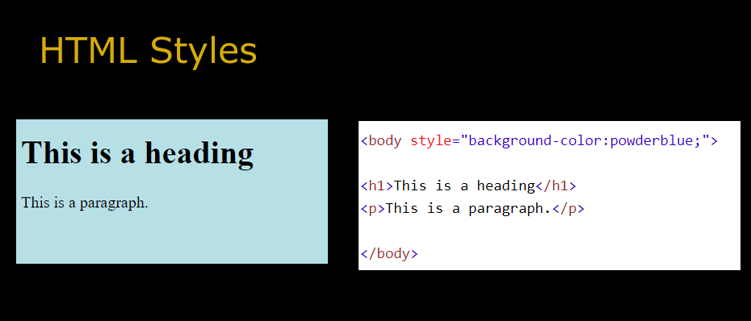

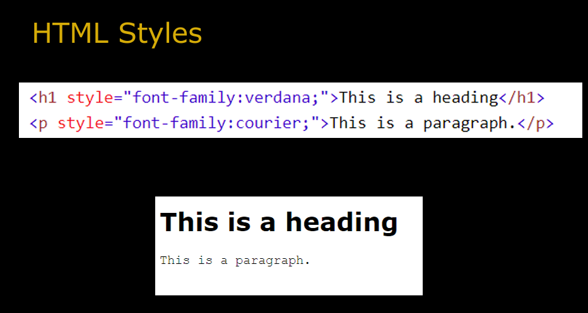

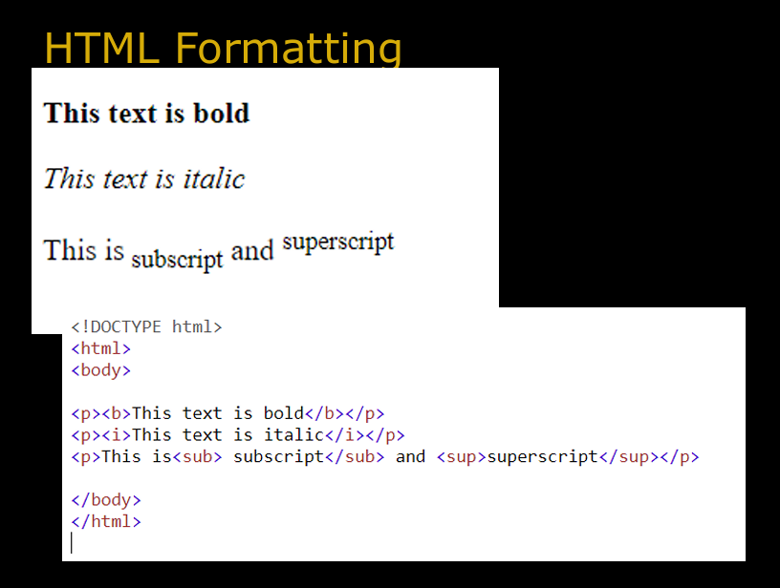

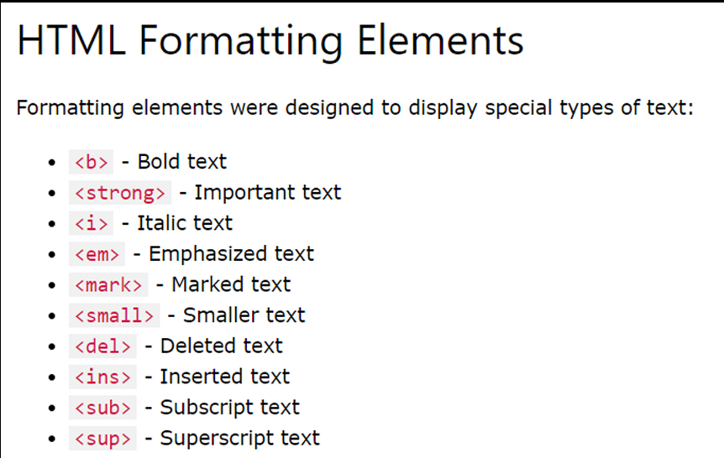

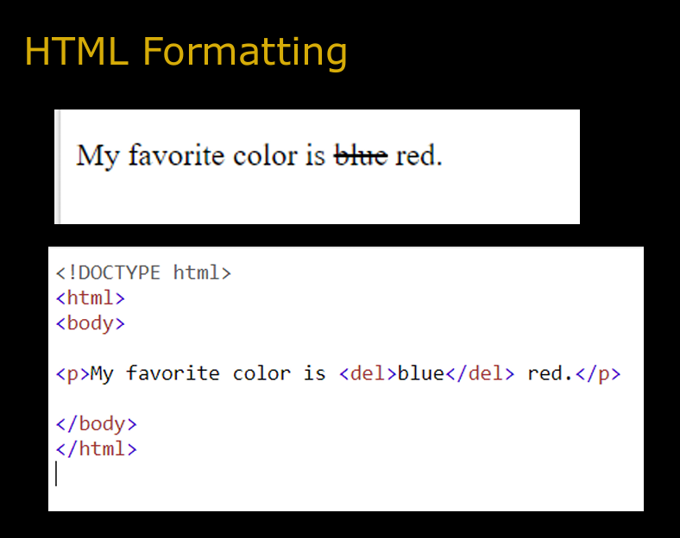

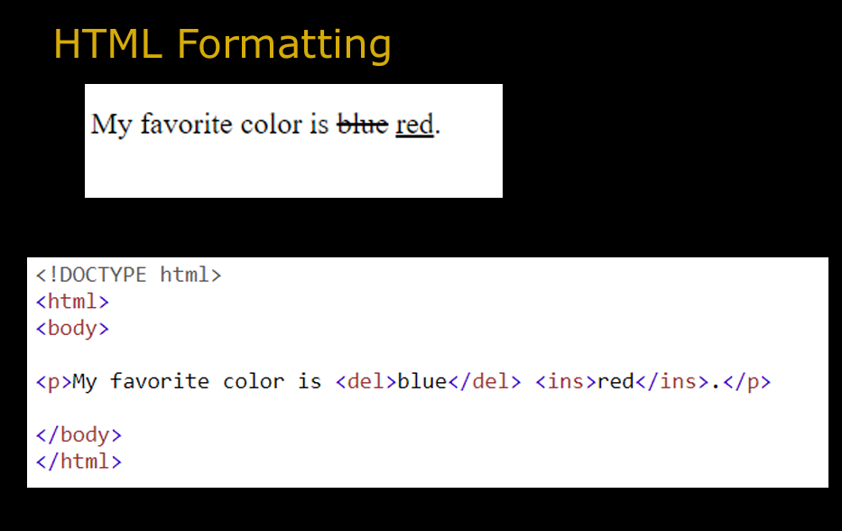

**HTML5 introduces several new <input> types like email, date, time, color, range, and so on. to improve the user experience and to make the forms more interactive. However, if a browser failed to recognize these new input types, it will treat them like a normal text box.**

**Examples:**

<form>

    <label for="mycolor">Select Color:</label>

    <input type="color" value="#00ff00" id="mycolor">

</form>

**Explanation of Each Part**

**<form> Tag:**

**The <form> tag is used to create a form. Forms are used to collect user input.**

**In this case, the form contains a color picker and a button.**

**<label> Tag:**

**The <label> tag is used to define a label for an input element.**

**The for attribute associates the label with the input element whose id matches the value of for.**

**When a screen reader encounters a <label> with a for attribute, it reads the label text aloud when the associated input element is focused. This helps visually impaired users understand what the input field is for.**

**<input> Tag:**

**The <input> tag is used to create an input field where users can enter data.**

**In this case, the type="color" attribute creates a color picker.**

**The value="#00ff00" attribute sets the default color to green (#00ff00).**

**The id="mycolor" attribute uniquely identifies this input element.**

**<button> Tag:**

**The <button> tag is used to create a clickable button.**

**The type="button" attribute specifies that this button does not submit the form.**

**The onclick="getValue();" attribute specifies that the getValue() function will be called when the button is clicked.**

**To make the button functional, you need to define the getValue() function in JavaScript. This function will retrieve the selected color from the input field and display it**

<form>

    <label for="mydate">Select Date:</label>

    <input type="date" value="2019-04-15" id="mydate">

</form>

**HTML Tables**

**HTML tables are used to display data in a structured, grid-like format. They consist of rows and columns, making them ideal for organizing information such as schedules, product details, or comparisons.**

<table>

    <tr>

        <th>Make</th>

        <th>Model</th>

        <th>Mileage</th>

    </tr>

    <tr>

        <td>Ford</td>

        <td>Edge</td>

        <td>10348</td>

    </tr>

    <tr>

        <td>Pontiac</td>

        <td>Vibe</td>

        <td>73630</td>

    </tr>

</table>

**Explanation of Each Part**

**<table> Tag:**

**The <table> tag defines the table. All table-related elements are nested inside this tag.**

**<tr> Tag:**

**The <tr> (table row) tag defines a row in the table. Each row contains one or more cells.**

**<th> Tag:**

**The <th> (table header) tag defines a header cell. Header cells are typically used for column or row labels and are bold and centered by default.**

**<td> Tag:**

**The <td> (table data) tag defines a standard cell in the table. It contains the actual data.**

**Rendered Output**

**The above code will render the following table:**

| **Make** | **Model** | **Mileage** |
| --- | --- | --- |
| Ford | Edge | 10348 |
| Pontiac | Vibe | 73630 |

1. **HTML5 Web Storage:**
   * **Provides a way to store data locally in the browser.**
   * **Two types: localStorage (permanent) and sessionStorage (temporary).**
   * **Faster and more efficient than cookies, with a larger storage capacity.**
2. **HTML5 Application Cache:**
   * **Allows web applications to work offline by caching resources.**
   * **Improves performance and reduces server load.**
   * **Requires a manifest file to specify resources for caching**.

**Comparison: Web Storage vs. Application Cache**

| **Feature** | **Web Storage** | **Application Cache** |
| --- | --- | --- |
| **Purpose** | Store data locally (key-value pairs). | Cache resources for offline use. |
| **Storage Type** | Data storage (strings). | Resource caching (HTML, CSS, JS, etc.). |
| **Capacity** | Up to 5MB per domain. | Depends on browser and user settings. |
| **Persistence** | Local Storage: Permanent. | Persistent until the cache is cleared. |
| **Use Case** | Store user preferences, session data. | Enable offline access to web apps. |