mostfa mohamed mahmoud hussien farrag (49)  
ziad taha ali (19)

programming 2

Computer science department

# User guide

## drwaing shape

The user can draw any of this shape (Circle , ellipse , Square , Rectangle , Triangle , Line )   
by pressed the button shape and drag .

Drawing triangle is different   
first : click to set the first point

Second : while moving the it draw the line

Third : click to put the second line

Fourth : while moving the triangle drawing

Fifth : click to draw triangle

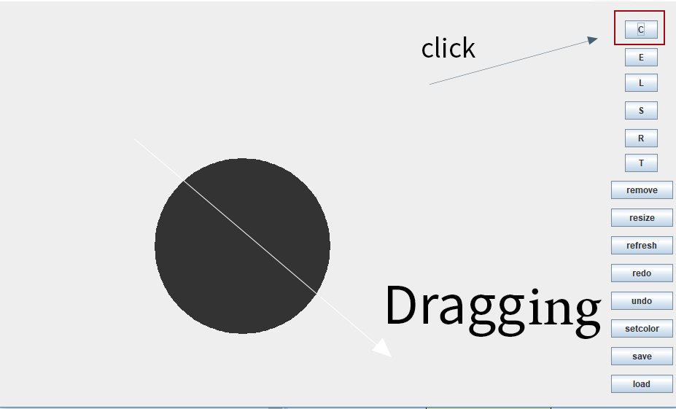

## undo

The user can undo any of his actions by clicked undo button   
note : the maximum number of undo is 20

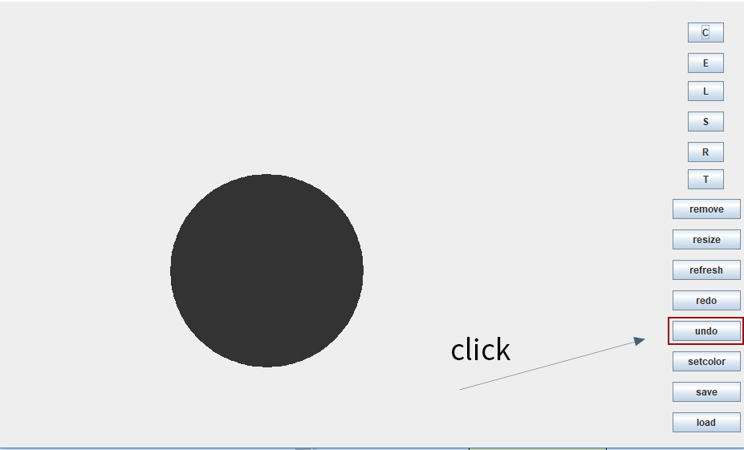

## redo

It is one of most important feature .  
the user can redo all of his undo action by clicked redo button

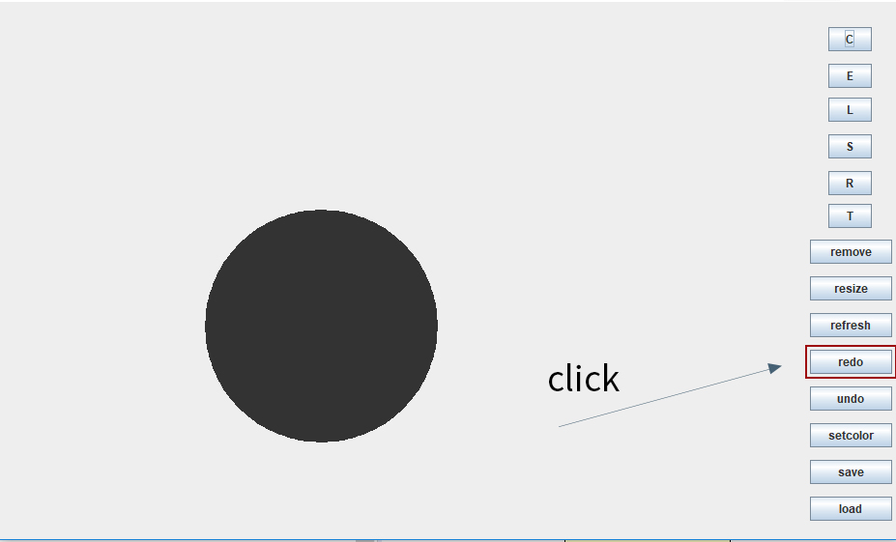

## refresh

It give the user the ability to redraw all the shapes again

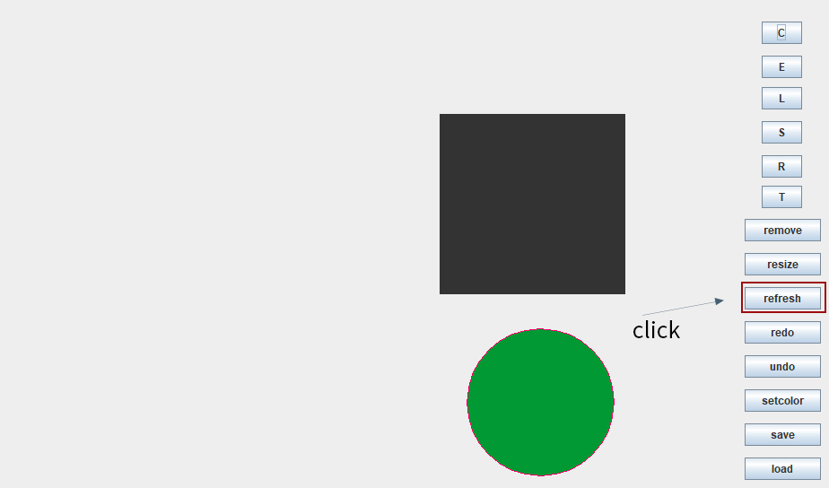

## selection

You can select any of drawing by double clicked on the shape

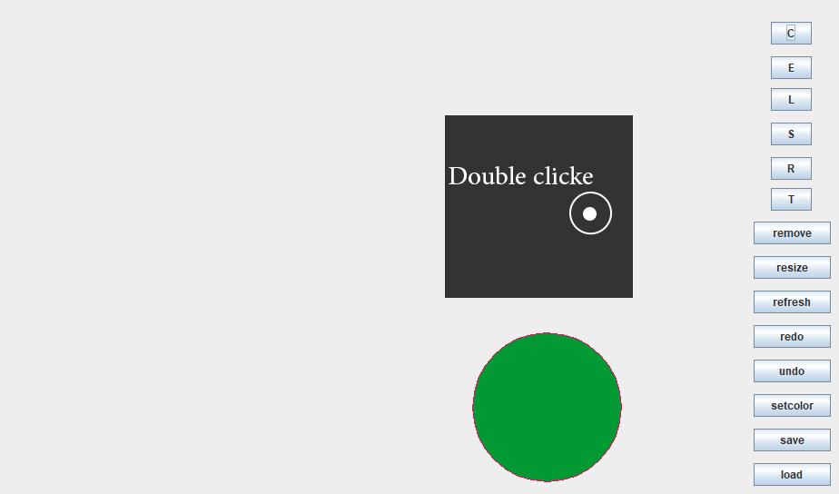

## resize and move

After selection the user can resize or move the shape by drag the shape

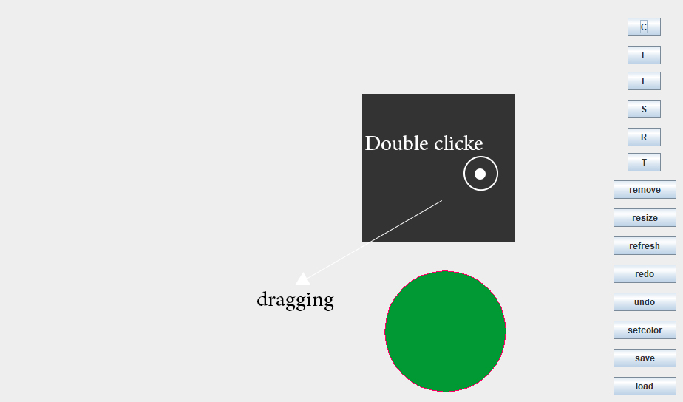

## remove

The user can remove the selected shape by click in the remove button

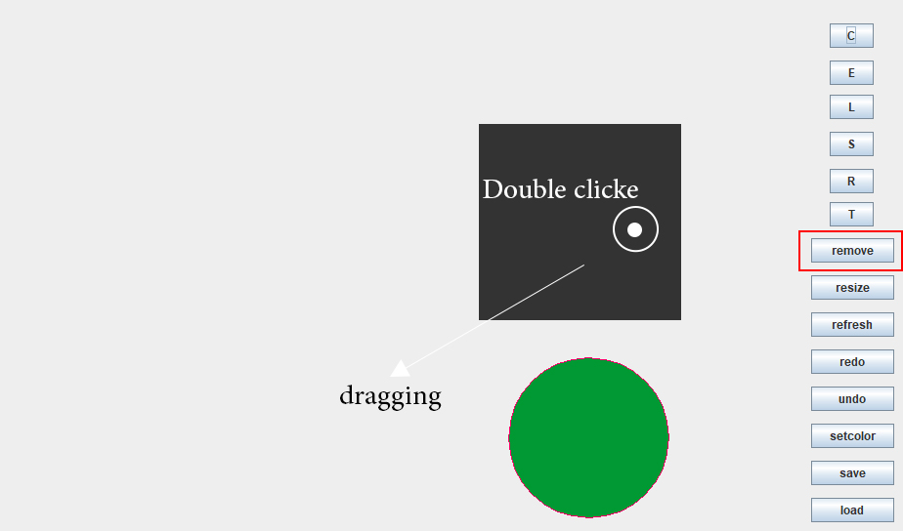

# UML diagram

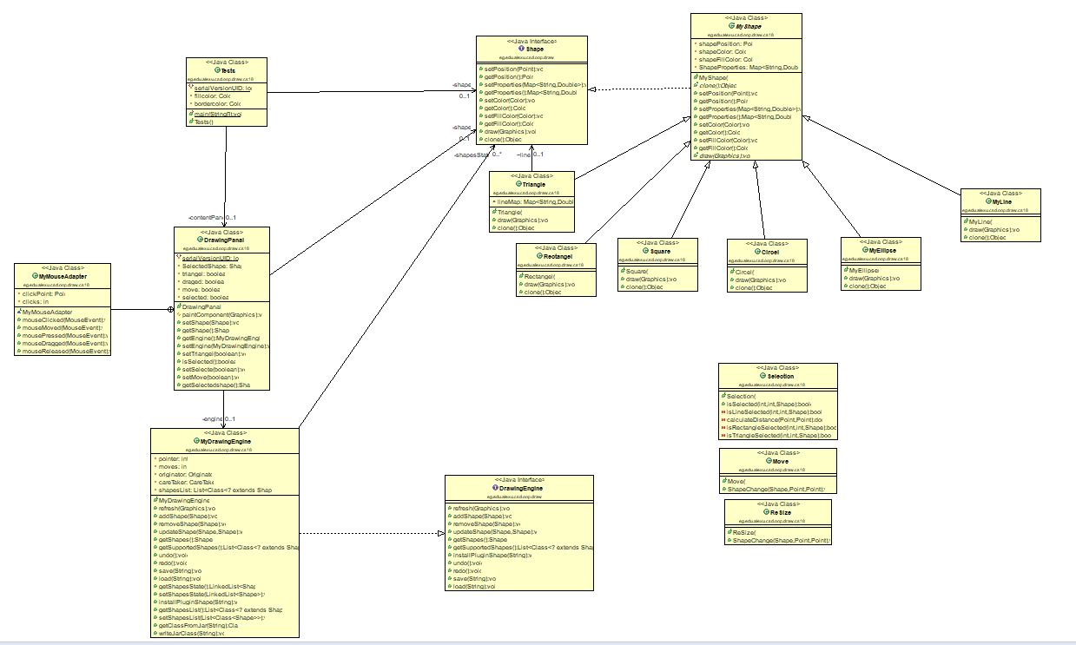

## class myshape

It is a abstract class implement Shape interface .

It have all the common function in all shapes .

All of ( Myline - Square – MyEllipse – Square – Triangle … ) is extend MyShape .

class Tests

it is the gui class it

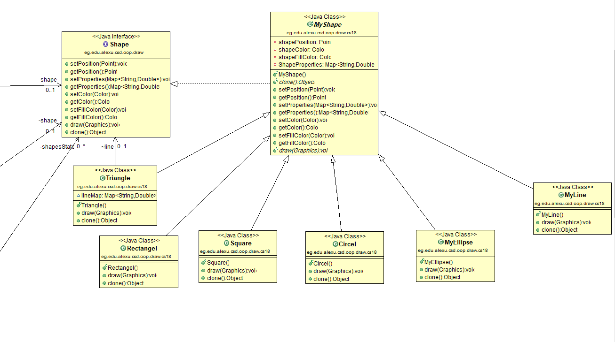

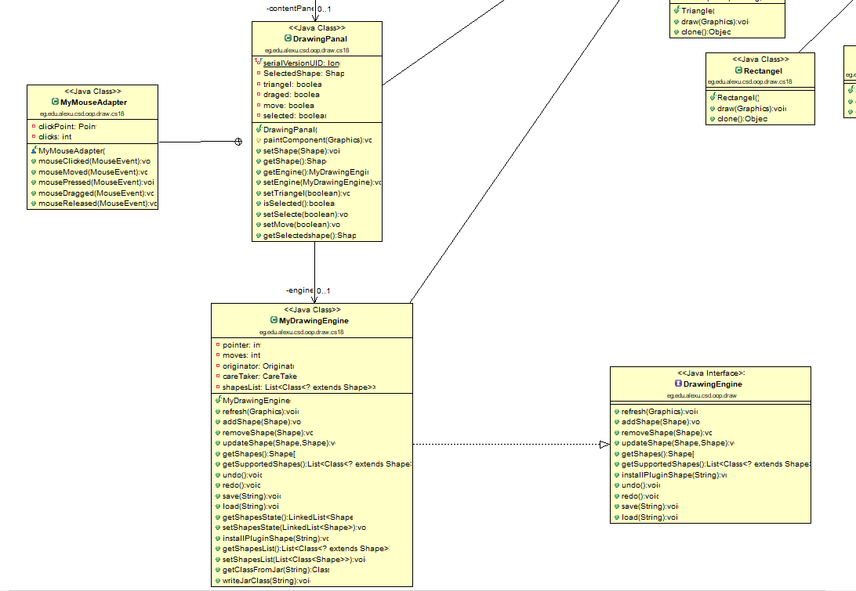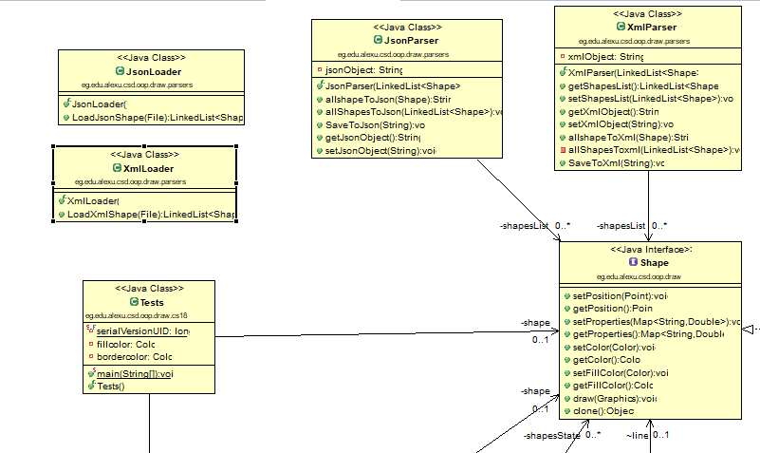

we used memento design pattern in the undo and redo to save the states

by saving the states(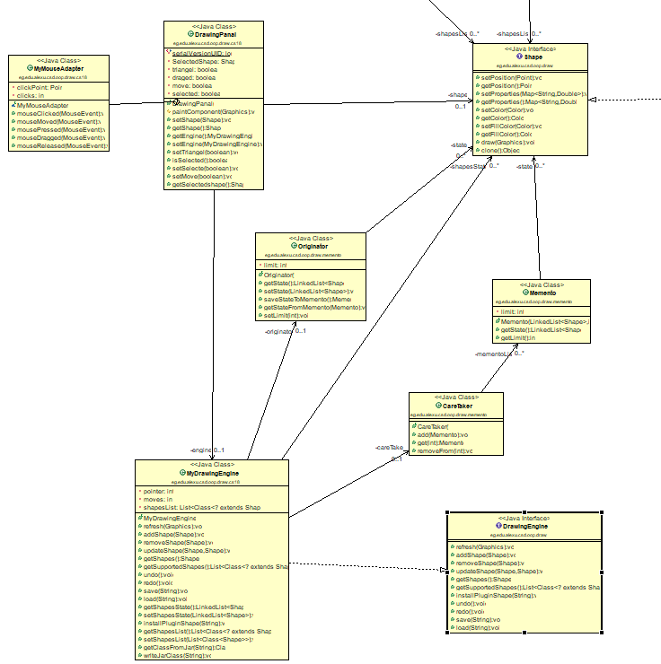mementos)in array of mementos and using the originator and the care tacker classes

do the work of controlling saving data .

we used parsers package with parsers and loader classes to manage the save and load operations

xml loader and parser ,Jsonloader and parser.