Image Processing Project
Preprocessing and Quality Analysis for TIFF Image Dataset
Project Documentation

Course / Subject | Image Processing
Project Repository | github.com/ziadahmed789/image-processing-project
Main Notebook | notebook/preprocessing.ipynb
Dataset Format | TIFF images - RawDataQA series

Team Members
No. | Student Name | Student ID
1 | Khalid atef | 200042795
2 | Ziad ahmed | 200042835
3 | Omar mahmoud | 200039183
4 | Ahmed sherif | 200039943
5 | Mahmoud azmy | 200042700
6 | Youssef osama | 200041354

Abstract

This project presents a practical image preprocessing workflow using Python for a large TIFF-based image dataset. The repository contains a Jupyter Notebook named preprocessing.ipynb, a Data folder containing RawDataQA TIFF images, and a requirements file listing the main libraries used in the project: NumPy, OpenCV, Pillow, Matplotlib, Jupyter, ipykernel, and scikit-image. The purpose of the project is to read image data, apply preprocessing operations, prepare images for analysis, and visualize intermediate and final results. Such preprocessing is an essential step in image processing because it improves data quality, reduces noise, standardizes image format, and makes the dataset ready for future analysis or model training.

Keywords
Image Processing, Preprocessing, OpenCV, NumPy, TIFF Images, scikit-image, Python, Jupyter Notebook.

Repository Overview
Repository name | image-processing-project
Main code file | notebook/preprocessing.ipynb
Dataset folder | image-processing-project/Data
Sample dataset naming | RawDataQA-1-1 (n).tiff
Programming environment | Python + Jupyter Notebook

Introduction

Digital image processing focuses on acquiring, enhancing, transforming, and analyzing images using computational techniques. Before applying advanced analysis, images usually need preprocessing to correct inconsistencies such as noise, different image sizes, unwanted color formats, or unstable intensity ranges.
In this project, the preprocessing stage is implemented in a Jupyter Notebook using common Python image-processing libraries. The dataset is stored as TIFF images, which are frequently used in technical and scientific imaging because they can preserve high-quality image information. The workflow is designed to load these images, inspect their properties, apply processing steps, and display the output for evaluation.
The project is important because clean and standardized image data leads to more reliable results. Whether the next stage is segmentation, object detection, quality assessment, or classification, the preprocessing step directly affects final performance.

Project Objectives
- Load and inspect a TIFF image dataset stored in the project Data folder.
- Apply preprocessing operations that improve image quality and consistency.
- Use Python libraries such as OpenCV, NumPy, Pillow, Matplotlib, and scikit-image.
- Visualize original and processed images to compare the effect of preprocessing.
- Prepare clean image data for possible future computer vision tasks.

Tools and Libraries
Library | Role in project | Why it is useful
NumPy | Array operations | Images are handled as numerical arrays.
OpenCV | Image reading and processing | Provides fast image-processing functions.
Pillow | Image loading and format support | Useful for working with image files.
Matplotlib | Visualization | Displays original and processed outputs.
scikit-image | Advanced processing utilities | Supports scientific image-processing tools.
Jupyter | Notebook execution | Makes code, results, and explanation easy to combine.

Methodology

The preprocessing pipeline can be summarized in the following stages:
Stage | Description
1. Import libraries | Load the required Python packages for image reading, numerical processing, and visualization.
2. Load dataset | Read TIFF images from the Data folder and organize them for processing.
3. Inspect image properties | Check image size, shape, channels, and intensity range.
4. Preprocess images | Apply operations such as color conversion, resizing, normalization, filtering, or enhancement as needed.
5. Visualize results | Display the original image beside the processed result to evaluate the output.
6. Save or reuse output | Use the processed images in later image analysis or machine learning steps.

Figure 1: Imports and project setup code
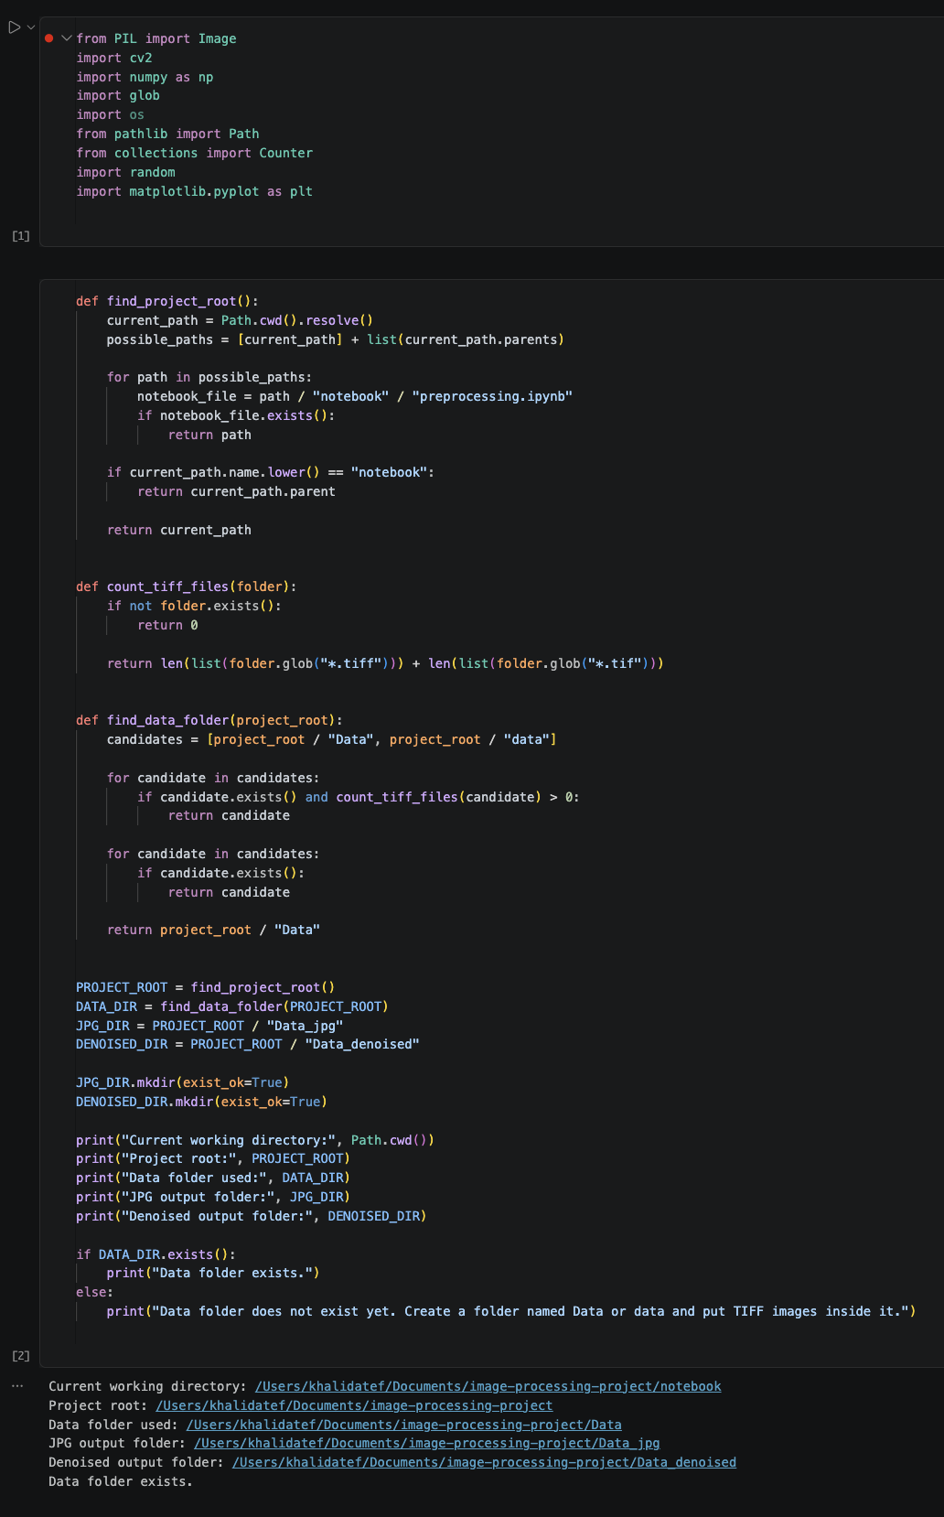
Caption: This screenshot should show the imported libraries and the initial project setup used to access the dataset.
Figure 2: Dataset loading and image reading code
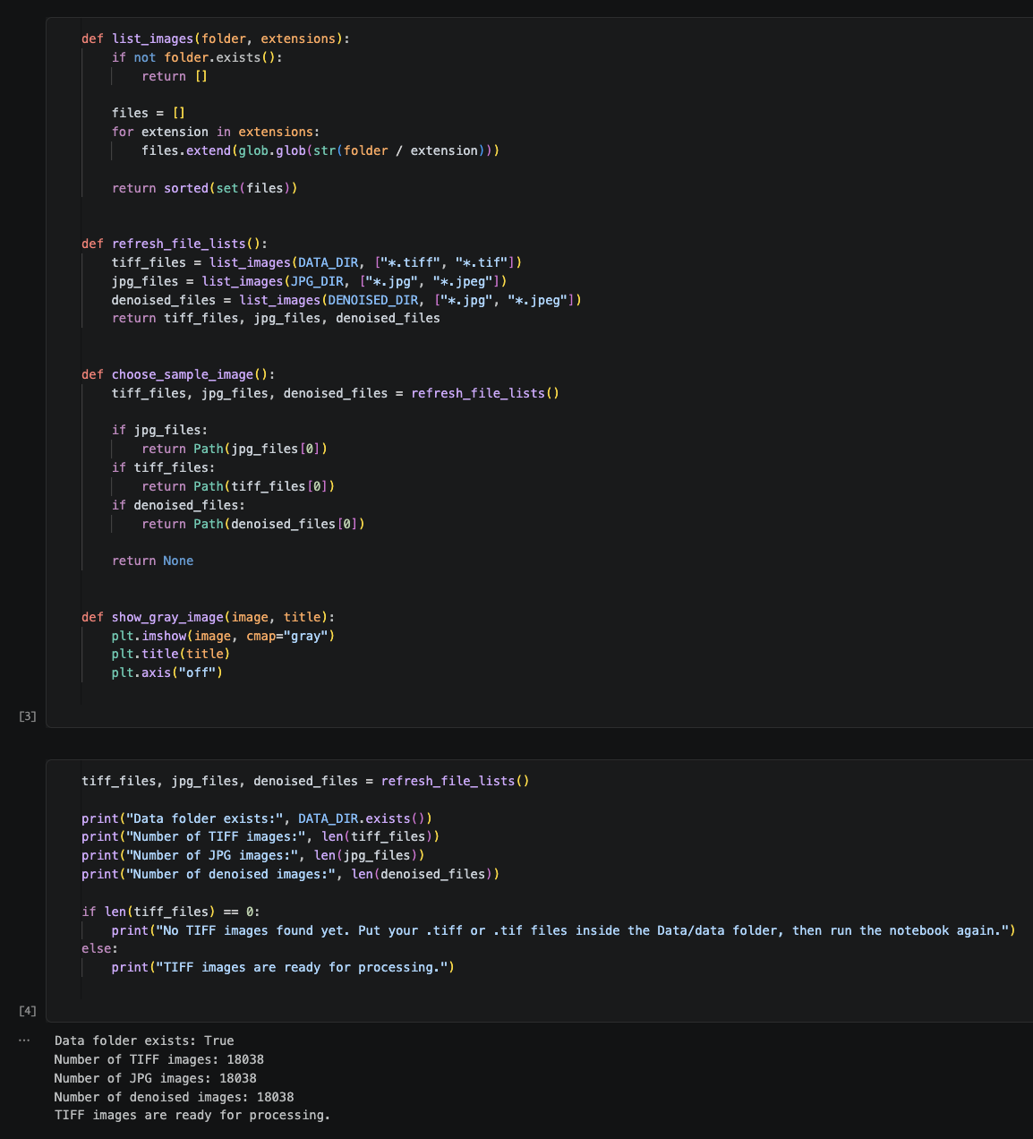
Caption: This screenshot should show how TIFF images are loaded from the Data folder.
Figure 3: Main preprocessing code
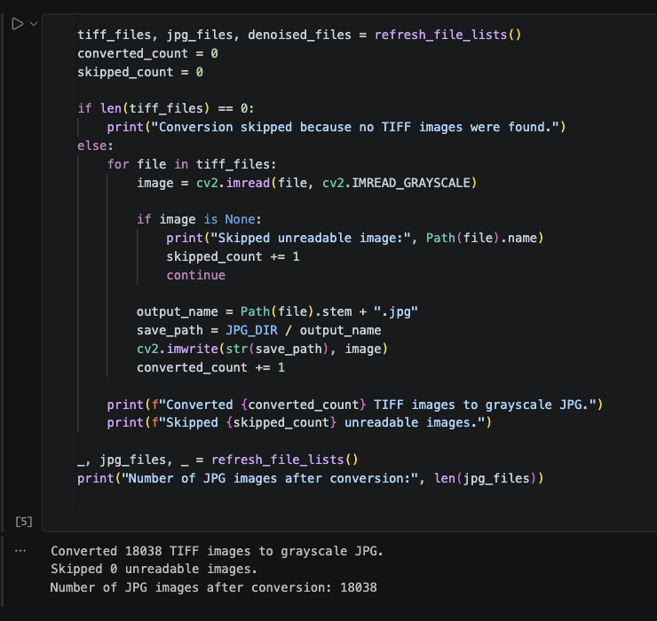
Caption: This screenshot should show the main image preprocessing operations applied to the selected image or image batch.

Run and Output Screenshots

Figure 4: Notebook run output - original image
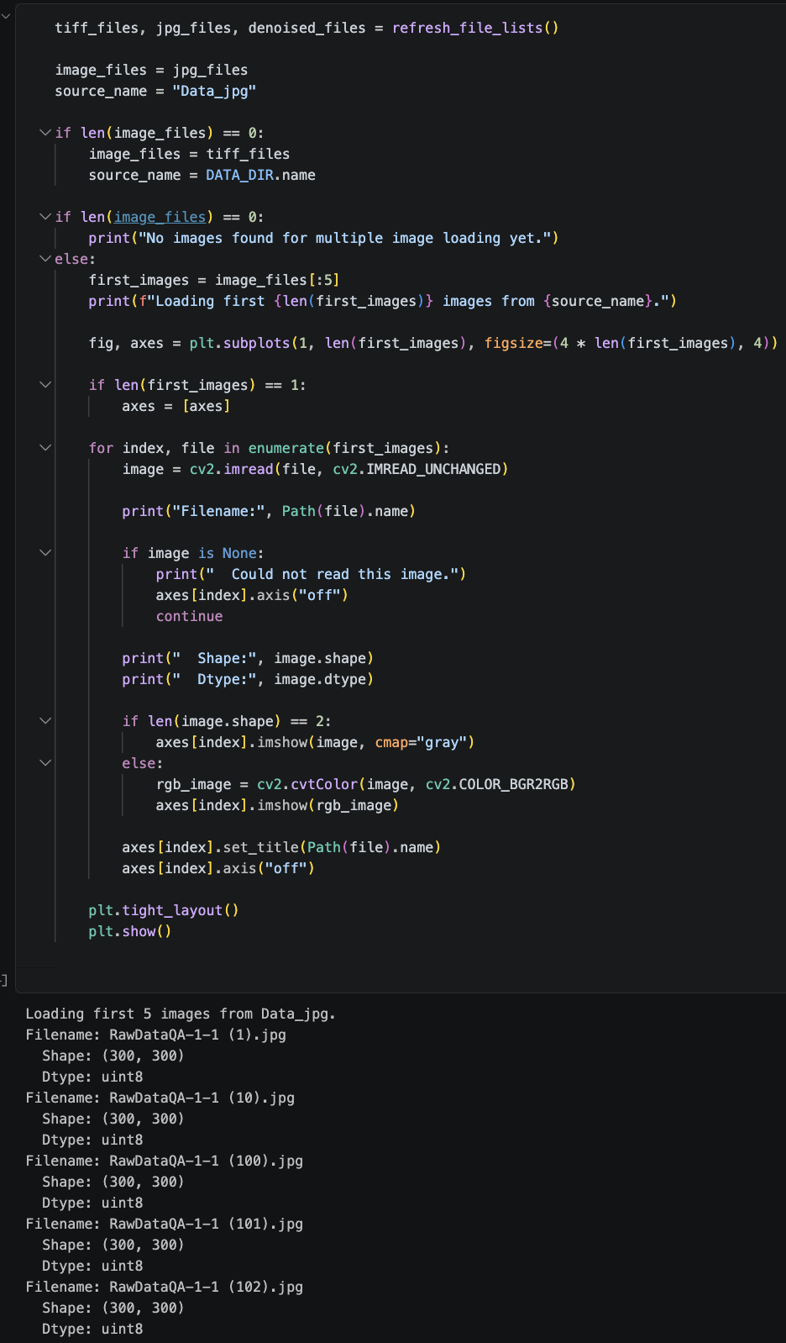
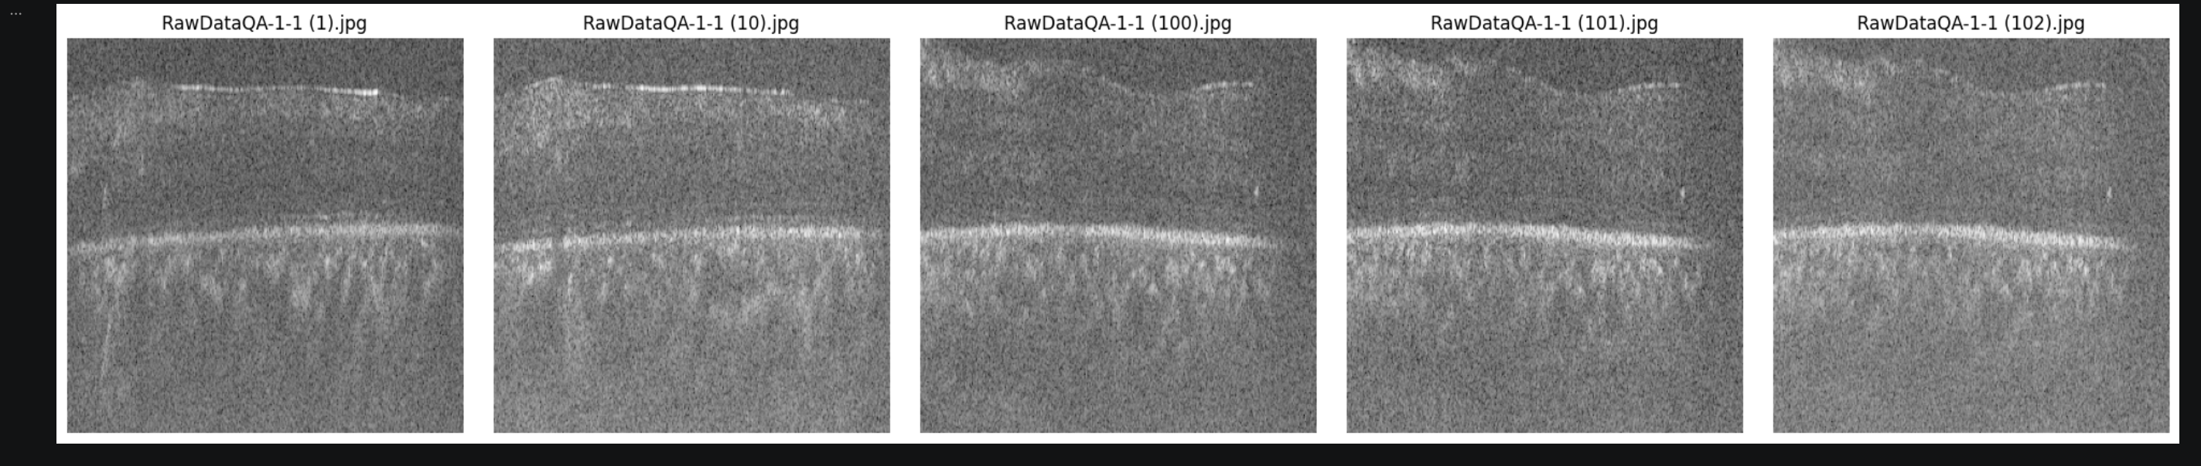

Caption: Original TIFF image displayed before preprocessing.
Figure 5: Notebook run output - preprocessed image
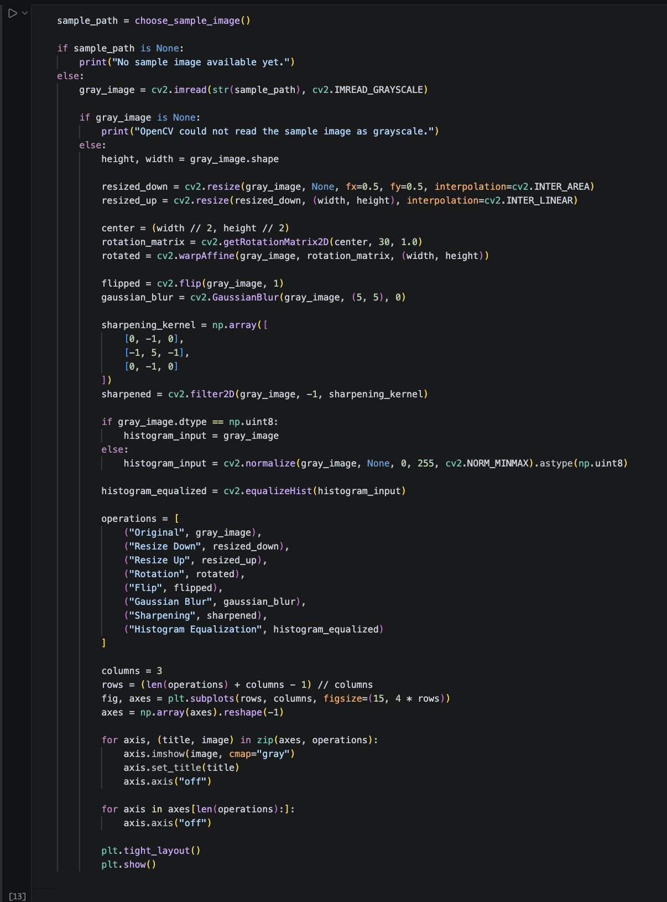
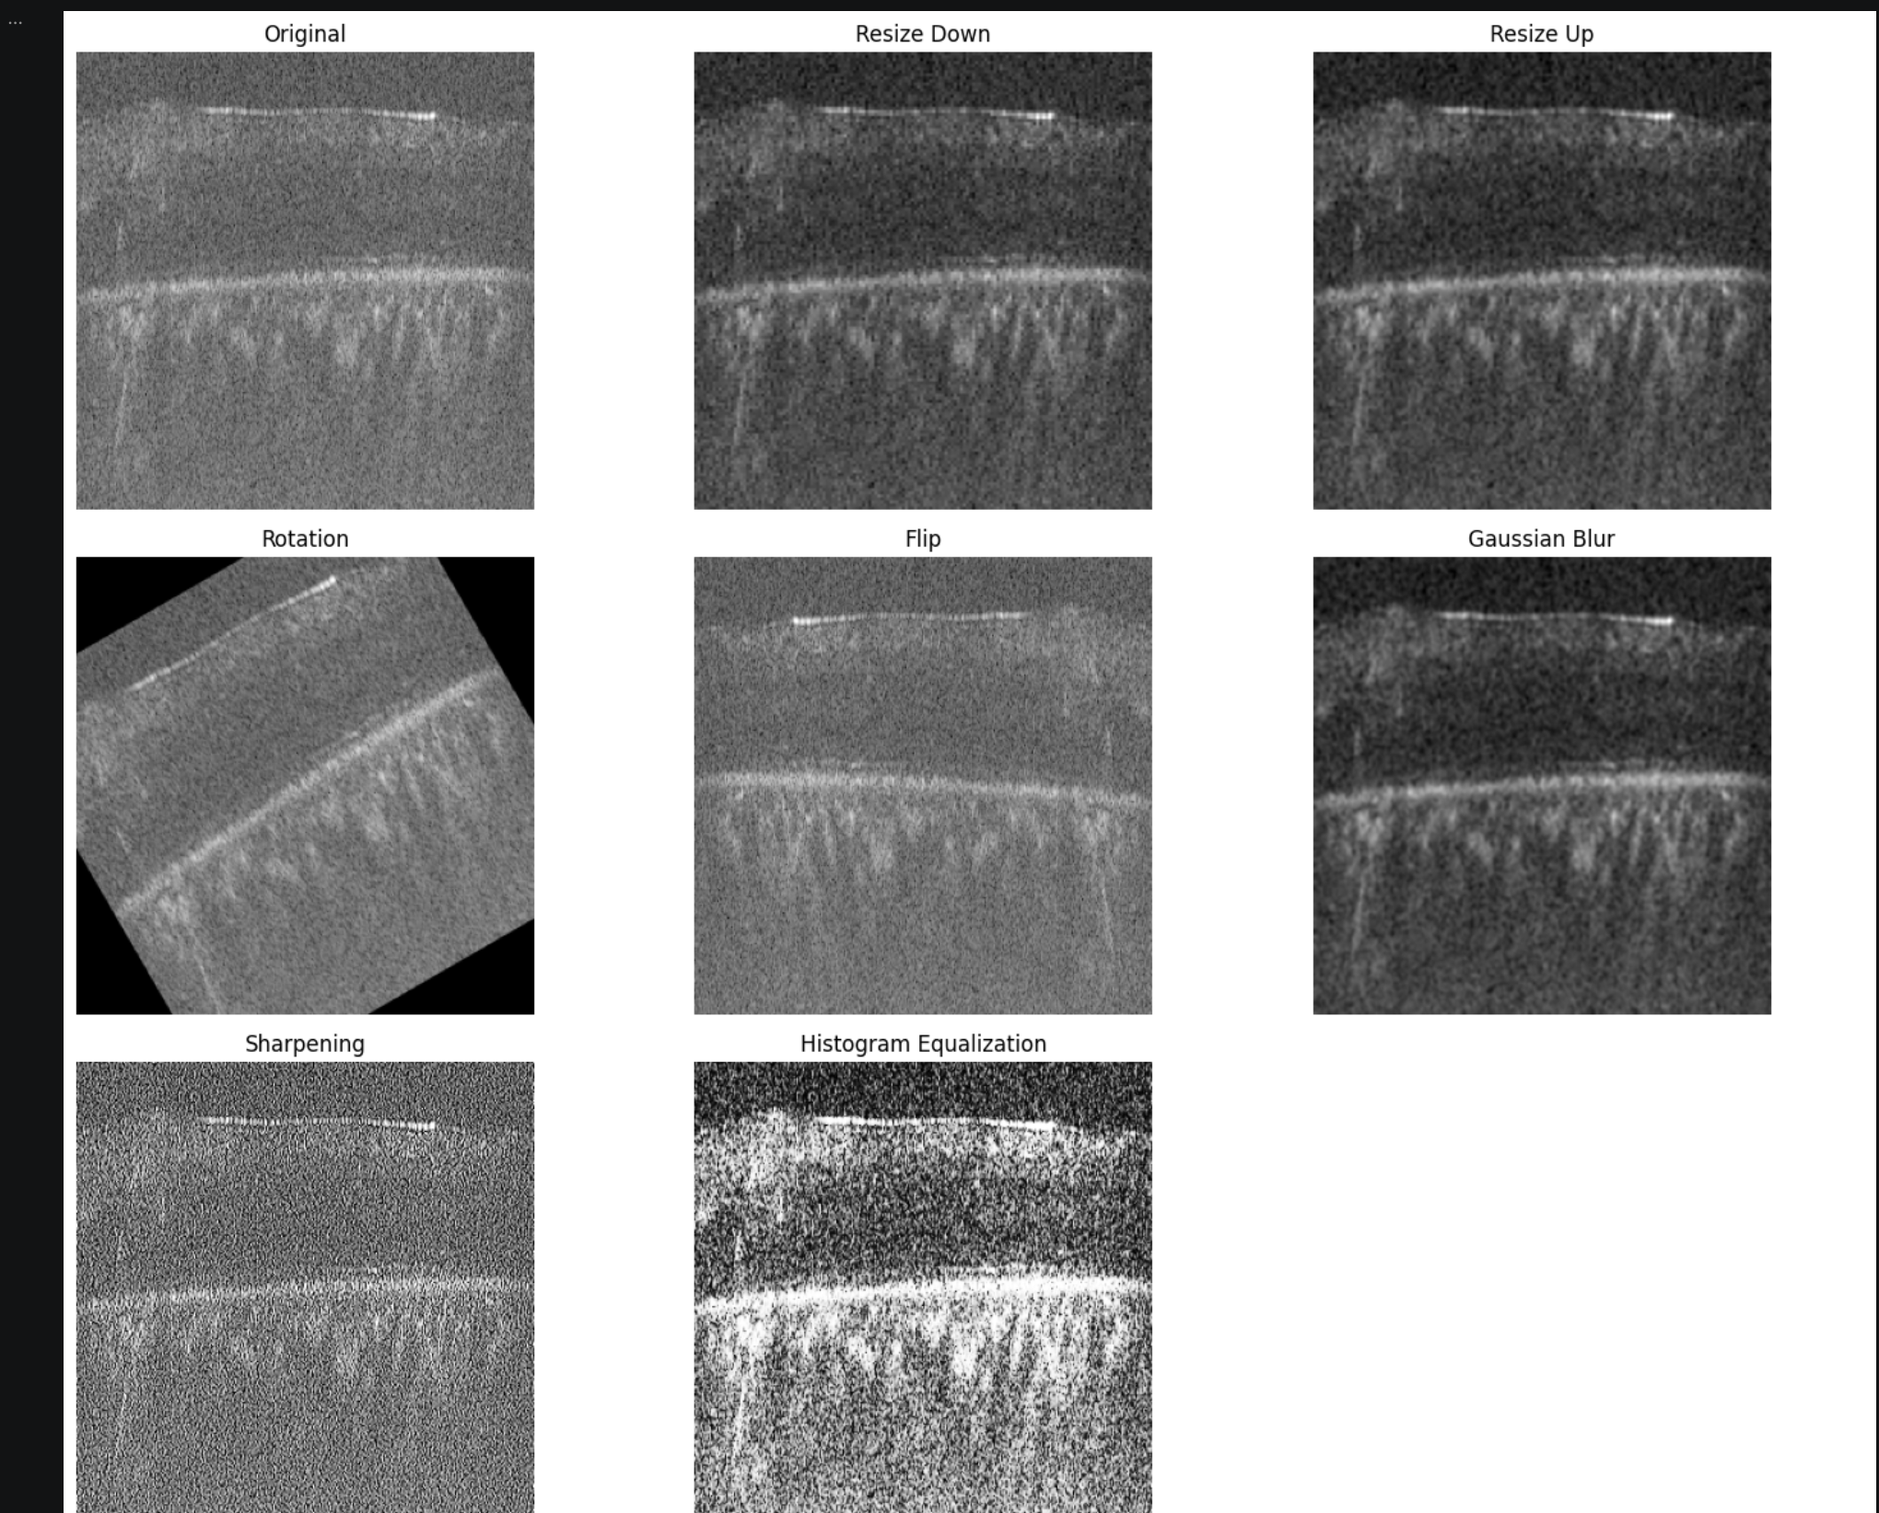
Caption: Output after applying preprocessing operations such as normalization, filtering, or enhancement.
Figure 6: Comparison between original and processed images
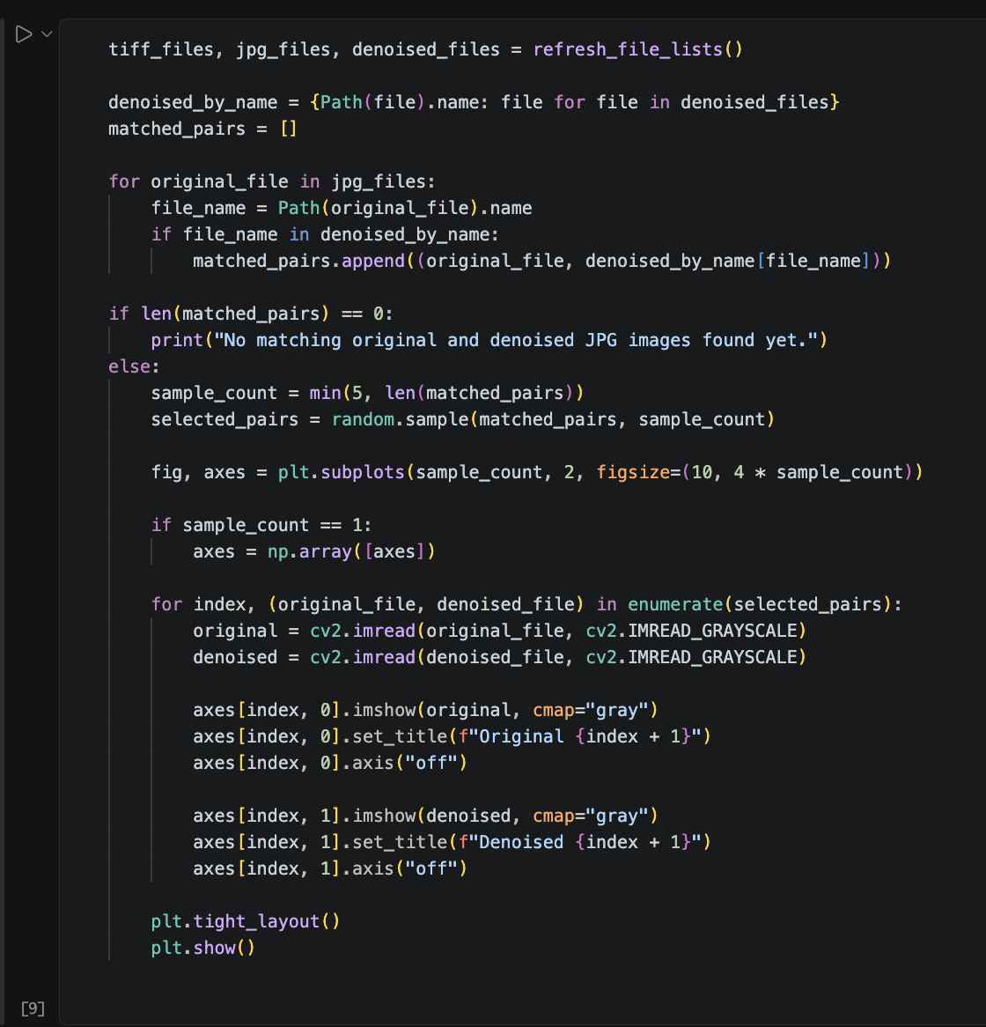
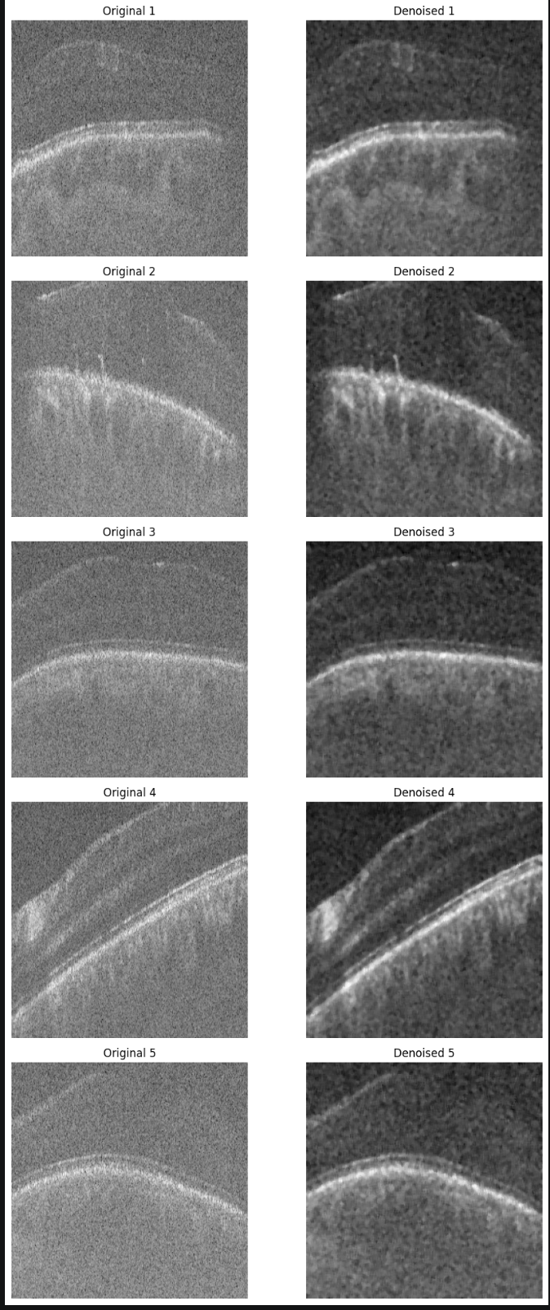
Caption: Side-by-side visual comparison showing the effect of preprocessing.

Discussion

The project demonstrates the importance of preprocessing before performing any advanced image analysis. By reading TIFF images and preparing them through numerical and visual operations, the notebook creates a cleaner and more consistent dataset.
The use of OpenCV and NumPy makes the workflow efficient because images are processed as arrays. Matplotlib helps verify the result visually, while Pillow and scikit-image provide additional flexibility for image loading and scientific processing.
The output screenshots should clearly show that the preprocessing pipeline improves image readability and prepares the data for later stages such as segmentation, feature extraction, or model training.

Conclusion
This documentation summarizes the Image Processing Project repository and explains its preprocessing workflow. The project uses Python and Jupyter Notebook to work with a TIFF image dataset, apply preprocessing steps, and display results. The report is prepared for printing and includes dedicated spaces for inserting screenshots from the code and notebook run outputs.

References
- Project repository: https://github.com/ziadahmed789/image-processing-project
- OpenCV documentation: https://docs.opencv.org/
- NumPy documentation: https://numpy.org/doc/
- scikit-image documentation: https://scikit-image.org/docs/

