CHAPTER 5
PROPOSED MODEL

III. PROPOSED MODEL
The proposed model aims to accurately classify a given input image as either real (authentic photograph) or AI-generated (synthetic image). The system is designed to be domain-agnostic, capable of generalizing across diverse image categories including faces, landscapes, animals, food, and artwork, as well as across a broad range of generative models. The proposed architecture addresses the central challenge of cross-generator generalization, where a model trained on images from certain generators must correctly identify images produced by unseen or newer generators.
To achieve the required detection capability, the proposed model integrates multiple data sources, applies a comprehensive preprocessing pipeline, and leverages a state-of-the-art deep learning backbone through a two-phase transfer learning strategy. The overall architecture of the proposed model is illustrated in Fig. 1.

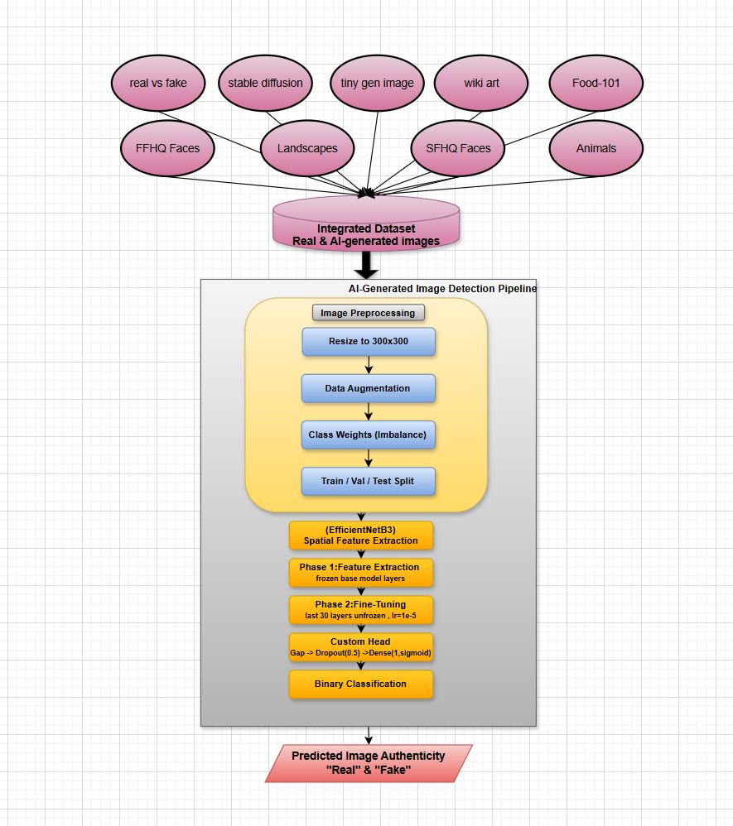
Fig. 1. The Proposed Model Pipeline for AI-Generated Image Detection

A. Data Description
A key design decision in this work is the construction of a diverse and comprehensive dataset covering a wide variety of content domains and generative models. Relying on a single dataset was found in preliminary experiments to produce models with inflated in-distribution accuracy but poor real-world generalization, motivating a multi-source integrated dataset strategy.
The integrated dataset is assembled from nine distinct data sources. The real image sources include: FFHQ Faces, containing high-quality photographs of human faces; Landscapes, providing authentic natural scenery; Animals, consisting of real photographs of various species; Food-101, a well-known benchmark of food photography; and Wiki Art, a collection of digitized real-world artworks. On the AI-generated side, the sources include: a Real vs. Fake general-purpose detection dataset; Stable Diffusion generated images representing one of the most widely deployed text-to-image models; Tiny Generated Images providing samples from diverse lightweight generative models; and SFHQ Faces, which contains synthetically generated human face images.
All nine sources are merged into a single integrated dataset under a binary labeling scheme. The dataset is partitioned into training, validation, and test splits, ensuring that the test set remains entirely unseen during model development to guarantee a fair and unbiased evaluation of generalization performance. An analysis of the dataset reveals a class imbalance between real and AI-generated categories, which is addressed through class weight computation applied during training.

B. Proposed Model Component Description
The proposed model consists of three main components: the Image Preprocessing Component, the Spatial Feature Extraction Component based on EfficientNetB3, and the Binary Classification Component. Each component is described in detail in the following subsections.

1) Image Preprocessing Component
Before being passed to the deep learning model, all input images undergo a standardized preprocessing pipeline:
- Resize to 300×300 pixels: All images are resized to a fixed resolution of 300×300 pixels, the optimal input size for the EfficientNetB3 backbone.
- Data Augmentation (Training Only): Augmentation is applied exclusively to the training set and includes random shearing (shear range = 0.1), zoom variations (zoom range = 0.2), random rotations (up to 15 degrees), and random horizontal flipping. No augmentation is applied to the validation or test sets.
- Class Weight Computation: Class weights are computed and applied during training to counteract the class imbalance. The weight for each class is calculated as the inverse of its relative frequency, ensuring the minority class receives proportionally higher importance during parameter updates.
- Train / Validation / Test Split: The integrated dataset is divided into three non-overlapping splits used for model training, hyperparameter tuning, and final held-out evaluation respectively.

2) Spatial Feature Extraction Component: EfficientNetB3
The core of the proposed model is built upon EfficientNetB3, a convolutional neural network introduced by Tan and Le (2019) as part of the EfficientNet family. EfficientNet models are designed using a compound scaling strategy that simultaneously and uniformly scales network depth, width, and input resolution using a fixed set of scaling coefficients. This approach produces models that achieve superior accuracy relative to their parameter count compared to conventional scaling strategies that adjust only one dimension at a time.
EfficientNetB3 operates on an input resolution of 300×300 pixels and contains approximately 12 million parameters. It is built upon Mobile Inverted Bottleneck Convolution (MBConv) blocks, which employ depthwise separable convolutions and Squeeze-and-Excitation (SE) modules to learn channel-wise feature recalibration. As illustrated in Fig. 2, the architecture progressively processes the input through a series of MBConv stages with varying kernel sizes (3×3 and 5×5) and increasing channel depths, before a final Conv 1×1, pooling, and fully connected stage produces the feature representation passed to the classifier. These design choices allow EfficientNetB3 to capture rich spatial hierarchies and subtle textural artifacts properties that are particularly valuable for detecting the characteristic traces left by AI generative models.
It is important to note that while Fig. 2 illustrates the general EfficientNetB3 backbone architecture, the classifier head used in the present work differs from that shown in the figure. In this study, the standard top layers are removed and replaced by the custom binary classification head described in Section B.4, which is specifically designed for the real vs. AI-generated detection task.
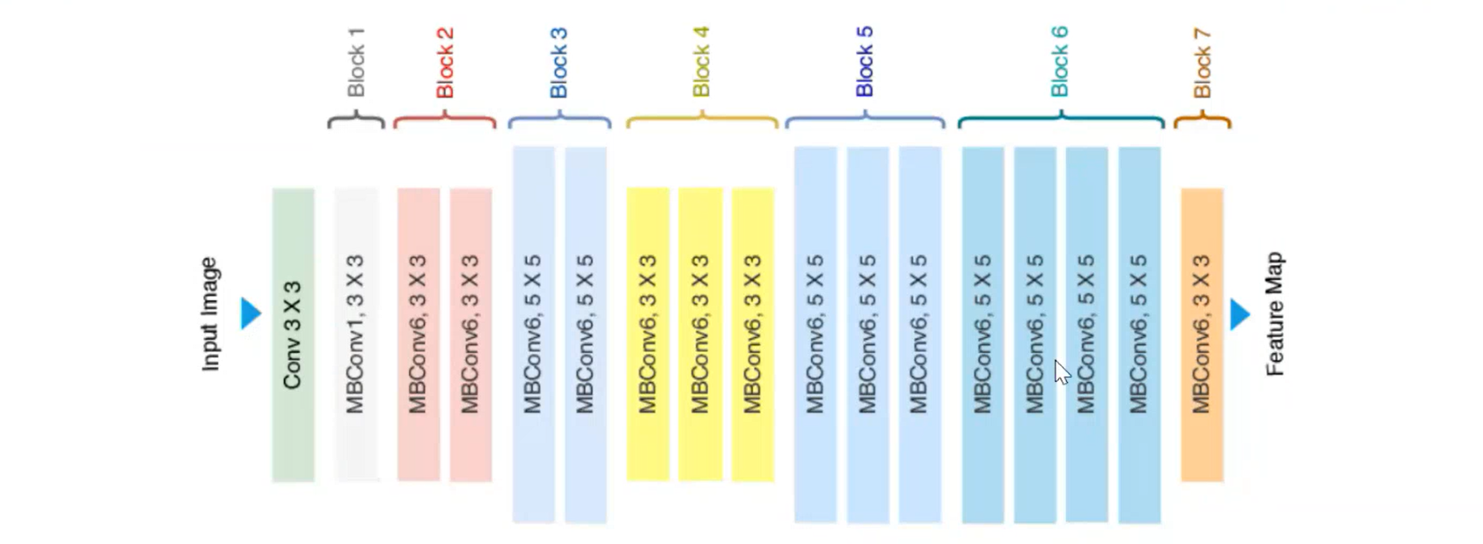

Fig. 2. General Architecture of EfficientNetB3 Backbone (Tan and Le, 2019). Note: The classification head used in this work differs from that shown above; see Section B.4.
The base EfficientNetB3 model is loaded with its pre-trained ImageNet weights, with the original top classification layers excluded (include_top=False). This allows the network to serve as a powerful feature extractor, leveraging visual representations learned from over one million images across 1,000 object categories.

3) Backbone Selection: EfficientNetB3 vs. VGG16
Prior to selecting EfficientNetB3 as the final backbone, VGG16 was evaluated as an alternative baseline. VGG16 is a well-established deep convolutional network consisting of 16 weight layers with 3×3 convolution filters, widely used as a transfer learning backbone. Both architectures were trained and evaluated on the same integrated dataset under identical preprocessing and training conditions to ensure a fair comparison.
As summarized in Table 1, VGG16 achieved a validation accuracy of 88% and a test accuracy of 86%. EfficientNetB3 outperformed VGG16 on both splits, reaching 90% validation accuracy and 94% test accuracy. Furthermore, VGG16 contains approximately 138 million parameters compared to EfficientNetB3’s 12 million, making it substantially more computationally expensive without a corresponding gain in accuracy. Based on this empirical comparison, EfficientNetB3 was selected as the final backbone due to its higher detection accuracy, significantly better parameter efficiency, and stronger generalization capability.

Table 1. Backbone Comparison: VGG16 vs. EfficientNetB3
Backbone | Parameters | Validation Accuracy | Test Accuracy | Selection
VGG16 | ~138M | 88% | 86% | ✘
EfficientNetB3 | ~12M | 90% | 94% | ✔ Selected

4) Two-Phase Transfer Learning Strategy
The training of the EfficientNetB3 backbone is structured in two sequential phases:
- Phase 1 – Feature Extraction (Frozen Base): All layers of the EfficientNetB3 base model are frozen. Only the custom classification head is trained, allowing the model to adapt to the binary detection task while fully preserving the pre-trained ImageNet features. An Adam optimizer with a learning rate of 1×10⁻⁴ is used, along with an EarlyStopping callback that monitors validation loss and restores the best weights if performance stops improving.
- Phase 2 – Fine-Tuning (Partial Unfreeze): The last 30 layers of the base model are unfrozen while all earlier layers remain frozen. This selective fine-tuning allows the model to refine high-level feature representations relevant to detecting AI-generated artifacts, while avoiding catastrophic forgetting of the general visual features learned from ImageNet. A reduced learning rate of 1×10⁻⁵ is used to ensure stable and gradual weight adaptation.

5) Binary Classification Component
A custom classification head is appended on top of EfficientNetB3 to perform the final binary prediction, consisting of:
- Global Average Pooling (GAP): A GlobalAveragePooling2D layer computes the spatial average of each feature map produced by the base model, yielding a compact fixed-length feature vector while significantly reducing the parameter count.
- Dropout Regularization: A Dropout layer with a rate of 0.5 randomly deactivates 50% of neurons during training, serving as a strong regularizer that reduces overfitting and improves generalization to unseen generators.
- Output Dense Layer: A single Dense neuron with a sigmoid activation function produces a classification probability in [0, 1], where values closer to 0 indicate an AI-generated image and values closer to 1 indicate a real photograph. The model is compiled with binary cross-entropy loss.

C. Model Training and Optimization
The model is trained using binary cross-entropy loss with the Adam optimizer at a batch size of 32. An EarlyStopping callback monitors the validation loss and halts training when no improvement is observed over a patience window of 10 epochs, restoring weights from the best-performing epoch. A ReduceLROnPlateau callback further reduces the learning rate when the validation loss plateaus, enabling finer convergence during Phase 2 fine-tuning.

D. Model Evaluation Strategy
Performance is assessed on the held-out test set using the following metrics:
- Accuracy: The overall proportion of correctly classified images across both classes.
- Confusion Matrix: A breakdown of True Positives, True Negatives, False Positives, and False Negatives revealing specific error types.
- Precision, Recall, and F1-Score: Class-level metrics reported separately for real and AI-generated categories, critical given the class imbalance.
- ROC Curve and AUC Score: The Receiver Operating Characteristic curve and Area Under the Curve providing a scalar summary of the model’s overall discriminative ability.

E. Summary of Proposed Model Components
Table 2 summarizes the key components and design choices of the proposed model.

Table 2. Summary of the Proposed Model Design Choices
Component | Method / Choice
Backbone Architecture | EfficientNetB3 (pre-trained on ImageNet)
Input Resolution | 300 × 300 pixels
Training Strategy | Two-Phase Transfer Learning
Phase 1 | Frozen base, train head only (lr = 1×10⁻⁴)
Phase 2 | Last 30 layers unfrozen, fine-tune (lr = 1×10⁻⁵)
Classification Head | GAP → Dropout(0.5) → Dense(1, Sigmoid)
Loss Function | Binary Cross-Entropy
Class Imbalance Handling | Class Weight Computation
Data Augmentation | Shear, Zoom, Rotation, Horizontal Flip (train only)
Regularization | Dropout(0.5) + EarlyStopping + ReduceLROnPlateau
Number of Data Sources | 9 integrated sources
Validation Accuracy | 90%
Test Accuracy | 94%
Output | Binary: Real (1) or AI-Generated (0)

