Network Report
Multiplayer Flappy bird

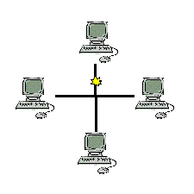

Ziad Ashraf Shreet 3947

Omar Wagdy Salah 4095

Amr Saleh

Rana Medhat

when you open the game menu panel will appear for the modes

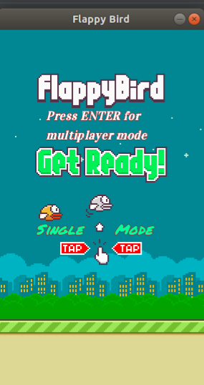

A flappybird game with two modes :
-Single mode
-multiplayer mode ridges

first in the welcome panel you have two options to select one for single player by clicking Up_Key or Hit enter to join the multiplayer mode
in the single player simply you click Up_Key and playing single the score is calculated while playing the game .

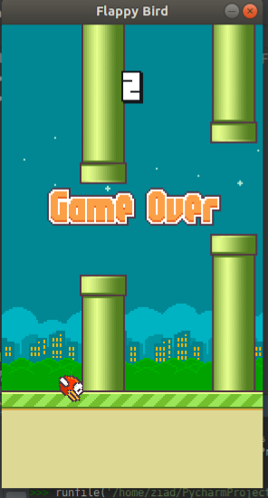

in Multiplayer Mode :

first when we click (Enter_Key) the player send Udp Broadcast to the players in that mode and waiting for any player wants to play when the player enter the mode he/she should broadcast to find the other player
first player receive the ip address and tcp port of the second player and create TCP connection with him .
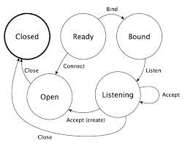
Udp connection :
- player 1 send broadcast
-player 1 wait to receive a message
-player 2 sends broadcast
- player 1 recieves the message
-player 1 create a tcp connection
-player 1 sends “ lets create a tcp connection “
-player 2 start the connection

int the multiplayer mode the game show the opponent score and your score when any player crashes the game will be terminated and announce the winner .

