**PHASE 2**

**Level 0:**

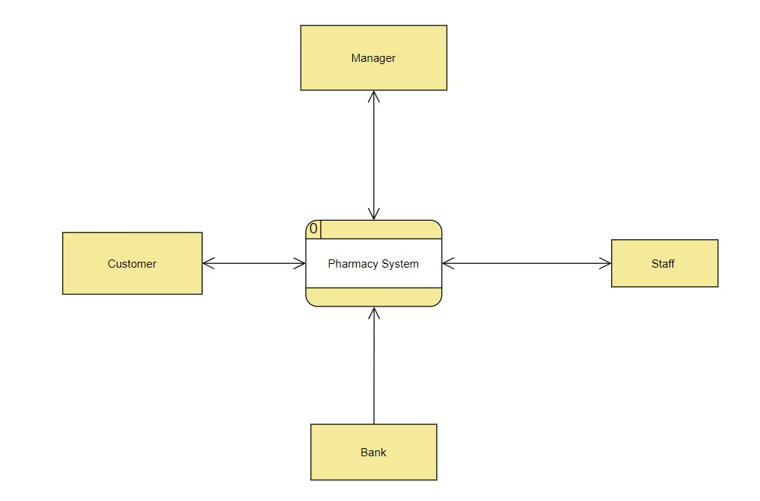

# **Level 1:**

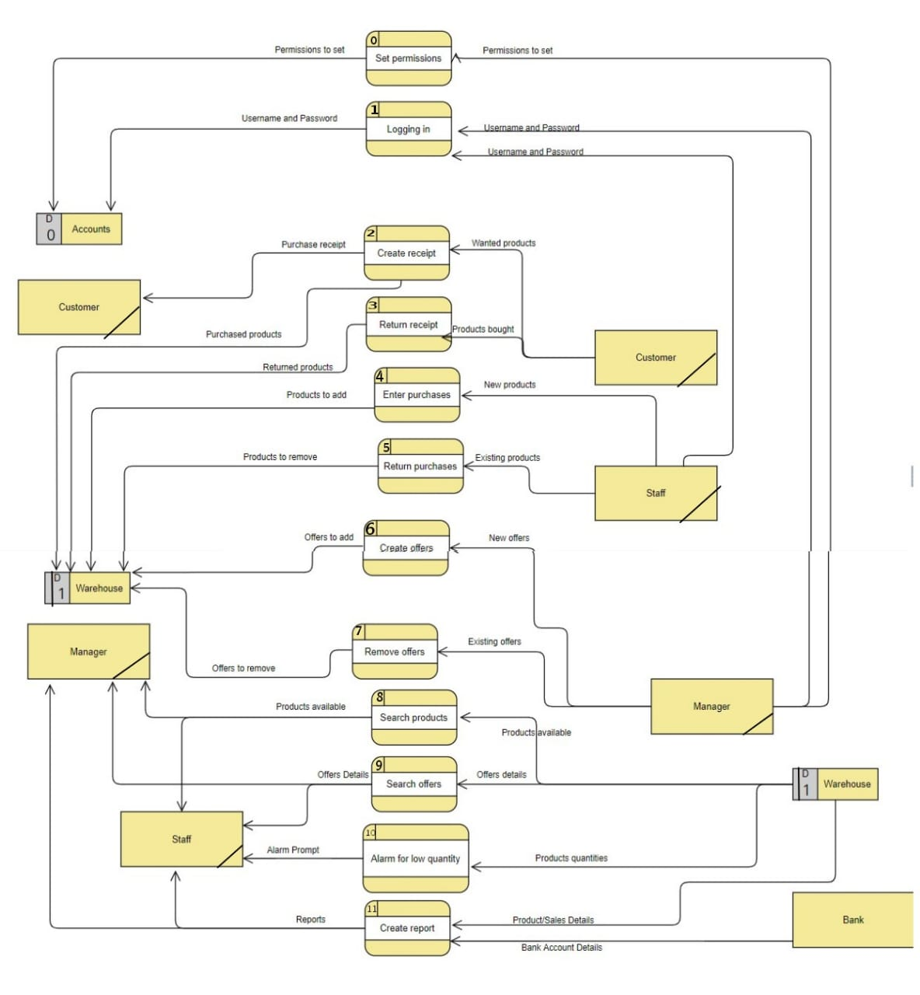

**Prepared by**

**Ziad Ahmed Mohamed 42010617**

**Amro Ismail 42010612**