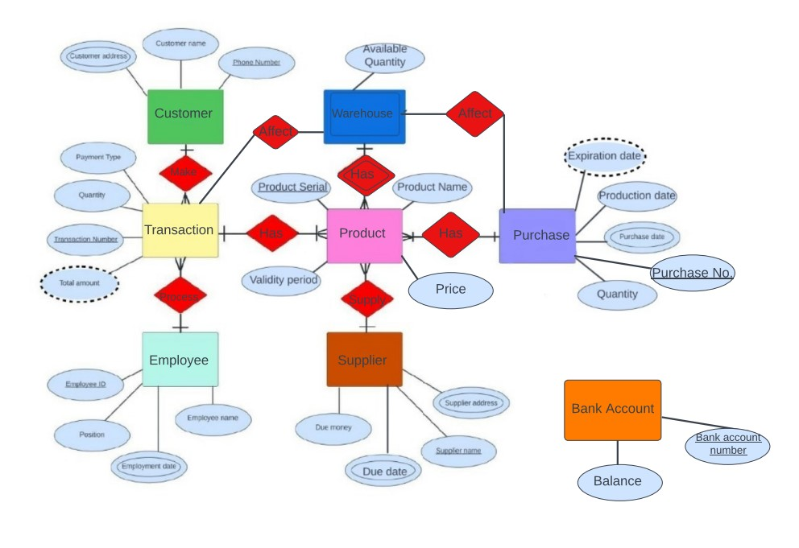

**Prepared by:**

**Ziad Ahmed Mohamed 42010617**

**Amro Ismail 42010612**