JS – Task01
- Explain how var works in JavaScript. What is variable hoisting? Give a code example.
Var is function scoped not blockscoped
Hoisted means JS move declaration of all variable at the top of file so interpreter can read them first and the intial value will be “undefined ”
Var can be hoisted
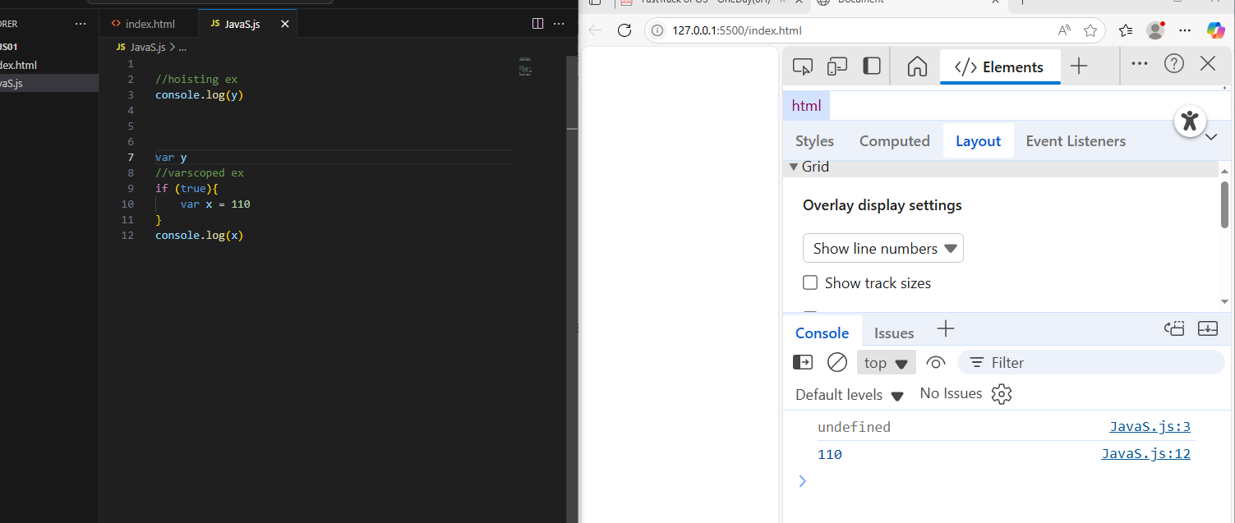

- What is the scope of a variable declared with var inside a function? What about inside a block (e.g., an if statement)?
If it is function it will be accessed and modified in function only
It cannot be inside a block it is go to the scope that is if block in it
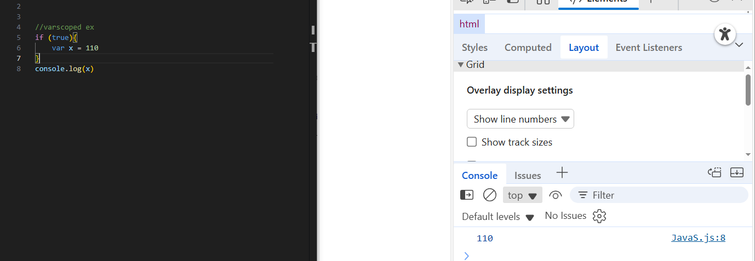
- List all JavaScript primitive types in ES5. Give an example of each.
-Number ex: var num = 42;
-String ex: var name = "Ziad Helal";
-Boolean ex: var b=true;
-Undefined ex: var x ; console.log(x);
-null ex: var null=null;

- What is the difference between a primitive type and an object type? Give an example where this difference is important.
- Primitive Type : stored in stack and its values is simple and immutable
- Object Type : stored in heep and its reference in stack it is a mutable type
- Where It’s Important : it is important in Comparision
- Ex: 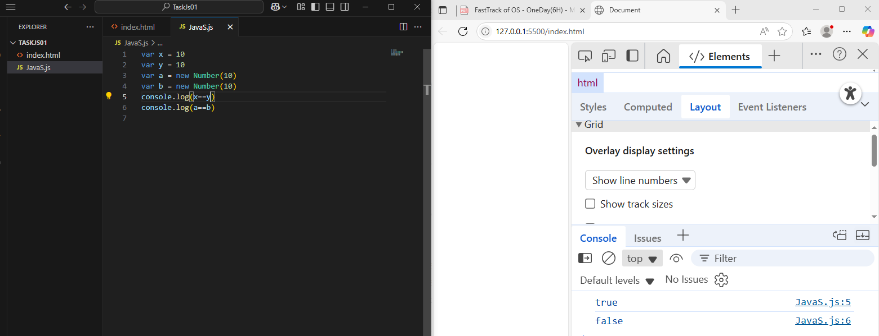

- Create a number, string, and boolean using both literal and constructor syntax. Show the difference in their types using typeof.
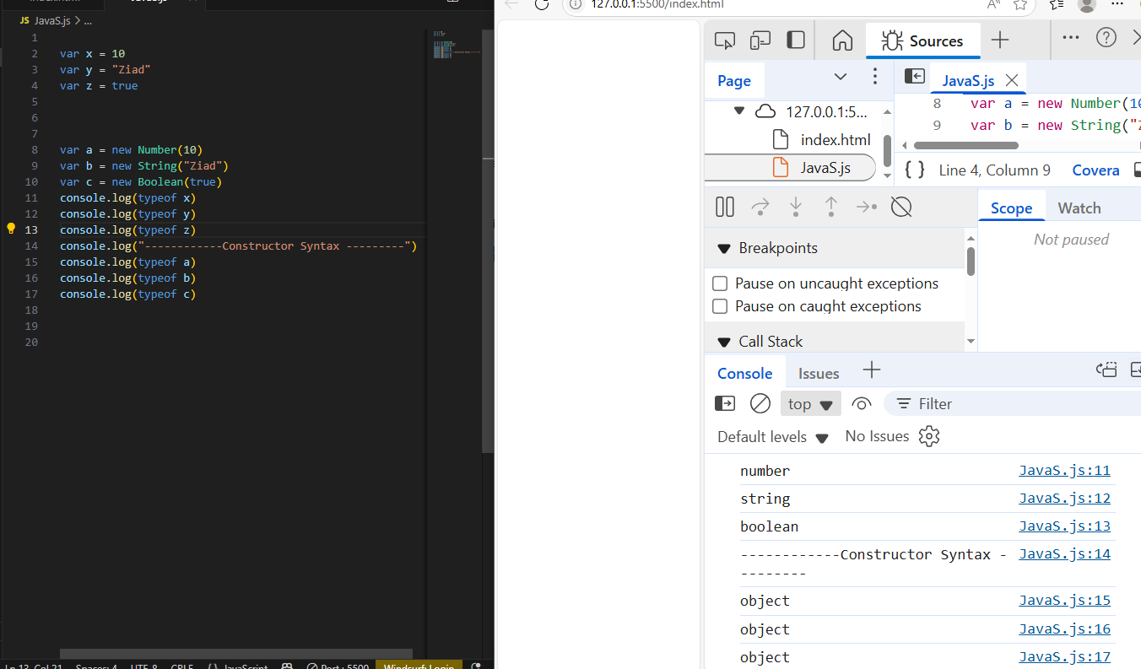

- Why is it generally recommended to use literals instead of constructors for primitive types?
literals : simple and efficient and east to read.
Constructors: create objects so it is more slower
So literals is recommended

7. Given the following code, what will be the output? Explain why.
var x = 123.4567;
console.log(x.toFixed(2));
console.log(x.toPrecision(4));
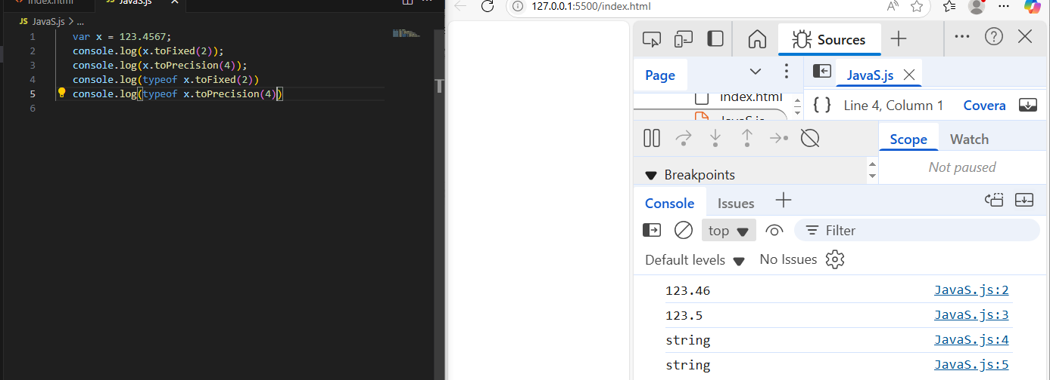
Both return string but toFixed the input number represent number after point
but toPercision the input number represent to the hole number (before point + after point)
- What is NaN? How can you check if a value is NaN? Give an example.
NaN is represented to Not a Number We can check if a value is NaN by isNaN() Func
Ex: 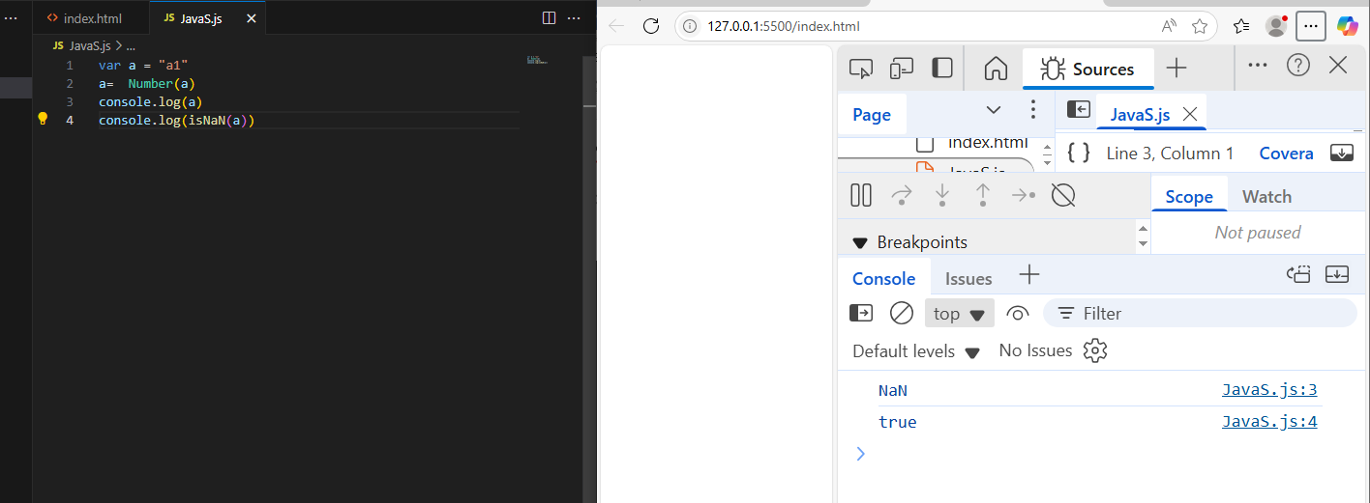
- What is the difference between parseInt, parseFloat, and Number? Give an example for each.
ParseInt return int ParseFloat return float ant both return NaN when the Input start with string
But if the input start with number both will return number until string raises
Number return Number if it Number (Int or Float)but if any char with this input it returns NaN
Ex: 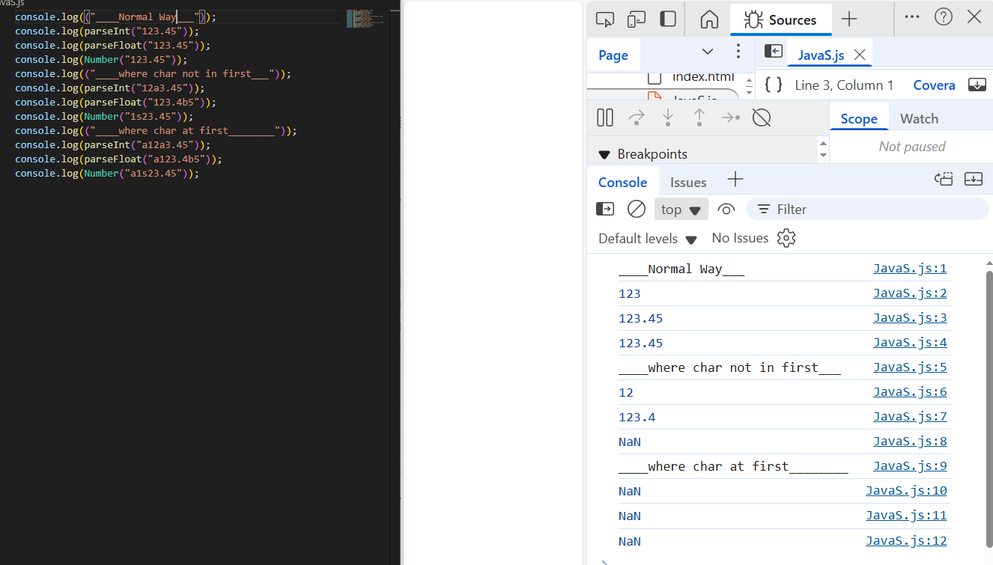

- What is the difference between implicit and explicit type casting? Give an example of each.

Explicit cast : developer convert type manually by (parseInt, parseFloat, Number and String and so on)
Implicit cast : engine convert automatically without developer changings by (+ and so on )
Ex: 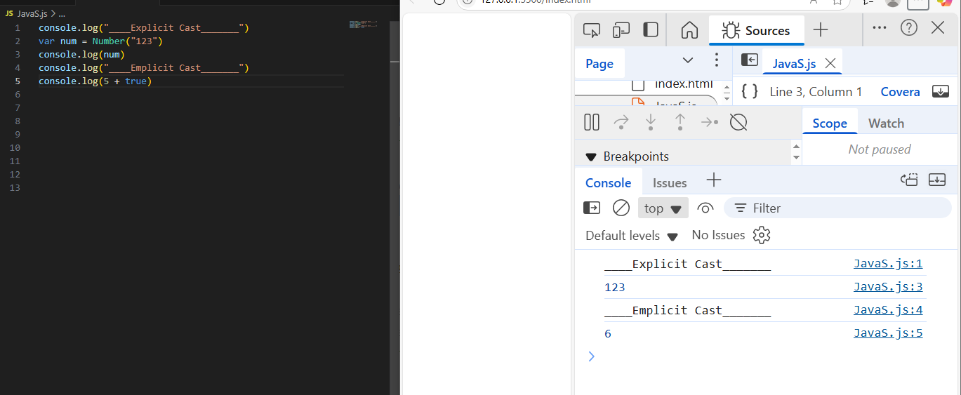

11. What will be the result and type of the following expressions? Explain your answer.
- true + 5
- "10" - 2
- 12 - "1a"
- 5 / 0
- 5 + undefined
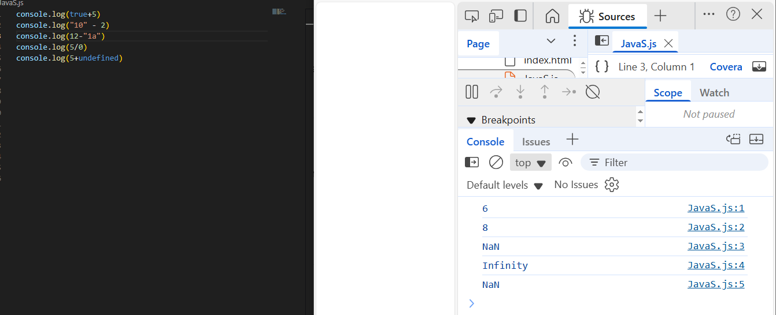
Lets explain
- True can covert to 1 so 1+5=6
- ( - ) expects number and number (“10”) = 10 so 10 – 2 =8
- 12-“1a” number convert “1a” to NaN so 12-NaN=NaN
- 5/0 is infinity which is number
- 5+undefined = undefined because undefined manipulate(+ - * /) with any var return undefined \

12. What will be logged to the console in the following code? Explain each step.
var a = "15.5";
var b = +a;
console.log(b, typeof b);
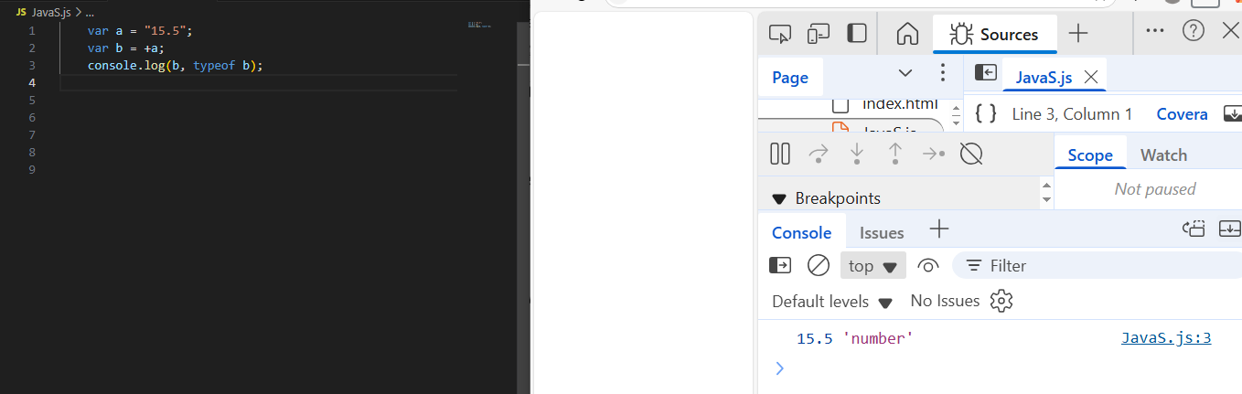

Step 1 assining string with 12.5 value to variable a
Step 2 implict casting to Number the variable and stored in variable b
Step 3 print the value of variable b and the type of it

13. What will be the output of:
var result = 20 > true < 5 == 1;
console.log(result);
Explain why.
When comparison JS try to convert true to 1 implictly
It will be 20>1 =true 1 < 5 = true 1 ==1 = true

14. Write a function that takes a string and returns true if it can be converted to a valid number, and false otherwise. 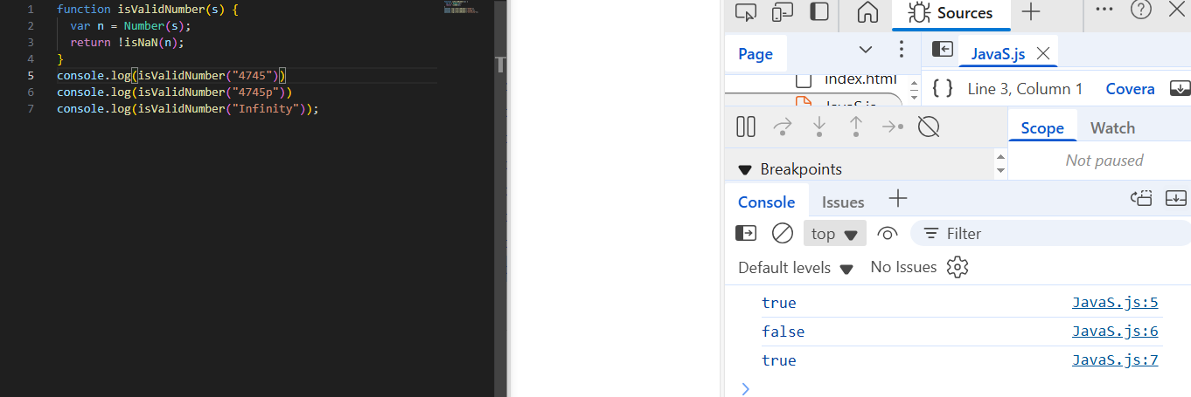
15. Write a program that prints all numbers from 1 to 20 using a while loop.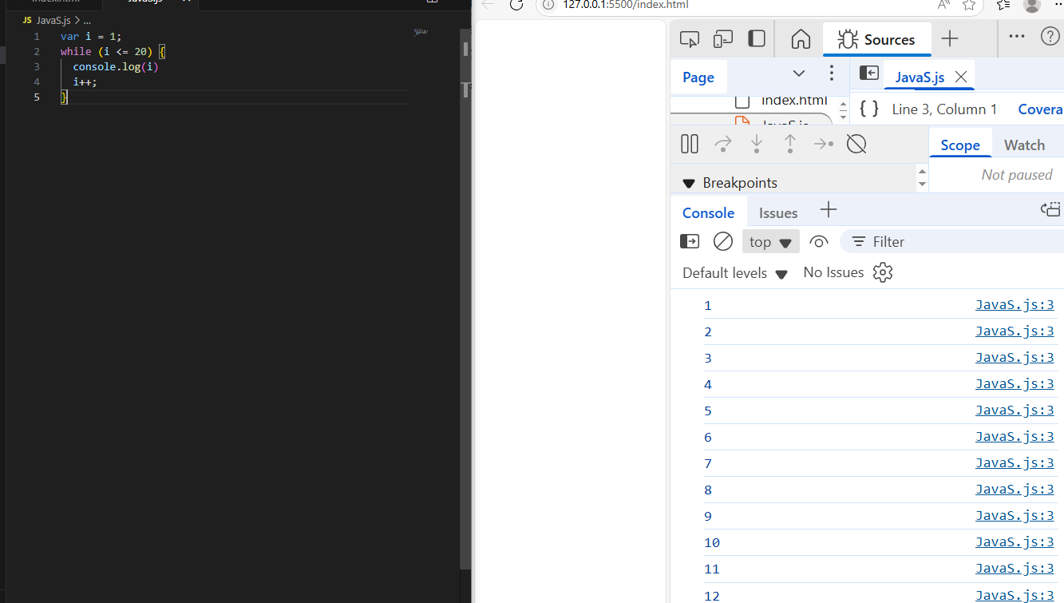
16. Write a program that asks the user to enter numbers until they enter 0, using a do...while loop. After the loop ends, print the sum of all entered numbers (excluding 0).
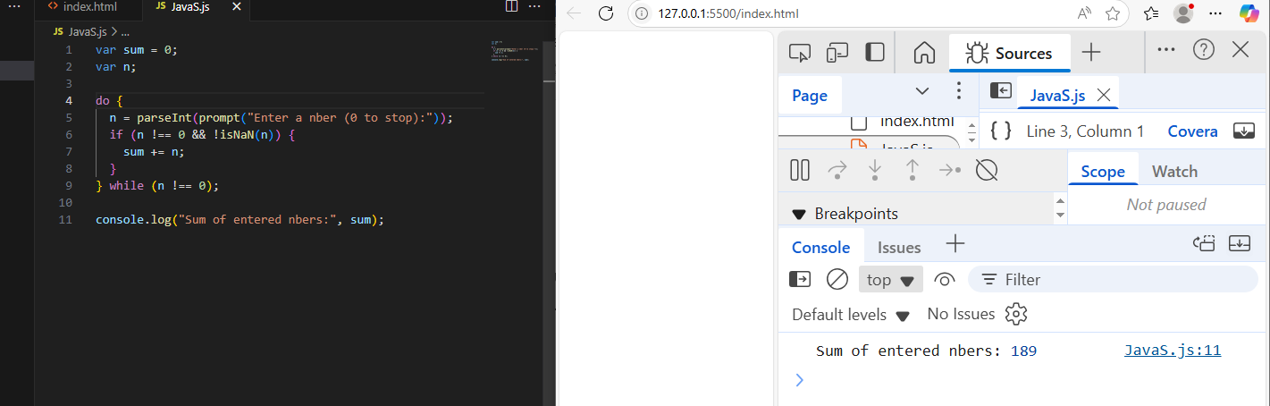
17. Write a program that takes a number from 1 to 7 and prints the corresponding day of the week using a switch statement. Use a for loop to test your program with all numbers from 1 to 7.
