- Open a new window with a specific URL and size, then close it after 3 seconds using JavaScript.

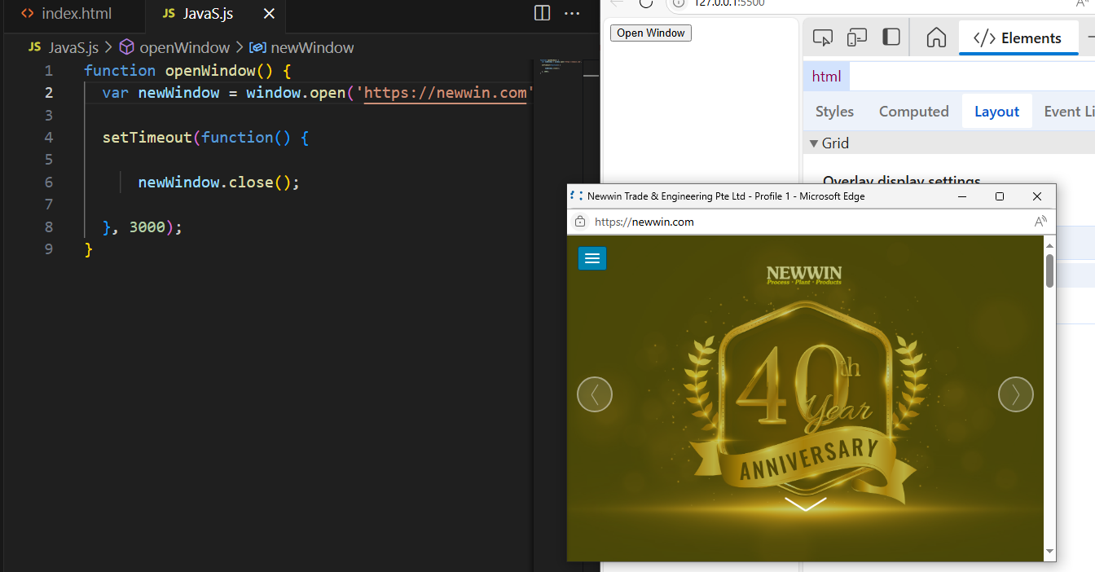
- Display the browser's user agent string in an alert.
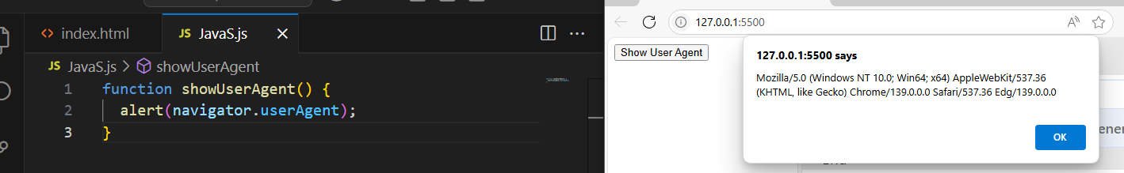

- Use `navigator` to detect if the browser is online or offline and log the result.
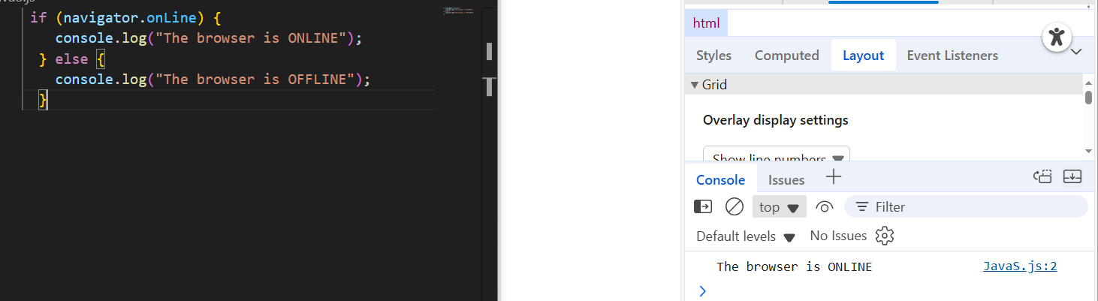

- Write code to reload the current page after 5 seconds.
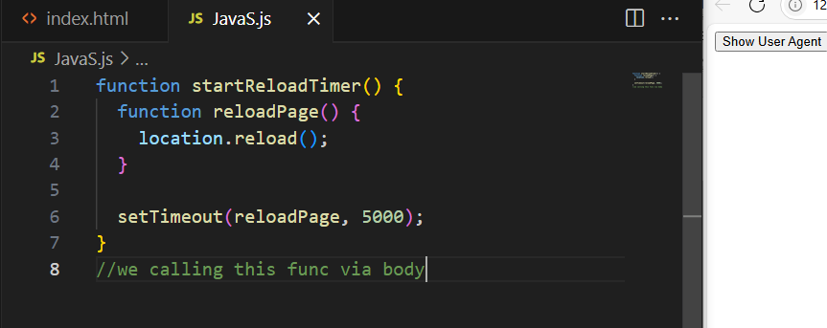
- Get the current page URL, protocol, and hostname using `location` and log them.

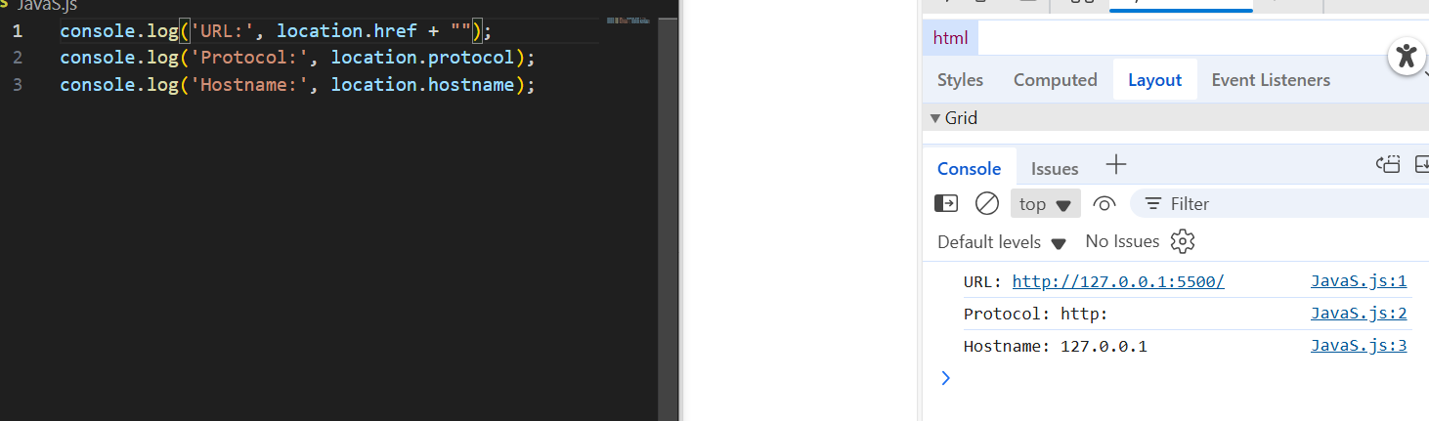
6. Use `history` to go back one page, then forward one page (write the code, don't actually run it).
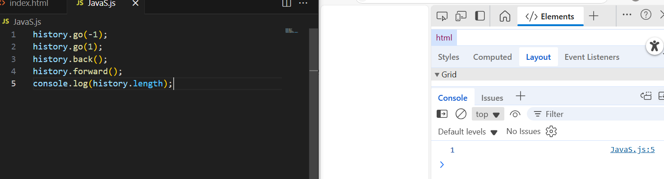
7. Show the screen width and height in a div -change the div content- on the page.
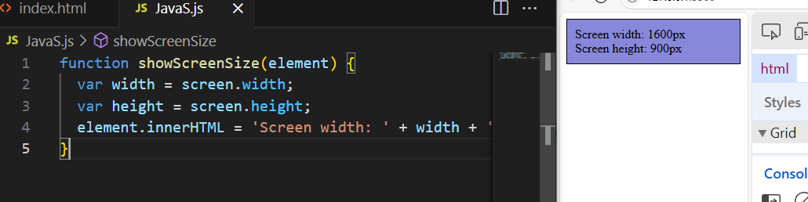
8. Use `setTimeout` to change the content of a hyperlink -a- with a new content after 2 seconds, and provide a button to cancel it.
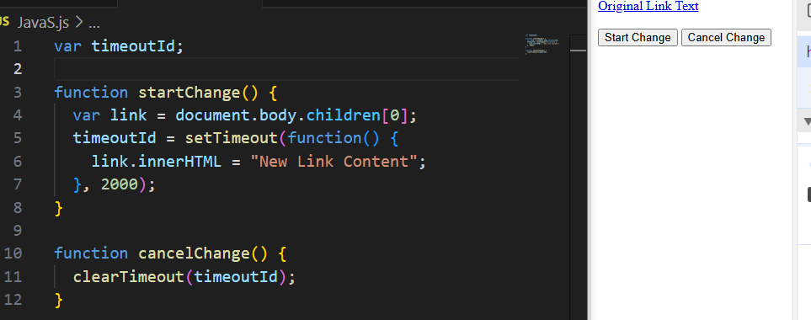
9. Use `setInterval` to update the time on the page title every second, and a button to stop it. 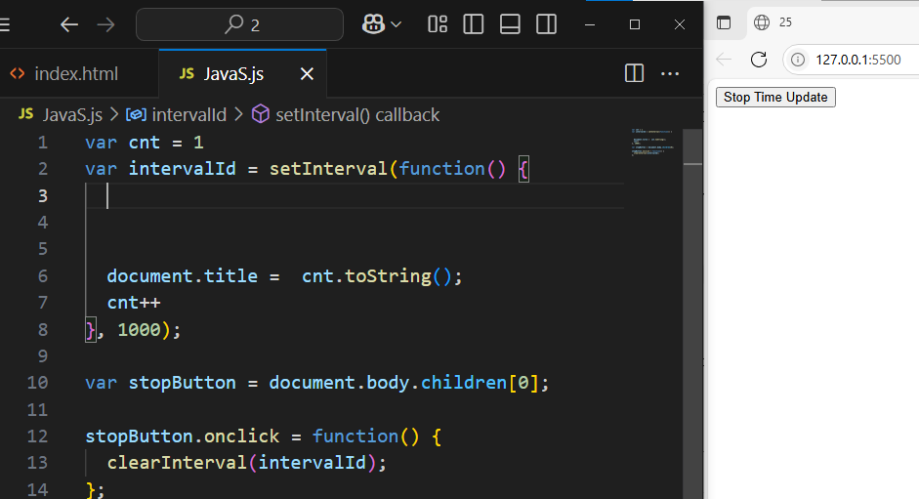
10. Show a confirm dialog asking "Do you want to continue?" and log the user's choice("user said yes", "user said no").
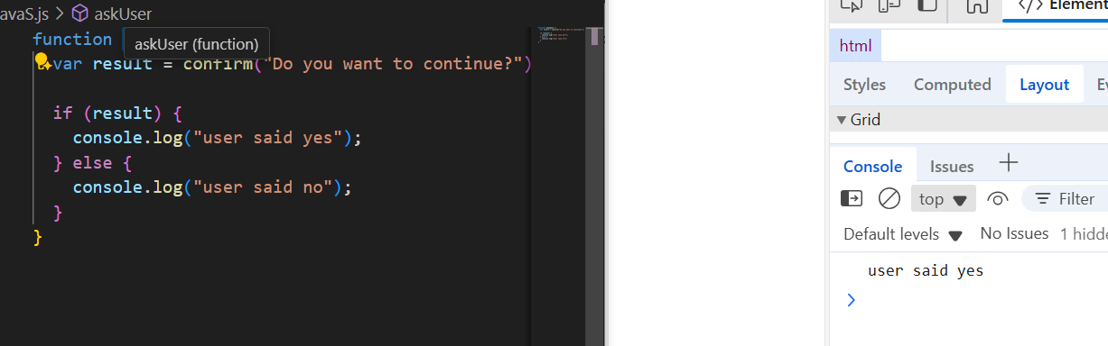
---
DOM Traversal (Nodes, Elements, Collections)

11. Select the first `<ul>` in the document and log its `childNodes` and `children` properties. Explain the difference in a comment. 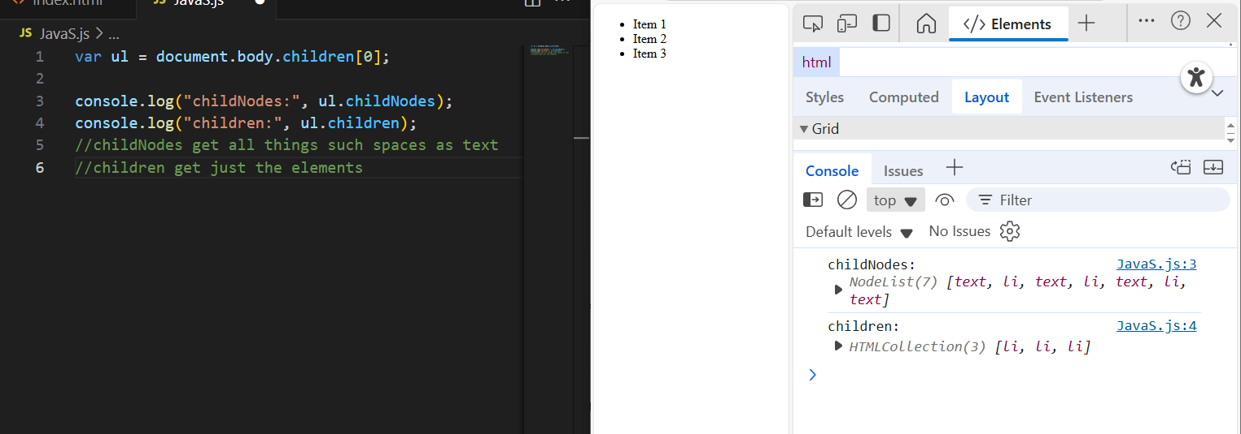

12. Write a function that logs the tag names of all direct child elements of `<body>`.
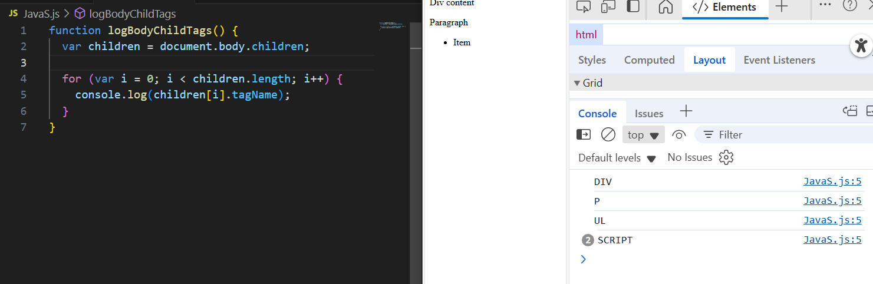
13. Given a parent element, loop through its `childNodes` and log only the nodes that are elements (not text/comments). 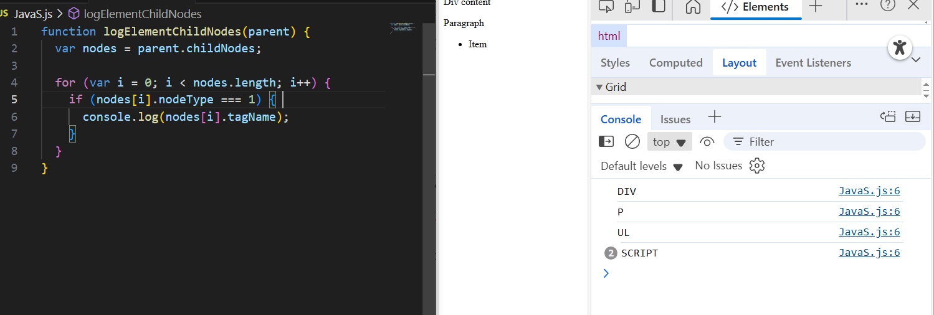
14. Use `firstChild` and `firstElementChild` on a container and explain the difference in a comment.
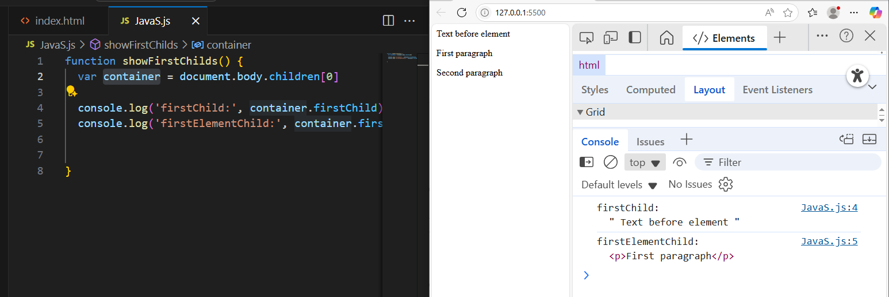
15. Write code to get all `<li>` elements inside a `<ul>` using `children` and explain the difference.
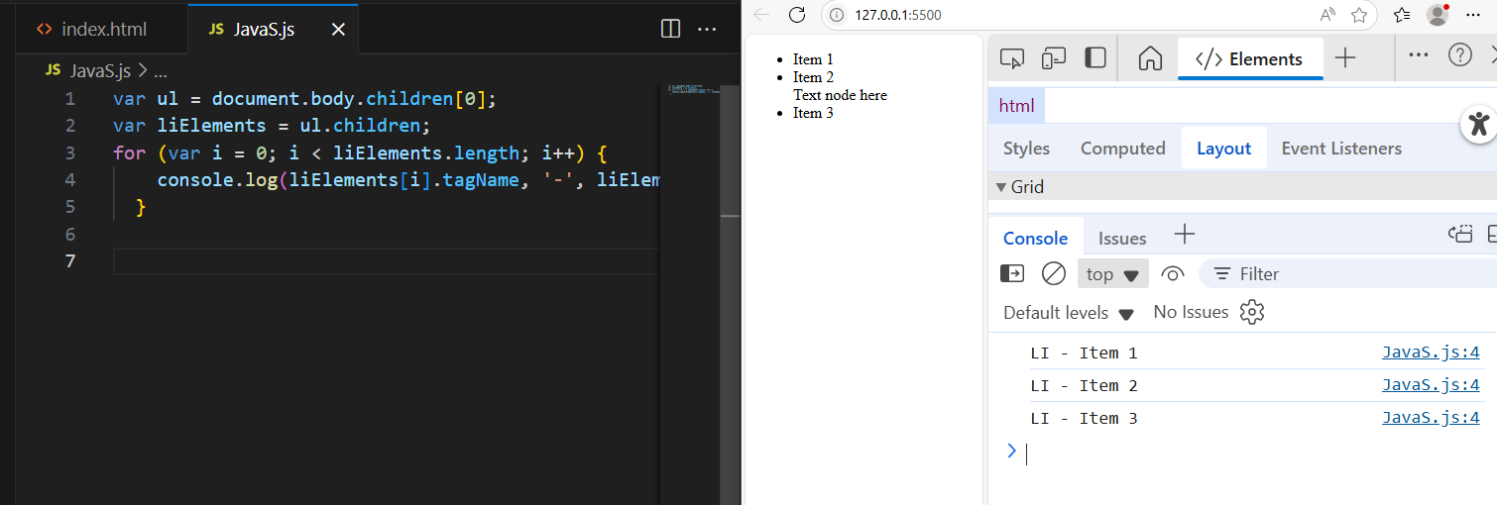
17. Write a function that logs all sibling elements of a given element (excluding itself). 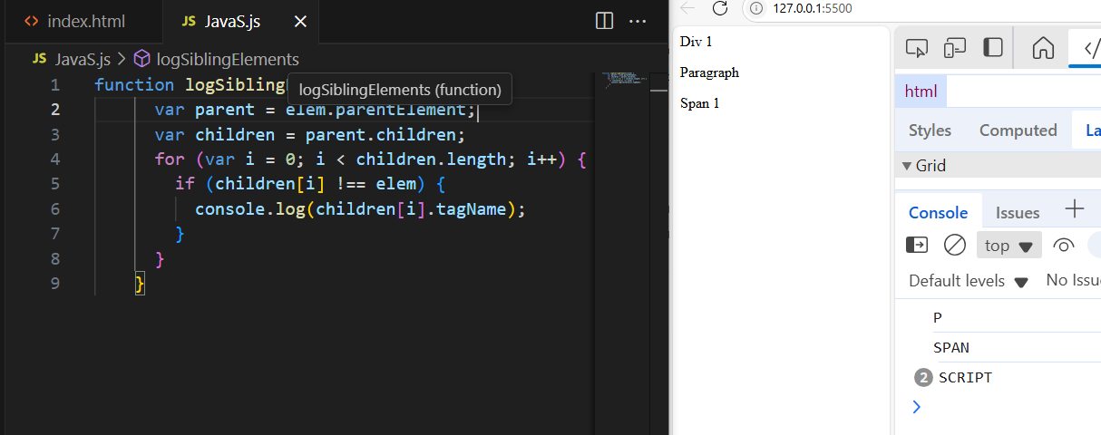
18. Use `nextSibling` and `nextElementSibling` to traverse from the first child to the last child of a `<ul>`, logging each node.
19. Count how many element children a given node has (not using `children.length`).
20. Write a function that takes the first form element and logs the names and values of all its input fields using the `elements` collection.
21. Access all forms in the document using `document.forms` and log their names.
22. Access all images in the document using `document.images` and log their `src` attributes.
23. Write a function that takes a form and disables all its input fields using the `elements` collection.
24. Use `Array.from` to convert `document.images` to an array and filter images with width > 100px.

