1. Select the first <div> on the page using getElementsByTagName and log its innerHTML.
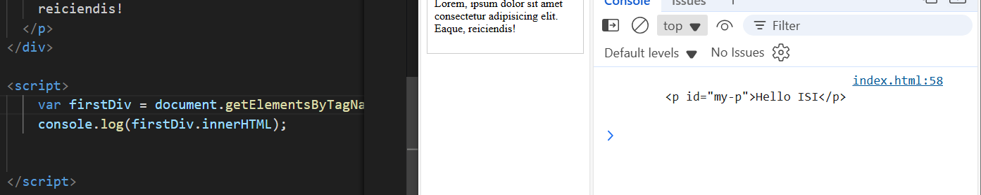

2. Using getElementById change the text of #my-p to "Hello DOM".
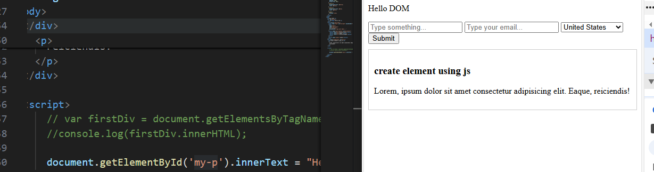
3. Use querySelector to select the element with class "target-div" and log its nodeName.
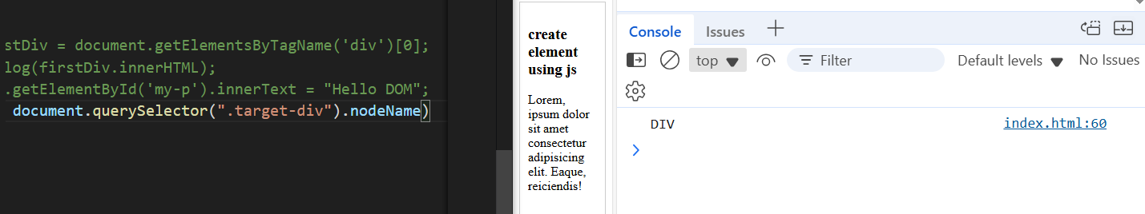
4. Use querySelectorAll to count how many <div> elements exist; log the count.
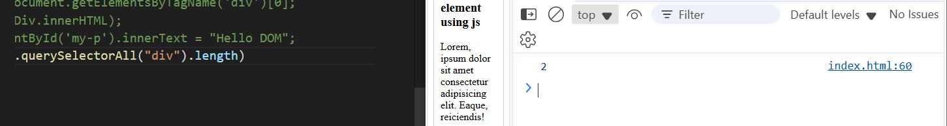
5. Use getElementsByName on the email input (name="user-email") and set its value to "user@test.com".
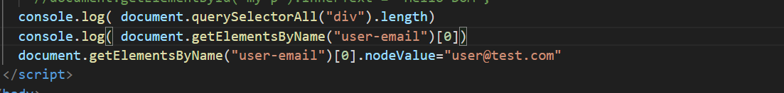
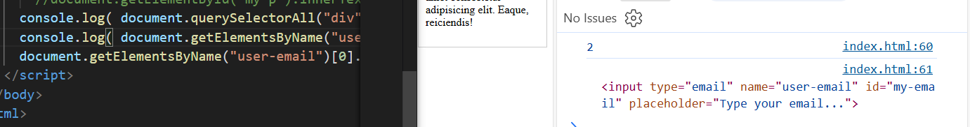
6. Check if the text input has a "name" attribute; if not add name="user-name" via setAttribute.
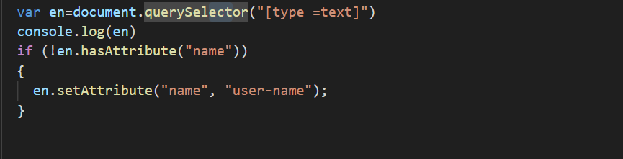
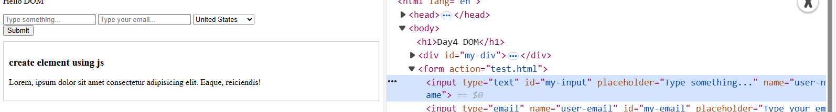
7. Append the string " - UPDATED" to the existing innerText of #my-p (keep original text).

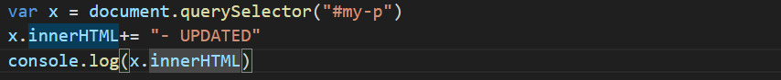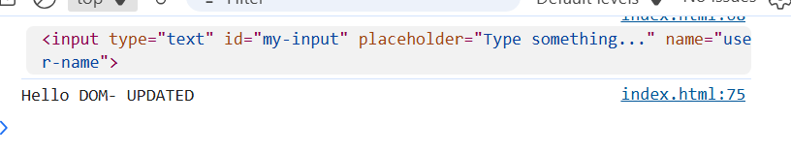
8. Create Images slider that work automatically and with next/prev/start/stop buttons.

9. Set the placeholder of the text input to "Type your full name" using setAttribute.
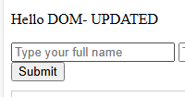

10. Log whether the email input has attribute "required"; if missing add it.
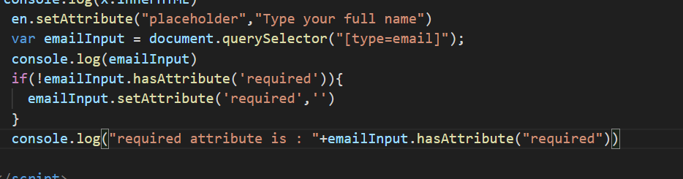
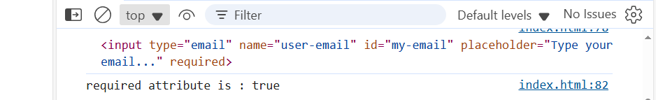
11. Write function getSelectedValue(selectId) returning the current selected option value.
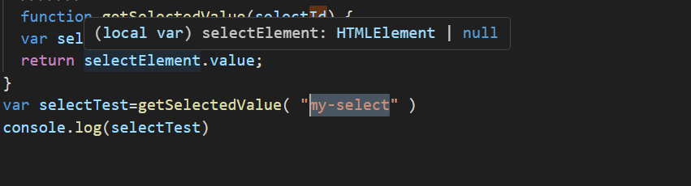
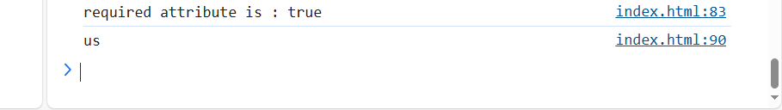
12. Loop through all options of the select and log each option's text and value.
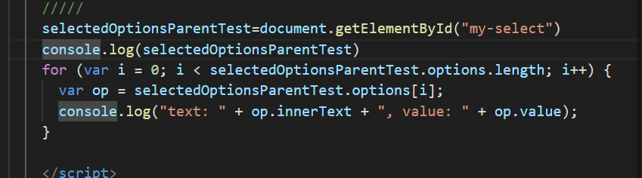
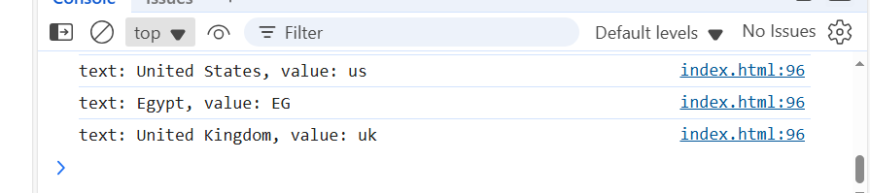

13. Programmatically select the option with value "EG".
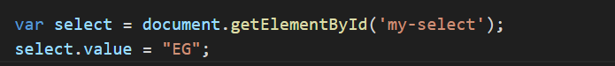
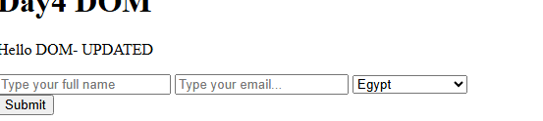
14. Create function selectByText(selectId, text) that selects the first option whose text matches exactly
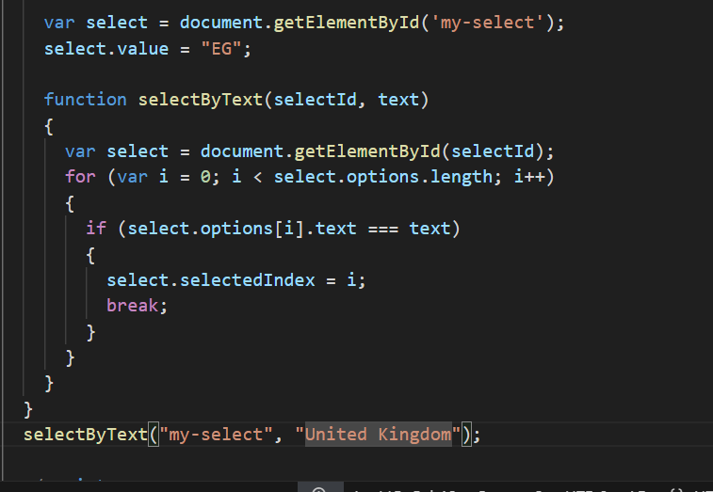.
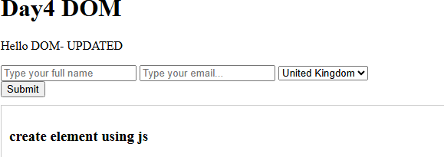

15. Replace innerHTML of #div-2 with a <p><b>Bold Text</b></p> (ensure bold renders, not printed literally).

16. Add classes class-a and class-b to #div-2 then remove class-b (using classList).

17. Toggle class "hidden" on #div-2 twice; comment final visibility.

18. Create function insertAfter(refNode, newNode) that inserts newNode immediately after refNode.

19. Create a new <div> saying "Dynamic Box" with yellow background and append inside #div-2.

20. Insert a new <p> BEFORE the first child of #div-2 (insertBefore).

21. Insert a <span> with text "AFTER END" right after #div-2 using insertAdjacentHTML.

22. Form onsubmit: prevent default and log values of text, email, and select inputs.

23. Add input event on the text input that logs its length whenever it changes.

24. Write validateEmailSimple(value) returning true if value contains both '@' and '.'; add 2 passing / 2 failing examples (comments).

25. Create an element, append it to #div-2, then remove it using parent.removeChild(child).

25. Create an element, append it to <div id="wrapper">
<p id="first">First</p>
<p id="second">Second</p>
</div>

26. Clone #div-2 , set clone id="div-2-clone", and insert it after original using insertAfter.

27. Highlight all text & email inputs (green border) in a function highlightInputs(form) and call it on DOMContentLoaded.

28. Build function buildCard(title, content) returning <div class="card"> with an <h3> and <p>; append two cards to body.

29. Add delegated click listener on body logging when a .card is clicked.

30. Reflection (comment): Which two tasks were most challenging and why?

31. create and unordered list dynamically with at 10 items, the odd list items should have class "odd" and even items "even", -create the two classes in your CSS file-

