Table of Contents
1 Introduction 2
1.1 Aim 2
1.2 Document Structure 2
1.3 Incentives 2
1.4 Musical Data and Processes 4
2 Requirements 6
2.1 The User 6
2.2 The Process 7
2.3 The System 8
3 User Interface 9
3.1 User Interfaces 9
3.2 The Application GUI 10
4 Design and Implementation 16
4.1 Data Structures 16
4.2 Operations 19
5 Significance 30
6 Improvements 32
7 Conclusion 34
Glossary 36
Bibliography 37

1 Introduction
The purpose of this section is to provide some background information about our application, Amen, and this document. We will begin by stating our aims. Next we will give a description of the structure of this document. We will then discuss the incentives for creating Amen. Finally we will present a discussion of musical data and processes.
1.1 Aim 2
1.2 Document Structure 2
1.3 Incentives 2
1.4 Musical Data and Processes 4

1.1 Aim
There is a style of composition that takes audio samples typically of existing music and rearranges them to create new pieces. The aim of this system is to provide a graphical interface for rearranging waveforms as well as to provide varying degrees of automation. The system has been designed to be simple yet flexible. The emphasis will be on creating a concise, fully functional prototype. As this is the first attempt at such a tool, it may be necessary to sacrifice some of the more advanced features.

1.2 Document Structure
This document has been divided into seven main sections; the introduction, requirements, user interface, design and implementation, significance, improvements and conclusion. In the introduction we will present some background information about this documents and the application. In the requirements section we will highlight the various requirements on the application. In the user interface section we will explain our user interface and attempt to justify our design decisions. In the design and implementation section we will provide a general discussion of the design and implementation of our application. In the significance section we will attempt to determine the significance of our application as a tool for musical composition. In the improvements section we will discuss some possible future improvements for our application. Finally we will conclude by discussing how we have attempted to meet our aims.

1.3 Incentives
The purpose of this section is to describe some of the incentives for creating Amen. We will begin with a description of the musical styles that have inspired the application. We will continue with a analysis of some current methods for rearranging waveforms.
With the event of the digital signal processor (DSP) came a paradigm shift in musical thinking. The DSP provides a way of converting digital signals to analogue signals. As a result it is possible to store and manipulate waveform information using a computer and realise that waveform as a vibration, an audible sound. The computer presents many new ways of manipulating sound. For example we can interpolate between two waveforms, we can apply filters to a waveform, and we can arrange and rearrange waveforms indefinitely. The computer can also be used to imitate sounds from the world around us. For example, we can use sampling techniques to record existing sounds, and we can generate instruments based on our own physical models. As one would expect, many new styles of musical composition grew from this innovation. Some attempted to broaden existing musical styles, others were more eager to innovate. Of these styles, the one that first inspired the design of this application has been named ‘Drum and Bass.’
Drum and Bass is characterised in part by fast-complicated rhythms. These rhythms were originally created by dividing a sampled drum loop into shorter sections and placing those sections into a new sequence. As always with music, it is difficult to say when this process was originated. The sampled drum loops that are so often used for this style of composition have been in circulation for decades. Two of the most famous drum loops were sampled from the songs ‘Amen Brother’ by The Winstons and ‘Think’ by Lyn Collins. The precursor to Drum and Bass was known as ‘Hardcore’ or ‘Rave.’ Rave was a very hectic style, both fast and energetic. Beats were often constructed from two or more sampled drum loops being played simultaneously at a high tempo. Overlapping beats combined to create new sounds and the resulting rhythms were often very complex and interesting. Often these new rhythms were also very cluttered. The intention now was to devise a method of creating fast, complicated rhythms without the unwanted clutter of the previous technique. A new technique was discovered by reverting to the original drum loops. The same drum loops were divided into shorter sections and sequenced into a new order. Complex rhythms could thus be constructed without the clutter of the other technique. This process grew in its usage and a new style was slowly born. This technique is increasing in popularity and manifesting itself in different styles of music including Trip-Hop, Jazz, and Pop. The technique is also being refined and applied to different types of sampled loops, most noticeably vocals. Drum and Bass itself is still growing and inspiring the creation of new styles such as Tech-Step and Jungle which themselves rely heavily on the process of rearranging waveforms.
Although there are applications that can be used together to rearrange audio waveforms, it is difficult to find any designed specifically for that purpose. Both sampling tools and sequencing tools are common types of application that can be used for this process. Most sampling tools will provide some cut and paste facility. Some will even help to find zero-points or provide some form of beat tracking. As a result, sampling tools can be very good for dividing waveforms into shorter sections. Although it is also possible to rearrange these sections, it is often a slow process with little room for error. This is for two main reasons. Firstly, sampling tools are not designed primarily for this rearranging process and will not provide the necessary temporal controls. Secondly, sampling tools do not generally provide a level of abstraction suitable for simplifying the process. Sequencing tools are designed primarily for sequencing sounds. The individual waveforms are treated as a whole and cannot be easily subdivided. As a result, sequencing software must be used in conjunction with a sampler. This is not always practical as a large amount of time can be wasted as the two applications communicate with each other. In addition, the process can become impractical as the number of subdivisions increases. In all cases, the ability to make quick changes and test the new sequence is often lost to the complexity of the program. Thus the cycle of design, implementation, and assimilation slows down and creativity becomes stifled. One application designed explicitly for the process of rearranging waveforms is called Re-Cycle. Produced by Steinberg, Re-Cycle is designed to separate a drum loop into shorter sections. The application can be used in conjunction with a sequencer, where the shorter sections are treated as separate instruments. Although this system goes some way towards simplifying the procedure, it is still only marginally less laborious than using the sequencer-sampler combination.

1.4 Musical Data and Processes
The purpose of this section is to provide some background into musical data and processes. We will discuss a framework for musical data and processes, give some examples of the computerisation of these musical processes, and attempt to fit our application into this framework.
The framework we will use to describe musical data and processes is that proposed by F. Richard Moore. The following chart provides an illustration of this framework:
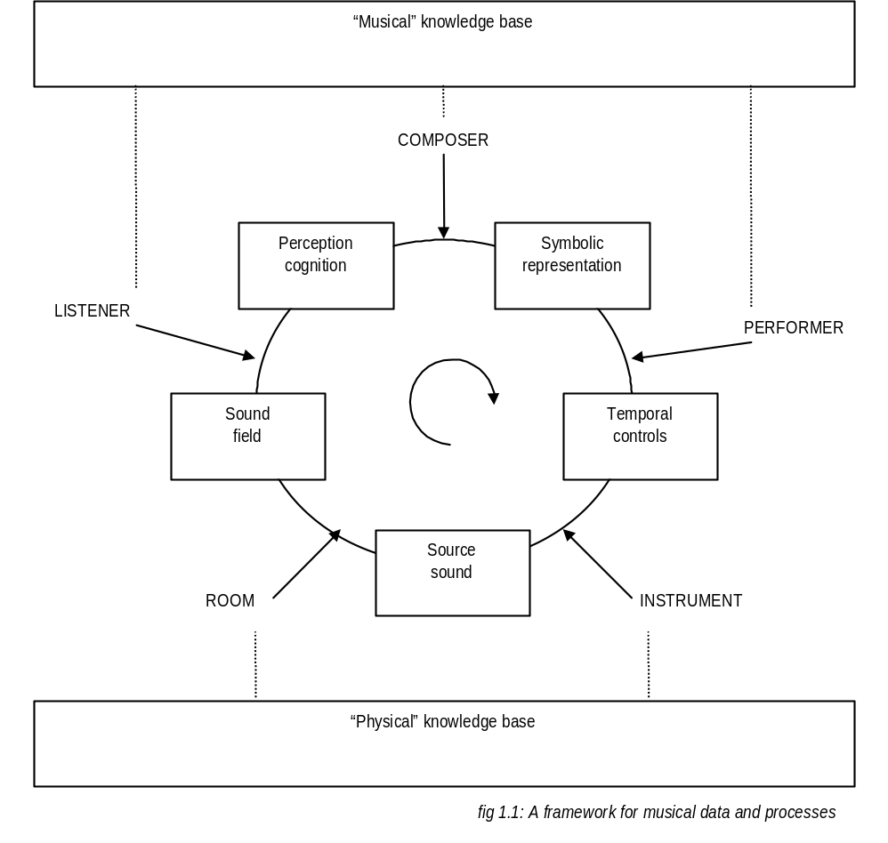
This chart attempts to present a system of musical data and processes. The boxed information represents types of musical data. The capitalised words represent types of musical process. Here the performer, composer and listener are described as musical processes that transform musical data. These three processes draw from a ‘musical’ knowledge base to perceive, represent, and control musical data. The room and the instrument also transform musical data. These processes draw from a ‘physical’ knowledge base to create and define sound. The ‘musical’ knowledge base can consist of information such as experiences with musical instruments and personal musical preferences. The ‘physical’ knowledge base can consist of information such as the physical properties of sound and vibration. The next five types of musical data form a perpetual cycle. These are symbolic representation, temporal controls, source sound, sound field, and perception cognition. Symbolic representation is the way the composer chooses to represent musical information. This leads to temporal controls, the way in which the performer controls the musical information represented by the composer. This in turn produces a source sound, the sound the instrument creates from the performer’s temporal controls. This becomes a sound field, the sound created by the room as it effects the instrument’s source sound. Finally this leads to perception cognition, the way in which the listener understands the sound field created by the room.
Computers have been used to control the various processes listed in this framework. The computer as a composer is an area currently being explored with much interest. Algorithmic composition is used to construct compositions that truly stretch the classical definitions of music. The computer as a performer is evident in much modern music. The precision and control afforded by sequencing tools and such like are far more reliable than those afforded by the human performer. The computer as an instrument is also evident in much modern music. The computer can control the exact shape of an audio waveform giving the computer the ability to imitate traditional instruments as well as to create new instruments. The computer can be used to emulate the physical properties of a room. While a computer cannot effect the dynamics of the room it is being used in, the computer can apply effects such as reverb to the source sound and emulate other rooms. Finally we can use the computer as the listener. Subjects such as beat tracking, pitch correction and speech recognition all rely on the computer being able to ‘listen’ to audio signals in some way.
Where does our application fit into this process? Amen acts as a performer and a composer. We provide a symbolic representation of our musical information tailored to a certain task. Amen then performs our musical information, generating the appropriate temporal controls and communicating with the appropriate hardware which then instruments the source sound. We simplify the symbolic representation to lessen the workload of the user. We also provide a tool for simplifying the composition process. Here the task of composing is simplified to certain tasks pertinent to the musical style. In addition, the application uses a limited form of perception cognition to algorithmically compose musical information. In all cases, the application is using a ‘musical’ knowledge base to simplify the process of the user. The users do not need to concern themselves with the information stored in this knowledge base. As a result they are given more time to concentrate on the task at hand. We must ensure the cycle moves as quickly as possible. In this way the sequence can be continually reengineered. This cycle of quick and continuous improvement should limit anticipation errors.

2 Requirements
The purpose of this section is to highlight some requirements on the application. We will attempt to highlight specific design issues. Possible solutions to issues raised in this section will be discussed at length in later sections. We will begin with a description of the typical user and the requirements of the application in the context of the user. We will then proceed with an analysis of the rearrangement process and the requirements of the application in the context of this process. We will conclude with a description of the requirements on the system the application is intended to be used with.
2.1 The User 6
2.2 The Process 7
2.2.1 Offset Location 7
2.2.2 Sequence Arrangement 8
2.3 The System 8

2.1 The User
The purpose of this section is to understand the requirements on application in the context of the user. This application is aimed at a wide variety of users. We want to ensure it is both simple enough for the casual user and powerful enough for the experienced musician. First we will discuss some design decisions taken with the casual user in mind. Then we will discuss some design issues taken with the experienced musician in mind.
Here we will define the casual user as having fairly limited knowledge music. We will assume that they have at least a rudimentary understanding of computing. We make three main design decisions with the casual user in mind. The first design decision is to ensure that the initial settings are as innocuous as possible. In this way, the user is presented with information that is easier to understand at first glance. We will accomplish this by using the most common settings in western music such as the 4/4 time signature. The second design decision is to provide a degree of automation. It should be possible to approach the application with a minimum amount of musical experience and create a reasonable composition. In this way the application should be capable of performing any of the user operations itself with a modest amount of success. In addition, the results should be available for the user to edit. The final design decision is to provide a simple, intuitive interface. The user should need no knowledge of traditional notation or music theory to understand the symbolic representation. In addition, the interface should be suitably abstract that the user need not be concerned with the more laborious operations.
Here we will define the experienced musician as having an extensive understanding of music and some understanding of available electronic music tools. We will assume that they have at least a rudimentary understanding of computing. Many of the design decisions taken with the casual user in mind can be adapted to suit the experienced musician. The automation implemented for the casual user will be useful here as it can be used to inspire. The experienced musician is likely to want the ability to edit the results of any automated process to suit their personal taste. In addition, we can assume the musician may want more control over environment settings such as time signature and envelope window size. This level of control should be accessible. Another important design decision is to keep the rearranging process quick and easy. This is one of the key advantages of our application. The musician should be able to edit the waveform easily such that it is simple to test different ideas with the minimum effort. In this way, the musician should find it easier to realise his intentions, as there is a continual cycle of improvement. This would require the user interface to be suitably abstract such that the more tedious procedures could be ignored.

2.2 The Process
In this section we will discuss the requirements on the application in the context of its intended task. Our application is intended to provide a facility for rearranging waveform audio. This form of composition can be separated into two tasks. First we must divide the original waveform into smaller parts. Next we must arrange these parts into some sequence. The way we achieve this is by locating offsets. Offsets are points from which the waveform can be played and left to loop naturally. These offsets can then be played in a sequence of our choosing.
Let us now recall the five musical processes described in section 1.4. These are the composer, the performer, the instrument, the room, and listener. It may be useful to remind ourselves of the cyclic arrangement of these processes as illustrated by figure 1.1. Each process leads to the next in a clockwise motion. For our application to be an improvement over current methods, we must ensure this cycle moves as quickly as possible. Thus the sequence can be continually redesigned, implemented, and assimilated. This process of quick continual improvement increases the quality of the finished product as it lessens the effect of anticipation errors. Anticipation errors are the most common form of compositional error. These occur when a composer incorrectly anticipates the effect of their actions.
In the following sections we will discuss the specific requirements pertaining to offset location and sequence arrangement.

2.2.1 Offset Location
The user should be able to manually set offset positions. This would require both a means to position an offset, and a means to check the position of an offset. There should be some means for graphically positioning an offset on a representation of the waveform. There should also be some means for numerically setting the exact position of an offset. The position of a previously set offset should be easy to change using any of the aforementioned techniques. It should always be possible to see a graphical representation of the offsets at their positions on the waveform. It should also be possible to check the positions of these offsets aurally at a user-selected tempo.
There should be some automation of the offset selection process. This could involve the ability to separate offset locations by regular intervals, as well as the option to move an offset to the position of the nearest onset. The user should have a means of separating the offsets by regular intervals to represent the regular beat distribution of much western music. As the number of offsets is fixed for this prototype, that spacing could be set by default when a sample is loaded. In this way, the user is immediately presented with usable offset positions. In addition, it should be possible to automatically move an offset to the position of the nearest onset. We use the word ‘onset’ to describe the beginning of a specific sound in a waveform. We can assume the user is most often interested in positioning offsets at the beginning of specific sounds. Thus computer aided onset location is automating the process of offset location.
Ideally the total number of offsets would be variable. However, we are going to fix the number of offsets as this allows us to make several assumptions that will greatly simplify the implementation process. We can justify this decision by reminding ourselves that we are creating a prototype to test a concept. Variable numbers of offsets will be a feature reserved for future implementations.

2.2.2 Sequence Arrangement
The user should be able to manually construct a sequence of offset positions. This requires some level of abstraction so that the user can experiment with different sequences and not concern themselves with the temporal issues and other details. This could be achieved using a suitable graphical representation of the sequence. It should be possible to rearrange offsets by manipulating this representation. The representation of the sequence should not rely on the knowledge of common practice notation. Certain properties of the sequence such as resolution and duration should be changeable. It should be possible to check the construction of the sequence aurally and at a user-selected tempo.
There should be a means to automatically generate sequences. It should be possible to provide the application with a waveform and a selection of parameters and expect some algorithmically generated sequence. The user should be able to edit the generated sequence. The user should be able to control the density, length, irregularity, and disarrangement of the sequence to be generated. The density of a sequence concerns the amount of silence in the rendered waveform. The length of a sequence concerns the duration of the playing time. The irregularity of a sequence concerns the extent to which the placement of offsets deviates from regular time intervals. The disarrangement of a sequence concerns the extent to which offsets are sequenced out of their natural order.
If time permits, it would be useful to include some smoothing process. This process will attempt to remove the audible clicks that sometimes occur when sampled audio waveforms are in some way rearranged. It should be possible to disable this process.
A future improvement would be to allow inclusion of some form of effects processing. Sections of the sequence could be given specific properties to indicate that they are to be manipulated in some way. Possible effects include amplitude, reverb, echo, flange, distort, and reverse. The inclusion of this feature is a distinct possibility and the implementation should be designed with this in mind. This subject is discussed on more detail in section 6.

2.3 The System
The system will have the following hardware and software requirements. The software will be designed to run on a standard Pentium PC equipped with a 16-bit soundcard. It will also require a minimum screen resolution of 640x480x256. In addition, the system will require the Microsoft Windows 95 operating system installed with the DirectX 3.0 drivers. These are the minimum system requirements.

3 User Interface
The purpose of this section is to discuss the design of our application’s user interface. We will begin with some background information about user interfaces and we will continue with a discussion of the graphic user interface (GUI) we have designed for Amen.
3.1 User Interfaces 9
3.2 The Application GUI 10
3.2.1 Overall 10
3.2.2 Main Controls Window 11
3.2.3 Offset Editor Window 13
3.2.4 Sequence Editor Window 13
3.2.5 Sequence Generator Window 14

3.1 User Interfaces
The purpose of this section is to discuss user interfaces and our reasons for using them. We will begin with a general discussion on the usefulness of user interfaces. We will continue with a brief discussion of graphic user interfaces (GUIs).
User interfaces are beneficial because they specialise the vast range of activities computers are capable of to the particular task in mind. Unfortunately user interfaces are difficult to design. This is because they combine psychology and computer science. These are two very different disciplines that must be combined. We design our interface to provide abstractions of the musical data. In this way we can hide the more complicated detail from the user. In addition we provide a new level of interactivity. In this way, the user may now experiment with various inputs more freely. We can also force the user into a certain organised thought progression. Operations that are relevant to each other could be grouped and presented to the user at the same time. In addition, the user could be forced into a certain sequence of operations.
We will be using a GUI for our application. We have chosen a graphical interface because it allows us to help the user visualise the process, thus making the application easier to use. We can now represent our abstractions visually. For example, a sequence of offsets can be shown as line of coloured boxes. With this new representation it is much quicker to identify repeated offsets. If our boxes have equal dimensions, our new representation could also give an impression of duration. We need to find some representation of the waveform that can be easily manipulated by the composer. Ideally the composer could use sound to communicate with the computer. This sort of approach would not be possible given our system specification. We need to find an alternate representation. We cannot use the computer’s internal representation of the waveform and the sequence. The computer stores this information as a collection of numerical values. A human being would find it difficult assimilate a large quantity of numerical data. A human may also find it difficult to relate the numerical values to the sounds they represent. Thus a graphical representation of the data is the best choice as it is easier to manipulate, faster to assimilate, and easier to relate to the sound it represents.

3.2 The Application GUI
The purpose of this section is to describe the GUI of our Application. We well begin with an overall description of the GUI. We continue by discussing the specific windows of the GUI in more detail.

3.2.1 Overall
In this section we will discuss GUI design decisions pertinent to the overall application. These include our choices of GUI styles, methods of control, and methods of offset identification.
We have chosen to use a Windows 95 style interface for our GUI. In this way we can benefit from the significant amount of research that has gone into making this style of GUI user-friendly. In addition we can benefit from the fact that our users will be familiar with this style of interface. Sometime it is preferable to style the GUI such that it has the appearance of a similar existing tool. For example, our application could be designed to look like the Roland TB-808 or some other common drum machine. This may make the application easier to use for musicians familiar with the device whose interface is being copied. Unfortunately there are two main flaws. First, such interfaces make the application more difficult for someone who isn’t familiar with the interface of the device being copied. We can assume that more of the users interested in our application will be familiar with the Windows 95 style interface. Second, interfaces based on existing devices are difficult to expand. This is because it is difficult to add features and change existing features to an application without changing the interface. Thus we are limited to the functionality of the device being imitated. These two flaws are compounded by the fact that a copied interface is only beneficial in the short term.
Our application is separated into four main windows. These are the main controls window, the offset editor window, the sequence editor window, and the sequence generator window. The following diagram illustrates the relationships between these windows:
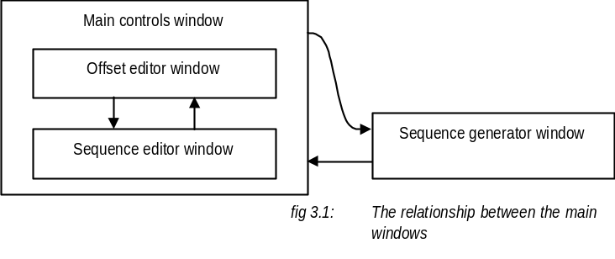
Here we see two distinct areas, the main controls window and the sequence generator window. The main controls window contains the offset editor window and the sequence editor window. The user is thus forced into one of two frames of mind. We want the user to be thinking either about the editors and the main controls or the sequence generator. Some of the windows such as the file dialog window have not been included in this diagram to prevent confusion. For the most part such windows are controlled by MFC.
Now we will consider the control method. We have two input devices at our disposal, the mouse and the keyboard. The mouse is useful for general operations that involve graphical representation and do not require too much precision. One example would be the manipulation of the sequence editor window. The keyboard is useful for entering numerical data such as setting the precise position of an offset. The keyboard is also useful for instigating frequently repeated commands such as the ‘generate’ button in the sequence generator. We can use both methods simultaneously if needs be.
We also need a method for identifying and distinguishing between different offsets. For this prototype we will be using colour as a temporary solution. Colour is not generally a good means for distinguishing between different items because colour perception is highly subjective. In addition, some people have difficulties distinguishing between different shades. We cannot use fill patterns to distinguish between offsets as the offset position markers are too thin too properly display a fill pattern. The only other solution is some form of labelling. Such a process may take a disproportionate time to develop. For reason, offset labelling will be implemented in a later version.
We have the additional problem of identifying the current offset. Originally this was done by changing the colour of the currently selected offset to white. This was confusing because the current offset was often being changed rapidly. The result was a display that seemed hectic as it flashed between different colours seemingly at random. One alternative is to indicate the colour of the current offset in a box on the main controls window. Although it may not be immediately obvious to the first time user, this could be sufficient in the long term. An alternative would be to use both techniques in conjunction after adapting the first technique. Instead of painting all instances of the current offset white, we could have them flashing white at regular time intervals. Because the current offset would be constantly flashing at a regular time interval, the appearance of hectic colour switching would be lessened. In this way the current offset would be easily identifiable, the purpose of the flashing would be immediately obvious, and the hectic colour switching would be abated.
We will now continue by discussing the main controls window, the offset editor window, the sequence editor window, and the sequence generator window in more detail.

3.2.2 Main Controls Window
In this section we will discuss the main controls window in more detail. We will begin with a description of the arrangement of the window. We will continue with a discussion of some notable features of the window and its control mechanism. We will finish with the illustration of some possible improvements.
The main controls window is the first window to be presented to the user. It contains the bulk of the information for the application. This information includes the main controls section, the offset editor, and the sequence editor. The offset editor and the sequence editor can be further subdivided. The following illustration depicts the main controls window and labels some of the subdivisions:
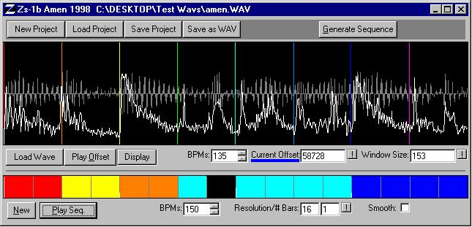
Main controls
Offset editor window
Offset editor controls
Sequence editor window
Sequence editor controls
Fig 3.2:The Main controls window

The main controls window has been loosely divided into three sections. The first is the main controls section. The second is the offset editor, which consists of the offset editor window and the offset editor controls. The third is the sequence editor, which consists of the sequence editor window and the sequence editor controls. The loose division between the main controls section, the offset editor, and the sequence editor is achieved using carefully placed dark grey rectangles.
We will now discuss some notable features of the main controls window. Of note are the method used to distinguish between different offsets and the method used to indicate the current offset. These methods are discussed in section 3.2.1. Also note the use of the title bar to display the filename of the waveform currently being manipulated. The ‘window size’ controls are used to adjust the window size of the volume envelope. These volume envelope windows are discussed in section 4.2.3. Certain controls such as the ‘new project’ button and the ‘new sequence’ button generate a message box requesting validation before continuing. These controls perform in this way because they destroy data in some significant way.
Controls can be operated in several ways. All numerical data can be edited using the keyboard. The keyboard is also used to trigger the ‘play offset’ button, the ‘play sequence’ button, and the ‘generate sequence’ button. These buttons were chosen because they are the most frequently used. All of the controls can be cycled between using the TAB button. The edited contents of controls containing numerical data are not used until triggered by a button-press. These buttons can either be triggered using the mouse or the keyboard. The value of the ‘BPM’ controls can be increased and decreased using the mouse. This technique is often faster for numerical data that is likely to be incremented by small values.
We could significantly improve the application by visually identifying disabled controls. Controls can be disabled when the application enters certain states. One example would be during sequence playback when the application enters a state where the ‘stop’ button is the only control that responds to any input. There is no way for the user to visually identify those buttons that are activated and those that are disabled. This can lead to confusion when user enters such a state for the first time.

3.2.3 Offset Editor Window
The purpose of this section is to describe the offset editor window. We will begin with an explanation of the information displayed by the window and continue with a discussion of the control method.
The offset window displays the original waveform, the offsets at their appropriate positions, the volume envelope, and a line indicating zero amplitude. We have to chosen to graphically represent our waveform with sample number on the x-axis and amplitude on the y-axis. In this way we can observe the changing amplitude. This is useful because rapidly changing amplitudes often indicate possible onset locations. Another technique, known as spectrum representation, allows us to show the construction of our waveform from a set of sinusoidal harmonics. While this could also be useful, we will not use this method as it can be less intuitive for the casual user. The offset positions will be displayed as vertical lines on the waveform and identified using colour. For a discussion of the use of colour to identify offsets see section 3.2.1.The volume envelope is an important part of the onset location process as discussed in section 4.2.3. For this reason we will also display the volume envelope. This will make it easier to visually identify onsets and to set appropriate window sizes. As the two waveforms will be super imposed, the offset editor window may become cluttered. Thus we will include an option to replace the visual representation of the volume envelope with a horizontal line indicating zero amplitude.
When an offset or a sequence is played, all information will be removed with the exception of the waveform. The current play position will be indicated with a vertical line, as will the original position of the offset. The colour of these lines will match the colour of the offset being played. This is done so the user can relate the sound the waveform produces to the graphical representation of the waveform. When a sequence is played, the offset window will at any time indicate the sample on the original waveform that is currently being used. A vertical line is used to indicate the current sample. The colour of this line corresponds to the colour of the last sample triggered. This is done so the user can relate the sequence to the original waveform.
The window will be controlled using the mouse. If the left button is pressed while the pointer is over an offset that offset is selected as the current offset. If the mouse button is held and the mouse is moved, the offset is also moved. The graphical representation must move with the pointer such that the user can see the position of the offset on the waveform as it is being moved. When the button is released the, offset is set at the position of the pointer. The right button behaves in a similar fashion. When the right mouse button is used the automatic onset location facility is initiated. We change the mouse pointer to indicate an offset has been selected. Before, we inverted the window as an indicator. This was decided to be too dramatic an effect. We assume inverting the mouse pointer is sufficient as the user will be concentrating on the pointer when in the process if selecting an offset. When the right mouse button is used we display a question mark next to the inverted pointer. This should suggest to the user that something is being questioned. In this case the user is asking the application to find the closest onset.

3.2.4 Sequence Editor Window
The purpose of this section is to explain the sequence editor window. We will begin with an explanation of the information displayed by the window and continue with a discussion of the control method.
We need to find some means to abstract the sequence data. We want this representation to be as simple as possible such that the composer is not distracted from the task at hand. We are trying to display the arrangement of offset locations. The minimum information we need to display in the sequence window is the position of the offsets in relation to the other offsets. Thus the sequence is represented by a series of adjacent boxes or cells. Each cell represents a time unit. The cell is either filled with a colour or left black. The colour of the cell corresponds to the colour of the offset that is to be triggered at the beginning of that time unit. Adjacent cells indicate the waveform is to be left to loop naturally. This system may need to be adapted as the same offset cannot be easily triggered in quick succession. Markers will be placed to divide the bar into four units. This will be useful as the display may become confusing as higher resolutions. Here we are making the assumption the user will be using waveforms containing four beats. This is not always the case and may have to be changed in the future.
During sequence playback, it may be useful to highlight the cell currently being played. This may help to alleviate initial conceptual problem that users may have as the attempt to associate the sequence with the generated waveform. Currently this is done by the less obvious method of tracing the original waveform. This method is discussed in section 3.2.3.
The sequence editor window is controlled using the mouse. The left mouse button toggles cells between the current offset value and the empty cell value. The right mouse button cycles through the offset values if clicked while the pointer is over a filled cell. This is done so the user can select new offsets without having to move to the offset window. In the future, the right mouse button can be used to display a set of cell parameters which will control the way in which that cell is played back. Some possible parameters are discussed in section 6. Other parameters may be included to deal with the previously mentioned problem of repeatedly re-triggering the same offset.

3.2.5 Sequence Generator Window
The purpose of this section is to explain the sequence generator window. We will begin with an explanation of the information displayed by the window and continue with a discussion of the control method. Finally, we will present some possible improvements.
The sequence generator window is used to display the parameters for the sequence generation function. The exact meaning of these parameters is discussed in section 4.2.6. The sequence generator window is displayed when the ‘sequence generator’ button on the main controls window is pressed. The following illustration depicts the sequence generator window:
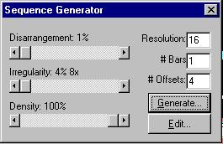
fig 3.3: The sequence generator window

Most of these controls are similar to those discussed in section 3.2.2. The only control we have not discussed is the slide bar. We use these to set the disarrangement, irregularity, and density values. We use slide bars because they present a visual indication of the location of the selected value relative to the maximum and minimum values. A single slide bar represents the irregularity even though it is actually defined by two variables. This is done because we want the user to think of irregularity as a single variable.
The sequence generator window could be improved with the inclusion of animated icons. It is not immediately obvious how the disarrangement, irregularity, and density values effect the generated sequence. Perhaps placing icons next to each of the slide bars could alleviate this. Each icon would present the action of the appropriate value. As new values were entered these icons would change to represent the result of such changes.

4 Design and Implementation
In this section we will provide a general discussion of the design and implementation of Amen. It is important to remember that we are implementing a prototype to test the usefulness of such an application. Because some areas may need to be compromised, we will discuss the strengths and weaknesses of many alternate approaches as well as the current implementation. We will discuss the organisation of files, the main data structures, and the main operations.
4.1 Data Structures 16
4.1.1 Offset 17
4.1.2 Waveform 17
4.1.3 Sequence Cells 18
4.1.4 Sequence Buffer 18
4.1.5 Overall 19
4.2 Operations 19
4.2.1 File I/O 20
4.2.1.1 PCM Waveform-Audio Data Format 20
4.2.1.2 AMN Project Files 21
4.2.2 Offset Window and Sequence Window 21
4.2.3 Automatic Onset Location 22
4.2.3.1 Calculating Envelopes 22
4.2.3.2 Finding Onsets 23
4.2.4 Audio Waveform Playback 23
4.2.4.1 Sequence Playback 24
4.2.4.2 Sequence Smoothing 24
4.2.5 Resolution/Duration Adjustment 25
4.2.6 Sequence Generation 25
4.2.6.1 Disarrangement 26
4.2.6.2 Irregularity 27
4.2.6.3 Density 28

Two of the main concerns during the design and implementation of Amen are portability and expandability. These concerns are addressed by the careful separation of processes. The main functions of the application are all contained in a single file. This file is written in ANSI C to ensure portability. The system interface is implemented using MFC and written in C++. The routines dependent on the sound hardware are implemented using DirectX and written in C++. The PCM Waveform-Audio File Format (WAV) routines are implemented using the Windows Multimedia System and a written using an adaptation of C. The system-dependant routines are distributed amongst several files. These files each represent one of the main windows. WAV routines are contained in separate functions.

4.1 Data Structures
In this section will discuss some of the main data structures used by Amen. The data structures have been organised in such a way that they fit easily into the conceptual structure of this application. We will discuss the composition of these data structures as well as some of their strengths and weaknesses.

4.1.1 Offset
Offsets are represented as an array of indexes into the array containing the samples. The following diagram illustrates the offset data structure:
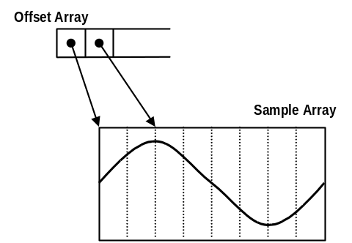
This representation should be sufficient while we are dealing with a fixed number of offsets. In this case we have fixed the number of offsets at eight. Because the original waveform should represent four beats, eight offsets should present sufficient control. A possible improvement would be to allow a user defined number of offsets.

4.1.2 Waveform
Waveforms are represented as a structure that contains information about the original waveform as well as information about the volume envelope. The following diagram illustrates the waveform data structure:
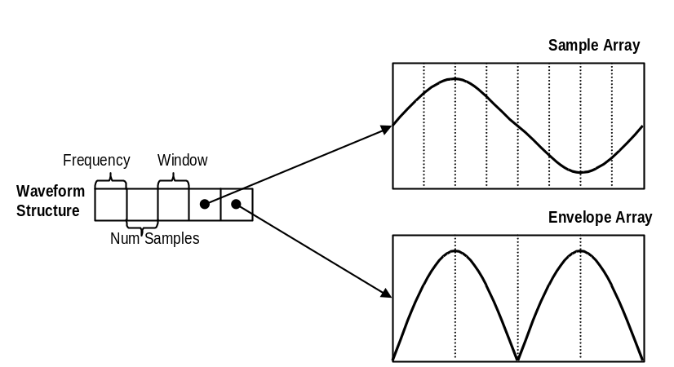
Waveform information consists of the original frequency of the waveform, the number of samples the waveform contains, and an array containing those samples. The samples are stored as floating point numbers between –1.0 and 1.0. We use this technique to ensure future compatibility. Normalised sample values allow us to easily incorporate newer sound file formats, as we are not limited to a certain sample range. It is interesting to note that it is generally best to use floats as opposed to doubles to represent normalised samples. This is because we do not need the extra precision that doubles provide. This is compounded by the fact that calculations often result in the loss of sound quality.
Envelope information consists of the size of the envelope window as well as an array containing the envelope. The envelope is stored as an array of floating point numbers between 0.0 and 1.0. We don’t need negative numbers because the envelope represents the absolute value of the waveform. The number of elements in the envelope array can be calculated by dividing the number of samples in the wave by the size of the envelope window.
It may be useful to also include the filename of the waveform as a part of the structure. The current implementation does not incorporate the filename into the structure to ensure the main structures remain system independent. Whether storing filenames actually promotes system-dependence is arguable.
We can also ask if the envelope information should be stored in a separate structure. This is discussed in section 4.1.5.

4.1.3 Sequence Cells
The sequence cell structure represents a single time unit of the sequence. The structure contains an index into the array of offsets. The following diagram illustrates the sequence cell data structure:
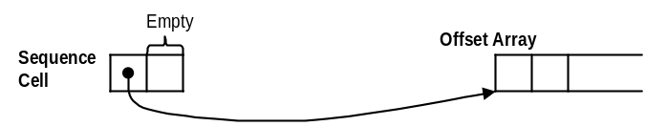
The empty area is reserved for future versions. It is intended to contain effect information for the time unit. For each cell the user will be able to specify several parameters such as volume, echo delay, and echo decay. The empty area is reserved for that information. This is discussed in more detail in section 6.

4.1.4 Sequence Buffer
The sequence is represented by a structure that contains information about the sequence of offsets and the rearranged waveform. The following diagram illustrates the sequence buffer data structure:
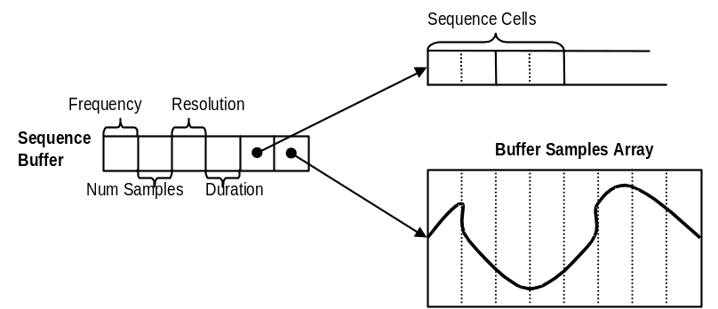
The sequence buffer structure contains the sequence resolution, the sequence duration, two representations of the sequence, as well some additional information about those representations.
The first representation of the sequence consists of an array of sequence cells. Each sequence cell represents an equal amount of time and the offset to be played in that time. If a cell is empty no sound is played. If a cell contains a different offset value than the previous cell, the original waveform is started at the offset location and left to loop naturally. If a cell contains the same offset value to the previous cell, the waveform is left to continue playing and loop naturally.
The second representation of the sequence consists of an array of samples. This array is the rearranged version of the original waveform. As with the original waveform the frequency is stored, the number of samples is stored, and the samples are stored as an array of floating point values between –1.0 and 1.0. This is the buffer used for sequence playback. If we were calculating the sequence in real-time, this buffer would not be necessary. For a detailed discussion of real-time and buffered playback refer to section 4.2.4.1.

4.1.5 Overall
Although this system of data structures fits easily into the conceptual organisation of the application, it is not necessary the most efficient way of organising the data. One possible change would be the removal of the frequency information. Another would be the separation of the waveform structure into two simpler structures.
It can be argued that the frequency information in the waveform structure and the sequence structure is unnecessary. One time this information is used is when a new sound file is loaded. At this time the playback frequency of the offset window and the sequence window are set to the frequency of the newly loaded sample. It would seem that the only other time this information is used is when a sequence is saved as a WAV file. At this time the sequence is saved at the frequency of the original sample. In both these cases, only the frequency information in the waveform structure is used. This renders the frequency information in the sequence buffer completely useless. In addition, the frequency of new sound files is currently set at a constant value. On the other hand, even though this information is currently unnecessary it is almost certain that it will become useful as the application is expanded.
It can be argued that we could improve the application by separating the current waveform structure into two simpler structures. Let us observe that the sequence buffer structure and the waveform structure have a similar construction. This is because they both contain a representation of a wave. We could separate the current waveform structure into a new envelope structure and a new waveform structure. The new envelope structure could contain the length of the envelope, the window size, an array representing the envelope, as well as a pointer to a waveform structure. This pointer would point to the waveform the envelope represents. The new waveform structure would contain only the frequency of the wave, the number of samples in the wave, and an array of the samples. The original waveform is represented as an instance of the new waveform structure and as instance of the new envelope structure. The sequence buffer structure can be changed such that it points to an instance of the new waveform structure. All the repeated information in the sequence buffer structure could then be removed. This would probably be a more efficient way of organising our data but it would make the implementation of the application more difficult to understand.

4.2 Operations
In this section we will discuss the design and implementation of some of the more interesting operations Amen performs. These include file i/o, the offset window and sequence window, automatic onset location, audio waveform playback, resolution/duration adjustment, and sequence generation.

4.2.1 File I/O
Amen deals with two main file formats; the PCM Waveform-Audio Data Format (WAV), and AMN project files. WAV files are widely used to store audio waveform data. The use of WAV files allows the application to be compatible with many other Windows based sound tools. AMN project files are specific to the application and are used to store various project settings.

4.2.1.1 PCM Waveform-Audio Data Format
We have chosen The PCM Waveform-Audio Data Format (WAV) to ensure compatibility with many other Windows based sound tools. In this section we will discuss how we are using the WAV format, discuss the operations that use the WAV format, and illustrate the various measures taken to ensure expandability.
The WAV format is used for waveform audio. This is not the only waveform audio data format. We have chosen WAVs because of their wide usage. WAVs are the audio format of choice for the Windows operating systems. The application is limited to 44100Hz mono 16 bit WAV files. We have fixed these values to simplify the application. These values were chosen, again, because of their wide usage. We will use the Win32 multimedia libraries to manipulate WAVs. These libraries provide functions for loading WAVs, saving WAVs, reading audio data from WAVs, and writing audio data into WAVs.
WAVs will be used to both load a waveform for manipulation and to save the sequence as a waveform. Of these two operations, the later is the more interesting. This process involves rendering the sequence buffer as discussed in section 4.2.4.1,creating a WAV file to store the buffer, converting the buffer information into the appropriate format, and writing the converted buffer information into the WAV file. The application currently discards the sequence’s tempo information and saves the sequence at the frequency of the WAV file that has been rearranged. Maintaining the tempo information in the saved WAV would involve resampling the sequence buffer at a new frequency. This is a complicated process and will not be implemented in this version of the application.
To ensure expandability all the WAV specific operations have been isolated from the other operations. It is inevitable that the application will be expanded to deal with a wider range of file formats. To accommodate this possibility, WAV specific operations have been clearly separated from the rest of the application. WAV input and output are dealt with by two functions. These functions are quite similar so we will only look at the function for loading WAV files. Given a file name, this function tries to fill a waveform data structure (discussed in section 4.1.2) with the appropriate information. Although 16 bit WAVs represent samples as signed byte pairs, this function converts this information into floating point numbers between –1.0 and 1.0. Because the application is designed to deal with normalised samples, file formats with differing sample ranges can be easily accommodated. The function returns one value if it fails and another if it succeeds. This feature allows the function to be easily incorporated into a more general loading procedure. This more general procedure is responsible for locating the file using a dialog window, initialising various internal variables, setting up the direct sound buffer and refreshing the screen with the appropriate values.

4.2.1.2 AMN Project Files
AMN project files are used to store various project settings. Currently the following variables are stored in the AMN project files:
- the offset positions
- the current offset
- the length of the original waveform
- the window size of the envelope
- the frequency of the sequence
- all of the sequence information excluding the rendered sequence buffer
- the path and filename of the original waveform

From this information we can reconstruct the state of the application. Currently we do not store any waveform information. The filename and path are used to locate and load the original waveform. The sequence buffer can then be rendered using this information. We do not store waveform information because it often very large, thus project files are kept relatively small. This poses a problem when files cannot be located. This may happen because a file has been moved or deleted. In this case we give the user the option to locate the original file or a new one. If the user chooses a new file we assume that the two files are of differing lengths. We do two things to accommodate this eventuality. Firstly we set the envelope window size to a default value. Secondly, we use the length of the original waveform to relate the old offset positions to the new waveform.

4.2.2 Offset Window and Sequence Window
The offset window and the sequence window are very similar in their construction. In this section we will discuss the major features they share, as well as some of the issues involved with displaying a waveform.
Both the offset window and the sequence window are implemented as child windows. They are responsible for drawing their display, and handling mouse inputs in their portion of the screen. Each consists of several separate functions for drawing the various contents of the window. For example, the offset window has separate functions for drawing the original waveform, the offset positions, the volume envelope, and the zero points. This allows us to display only the relevant information at any time. All of these functions are designed to work with variable window sizes. This decision affords us two advantages. Firstly, we can use resizable windows for our application. Secondly, we simplify the process of magnifying the waveform in future versions. Mouse input is handled using the appropriate MFC functions. These provide information about the state of the mouse buttons and the pointer co-ordinates. Using this information we can decide the appropriate actions to take. For more information on mouse button actions and display contents refer to section 3.2.
We have already discussed the information we want to display in section 3.2. Waveforms are to be displayed as two-dimensional graphs with amplitude on the y-axis and time on the x-axis. Thus we simply need to read through the array of samples using the index as the x co-ordinate and the contents as the y co-ordinate. In displaying this information we must deal with two issues; the representation of scaled waveforms and the process of connecting points.
It is somewhat inevitable that we will be required to scale the representation of a waveform such that it fits in a certain area. When a point on our graph is required to represent several samples, how do we decide what amplitude to plot? Possibly the best method is to average the sample values. Unfortunately this can require more computational time than we can afford. So we compromise by displaying the value of the sample with the largest amplitude. As this display is used for visually identifying onsets we assume that it is preferable to present the user with the worst case, thus their selection will always be reasonable. Displaying the sample with the lowest amplitude will provide a graph that may not indicate a reasonable choice of onset position.
The problem of connecting points on the graph does not have an obvious solution. The following diagrams illustrate this:
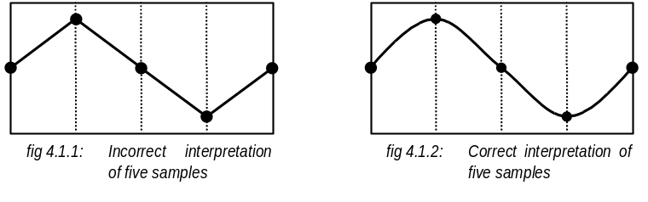
These figures illustrate two ways of connecting the points on our graph. These points represent single sample values. In the first figure we connect the points using simple straight lines. The second figure shows how the samples should actually be interpreted. Although this is the correct interpretation we use the first method. We do this because connecting the points with straight lines is faster to compute. In addition, each point often represents several samples, thus we have already lost the need for the level of detail displayed by the second figure.

4.2.3 Automatic Onset Location
In this section we will discuss the automation of the onset location procedure. We will first look at the calculation of volume envelopes. Next we will describe how to find onsets using a volume envelope.

4.2.3.1 Calculating Envelopes
To calculate a volume envelope for a waveform we must first calculate the absolute value of every sample. A window is a number of adjacent samples. The waveform is divided into windows and the maximum value in each window is found. This gives us an abstraction of the waveform that represents the changing amplitudes.
Consider the following example:
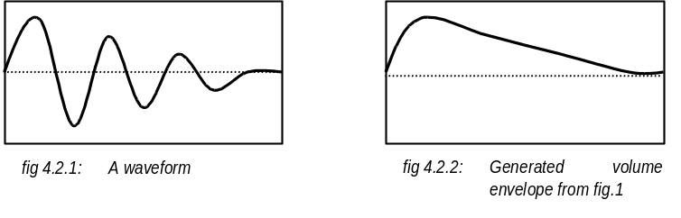
The first figure shows a waveform. The second figure shows a volume envelope for that waveform. The shape of this envelope depends on the size of the envelope window. In the application we calculate the initial size of the window using the length of the sample. We choose the initial window size such that the envelope can be displayed in the offset window with the minimum need for horizontal scaling. This is done so that the user can make visual judgements about the envelope without having to deal with unseen information. One alternative technique for generating the volume envelope would be to average the amplitudes of the samples in the window instead of simply taking the largest value. We can generate smoother envelopes if we adjust our algorithm so that the windows overlap. This is a more sophisticated process.

4.2.3.2 Finding Onsets
We currently find onsets using the volume envelope. Once a sample is selected it is mapped to a point on the envelope. The offset is moved to the adjacent point on the envelope with the lowest value. We continue to move the offset in the same direction until the next point on the envelope has a value larger than the current value. An alternate approach would use the slope of the envelope at a given point. When using this technique we assume that the most appropriate choice of offset is the portion of the envelope with the steepest slope.
We could perhaps use a more sophisticated method for locating these offsets. If we can assume a certain time signature we can divide the waveform accordingly. This happens by default when a waveform is loaded. The waveform is assumed to be four beats long and so divided into eight equal sections. But can we determine the time signature from the waveform alone? This is a question that we are still trying to answer. Some algorithms try to classify rhythms as a collection of heavy and light beats and then find patterns in their distribution. In most cases our waveforms are going to represent a single bar of audio and so do not provide enough variations to meet the requirements of such algorithms. Still, it is not inconceivable that some form of beat tracking could be made useful to us in finding suitable onsets.

4.2.4 Audio Waveform Playback
In this section we will discuss audio waveform playback. We will discuss Direct Sound and tempo controls, sequence playback techniques, and sequence smoothing
Currently Direct Sound handles the bulk of the playback operations. Direct Sound is part of the DirectX SDK. Using Direct Sound we can secure a representation of the sound hardware and use this abstraction to playback audio information. Direct Sound takes care of the cumbersome compatibility issues. We write audio information into a buffer. We can then play that audio information from any offset at our choice of frequency measured in hertz (Hz).
We have decided to specify tempo to the user as beats per minute (BPMs.) We chose BPMs as the application is designed to work primarily with drum loops. To convert BPMs to Hz we must first assume that our original waveform is four beats long. We can then calculate the playback frequency using the length and frequency of the original waveform. This technique only works work for samples that are four beats long. We could improve this process with method of identifying the number of beats in any waveform. Some benefits of beat tracking are discussed in section 6.

4.2.4.1 Sequence Playback
Currently we are rendering the sequence as an audio waveform and playing it using a Direct Sound buffer. First we use the duration information with the original waveform length to calculate the length of the sequence buffer. Next we work our way through the sequence cells filling the sequence buffer with the appropriate information from the original waveform. Finally we convert the sequence buffer into the appropriate format and copy it into the Direct Sound Buffer. The Direct Sound Buffer is now ready to be played. The buffers are rendered when the ‘play sequence’ button is pressed. As a result there is a considerable latency between the button press and the actual playback. The duration of this latency depends on the specifications of the computer and the length of the sequence. An alternate approach would be to play the sequence in real-time.
Playing the sequence in real-time would remove the latency and require less memory as no buffers need to be rendered or stored. Using this technique we need some form of time monitoring. We could then ‘trigger’ the original waveform from the appropriate position at the appropriate time. This approach has been discarded for two main reasons. The first reason is the inconsistency of Windows timers. Time is handled in Windows 95 by sending messages to the application at a specified interval. Our application shares the same message channel as all other applications. As a result the timer intervals are inconsistent and unreliable. Although the multimedia timers are an improvement over Windows timers, there was still too much inconsistency across different configurations. The second reason for discarding this approach is the intended inclusion of effect information for the sequence. One likely expansion is the ability to specify parameters for each sequence cell. These parameters would effect the way the original waveform is played. Although it is conceivable that some of these effects could be generated in real-time, many are too processor intensive. This predicament is heightened when several effects are used in conjunction. sequence cell parameters are discussed on section 6.

4.2.4.2 Sequence Smoothing
Sequence smoothing is the name we have given to the process of smoothing transitions between reordered blocks. It is likely that we will incur large shifts in amplitude between samples as different portions of the waveform are being moved into unnatural positions. These shifts in amplitude can cause an audible clicking noise. We remove these clicks by applying a volume envelope to the waveform. For more information on volume envelopes refer to section 4.2.3.1.
The following diagram illustrates how it is possible to force a waveform to fit into a volume envelope:
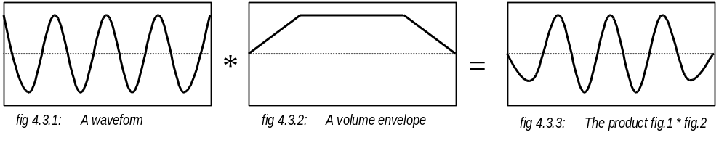
Figure one depicts a waveform. Figure two depicts a volume envelope. If we multiply each point on the waveform with the corresponding point on the envelope we produce the waveform depicted in figure 3. The following diagram illustrates how this technique can be used to remove clicking sounds:
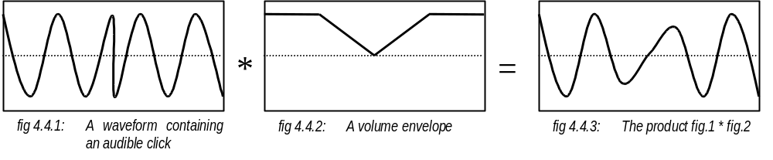
Figure one depicts a waveform with an audible click at the halfway point. We can use the envelope in figure two to change the values either side of the click and produce the smooth transition illustrated by figure three. The application uses this technique to remove clicks from the rendered sequence buffer. We use the sequence cell information to identify possible clicking points. The shape of the envelope depends on the resolution of the sequence. One possible improvement would be to apply a more sophisticated volume envelope such as a Bessel curve.

4.2.5 Resolution/Duration Adjustment
When changing the resolution or duration of a sequence cell list we must be careful to not lose existing sequence information. This is a fairly straightforward process. When a change is called for we locate a new area of memory to hold our array of sequence cells. We carefully fill this array using the information in the old array and scaling it accordingly. Only then do we destroy old array.

4.2.6 Sequence Generation
In this section we will provide a discussion of algorithmic composition as well as a description of the system used by our application. For a more abstract description of our sequence generator and the parameters, see section 2.2.2.
Algorithmic composition is a difficult term to describe. By drawing from reliable definitions of the words ‘algorithmic’ and ‘composition’ we may be able to construct the following description:
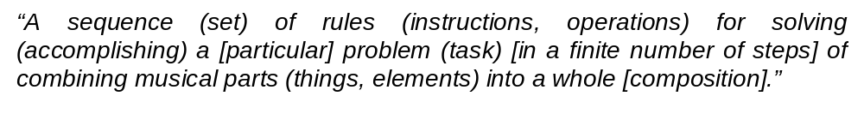
First we observe that computers do not necessarily have to be involved in algorithmic composition. Thus the term separates those composers that create their music using rules from those that do not use rules. Traditionally, algorithmic composition techniques include some level of intervention in selection of viable music from a larger superset of machine generated results. Therefore, our application must be capable of generating music using a set of rules and presenting the results to the user such that they may be considered.
Our algorithm makes several important assumptions. We assume the original waveform represents a single bar of music and consists of four beats. We assume that there are a total of eight offsets that are separated by regular intervals of time. We assume that sequences which are longer than a single bar are not expected to have any specific structure involving repetition.
Our algorithm uses a three-step process to generate a sequence. The first step applies disarrangement, the second step applies irregularity, and the last step affects density. In the next three sections we will discuss these steps in more detail.

4.2.6.1 Disarrangement
We have defined disarrangement as the extent to which the offsets are sequenced out of their natural order. We effect this by first compiling a list of the selected offsets in their natural order for the entire sequence. At this stage only the number of offsets to be used is selectable. The exact offsets used and their positions are selected by the algorithm. The compiled list is re-read and random values are added to or subtracted from each entry. These new values refer to all of the offsets. The size of these values depends on the extent of disarrangement specified by the user and never exceeds the total number of offsets. Thus the level of disarrangement defines the extent to which the offsets are sequenced out of their natural order. The following diagrams illustrate this process.
First we assume our offsets are distributed evenly. This diagram depicts a 32 sample long waveform divided into eight offset positions:
0  Offset number | 1 | 2 | 3 | 4 | 5 | 6 | 7
0  Offset location | 4 | 8 | 12 | 16 | 20 | 24 | 28

Next we will assume that the user wishes to generate a two bar long sequence using four offsets. We must construct a list of the selected offsets in their natural order. The following diagram depicts this list of offset numbers:

0  List of offset numbers | 2 | 4 | 6 | 0 | 2 | 4 | 6

We now assume the user has provided a low disarrangement value. From this we decide to add random values between -1 and 1 to each element in the list of offset numbers. The following diagram depicts the a possible resultant list of offset numbers:

0  List of offset numbers | 3 | 4 | 6 | 7 | 1 | 3 | 6

Thus the disarrangement value is effecting the extent to which the offsets are sequenced out of their natural order.

4.2.6.2 Irregularity
We have defined irregularity as the extent to which offset placement deviates from regular time intervals. We effect this by using the newly generated offset list from the previous section. We know the intended resolution and duration of the sequence and use this information to scale our new offset list giving each offset a natural position. We know that these offsets should be placed at regular intervals. Using the irregularity extent and irregularity resolution specified by the user, we add random values to the natural location. The irregularity extent effects the range of these values and the irregularity resolution effects the base units. The array of sequence cells is then re-read and empty cells are filled with the offset value of the previous cell. In this way the irregularity effects the extent to which offset placement deviates from regular time intervals. The following diagrams illustrate this process.
First we will assume we have generated an offset list for a sequence which is two bars long and uses two offsets with a disarrangement value of zero. The following diagram depicts this offset list:

0  List of offset numbers | 4 | 0 | 4

Next we assume the user has specified a resolution of eight and a duration of two. We scale the list of offsets and fill the sequence cell array with the appropriate values. These values should be separated by regular intervals. The following diagram depicts the newly generated sequence cell array:

0  Sequence cell array |  |  |  | 4 |  |  |  | 0 |  |  |  | 4

Now we will try generating the same array only this time we assume an irregularity resolution of two and a resolution extent equivalent to one. Thus the position of the offset numbers will deviate by random numbers between –1 and 1 multiplied by two. The following diagram depicts a possible resultant sequence cell array:

0  Sequence cell array |  | 4 |  | . |  |  |  | . |  | 0 |  | 4

The final step is to fill empty cells with the offset value of the previous cell. The following diagram shows the previous sequence cell array after the empty cells have been filled:

0  Sequence cell array | 0 | 4 | 4 | 4 | 4 | 4 | 4 | 4 | 4 | 0 | 0 | 4 | 4 | 4 | 4

In this way the irregularity effects the extent to which sequence cells deviate from regular time intervals.

4.2.6.3 Density
We have defined density as the ratio of sound over sequence length. We change the density of the sequence by adding silence. A non-empty cell is randomly selected from the sequence cell array. We move right until the next cell has a different value to the original cell and fill the cell we are currently over with the empty value. We repeat this process a certain number of times depending on the density value. The following diagrams illustrate am example of this process.
First we assume we have generated the sequence cell array from the previous section. Next we select a sequence cell at random. The following diagram depicts the sequence cell array with the randomly selected non-empty value in parentheses:

0  Sequence cell array | 0 | 4 | 4 | (4) | 4 | 4 | 4 | 4 | 4 | 0 | 0 | 4 | 4 | 4 | 4

Next we move right until the next cell has a different value to the original cell and fill the cell we are currently over with the empty value. The following diagram depicts the sequence cell array with the new empty cell:

0  Sequence cell array | 0 | 4 | 4 | (4) | 4 | 4 | 4 | 4 |  | 0 | 0 | 4 | 4 | 4 | 4

Now let us assume the user has requested a density of .75. As we have sixteen cells in our array we must empty four. We repeat the previous step a total of four times. The following diagram depicts a possible outcome.

0  Sequence cell array |  | 4 | 4 | 4 | 4 | 4 | 4 |  |  | 0 | 0 | 4 | 4 | 4

In this way the density effects the ratio of sound over sequence length.

5 Significance
In this section we will attempt to determine the significance of our application as a tool for music composition. For this reason it is important to take a close look at the uses of our application as well as the opinions of people from different musical backgrounds.
Amen was designed primarily to simplify the process of rearranging drum loops. Amen can also be used in other interesting and unique ways. First we will discuss three ways in which Amen simplifies the process of arranging drum loops. Amen allows the user to easily experiment with different sequence arrangements. Also, the application forces a certain regular timing. Thus it can be used to create extremely complicated drum loops which still stay in regular time. The sequence generator is very good at suggesting interesting new arrangements of beats. This is helpful when inspiration is lacking.
Amen can also be used in several other interesting ways. The user is not limited to percussive waveforms. There is no reason why we cannot experiment with tonal sound. Recent experiments using piano samples produce very interesting results. Amen is good for creating variations to existing pieces. This is because rearranged waveforms often retain the same ‘flavour’ as the original sound. In addition, simple variations can be generated at the later stages of development, after the original source is no longer available. Using another approach, we can isolate the original sounds in a waveform and use the application in the same way as we might use a traditional drum machine such as the TB-909 by Roland. These are not the only ways in which the application can be used. The sequence can be split using a less common resolution. Resolution values can be used to force a waveform into a particular time scale. The sequence generator is capable of creating sequences that are quite enchanting. These sit on the edge of comprehension. The mind understands there is a pattern, but cannot easily identify it without the addition of a more understandable backing. These uses will certainly grow with the inclusion of sequence cell parameters. Sequence cell parameters are discussed in section 6.
So is Amen useful to people with different musical backgrounds? Several people with differing musical backgrounds were shown the application and informally quizzed for their opinions. Most people tested found the application enjoyable and worth investing some time in.
Those without musical background found they could easily construct new sounds, but had difficulty understanding the application in any detail. Often they had trouble understanding the controls. This can be alleviated by the inclusion of context-sensitive help. Online help is a fairly straightforward feature to implement and is intended for the next version of Amen. Also, some had difficulty understanding the process. In most of these cases the people were not familiar with the representation of audio as a waveform. Thus they were unable to associate what was being displayed with what they were hearing. This cannot be easily rectified. Still this is not a major problem as most found the application could still be used to create suitable waveforms. This would suggest an understanding of the process would come with experience. The application is designed to be used with other musical software to create finished compositions. Those without a musical background were often not familiar with other musical software. As a result, these people saw the application as an amusing diversion and not a tool.
Those with a musical background were keen to experiment with the application. Most tested had very different musical backgrounds. Most found the simplicity appealing. ‘Drum and Base’ beats are becoming increasingly complicated and difficult to construct. The application presents itself as an invaluable tool for overcoming this problem. Some found the ability to create loops with deceptive rhythms appealing. Such loops contain sounds that seem to be sequenced in some irregular time until they are placed in the context of a regular beat. The application’s ability to randomly generate sequences was also found to be appealing. Thus it is easy to create several variations of a piece of music without losing the ‘feel’ of the original. Some found the ability to isolate individual sounds interesting. This could be useful for isolating individual instruments in a waveform. The application could then be used like a traditional drum machine, with each sequence cell being used to trigger an individual instrument.
Most people tested shared the same conceptual problem. These people had trouble relating the representation of the sequence to the sound being produced. This was somewhat lessened by the playback tracing in the offset editor window discussed in section 3.2.3. The cause of this trouble is the playback method for adjacent sequence cells with matching offset values. Here the offset is not re-triggered but left to loop naturally. This property is essential for the construction ‘Drum and Bass’ style rhythms. Once explained, the conceptual problem is often easily understood. This would imply that both online help, and experience would greatly alleviate the problem. Some form of sequence playback tracking in the sequence editor window may also help. Such a system could work by highlighting the sequence cells as the are played, being careful to highlight any adjacent cells with matching offset values. It may also help if we changed the appearance of the resolution dividers between such cells. This would also be beneficial for the future when sequence cell parameters are implemented. Sequence cell parameters are discussed in section 6.

6 Improvements
There are many ways in which our application can be improved. These are discussed throughout our document. Some of the more immediate improvements we will now discuss concern file formats, offset control, sequence cell parameters, beat tracking, the sequence generator, as well as some more general concerns.
It would be useful to support a wider range of file formats. Currently we only support 16-bit mono PCM waveform-audio files (WAVs) sampled at 44100mHz. The first improvement would be to support 8-bit WAVs and WAVs sampled at other frequencies. We could also support a wider range of audio waveform file formats such as AIFF and IRCAM. It could also be useful to save the finished sequence as MIDI, MOD, or C sound files, only this would be significantly more challenging to implement. Another improvement might be to save transposed waveforms. This would require some form of resampling and would allow us to save the sequence at the tempo it was edited at. A much more ambitious improvement would be to allow support for stereo waveforms. This would require a redesign and a new implementation of the application.
Certain aspects of offset control could also be improved. This could be accomplished in the following ways:
- variable offset number
- offset labelling
- waveform magnification
- offset selection menu
- offset loop ranges

It would be better to allow the user a variable number of offsets. Currently we have fixed the number at eight. This may be too many or not enough. Before we could implement this change we need to devise a new method for identifying offsets. Currently we are using colour coding. Colour coding is not a good method as it can sometimes be difficult to differentiate between different colours. This becomes more of a problem as the number of colours grows and the difference between them becomes smaller. A more suitable technique would be some form of labelling. Another improvement would be the inclusion of a zoom feature for magnifying portions of the original waveform. This would allow higher precision over graphical offset location. The application could also be improved by making offsets easier to select. Perhaps this could be achieved using a special menu that is displayed when the ‘current offset’ indicator is clicked on. One final improvement could be to set offset ‘ranges.’ An offset could be given duration as well as a location. Once played, the offset could loop each time it reached its full duration.
The most likely improvement is the inclusion of sequence cell parameters. Each sequence cell could be given a set of parameters to determine the way in which that cell is played. One possible parameter would change the amplitude of the waveform for the duration of the time unit represented by the cell. Another might force the waveform to be played in reverse. There are many possible processing effects that we might incorporate such as reverberating, flanging, and echoing. Another possible parameter would force an offset to be re-triggered regardless of the contents of the adjacent cell. This would require us to devise some new system for displaying adjacent sequence cells with the same offset value. Perhaps we could remove the resolution boundary between sequence cells where the offset is left to loop naturally. This would also help to lessen the conceptual problems users were facing in relating the sequence representation to the sequence playback.
The application could be improved with the inclusion of some form of beat tracking. This would allow us to guess the time signature of the loaded waveform and initialise the application accordingly. For example, if the waveform consisted of six beats we could set the resolution to twelve, set the number of offsets to six, adjust the BPM calculation, and adjust the sequence generator appropriately. Currently we assume that the original waveform consists of either four or eight beats and have set the default values accordingly. If a beat tracking system is implemented, it should also be possible for the user to set the perceived number of beats manually.
Both the user interface and the algorithm of the sequence generator could be improved. The sequence generator interface could be made clearer if the effects of the various variables were explained in more depth. This could be done using animated icons or online help. In addition, it would be more convenient if the sequence generator had its own ‘sequence playback’ button. The actual algorithm used to generate the sequence could also be significantly improved. Certain choices such as offset position could be weighted such that they are more likely to occur. Longer sequences could be given some structure with certain variations being repeated. The generator could be designed to work with offsets that are not spaced at regular intervals.
Some more general improvements could also be implemented. These might include:
- disabled controls
- sequence cut, copy and paste
- sequence playback tracking
- online help

Controls could be made to change their appearance when the are disabled. This would help to avoid confusion when the application enters states where certain controls are visible but unusable. Another improvement would be to implement some more sophisticated controls for sequence editing such as cut, copy and paste functions. Thus the user could easily repeat or move sections of the sequence. Some form of sequence playback tracking could also improve the application. When a sequence is being played back, we could provide some form of visual indication of the sequence cell currently being played. This would help the user relate the visual representation to the sequence with the sound being produced. We could also improve the application by providing some form of online help. This could consist of a Windows help file that presented an online user manual. This could also consist of some form of context-sensitive help. Using this system, the user could find information on a specific control simply by enabling the context-sensitive help and selecting the relevant control.

7 Conclusion
In conclusion, we have succeeded in meeting all of our aims with a degree of success. We will begin this section with summary of our document. We will continue with a description of the ways in which we have attempted to meet our aims.
This document began with some background information about our application, Amen. Here we discussed our aims, this document, our incentives, as well as a framework for musical data and processes. Next we highlighted some requirements of the users and the process on our application. We continued by addressing the user interface design. We began with some background information about user interfaces and continued with a discussion of our application’s interface. In the design and implementation section we discussed the strengths and weaknesses of various approaches to meeting our requirements. In the process we highlighted the solutions we chose for this first implementation. Next we attempted to determine the significance of our application as a tool for music composition. We attempted to accomplish this by taking a close look at the uses of our application as well as the opinions of people from different musical backgrounds. We continued by highlighting some of the main ways in which our application could be improved. And finally we conclude with an illustration of the way in which we have attempted to meet our aims.
The aim of this project was to create an application to facilitate the process of rearranging audio waveforms. We knew this application had to be quick and easy to use. At the same time we knew the application would have to be flexible. We also knew we had to provide some level of automation. Finally, we knew that we were preparing a prototype that may need to be expanded in the future.
We made the application quick and easy to use in two main ways. First we presented the user a graphical interface. This helps the user by making it easier to visualise the process and its effects. Also we presented the user with abstracted version of the process. Many of the more tedious processes, such as the timing calculations, are hidden from the user. In this way the users are free to concentrate their full efforts on the final product.
We made the application flexible by ensuring the user had control over as many of the variables as possible. The user is not limited to any resolution or duration. Offsets can be placed anywhere. The process can be applied to any type of sound. As a result we have already found several different ways of using the application, all of which deviate from the intentional method.
We have provided several levels of automation. We divided the process into two subtasks, offset location and sequence composition. We ensured that each of these tasks could be accomplished both automatically by the computer as well as manually by the user. We automated the offset location process by making it possible for the computer to locate the closest onset to any given sample. We automated the sequence composition by making it possible to algorithmically generate a sequence from certain parameters.
We have created a prototype with a view to future expansion. We carefully thought about possible future improvements. With these improvements in mind we have created a framework such that they may be implemented with the minimum amount of modification to the existing application. Amen is being distributed using the Internet for the purpose of testing usage. If the application produces a favourable response we can continue its production.
In conclusion, we have succeeded insofar as we have meet all of our aims with a degree of success. We have certainly not created a perfect application, but we have made the first steps towards a new tool for musical composition. For this reason we must not be discouraged by all the possible improvements we envisage. Because of them we know we have taken the first steps in the right direction; not to come up against a wall, but to continue into the future.

Glossary
Bar: for the purpose of this document we will define a bar as the length of the audio waveform to be arranged.
Density: the ratio of sound over sequence length.
Disarrangement: the extent to which the offsets are sequenced out of their natural order.
DirectX: a software development kit produced by Microsoft. We use DirectX for low latency response and hardware abstraction.
Duration: a measure of the number of bars in a sequence.
Envelope: an abstracted waveform that represents the changing amplitude of an audio waveform.
Envelope window: An area measurement used in calculating volume envelopes. The size of the envelope window defines the level of abstraction of the envelope.
GUI: abbreviation for ‘graphic user interface.’
Irregularity: the extent to which offset placement deviates from regular time intervals.
MFC: abbreviation for ‘Microsoft Foundation Classes.’
Microsoft Foundation Classes: a set of classes developed by Microsoft for the production of Windows 95 style GUIs.
Offset: a sample position within an audio waveform from which playback can be initiated and left to loop naturally.
Onset: a sample position within an audio waveform that falls at the beginning of a specific sound in that waveform.
Resolution: the number of sequence cells each bar is going to be divided into.
Sequence: A series of sequence cells that represent the rearranged audio waveform.
Sequence cell: one of a series of equally sized time units that subdivide the sequence. Offsets playback is commonly initiated at the beginning of a sequence cell.
Window: see ‘envelope window.’

Bibliography
Implementation:
Lovette, Lance; Brian, Marshall: Developing Professional Applications for Windows 95 and NT Using MFC; P T R Prentice Hall, 1997.
Kernighan, Brian W.; Ritchie, Dennis M.: The C Programming Language; P T R Prentice Hall, 1988.
Pohl, Ira: C++ for C Programmers; The Benjamin/Cummings Publishing Company, Inc., 1994.
Tisher, Michael; Jennrich, Bruno: PC Intern The Encyclopedia of System Programming; Abacus, 1996.
Kolb, Jason: Win32 Game Developers Guide with DirectX 3; The Wait Group, 1997.
Microsoft online documentation for DirectX, MFC, and Visual Development Studio.

Computer Music:
Moore, F. Richard: Elements of Computer Music; P T R Prentice Hall, 1990.
Cope, David: “Algorithmic Composition [re]Defined,” Position Papers for the Second Panel on Algorithmic Music; ICMC Proceedings 1993.
Chin, Francis; Wu Stephen: “An Efficient Algorithm for Rhythm-finding,” Computer Music Journal; Vol. 16, No. 2, Summer 1992.
Roads, Curtis; “Research in Music and Artificial Intelligence,” ACM Computing Surveys; Vol. 17, No. 2, June 1985.
Gordon, John W.: “System Architecture for Computer Music,” ACM Computing Surveys; Vol. 17, No. 2, June 1985.
Tanaka, Atau: “Interaction in Algorithmic Composition,” Position Papers for the Second Panel on Algorithmic Music; ICMC Proceedings 1993.
Austin, Larry: “Modelling Music with Computers: Random Thoughts,” Position Papers for the Second Panel on Algorithmic Music; ICMC Proceedings 1993.
Laske, Otto: “What is Composition Theory?” Position Papers for the Second Panel on Algorithmic Music; ICMC Proceedings 1993.

Culture:
‘www.techno.de/mixmag/interviews/JungleHistoire.html’-Mixmag, article on the history of jungle.
Irwin, Tim; Irwin Dan: “The Ultimate Guide to Breakbeat,” DJ; Vol 2/31, No. 7, January-13 February 1998.
‘www.steinberg-us.com/products/digitalaudio/recycle/index.html’-Steinburg, maker of re-cycle.

User Interface Design:
Thimbleby, Harold: User Interface Design; ACM Press, 1990.
Pennycook, Bruce W.: “Computer-Music Interfaces: A Survey,” ACM Computing Surveys; Vol. 17, No. 2, June 1985.

This chart is discussed in greater detail in Moore’s book, Elements of Computer Music. p 6
From Moore, Elements of Computer Music. p 397
From Thimbleby’s User Interface Design. p 6
Francis Chin and Setphen Wu propose one example in their paper, “An Efficient Algorithm for Rhythm-finding.”
From David Cope’s position paper, “Algorithmic Composition [re]Defined.”
Form Atau Tanaka’s position paper, “Interaction in Algorithmic Composition.”

