

Facultyofengineering-Shoubra BenhaUniversity

ResearchArticle/ResearchProject/Literature Review

infulfillmentoftherequirementsof

|  |  |
| --- | --- |
| Department | Engineering mathematics and physics |
| Division | ---------------- |
| AcademicYear | 2019-2020 preparatory |
| Coursename | Computer |
| Coursecode | ECE001 |

Title:-

Coputer Engineering Role in COVID 19 Pandemic

By:

|  |  |  |  |
| --- | --- | --- | --- |
|  | Name | Edumail | B.N |
| 1 | Ziad samir mokhtar mohamed | Zeyad195407@feng.bu.edu.eg | 368 |

Approvedby:

|  |  |
| --- | --- |
| Examinerscommittee | Signature |
| Dr. Ahmed bayomi  Dr. Shady Elmashad  Dr. Abdelhamid Attaby |  |
|  |  |
|  |  |
|  |  |
|  |  |

# Researchobjectives

The research aims to know the concept of artificial intelligence and its importance and the method of currency and its various types with mentioning its ratings and benefits of its use and also the harms of its use and the most important leading companies in this field

Tableofcontents

|  |  |
| --- | --- |
| Subject | Page |
| Researchobjectives | 1 |
| Introduction | 1,2,3 |
| Literature Review | 3,4,5,6,7 |
| Results end Disction | 8 |
| Screenshoots | 9,10 |
| References | 11 |

# Introduction

A recent study conducted by researchers from the British universities of Oxford and Yale, USA, revealed that there is a 50% chance that artificial intelligence will outperform human intelligence in all fields within 45 years, and it is expected that it will be able to assume all human functions within 120 years. The results of the study do not exclude that this happens before this date.According to the study, "machines will overtake humans in translating languages ​​by 2024, writing school articles by 2026, driving trucks by 2027, working in retail in 2031, and even writing one of the best-selling books by 2049, and in performing surgeries by Year 2053 ".The study stressed that artificial intelligence is rapidly improving its capabilities, and is increasingly establishing itself in historically dominated fields, for example, the Alpha Go program, owned by Google, recently defeated the world's largest player in the ancient Chinese game known as "Atmosphere". In the same vein, the study also predicts that autonomous driving technology will replace millions of taxi drivers. Alpha Go is one of the biggest challenges for the computer, and experts believe it exceeds the challenge of chess.The study polled 352 opinions of experts in machine learning and artificial intelligence to predict the extent of progress that can be made in this field during the next few decades, as well as knowing the exact timing of the growth of capabilities of artificial intelligence and its superiority in specific occupations, as well as monitoring their expectations about when it becomes superior to humans in all tasks ? What are the social implications of this progress?According to the study, many experts expect that within a century, artificial intelligence will be able to do anything a person can do."We're currently working on comparing brain power to supercomputers to help figure out enough devices to run something as complex as the brain," Katja Grace, a researcher at the Institute for the Future of Humanity at Oxford University and head of the research team, told Science. She adds: The technical summary that we reached in our study has concluded that artificial intelligence at the human level will have far-reaching effects on society, particularly during the next century, explaining that most of the benefits of civilization stem from intelligence, and it is very important to search for ways to enhance The benefits of artificial intelligence without replacing it in the job market.On the social and economic impacts of that progress, as is the case with the likely expectations of high unemployment and growing poverty, Grace said: "The social effects of the development of artificial intelligence will depend on how society reacts to it, and that can lead to many numbers of unemployed people and a lack of rates. Material income for them, or it could lead to almost everyone being supported by technology and freeing them from many businesses, making them able to spend their time doing other activities that are beneficial to them. ”

# LiteratureReview

Artificial intelligence is the behavior and specific characteristics of computer programs that make them mimic human mental capabilities and working patterns. Among the most important of these characteristics is the ability to learn, infer, and react to situations not programmed in the machine. However, this term is controversial due to the lack of a specific definition of intelligence.And artificial intelligence is a branch of computer science. Artificial intelligence is defined by many works as "the study and design of smart clients", and a smart customer is a system that absorbs its environment and takes situations that increase its chance of success in achieving its mission or the mission of its team.This definition, in terms of goals, actions, perception, and environment, refers to Russell & Norvig (2003) and other definitions also include knowledge and learning as additional criteria. Computer scientist John McCarthy originally coined this term in 1956, and he defined himself as "the science and engineering of making smart machines." Andreas Kaplan and Michael Heinleen define artificial intelligence as "the system's ability to interpret external data correctly, learn from this data, and use that knowledge to achieve Specific goals and tasks through flexible adaptation. This field was founded on the assumption that the kingdom of intelligence can be accurately described to the extent that the machine can simulate it. This raises a philosophical debate about the nature of the human mind and the limits of scientific approaches, issues that have been discussed in legendary, fictional, and philosophical tales from ancient times. Controversy also revolves around what intelligence and its types a person possesses, and how they simulate a machine. Artificial intelligence was and still is the cause of highly optimistic ideas, and it has suffered severe setbacks throughout history, and today it has become an essential part of the technology industry, bearing the burden of the most difficult problems in modern computer science. AI research is highly specialized and technical, to the point that some critics criticize the "disintegration" of this field. AI sub-domains center around specific problems, the application of special tools and ancient theoretical differences of opinion. Major problems with artificial intelligence include capabilities such as logical thinking, knowledge, planning, learning, communication, perception, and the ability to move and change things. And general intelligence (or “strong artificial intelligence”) remains a long-term goal of some research in this field. In the mid-twentieth century, a few scientists began exploring a new approach to building smart machines, based on recent discoveries in neuroscience, a new mathematical theory of information, and the development of cybernetics, and above all, by the invention of the digital computer, a machine was invented that could simulate Human computational thinking process. He founded the modern field of artificial intelligence research at a conference on the Dartmouth College campus in the summer of 1956. These attendees have become the leaders of artificial intelligence research for decades, especially John McCarthy and Marvin Minsky, Allen Noel and Herbert Simon who founded artificial intelligence laboratories at the Massachusetts Institute of Technology (MIT), Carnegie Mellon University (CMU) and Stanford. They and their students wrote programs that surprised most people. The computer solved problems in algebra, established logical theories, and spoke English. By the mid-1960s, that research was generously funded by the US Department of Defense. These researchers made the following expectations:In 1965, H. a. Simon: “Within twenty years, machines will be able to do whatever work a person can do.” 1967, Marvin Minsky: “In one generation ... the problem of creating 'artificial intelligence' will be largely solved.” But they failed to realize the difficulty of some of the problems they faced. [15] In 1974, in response to Sir James Lighthill's criticism of England and the continuing pressure from Congress to fund more productive projects, the US and British governments cut their funding for all unearthed exploratory research in artificial intelligence, which was the first setback in AI research. In the early 1980s, AI research saw a new awakening through the commercial success of "expert systems", which is one of the AI ​​programs that simulates the knowledge and analytical skills of one or more human experts. By 1985 the profits of artificial intelligence research in the market had reached more than $ 1 billion, and governments had started funding again. A few years later, beginning with the collapse of the Lisp Machine (one of the programming languages) market in 1987, AI research saw yet another setback, but longer. In the 1990s and early 2000s, AI has had greater successes, albeit somewhat behind the scenes. Artificial intelligence is used in logistics, data mining, medical diagnosis and many other areas throughout the technology industry. This success is due to several factors: the great power of computers today (see Moore's Law), an increased focus on solving specific sub-problems, and creating new relationships between the field of artificial intelligence and other areas of work in similar problems, and above all, researchers began adhering to strong mathematical approaches And strict scientific standards

-Types of artificial intelligence

(1)Minimal artificial intelligence

It is artificial intelligence that specializes in one field. For example, there are artificial intelligence systems that can beat the world champion of chess, and it's the only thing you do.

(2)General artificial intelligence

This type refers to computers with a level of human intelligence in all areas, that is, it can perform any intellectual task that a person can perform. Creating this type of intelligence is much more difficult than the previous type and we have not reached this level yet.

(3)Super artificial intelligence

Oxford philosopher Nick Bostrom defines supreme intelligence as “an idea that is much smarter than the best human minds in almost every field, including scientific creativity, general wisdom, and social skills.” Because of this type, the field of artificial intelligence is an interesting field to delve into. In the 21st century, AI research has become highly specialized and technical, and it has been divided into deep subspecies so deep that they are so few to each other. The field sections grew around specific institutions, researchers worked, to solve specific problems, and differences of opinion a long time ago emerged about how artificial intelligence should work and widely applied various tools. Artificial intelligence has been used successfully in a wide range of areas including expert systems, natural language processing, voice recognition, image discrimination and image analysis as well as medical diagnostics, stock trading, automated control, law, scientific discoveries, video games, toys and search engines on the Internet. Often, when technology is widely used and not seen as an artificial intelligence, it is sometimes described as the effect of artificial intelligence. It can also be incorporated into 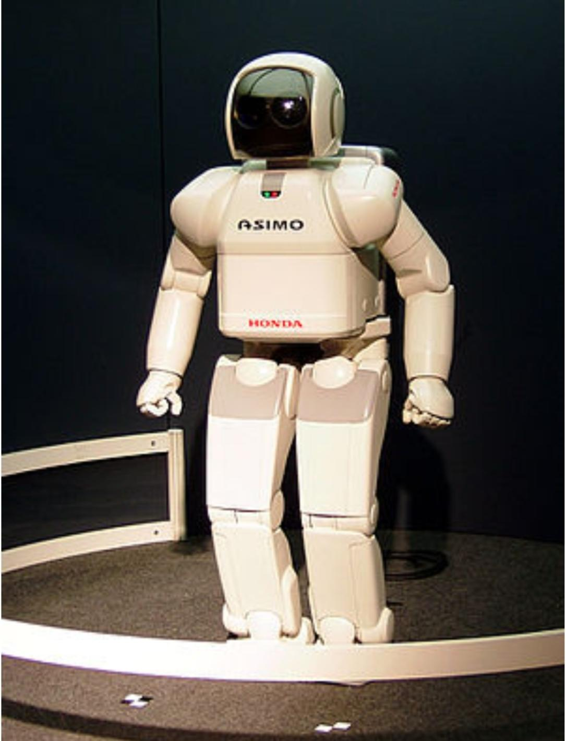artificial life.

# Resultsanddiscussion

Artificial Intelligence is considered one of the branches of computer science, and one of the main pillars upon which the technology industry is based in the current era, and the term artificial intelligence - which is referred to by the acronym (AI) - can be defined as the ability of digital machines and computers to perform certain tasks that mimic They are similar to those of intelligent beings. Such as the ability to think or learn from previous experiences or other processes that require mental processes, as artificial intelligence aims to reach systems that enjoy intelligence and behave in the way that humans behave in terms of learning and understanding, so that these systems provide to their users various services of education and guidance Interaction, etc. The emergence of the term artificial intelligence dates back to the fifties of the twentieth century, and specifically in the year 1950 AD when the scientist Alan Turing introduced what is known as the Turing Test, which means assessing the intelligence of a computer and classifying it Smart if he can mimic the human mind. One year after the Turing test appeared, the first program using artificial intelligence was created by Christopher Strachey - who was head of programming research at Oxford University - as he was able to Run checkers (English: checkers) via a computer and develop them, then Anthony Oettinger (Cambridge: Anthony Oettinger) from the University of Cambridge designed a computer simulation experiment for the shopping process carried out by the human person in more than one store, and this simulation aimed at Measuring the computer's ability to learn, and this was the first successful experiment for what is known as machine learning.The concept of artificial intelligence was officially announced in 1956 AD in Dartmouth College, but no progress was made. AD over a period of about twenty years, and this may be due to the limited computer capabilities that were available at that time. In 1979 the Stanford Vehicle was built, which is the first vehicle driven by a computer, and in 1997 CE the first computer was able to Overcoming a human competitor in the game of chess, and the pace of acceleration in artificial intelligence began in the beginning of the twenty-first century until interactive robots became available in the stores, and the matter went beyond that so that there was a robot that interacts with different feelings through facial expressions, and other Robots that have become difficult missions such as Nomad, which searches and explores remote places in the Antarctic, and locates meteorites in the region

# Screenshoots

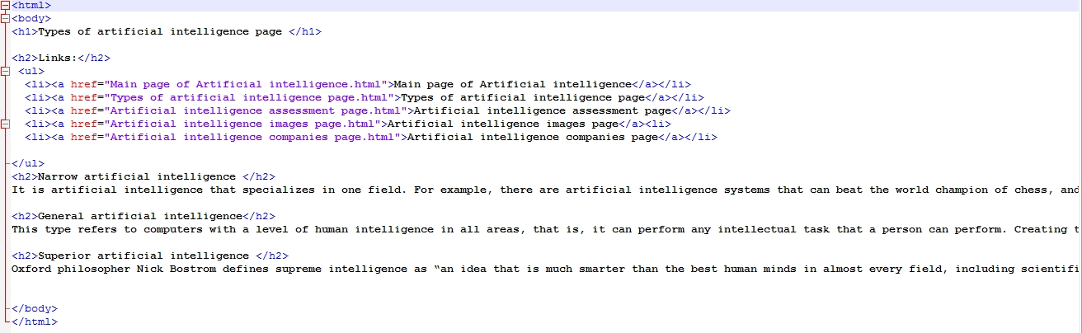

ه

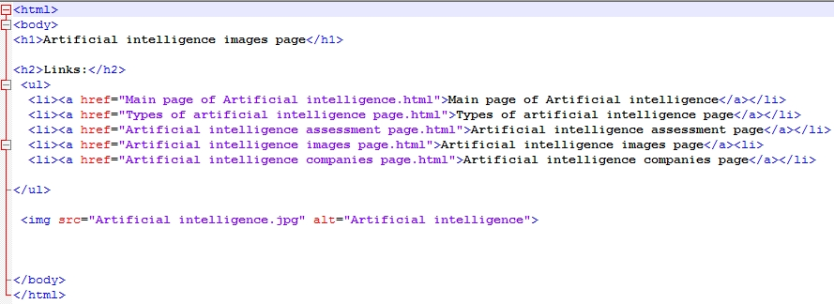

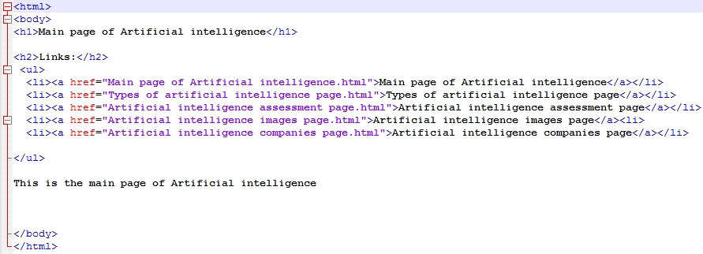

# References

1. <https://archive.org/details/artificialintell0000luge>
2. [Nilsson, Nils](https://ar.m.wikipedia.org/w/index.php?title=Nils_Nilsson&action=edit&redlink=1) (1998), *Artificial Intelligence: A New Synthesis*, Morgan Kaufmann Publishers
3. <https://web.archive.org/web/20090725025030/http://www.cs.ubc.ca:80/spider/poole/ci.html>
4. <https://archive.org/details/artificialintell00wins>
5. <https://web.archive.org/web/20080619021029/http://www.acm.org:80/class/1998/I.2.html>
6. <https://web.archive.org/web/20200202132701/http://people.csail.mit.edu/brooks/papers/elephants.pdf>
7. [*Dreyfus, Hubert*](https://ar.m.wikipedia.org/wiki/Hubert_Dreyfus); Dreyfus, Stuart (1986), Mind over Machine: The Power of Human Intuition and Expertise in the Era of the Computer, Oxford, UK: Blackwell
8. [*Haugeland, John*](https://ar.m.wikipedia.org/w/index.php?title=John_Haugeland&action=edit&redlink=1) (1985), Artificial Intelligence: The Very Idea, Cambridge, Mass.: MIT Press, [*ISBN*](https://ar.m.wikipedia.org/wiki/%D8%B1%D9%82%D9%85_%D8%A7%D9%84%D9%83%D8%AA%D8%A7%D8%A8_%D8%A7%D9%84%D9%85%D8%B9%D9%8A%D8%A7%D8%B1%D9%8A_%D8%A7%D9%84%D8%AF%D9%88%D9%84%D9%8A) [*0-262-08153-9*](https://ar.m.wikipedia.org/wiki/%D8%AE%D8%A7%D8%B5:%D9%85%D8%B5%D8%A7%D8%AF%D8%B1_%D9%83%D8%AA%D8%A7%D8%A8/0-262-08153-9)
9. <https://web.archive.org/web/20190825201123/http://www.inf.ed.ac.uk:80/about/AIhistory.html>
10. Kolata, G. (1982), "How can computers get common sense?", *Science*, صفحات 1237–1238