

Faculty of Engineering

Cairo University

**Variable:**

**Syntax**

Team 1

**Student Names**:

Abdelrahman Mohamed Emam 1170386

Abdelrahman Mohamed Shahda 4180281

Abdelrahman Salah Salem 1170132

Ziad Kamal 1170397

**Submitted To:** Dr. Mona Farouk

Eng. Mahmoud Khaled

Eng. Mariam Mahmoud

**Due Date:** 28/5/2021

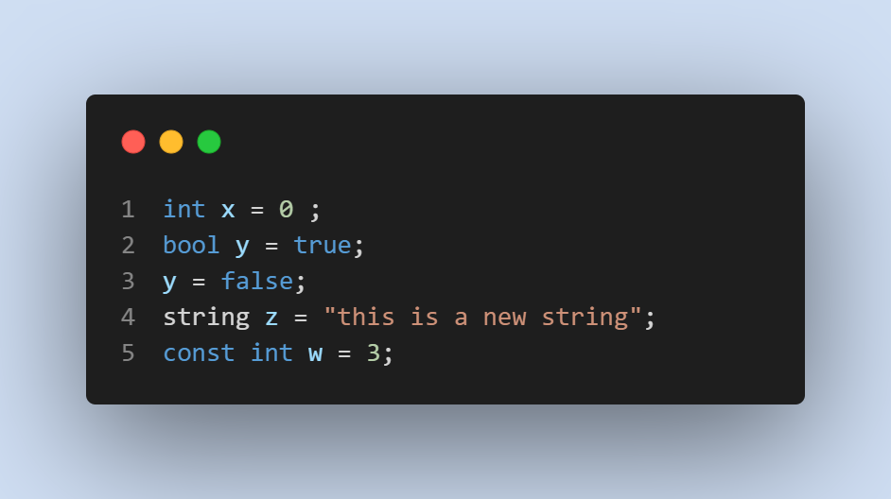

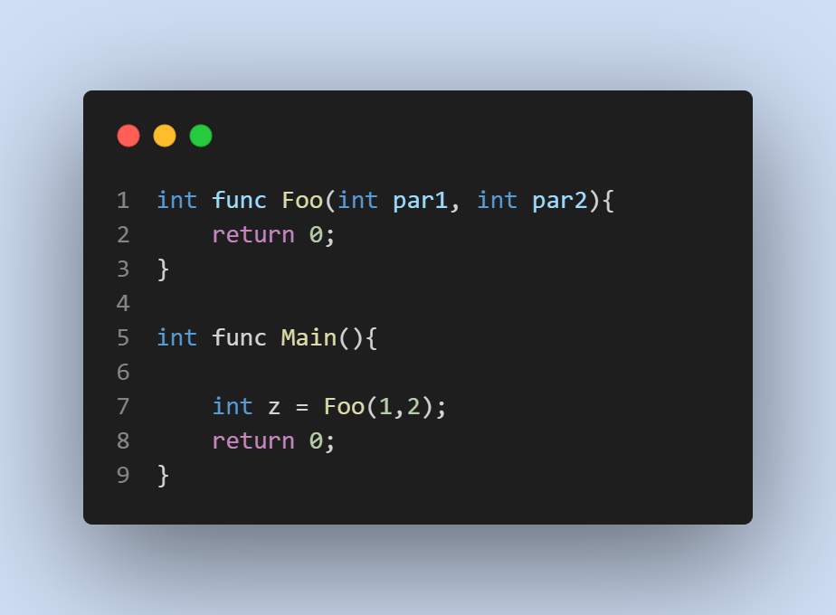**Functions:**

**Flow Control:**

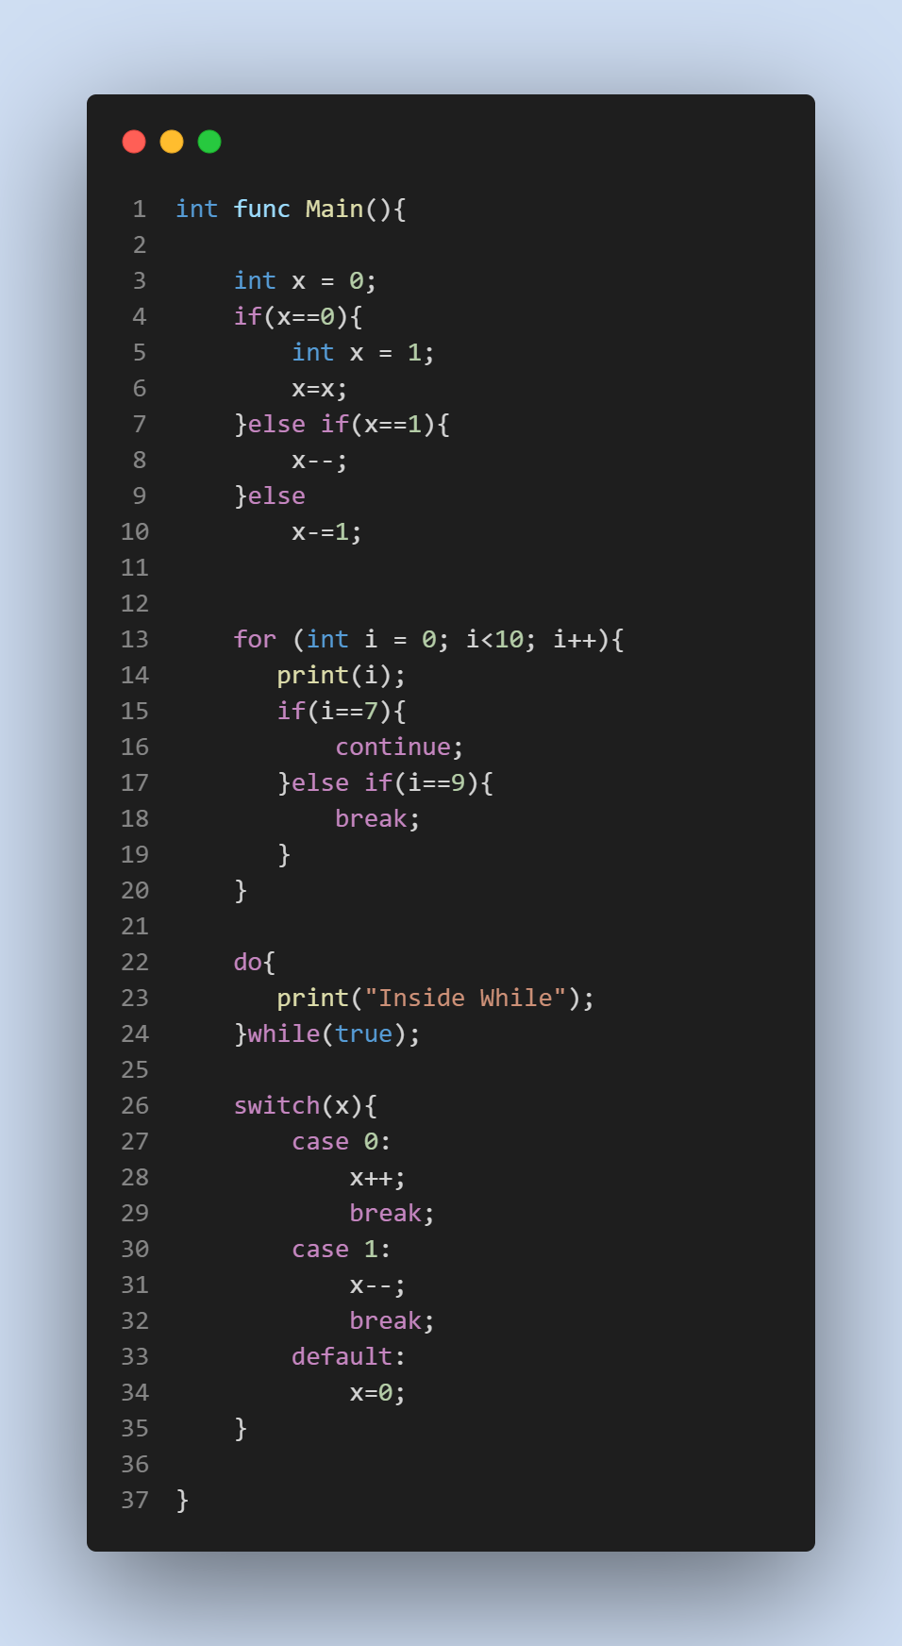

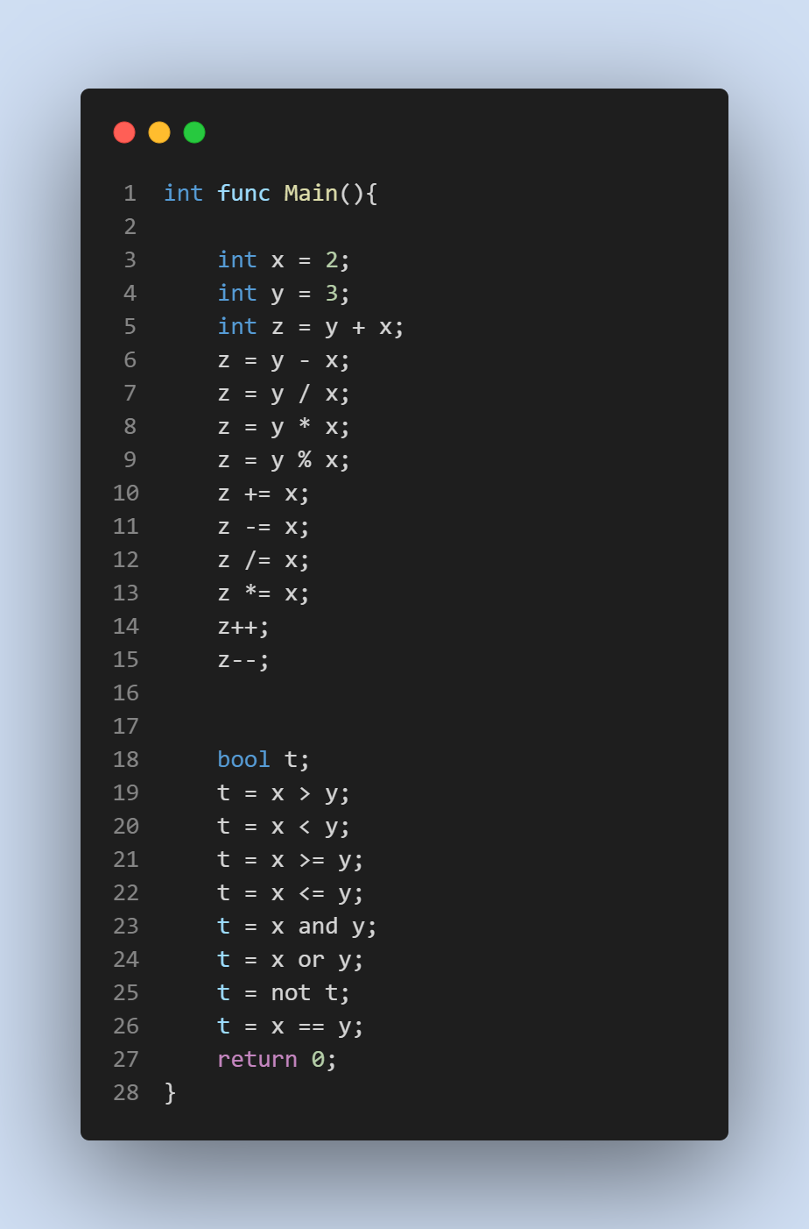

**Assumptions:**

1. Function names start with capital letter

2. Variable name starts with small letter

3. Cannot escape special characters in the string value

4. NIL is used instead of NULL

5. Statements cannot be empty (at least semicolon)