Zia-ur-rehman
23F-0547
Data Science
*******************************************
*--(Question-01)--*
*--(1)--*
Load the dataset and print
import pandas as pd
employee=pd.read_csv("D:/dataset/Employee.csv")
employee_training_data=pd.read_csv("D:/dataset/employee_training_dataset.csv")
Shape, column names, data types
print("*****Employee******")
print("shape : ",employee.shape)
print("Column name : ",employee.columns.tolist())
print("DataType : ",employee.dtypes)
Output:
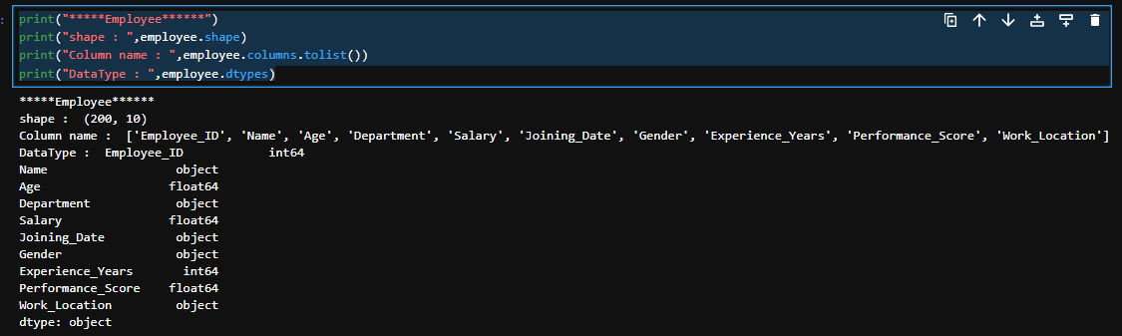
Count of missing values per column
missing_values=employee.isnull().sum()
print("missing number of value : ",missing_values)
Output:
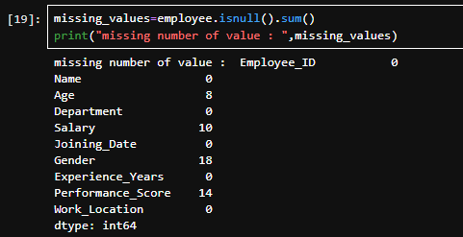
• Count of duplicates
duplicates=employee.duplicated().sum()
print("Duplicates : ",duplicates)
Output:
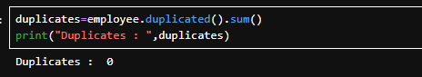

*--(2)--*
Select only the Name, Age, and Salary columns from the dataset
employee.loc[:,["Name","Age","Salary"]]
Output:
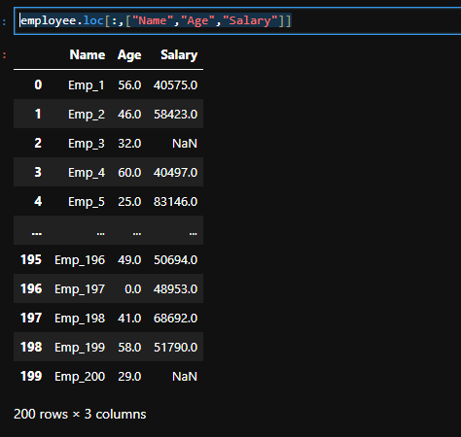

*--(3)--*
Extract the first 10 rows and the last 5 rows of the dataset
First ten rows:
employee.head(10)
Output:
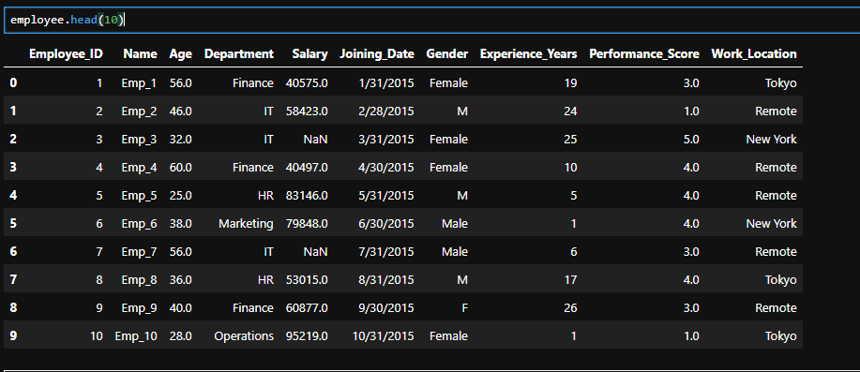
Last 5 rows:
employee.tail(5)
Output:
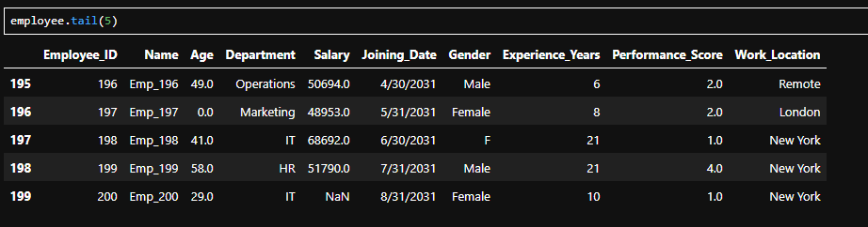
*--(4)--*
Slice rows where Age is between 30 and 40 and Department is “Engineering”.

print(employee[(employee["Age"].between(30,40))&(employee["Department"]=="Engineering")])
Output:
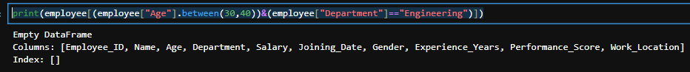
No such employee exit in the dataset.

*--(5)--*
Select all employees from “New York” with Performance_Score above 8.
Code:
print(employee[(employee["Work_Location"]=="New York")&(employee["Performance_Score"]>8)])
Output:
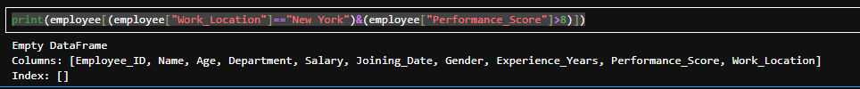

*--(6)--*
Select the first 5 rows and the last 5 rows of numerical columns only.
Code:
numeric_col=employee.select_dtypes(include=["number"])
print(numeric_col)
Output:
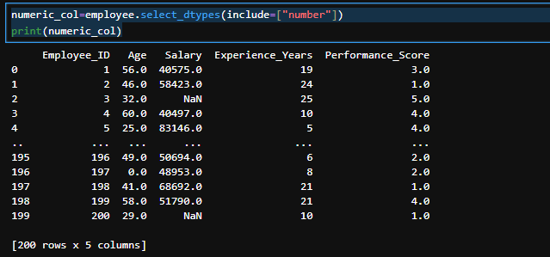

*--(7)--*
Identify and fix:
Mixed categorical values (e.g., "Male", "M" → "Male")
Code:(for Gender Column)
employee["Gender"]=employee["Gender"].replace({
"M":"Male",
"F":"Female"})
Code:(for Department Column)
employee["Department"]=employee["Department"].replace({
"HR":"Human Resources",
"IT":"Information Technology"
})
Output:
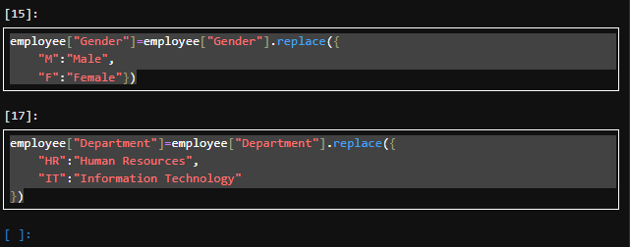
Impossible values (e.g., negative ages, unrealistic salaries)
Code:
import numpy as np
employee.loc[(employee["Age"] < 0) | (employee["Age"] > 120), "Age"] = np.nan
employee.loc[(employee["Salary"] < 10000) | (employee["Salary"] > 500000), "Salary"] = np.nan
Output:
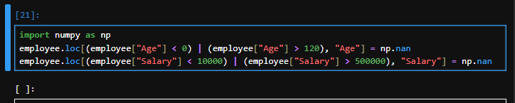
Standardize categorical values.

o Consistent spelling or capitalization
o Standardizing abbreviations or codes

Code:
employee["Gender"]=employee["Gender"].str.title()
employee["Department"] = employee["Department"].str.title()

employee["Department"] = employee["Department"].replace({
"Hr": "Human Resources",
"Human Resources": "Human Resources",
"It": "Information Technology",
"Info Tech": "Information Technology"
})
Output:
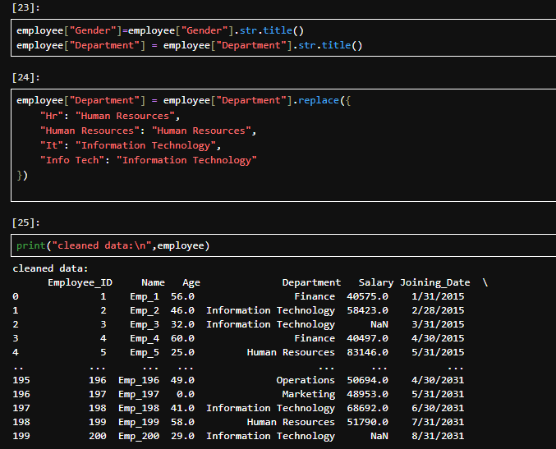

*--(Question-02)--*
Part-I
- Handle missing values:
• Numerical: Fill with mean, median, and compare results.
• Categorical: Fill with mode or add a new category “Unknown”.
Code:
Means:
data_mean = employee.copy()
data_mean["Age"] = data_mean["Age"].fillna(data_mean["Age"].mean())
data_mean["Salary"] = data_mean["Salary"].fillna(data_mean["Salary"].mean())
Median:
data_median = employee.copy()
data_median["Age"] = data_median["Age"].fillna(data_median["Age"].median())
data_median["Salary"] = data_median["Salary"].fillna(data_median["Salary"].median())
Mode:
data_mode = employee.copy()
data_mode["Gender"] = data_mode["Gender"].fillna(data_mode["Gender"].mode()[0])
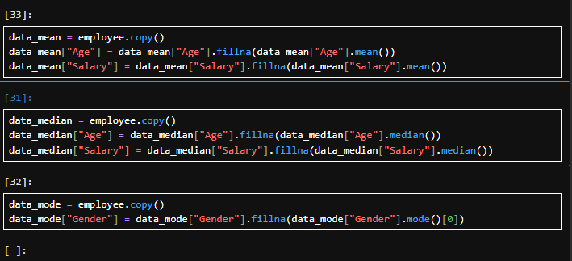
Output:
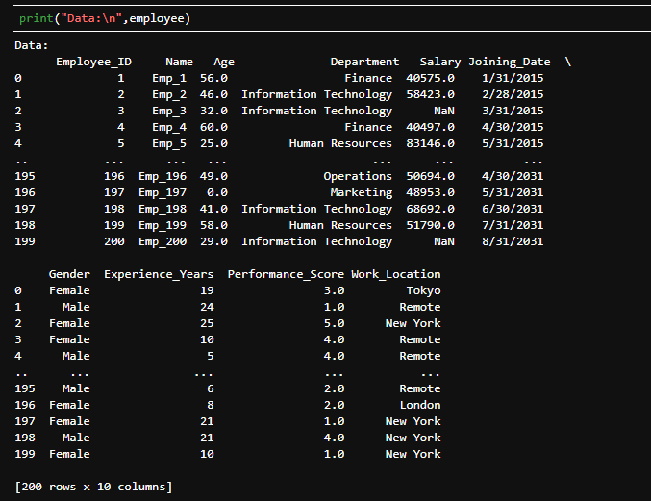
Part-II
Detect outliers in Salary and Age using:
• Interquartile Range (IQR) method
Code:
def detect_outliers_iqr(df, column):
Q1 = df[column].quantile(0.25)
Q3 = df[column].quantile(0.75)
IQR = Q3 - Q1
lower_bound = Q1 - 1.5 * IQR
upper_bound = Q3 + 1.5 * IQR

print(f"\n{column} → Q1={Q1}, Q3={Q3}, IQR={IQR}, Bounds=({lower_bound}, {upper_bound})")

outliers = df[(df[column] < lower_bound) | (df[column] > upper_bound)]
return outliers

print("IQR Outliers in Age:\n", detect_outliers_iqr(employee, "Age"))
print("\nIQR Outliers in Salary:\n", detect_outliers_iqr(employee, "Salary"))

• Z-score method
Code:

from scipy.stats import zscore
data = pd.DataFrame({
"Name": ["Ali", "Sara", "John", "Ayesha", "Omar", "Zara"],
"Age": [25, 30, 40, 22, 150, 28], # 150 = outlier
"Salary": [50000, 70000, 80000, 60000, 12000000, 75000] # 12M = outlier
})

def detect_outliers_zscore(df, column, threshold=3):
z_scores = zscore(df[column])
df["Z_" + column] = z_scores

outliers = df[np.abs(z_scores) > threshold]
return outliers

print("Z-score Outliers in Age:\n", detect_outliers_zscore(employee.copy(), "Age"))
print("\nZ-score Outliers in Salary:\n", detect_outliers_zscore(employee.copy(), "Salary"))
Output:
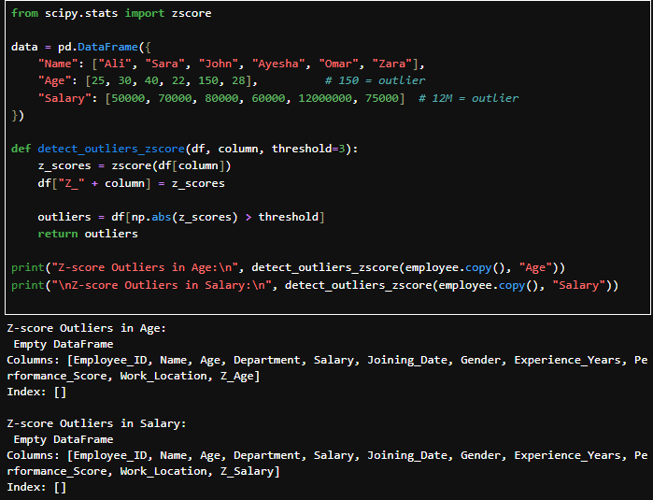

Part-III
Code:
import pandas as pd
import numpy as np

def iqr_bounds(series):
Q1 = series.quantile(0.25)
Q3 = series.quantile(0.75)
IQR = Q3 - Q1
lower_bound = Q1 - 1.5 * IQR
upper_bound = Q3 + 1.5 * IQR
return lower_bound, upper_bound

def cap_outliers(df, column):
lower, upper = iqr_bounds(df[column])
df[column] = np.where(df[column] < lower, lower,
np.where(df[column] > upper, upper, df[column]))
return df

print("Before:\n", employee.describe())

lower_age, upper_age = iqr_bounds(employee["Age"])
lower_sal, upper_sal = iqr_bounds(employee["Salary"])

removed = employee[(employee["Age"] >= lower_age) & (employee["Age"] <= upper_age) &
(employee["Salary"] >= lower_sal) & (employee["Salary"] <= upper_sal)]

print("\nAfter Removing Outliers:\n", removed.describe())

capped = employee.copy()
capped = cap_outliers(capped, "Age")
capped = cap_outliers(capped, "Salary")

print("\nAfter Capping Outliers:\n", capped.describe())
Output:
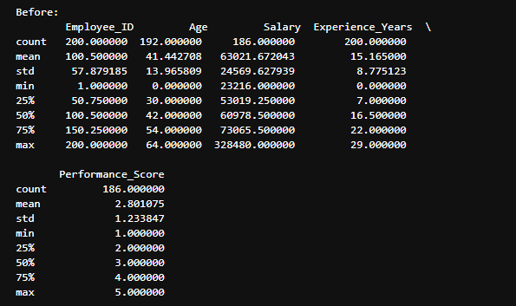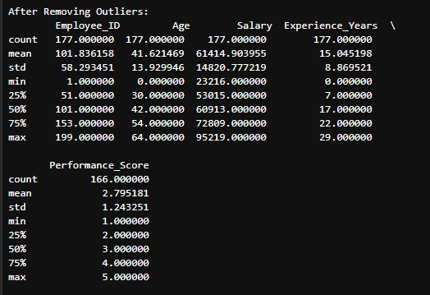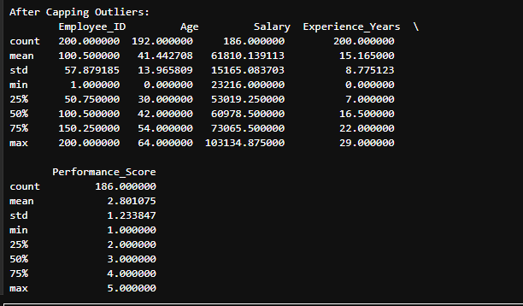

*--(Question-03)--*
Part-I
For numerical columns (Age, Salary, Experience_Years, Performance_Score): • Calculate mean, median, mode, variance, standard deviation, IQR, min, max, range.
Code:
import pandas as pd
import numpy as np
from scipy import stats

def calculate_stats(series):
Q1 = series.quantile(0.25)
Q3 = series.quantile(0.75)
IQR = Q3 - Q1
return {
"mean": series.mean(),
"median": series.median(),
"mode": series.mode().iloc[0],
"variance": series.var(),
"std_dev": series.std(),
"IQR": IQR,
"min": series.min(),
"max": series.max(),
"range": series.max() - series.min()
}

for col in ["Age", "Salary", "Experience_Years", "Performance_Score"]:
print(f"\n--- {col} ---")
print(calculate_stats(employee[col]))
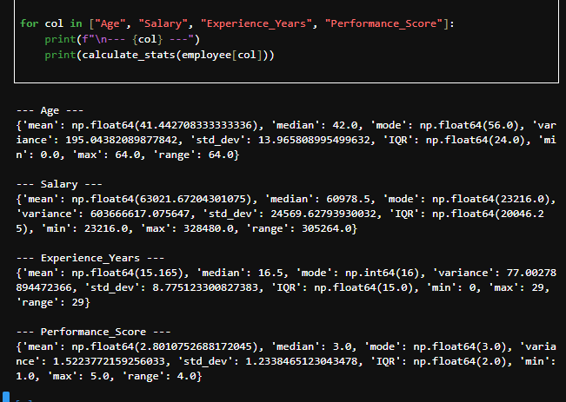Part-II
Plot distributions:
• Histograms
• Boxplots
• KDE (Kernel Density Estimation) plots
Code:
import matplotlib.pyplot as plt
import seaborn as sns

numeric_cols = ["Age", "Salary", "Experience_Years", "Performance_Score"]

for col in numeric_cols:
plt.figure(figsize=(15,4))

#histogram
plt.subplot(1,3,1)
sns.histplot(employee[col], kde=False, bins=10, color="skyblue")
plt.title(f"Histogram of {col}")

# boxplot
plt.subplot(1,3,2)
sns.boxplot(x=employee[col], color="lightgreen")
plt.title(f"Boxplot of {col}")

# KDE plot
plt.subplot(1,3,3)
sns.kdeplot(employee[col], fill=True, color="orange")
plt.title(f"KDE of {col}")

plt.show()
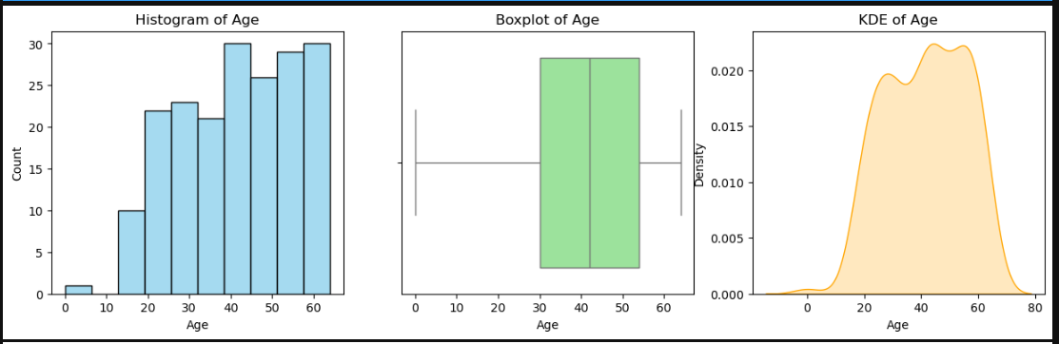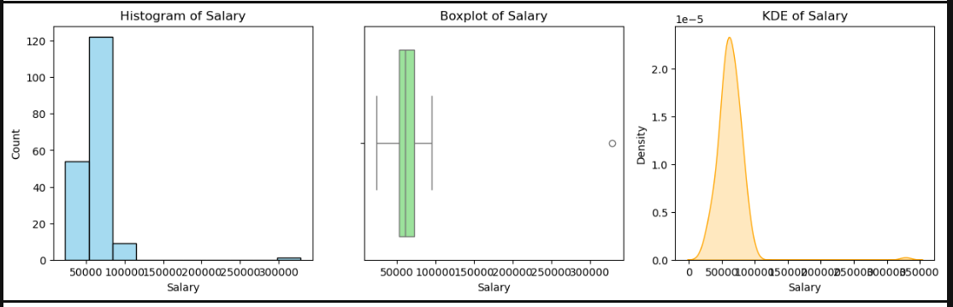
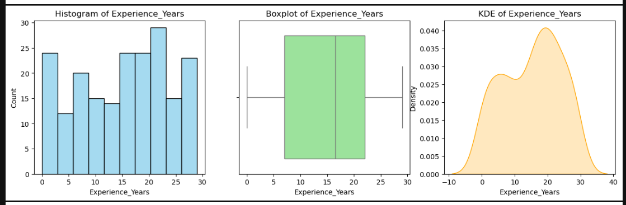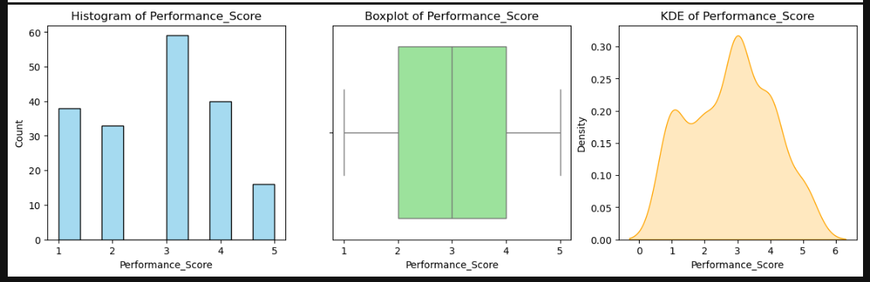
Part-III
Identify which features are skewed and apply transformations (Log / Box-Cox / Yeo-Johnson).
Code:
from sklearn.preprocessing import PowerTransformer

for col in numeric_cols:
skew = employee[col].skew()
print(f"{col}: Skewness = {skew:.2f}")
employee_log = employee[numeric_cols].apply(lambda x: np.log1p(x))

pt_boxcox = PowerTransformer(method="box-cox", standardize=False)
pt_yeo = PowerTransformer(method="yeo-johnson", standardize=False)

employee_yeo = pd.DataFrame(pt_yeo.fit_transform(employee[numeric_cols]),
columns=[c+"_yeo" for c in numeric_cols])
print("\nAfter Yeo-Johnson Transformation (first 5 rows):")
print(employee_yeo.head())
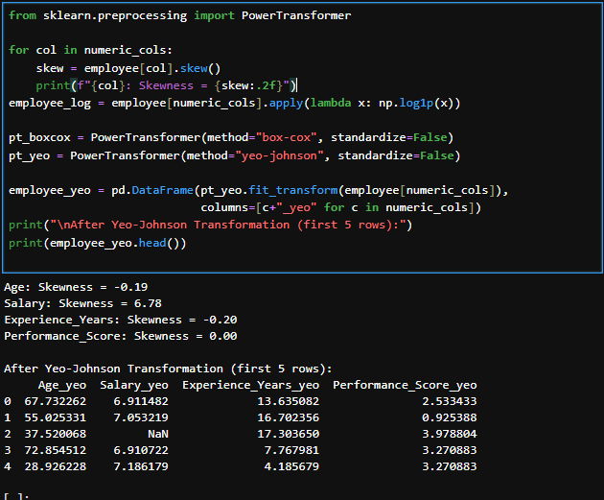

*--(Question-04)--*
Part-I
Code:
avg_salary_dept = employee.groupby("Department")["Salary"].mean()
print("Average Salary per Department:\n", avg_salary_dept)
avg_perf_gender = employee.groupby("Gender")["Performance_Score"].mean()
print("\nAverage Performance Score per Gender:\n", avg_perf_gender)
exp_stats_location = employee.groupby("Work_Location")["Experience_Years"].agg(["min", "max", "mean"])
print("\nExperience Stats per Location:\n", exp_stats_location)
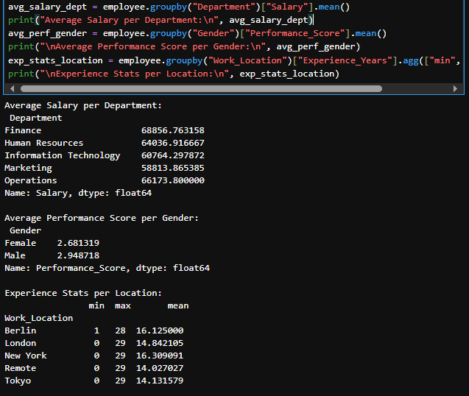
Part-II
Code:
summary_stats = employee.groupby("Department").agg({
"Salary": ["mean", "median", "std"],
"Age": ["mean", "median", "std"]
})
print("\nSummary Table for Salary & Age by Department:\n", summary_stats)
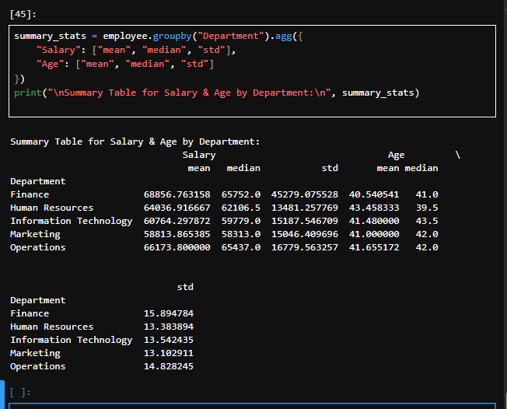
Part-III
Code:
pivot_salary = pd.pivot_table(employee,
values="Salary",
index="Department",
columns="Gender",
aggfunc="mean")
print("\nPivot Table - Avg Salary by Department & Gender:\n", pivot_salary)

pivot_perf = pd.pivot_table(employee,
values="Performance_Score",
index="Department",
columns="Work_Location",
aggfunc="mean")
print("\nPivot Table - Avg Performance Score by Department & Location:\n", pivot_perf)
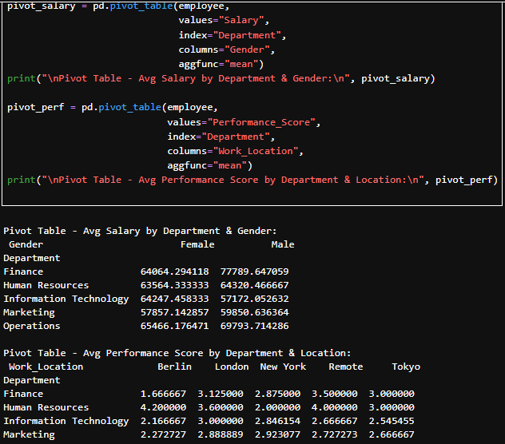

*--(Question-05)--*
Part-I
Code:
from sklearn.preprocessing import LabelEncoder, OneHotEncoder
import pandas as pd

# --- Before encoding ---
print("Shape before encoding:", employee.shape)

le = LabelEncoder()
employee["Gender_Label"] = le.fit_transform(employee["Gender"])
# Male=1, Female=0

employee_encoded = pd.get_dummies(employee, columns=["Department"], prefix="Dept")

# --- After encoding ---
print("Shape after encoding:", employee_encoded.shape)
print(employee_encoded.head())
output:
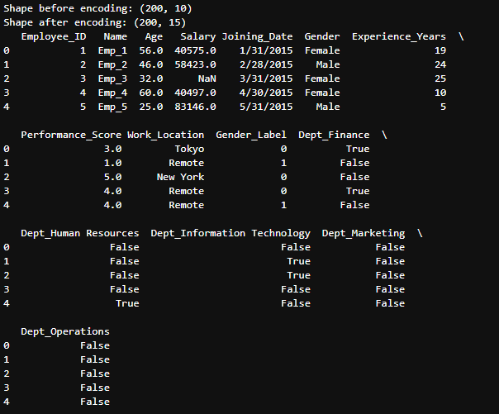
Part-II
Code:
from sklearn.preprocessing import MinMaxScaler, StandardScaler, RobustScaler
# Select numerical columns
num_cols = ["Age", "Salary", "Experience_Years"]
minmax = MinMaxScaler()
standard = StandardScaler()
robust = RobustScaler()

employee_scaled = employee_encoded.copy()
employee_scaled[["Age_MinMax", "Salary_MinMax", "Exp_MinMax"]] = minmax.fit_transform(employee_scaled[num_cols])
employee_scaled[["Age_Std", "Salary_Std", "Exp_Std"]] = standard.fit_transform(employee_scaled[num_cols])
employee_scaled[["Age_Robust", "Salary_Robust", "Exp_Robust"]] = robust.fit_transform(employee_scaled[num_cols])

Part-III
Code:
comparison = employee_scaled[["Age", "Salary", "Experience_Years",
"Age_MinMax", "Salary_MinMax", "Exp_MinMax",
"Age_Std", "Salary_Std", "Exp_Std",
"Age_Robust", "Salary_Robust", "Exp_Robust"]].head()

print("\nOriginal vs Scaled Values:\n", comparison)
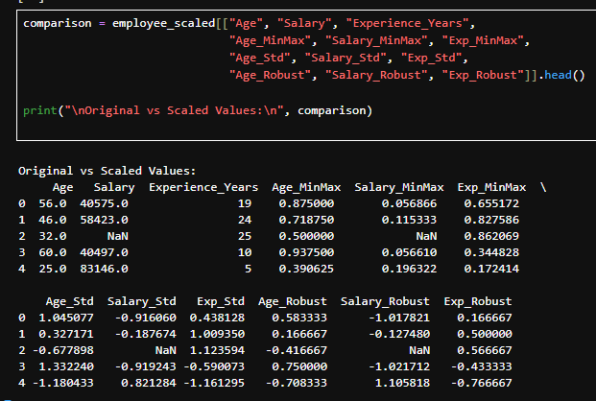
*--(Question-06)--*
Part-I
Code:
Set Employee_ID:
employeeTrainingData["Employee_ID"]=employeeTrainingData["Employee_ID"].str.replace("E","").astype(int)
Merge the datasets:
merged_df = pd.merge(employee, employeeTrainingData, on="Employee_ID", how="inner")

Output:
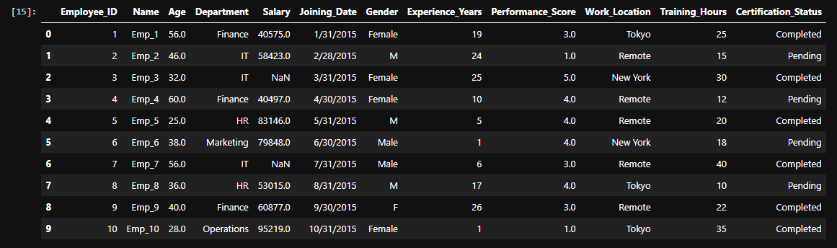
Part-II
Code:
merged_df["Salary_per_TrainingHour"] = merged_df["Salary"] / merged_df["Training_Hours"].replace(0, 1)
Output:
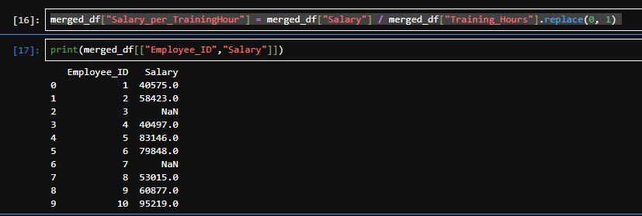

Part-III
Code:
salary_comparison = merged_df.groupby("Certification_Status")["Salary"].agg(["mean", "median", "count"])
Output:
