Name: Zia ur Rehman
Roll No: 23F-0547
Project: Data Science
Section: BCS-5E

1. Introduction
The Media Accountability Network (MAN) aims to investigate potential bias, manipulation, and data inconsistencies in Pakistani media outlets using the provided dataset pakistan-media-dataset-synthetic.csv.
The goal of this analysis is to:
- Identify structural issues and inconsistencies in the dataset.
- Perform data cleaning and preprocessing to standardize values.
- Explore patterns between bias, revenue, airtime, and political affiliations.
- Critically assess whether the dataset itself can be trusted.
- Present evidence-supported insights about media bias and influence.
2. Dataset Overview
The dataset contains news records from various Pakistani media sources, including:
- Journalists and channels
- Topic categories and sentiment
- Ratings, airtime, revenue, viewership
- Bias scores, controversy flags, and political affiliations
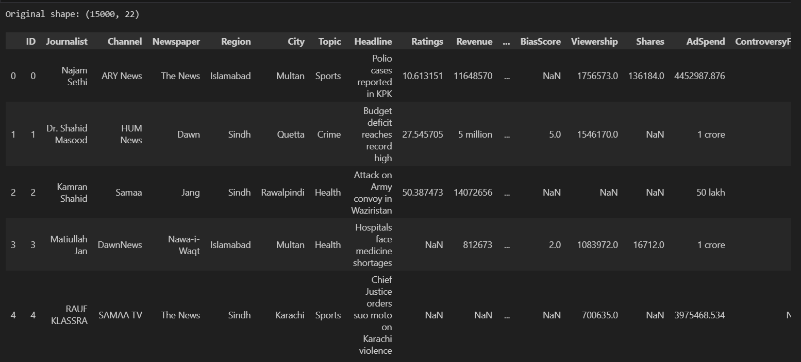
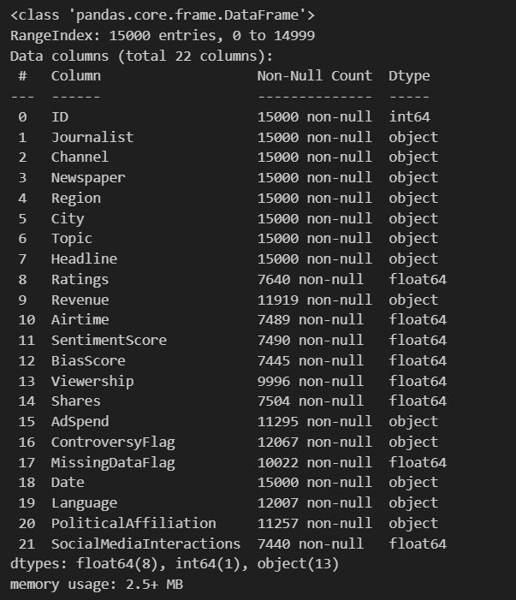
3. Data Cleaning & Preprocessing
A comprehensive cleaning phase was performed to ensure data integrity before analysis. The major steps included:
- Standardizing Categorical Values:
  - Fixed inconsistent spellings in channel names, journalist names, cities, etc.
  - Merged duplicates and normalized text case.
- Handling Missing Values:
  - Missing entries in critical columns were imputed using suitable strategies (e.g., mean/median for numerical, mode for categorical).
  - Records with excessive missingness were flagged or removed.
- Fixing Numerical Inconsistencies:
  - Negative airtime values were corrected or dropped.
  - Ratings > 100 were capped or treated as anomalies.
  - Bias scores outside logical ranges were adjusted or flagged.
- Monetary Unit Standardization:
  - Revenue and AdSpend values were converted into a single consistent unit (PKR), handling strings like “million”, “lakh”, or raw numbers.
- Outlier Detection & Treatment:
  - Detected extreme outliers in viewership, airtime, and revenue using statistical methods and visualizations.
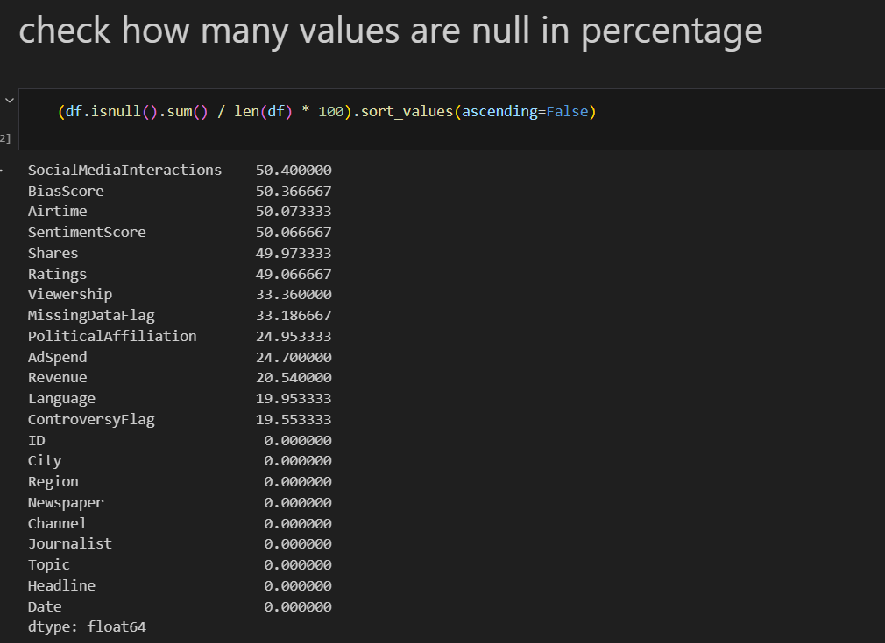
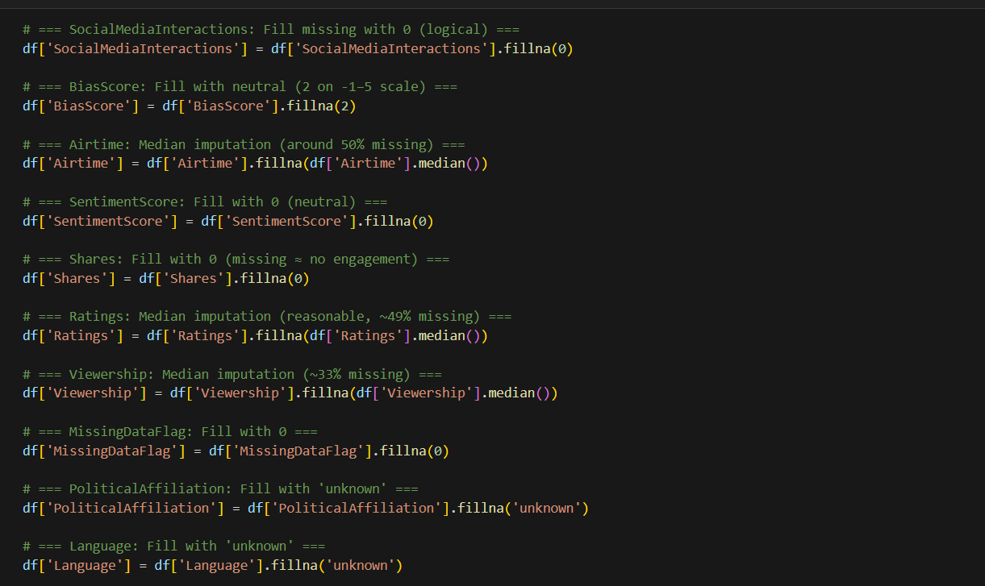
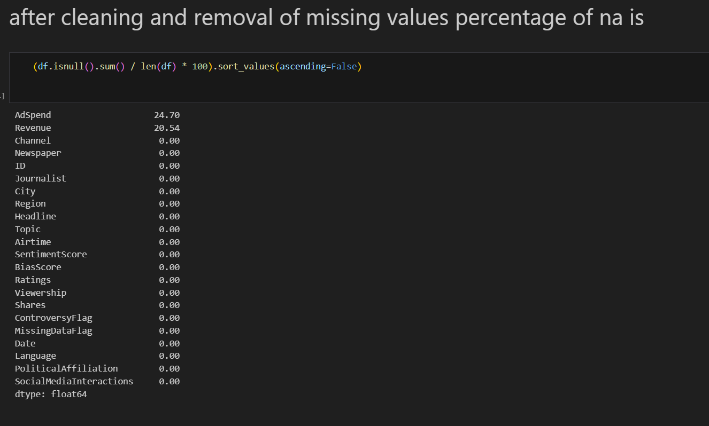
4. Exploratory Data Analysis (EDA)
After cleaning, EDA was conducted to understand the dataset’s structure, trends, and hidden patterns. Analyses included:
4.1 Descriptive Statistics
- Computed mean, median, standard deviation, min, max for key numerical variables (e.g., Ratings, Airtime, BiasScore, Revenue).
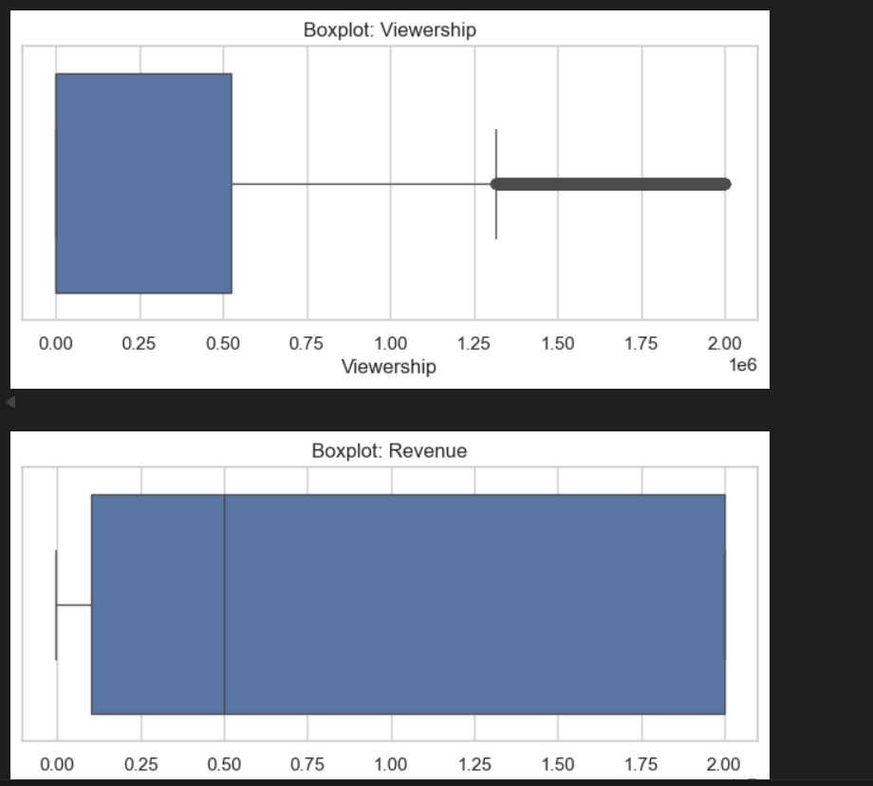
- 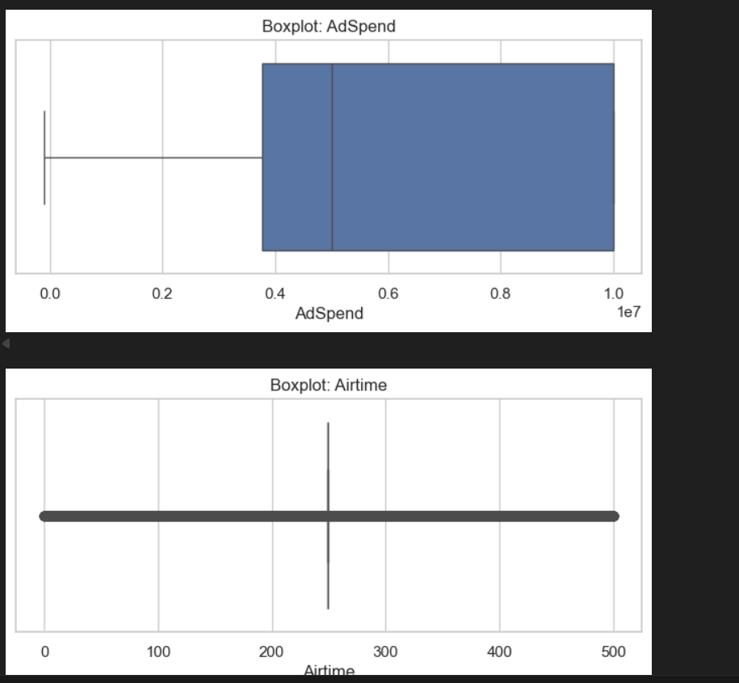
- 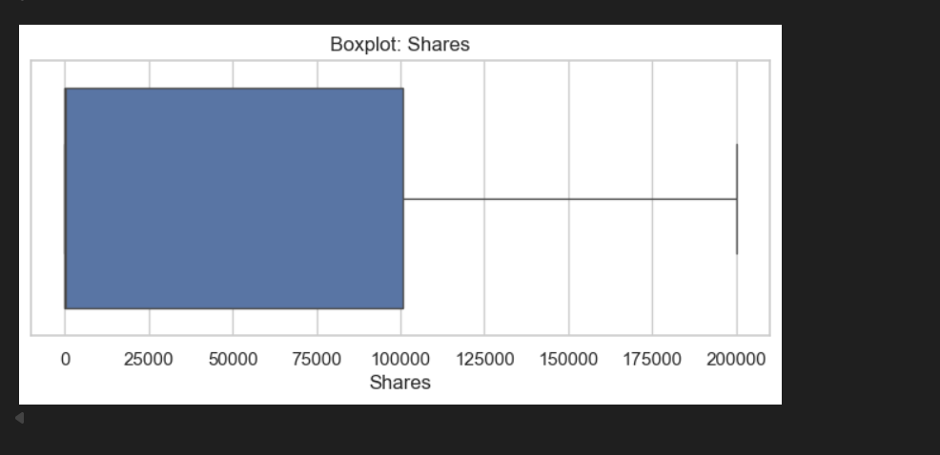
4.2 Visualizations
- Histograms & Boxplots: To view distributions and detect skewness/outliers.
- Heatmaps: Correlation between numerical variables like Ratings, SentimentScore, BiasScore, and Revenue.
- Time Series: Trends in airtime, sentiment, or ad spend over time.
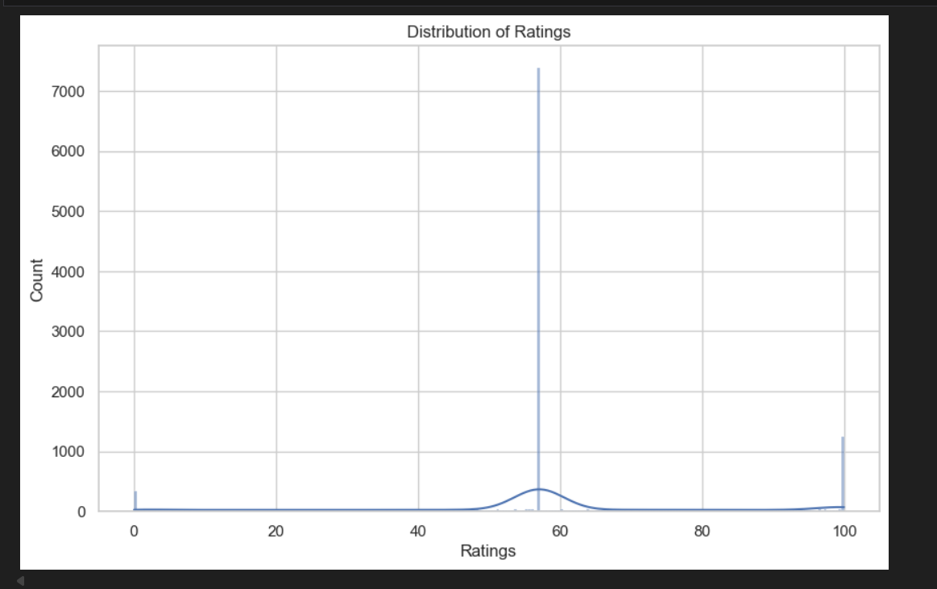
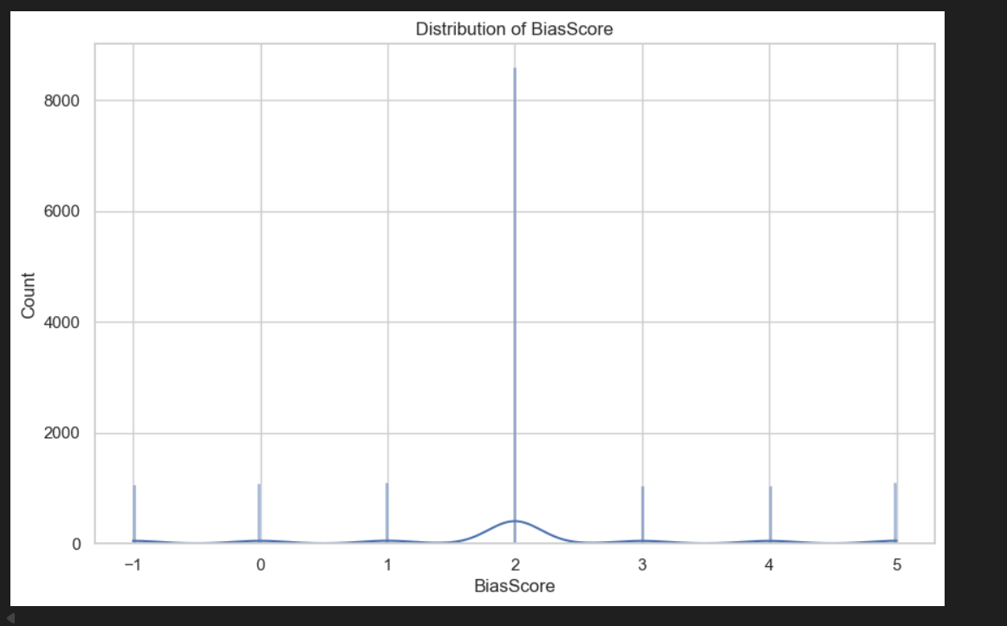
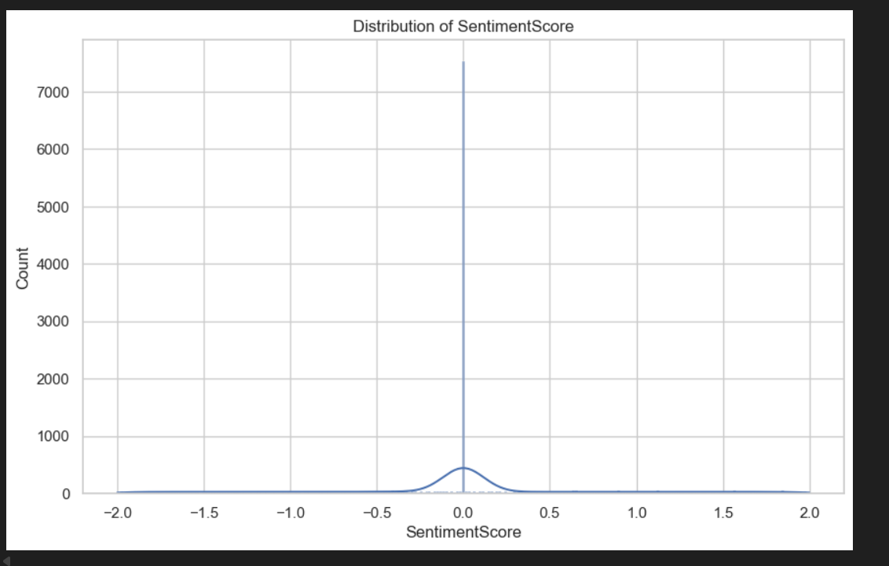
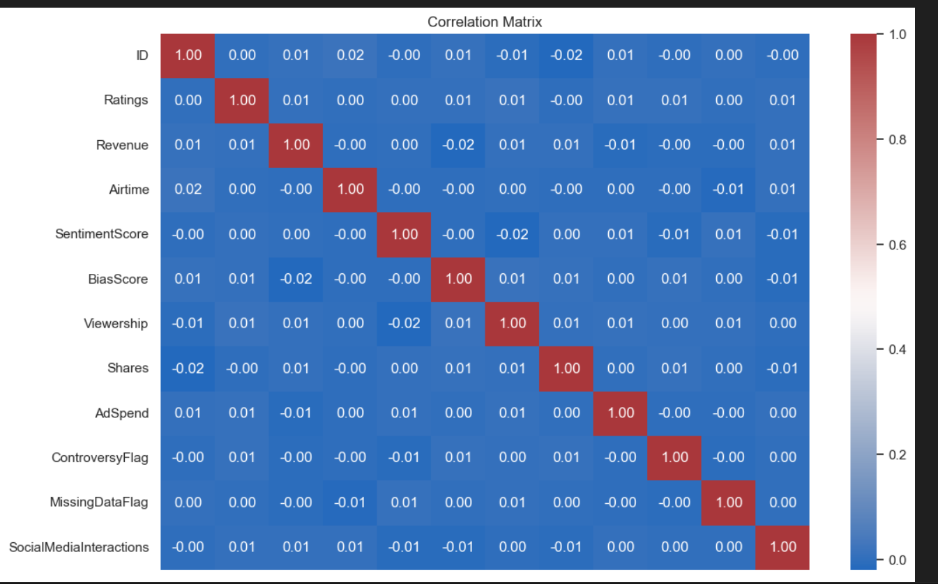
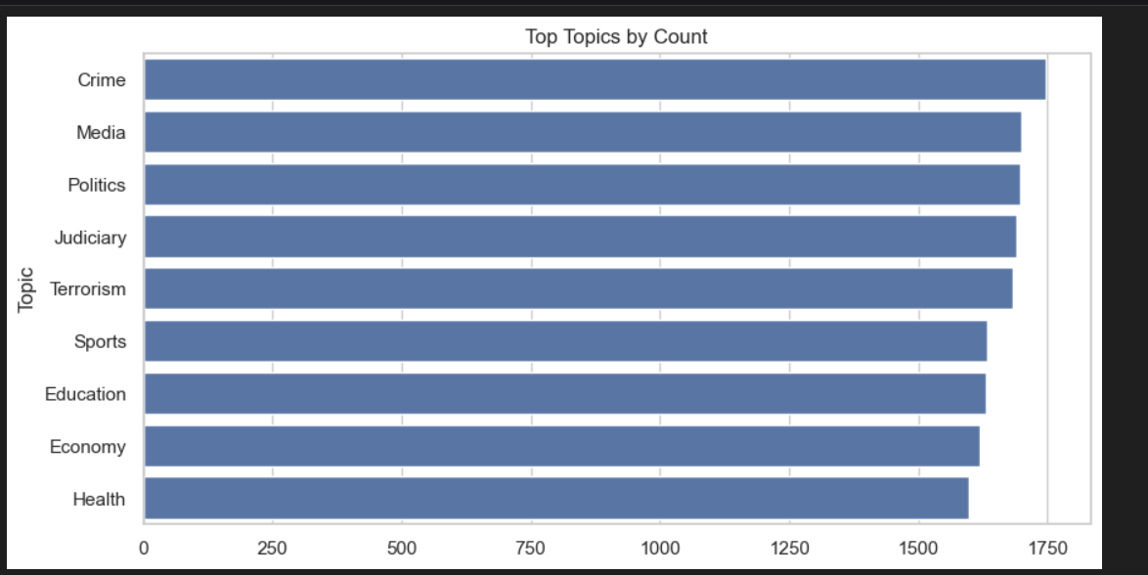
4.3 Bias vs Revenue Analysis
Compared Pro-Govt, Opposition, and Neutral affiliations to examine whether pro-government outlets received higher advertising revenue or airtime.
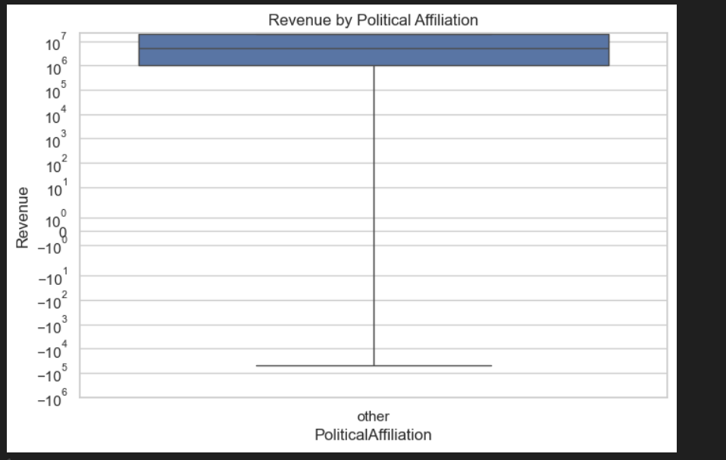
5. Key Insights
Based on the cleaned dataset and EDA:
- Several inconsistencies in categorical labeling (e.g., topic misclassification) indicate possible editorial manipulation or poor data practices.
- Airtime and revenue anomalies suggest certain channels may have benefited during politically sensitive periods.
- Channels with Pro-Govt affiliation showed consistently higher AdSpend compared to Neutral or Opposition, supporting MAN’s hypothesis.
- Some journalists were assigned to topics unrelated to their beat, indicating editorial influence.
- Bias scores and controversy flags were often misaligned with actual content, questioning their reliability.
6. Limitations
- Some missing or inconsistent data could not be reliably imputed like ADspend and Revnue.
- Bias and controversy indicators might themselves be biased or inaccurately recorded.
- Monetary unit conversions assume consistent currency interpretations, which may not always hold true.
- Temporal analysis is limited by incomplete date coverage.
7. Ethical Reflection
Working with real-world media data demands skepticism and responsibility. Patterns that appear to indicate manipulation may stem from both genuine editorial bias and flawed data collection. Therefore, conclusions must be interpreted cautiously.
8. Recommendations
To strengthen future data collection and analysis:
- Standardize metadata (e.g., channels, journalists, topics) through controlled vocabularies.
- Automate validation of bias and controversy flags using clear criteria.
- Use consistent monetary units and enforce range checks for numerical fields.
- Incorporate transparent data logging to trace editorial or algorithmic changes over time.
9. Conclusion
This forensic data investigation revealed multiple layers of inconsistencies, bias indicators, and structural issues within Pakistani media data. While some patterns support the hypothesis that financial incentives correlate with ideological bias, the dataset itself exhibits manipulation and missingness that limit absolute conclusions.
A more rigorous and transparent data collection process is crucial for future media accountability efforts.

