App 4
The Beatles

Overview

The Beatles music is available at iTunes, and App4 is dedicated to The Beatles. This app should utilize the following Controller classes:

UIViewController
UITableViewController
UINavigationController
UITabBarController

The opening display of this app is shown below
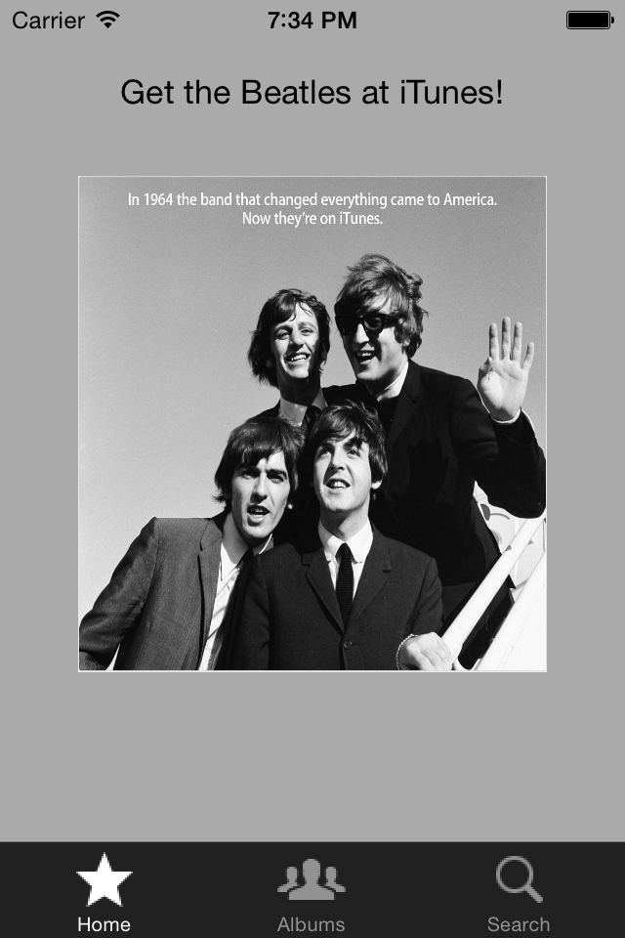
There should be 3 tabs associated with the UITabBarController - Home, Albums, and Search. Only the Home and Albums tabs are required to be implemented for App4. The Search tab will be used for searching for the song titles or song lyrics for a given phrase – we’ll implement this functionality using an sqlite datatabase in a future app. The default white screen can be displayed once the search tab is pressed. Feel free to use different image icons with the tabs, but the following are supplied with App4 (stored in tabBars.zip):
fave.png album.png search.png

You can customize the tab bar with these images (or other images), or even use the built-in System icons if you like. The top-level UIViewController is displayed first and is associated with the Home tab. The intro.jpg image is the first image of the slide show followed by all the album covers as shown below:

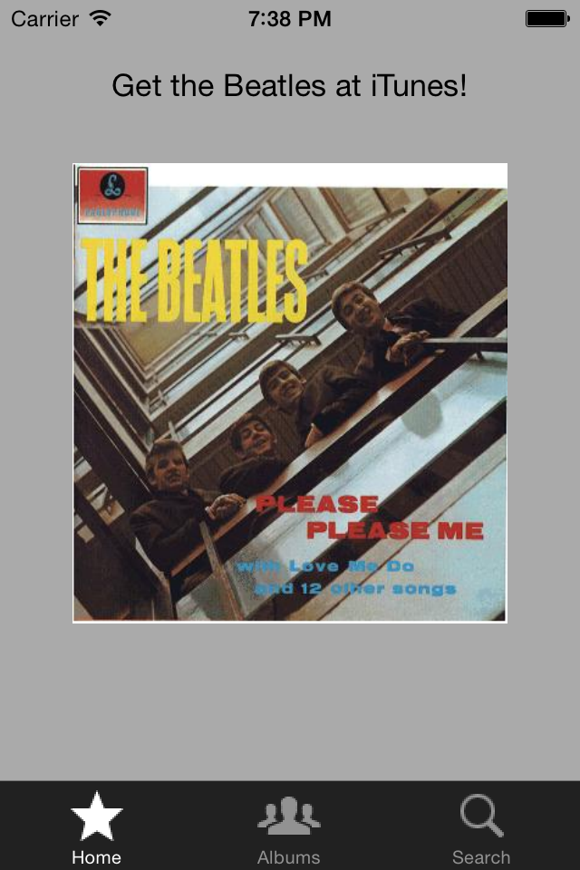
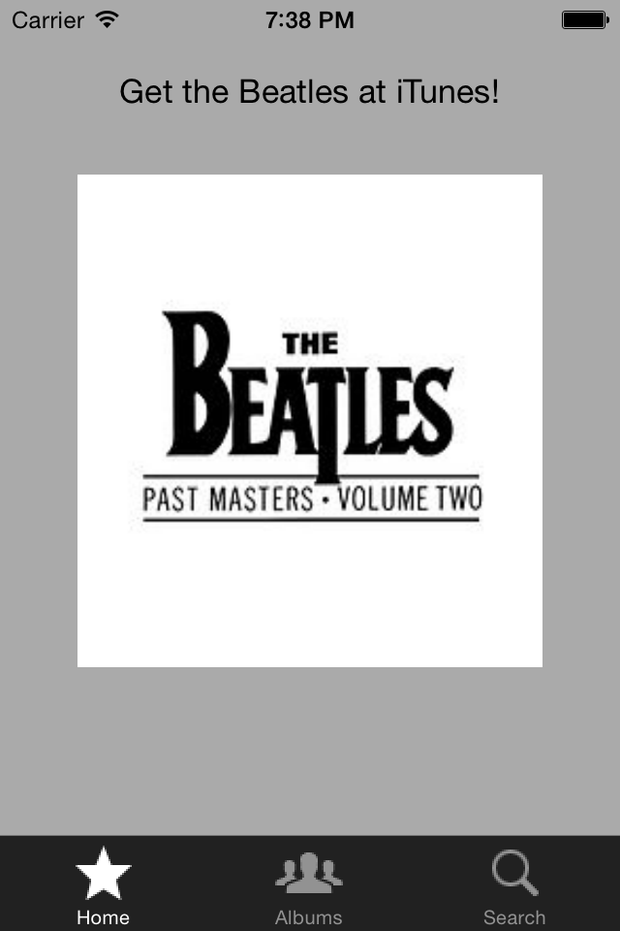
First Album of Slide Show Last Album of Slide Show

The picture intro.jpg is re-displayed after the Last Album (Past Masters Volume II) has been displayed. The slide show repeats indefinitely..
The 16 images are repeated indefinitely.

The album covers used in this app for the slide show are shown below:
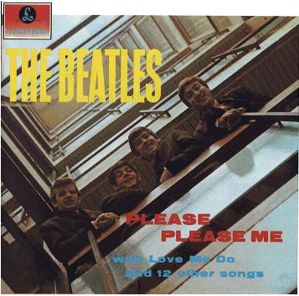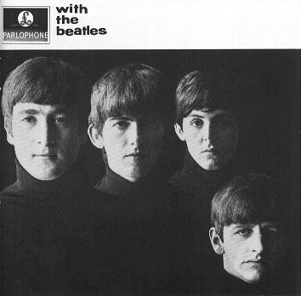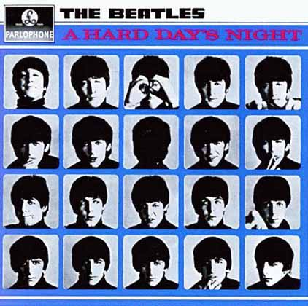
Please Please Me With The Beatles A Hard Day’s Night

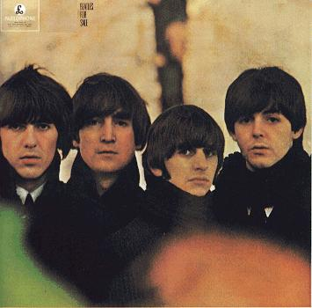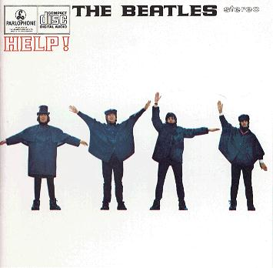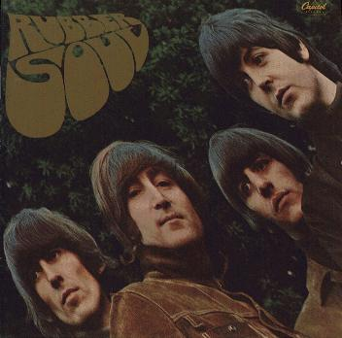
Beatles For Sale HELP! Rubber Soul

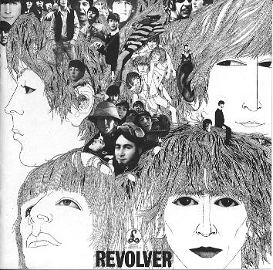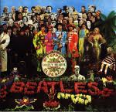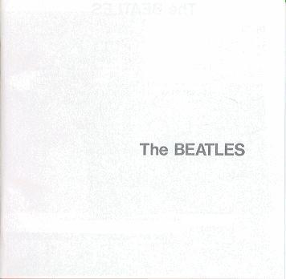
Revolver Sgt. Pepper The White Album

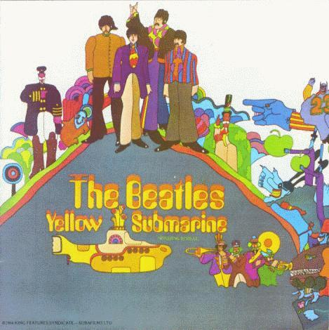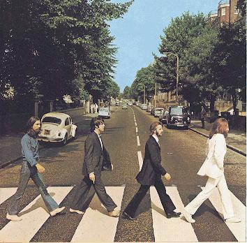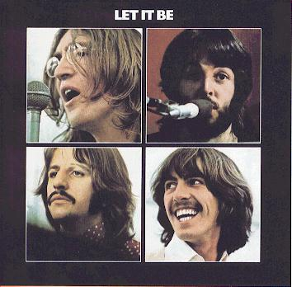
Yellow Submarine Abbey Road Let It Be

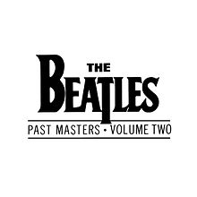
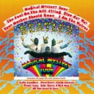
Magical Mystery Tour Past Masters Volume I Past Masters Volume II

These album images are stored in albums.zip.

The following UITableViewController is displayed once the Album tab is pressed:

All Album names, their release date, their album cover, and accessory disclosure button is displayed within each cell.

The remaining albums can be accessed by scrolling. The remaining albums are shown below:

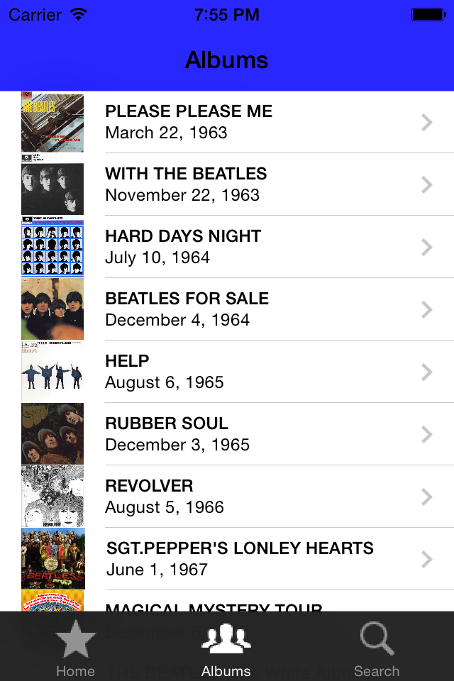
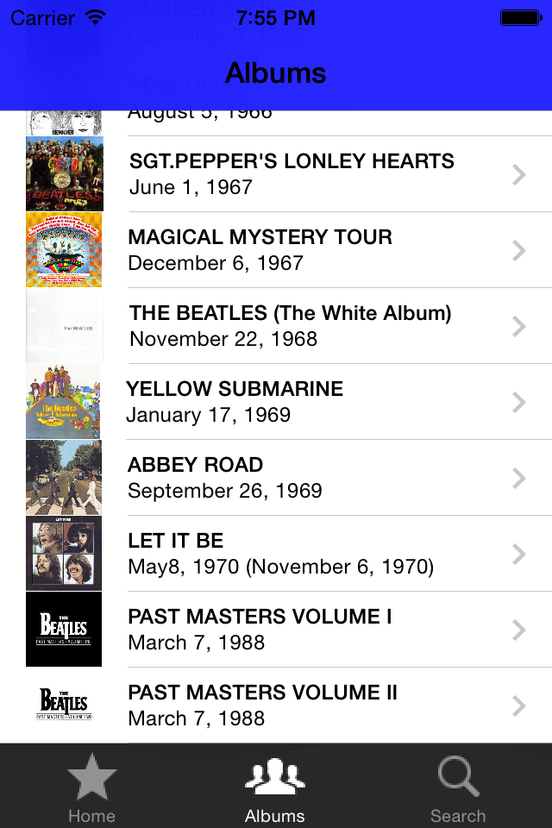

Selecting a given cell (e.g., Album) will display all the songs for that album. Suppose the first cell labeled with album Please Please Me is selected. All the songs on this album are then displayed in the next UITableViewController as shown below:
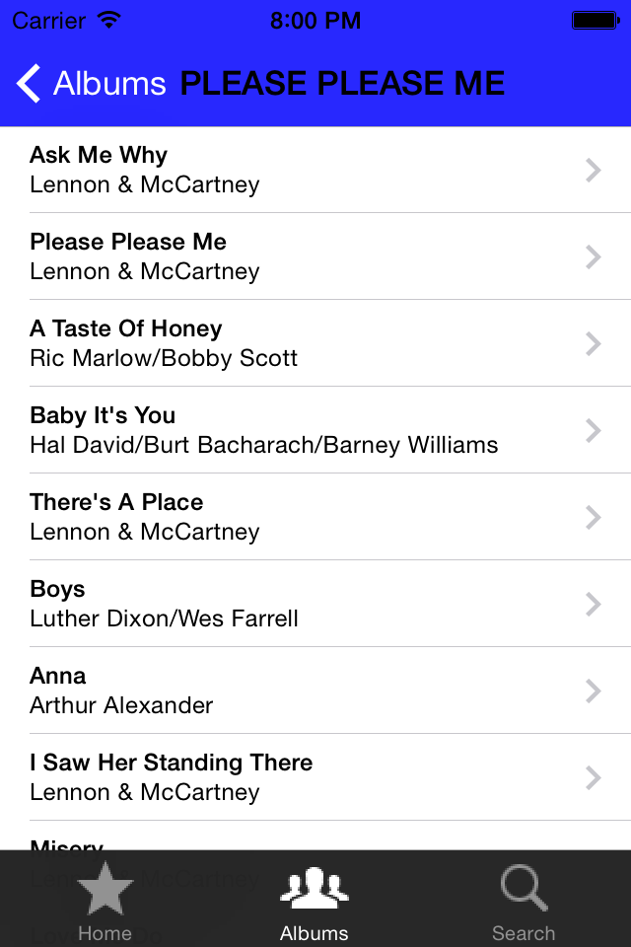

Pressing a given song cell in the display above will perform the following operations:

- Search the youTube website for the best matching music video for the selected song that has the most views (You will need to use the YouTube API in order to do this).

- Display a viewController/view and UIWebView that allows the user to play the best matching video.

- The song title is displayed in a label beneath the video

The best matching music video is defined as the one that:

- Has the name of the artist (i.e., “The Beatles”) in the title of the youTube video and
- Also has the name of the song in the title

You will need to do additional processing on the list from the YouTube API in order to detect the best matching video.

Because Sony has removed many videos from YouTube, a Cover Video may be the best matching video in some cases.

An example of the view that is displayed after pressing “Please Please Me” is shown below:
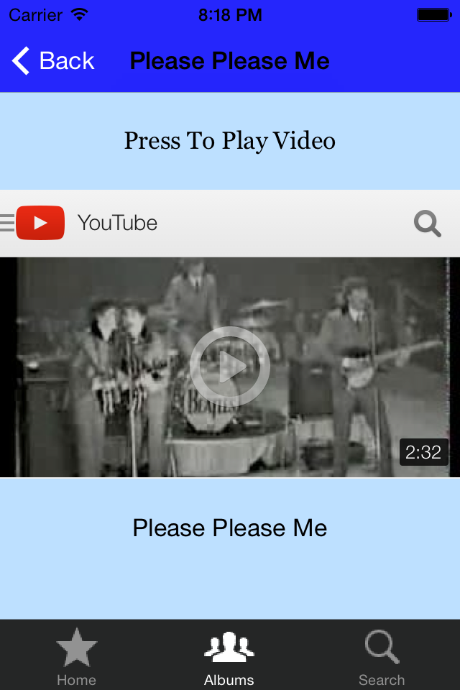

UILabel

UIWebView

UILabel

Pressing the button provided by YouTube results in the playing of the video in the YouTube player provided by the iOS. The user will have the option to stop the video by pressing the “Done” button that is displayed by the YouTube player. The user will then have the option of pressing the back button and selecting a different song or album.

Pressing the left (Back) button will redisplay the previous screen showing all songs of Please Please Me.

The user can now press a different song (cell) and the video for that song will be displayed. Pressing the left button (Albums) will return to the previous UITableViewController showing all the albums again.

The user can now select any displayed album, which will display all songs for that album (in the form of a UITableView). The user can then select any song of that selected album and the video for that song will be played.

In other words:

All 15 albums are displayed.
All songs for each album are displayed when a specific album selected
The video for a given song is displayed when the song is selected.

Data Files

The following 16 data files are stored in data.zip.

A file named albums.plist. It is written as an NSDictionary. The dictionary has as a key the name of the album while the value has the producer of the album, the release date of the album, and the file name of the album image.
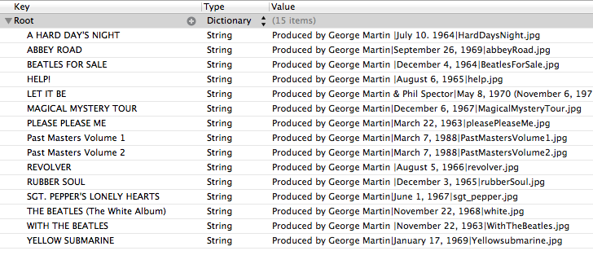

The album name (as extracted from the NSDictionary keys) is used to create 15 separate files containing the song list for each album. The format for the file name is

AlbumName_songs.plist

Where AlbumName is the name of the album as shown above. The spaces are replaced with underscores “_” .

An example of BEATLES_FOR_SALE_songs.plist is shown below:
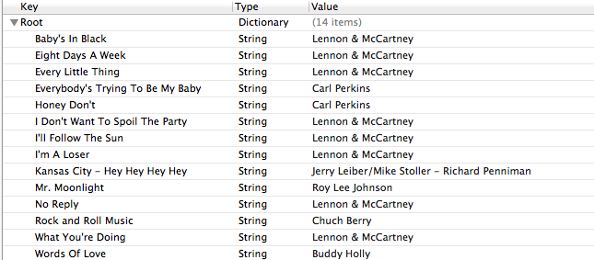

The key is the song’s tile, while the value is the composer. There are 15 files containing the song list for each album.

What you Submit

You should name your Xcode project TheBeatles. Zip up the entire Xcode project. Submit the zip file via Blackboard. Make sure that all necessary files are included in your project. Please test your project on a Mac in Room 214 or UCA Library to assure that your App runs correctly.

Grading
It’s important to provide the core functionality of the App as specified in this document. You will not be graded on how identical your App’s is to the example. Feel free to use different backgrounds, different options, and different layouts too if you like.

