App 3
Internet TV App

Overview

The purpose of this App is to allow the playing of Internet Television channels as selected and configured by the user. A list of initial Internet Television station callLetters followed by the corresponding streaming video URLs are provided below:

Station Call Letters
"France24","MLB","The Blaze","Weather","ABC","CBS", "Free Speech", "Travel", "SECDN", "Daytona", "HouseTV","ROKU","Orange County", "Seminole County",
"University of Texas", "Temple University","University of California"

Streaming Video URLs
http://static.france24.com/live/F24_EN_LO_HLS/live_web.m3u8
http://cmctv.ios.internapcdn.net/cmctv_vitalstream_com/live_1/CMCUSA/CCURstream0.m3u8
http://mlblive-akc.mlb.com/ls01/mlbam/mlb_network/NETWORK_LINEAR_1/MLB_VIDEO_MLBN_FAUX_LINEAR_STREAM_1_MLB_Network_Linear_Stream_Tuesday_20170704_1499230681478/2400K/2400_slide.m3u8
https://theblaze.global.ssl.fastly.net/live/theblaze/master.m3u8
http://weather-lh.akamaihd.net/i/twc_1@92006/master.m3u8
http://abclive.abcnews.com/i/abc_live4@136330/master.m3u8
http://cbsnewshd-lh.akamaihd.net/i/CBSNHD_7@199302/master.m3u8
https://edge.free-speech-tv-live.top.comcast.net/out/u/fstv.m3u8
http://media4.tripsmarter.com:1935/LiveTV/ACVBHD/chucklist.m3u8
http://na-all15.secdn.net/pegstream3-live/play/c3e1e4c4-7f11-4a54-8b8f-c590a95b4ade/playlist.m3u8
http://oflash.dfw.swagit.com/live/daytonabeachfl/smil:std-4x3-1-a/chucklist.m3u8
http://video.oct.dc.gov/out/u/DCN.m3u8
http://d3ktuc8v2sjk6m.cloudfront.net/livetv/ngrp:HouseChannel_all/chucklist.m3u8
http://173.199.158.79:1935/roku/myStream/playlist.m3u8
http://otv3.ocfl.net:1936/OrangeTV/smil:OrangeTV.smil/chunklist_w1007974604_b894100_sleng.m3u8
http://video.seminolecountyfl.gov:1935/live/SGTV/chunklist.m3u8
http://tstv-stream.tsm.utexas.edu/hls/livestream_hi/index.m3u8
http://streaming.temple.edu/tutvlive/_definst_/mp4:play/chunklist.m3u8
http://diffusionm4.assnat.qc.ca/canal9/250.sdp/playlist.m3u8

//All of these URLs were functional as of Monday, October 1st 2018.

The App will also allow the user to add channels as desired (no limit to the number of channels is specified).

The App is to be implemented using the TabBarController as shown below:
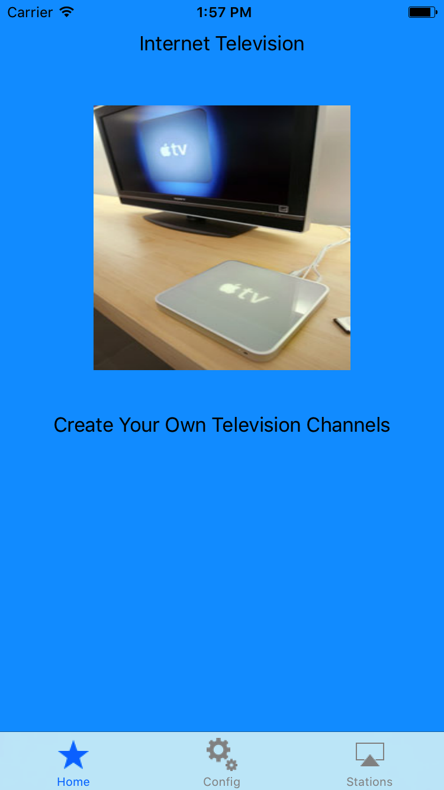

Slide Show consists of home.png, image1.png, image2.png

First view displayed by App

The 1st (leftmost) tabbar item should be a custom tab bar item called Home
The middle tabbar item should be a custom tab bar item named Config
The last (rightmost) tabbar item should be a custom tab bar item named Stations

The following images (stored in tabbarimages.zip) contain the images that you can build the tab bar with:
28-star.png 20-gear2.png viewer-7.png
Home Config Stations

The HomeController

The 1st View9Controller displayed by the TabBarController should be named HomeController. The HomeController should display a slideShow illustrating the following images:
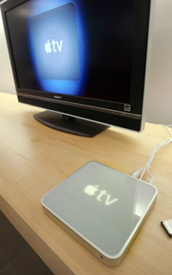


homeimage.png image1.png image2.png

The slideshow should display each image for appx 5 seconds. The slideshow should rotate the 3 images continuously for an indefinite period of time.

Pressing the rightmost button should display the initial set of television channels managed by the StationController viewController. The buttons must be scrollable.

The television station callLetters should correspond to the 1st set of station call letters provided on page 1.

An example screen is shown below:

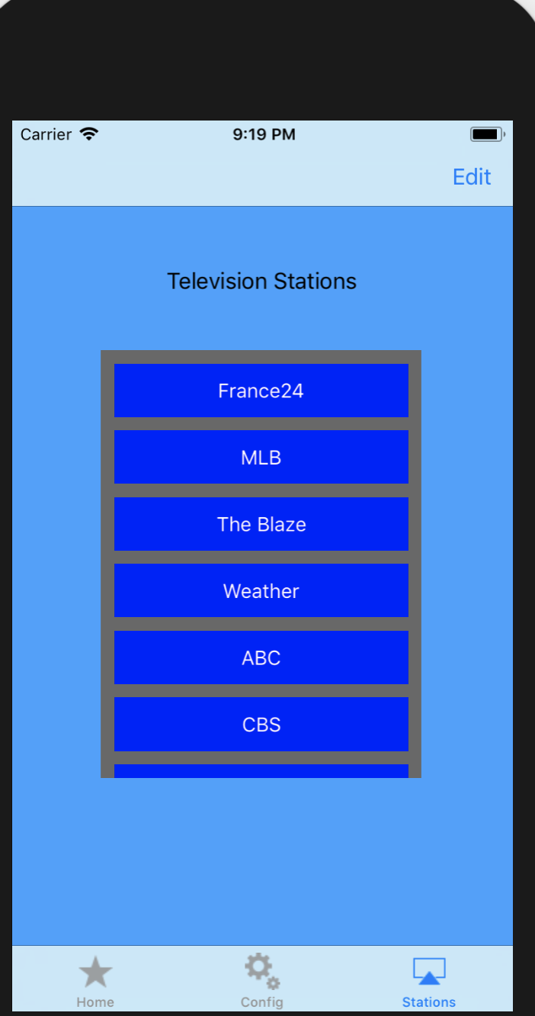
For this example There are more buttons not shown. scrolling will show additionalbuttons – the buttons must be scrollable in both directions)

Pressing any of the buttons shown above will result in an AVPlayerController playing the corresponding URL (shown on page 1) as shown below:

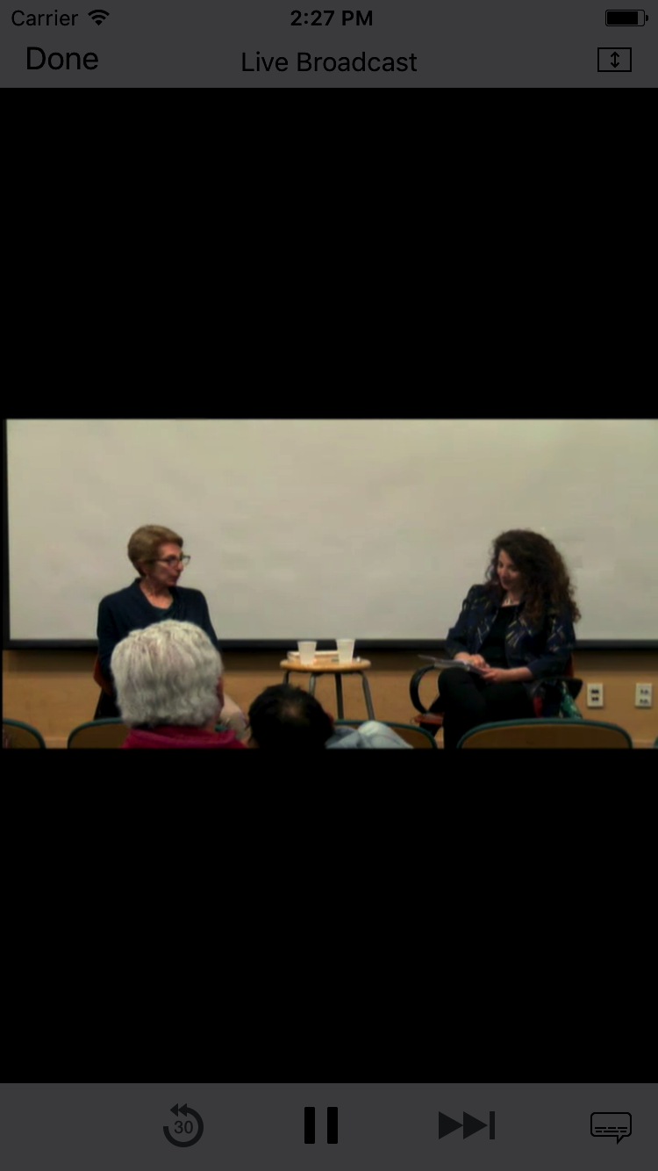
The streaming video/audio will play continuously until the user presses “Done” button. Upon pressing “Done”, the previous viewcontroller (StationController) will be displayed again as shown below:

Pressing the “Edit” button will display the buttons once again as shown below in a viewController named EditController:

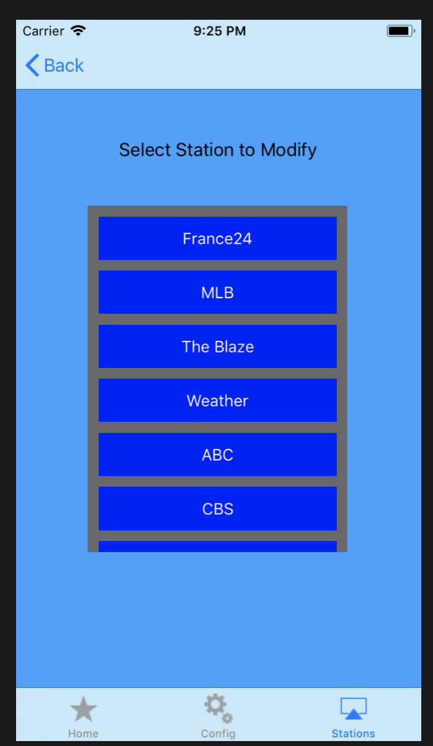

This viewController will allow the user to modify the URL for a given Station Call Letters. Pressing any of the buttons will display another viewcontroller – named ModifyController – that will allow the user to modify the URL that corresponds to the button pressed on the previous display. For example, if the user presses MLB button displayed by the EditController, the following is displayed:

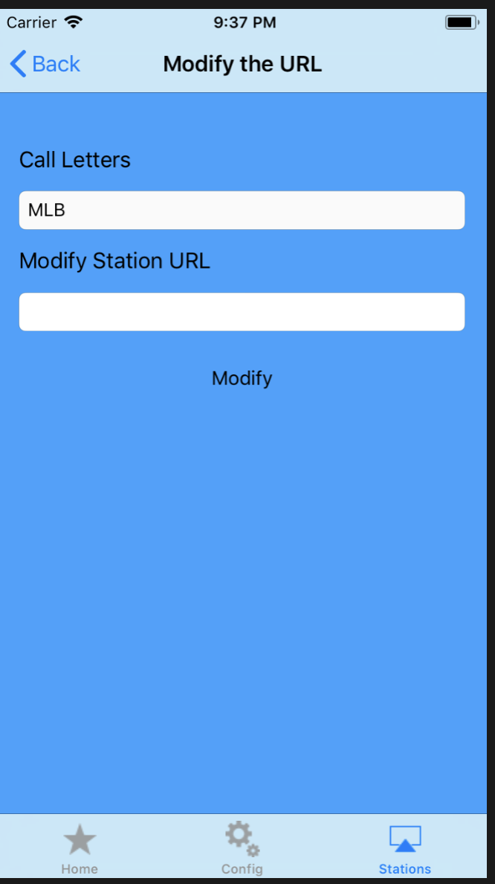
The Station CallLetters are not editable (cannot be modified) and should be displayed in the top text field, while the URL can be modified. The user can enter a new URL and then press the Modify button. Pressing the Back button results in the EditController redisplayed.

Upon pressing the Back button on the EditController results in the StationController being displayed.

Pressing the button on the StationController with the newly associated URL will result in the new URL being invoked. (The new URL will only be used for the duration of the current running of the App (the new URL does not have to be available when the App restarts).

Pressing the middle tab of the tabbarcontroller – named Config – should invoke the ConfigController viewcontroller and display the following view:

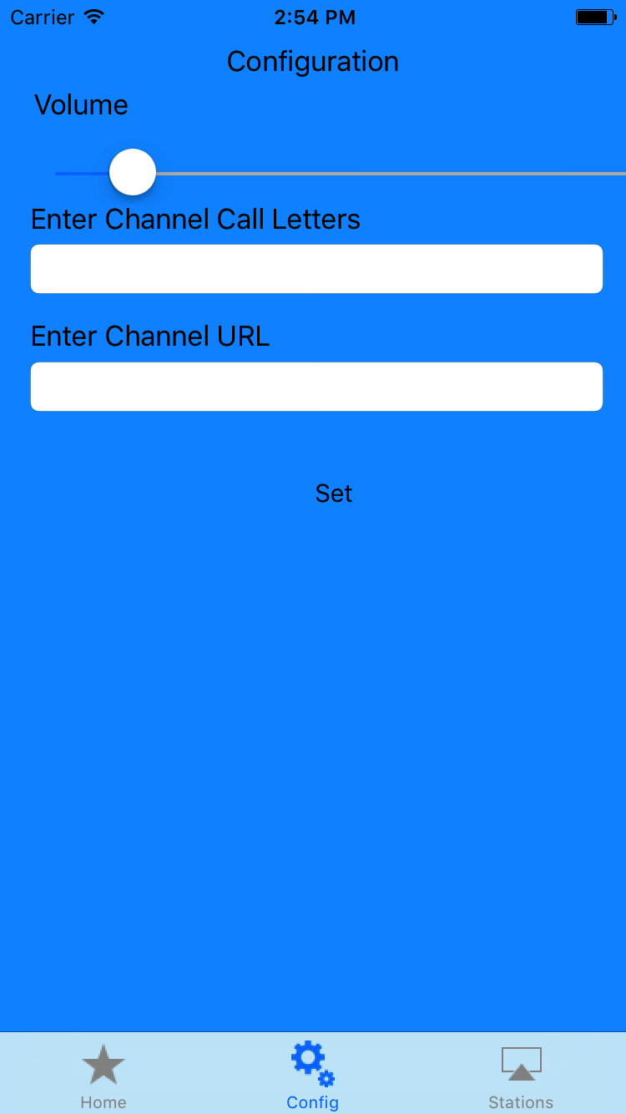

The top slider is for setting the volume of the AVPlayer that will be playing the streaming video. The AVPlayer's volume should be set to this volume before the playing of the internet televison channel (see page 3).

The next 2 text fields correspond to a new Station Call Letters and new URL as entered by the user. For this App, assume that the station call letters and url have not been previously set (i.e., the call letters/urls are not displayed on the StationController view)

The user will be allowed to enter a new Station and URL as shown below:

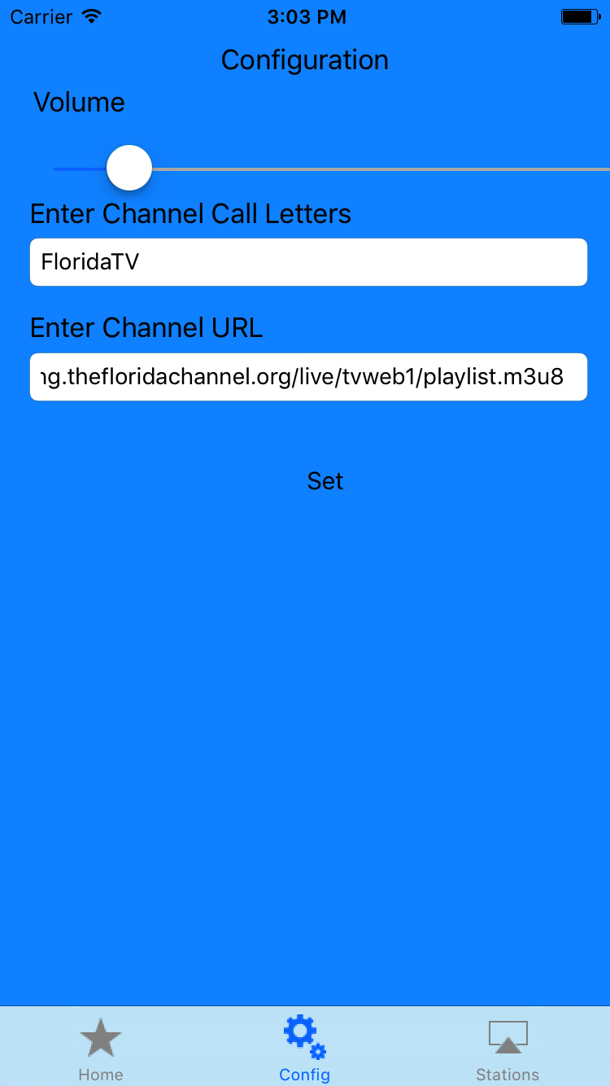
Pressing “Set” means that this new Station/URL combination will be available when the Stations Tab is selected. Pressing the Station tab should result in a new button labeled “FloridaTV” added as the bottom button.

Pressing the newly added station – FloridaTV for this example – will play the new URL. This newly added station/url combination only has to exist for the duration of the current running of this App (it does not have to exist if the App is restarted).

The user can add as many new Stations/URLs as desired. Your app must automatically add a new button to the StationController and EditController. The newly added URL must play.

You will not need to use file storage in any way to implement this App.

What you Submit

Name your Xcode project InternetTelevision. Zip up the entire Xcode project. Additional URLs for testing have been provided.

Grading
It’s important to provide the core functionality – the multi-view App as described. You will not be graded on how exactly similar your App is to mine. Feel free to use different arrangements, different options, and different layouts if you like.

