App 1
Flags of the World

Overview

The purpose of this App is the provide the learning of the different Flags of the World by using the Flash Card method. There are 222 flags utilized by this app, and the flags are stored in two different sets of images labeled as follows:

The 1st set represents the “question images”




inage0.png image1.png image2.png ….. image221.png

While the 2nd set represents the “answer images” as shown below:


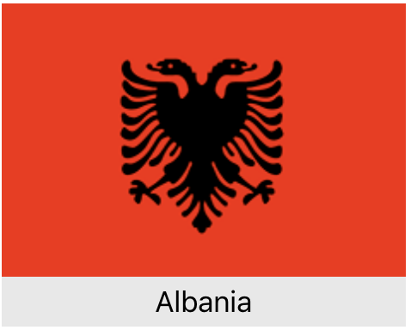

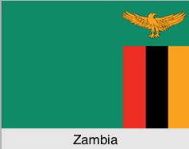
….......
pic0.png pic1.png pic2.png pic221.png

This App must be a Single-View App that should utilize a Storyboard whose example is shown below:

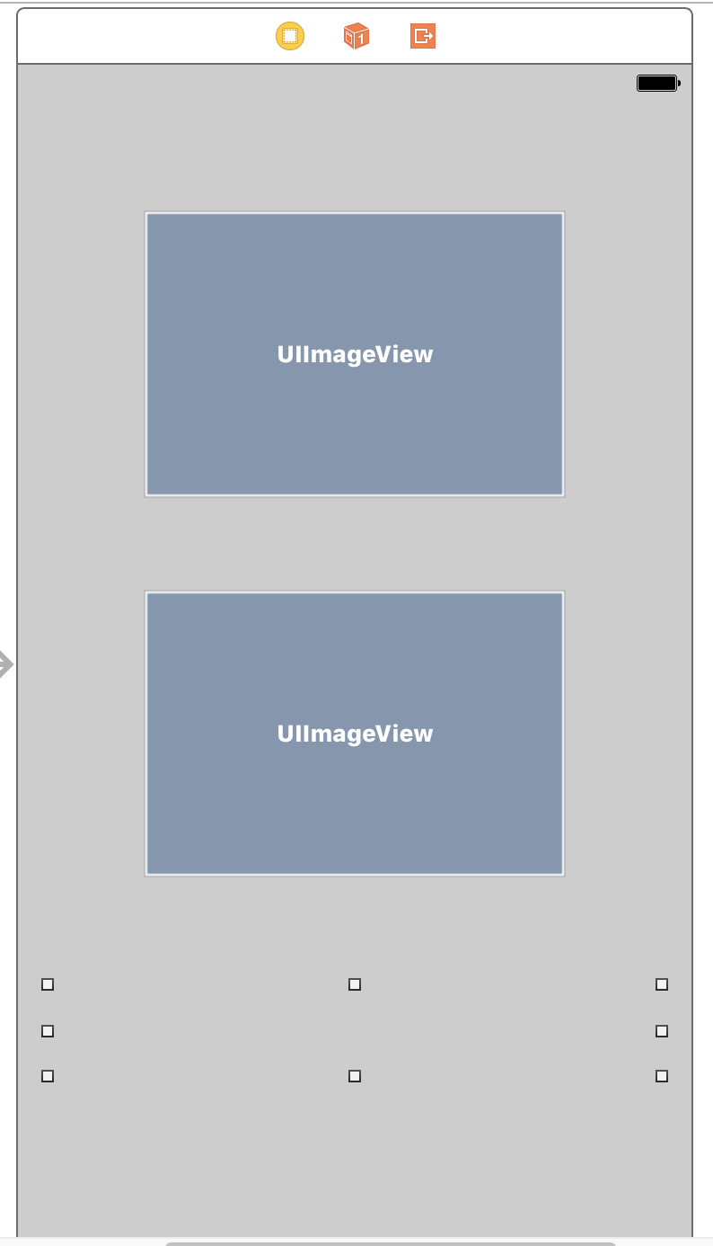
Question image displayed here for appx 10 seconds.

Answer image displayed here for appx 3 seconds. (Should be blank for first 7 seconds)

UILabel for displaying informational messages (empty initially)

Note that the set of question images and answer images are identical except for the name of the country beneath the flag for the answer images. The App will perform the following operations:

- 10 unique flags are selected randomly from the set of question images. A different set of flags must be selected randomly each time the App is invoked.

- The 10 answer images that correspond to the randomly generated question images of step (1) are then selected.

- The App will then display the the 1st of the 10 question images in the top UIImageView while the bottom UIImageView will remain blank. An example of this is show below:

The App should display this 1st question image in the top UIImageView for approximately 7 seconds while the bottom UIImageView remains blank during this time span.

- After the approximate 7 seconds have elapsed, the corresponding answer image is displayed in the bottom UIImageView as shown below:
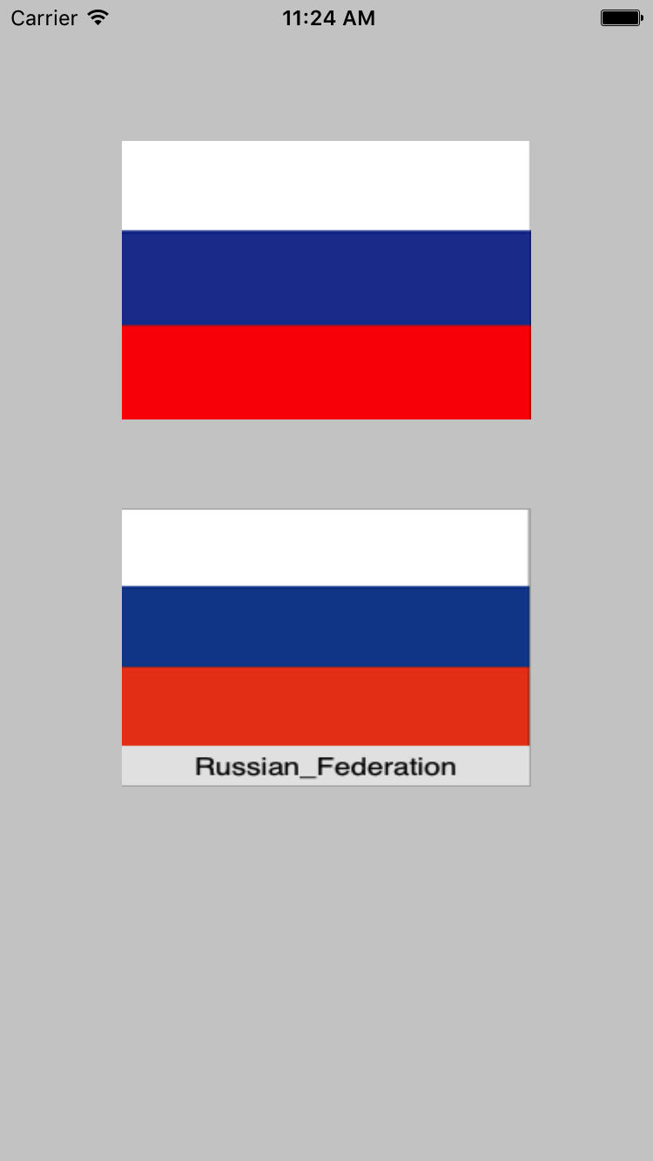
The top UIIMageView should then continue displaying the current question image and the corresponding answer image for approximately 3 more seconds. After 3 seconds the next question image should be displayed as shown in step 5.

- The next randomly generated question image in the top UIImageView should then be displayed along with a blank image in the bottom UIImageView as shown below:

Again the App should display the new question image and the blank bottom UIImageView as shown above for approximately 7 seconds.

- The corresponding answer image along with the new question image are then displayed together for approximately 3 seconds as shown below:
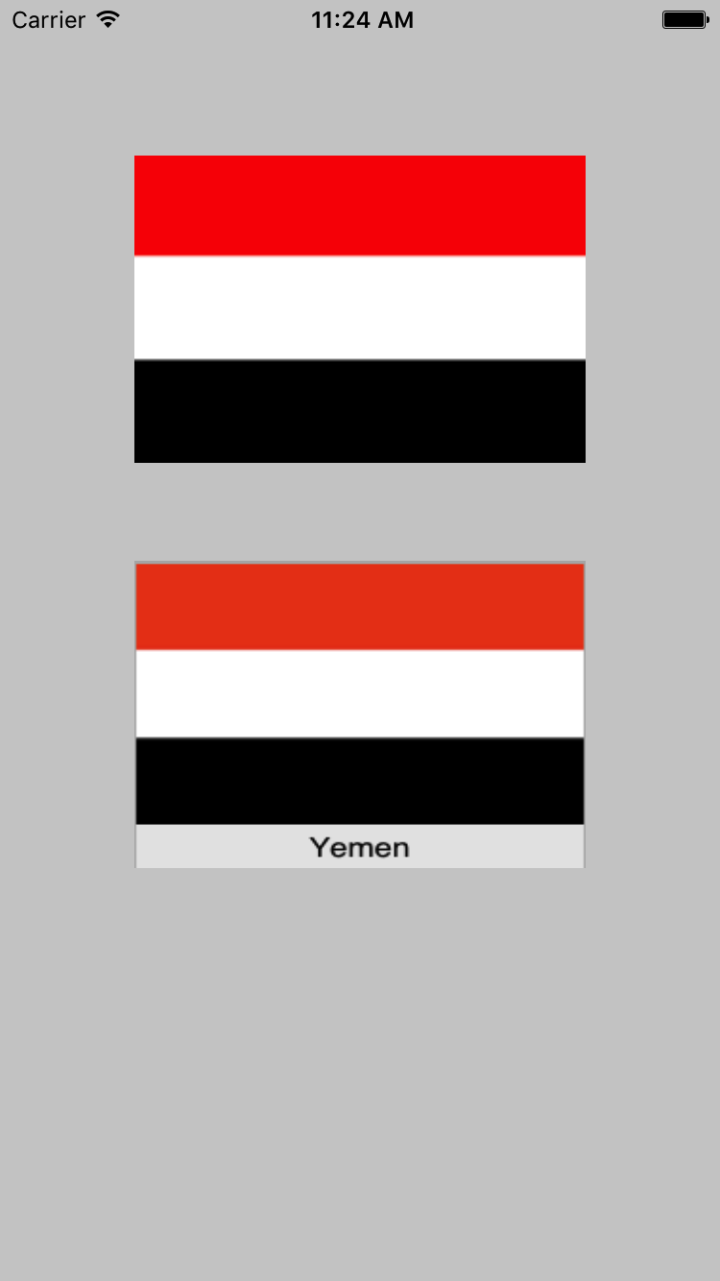
- This process continues until the sequence of all 10 randomly generated question images are displayed followed by its corresponding answer image.

After the last question image/answer image pair is displayed, redisplay the sequence again beginning with the 1st displayed question image/answer image pair. Repeat the sequence continuously forever.

The display of the questionImages can be implemented by a slide show invoked on the top UIImageView. The slide show simply contains the set of 10 randomly generated question images.

The bottom UIImageView which displays the answer images for approximately 3 seconds can also be implemented as a slideShow invoked on the bottom UIImageView. This slide show must contain the corresponding answer images.

Hint: If you display each question image for a total of 10 seconds, the bottom UIImageView's slideShow could utilize a set of blank images (specified by blank.png) to assure that the bottom UIImageView is blank for approximately 7 seconds. This slideShow could then contain 3 answer images to assure that the answer is displayed for 3 seconds. An example of this sequence is shown below:


blank.png blank.png ….. (repeated for 7 images) picXXX.png...(repeat 3 times)

The duration for each slide Show (top UIImageView, bottom UIImageView) should be the same.

Required Class

Quiz //Data (Model) Class

This class manages the image data needed for this App. For this App, the image data pertains to the following:

222 question images of the form image#number.png (#number pertains to an integer number
between 0 and 221)

222 answer images of the form pic#number.png (#number pertains to an integer number between 0 and 221)

You can declare any private properties for the Quiz class you like – all properties must be private.

Required initializer

public init(questionPrefix : String, answerPrefix : String, totalImages : Int)

Input parameter: questionPrefix : String
This input parameter is a String containing the prefix for each question image. For this App the questionPrefix would be image.

Input parameter: answerPrefix : String
This input parameter is a String containing the prefix for each answer image. For this App the answerPrefix would be pic.

Input parameter: totalImages : Int
The total number of images for each set. For this App, the totalImages would be 222.

You can write the initializer any way you like. It can be used for initializing any private properties that you choose. The central concept is that the 3 provided input parameters are required and needed to create a Quiz object.

Required Methods:

public func getQuestionImages()->[UIImage]?
This method returns an array of 10 UIImage objects corresponding to the Question images. The images for this App are of the form image###.png where ### is a number between 0 and 221. The images must be randomly selected and must be unique.

The method returns nil if any of the randomly selected image###.png image files are unable to be loaded into a UIImage object and subsequently unable to be stored within the array of UIImage objects returned by this method.

public func getAnswerImages()->[UIImage]?
This method returns an array of 10 UIImage objects corresponding to the Answer images. The images for this App are of the form pic###.png where ### is a number between 0 and 221. The images must be correspond exactly (based on the subscripts) to the array of UIImages returned from the getQuestionImages method.

The method returns nil if any of the randomly selected pic###.png image files are unable to be loaded as a UIImage object and subsequently unable to be stored within the array of UIImage objects returned by this method.

Guidelines for viewDidLoad method in ViewController class

- invoke super version of viewDidLoad
- Create a Quiz object using the initializer shown above
- Invoke getQuestionImages on the Quiz object
- If nil is returned from getQuestionImages display “Unable To Run Quiz” in the UILabel,
and the App stops
- Invoke getAnswerImages on the Quiz object
- If nil is returned from getAnswerImages display “Unable To Run Quiz” in the UILabel
and the App stops
- Use the resulting array from getQuestionImages to initialize a slide show for the top UIIMageView
- Using the resulting array from getAnswerImages to initialize a slide show for the bottom
UIImageView
9. Set the appropriate time intervals for both slide shows
10. Start the slide show for the QuestionImages
11. Start the slide show for the AnswerImages
12. Both slide shows run indefinitely

What you Submit

Name your Xcode project FlagQuiz. Zip up the entire Xcode project. Submit the zip file via Blackboard.

Grading
It’s important to provide the core functionality - the slide show of pictures. You will not be graded on how exactly similar your App is to mine. Feel free to use different arrangements, different options, and different layouts if you like.

