
CAPSTONE PROJECT 2
Final Project Report
ZY-Path: A GUI-Based AI Histopathology
Image Classification Platform
by
LI ZI YAO
24018160
Bachelor of Software Engineering (Hons)
Supervisor: Dr Wan Siti Halimatul Munirah Wan Yahya @ Wan Ahmad
Semester: 8
Date: 5 November 2026
School of Computing and Artificial Intelligence
Faculty of Engineering and Technology
Sunway University

Acknowledgements
I would like to thank my supervisor, Dr Wan Siti Halimatul Munirah Wan Yahya @ Wan Ahmad, for her guidance throughout this capstone project, for providing the reference classification training code, and for providing the segmentation model and inference notebook. I conducted the classification training and evaluation and developed the desktop application, including model integration, result inspection, history, export and the associated interaction workflows.
I also acknowledge the researchers and maintainers whose open-source work makes this project possible, particularly the PyTorch, torchvision, Qt/PyQt, Pillow, NumPy, Matplotlib, SQLite and fpdf2 communities. Their software and documentation provided the foundation for implementing and testing ZY-Path. The published digital-pathology and usability research discussed in this report informed the project's scope and evaluation design.

Abstract
ZY-Path is a local desktop application that makes supported histopathology models accessible through a graphical workflow for students, educators and researchers. Built with PyQt5, PyTorch and SQLite, it combines CPU-based Single image and Tiled analysis classification, supervisor-provided segmentation, linked image inspection, recorded history, cooperative cancellation and PNG/PDF export. The classifier achieved 90.68% accuracy and 88.59% macro-F1 on 7,180 native-sized CRC-VAL-HE-7K patches through the default Pillow core; 548 automated Windows cases passed at revision d9fb8e5, followed by 15 manual acceptance cases at the final revision fbe152a. Ten participant records produced a mean System Usability Scale score of 74.50 (sample SD 10.66); 72 of 96 evaluable tasks were completed independently and 22 with assistance, with interpretation and recorded-rerun tasks identifying areas for improvement. The project contributes an integrated educational and research workflow; broader predictive generalisation, dedicated performance benchmarking and clean-machine packaged deployment remain outside the completed evaluation.
Keywords: digital pathology; desktop application; PyQt5; PyTorch; tiled classification; semantic segmentation; reproducible workflow.
Table of Contents

Acknowledgements i
Abstract ii
List of Figures vi
List of Tables vii
Chapter 1: Introduction 1
1.1 Background and Motivation 1
1.2 Problem Formulation 2
1.2.1 Problem Statement 3
1.3 Hypothesis 4
1.4 Project Objectives 4
1.5 Scope of Work 5
1.6 Research Significance 7
Chapter 2: Literature Review 8
2.1 Introduction 8
2.2 Thematic Analysis of Related Research 8
2.2.1 Digital histopathology and the unit of analysis 8
2.2.2 Classification architectures and pretrained deployment 9
2.2.3 Semantic segmentation and multiscale context 9
2.2.4 Tiled classification, coverage and confidence 10
2.2.5 No-code interaction and transparent constraints 11
2.2.6 Persistence and reproducible workflows 11
2.2.7 Human-centred design and evaluation 11
2.3 Review of Existing Solutions and Platforms 12
2.3.1 QuPath 12
2.3.2 Slideflow and Slideflow Studio 12
2.3.3 WSInfer and QuPath integration 13
2.3.4 Cytomine 13
2.3.5 Commercial environments 13
2.4 Comparative Evaluation of Existing Systems 14
2.5 Identified Research Gaps and Project Positioning 15
2.6 Technological Infrastructure and Implementation Considerations 15
2.7 Synthesis of Findings and Project Implications 16
2.8 Summary 17
Chapter 3: Methodology 18
3.1 Overview of System Methodology 18
3.2 Functional and Non-Functional Requirements 20
3.2.1 Functional Requirements 20
3.2.2 Non-Functional Requirements 21
3.2.3 Ethical Considerations 23
3.2.4 Accessibility Compliance 23
3.3 Methodologies, Tools, and Techniques 24
3.3.1 Model representations and executable validation 24
3.3.2 Classification training and model configuration 25
3.3.3 Classification preprocessing and resize provenance 26
3.3.4 Explicit classification modes and crop geometry 26
3.3.5 Class probabilities, maps and estimated coverage 27
3.3.6 Segmentation pathway and label restoration 29
3.3.7 Background execution and cancellation 30
3.3.8 History schema, artifacts and rerun isolation 31
3.3.9 Export and local model defaults 33
3.4 User Interface (UI) and User Experience (UX) Design 34
3.4.1 Principles and information hierarchy 34
3.4.2 Spatial results and progressive disclosure 35
3.4.3 Control states, settings and help 35
3.4.4 Responsive windows and platform limits 36
3.5 Unified Modeling Language (UML) Diagrams 36
3.5.1 Use Case Diagram 36
3.5.2 Sequence Diagram 37
3.5.3 Class Diagram 39
3.5.4 Activity Diagram 40
3.6 Testing Methodology 42
3.6.1 Development Testing 42
3.6.2 Module Testing and Fallback Handling 42
3.6.3 Manual System Testing 43
3.6.4 User Acceptance Testing (UAT) 43
3.6.5 Testing Summary 44
3.6.6 Requirements Traceability Matrix 45
3.7 Risk Management and Mitigation Strategies 48
3.8 Summary 49
Chapter 4: Results and Discussion 50
4.1 Introduction 50
4.2 System Implementation Results 50
4.2.1 Implemented workflow and scope 50
4.2.2 Classification results and spatial inspection 51
4.2.3 Segmentation results 54
4.2.4 History, rerun and export 55
4.2.5 Settings, cancellation and interface polish 59
4.2.6 Classification training and test results 62
4.3 Functional Testing Results 67
4.3.1 Recorded automated results 67
4.3.2 Challenges, resolutions and evidence 69
4.3.3 Windows startup and window-state observations 72
4.3.4 Runtime and deployment verification status 73
4.4 User Acceptance Testing Results 73
4.4.1 Participant Demographics 74
4.4.2 Quantitative Results 74
4.4.3 Feature Usage and Ratings 75
4.4.4 System Performance and Acceptability 76
4.4.5 Qualitative Feedback Analysis 77
4.5 Discussion 78
4.5.1 Achievement of Research Objectives 78
4.5.2 Comparison with Existing Solutions 79
4.5.3 Limitations and Constraints 80
4.5.4 Implications for Future Development 81
4.6 Summary 82
Chapter 5: Conclusion and Future Work 83
5.1 Conclusion 83
5.2 Future Work and Recommendations 84
5.3 Research Contributions 84
5.4 Summary 85
References 86
I. Peer-Reviewed Journal Articles 86
II. Peer-Reviewed Conference Papers 86
III. Books and Book Chapters 87
IV. Magazine and Technical Articles 87
V. Standards, Documentation, and Online Resources 87
Appendices 89
Appendix A: Project Timeline and Planning 89
A.1 Proposal baseline 89
A.2 Implementation and outstanding milestones 94
A.3 Completion sequence 96
Appendix B: User Acceptance Testing Details 96
B.1 Participant information and consent briefing 96
B.2 Background questions 96
B.3 Standard task script and observation rules 97
B.4 System Usability Scale questionnaire 98
B.5 Feature-specific ratings and open questions 99
B.6 Scoring, missing data and reporting 99
Appendix C: Implementation and Evidence Index 99
C.1 Evaluated source and evidence 99
C.2 Evidence interpretation 102
Appendix D: Manual Windows Acceptance and Supporting Figures 104
D.1 Native acceptance record 104
D.2 Supporting interface figures 106
Appendix E: Independent Model Evaluation Protocol 106
E.1 Classification 106
E.2 Segmentation 107
E.3 Runtime and deployment 107

List of Figures

Figure 1.1. TUM-labelled H&E patch from CRC-VAL-HE-7K. 1
Figure 2.1. Whole-image, tile-class and pixel-level outputs. 10
Figure 3.1. Logical architecture and artifact flow. 19
Figure 3.2. Annotated interface wireframe. 34
Figure 3.3. Use case diagram. 37
Figure 3.4. Inference and persistence sequence diagram. 38
Figure 3.5. Implementation-level class diagram. 39
Figure 3.6. Analysis activity diagram. 41
Figure 4.1. Windows Single image classification overview. 51
Figure 4.2. Tiled classification interface with a synthetic fixture. 52
Figure 4.3. Windows classification and original-crop inspection. 54
Figure 4.4. Windows segmentation and original-image comparison. 55
Figure 4.5. History, recorded Re-run and current-preference Run. 58
Figure 4.6. Segmentation PDF pages and exported files. 59
Figure 4.7. Guide & Support interface. 60
Figure 4.8. English history-calendar popup. 60
Figure 4.9. Cancellation-related views and task defaults. 62
Figure 4.10. Classification training and validation curves. 63
Figure 4.11. CRC-VAL-HE-7K confusion matrix. 65
Figure 4.12. Complete Windows pytest log excerpt. 69

List of Tables

Table 2.1. Scope-based comparison of pathology platforms. 14
Table 3.1. Functional requirements and acceptance conditions. 20
Table 3.2. Non-functional requirements and verification boundaries. 21
Table 3.3. Classification class order and fixed display palette v1. 28
Table 3.4. Built-in segmentation labels and display colours. 30
Table 3.5. Implemented persistent data structures. 31
Table 3.6. Requirements traceability matrix. 45
Table 3.7. Risk register and residual mitigations. 48
Table 4.1. Classification evaluation summary. 63
Table 4.2. Class-wise classification performance on 7,180 test images. 64
Table 4.3. Complete Windows automated execution for the evaluated source. 67
Table 4.4. Windows hardware record (19 October) and test runtime (2 November). 68
Table 4.5. Implementation challenges, corrections and supporting evidence. 69
Table 4.6. Participant profile and reported study conditions. 74
Table 4.7. SUS distribution and participant-task outcomes. 75
Table 4.8. Feature ratings with response-specific denominators. 76
Table 4.9. Objective achievement and evaluation scope. 78
Table A.1. Original CP1 planning baseline, retained from the submitted proposal. 89
Table A.2. Original CP2 planning baseline, retained from the submitted proposal. 91
Table A.3. Evidence-based milestone status. 94
Table B.1. UAT tasks and success criteria. 97
Table C.1. Principal evidence sources. 100
Table C.2. Windows automated execution history. 103
Table D.1. Windows manual acceptance procedures and observed outcomes. 105

Chapter 1: Introduction

1.1 Background and Motivation
Histopathology is a reference method for diagnosing many diseases, including malignancies. In haematoxylin and eosin (H&E) images, the staining of nuclei and cytoplasmic structures provides morphological information that trained professionals interpret in context. Digital imaging makes these observations available for storage, teaching and computational analysis. A model's output, however, is an inference from image appearance and must not be equated with a verified clinical diagnosis (Litjens et al., 2017; Kather et al., 2019). Figure 1.1 illustrates this tissue context using a TUM-labelled patch from CRC-VAL-HE-7K.
Figure 1.1. TUM-labelled H&E patch TUM-TCGA-AAHIDTWA.tif, 224 × 224 pixels. Source: CRC-VAL-HE-7K, identified by the author; dataset DOI 10.5281/zenodo.1214456.
Convolutional neural networks support classification and segmentation through learned visual representations. DenseNet provides feature reuse through dense connectivity (Huang et al., 2017). U-Net illustrates an encoder–decoder approach to spatial prediction (Ronneberger et al., 2015), while UPerNet combines multiscale processing for scene parsing (Xiao et al., 2018). Their practical use also depends on apparently small implementation choices: the channel order, numerical range, interpolation method, class order and image scale must agree with the model’s requirements. A visually convincing result does not by itself demonstrate that these choices are correct.
Existing pathology platforms offer graphical inspection and analysis. QuPath provides an extensible image-analysis environment (Bankhead et al., 2017). Slideflow Studio supports whole-slide visualisation (Dolezal et al., 2024). WSInfer integrates reusable pretrained models with QuPath (Kaczmarzyk et al., 2024). ZY-Path addresses a focused workflow within this landscape by connecting supported local model loading, distinct analysis modes, spatial inspection and persistent inference records in one desktop application.
The software is aimed at students, educators and biomedical researchers who wish to inspect model behaviour without writing inference code. It separates two questions that are often confused: whether an application runs the intended calculation, and whether the resulting predictions are accurate for a clinical or research population. The former can be investigated with controlled software tests. The latter requires appropriately labelled independent data, known sampling conditions and a valid evaluation design.

1.2 Problem Formulation
The application-level problem is to turn a compatible trained model and a raster pathology image into a traceable analysis result through a graphical workflow. An analysis can be represented as R = f(I, M, T, P, G), where I is the source image, M the model, T the selected task and classification mode, P the preprocessing contract, and G the spatial sampling geometry. Results should retain enough of these inputs to explain what was run and to support a subsequent rerun. Display choices, such as overlay opacity, should change presentation rather than the underlying prediction or coverage calculation.
This formulation extends the CP1 image-level workflow to explicit tiled classification. Whole-image classification produces one probability vector for the complete resized image. Tiled classification produces one vector per crop and a spatial class map. Segmentation produces a pixel-label map through a separate model pathway. Treating these outputs as interchangeable would misrepresent their evidence, particularly when a tile-level coverage estimate is mistaken for a pixel-accurate boundary.
The research questions guide the implemented scope and its evaluation:
RQ1: Can a desktop graphical interface enable users without programming experience to load supported, trusted PyTorch models and perform histopathology classification and segmentation?
RQ2: Can classification probabilities, segmentation maps and spatial statistics be presented clearly enough for users to inspect and interpret model outputs in an educational or research workflow?
RQ3: How do integrated history search, record restoration and recorded rerun support analysis continuity and usability?
In this project, direct loading refers to trusted model representations with supported input/output and metadata contracts. Recorded rerun restores a previous analysis configuration under stable files and dependencies. These operational definitions guide the requirements and evaluation; their boundaries are discussed in Section 4.5.3.

1.2.1 Problem Statement
Three connected problems define the project. First, deployment decisions are difficult to inspect when model compatibility, preprocessing and task selection are spread across scripts or tools. ZY-Path needs to expose a simple workflow while rejecting unsupported combinations, retaining the actual model/task information and making consequential parameters visible.
Second, interpretation requires spatial and statistical clarity. A source image, a class-colour map, an overlay and a probability chart answer different questions. A user should be able to compare corresponding coordinates, see the class legend, inspect tile confidence and distinguish estimated tile coverage from segmentation pixel counts. Large images and narrower windows must remain usable without losing essential controls.
Third, completed analyses need continuity. Users should be able to retrieve a record, inspect its saved result, export a report and rerun its recorded model, mode and parameters. Keeping these settings separate from current preferences makes the previous analysis intelligible and reduces manual reconstruction of its configuration.

1.3 Hypothesis
The project adopts three evaluation propositions corresponding to the original research questions. H1 is that a constrained, model-aware desktop workflow can execute classification and segmentation without users writing inference code. H2 is that explicit visual and statistical distinctions between single-image classification, tile estimates and segmentation will support usable result inspection. H3 is that restoring recorded inputs and parameters will support continuity and reduce the need to reconstruct a previous analysis manually.
H1 is examined through executable requirements, supported-model workflows and end-to-end checks. H2 combines inspection tasks with perceived usability. H3 separates correct technical restoration from successful user retrieval and rerun. The participant records provide formative evidence for these user-facing questions; they do not establish causal efficiency improvements or clinical model validity.
For the pilot study, SUS provides a descriptive measure of perceived usability; its interpretation uses the actual sample, tasks and score distribution (Brooke, 1996; Bangor et al., 2009). Hypothesis assessment combines the technical evidence with the corresponding user evidence rather than treating software tests as responses to a usability survey.

1.4 Project Objectives
The project has seven objectives:
O1: Develop a local, no-code desktop workflow for histopathology image analysis without a running application server.
O2: Allow trusted, compatible pretrained PyTorch models to be selected through a graphical file browser and validated before inference.
O3: Support classification and segmentation with model-appropriate preprocessing, output parsing and explicit spatial sampling where applicable.
O4: Present class labels, probabilities, overlays, independent class legends and source/result comparisons in a readable interface.
O5: Export analysis presentations and available metadata as PNG images and structured PDF reports.
O6: Persist completed analysis records and associated artifacts locally with their actual task, model and analysis parameters.
O7: Support history search, date filtering, record restoration and rerun using the recorded settings.
To support O2 and O3 with model evidence, I also trained and evaluated the classifier using the reference code provided by my supervisor. This supporting research activity supplies a documented checkpoint and patch-level evaluation; it is separate from the inference-only GUI and introduces no new neural architecture.
Tiled analysis, cancellation, task-specific model defaults and responsive comparison views refine these objectives. O1 is implemented through local source execution without an application server; producing and validating a standalone executable is a further deployment objective addressed in Sections 4.3.4 and 5.2.

1.5 Scope of Work
The implemented scope comprises standard raster-image loading, local CPU inference, model validation, two explicit classification modes, compatible segmentation, result inspection, local history, cancellation and export. PNG, JPEG, TIFF and BMP are offered through the image-selection workflow. The pipeline opens the first image frame and converts it to RGB; it does not traverse a multi-resolution slide pyramid.
Single image classifies the complete selected image regardless of its dimensions. Tiled analysis uses the chosen source tile width and height even when the image fits in one tile. Consequently, a small image is not silently assigned a different inference pathway merely because a global large-image switch is enabled. Both modes use the recorded classifier contract.
The built-in classifier uses the ordered classes ADI, BACK, DEB, LYM, MUC, MUS, NORM, STR and TUM. Segmentation has a separate nine-label vocabulary and palette. Classification source tiles begin at an editable 512 × 512 pixels, with training-scale equivalence explicitly unconfirmed; the consequences of source scale and edge resizing are discussed in Section 4.5.3.
The following CP1 exclusions remain applicable:
Model training and optimisation within the application
The desktop application is inference-only. Classification training was carried out separately using the reference code provided by my supervisor; the resulting model was then integrated into ZY-Path. Training loops and hyperparameter tuning are not exposed through the GUI.
Dataset creation and annotation
The application does not include tools for image labelling, ground-truth mask creation or training-dataset organisation.
Cloud deployment and web-based services
The native desktop application provides no web interface, REST API or hosted inference service.
Multi-user collaboration and annotation
Designed for single-user use on a local machine, it does not support shared workspaces, simultaneous editing, or team-based annotation workflows.
Clinical diagnosis and medical certification
The software is intended solely for educational and research purposes; it must not be used for making clinical decisions or issuing medical certifications.
Two exclusions require clarification. Large raster images can now be divided into tiles and reconstructed as a class map; therefore, tile extraction and reconstruction are no longer excluded. Native gigapixel whole-slide reading, pyramid navigation, scanner-specific metadata handling and slide-level diagnostic validation remain outside scope. No Grad-CAM or other explanation method is implemented; a class overlay visualises model output and is not a causal explanation of the model.
Local source execution requires the selected model files and the verified UPerNet configuration in the local Hugging Face cache. Frozen-build support instead packages that configuration with the application. Windows source execution and real-classifier validation are documented in Section 4.3.3; building and validating a clean-machine offline distribution remain separate activities in Section 4.3.4.

1.6 Research Significance
ZY-Path makes supported pathology models accessible through a local graphical workflow that combines inference, spatial inspection and saved analysis records.
For education, the interface gives students and researchers a way to explore supported model outputs without writing inference code. Visible modes, class legends, source comparisons and retrievable records connect technical settings to the interpretation of a result.
The engineering contribution combines explicit model requirements, separate classification and segmentation displays, linked image inspection and persistent analysis records. These features expose the settings behind each result and distinguish tile-class coverage from model confidence.
SDG 3: Good Health and Well-Being
The project supports the educational groundwork for digital pathology by making research model outputs and their limitations accessible for inspection. It does not assess patient outcomes.
SDG 4: Quality Education
Students and researchers can select models, compare outputs with source images and revisit saved analyses without writing inference scripts. These activities support practical learning about image analysis and its limitations.
SDG 3 and SDG 4 provide the wider motivation. The evaluation combines software behaviour, classifier performance and a ten-participant usability dataset; educational usefulness is assessed through tasks and responses rather than a claim of clinical benefit.

Chapter 2: Literature Review

2.1 Introduction
This chapter reviews the domain concepts, existing platforms and implementation trade-offs that inform ZY-Path. The CP1 themes—digital histopathology, pretrained models, local persistence and human-centred interaction—are retained. The CP2 review adds spatial sampling, preprocessing provenance and the distinction between software verification and model validation because these became consequential during implementation.
The review follows a thematic narrative approach, combining foundational research, platform publications and primary technical documentation. Each theme is linked to an implementation decision or evaluation requirement. Platform comparisons concern documented capabilities and their relevance to the selected task, with source limitations recorded in the reference audit.

2.2 Thematic Analysis of Related Research

2.2.1 Digital histopathology and the unit of analysis
Histopathology examines stained tissue to interpret cellular morphology and tissue architecture. H&E images provide patterns relevant to diagnosis and research, while digital analysis translates those images into computational inputs (Litjens et al., 2017). The unit of analysis must be explicit because an image patch, a larger raster region and a whole-slide pyramid have different sampling and resource requirements.
NCT-CRC-HE-100K contains 100,000 colorectal tissue patches across nine categories, while CRC-VAL-HE-7K provides a separate labelled evaluation collection (Kather et al., 2019). This project used the former for training and internal validation and the latter for the recorded 7,180-image test. The actual split manifests and measured results are described in Sections 3.3.2 and 4.2.6.
Dataset identity and pixel dimensions alone do not specify the physical field of view of an arbitrary imported raster image. Consequently, ZY-Path exposes source crop dimensions independently of network input dimensions. Section 4.5.3 discusses the resulting scale and generalisation limits.

2.2.2 Classification architectures and pretrained deployment
Image classification assigns a category to an image or patch, whereas semantic segmentation assigns categories to spatial locations. ZY-Path supports both tasks through separate model pathways. Residual networks use shortcut connections (He et al., 2016), DenseNet uses dense feature reuse (Huang et al., 2017), and EfficientNet applies compound scaling (Tan & Le, 2019).
DenseNet concatenates earlier feature maps into later layers to encourage feature reuse (Huang et al., 2017). The classifier trained for this project uses four dense blocks with two dense layers each. Its precise configuration, rather than a generic family name, governs checkpoint reconstruction and is reported in Section 3.3.2.
Architecture selection and application integration answer different questions. Residual networks and EfficientNet provide useful comparative foundations (He et al., 2016; Tan & Le, 2019), while ZY-Path concentrates on reconstructing supported models from metadata and presenting their outputs under explicit contracts. The project evaluates its chosen classifier rather than conducting an architecture benchmark.
Reusing a trained model for application inference is distinct from fine-tuning an ImageNet model. The classification training code directly instantiates DenseNet without loading pretrained ImageNet weights. I trained that configuration separately before integrating the selected checkpoint into the application; the GUI itself remains inference-only.

2.2.3 Semantic segmentation and multiscale context
U-Net established an influential encoder–decoder approach to biomedical segmentation with skip connections that preserve spatial information (Ronneberger et al., 2015). UPerNet combines multiscale feature processing for scene parsing (Xiao et al., 2018). The current built-in integration reconstructs UPerNet through Transformers using a Swin Base backbone (Liu et al., 2021). U-Net is relevant background, not the architecture of the built-in segmentation checkpoint.
Segmentation predicts categories on a spatial grid. UPerNet’s overlapping-window pathway combines class probabilities before selecting labels, then restores the discrete mask with nearest-neighbour interpolation. This preserves label identities during restoration and provides the basis for the software’s pixel-coverage statistics; predictive boundary quality requires separate annotated-mask evaluation.

2.2.4 Tiled classification, coverage and confidence
Spatial class maps can be constructed by assigning each crop's predicted class to its source region. This is useful for inspection but is coarser than segmentation. A class covering a large tile may occupy only part of that tile in the actual tissue. The resulting coverage must consequently be described as a tile-class estimate. Edge crops also matter: a smaller final crop must contribute fewer pixels to area coverage than a complete crop.
The model's softmax output is a normalised score over its classes. It is not automatically calibrated as the probability that an interpretation is correct (Guo et al., 2017). A high-confidence majority class across many tiles can arise from genuine image content, sampling scale, preprocessing mismatch or model/domain limitations. ZY-Path exposes per-tile probabilities and coordinates so these possibilities can be investigated rather than using a coloured map as proof of accuracy. Figure 2.1 distinguishes the three output meanings: whole-image classification, tile-class estimates and pixel segmentation.
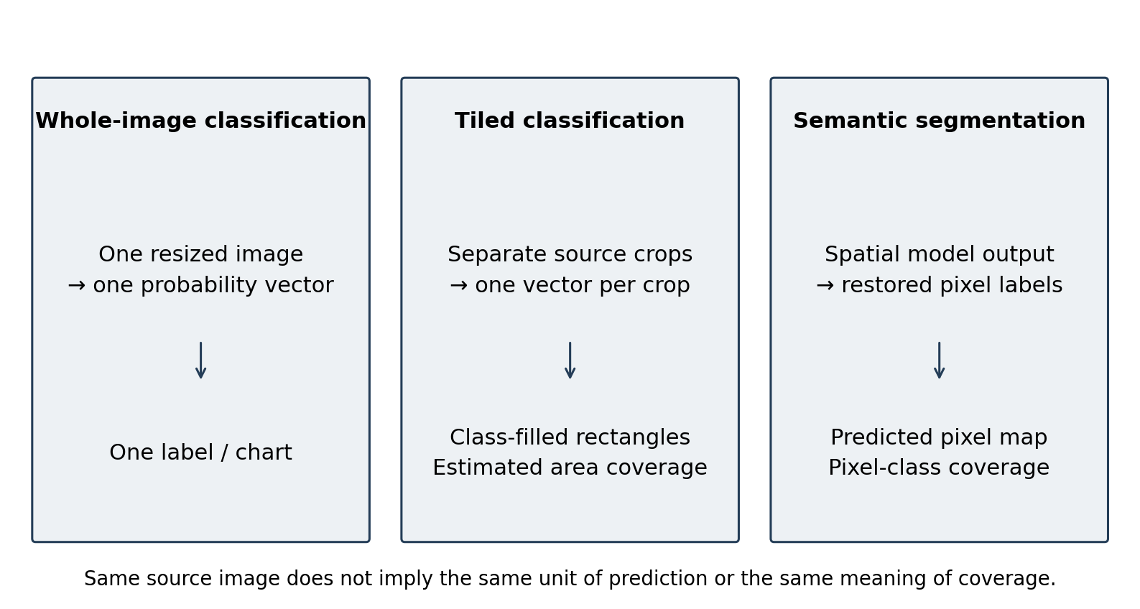
Figure 2.1. Three output meanings: whole-image classification, source-tile estimates and pixel segmentation. Author-created conceptual diagram; it contains no model accuracy results.

2.2.5 No-code interaction and transparent constraints
No-code deployment removes the need to write inference commands, but it does not remove the need for valid inputs. A .pth suffix cannot identify the network architecture, class order, normalisation or trustworthiness of a file. The interface must expose consequential choices and fail clearly when compatibility is not established. WSInfer's reusable-model approach provides an important precedent for model-aware graphical integration (Kaczmarzyk et al., 2024).
No-code interaction is implemented through explicit task controls and interpretable defaults. The mode, source dimensions and resize backend are visible before execution, and a stored record preserves the settings actually used. Separating model adapters, presentation and persistence also localises responsibility for changes, consistent with modular software design principles (Gamma et al., 1994).

2.2.6 Persistence and reproducible workflows
Persistent analysis records connect an image, model, task, parameters and saved output. For a single-user desktop workflow, an embedded database avoids administering a separate database service. SQLite’s implementation role is described once in Section 2.6; this section concerns the reproducibility requirements placed on the stored records.
A recorded configuration supports rerun only while its referenced files and compatible dependencies remain available. ZY-Path therefore uses the term recorded rerun for restoring the saved task, model and analysis parameters. Section 4.5.3 distinguishes this workflow continuity from immutable provenance.

2.2.7 Human-centred design and evaluation
Usability inspection and empirical user evaluation answer complementary questions. Inspection can expose inconsistent feedback or inaccessible controls, whereas task observation and questionnaires show how intended users actually experience the system (Yen & Bakken, 2012). Nielsen's heuristics support visible status, user control, consistency, error prevention and recognition rather than recall (Nielsen, 1994).
The System Usability Scale is a ten-item questionnaire for perceived usability (Brooke, 1996). Bangor et al. (2009) provide an interpretive framework relating SUS scores to adjective ratings. These sources support the selected instrument and contextual interpretation, while task outcomes and qualitative observations explain which interactions influence the score.
SUS provides a standard ten-item instrument, but its 0–100 score is not a percentage of tasks completed or a measure of diagnostic accuracy (Brooke, 1996). Interpretation should include sample composition, missing data and the tasks users attempted. Feature-specific ratings and qualitative feedback can explain a SUS result, but should be analysed separately rather than added to the standard SUS calculation.

2.3 Review of Existing Solutions and Platforms

2.3.1 QuPath
QuPath is an open-source digital-pathology application with image visualisation, annotation, quantitative analysis and project-oriented workflows (Bankhead et al., 2017). It already provides a graphical interface and extensibility through scripts and extensions. Scripting is relevant to advanced customisation but is not a prerequisite for every interaction. Its whole-slide and annotation capabilities exceed the current scope of ZY-Path.
QuPath’s whole-slide, annotation and extensibility functions serve a broader image-analysis task. ZY-Path instead centres on supported local model files and individual analysis records. This is a comparison of workflow scope; the performance and usability questions require the empirical design discussed in Section 4.5.2.

2.3.2 Slideflow and Slideflow Studio
Slideflow supports deep-learning development for digital histopathology, with slide processing, model training and real-time whole-slide visualisation (Dolezal et al., 2024). Its official repository explicitly describes Slideflow Studio, model-development functionality, stain-processing tools and visualisation.
Slideflow’s training and whole-slide capabilities address a broader research lifecycle. ZY-Path selects the inference-and-record portion of that lifecycle for individual users. This trade-off motivates a task-based usability study rather than an assumption that fewer features necessarily produce a better interface.

2.3.3 WSInfer and QuPath integration
WSInfer makes pretrained deep-learning models reusable in a pathology workflow and integrates inference with QuPath (Kaczmarzyk et al., 2024). Its emphasis on model sharing and a standardised interface is directly relevant to the compatibility and provenance requirements of ZY-Path. It also demonstrates that no-code model use is not a unique invention of this capstone.
WSInfer provides a close precedent for accessible pretrained-model inference. ZY-Path’s particular design combines explicit Single image/Tiled analysis controls, linked result inspection and local record retrieval/export. The comparison concerns this arrangement of functions within a raster-image application.

2.3.4 Cytomine
Cytomine supports collaborative analysis of very large images, image annotation and integration of analysis workflows (Marée et al., 2016). A collaborative web architecture is appropriate where shared images and multi-user annotation are central. It introduces infrastructure and administration considerations that differ from a single-user local desktop application.
ZY-Path trades these collaborative and large-image-management capabilities for a local application with no running application server. That trade-off is a scope choice. A local SQLite database does not replace a collaborative repository, access-control system or institutional image-management infrastructure.

2.3.5 Commercial environments
Commercial platforms such as Aiforia Create provide an alternative model-development and deployment environment (Aiforia, n.d.). Their value can include managed workflows and institutional support, while licensing, deployment and import interfaces depend on the product and agreement. This project did not obtain licensed installations or independently test their supported model formats.
For this project, local control of the source code, model selection and analysis records is the relevant deployment choice. Product-specific licensing, import and support arrangements require current primary documentation; they are not treated as universal disadvantages of commercial systems.

2.4 Comparative Evaluation of Existing Systems
Table 2.1 compares platform purposes and documented workflow scope. It separates an unexamined capability from an absent one and uses no aggregate ranking because the applications address different tasks. Source publications are cited in Sections 2.3.1–2.3.5.
Table 2.1. Scope-based comparison of pathology platforms.
System | Documented emphasis | Interface/deployment | Relation to ZY-Path
QuPath | Whole-slide viewing, annotation, quantitative analysis and extensions | Graphical desktop; optional scripting | Broader image-analysis scope; advanced extension setup differs from a constrained model-file workflow
Slideflow/Studio | Model development and whole-slide visualisation | Python research environment plus graphical Studio | Includes training and WSI capabilities outside this project's scope
WSInfer + QuPath | Reusable pretrained pathology inference | Inference integrated with a desktop pathology viewer | Closest precedent for graphical model use; model-distribution and WSI focus differs
Cytomine | Collaborative large-image annotation and analysis | Web/server-oriented collaboration | Supports multi-user work excluded from ZY-Path
Aiforia Create | Commercial AI model development/deployment | Vendor-managed product options | Import, licensing and history details not independently evaluated
ZY-Path | Supported local inference, spatial inspection, record restoration and export | PyQt5 desktop with local CPU and SQLite | Focused raster workflow; classifier evaluated on 7,180 patches; 10-person formative UAT analysed; packaged deployment unverified
Source: platform publications and product documentation cited in Sections 2.3.1–2.3.5; ZY-Path scope from the project implementation.

Two considerations follow. First, classification/segmentation support alone is insufficient for comparing workflows: users also need to understand sampling scale, probability meaning and provenance. Second, a lighter local workflow can be useful without replacing an established WSI platform. ZY-Path's evaluation should therefore test its own requirements before making comparative claims.

2.5 Identified Research Gaps and Project Positioning
The project addresses three scoped integration needs. The first is model-aware accessibility: compatible models should be usable through graphical controls while unsupported inputs are rejected with actionable messages. The second is interpretive consistency: source, overlay, class map, per-tile detail and aggregate statistics should use the same spatial coordinates and explicit task semantics. The third is record continuity: history restoration, rerun and export should retain the analysis configuration rather than current defaults.
The resulting project position is a focused desktop integration for individual educational and research use. Model training and patch-level evaluation support the classification component, while the application contribution connects compatibility, spatial interpretation and record continuity as observable requirements.
Automated checks verify coordinates and restored settings, while participant tasks examine whether coverage, confidence and recorded rerun are understood. The UAT therefore includes interpretation tasks as well as ordinary interaction; Section 4.4 reports both completion outcomes and remaining difficulties.

2.6 Technological Infrastructure and Implementation Considerations
Python remains the implementation language because it connects the desktop GUI, tensor inference and scientific imaging libraries. The CP1 three-layer concept remains useful: presentation is implemented in ui/, inference in core/, and persistence/report generation in data/. MainWindow also coordinates saving and display, so the design is a layered desktop application rather than a perfectly isolated MVC implementation.
SQLite stores structured records in an embedded, serverless database, making it suitable for a local application without a separately administered database service (Kreibich, 2010; SQLite, n.d.). In ZY-Path it links inference identity and timestamps to task-specific metadata and saved artifacts. Parameterised operations and transactions provide the database component of persistence, while external artifact handling remains the coordinator’s responsibility.
PyQt5 supplies windows, layouts, signals and worker threads (Riverbank Computing, n.d.). Qt’s QGraphicsView provides source-coordinate transformations, linked navigation and vector grid painting (The Qt Company, n.d.). PyTorch supplies model execution and inference_mode (Paszke et al., 2019). NumPy supports array-based image conversion (NumPy Developers, n.d.), while Pillow supplies image decoding and resampling (Pillow Contributors, n.d.). Matplotlib renders the Single image probability chart (Hunter, 2007), and fpdf2 generates structured PDF reports (fpdf2 Contributors, n.d.). These choices connect the interface to a local scientific-Python stack without a web backend.
The dependency declarations specify PyQt5 5.15.x, PyTorch 2.1.x, torchvision 0.16.x, Transformers 4.38.2, Pillow 10.x, NumPy 1.26.x, Matplotlib 3.8.x, OpenCV-headless 4.11.0.86 and fpdf2 2.7.x. These are declared ranges or pins, not a complete environment lock. OpenCV is used only for the explicitly selectable classifier resize backend; Pillow bilinear remains the default. No REST API, web frontend or remote inference service is required by the implemented application.
Source-based UPerNet reconstruction loads its configuration from the local Hugging Face cache with local_files_only=True. The Windows build script and PyInstaller specification now describe how to collect the permitted weights, verified configuration, report font and runtime dependencies (PyInstaller Development Team, n.d.). Frozen execution reads the bundled configuration. These implemented build preparations are distinct from an actual version-matched build and clean-machine offline acceptance, whose status is assessed in Section 4.3.4.

2.7 Synthesis of Findings and Project Implications
The literature supports pretrained-model reuse, explicit task semantics and complementary software and user evaluation. Existing graphical pathology platforms provide the context for assessing ZY-Path’s narrower contribution: correct local integration and clear interpretation of recorded results.
Three implications guide implementation. Model metadata must govern preprocessing and labels. Spatial presentation must preserve coordinate meaning across Fit, zoom, comparison and restoration. Persistent records must keep the actual analysis configuration, while communicating their dependence on files and environment stability. These implications are translated into the requirements and traceability matrix in Chapter 3.

2.8 Summary
The reviewed work establishes the conceptual basis for a local inference application and clarifies its boundaries. The final implementation retains the CP1 emphasis on a no-code interface, local persistence and result export, while adding explicit tiled classification and stronger presentation/provenance controls. The next chapter explains how these design choices are implemented and how their available evidence is evaluated.

Chapter 3: Methodology

3.1 Overview of System Methodology
I developed ZY-Path through iterative implementation and regression-driven refinement of the CP1 design. Each iteration connected a requirement or observed defect to the affected code, an implementation change and an appropriate regression check. Observations during Windows testing informed interface corrections, while automated Qt tests made those cases repeatable.
The implemented system has three logical layers. The presentation layer contains the main window, inference/history/action panels, settings and result viewers. The core layer loads models, prepares inputs, executes inference and parses outputs. The data layer stores records and creates export files. MainWindow coordinates transitions between these layers, including saving result artifacts before inserting a completed history record. Figure 3.1 shows these layers and the flow of model, image, result and history artifacts.
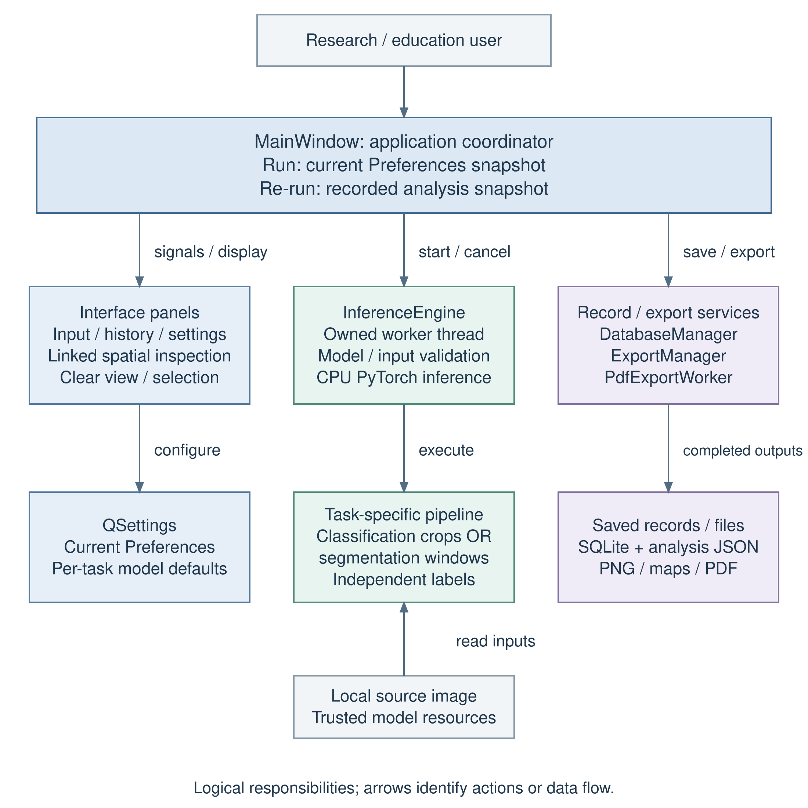
Figure 3.1. Implemented logical architecture and artifact flow. Source: author, based on the project’s Python modules.
The final implementation described in this thesis is revision fbe152a. I completed its 15-case Windows manual acceptance on 2 November 2026. The preceding revision d9fb8e5 supplies the complete 548-case automated Windows regression from the same date. Classification methods are documented by the training code provided by my supervisor, my training/validation records and corresponding test outputs; the segmentation pathway follows the model and reference notebook provided by my supervisor. Appendix C identifies these source states and their supporting records.

3.2 Functional and Non-Functional Requirements

3.2.1 Functional Requirements
The requirements preserve the original model–image–inference–history workflow and add explicit spatial analysis and state-management requirements revealed during development. A requirement describes intended behaviour; its implementation and evidence status are recorded separately in Section 3.6.6. Table 3.1 specifies each functional requirement and its observable acceptance condition.
Table 3.1. Functional requirements and acceptance conditions.
ID | Requirement | Observable acceptance condition
F01 | Load supported raster images | Selected input is identified and rendered; invalid files produce a clear error
F02 | Load and validate trusted compatible models | Supported representations load; finite output/task/class checks reject unsupported inputs
F03 | Run single-image classification | The complete selected image is processed once and yields ordered class probabilities
F04 | Run explicit tiled classification | Selected width/height generate non-overlapping real crops, including partial edges
F05 | Show classification statistics | Nine-class legend, numbered tiles, linked image/table selection, original-crop preview, per-tile confidence and actual-area estimates agree with stored tiles
F06 | Run compatible segmentation | The segmentation model produces a restored label map, overlay and its own legend/counts
F07 | Inspect spatial results | Overlay/map/original, opacity, linked navigation and vector grid remain aligned during zoom, panning and divider resizing
F08 | Save completed history | A record connects actual model/task/mode/parameters to saved artifacts
F09 | Search and filter history | Keyword and inclusive local-date queries return the expected records
F10 | Restore a stored result | Restoration displays the recorded result without initiating a new forward pass
F11 | Rerun a record | The recorded model, image, task and parameters take precedence over current defaults
F12 | Export results | PNG/PDF retain recorded identity/statistics; PDF quality is selectable, background export can be cancelled and an existing destination is replaced only after successful completion
F13 | Cancel inference | Cooperative cancellation leaves no new completed record and preserves the previous result
F14 | Configure task-specific model defaults | A validated local default can be saved/restored independently for each task
F15 | Configure analysis and interface preferences | Mode, tile dimensions and resize method persist; ordinary Run uses current preferences and Re-run uses the selected record snapshot
F16 | Manage records safely | Confirmed deletion removes selected records/app-owned artifacts without deleting source inputs
F17 | Clear the workspace and history selection | Clear view removes transient input/result/session state while retaining saved history/files/settings; Clear Selection leaves no selected history row
Source: author’s requirements derived from the CP1 objectives and implemented workflows.

3.2.2 Non-Functional Requirements
Table 3.2 links the non-functional requirements to their verification approaches and current implementation boundaries.
Table 3.2. Non-functional requirements and verification boundaries.
ID | Quality requirement | Verification approach | Present boundary
N01 | Responsive interaction | Worker-thread signals; cancellation and close-lifecycle tests | A model operation may delay cancellation acknowledgement
N02 | Traceable analysis | Recorded parameters, restored metadata and rerun isolation tests | File hashes and complete environment snapshots are not persisted per run
N03 | Local data handling | Code-path inspection; local SQLite/artifact storage | Local files are not automatically encrypted or backed up
N04 | Readable/resizable interface | Small logical screens, font/DPI simulation, theme and focus tests | Automated Windows layout cases passed at d9fb8e5. Manual W01–W15 passed at fbe152a on a 2560 × 1600 display at 175% scaling; assistive-technology compliance was not assessed.
N05 | Measurable runtime/resource use | Potential future fixed-workload CPU timing and memory study; separate loading, inference and export | No dedicated runtime or memory benchmark conducted; no numerical efficiency claim
N06 | Predictable error handling | Missing-file, invalid-model, export/database and cancellation tests | Structural model validation is not a security or accuracy certificate
N07 | Deployable offline runtime | Local configuration/weights and clean-machine packaging checks | Build script/specification and local-resource checks implemented; actual packaged artifact, clean-machine and offline acceptance unverified
N08 | Maintainability and regression control | Layered modules, named tests, source revision and preserved failure reporting | Regression requirements are linked to named cases and source versions; a passing test count is not a code-coverage percentage.
Source: author’s quality requirements and recorded verification scope.

Verification is reported by requirement and named test assertion. The Windows pass count measures executable cases rather than code coverage; the original coverage target is retained in the proposal baseline in Appendix A.
Windows layout acceptance concerns access to essential controls, resizing, restoration and comparison-view adaptation. I checked the 15 cases in Appendix D on Windows 11 Home Chinese Edition, version 22H2 (OS Build 22621.3593), at 175% display scaling and a 2560 × 1600 display resolution. Dedicated timing and memory benchmarking is outside the completed evaluation.

3.2.3 Ethical Considerations
The application is an educational and exploratory research tool. It does not issue medical diagnoses, recommend treatment or replace professional review. Labels such as TUM and Cancerous epithelium are model categories, not verified findings about an individual patient. Softmax confidence is displayed as model output and must not be presented as a clinically calibrated risk estimate.
Image demonstrations use de-identified research examples. All ten participants consented to participation. Quotation consent is recorded separately: P05 and P10 did not permit verbatim quotation, so their comments are not quoted.
Local execution avoids uploading images to an inference service, but it does not automatically provide encryption, secure deletion, access control or regulatory compliance. History files, exported reports and backups remain subject to the host computer's security arrangements. Reports intended for sharing should be inspected for identifying paths and metadata.
Model trust is a further ethical and technical concern. The loader first attempts supported loading paths, including a weights-only torch.load attempt, but retains a fallback for serialized modules. Such files can execute code during deserialisation. The intended workflow therefore accepts trusted models from known sources; a file-extension filter and dummy forward pass must not be described as a sandbox or malware detector (PyTorch Contributors, n.d.).

3.2.4 Accessibility Compliance
Accessibility is addressed as a set of design and verification activities. Controls use text labels and tooltips; class legends include names and numerical values as well as colour; the interface supports keyboard focus and Space toggling for result checkboxes; scroll areas and draggable splitters expose content in smaller windows. High-DPI sizing uses Qt logical coordinates rather than multiplying screen geometry by the device pixel ratio.
WCAG 2.2 informs the review of keyboard access, contrast and non-colour cues, adapted to a desktop interface (W3C, 2023). Native assistive-technology testing and a complete contrast/accessibility audit are further evaluation activities; their present status is included in Section 4.5.3.
The nine-class palette is accompanied by names, counts and numerical statistics so interpretation does not depend on colour alone. Stable control geometry and a visible keyboard focus cue support mouse and keyboard interaction. These design choices are evaluated through controlled interaction tests and the ten-participant user study.

3.3 Methodologies, Tools, and Techniques

3.3.1 Model representations and executable validation
ModelLoader accepts .pt/.pth files subject to existence, non-empty-file and maximum-size checks. The maximum is 500 × 1024² bytes, or 500 MiB. It attempts TorchScript, serialized nn.Module objects and supported checkpoint dictionaries. Named torchvision reconstruction is limited to the architectures explicitly registered in the loader; a general state dictionary with no recognised architecture contract is not arbitrarily guessed.
The CRC checkpoint contains DenseNet configuration, class labels, raw255 preprocessing and a 224 × 224 input size. The UPerNet state-dictionary path reconstructs the nine-class Swin Base configuration from the local Hugging Face cache and loads the weights strictly. Missing configuration or incompatible state shapes produces an actionable validation error.
Inference uses PyTorch on CPU. The 2 November Windows resource manifest records 1,726,089 bytes (1.646 MiB) for the classification checkpoint and 489,488,187 bytes (466.812 MiB) for the segmentation checkpoint. Both files were present and unchanged through the test execution; Appendix E records their SHA-256 identities. These are stored checkpoint sizes. Structural compatibility permits supported model representations, not arbitrary task or label semantics.
Validation executes a float32 RGB probe of shape (1, 3, 224, 224), extracts a tensor or an object’s logits field, rejects non-finite values and identifies classification output (1, C) or segmentation output (1, C, H, W). The final revision requires at least two classification logits and checks declared label count against output-channel count during selection, default-model validation and inference. Single-logit binary classifiers are rejected because their sigmoid/threshold semantics are not implemented. These checks establish executable compatibility; predictive and model-trust limits are discussed in Section 4.5.3.

3.3.2 Classification training and model configuration
Using the reference training code provided by my supervisor, I trained torchvision.models.DenseNet with growth_rate=32, block_config=(2, 2, 2, 2), num_init_features=64, bn_size=4, drop_rate=0 and num_classes=9. The training logs report 416,457 parameters. The class order is ADI, BACK, DEB, LYM, MUC, MUS, NORM, STR and TUM.
The training loader decodes images with OpenCV and converts BGR to RGB. Validation uses deterministic Resize(224, 224), ToTensorV2 and float conversion, with values retained on the raw255 scale. Training used class-weighted cross-entropy, Adam with initial learning rate 0.001 and weight decay 10⁻⁶, and ReduceLROnPlateau with factor 0.5, patience 3 and minimum learning rate 10⁻⁶; batch size was 32 with two data-loading workers.
Training augmentation uses Resize(224, 224), vertical and horizontal flips with probability 0.5 each, a hue shift from −25 to 0 with saturation and value unchanged, rotation with constant-zero borders, a 224-pixel random-sized crop, and ToTensorV2 followed by float conversion. Unspecified settings use the recorded Albumentations 1.3.1 defaults. Because the crop follows resizing to 224 × 224 with a fixed height range of 224, it does not establish training across different source fields of view. The exact settings remain in the accompanying training script.
The seed-42 manifests partition NCT-CRC-HE-100K into 80,002 training and 19,998 validation images using stratified patch-level sampling. Manifest file hashes agree with the experiment configuration, and their relative image paths are disjoint. Training continued to 30 epochs despite the initial experiment directory name ending in 10ep; the checkpoint at epoch 26 had the lowest recorded validation loss. The training logs identify an NVIDIA L4, distinct from the CPU-only Windows application environment.
Class weights are calculated as w_c = 1 − n_c / Σ_j n_j from the training counts; they are not inverse-frequency weights. Cross-entropy uses a summed reduction, with epoch reporting normalised by the accumulated class-weight denominator. The script seeds Python, NumPy, PyTorch and the data-loader generator with 42, seeds workers from their PyTorch worker seed, disables cuDNN benchmarking and requests deterministic cuDNN behaviour. Continuation restores the model, optimizer and scheduler states. The reported results describe this recorded run; no multi-seed training-variation study was conducted.
The formal nine-class run is identified by its manifests, completed metrics, checkpoint and test-7k outputs. Older three-class scripts and smoke-check experiments remain development materials and are not used to establish the CRC results. The internal training/validation manifests have disjoint image paths, but the stratified random split operates on patches and does not enforce patient- or slide-level separation.

3.3.3 Classification preprocessing and resize provenance
Preprocessor converts each input to RGB and outputs a contiguous float32 NCHW tensor. For the built-in classifier, the tensor shape is (1, 3, 224, 224) and the profile is raw255: pixel values are kept on their original approximately 0–255 scale. The optional imagenet profile divides by 255 and applies mean (0.485, 0.456, 0.406) and standard deviation (0.229, 0.224, 0.225). It is not silently substituted for the built-in raw255 profile.
The default classification resize backend remains pillow_bilinear. The optional opencv_linear backend explicitly calls cv2.resize(..., interpolation=cv2.INTER_LINEAR), retains uint8 interpolation rounding and then converts to float32. Both single-image and tiled classification use the selected backend through the same Preprocessor implementation. The backend name is stored with the analysis so rerun does not depend on a later preference change.
The original evaluation used Albumentations 1.3.1 and OpenCV 4.8.1, with A.Resize(224, 224) retaining its default linear interpolation. Pillow bilinear and OpenCV INTER_LINEAR can differ when resampling is necessary. A Windows rerun through the default Pillow pathway is reported in Section 4.2.6; all 7,180 source patches were already 224 × 224, so this run validates the native-sized patch pathway rather than general equivalence when larger crops are resized.

3.3.4 Explicit classification modes and crop geometry
Single image resizes the complete selected image and obtains one class-probability vector. Tiled analysis instead partitions source coordinates into non-overlapping rectangles. For image width W, height H and selected source tile width w and height h, the number of tiles is:
N = ceil(W / w) × ceil(H / h). (3.1)
At source location (x, y), the crop rectangle is [x, y, min(x+w, W), min(y+h, H)]. The right and bottom coordinates are exclusive. Each rectangle is cropped from the actual source image, independently resized to network input and classified once. Partial edge crops contain real pixels only; they are neither padded nor replaced by the complete image or a previous crop.
For W=3552, H=3536 and w=h=512, Equation 3.1 gives seven columns and seven rows, or 49 tiles. The final column is 480 pixels wide, the final row 464 pixels high, and the bottom-right area 222,720 pixels. A deterministic fixture verifies these coordinates and complete non-overlapping coverage.
Source crop dimensions determine the field of view before resampling to 224 × 224. At the source dataset’s nominal 0.5 μm/pixel, a 224-pixel edge spans 112 μm. If a new raster’s resolution r is known in μm/pixel, a candidate crop edge covering that field is approximately 112/r pixels; this is a physical-scale calculation, not evidence of optimal predictive performance. The interface retains 512 × 512 as an editable starting value. Values such as 256 and 300 are exploratory source-crop candidates, while the network input remains 224 × 224. A controlled comparison should keep the crop centre, source image, model, backend and display dimensions fixed. Predictive performance at alternative crop sizes requires labelled evaluation at the chosen scale.
Ordinary Run Inference captures the current tile dimensions and resize backend when inference starts. History restoration leaves those defaults intact, while Re-run uses its saved parameter snapshot. Changes made during inference apply to the next run. Regression tests check crop geometry and parameter isolation across restoration, rerun, input changes and clearing the view. Before a tiled run, the coordinator and worker check the crop count against a 10,000-tile limit; the predictor and stored tile-table viewer enforce the same limit. Excessive requests produce an instruction to increase crop dimensions or use a smaller image, without silently changing the selected geometry.

3.3.5 Class probabilities, maps and estimated coverage
For tile i with class logits zᵢ, the softmax probability for class c is pᵢc = exp(zᵢc) / Σⱼ exp(zᵢⱼ). The tile label is kᵢ = argmax_c pᵢc and its displayed confidence is pᵢ,kᵢ. These values are retained alongside the source rectangle. The ordered nine-class colour corresponding to kᵢ fills that crop's source coordinates in the classification map.
Let aᵢ denote the actual crop area. The tile count for class c is n_c = Σᵢ 1(kᵢ=c), while its estimated covered area and ratio are:
A_c = Σᵢ aᵢ 1(kᵢ=c), r_c = A_c / (W × H). (3.2)
The denominator includes the complete source image, including crops assigned to background or other classes. Counts and coverage answer different questions. A small edge crop contributes one tile to n_c but only its real area to A_c. The ratios sum to one for a complete partition, apart from numerical rounding in display.
The implementation also retains an aggregate class based on area-weighted mean probabilities:
q_c = Σᵢ aᵢ pᵢc / (W × H), k* = argmax_c q_c. (3.3)
This aggregate need not equal the class with the largest r_c because probability mass and hard-class coverage are different summaries. It is not a new whole-image forward pass. The history table therefore shows tile count and largest estimated coverage, leaving whole-image confidence blank; PDF metadata distinguishes “Aggregate tile label” and “Area-weighted mean probability”. Table 3.3 records the classifier’s fixed class order and dedicated nine-colour display palette.
Table 3.3. Classification class order and fixed display palette v1.
Index | Label | Tissue category | RGB
0 | ADI | Adipose | (230, 159, 0)
1 | BACK | Background | (210, 210, 210)
2 | DEB | Debris | (86, 180, 233)
3 | LYM | Lymphocytes | (0, 158, 115)
4 | MUC | Mucus | (240, 228, 66)
5 | MUS | Smooth muscle | (0, 114, 178)
6 | NORM | Normal colon mucosa | (213, 94, 0)
7 | STR | Stroma | (204, 121, 167)
8 | TUM | Tumour epithelium | (120, 60, 140)
Source: classification checkpoint class order and the application’s classification display palette; colours are display metadata.

The palette is application display metadata, not evidence of a training colour convention. ClassificationTileSpec validates source/input dimensions, nine unique model classes, matching class order, matching preprocessing and nine distinct RGB colours. An incompatible class contract is rejected rather than substituted with segmentation labels.

3.3.6 Segmentation pathway and label restoration
My supervisor provided the segmentation model and the reference notebook predict-upernet-tme-tissue-overlap.ipynb; I did not participate in segmentation training. The model was trained on breast-cancer data, and the 3552 × 3536 demonstration image also comes from a breast-cancer dataset. The specific dataset names and the image resolution in micrometres per pixel are unavailable. The notebook constructs a nine-label UPerNet using the openmmlab/upernet-swin-base configuration. Its large-image example uses source tile=1000 and stride=512, which are the application defaults; network input is 224 × 224. The application runs on CPU with batch size one, whereas the notebook example requests CUDA and defaults to batch size eight.
For the UPerNet pathway, the final window on each axis is aligned with the image edge. Images smaller than a source tile are reflect-padded. Each RGB patch is resized with Pillow bilinear, scaled to 0–1 and normalised with ImageNet mean (0.485, 0.456, 0.406) and standard deviation (0.229, 0.224, 0.225). Softmax probabilities are accumulated on a reduced-resolution canvas with a two-dimensional Hann window plus 0.001, normalised by accumulated weights, converted to labels and restored by nearest-neighbour interpolation before cropping to the original dimensions.
The resulting nine-label counts use the final restored label map. Pixel coverage is class pixel count divided by W × H, including Exclude and Whitespace/Empty in the denominator. It is a statistic of a predicted mask, not an editable estimate of ground truth. The output retains its actual tile/stride/input metadata and its own colour semantics.
Table 3.4. Built-in segmentation labels and display colours.
Index | Model label | RGB
0 | Exclude | (0, 0, 0)
1 | Cancerous epithelium | (255, 0, 0)
2 | Stroma | (0, 255, 0)
3 | TILs | (0, 0, 255)
4 | Normal epithelium | (255, 255, 0)
5 | Junk/Debris | (128, 0, 128)
6 | Blood | (0, 255, 255)
7 | Other | (255, 165, 0)
8 | Whitespace/Empty | (255, 255, 255)
Source: supervisor-provided segmentation notebook; labels and RGB values match the application constants.

The nine-label order and RGB colours in Table 3.4 match the reference notebook. Generic compatible segmentation models use a separate prepared-tensor and OutputParser pathway. The model filename’s 100ep and panoptils strings are retained as identifiers; training duration and dataset provenance are not inferred from those strings.

3.3.7 Background execution and cancellation
InferenceEngine subclasses QThread and emits result_ready, error_occurred, progress_changed, status_changed and cancelled signals. ModelValidationThread performs asynchronous validation. The GUI captures the intended task and parameters before starting a worker, locks conflicting controls while busy and updates status/progress through signals rather than running the forward pass in the GUI event loop.
Cancel sets a threading.Event. The worker checks it before/after key stages and between tile operations; it cannot interrupt a running PyTorch forward operation at an arbitrary instruction. The interface therefore distinguishes the request (“Cancelling...”) from acknowledgement, keeping inputs locked until the worker exits. A late result after cancellation is rejected, and no partial completed record is saved. Closing while a worker or model-validation task is active waits for cleanup rather than terminating the thread forcibly.
A final lifetime guard also waits for an active worker before Qt destroys its owning widget. Model-validation signals connect to QObject-bound receivers, so destruction disconnects pending callbacks instead of allowing them to access deleted controls. Regression cases cover forced parent deletion and both successful and failed validation signals for built-in models, custom models and task-default settings.

3.3.8 History schema, artifacts and rerun isolation
DatabaseManager uses sqlite3 connections with parameterised statements and transaction handling. The base inference_records table stores paths, task, label/confidence where applicable, result-image path and timestamp. A companion segmentation_artifacts table stores artifact paths and analysis_json; despite its legacy name, it also carries tiled-classification and single-classification parameter metadata. Table 3.5 summarises the persistent structures and the purpose of their principal fields.
Table 3.5. Implemented persistent data structures.
Structure | Principal fields | Purpose
inference_records | id, image_path, model_path, task_type, result_label, confidence, result_image_path, timestamp | Searchable completed-analysis identity and base metadata
segmentation_artifacts | record_id, result_labels_path, result_color_mask_path, result_overlay_path, analysis_json | Optional spatial artifacts and recorded analysis/presentation metadata
Classification analysis JSON | mode, resize_backend, classes/colours, source/input sizes, tiles/probabilities, counts, areas, scale_status, presentation | Preserve tile semantics and restore/reuse the actual parameters
Segmentation analysis JSON | recorded task/model, labels/colours, dimensions, tile/stride/input, counts, presentation | Restore spatial results without borrowing classification semantics
QSettings | theme, current/default classification settings, per-task default model paths, reminders, window geometry | User preferences, distinct from completed record parameters
Source: project database schema, task metadata and QSettings implementation.

UTC timestamps are stored and converted for local display/filtering. A date range is interpreted as inclusive local days, preserving the final microsecond at 23:59:59.999999 when converting the end bound to UTC. Initial search and filter-preserving reload use the same boundary. Both date selectors and popup calendars explicitly use English, while the date format remains yyyy-MM-dd. Searches cover image/model names and do not perform visual image-similarity retrieval.
Restoring a record reads its saved artifacts and metadata without rerunning the model. Rerun selects exactly one recorded analysis and uses its model, source image, task, mode, tile dimensions and resize backend. Missing files produce a clear message rather than an unannounced substitution. Current defaults do not relabel an existing record. Confirmed deletion removes selected records and their managed result files, including JSON sidecars, while preserving original inputs, surviving records’ referenced files and files selected for an active operation.
Clear view removes the current input, visible result and session metadata and clears history selection. It does not delete saved analyses or source files. Clear Selection, Esc in the history table and a click on empty table space can leave no row selected. Restoring history also synchronises the left-side original-image thumbnail; the completed record retains its own identity independently of subsequent model selections.
The coordinator renders and saves all required result artifacts before inserting a completed history row and replacing the previous view. A handled file-write or database-insert failure removes the newly created partial files, reports the error and retains the preceding completed result. Existing-file collisions do not overwrite prior data. File writes and SQLite are nevertheless separate storage systems: an abrupt process or power failure can still interrupt cleanup, so this is not a distributed filesystem/database transaction.

3.3.9 Export and local model defaults
ExportManager uses Pillow/Matplotlib for PNG and fpdf2 for structured reports. Spatial exports can include analysis JSON, class/label maps and overlays as appropriate to the recorded task; a PDF includes available source/result images and metadata. The report uses the current result's recorded identity, not whichever model happens to be selected for a subsequent run. Changing overlay opacity or view mode changes presentation, not class labels, probabilities or stored counts.
PdfExportWorker snapshots the selected result, metadata, map and export options before background generation. Progress and cooperative cancellation keep the GUI responsive; the destination is atomically replaced only after a complete report is written. Standard PDF quality is the default: report display copies are sized for up to 300 DPI, large photographs and overlays use high-quality JPEG, and class maps use nearest-neighbour resizing with lossless encoding. Original resolution retains full image pixels with lossless encoding. Text, numerical tables, predictions, saved masks and source files are unchanged. The report distinguishes original image dimensions from display-copy quality and an export-time file checksum from an identity actually recorded at inference.
The Models settings page maintains independent classification and segmentation defaults. A candidate default is validated for the intended task before it is saved, and “restore built-in” resets that task's model preference. A missing custom default is reported as unavailable rather than silently falling back. Recorded rerun uses the saved model path. Defaults are convenience preferences, not a migration of earlier analyses to new weights.
The inference panel’s built-in/custom selector is a session choice. Selecting the built-in model clears the visible local-model filename while remembering that local choice for a later explicit return in the same session. This does not change either task’s saved startup default or relabel the completed result’s Session metadata. Interrupted custom validation is resumed when required rather than leaving a stale loading state.

3.4 User Interface (UI) and User Experience (UX) Design

3.4.1 Principles and information hierarchy
The interface keeps the CP1 three-region structure: input controls on the left, analysis/history in the centre and export/session actions on the right. Implementation changes replace fixed panel assumptions with draggable splitters, scrollable contents and bounded window restoration. The aim is to keep essential actions reachable while prioritising the analysis image. Figure 3.2 presents an annotated wireframe of this arrangement and its main user actions.
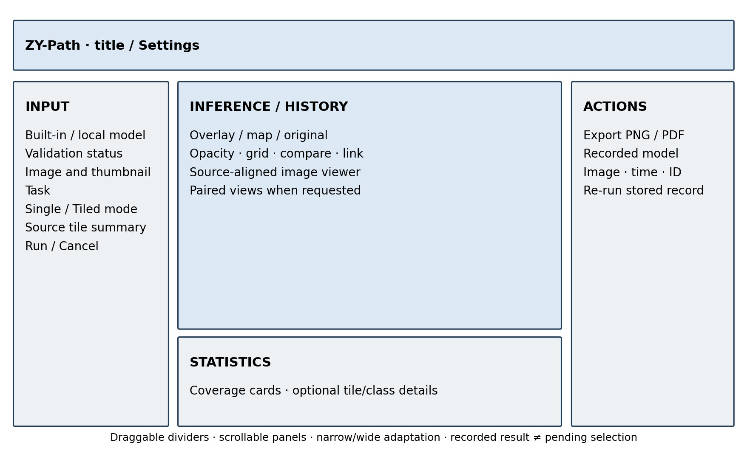
Figure 3.2. Annotated final workflow wireframe. This author-created design diagram summarises implemented regions and is not a Windows runtime screenshot.
Task and classification mode are visible before running. Status messages distinguish validation, inference, cancellation and completion, while completed-result metadata remains separate from a pending selection. These decisions apply visibility, consistency, recognition and user control from the usability literature (Nielsen, 1994; Yen & Bakken, 2012); the participant evaluation in Section 4.4 examines these interactions without attributing a causal effect to individual design changes.

3.4.2 Spatial results and progressive disclosure
Tiled classification and segmentation initially hide the duplicated source preview so the main analysis view has more space. Users can select Original image or enable Compare with original. Overlay is the default spatial presentation; opacity is adjustable, and a pure class/segmentation map remains available. The classification coverage cards stay visible without requiring navigation among Image, Legend and Tiles pages; per-tile and extended class details are disclosed when needed.
Tile boundaries and optional one-based numbers share image coordinates. Selecting a tile or its detail row identifies the same source crop, rectangle, label and confidence. This supports spatial inspection without requiring a separate page for each result component.
Linked comparison uses a common Fit scale and source-coordinate centre for the original and result. The pair stacks vertically in narrow windows and returns to a horizontal layout when space permits. Panning, zooming and divider resizing preserve spatial correspondence without changing predictions or statistics.
The classification grid is drawn over the image through the same coordinate transform, with a line width that remains legible during Fit and zoom. Image/grid alignment is preserved after resize and history restoration. The scale display accounts for device pixel ratio: 1:1 represents one source pixel per physical display pixel, while window bounds use Qt logical coordinates.

3.4.3 Control states, settings and help
Result controls provide a consistent clickable area and visible keyboard focus. Mouse, keyboard and scrolling interactions are designed to prevent unintended parameter changes while keeping essential actions accessible.
Settings provides a resizable, scrollable interface for export reminders, classification mode, tile dimensions, resize backend, task-specific colour references and layout reset. Changes apply to the main panel and new-run defaults without rewriting stored analyses. The Square action copies tile width to height, while the resize guide explains backend choices.
Guide & Support presents structured workflow guidance and reading-aware navigation. System Information displays runtime and dependency details that can be copied for support; About identifies version 1.0 and contact information.

3.4.4 Responsive windows and platform limits
Window fitting uses the current screen’s availableGeometry in logical coordinates and checks restored size/position. The implementation distinguishes normal, maximised and fullscreen states and avoids continuously forcing a size during interactive resize. Inner scroll areas may shrink vertically while Run, Cancel and Re-run retain usable space; their preferred content heights must not stretch the entire three-panel splitter beyond its viewport.
Automated checks cover small logical screens, narrow/wide transitions, scale-factor simulation, saved geometry and comparison/grid layout. The complete d9fb8e5 Windows suite passed these cases. Appendix D records the separate developer-led manual acceptance checks.

3.5 Unified Modeling Language (UML) Diagrams

3.5.1 Use Case Diagram
The primary actor is an educational/research user. No administrator or clinical approval role is implemented. Selecting a model includes compatibility validation. Tiled analysis is an explicit classification variant. Restore saved result and Re-run recorded analysis are separate use cases because only rerun performs inference and creates a new record; Search/filter locates records without executing either operation. Figure 3.3 maps these actions and their scope.
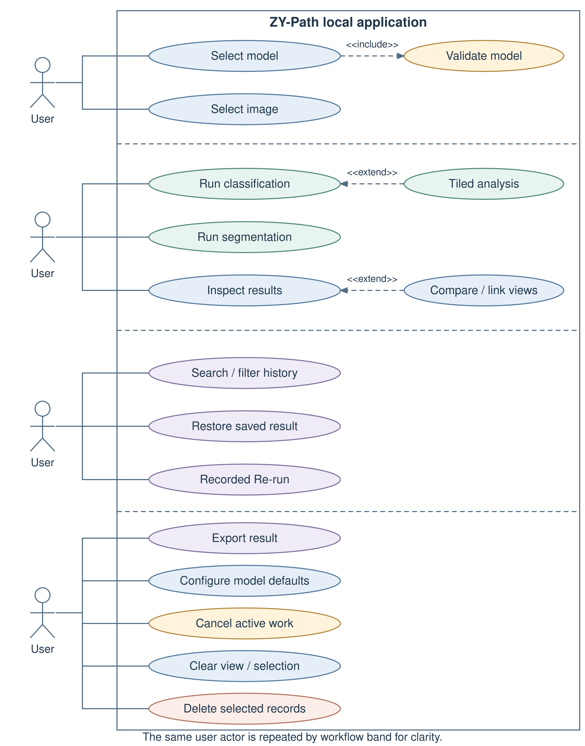
Figure 3.3. Use case diagram for the implemented local analysis workflow. File/model trust and clinical interpretation remain external responsibilities. Source: author, based on the implemented application.

3.5.2 Sequence Diagram
The sequence diagram follows a run after image, task and model selection. MainWindow snapshots the current preferences for ordinary Run or the selected record for Re-run, then starts the worker. Signals deliver progress and a completed result. The coordinator saves completed artifacts and inserts a record only after successful persistence. Figure 3.4 uses guarded alternative fragments for cancellation, pipeline error and persistence failure; these exits are distinct from completed history.
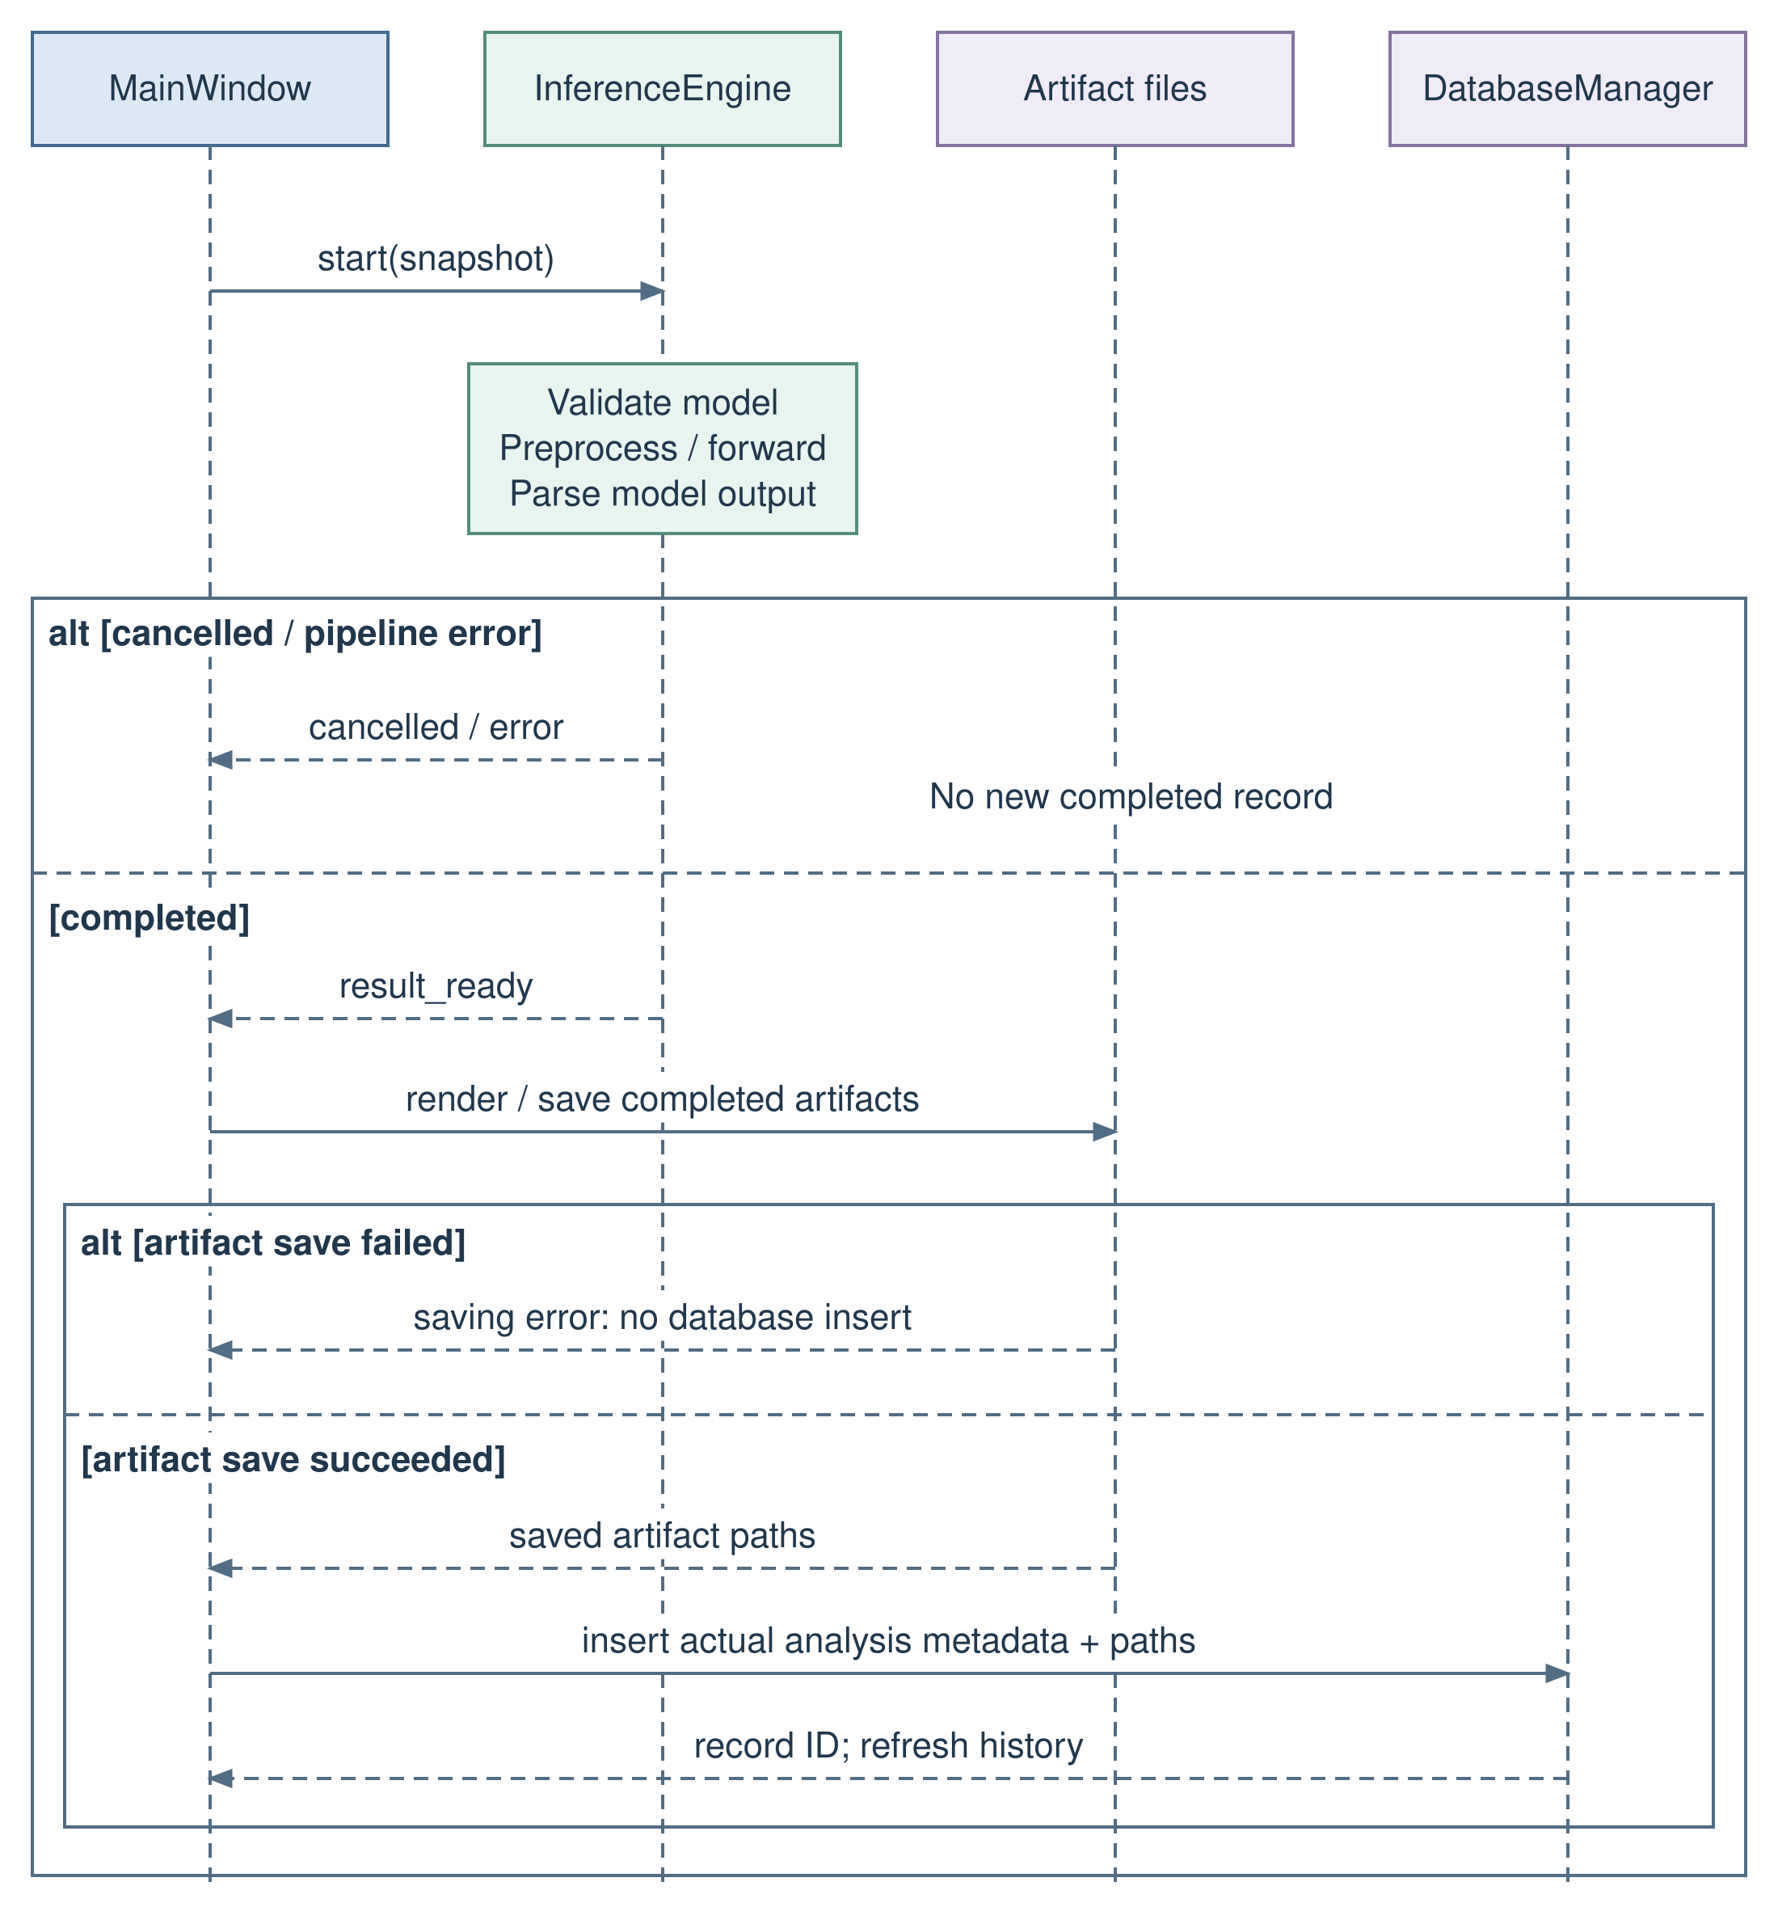
Figure 3.4. Sequence diagram for a run and its persistence boundary. Cancellation is acknowledged after a safe checkpoint; artifact-save failures must not be represented as successful saved records. Source: author, based on the implemented application.

3.5.3 Class Diagram
The class diagram shows selected runtime responsibilities rather than every widget. MainWindow coordinates input, history, inference, persistence and export. InferenceEngine depends on model loading, preprocessing and output parsing. PdfExportWorker delegates report generation to ExportManager. Spatial result pages use ImageComparison and ZoomableImageView. Figure 3.5 distinguishes coordination dependencies and worker inheritance for the current implementation.
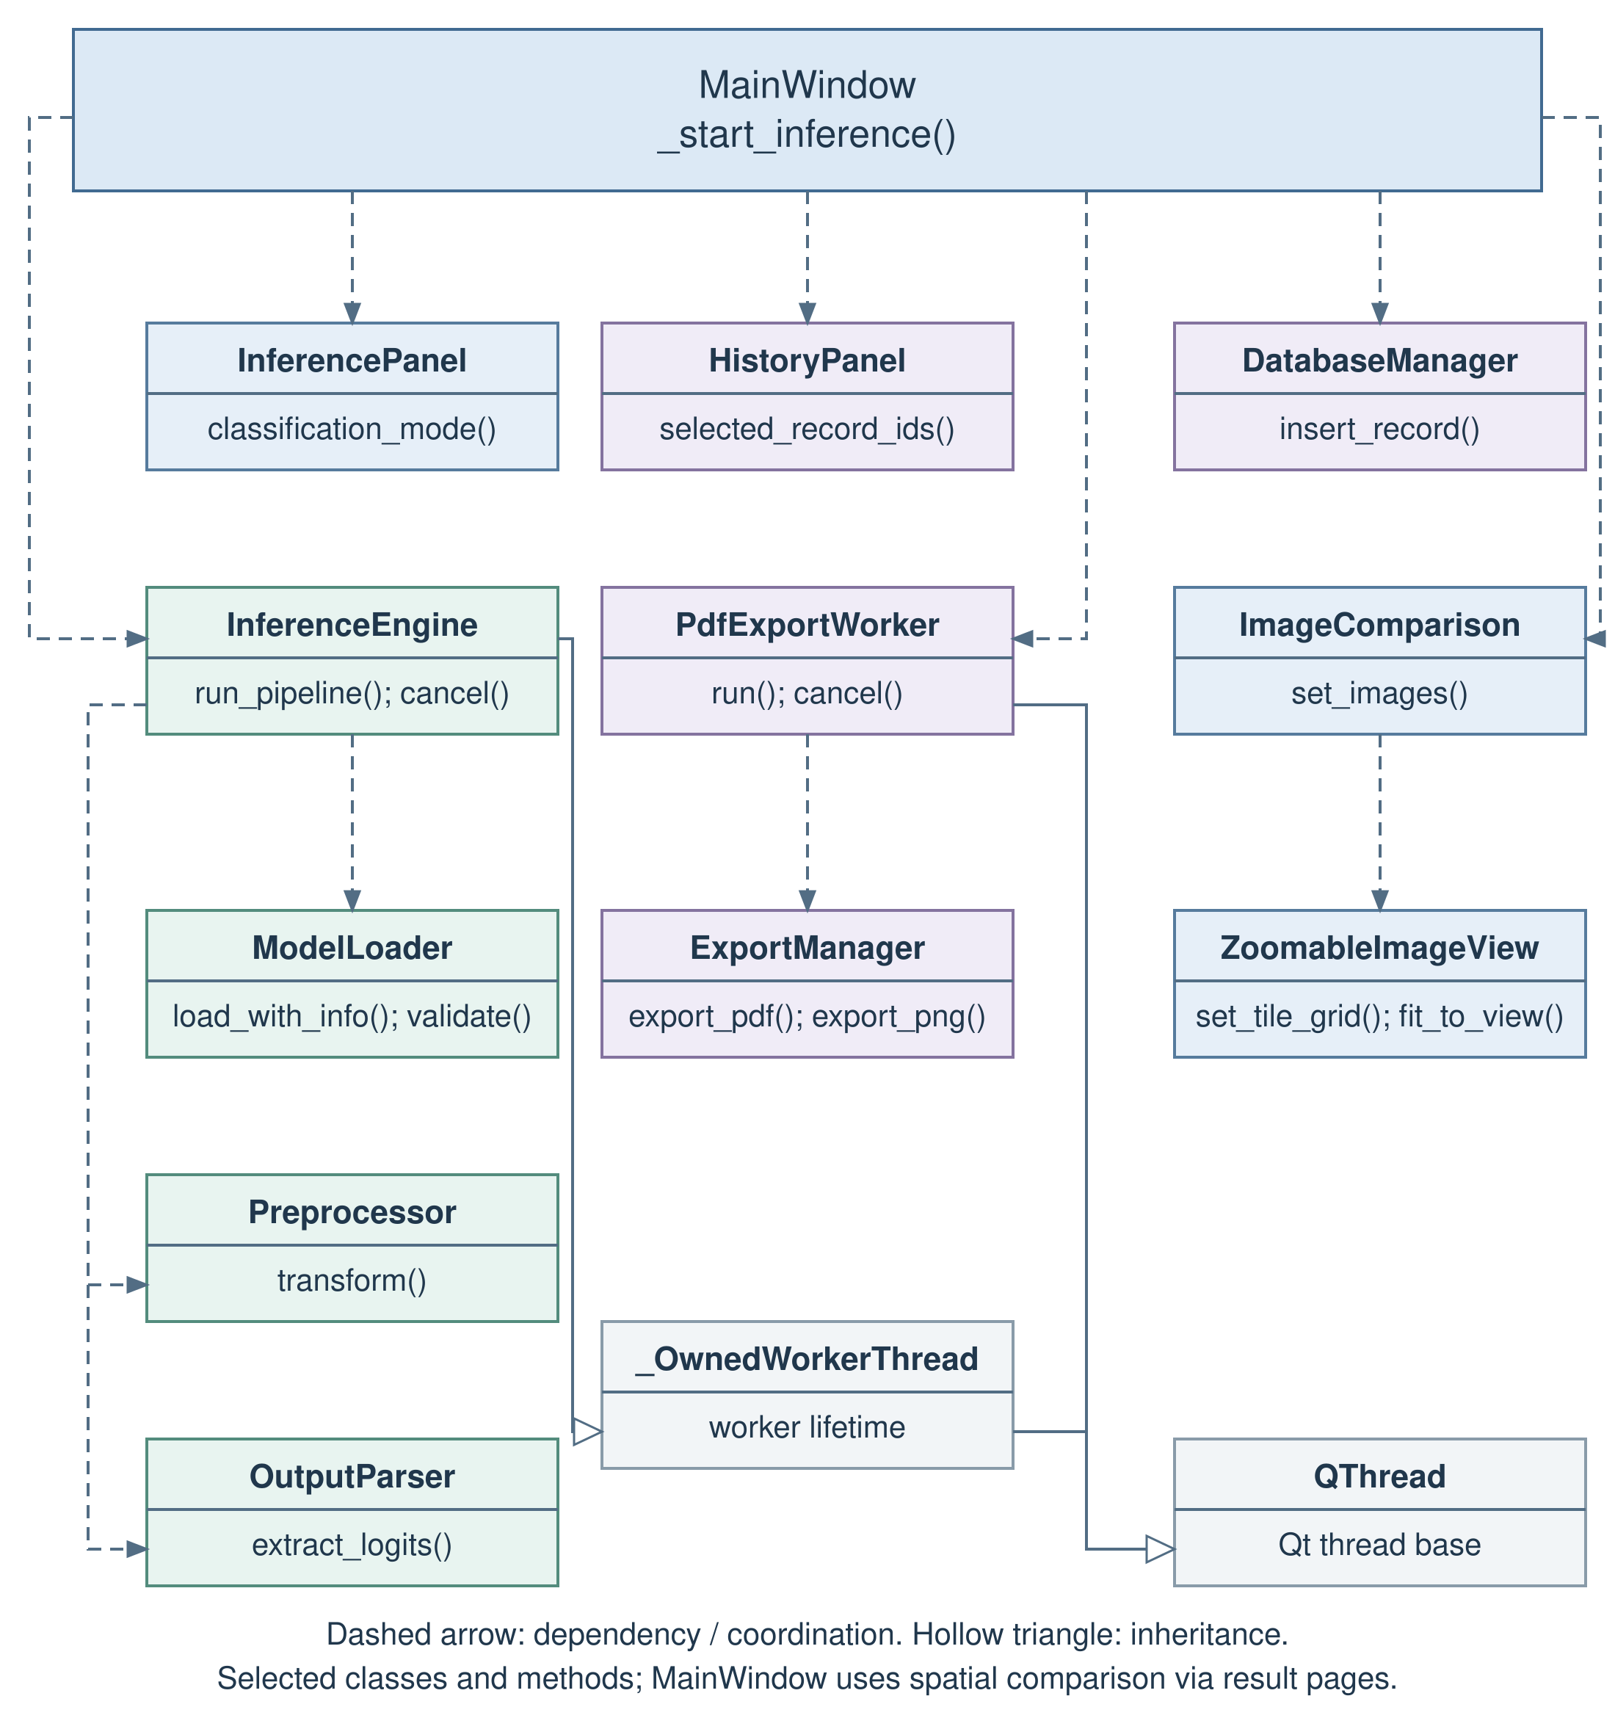
Figure 3.5. Implementation-level class diagram. Relationships show selected coordination dependencies and worker inheritance. Source: author, based on the implemented application.

3.5.4 Activity Diagram
The activity diagram distinguishes current-preference Run from recorded-parameter Re-run before selecting the task/mode pathway. Classification crops and segmentation processing regions retain independent geometry. Cancellation is checked at safe points before/after model work and between processing regions. Figure 3.6 labels the decisions and success/error exits; a request does not forcibly interrupt a running forward operation.
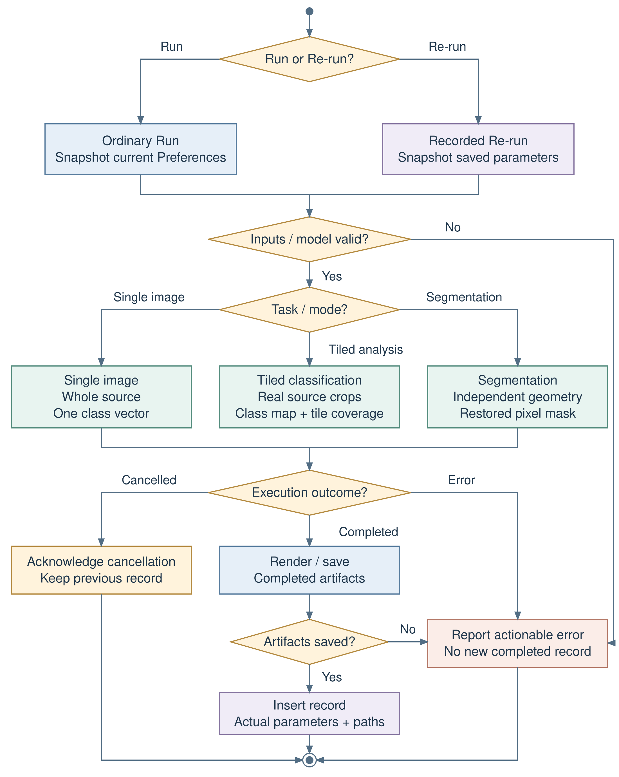
Figure 3.6. Activity diagram from parameter selection to completed persistence, with safe cancellation and error exits. Source: author, based on the implemented application.

3.6 Testing Methodology

3.6.1 Development Testing
Development verification combines component checks with cross-module tests using pytest and pytest-qt. The tests exercise model contracts, preprocessing, inference routing, persistence and user interaction at their observable interfaces.
Controlled cases use known in-memory networks, synthetic tensors and raster images, temporary SQLite databases and isolated QSettings stores. Real-file availability checks remain separate, so successful fixtures cannot substitute for the presence or validation of production model files.
Default application settings and application-data directories are isolated per test. On Windows, the organisation/application QSettings constructor normally reads the Registry; the test fixture redirects that constructor to a per-test INI store while preserving explicit file-based settings. Separate cases verify fresh defaults and persistence between instances in the same store. This prevents a saved Tiled analysis choice or maximised window from becoming an unintended precondition of unrelated tests. Production preference storage is unchanged.
The 2 November Windows test record uses Python 3.10.22, pytest 9.1.1, pluggy 1.6.0, PyQt5 5.15.11, Qt runtime/compiled version 5.15.2, anyio 4.15.1 and pytest-qt 4.5.0. PyTorch 2.1.2+cpu reported CUDA unavailable and 24 CPU threads. Table 4.4 gives the host hardware and separates its installed GPU from the actual computation device.
Assertions check external behaviour: crop coordinates and input values, area conservation, mode routing, probability order, saved metadata, rerun isolation, cancellation outcomes and accessible controls. GUI input tests use mouse/keyboard events, not only programmatic setChecked calls. Presentation tests check that Fit, zoom and grid changes do not alter analysis data. A screenshot can support inspection but does not replace these behavioural assertions.

3.6.2 Module Testing and Fallback Handling
The loader is tested against supported representations, invalid metadata, missing/empty files, wrong shapes and non-finite logits. Preprocessor tests verify RGB conversion, profile values and resize backends. Tile tests verify unique crops, right-exclusive rectangles, partial-edge areas and agreement of a direct crop with the same preprocessing pathway. Parser tests check softmax/class mapping and mask restoration.
Database and export tests use temporary artifacts to check CRUD operations, date bounds, report metadata and error propagation. Rerun tests change current selections/defaults to ensure they cannot overwrite recorded task or model parameters. Cancellation tests cover requests before load, at pipeline checkpoints, on the final tile and during GUI cleanup, including the rejection of a late result.
Fallback is intentionally constrained. Missing weights, missing cached UPerNet configuration and incompatible checkpoints produce explicit errors. An unsupported architecture is not replaced by a random network. A missing recorded model is not replaced with the current default. The software can remain available for other operations after an error, but “graceful handling” does not mean silently obtaining a prediction from a different model.

3.6.3 Manual System Testing
On 2 November 2026, I performed W01–W15 on revision fbe152a using the real-file workflows and expected outcomes listed in Appendix D. All 15 cases met their criteria. The environment was Windows 11 Home Chinese Edition 22H2, OS Build 22621.3593, with 175% display scaling and a 2560 × 1600 display resolution. Table D.1 records the observed behaviour. Display acceptance is limited to the tested 175% setting; other scaling settings and multi-monitor transitions were not part of this manual record.
The cases address window geometry, original/result comparison, grids and toggles, calendars, history and rerun, cancellation, Settings, export, model defaults, missing files, tile preferences and clearing the view. The record provides an overall outcome for each case rather than detailed execution traces. Its limitations are stated in Appendix D.

3.6.4 User Acceptance Testing (UAT)
The formative usability study includes ten consenting participants with varied computing and pathology experience. All completed the ten-item SUS questionnaire. The response workbook provides participant profiles, task outcomes, ratings and comments; its reporting limitations are discussed in Section 4.5.3.
Table B.1 defines ten tasks covering single-image classification, tile configuration and interpretation, comparison, segmentation, history, recorded rerun, export, cancellation and defaults. Task outcomes come from the response workbook; Appendix B reproduces the task instructions and success criteria.
The analysis uses ten complete SUS forms, 100 participant–task entries, feature ratings and 60 open-ended responses. Data cleaning standardised IDs to P01–P10, corrected the P03 consent entry and recoded P02/T04 and P04/T09 as Not attempted in accordance with the confirmed non-use records. Their earlier completion times were removed. The original response file and a separate correction log are retained.
For participant i with item responses xᵢj in 1–5, the SUS score is:
SUSᵢ = 2.5 × [Σ(odd j)(xᵢj−1) + Σ(even j)(5−xᵢj)]. (3.4)
Each complete SUS form is scored using Equation 3.4 before calculating the sample mean, sample standard deviation, median and range. The IQR uses inclusive linear interpolation, corresponding to Excel QUARTILE.INC. Independent and assisted completion are separate. Evaluable attempts comprise independent successes, assisted successes and unsuccessful attempts; blocked and not-attempted entries are reported separately. Feature means exclude blank ratings and retain feature-specific denominators.

3.6.5 Testing Summary
Four evidence streams are kept separate. Automated development/integration tests establish repeatable technical behaviour under controlled fixtures. Manual Windows testing establishes behaviour on the intended operating system, display configurations and real files. UAT evaluates observed task performance and user perceptions. Independent model evaluation supports predictive claims; no amount of GUI testing replaces it.
On 2 November 2026, revision d9fb8e5 completed the full native Windows Qt suite: 548 passed, 0 failed, 0 errors and 0 skipped, with 16 warnings in 224.89 seconds (exit 0). Table 4.3 presents this current-source result. Appendix C retains earlier Windows invocations with their original dates and versions; they are not added to the current total.

3.6.6 Requirements Traceability Matrix
Table 3.6 connects objectives and requirements to source modules and named tests. Its statuses distinguish the 548-case automated Windows regression at d9fb8e5, manual acceptance at fbe152a, recorded classifier evaluation, formative UAT and further model studies.
Table 3.6. Requirements traceability matrix.
Requirement / objective | Implementation | Principal executable evidence | Status and boundary
F01 / O3 | InferencePanel; image opening in InferenceEngine | test_inference_panel.py; test_inference_engine.py | Image-loading and input-error cases passed in the 548-case Windows suite at d9fb8e5. Relevant manual checks passed at fbe152a (Appendix D).
F02 / O2 | ModelLoader; ModelValidationThread | test_model_loader.py | Current Windows loader/probe and genuine built-in-path cases passed. Probes establish structural compatibility, not predictive accuracy.
F03 / O3 | Preprocessor; OutputParser | test_preprocessor.py; test_output_parser.py; test_inference_engine.py | Current Windows software cases passed; default-Pillow patch accuracy 90.68%, macro-F1 88.59% on native 224 × 224 inputs (Section 4.2.6).
F04–F05 / O3–O4 | ClassificationTileSpec; predict_classification_tiles | test_classification_tiles.py; test_classification_modes_display.py | Crop, mode, legend and actual-area fixture cases passed at d9fb8e5. Tiled-map predictive accuracy was not evaluated.
F06 / O3–O4 | large_image_segmentation; SegmentationResult | test_large_image_segmentation.py; test_segmentation_results_layout.py | Automated segmentation cases passed at d9fb8e5. Figure 4.4 and the actual report illustrate real-weight output; relevant manual checks passed at fbe152a. Ground-truth accuracy remains unevaluated.
F07 / O4 | ImageComparison; ZoomableImageView | test_linked_image_comparison.py; test_screen_fit_and_tile_grid.py | Coordinate, linked-view, Fit/zoom/grid and compact-viewport cases passed at d9fb8e5. Relevant manual checks passed at fbe152a, with 175% display scaling (Appendix D).
F08 / O6 | DatabaseManager; MainWindow artifact saving | test_database_manager.py; test_main_window_inference.py | Persistence/artifact cases passed at d9fb8e5. The final coordinator saves files before inserting a completed record and cleans handled partial writes. Relevant manual checks passed at fbe152a; source differences are retained in Appendix C.
F09 / O7 | HistoryPanel search/local-date queries | test_history_panel.py; test_result_controls_and_calendar.py | Windows query/calendar cases passed at d9fb8e5. UAT T06: 9 independent and 1 assisted completion.
F10–F11 / O7 | Stored restoration and recorded rerun | test_main_window_rerun.py; test_classification_modes_display.py; test_tile_preferences_lifetime.py | Automated restore/rerun checks passed at d9fb8e5. T07: 3 independent, 6 assisted and 1 unsuccessful; a causal efficiency improvement is not established.
F12 / O5 | ExportManager and export coordinator | test_export_manager.py; test_main_window_export.py; test_background_pdf_export.py; test_pdf_report_layout.py; test_pdf_image_quality.py | Automated export cases passed at d9fb8e5. Figure 4.6 and the actual PDF/JSON support report content; W10/W15 passed at fbe152a. The listed original PNG was not supplied for independent inspection.
F13 / O1 | Cooperative cancel and close lifecycle | test_cancellation_and_model_defaults.py; test_worker_lifetime.py | Automated cancellation/lifecycle cases passed at d9fb8e5. W08 passed at fbe152a; Figure 4.9 remains two independent cancellation-related views rather than one continuous test sequence.
F14–F15 / O1–O3 | ModelSettingsPage; SettingsDialog; QSettings | test_cancellation_and_model_defaults.py; test_preferences_interaction.py | Current Windows defaults, validation, preferences and history-isolation cases passed.
F16 / O6–O7 | Confirmed record/artifact deletion | test_main_window_delete.py; test_database_manager.py | Current Windows app-owned artifact cleanup and source-preservation cases passed.
F17 / O1, O6–O7 | MainWindow; InferencePanel; HistoryPanel | test_clear_view_and_history_sync.py | Clear view, zero-selection and source/history preservation passed in the d9fb8e5 Windows suite. W14 passed at fbe152a; participant UAT remains separate.
N01, N04 / O1, O4 | Worker signals; logical screen bounds; scroll layouts | test_window_lifecycle_and_theme.py; test_settings_polish_and_resize.py | Windows geometry and compact-layout cases passed at d9fb8e5. W01–W03/W09 passed at fbe152a; no multi-monitor or assistive-technology coverage is inferred.
N02, N06 / O2, O6–O7 | Metadata validation and explicit errors | test_main_window_rerun.py; test_cancellation_and_model_defaults.py | Current Windows missing-file/error handling and recorded-parameter cases passed; immutable provenance is not implemented.
N03 / O1 | Local filesystem/SQLite; no inference service | Source inspection of core/data and utils/paths.py | Local execution established by design and recorded source startup; security audit not performed.
N05, N07–N08 / O1 | Runtime/deployment/regression process | Recorded pytest logs; planned benchmark/package protocol | Complete native Windows suite at d9fb8e5: 548 passed, 0 failed/errors/skipped. Manual W01–W15 passed at fbe152a. Dedicated efficiency and clean-machine deployment remain outside this evaluation.
Source: the complete 2 November Windows automated log/XML at d9fb8e5 and named project tests; the 2 November manual record at fbe152a in Appendix D; classifier evaluation and participant records where stated.

Appendix C indexes the supporting records. Fixture tests, model evaluation, native observations and UAT each address different acceptance questions, so the matrix records their scope separately.

3.7 Risk Management and Mitigation Strategies
The CP1 risks concerning model compatibility, dependencies, packaging, CPU performance, recruitment and data reliability remain relevant. CP2 adds scale ambiguity and misleading spatial statistics because explicit tiled classification introduces sampling choices that a user might mistake for validated tissue measurements. Table 3.7 distinguishes implemented controls from future verification.
Table 3.7. Risk register and residual mitigations.
Risk | Consequence | Existing control | Remaining action
R1: model/preprocessing mismatch | Structurally valid but wrong input semantics | Metadata checks, explicit profiles/backends and ordered labels | Confirm physical scale, resampling beyond native-sized patches and dataset grouping; retain the selected checkpoint checksum.
R2: missing weights/cache/package dependencies | Default model cannot run offline | Clear errors; local-only UPerNet configuration request | Verify segmentation resources and permitted caches in a clean Windows package
R3: class-map/coverage misunderstanding | Tile estimates mistaken for pixel boundaries or diagnosis | Separate modes, palettes, legends and area labels | UAT interpretation task and confirmation of the uploaded image’s physical scale
R4: CPU/resource limits | Long runs or unresponsive experience | Worker execution, progress, cooperative cancel | Optional future fixed-workload timing and memory study; retain responsive worker and cancellation design
R5: window/DPI regressions | Hidden actions, clipped text or misaligned views | Logical-coordinate bounds, scroll areas, repeated resize tests | Native Windows docking/multi-monitor verification
R6: history/artifact loss | Incomplete restore or rerun | Transactions, file checks and app-owned deletion bounds | Backup/recovery policy and stronger artifact transaction design
R7: mutable paths/dependency drift | Rerun differs from the original | Recorded task/model path/parameters and revision logs | Per-run hashes, environment manifests and migration/version policy
R8: malicious or untrusted model | Code execution during deserialisation | Trusted-source workflow; weights-only load attempt | Signed/checksummed releases and restricted supported formats
R9: limited UAT recruitment | Uncertain usability/generalisation | Prepared protocol, questionnaire and task logs | Extend the ten-person mixed-background sample to more intended users and reassess the difficult interpretation tasks.
R10: overstatement of evidence | Unsupported accuracy or clinical claims | Keep participant outcomes, model evaluation and dated manual acceptance separate; obtain independent segmentation labels and source-matched release records. | Keep participant outcomes, model evaluation and dated manual acceptance separate; obtain independent segmentation labels and source-matched release records.
Source: author’s implementation risk assessment.

The register does not imply that every listed mitigation is implemented. In particular, backups, signed models, immutable provenance and clean-machine packaging are future actions. Risk review should be repeated when a model, dependency, display configuration or artifact schema changes.

3.8 Summary
The methodology combines separate task contracts, explicit crop geometry, spatial inspection, recorded rerun and cooperative cancellation. Evaluation includes source-matched Windows automated regression, my dated final-source manual acceptance, classifier test records and ten participant response records. These streams address technical, predictive and usability questions separately.

Chapter 4: Results and Discussion

4.1 Introduction
This chapter reports the implemented system and the source states identified in Appendix C. The complete 548-case automated Windows result applies to d9fb8e5; the 15-case manual acceptance applies to the final revision fbe152a. Interface figures illustrate separate recorded analyses from 30–31 October and do not establish their capture-time source revisions. Section 4.2 presents workflows and classifier evaluation, Section 4.3 reports software tests and native observations, and Section 4.4 reports the ten-participant UAT results.
Results are organised into implementation behaviour, automated verification, Windows runtime observations, classification performance and the participant UAT. The evidence boundaries, including segmentation evaluation, performance measurement and deployment, are consolidated in Section 4.5.3.

4.2 System Implementation Results

4.2.1 Implemented workflow and scope
ZY-Path presents a local three-region interface with input/model controls, central inference/history views and export/session actions. The implemented features correspond to the functional requirements in Chapter 3: supported image/model selection, model validation, explicit classification modes, segmentation, spatial inspection, saved records, retrieval/rerun, cancellation, defaults, deletion and export.
The Windows startup record on 19 October 2026 establishes classifier loading and validation. Figure 4.1 shows the Windows overview captured on 31 October: record #84 displays NORM-TCGA-ACCEDPAW.tif at 224 × 224 pixels, the NORM prediction at 99.9% confidence, the probability chart and the export/session actions including Clear view. The selected resize option is OpenCV linear. This is an observed prediction, not an additional accuracy experiment.
The implementation includes numbered tile inspection and original-crop preview, Square and resize guidance, Clear view and zero-row history selection, synchronised history input previews, stable linked navigation, clearer built-in/local model state, task-specific progress, background PDF generation and selectable report image quality. Ordinary Run reads current preferences independently of restored or rerun records. Their execution-evidence scope is defined in Section 4.3.1. The final source also strengthens model/label compatibility checks, failure-safe result persistence, managed-artifact cleanup, date-boundary handling and tiled-workload preflight (Sections 3.3.1, 3.3.4 and 3.3.8).
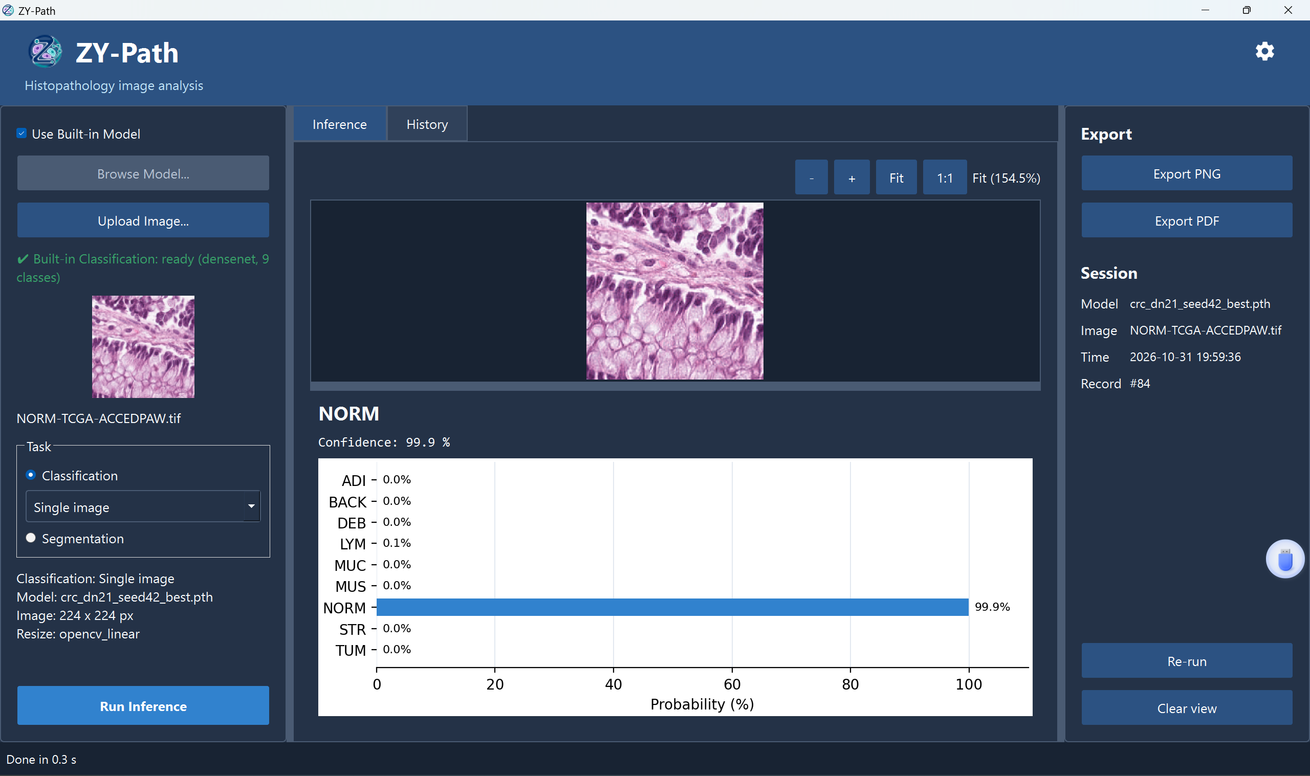
Figure 4.1. Windows application overview, 31 October 2026: Single image classification of a 224 × 224 patch, NORM at 99.9%, record #84, with OpenCV linear selected. Source: author’s Windows capture.

4.2.2 Classification results and spatial inspection
Single-image classification retains the original whole-image label, confidence and probability-bar chart. Tiled analysis produces a source-sized class-colour map, default overlay, nine-class coverage cards and detailed per-tile labels/confidences. The source tile width and height are editable, and the main panel explicitly shows Single image or Tiled analysis before running. Class order and palette remain independent of segmentation.
In the current viewer, optional tile numbers identify the same one-based entry in the image, detail table and original-crop preview. The input summary displays the current Run dimensions and planned grid. Restoring an older result preserves its recorded geometry in the result panel while leaving current new-run preferences intact.
Figure 4.2 is a retained earlier Qt result-view capture using a deterministic synthetic fixture. It illustrates the grid, paired views and statistics placement. The fixture contains 49 tiles with 47 STR, one NORM and one MUC assignments. These are prescribed test data, not predictions on the coloured source pattern. Figure 4.3 provides separate actual-image Windows observations, including tile numbers and original-crop inspection.
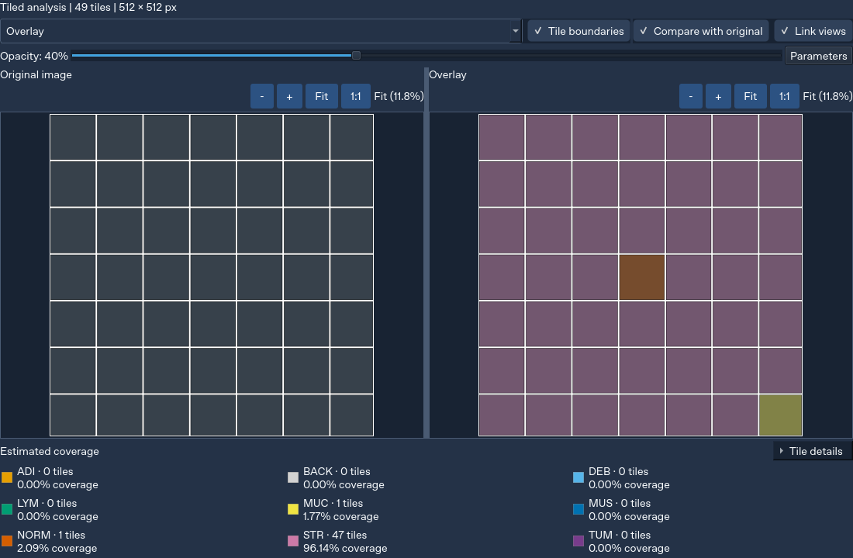
Figure 4.2. Tiled classification interface with source/result comparison and revised result toggles. Source: author’s Qt-simulated development capture; synthetic fixture, not a model result.
Figure 4.3(a–b) shows Single image and Tiled analysis for the same named 3552 × 3536 raster. The Single image result selects STR with 42.6% confidence. The tiled view reports 40 STR, five MUC, one MUS and three NORM tiles, with estimated area coverage 82.06%, 9.98%, 1.89% and 6.07%, respectively. Its 512-pixel source crops use RGB/raw255 and OpenCV linear resize to 224 × 224. Panel (c), from a separate analysis, identifies tile 31 as NORM at 59.47%, with rectangle [1024, 2048, 1536, 2560]. These observations demonstrate presentation and crop inspection; they do not supply ground-truth tile accuracy. The classification captures deliberately select OpenCV INTER_LINEAR, corresponding to the training script’s linear-resize choice; Pillow bilinear remains the application default and the backend of the independent evaluation in Section 4.2.6. Matching this resize choice does not establish physical-scale or stain matching.
Figure 4.3(a): Single image classification
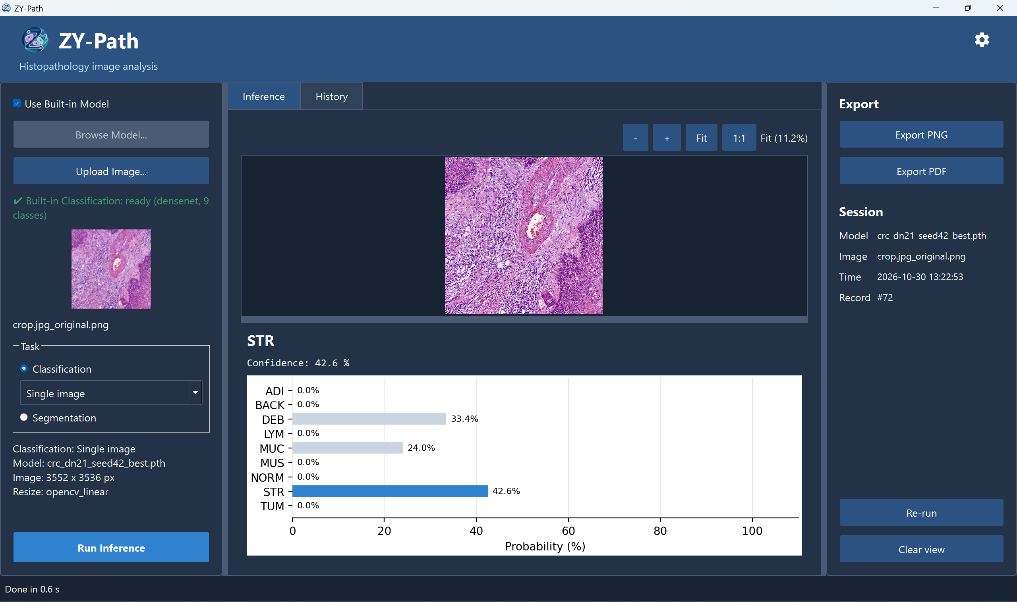
Figure 4.3 (continued): (b) Numbered tiled classification and estimated coverage
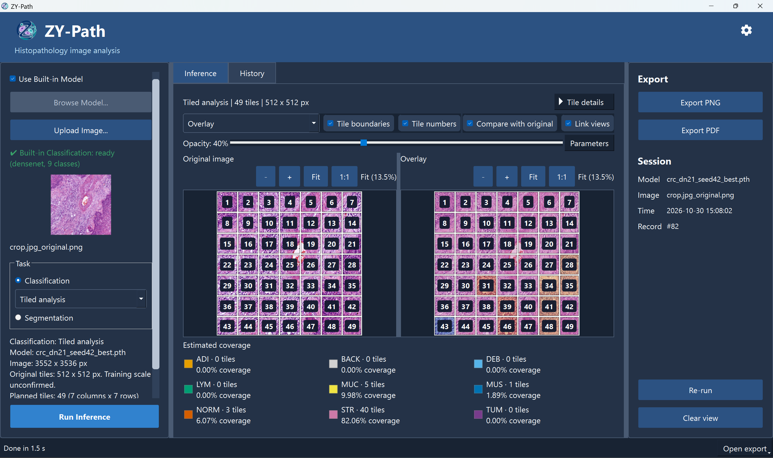
(c) Original-crop inspection from a separate recorded analysis
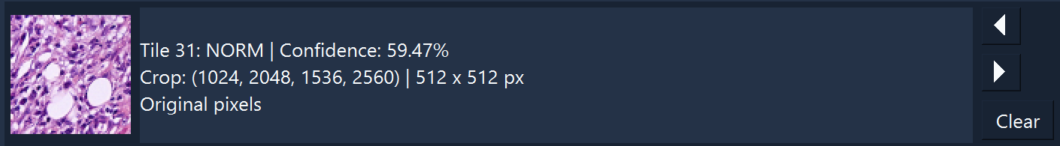
Figure 4.3. Windows classification workflow on a supervisor-provided breast-cancer raster: (a) Single image; (b) 49 numbered 512 × 512 source tiles; (c) crop inspection from the separate analysis #48. The CRC-trained classifier uses raw255 and OpenCV linear resize to 224 × 224. Source: author’s Windows captures.
The 3552 × 3536 breast-cancer raster in Figure 4.3 produces 49 crops at a 512 × 512 setting, with smaller right and bottom edges. Controlled tests verify unique source crops, RGB/raw255 preparation, class order, edge handling and area conservation. Applying the CRC-trained classifier to this image demonstrates the interface and sampling workflow; breast-tissue classification accuracy has not been evaluated. Its unknown physical resolution also prevents training-scale matching. The CRC patch results in Section 4.2.6 do not measure this tiled map.

4.2.3 Segmentation results
The segmentation result viewer now follows the same inspection pattern: an initial overlay without duplicate source preview, a pure segmentation map option, opacity control, optional original comparison and linked navigation. Its legend and restored-mask pixel counts use segmentation labels. Classification preferences do not alter its source tile/stride/input defaults.
The reference notebook establishes the segmentation architecture, preprocessing, labels and probability fusion. Figure 4.4 shows Windows record #86 dated 31 October, with the supervisor-provided UPerNet model and aligned source/overlay views. The visible statistics include 3,108,889 cancerous-epithelium pixels and 7,998,755 stroma pixels; the scrollable legend continues below the visible rows. Separately, the actual report/JSON records imagenet preprocessing, a 1000-pixel source window, stride 512, network input 224 and CPU execution. Its nine counts sum to 12,559,872 pixels, equal to 3552 × 3536. The report and screen show different analysis records; agreement of their counts is not an accuracy measurement. Annotated-mask evaluation remains unavailable (Section 4.5.3).
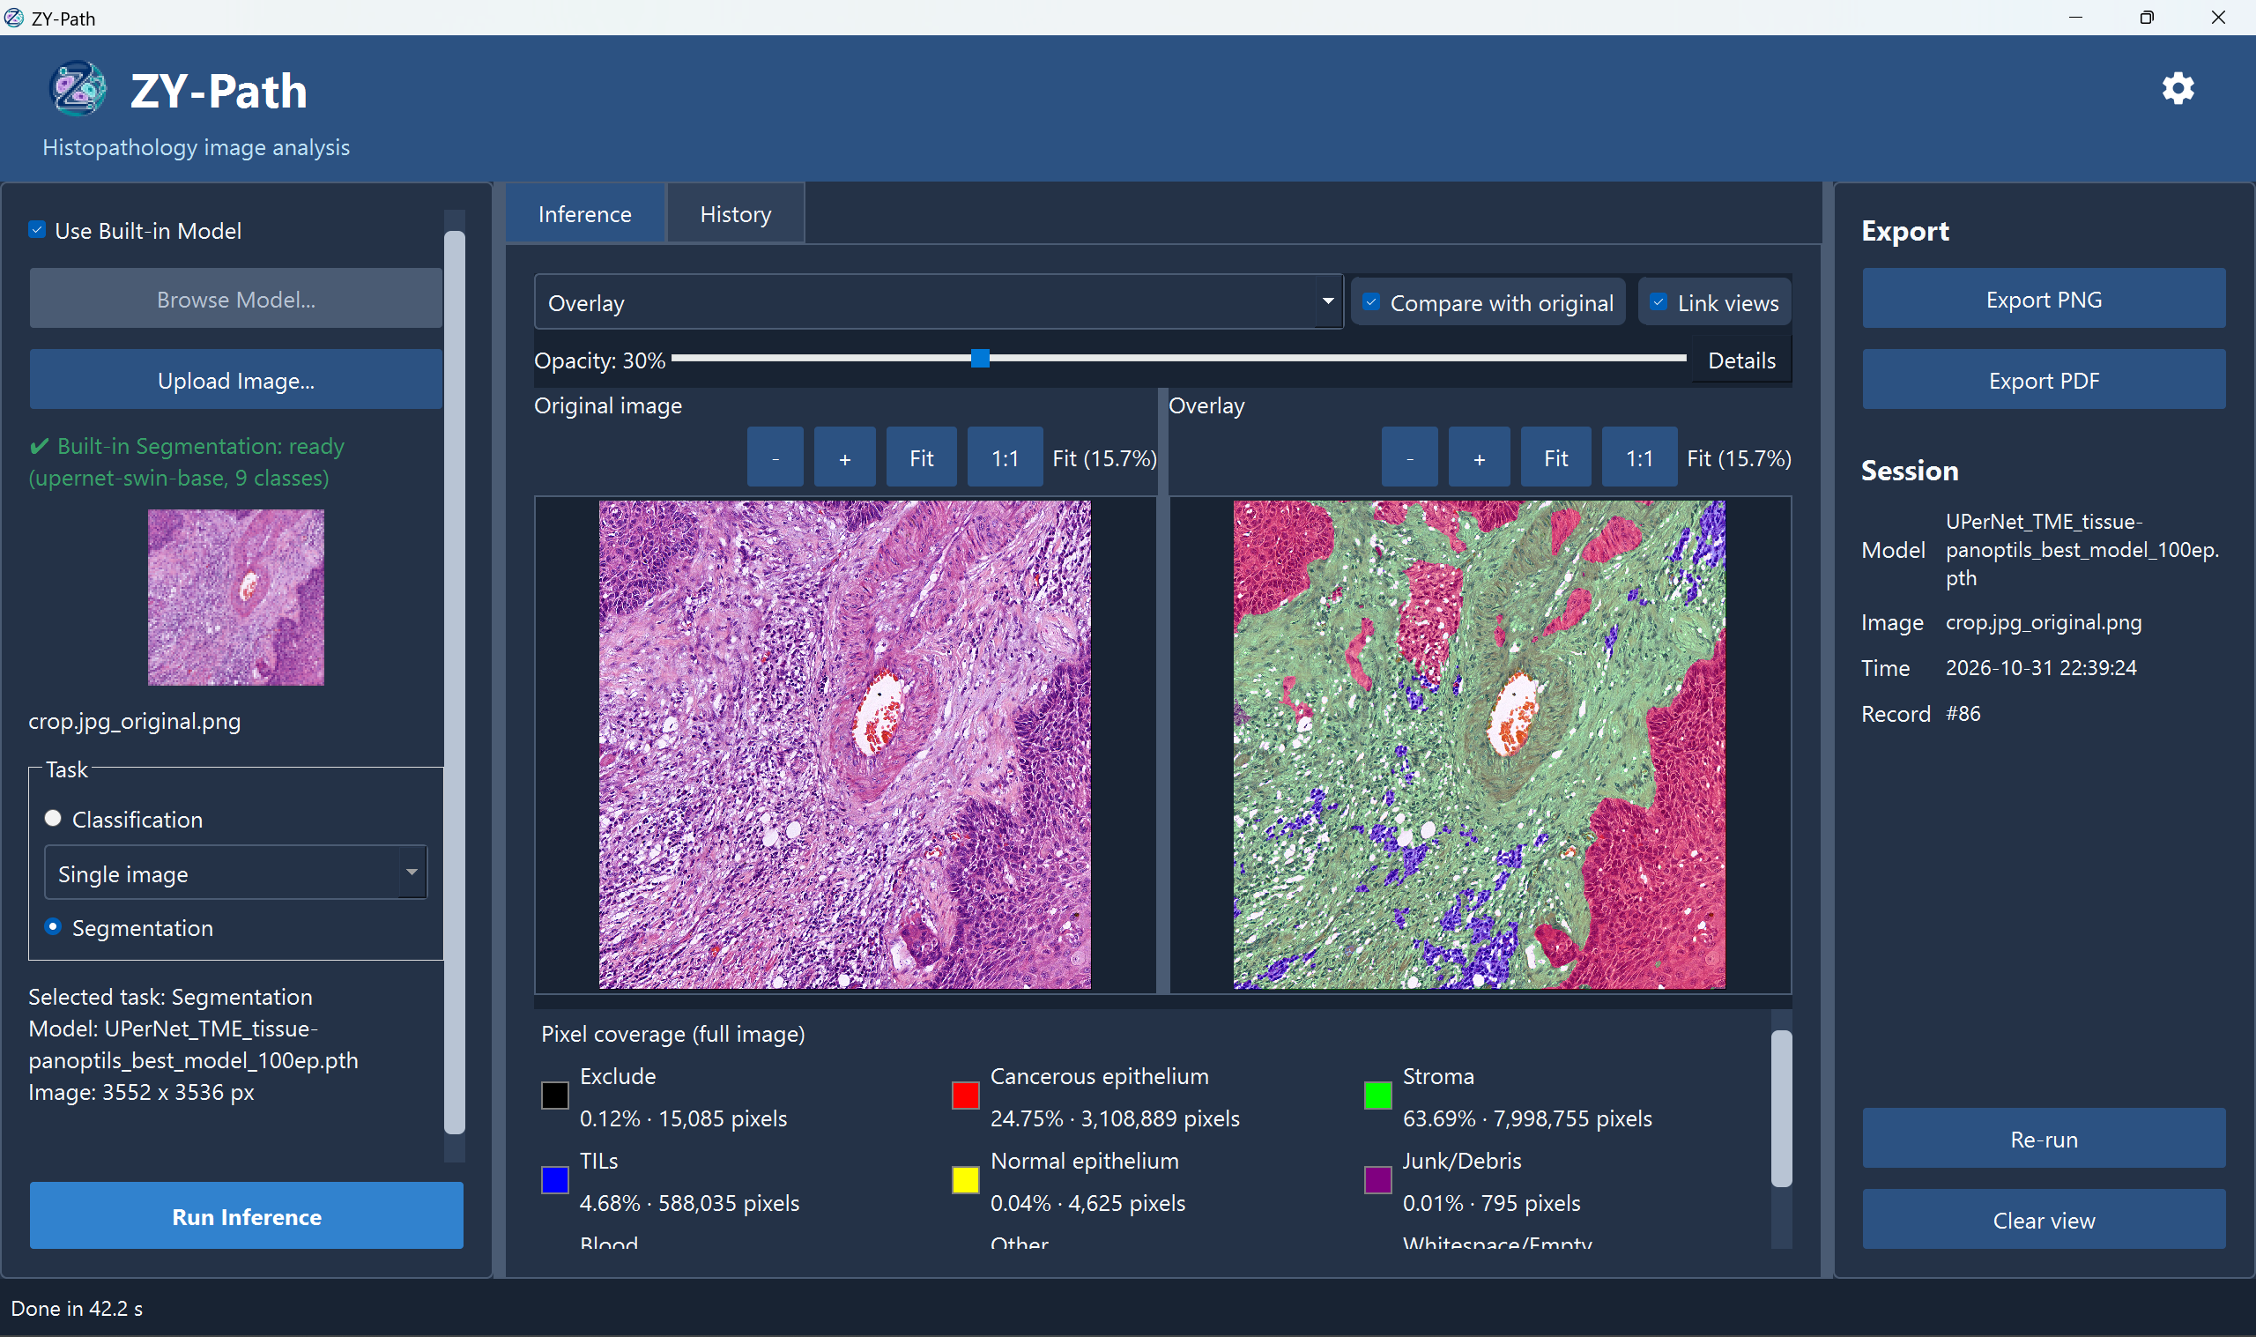
Figure 4.4. Breast-cancer raster comparison, 31 October 2026, record #86: 3552 × 3536 source, linked Fit views at 15.7% and opacity 30%, using the supervisor-provided UPerNet model. The pixel-coverage legend is scrollable. Source: author’s Windows capture.

4.2.4 History, rerun and export
History stores completed records and supports keyword/date filtering, restoration and a separate rerun action. A tiled-classification row reports tile count and the largest estimated class coverage; its Confidence cell remains “-” rather than implying a whole-image confidence. Detailed per-tile confidence is available when the result is restored. The internal aggregate remains available with its explicitly different PDF terminology. Figure 4.5 illustrates Windows history and recorded rerun.
Figure 4.5 documents parameter isolation on Windows. History contains both classification modes. The completed recorded Re-run #83 displays 512 × 512 source tiles and 49 tiles, while the current input summary remains at 256 × 256 and 196 planned tiles. Its parameter strip records 224 × 224 network input, raw255 and OpenCV linear resize. The separate ordinary Run #77 uses the current 256-pixel setting. Figure 4.6 shows the exported report and companion-file listing.
The current export implementation adds a background worker, cancellation and atomic replacement of completed PDF files. Standard and Original resolution settings distinguish sharing copies from full-pixel inspection. A controlled 2100 × 1500 synthetic texture/label fixture produced a classification report of 652,957 bytes in Standard versus 18,668,531 bytes at Original resolution, and a segmentation report of 652,071 versus 18,747,945 bytes. These measurements describe synthetic export fixtures, not model accuracy, a native Windows benchmark or a guaranteed Google Drive preview limit.
Figure 4.6(a–b) reproduces pages 1 and 2 of the same exported two-page PDF. The 875,021-byte Standard report identifies record #65, analysis time 25 October 2026 at 19:45:38 and export time 30 October 2026 at 14:43:26 +08:00. Its software version is 1.0, with CPU execution and the recorded source dimensions and segmentation parameters. Its export-time model hash matches the UPerNet resource identity in Appendix E; the report distinguishes that hash from historical inference identity. The companion JSON agrees with its timestamp and all nine pixel counts. Panel (c) lists a PNG whose original image file is not part of the companion materials.
Figure 4.5(a): History contains both Single image and Tiled analysis
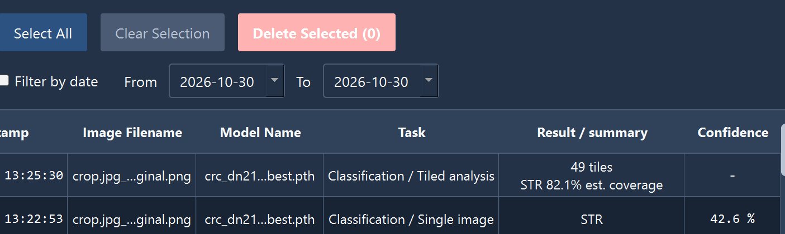
Figure 4.5 (continued): (b) Completed Re-run #83 and its parameter strip
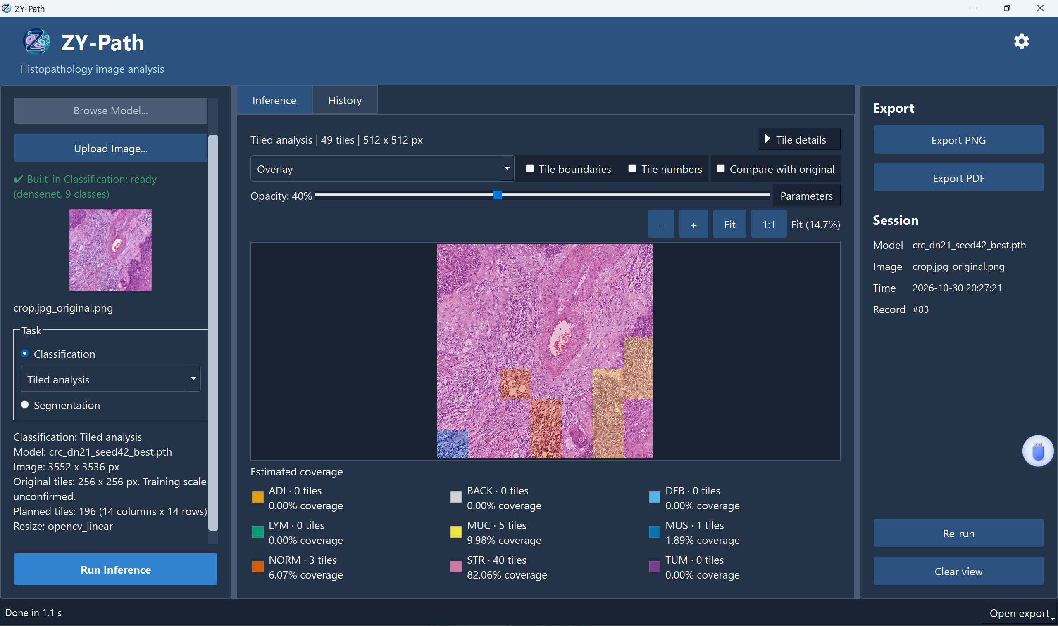
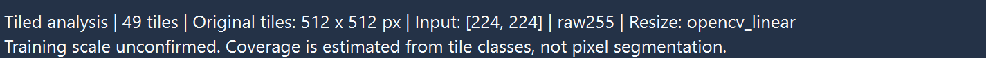
(c) Ordinary Run uses the current 256-pixel preferences
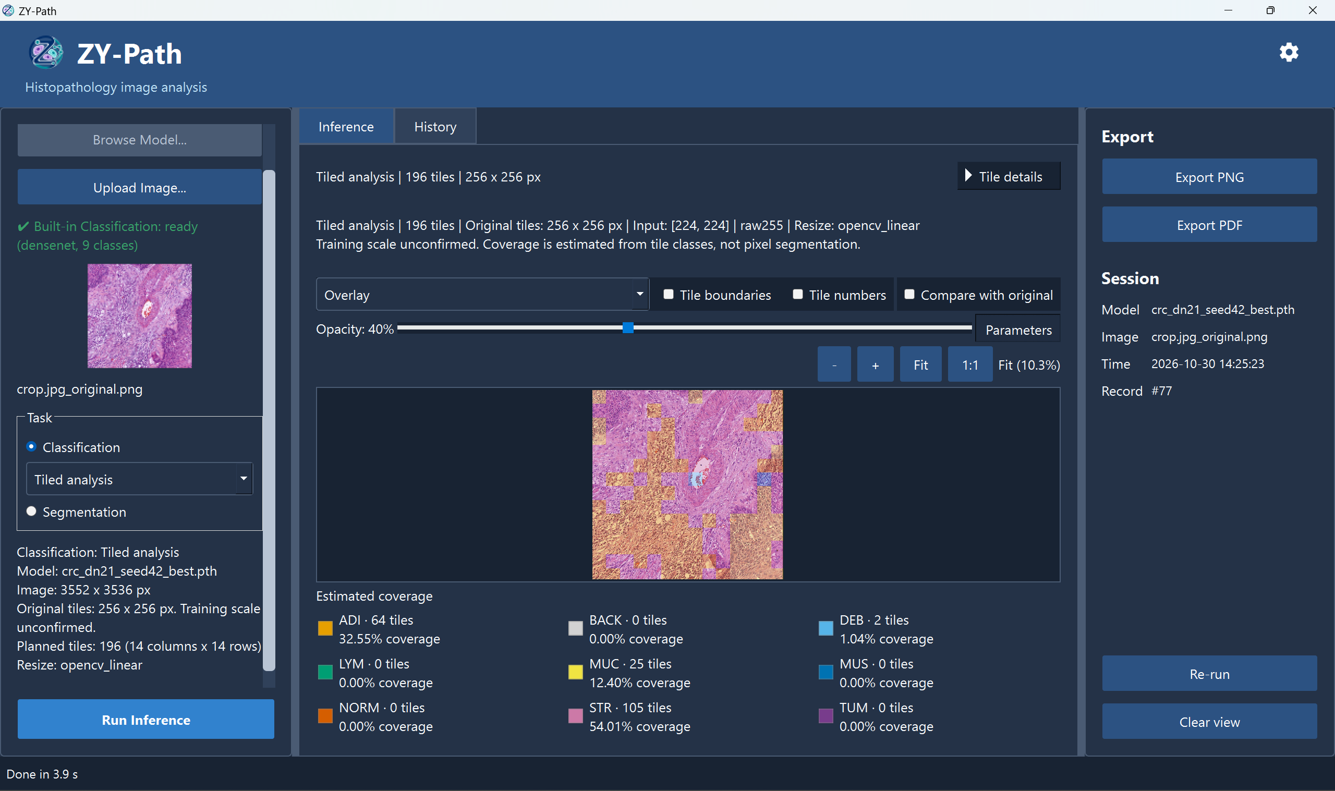
Figure 4.5. Windows parameter isolation: (a) History modes; (b) completed Re-run #83 with recorded 512 × 512/49 tiles and its parameter strip, despite current 256 × 256/196-tile defaults; (c) separate ordinary Run #77 with 256 × 256/196 tiles. Source: author’s Windows captures.
(a) Actual PDF page 1; (b) page 2 of the same PDF
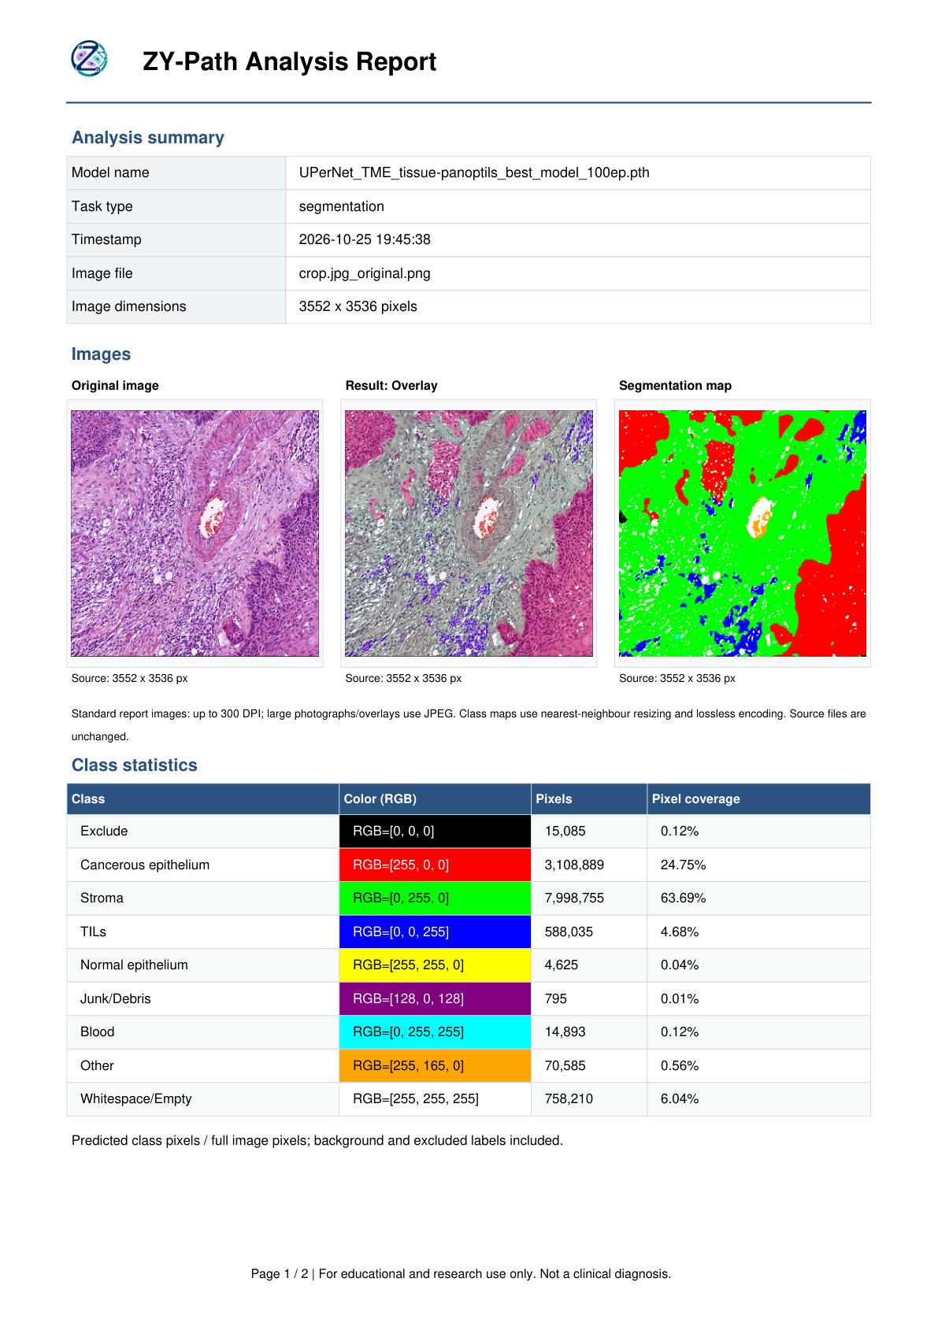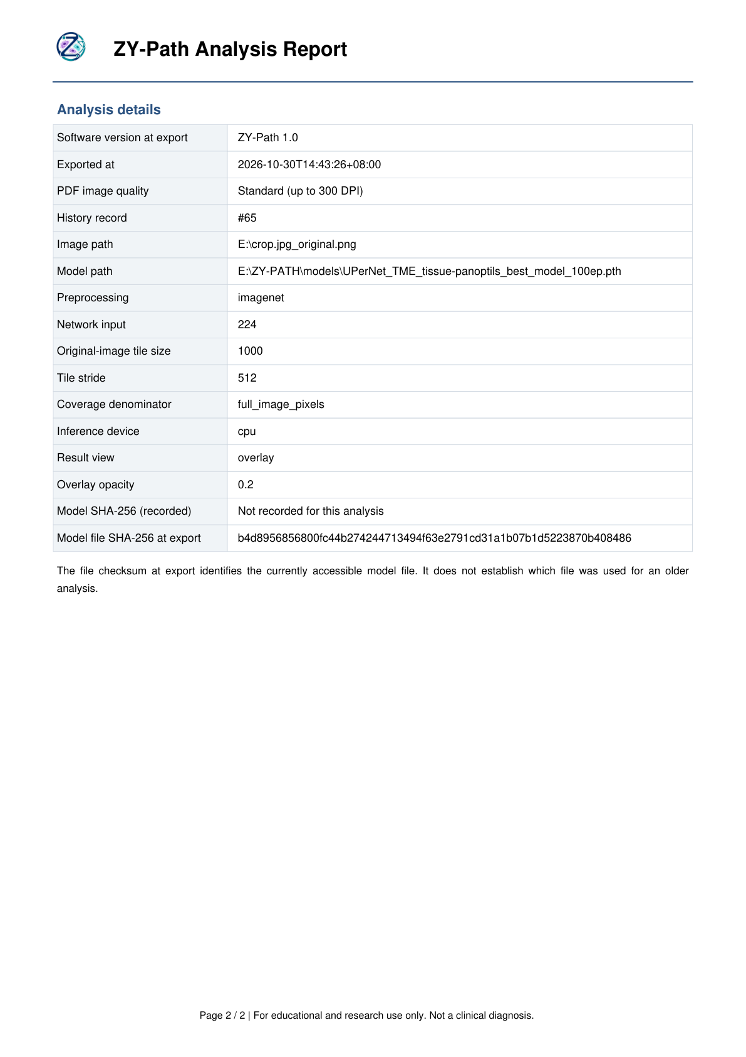
(c) Exported files listed in Windows
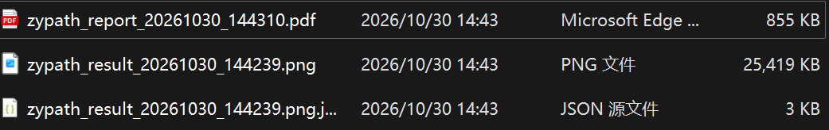
Figure 4.6. Pages 1–2 of the same actual Standard segmentation PDF and its Windows file listing. Record #65: analysis 25 October 2026, 19:45:38; export 30 October 2026. The listed PNG is not included in the companion materials. Source: author’s PDF, rendered faithfully, and file-list capture.

4.2.5 Settings, cancellation and interface polish
Settings includes Appearance, Preferences, Models, Guide & Support, System Information and About. Model defaults are independent per task and require validation. Preferences applies the classification mode immediately while retaining a separate startup default; closed dropdowns scroll the page instead of changing selections accidentally. Guide navigation remains visible and follows the current reading section, while the system-information copy confirmation expires rather than becoming permanent content. Figure 4.7 shows the implemented Guide & Support page and its navigation.
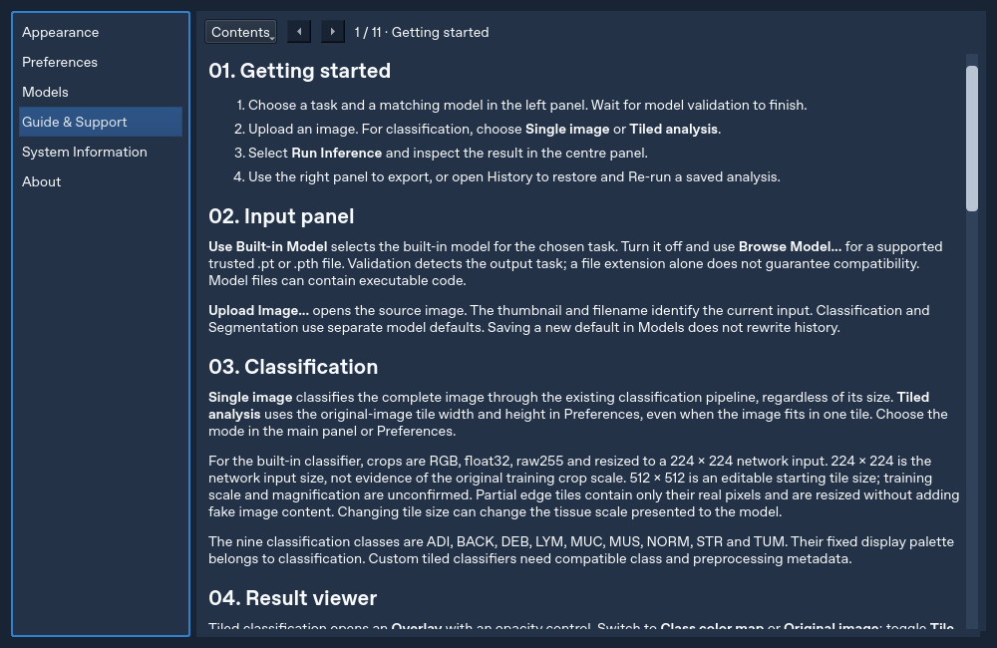
Figure 4.7. Implemented Guide & Support page with persistent Contents navigation and numbered guidance. Source: author’s Qt-simulated development capture; this is interface evidence.
The English calendar in Figure 4.8 was captured after setting the default locale to Chinese in a controlled run. The corresponding test opens each popup, checks English month/day labels, selects a date and verifies the unchanged date value and query signal.
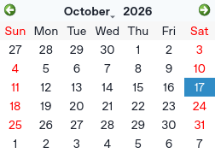
Figure 4.8. English history-calendar popup with a simulated Chinese default locale. Source: author’s Qt-simulated development capture; the selected date is test input.
Figure 4.9(a–b) contains two independent cancellation-related observations. Panel (a) shows classification progress at 228/400 while the Session panel displays completed record #79 at 14:32:35. Panel (b) shows “Inference cancelled. Previous completed results are unchanged,” with record #78 at 14:30:40; Segmentation is selected in the input controls while the retained result is classification. These are not a before/after pair from one demonstrated operation and do not establish database cleanup. Panels (c–d) demonstrate default configuration with the explicitly identified test model dummy_segmentation.pt and restoration of the built-in segmentation default; they do not measure trained-model predictive performance.
Figure 4.9(a): Classification progress; Session shows record #79
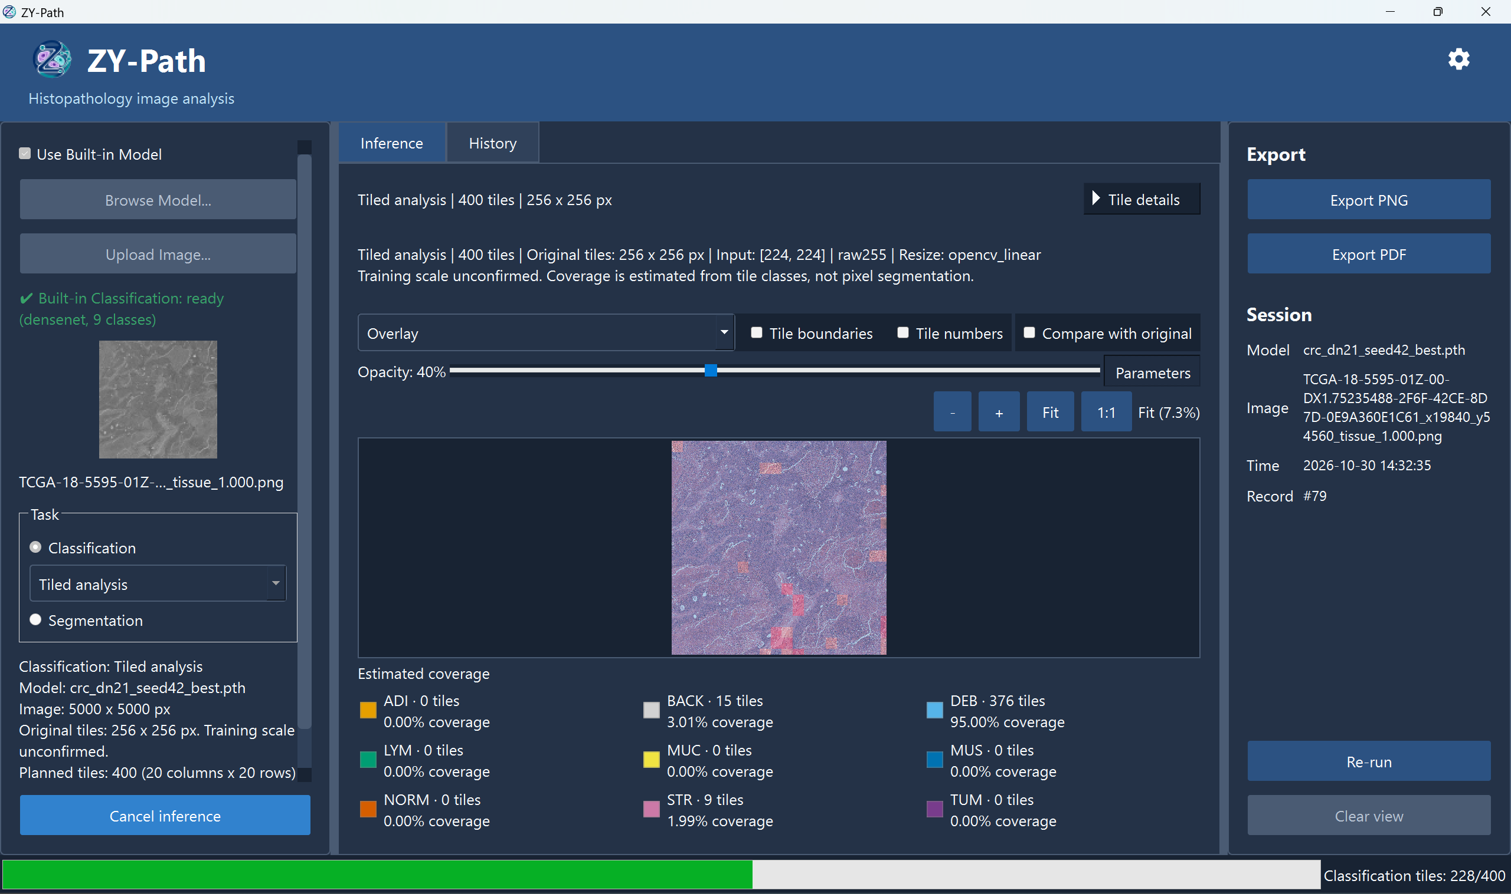
Figure 4.9 (continued): (b) Cancellation acknowledgement; Session shows #78
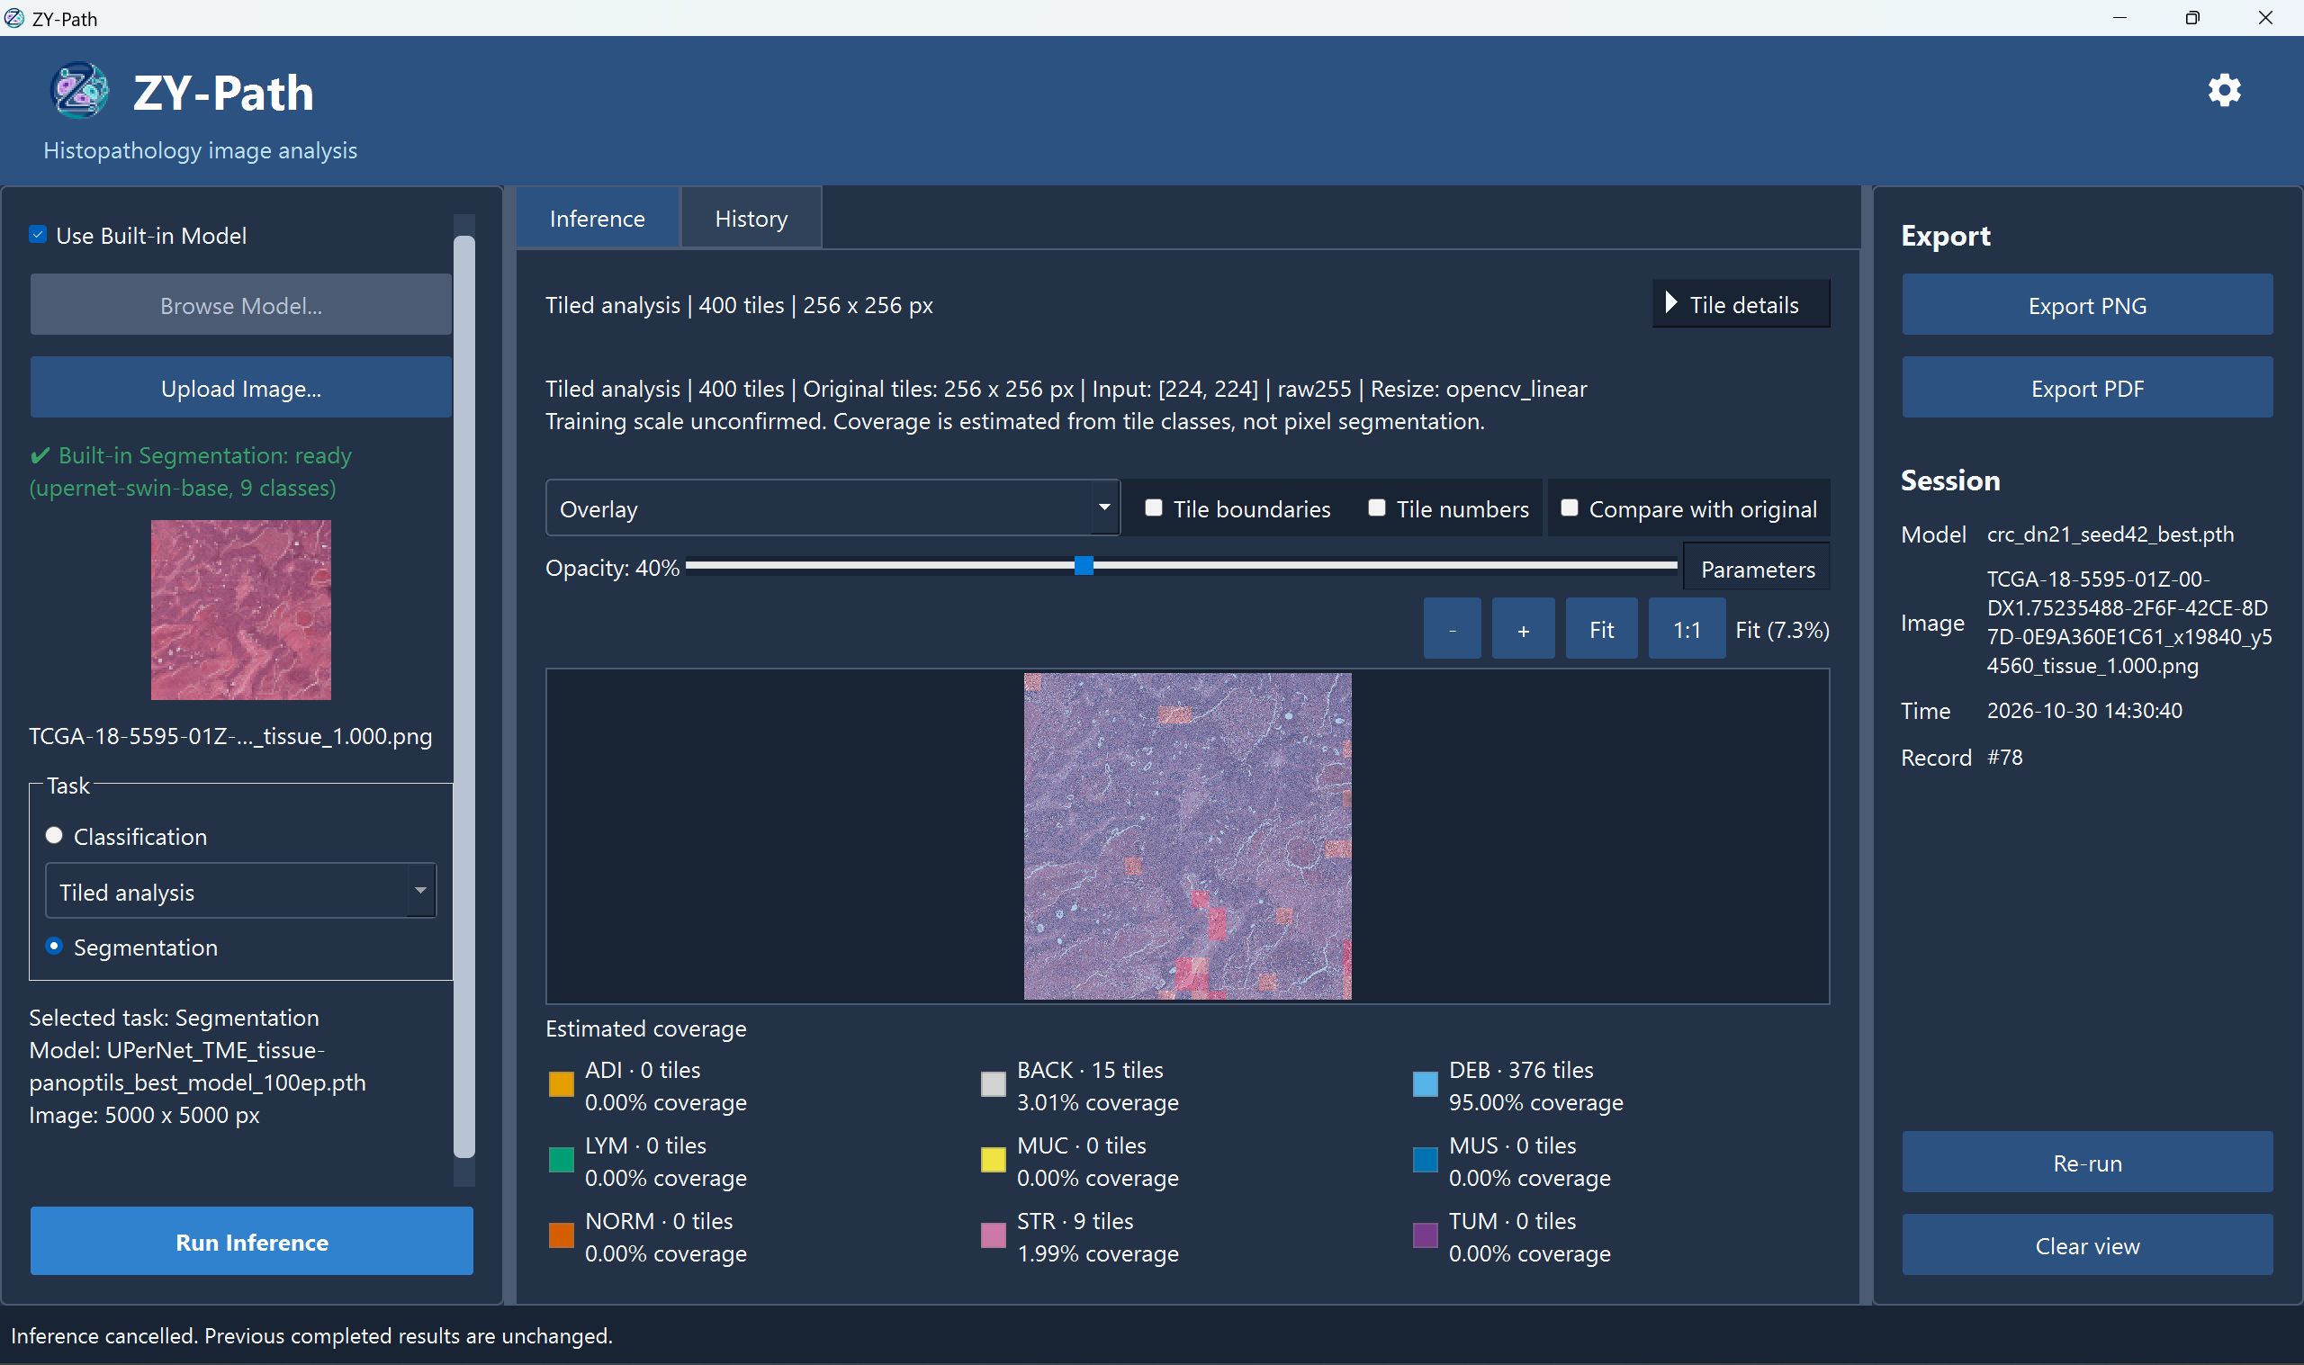
(c) Test-model default; (d) built-in segmentation default restored
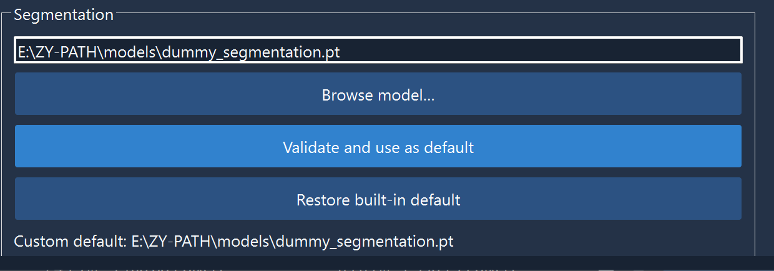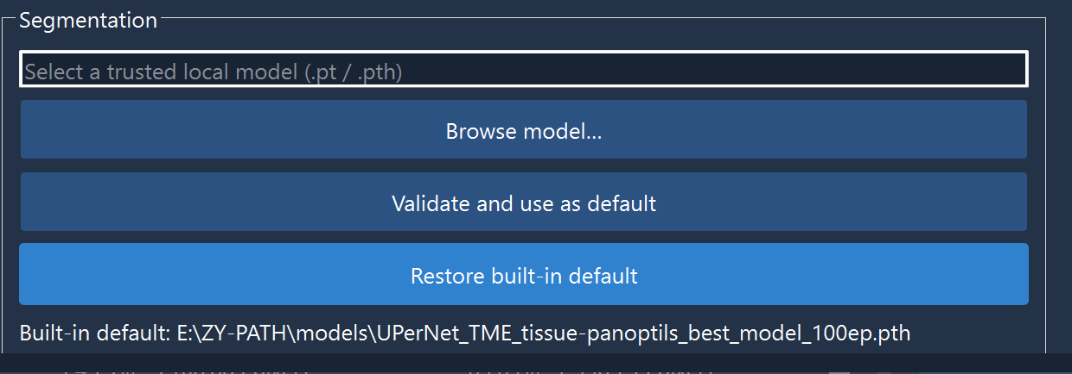
Figure 4.9. Independent cancellation-related views: (a) classification at 228/400 with Session record #79; (b) cancellation acknowledgement with record #78 and Segmentation selected. These are not one continuous sequence. Panels (c–d) show test-model default configuration and restored built-in default. Source: author’s Windows captures.

4.2.6 Classification training and test results
The formal experiment uses the seed-42 NCT-CRC-HE-100K manifests with 80,002 training and 19,998 validation images. Their hashes match config.json, and relative paths do not overlap. The training log identifies an NVIDIA L4. This training environment is separate from the CPU-only Windows application session.
The completed 30-epoch run selects epoch 26 by minimum validation loss (0.0275519), with validation accuracy 99.09% and macro-F1 99.09%. Continuation records establish the training history described in Section 3.3.2. Figure 4.10 illustrates the epoch-to-epoch variation in validation loss and accuracy.
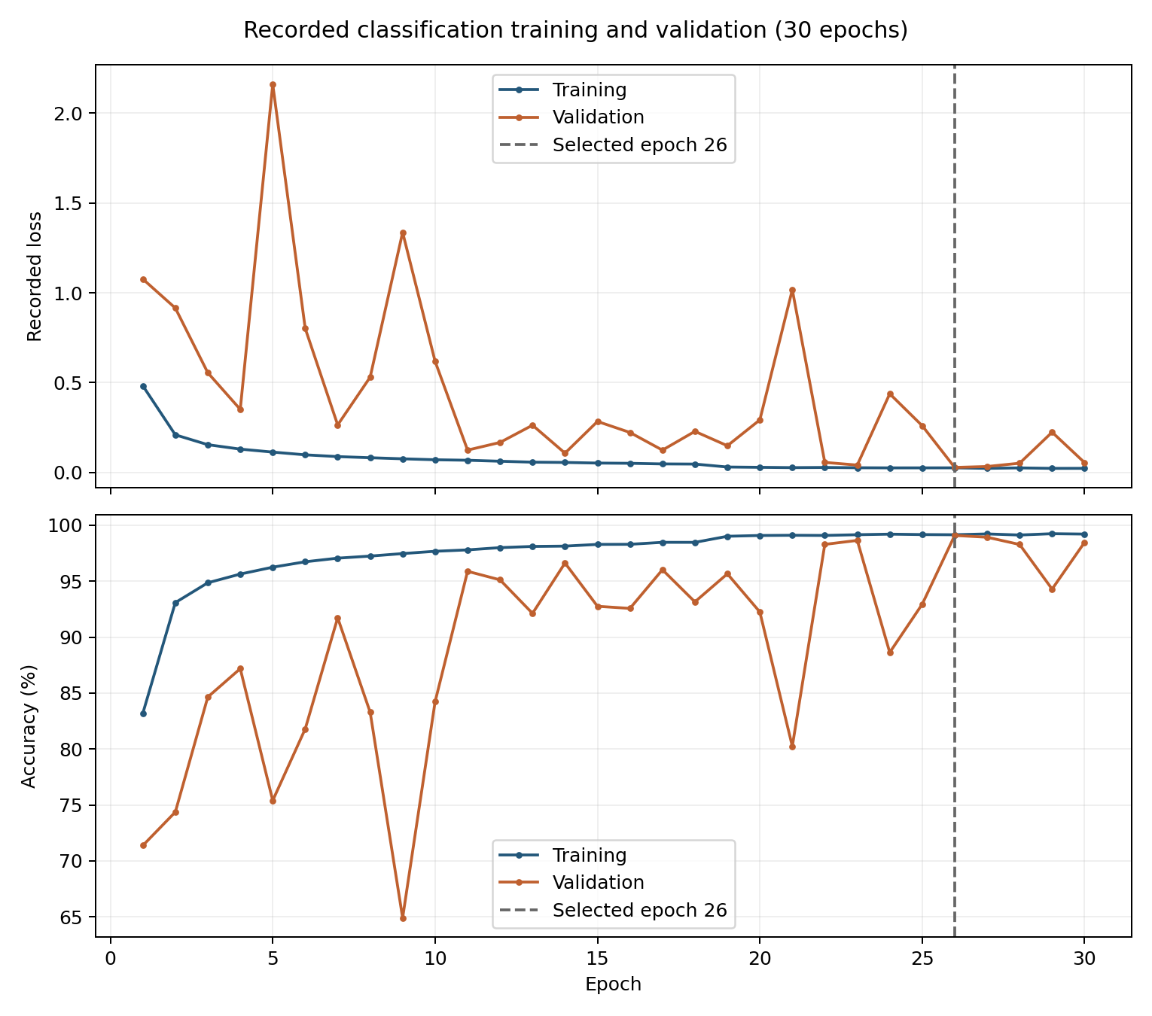
Figure 4.10. Classification training and validation over 30 recorded epochs, with the selected epoch 26 marked. Source: author’s plot of experiments/crc-dn21-seed42-10ep/metrics.csv.
Table 4.1 summarises the classifier’s training selection and external-test evaluation; Table 4.2 reports precision, recall and F1 for each class.
Table 4.1. Classification evaluation summary.
Measure | Recorded / recomputed result | Scope
Test collection | CRC-VAL-HE-7K; 7,180 images | Separate from the internal training/validation manifests
Correct / incorrect | 6,511 / 669 | Both runs: independently recomputed from their prediction CSVs
Test accuracy | 90.682451% | Original and default-Pillow runs: 6,511 / 7,180
Test macro-F1 | 0.885879 (88.59%) | Both runs; unweighted mean of nine class F1 values
Internal validation | 99.09% accuracy; 99.09% macro-F1 | Selected epoch 26; not the external test result
Checkpoint identity | Epoch-26 best_model.pth | SHA-256 matches summary.json; renamed for application use
Default application input | 7,180 native 224 × 224 RGB patches | Pillow; float32 raw255; CPU batch 1
Prediction agreement | 7,180 / 7,180 reference labels | Max probability difference: 0.002732
Original checkpoint size | 1,726,089 bytes (1.646 MiB) | Measured genuine classification checkpoint; no model conversion performed
Source: the classification experiment’s metrics.csv and test-7k outputs, together with the Windows default-Pillow evaluation of 19 October 2026. Per-image predictions from both runs reproduce the displayed aggregate results.
Table 4.2. Class-wise classification performance on 7,180 test images.
Class (support) | Precision (%) | Recall (%) | F1 (%)
ADI (1,338) | 97.43 | 84.90 | 90.73
BACK (847) | 98.83 | 100.00 | 99.41
DEB (339) | 79.76 | 98.82 | 88.27
LYM (634) | 95.17 | 99.37 | 97.22
MUC (1,035) | 96.59 | 93.14 | 94.84
MUS (592) | 61.24 | 73.14 | 66.67
NORM (741) | 90.21 | 94.47 | 92.29
STR (421) | 79.14 | 65.80 | 71.85
TUM (1,233) | 95.58 | 96.43 | 96.00
Source: class-wise reports and per-image predictions from the original evaluation and Windows default-Pillow rerun. Both runs give the same class counts and metrics; support is the number of true-class images. Displayed values are rounded.
Figure 4.11 shows the external-test confusion matrix, allowing the class-wise error patterns to be examined alongside the aggregate metrics.
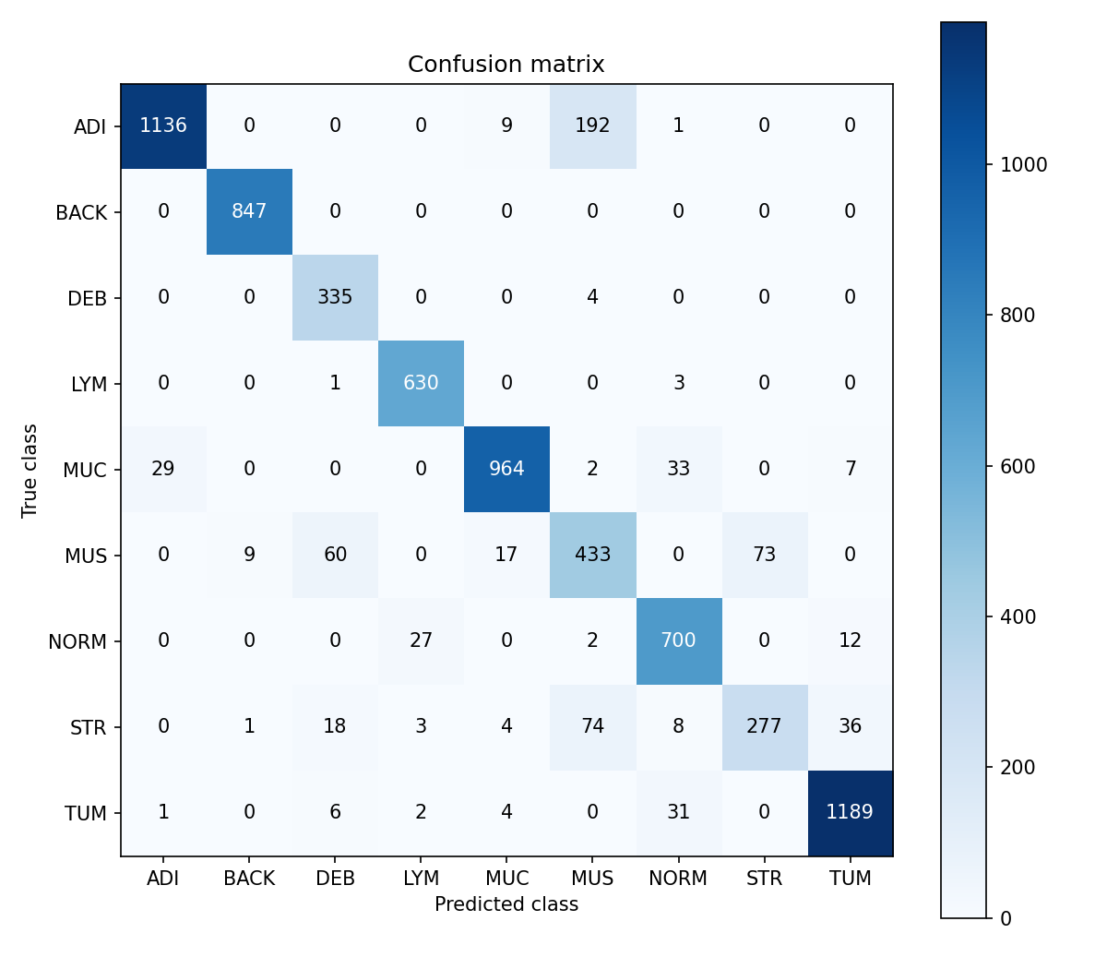
Figure 4.11. Nine-class confusion matrix for CRC-VAL-HE-7K. Source: the classification experiment’s saved matrix; the Windows default-Pillow predictions independently reproduce every count. Rows are true labels and columns predicted labels.
Performance varies substantially by category. BACK has F1 99.41%, while MUS and STR have F1 66.67% and 71.85%. The largest off-diagonal count is ADI predicted as MUS (192 images); MUS/STR confusion is bidirectional (73 MUS→STR and 74 STR→MUS). DEB recall is 98.82% but precision is 79.76%, showing that high sensitivity for one class can coexist with false positives. These differences justify presenting class-wise results alongside accuracy.
The selected-epoch validation accuracy exceeds external test accuracy by approximately 8.41 percentage points. Internal validation uses a stratified random patch-level split of the same 100,000-image pool as training, without patient grouping. In contrast, the CRC-VAL-HE-7K dataset documentation describes a test cohort of 50 patients with no patient overlap with NCT-CRC-HE-100K (Kather et al., 2018). The two estimates therefore assess different generalisation conditions. Class proportions also differ: ADI represents 10.41% of the 100K pool versus 18.64% of the test set, DEB 11.51% versus 4.72%, and MUS 13.54% versus 8.25%. These results do not isolate the contribution of patient grouping, cohort differences or class composition to the observed gap.
Training used NCT-CRC-HE-100K.zip, the standard Macenko stain-normalised release, rather than the separately distributed NONORM version (Kather et al., 2018). The dataset documentation specifies 224 × 224 pixels at 0.5 μm/pixel for both NCT-CRC-HE-100K and CRC-VAL-HE-7K. Stain normalisation of source images is distinct from raw255 or ImageNet numerical preprocessing of input tensors. Both validation and original test scripts use deterministic Resize, ToTensorV2 and float32 raw255; the Windows application-default Pillow rerun preserves every external-test predicted label. The observed score gap is not evidence of a stain-processing mismatch.
Both the class-wise results and the lower macro-F1 show that a global accuracy number alone is insufficient. The external test provides patient-independent patch evaluation according to the dataset design, while the internal validation score should not be interpreted as a patient-separated estimate. Patient-grouped internal validation and additional external cohorts would help assess how performance transfers across patients and collection conditions.
Both prediction CSVs contain 7,180 unique image paths with matching true labels, valid class argmax, maximum softmax score and probability sums. Recalculation gives 6,511 correct predictions, 90.682451% accuracy and 88.587944% macro-F1 for each run. Every class-wise metric and confusion-matrix entry agrees. The deployed classifier has the same checkpoint checksum as the original evaluated model; Appendix E records the execution configurations.
On 19 October 2026, I evaluated the labelled patches on Windows through the project’s ModelLoader, Preprocessor and OutputParser using the unchanged Pillow default, RGB float32 raw255, a 224 × 224 input and CPU batch size 1. All source patches were already 224 × 224. Input diagnostics against the installed OpenCV decoder and INTER_LINEAR produced zero tensor differences; the reference comparison retained all 7,180 predicted labels. Probability vectors were not identical: the maximum absolute probability difference was 0.002732. This comparison confirms native-sized patch predictions across the recorded runs, without establishing identical numerical output or resize behaviour at other source sizes.
The application-default Single image core therefore has a measured result on this labelled patch collection. Arbitrary 512-pixel source crops, tiled maps and physical-scale changes require their own ground-truth and scale design. These generalisation limits are discussed in Section 4.5.3.

4.3 Functional Testing Results

4.3.1 Recorded automated results
On 2 November 2026, revision d9fb8e5 completed all 548 collected tests on native Windows Qt: 548 passed, 0 failed, 0 errors and 0 skipped. The pytest summary reports 16 warnings and 224.89 seconds, with exit code 0. Table 4.3 presents this source-matched result. The recorded commit and source/resource manifests agree before and after the execution.
The completed invocation includes numbered tiles and original-crop inspection, Square, Clear view, background PDF export and quality selection, and current-preference Run versus recorded Re-run. The native Qt probe reported the windows platform. Programmatic regression completion is distinct from the real-image manual tasks in Appendix D and participant-based evaluation in Section 4.4.
Table 4.3. Complete Windows automated execution for the evaluated source.
Run / environment | Passed | Failed | Errors | Execution details
Windows, 2 Nov 2026; revision d9fb8e5 | 548 | 0 | 0 | 0 skipped; 16 warnings; 224.89 s; exit 0. Native Windows Qt; source and resources unchanged.
Source: the complete Windows log/XML, exit record and source manifests of 2 November 2026. Earlier Windows executions are listed separately in Appendix C.

The invocation ran without test-case selection or skipped cases. The 224.89-second value is the pytest console summary duration, not inference latency. The 16 warnings concern deprecated Matplotlib/Pyparsing, PyTorch TypedStorage and Hugging Face download interfaces. They did not prevent completion of the suite.
Table 4.4. Windows hardware record (19 October) and test runtime (2 November).
Category | Recorded specification | Interpretation
Operating system | Microsoft Windows 11 Home Chinese Edition; 10.0.22621, Build 22621; 64-bit | Windows Python/Qt environment; native acceptance assessed separately
CPU | 13th Gen Intel Core i9-13900HX; 24 cores; 32 logical processors | PyTorch CPU threads: 24
Memory | 15.81 GiB physical RAM | Physical system memory
Installed GPU | NVIDIA GeForce RTX 4060 Laptop GPU; driver 32.0.15.6094 | Installed hardware only; not used for these runs
Actual compute | PyTorch 2.1.2+cpu; CUDA available=False | CPU execution; no GPU acceleration claim
Python/test stack | Python 3.10.22; pytest 9.1.1; pluggy 1.6.0; anyio 4.15.1; pytest-qt 4.5.0 | Versions from the Windows test record
GUI stack | PyQt5 5.15.11; Qt runtime 5.15.2; Qt compiled 5.15.2 | 2 Nov: native windows Qt platform confirmed. Earlier 19 Oct display/DPR measurements remain separate observations.
Source: hardware recorded on 19 October 2026 and runtime/dependency records from the completed 2 November invocation, collected on the same Windows computer. The later collection did not remeasure RAM or GPU specifications; its runtime probe confirms CPU execution.
Figure 4.12 reproduces selected lines from the completed 2 November Windows pytest log at revision d9fb8e5; it is a test-log excerpt rather than an application screenshot.
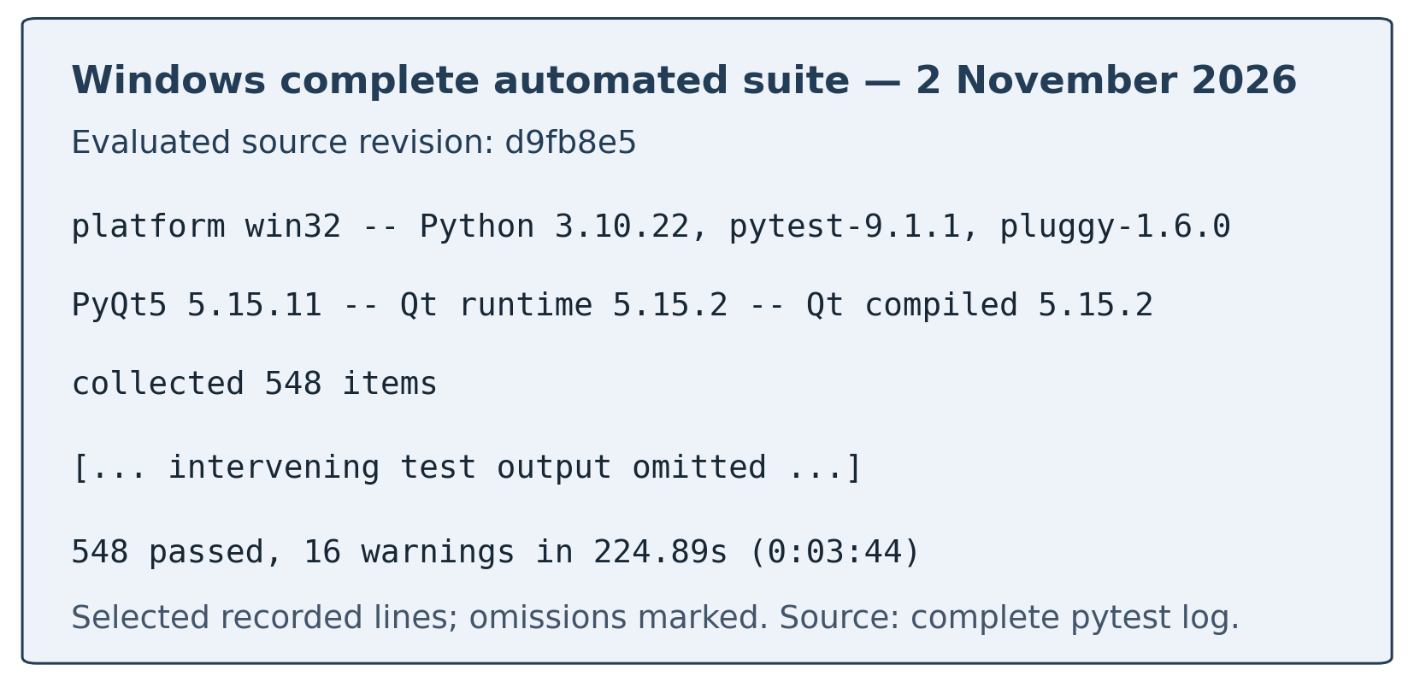
Figure 4.12. Complete Windows pytest report, 2 November 2026, revision d9fb8e5. Source: the recorded full-suite log; selected text is reproduced with omissions marked.
The current Windows suite passed its genuine built-in-model availability assertion and the history, rerun, worker-lifetime and layout cases. Its resource manifest includes both production checkpoints. The separate classifier evaluation in Section 4.2.6 supplies predictive measurements; file availability and synthetic fixtures do not measure segmentation accuracy.
Earlier Windows iterations exposed missing training prerequisites, thread-lifetime faults, settings leakage and platform-dependent layout/path assumptions. The 2 November execution additionally exercises the correction for window-state event reentrancy and explicit Qt enter/move/hover input in the scrollbar tests. Revision d9fb8e5 completed all 548 cases. Table 4.5 summarises the resolutions; Appendix C retains the dated earlier outcomes and source differences.

4.3.2 Challenges, resolutions and evidence
Table 4.5. Implementation challenges, corrections and supporting evidence.
Challenge | Actual cause or risk | Resolution | Evidence and limit
Missing/incorrect classifier assumptions | CP1 ResNet/ImageNet description disagreed with implemented DenseNet/raw255 contract | Use the actual nine-class DenseNet/raw255 metadata, training records and class order | Windows default-Pillow patch accuracy 90.68%, macro-F1 88.59%; agreement measured on native 224 × 224 images.
Misleading tiled history confidence | Aggregate tile output could appear to be a whole-image label | Tile summary and estimated coverage; separate aggregate PDF terminology | History/export semantic tests; no prediction values changed
Fit grid lines disappearing | Fine rasterised grid could vanish when the large image was reduced | Paint vector grid after the image using the same transform | Source-coordinate/grid tests across Fit, zoom and resize
Comparison stayed stacked after widening | A side legend could shrink the comparison below its breakpoint | Keep segmentation legend below paired images | Repeated main-window narrow/wide regression for both tasks
Oversized/clipped windows and settings | Child minimum sizes and wrapped-text sizing constrained the layout | Logical screen bounds, inner scrolling, measured legend/card sizes and pinned action space. | Automated small-screen/font and maximise/restore cases passed at d9fb8e5; relevant manual checks passed at fbe152a.
Tight focus box and unreliable label/padding clicks | Global focus border and native checkbox hit region differed | Stable rounded surface; full-rectangle hit area; keyboard-only focus cue | Mouse edge/text/padding, disabled and Tab/Space tests in both themes
Accidental preference changes by wheel | Closed combo boxes consumed scroll as selection input | Explicit selection; wheel forwarded to page scrolling | Popup/keyboard/wheel integration tests
Unclear cancellation/default ownership | Late worker results or current defaults could affect a record | Cooperative stop/late-result rejection; per-task defaults and recorded rerun | Cancellation/default/rerun tests with temporary artifacts
Calendar followed local language | Date popup inherited locale-dependent text | Explicit English locale for editors and calendars | Actual popup/day selection under Chinese default locale
Worker destroyed during model loading | Forced parent deletion bypassed deferred close while a QThread was still running | Wait for worker completion before destroying child threads; retain asynchronous normal close | Native fatal message identified the original cause; worker-destruction regressions also passed in the current 548-case Windows suite.
Validation callback accessed deleted controls | Queued lambda outlived its owning window or settings page | Use QObject-bound receivers disconnected with their owner | Six successful/error callback lifecycle cases passed for built-in, custom and task-default validation.
Run/Re-run clipped in short viewports | Right-side inner scroll-area height hint enlarged the full three-panel splitter | Allow vertical shrinking of scrolling content; retain pinned action space | 16/30px-scrollbar compact-body regressions and the original 480 × 360 Windows case passed.
Tile preference appeared to be ignored | History/re-run metadata remained in the input-panel cache; unchanged widget values emitted no refresh | Ordinary Run reads current preferences; only recorded Re-run supplies old parameters; finish/restore refresh the new-run summary | Current Windows preference-lifetime cases passed with actual crop boxes, current values and recorded rerun geometry.
PDF size and blocking export | Full image pixels embedded in small report panels; report generation was synchronous | Export-only display copies, Standard/Original resolution, task-preserving report metadata and cancellable atomic background generation | Current Windows PDF encoding, complete-path, data-preservation, layout and worker-lifecycle cases passed; online preview and real-image captures require their own observations.
Comparison drag/resize drift | Driver view was recentered during linked updates; viewport resize reused the wrong centre | Update the peer only, preserve source centre, proportional wheel zoom and rubber-band divider resizing | Automated Windows navigation and Fit/grid cases passed at d9fb8e5; W03/W04 passed at fbe152a.
Default settings affected unrelated tests | The organisation/application QSettings overload read saved native preferences, including Tiled mode and maximised state | Per-test INI settings and temporary application data; preserve ordinary preference persistence | Current Windows settings-sandbox, inference, history and window cases passed
Large-font controls and short action panel | Status text, scrollbar extent and implicit minimum-height hints consumed the available space | Upload before verbose status; reserve scrollbar width; aligned stacked tile inputs; compact pinned actions | Current Windows large-font, input-alignment and compact-body cases passed
Platform-dependent path representation | Windows audit messages used backslashes; PDF extraction added visual line breaks to long paths | Portable audit identifiers; retain exact path assertions after removing CR/LF layout characters; add a Windows path case | Current Windows build-input and complete segmentation-report path cases passed
Reentrant native window-state events | Native event dispatch could invalidate the event wrapper before later state access | Snapshot event type and previous state before parent dispatch and logging; use the saved values after reentrancy | Eight new event-lifetime/transition cases and the native maximise/restore case passed in the 548-case Windows execution.
Scrollbar hover test input and image sampling | Grabbed-image pixels use physical coordinates; native cursor movement did not always deliver Qt enter/hover events | Map logical sample points through image DPR and send explicit enter/move/hover input; retain exact colour, press, drag and disabled-state assertions | All four Light/Dark and horizontal/vertical cases passed in the complete native Windows execution. These are programmatic Qt input tests, not a human pointer-usability study.
Source: implementation changes and named regression cases in the complete Windows suite of 2 November 2026, with earlier records identified in Appendix C.

The corrections preserve the required behaviours. Test-only QSettings isolation removes dependence on saved user preferences without changing production storage. The PDF path check still requires the complete recorded path, allowing only extracted carriage-return and line-feed layout characters, and adds a Windows-path case. No test was deleted or skipped. Appendix C identifies the saved before/after diff; classification performance is reported separately in Section 4.2.6.

4.3.3 Windows startup and window-state observations
Windows source execution recorded successful loading and validation of the built-in classifier at approximately 14:23 on 19 October 2026. Loading completed from the checkpoint; validation identified DenseNet, classification, nine classes and output shape (1, 9), and the main window accepted the model. The later default-Pillow evaluation completed 7,180 real-patch predictions (Section 4.2.6).
The 19 October source-startup session reported devicePixelRatio=2.0 and availableGeometry=[0, 0, 1280, 758] in Qt logical coordinates, with normal, maximised and minimised state entries. The separate 19 October automated Windows application reported DPR 1.0, logical DPI 168 and availableGeometry=[0, 0, 2560, 1516]. Each record is interpreted within its own Qt application; these logical values are not substituted for a measured physical monitor resolution.
The 2 November automated Windows suite at d9fb8e5 passed programmatic maximise/restore, saved-geometry, comparison/grid, compact-panel, navigation, metadata wrapping, task-progress, model-source and tile-preference cases. I subsequently checked the final revision fbe152a through the 15 real-file manual workflows in Appendix D, at 175% scaling and 2560 × 1600 resolution.
All 15 manual cases met their criteria. I observed window restoration and responsive comparison, aligned crop inspection, mouse/keyboard toggle behaviour, English date filtering, recorded-parameter rerun, safe cancellation and close, readable settings, report export, task-specific model defaults, missing-file handling and clearing without deleting saved data. The outcomes supplement the earlier automated regression. Figures 4.1, 4.3 and 4.4 retain their own record IDs and dates; the figures are not a continuous recording of this manual session.

4.3.4 Runtime and deployment verification status
Table 4.4 documents the Windows hardware and CPU runtime. A dedicated repeated latency or memory benchmark was not conducted. Test-suite duration and the classifier evaluation-loop duration are not used as inference-performance measurements; no quantitative speed or memory-efficiency claim is made.
The demonstrated delivery route is source execution. The repository contains a Windows PyInstaller specification, build script, genuine-resource preflight, bundled-configuration support and release-manifest generation. A completed version-matched distributable and clean-machine/offline acceptance are outside this evaluation.

4.4 User Acceptance Testing Results
This section reports the formative usability results from ten participants: SUS, 100 participant–task entries, feature-specific ratings and open-ended feedback. The analysis uses the corrected records described in Section 3.6.4. Findings concern the educational and research workflow, rather than diagnostic performance or a controlled comparison with another application.

4.4.1 Participant Demographics
Table 4.6 summarises the ten consenting respondents, their reported backgrounds and study display conditions. All SUS forms are complete, with no participant excluded after the confirmed consent correction.
Table 4.6. Participant profile and reported study conditions.
Characteristic | Result | Basis / scope
Consented / complete records | 10 consenting records; 10 complete SUS forms; 0 exclusions after correction | Ten consenting participants with complete SUS forms
Participant role | Computing students 5; biomedical-science students 2; digital-pathology research assistant 1; biology educator 1; laboratory technician 1 | 10 participant profiles
Pathology experience | None 5; occasional 3; regular 2 | Self-reported
Programming/AI experience | None 1; basic 4; intermediate–advanced 5 | Self-reported
Prior use of pathology tools | Prior use 4; no prior use 6 | Self-reported
Testing devices/display scales | Windows 11 study laptop; 150% display scaling reported for all 10 | Self-reported study display conditions
Source: participant response workbook and documented data corrections.

Five respondents are computing students, two are biomedical-science students, and the remaining respondents are a digital-pathology research assistant, a biology educator and a laboratory technician. Five report no pathology experience, three occasional experience and two regular experience. This mixed but small sample provides formative feedback; it is not representative of practising diagnostic pathologists.

4.4.2 Quantitative Results
Table 4.7 summarises SUS and task outcomes. The mean SUS is 74.50, sample standard deviation 10.66, median 72.50 and range 55.00–90.00. The inclusive-interpolation IQR is 11.88. These values describe perceived usability, not a task-success percentage.
Table 4.7. SUS distribution and participant-task outcomes.
Measure | Reporting rule | Result
Valid SUS responses | All ten items in 1–5 | 10 complete forms
SUS mean and standard deviation | Score each participant before averaging | Mean 74.50; sample SD 10.66
SUS median, IQR and range | Report alongside the small-sample mean | Median 72.50; IQR 11.88; range 55.00–90.00
Independent task completion | Independent / evaluable; also show planned denominator | 72/96 evaluable = 75.00%; 72/100 planned = 72.00%
Assisted completion | Report separately from independent success | 22/96 evaluable = 22.92%
Critical errors and assistance | Count using the predefined task rules | 2 critical-error entries; 34 assistance events
Excluded task entries | Retained separately from failures | 3 not attempted; 1 blocked; 96 evaluable of 100 planned
Source: participant records analysed using SUS scoring rules (Brooke, 1996); task denominators and exclusions are stated explicitly.

Of 100 planned participant–task pairs, 72 were completed independently, 22 with assistance and two unsuccessfully; three were not attempted and one was blocked by an application closure. The evaluable denominator is 96, giving 75.00% independent completion and 22.92% assisted completion. Independent completion across all planned pairs is 72.00%. Reporting both denominators prevents exclusions from obscuring the incomplete or blocked tasks.

4.4.3 Feature Usage and Ratings
Table 4.8 reports feature-specific ratings on the participant 1–5 ease/clarity ratings. Each mean is calculated from numerical responses only; blank ratings are retained as missing rather than converted into low scores.
Table 4.8. Feature ratings with response-specific denominators.
Feature | Rating basis | Result
Model selection | Numerical ease/clarity ratings | 4.40/5; n=10
Mode and tile settings | Numerical ease/clarity ratings | 3.80/5; n=10
Legend and statistics | Numerical ease/clarity ratings | 4.00/5; n=10
Tile details | Numerical ease/clarity ratings | 3.70/5; n=10
Comparison / linked views | 1 missing rating excluded | 4.33/5; n=9
Segmentation inspection | Numerical ease/clarity ratings | 3.60/5; n=10
History / rerun | Numerical ease/clarity ratings | 3.20/5; n=10
Export | Numerical ease/clarity ratings | 4.50/5; n=10
Cancellation / progress | 2 missing ratings excluded | 4.75/5; n=8
Settings / help | 2 missing ratings excluded | 4.13/5; n=8
Source: participant feature-rating records; 1 = very difficult/unclear, 5 = very easy/clear.

Cancellation/progress receives the highest available mean rating, 4.75/5 from eight respondents, followed by export at 4.50/5 from ten. History/rerun has the lowest mean, 3.20/5 from ten. Task outcomes reinforce this distinction: T07, contrasting recorded Re-run with ordinary Run, has three independent successes, six assisted successes and one unsuccessful attempt. Tile interpretation T03 has five independent and five assisted successes, indicating that technical availability alone did not make these concepts immediately clear.

4.4.4 System Performance and Acceptability
Acceptability for the stated educational/research use is Yes for four respondents, Maybe for five and No for one. This distribution is more cautious than the overall SUS mean alone suggests. The results indicate useful workflow components together with a continued need for guidance and clearer interpretation.
P09’s nominated long workload is recorded as blocked because the application closed, so cancellation could not be evaluated in that attempt. This is a recorded system problem, not a participant error. Two critical-error entries occur elsewhere: P05 initially exported a different record before receiving help, and P07 treated estimated coverage as ground truth in a task that ended unsuccessfully. These observations qualify any broad claim of error-free operation.
The workbook records 34 assistance events. Task elapsed times combine interaction and application waiting and were not collected as a controlled stage-level benchmark; they are not used to claim inference speed. Neither the SUS mean nor the positively rated cancellation controls establish long-run reliability or diagnostic safety.

4.4.5 Qualitative Feedback Analysis
The 60 open-ended responses were analysed using the recorded initial codes and theme labels, grouped around navigation, statistical interpretation, recorded versus current settings, feedback and reliability. Theme counts refer to distinct participants, and overlapping themes are allowed. This is a descriptive analysis by one analyst; independent dual coding and thematic saturation were not assessed.
Four respondents (P01, P02, P04 and P07) discuss tile-class coverage explicitly; their accounts include both understanding and initial confusion. P01 writes, “Tile coverage looked like an exact area until I read that it is estimated from tile classes.” Recorded versus current settings appears for P01 and P06, consistent with the six assisted T07 completions. The learnability and guidance themes involve P02, P03, P05, P07 and P08. P07’s negative case is retained: “No, not without a tutorial; too many new concepts at once.” P09 highlights long-workload reliability. P05 and P10 are not quoted because they withheld quotation permission.
The findings prioritise clearer coverage explanations, more explicit Run/Re-run distinctions, easier first-use guidance and investigation of the reported long-workload closure. Export identity and keyboard navigation also merit further review. These are recommendations from the participant responses, not claims that new fixes have already been implemented or tested.

4.5 Discussion

4.5.1 Achievement of Research Objectives
Table 4.9 maps each research objective to the implemented outcome and the evidence available for assessing its achievement.
Table 4.9. Objective achievement and evaluation scope.
Objective | Implemented outcome | Evidence-based assessment
O1: local no-code workflow | PyQt5 application, background CPU work and cancel | Local PyTorch CPU workflow implemented; the source-matched Windows suite passed 548 cases. Clean-machine/offline delivery remains outside the completed verification.
O2: model loading/validation | Supported formats, metadata reconstruction and probe checks | Current Windows loader, task-default and genuine built-in-path cases passed. Structural compatibility is distinguished from model-specific predictive performance.
O3: inference tasks | Whole-image/tiled classification and segmentation | Default-Pillow patch evaluation remains 90.68% accuracy / 88.59% macro-F1 on 7,180 patches. Actual Windows captures demonstrate Single image, 49-tile classification and supervisor-model segmentation; tiled accuracy and segmentation ground truth remain unevaluated. Relevant manual checks passed at fbe152a (Appendix D).
O4: result inspection | Charts, overlays, legends, spatial detail and linked comparison | Inspection software checks passed; mean SUS 74.50/100. Tile interpretation T03: 5 independent and 5 assisted completions; feature-specific ratings are in Table 4.8.
O5: export | PNG/PDF with task-specific metadata/artifacts | Automated export cases passed; Figure 4.6 and the exported PDF/JSON add real report evidence. The 875,021-byte Standard PDF is one export observation, not a general performance benchmark. W10/W15 passed at fbe152a.
O6: persistent records | SQLite and saved analysis/presentation artifacts | Current Windows persistence, clear-view and history/source-preservation cases passed. Immutable per-run file identities, backup and recovery remain further work.
O7: retrieval/rerun | Search, local-date filter, restore and recorded rerun | Automated retrieval/rerun checks passed. T06: 9 independent/1 assisted; T07: 3 independent/6 assisted/1 unsuccessful. User-facing restoration is available, but rerun semantics need guidance; no causal efficiency claim.
Source: implementation and dated automated/manual Windows records, classifier evaluation and the corrected participant response dataset.

The implementation makes task/mode, source crop versus network input, resize backend and coverage semantics visible. Numbered inspection, navigation, export and separation of current preferences from recorded rerun support this workflow. The patch evaluation supplies a classifier result, while the dated automated Windows regression and final-source manual acceptance provide complementary software verification.
H1 is supported by implemented workflows, software checks and participant completion records. H2 receives qualified support from the SUS distribution and positively rated inspection features, while interpretation errors and assistance show remaining difficulty. The technical component of H3 is supported by restoration tests, but its user-facing component is mixed: T06 retrieval has nine independent completions, whereas T07 recorded-rerun interpretation has only three. No comparator was used, so reduced effort or improved efficiency is not established causally.

4.5.2 Comparison with Existing Solutions
ZY-Path is narrower than QuPath, Slideflow and Cytomine in whole-slide, annotation, training and collaborative functionality. Its value lies in a focused local arrangement of model-aware inference, spatial presentation and persistent per-run records. WSInfer provides a clear precedent for accessible pretrained-model use; the contribution here is the particular desktop workflow and its tested state semantics, not the invention of no-code pathology inference.
No comparative trial, installation-time study or task-time benchmark against another platform was carried out. It is therefore inappropriate to claim that ZY-Path is faster, more accurate, more usable or uniquely reproducible. A future comparison should use matched tasks and intended users, document the configuration of each tool and include the capabilities that the current project omits.

4.5.3 Limitations and Constraints
Classification performance is specific to its data and preprocessing. The 90.68% accuracy and 88.59% macro-F1 are reproduced by the original evaluation and the application-default Single image core on native 224 × 224 external-test patches. The dataset documentation identifies the external cohort as patient-independent from NCT-CRC-HE-100K; the internal training/validation split, however, is patch-based and does not enforce patient or slide separation (Kather et al., 2018). Its 99.09% validation accuracy may therefore be optimistic for cross-patient generalisation. The observed gap does not isolate a principal causal factor. Performance on arbitrary resized crops, different physical scales and tiled maps, together with calibration and content-duplicate checks, requires further evaluation.
Large raster tiling is implemented, but native WSI pyramid reading, physical-scale extraction and memory-bounded streaming remain outside scope. Full-resolution arrays and restored masks consume memory. The source datasets have a nominal resolution of 0.5 μm/pixel, but the application does not establish the physical resolution of arbitrary raster inputs. Its editable 512 × 512 classification starting value therefore has unverified training-scale equivalence, and rectangular edge crops are resized to the fixed network input.
Segmentation integrates a supervisor-provided model trained on breast-cancer data. I did not train the model, and the named training dataset, detailed training procedure and Dice/IoU report are unavailable. Figures 4.4 and 4.6 provide real-weight output and report examples. Neither these examples nor the controlled geometry/statistics tests measure segmentation accuracy; evaluation against authorised aligned ground-truth masks is still required.
The 548-case automated Windows result applies to d9fb8e5; my 15-case manual acceptance applies to fbe152a on one Windows computer at 175% scaling. The manual result does not establish behaviour at every display setting or replace a complete automated execution of the later revision. UAT adds ten participant records, including a blocked workload and two critical-error entries. The small mixed-background sample and absence of a comparator limit generalisation and causal conclusions. Assistive-technology compliance remains unassessed.
The demonstrated application runs through PyTorch on CPU. Dedicated repeated timing and memory measurements were not undertaken, so computational efficiency is not assessed quantitatively. Windows build tooling is implemented, but a version-matched distributable and clean-machine/offline acceptance are unverified; delivery demonstrated in this study remains source execution.
Model compatibility and provenance are constrained. Structural checks cannot guarantee semantic labels, calibrated confidence or safety of arbitrary serialised modules. Records reference mutable paths and do not provide immutable per-run identities, automatic backups, multi-user access control or an atomic transaction over external artifacts. These limits restrict the system to trusted-model educational and exploratory research use.

4.5.4 Implications for Future Development
The immediate empirical follow-up is to investigate the reported long-workload closure and repeat difficult interpretation and rerun tasks with a larger group of intended users under a recorded study build. Larger-crop and tiled predictive work requires separate authorised ground truth; usability findings do not establish biological generalisation.
Stronger provenance should then add immutable file identifiers, software/dependency manifests and versioned analysis schemas. A transactional artifact manifest and backup/recovery workflow would improve persistence robustness. Verified packaging should include model/configuration licensing, required local caches and a clean Windows test. Native accessibility/contrast checks and screen-reader feedback should inform further UI refinement.
Longer-term extensions include physical-scale-aware WSI reading, memory-bounded streaming, acceleration and explanation tools. Each requires its own datasets and validation. Classification maps and explanation views should retain distinct labels so that visualisation is not confused with validated biological findings.

4.6 Summary
ZY-Path implements model-aware inference, spatial inspection and record continuity. The documented classifier result is 90.68% accuracy and 88.59% macro-F1; automated Windows regression passed 548 cases at d9fb8e5, followed by 15 manual acceptance cases at fbe152a. The ten-response UAT yields mean SUS 74.50 (SD 10.66), with 72 independent and 22 assisted completions among 96 evaluable attempts. Interpretation, recorded rerun and long-workload reliability remain priorities; dedicated efficiency and packaged-deployment validation are outside the completed evaluation.

Chapter 5: Conclusion and Future Work

5.1 Conclusion
This capstone has developed ZY-Path from a CP1 proposal into a source-based desktop application for educational and exploratory histopathology image analysis. It combines compatible pretrained-model loading, CPU inference, graphical result inspection, local history and export through a PyQt5/PyTorch/SQLite implementation. The original objective of reducing the need to write inference code is addressed through a constrained graphical workflow rather than unrestricted model compatibility.
The implementation adds explicit single-image and tiled classification, independent segmentation presentation, numbered crop inspection, linked original/result navigation, task-specific defaults, cooperative cancellation and background PDF export with two quality settings. Ordinary Run reads current preferences, while recorded rerun restores its own snapshot. Clear view resets transient state without deleting history. These behaviours connect the interface to the meaning and provenance of each completed result.
The classifier evaluation produced 6,511 correct labels from 7,180 native-sized external-test patches, equivalent to 90.68% accuracy and 88.59% macro-F1. Software verification comprises the complete 548-case Windows automated regression at d9fb8e5 and my 15-case manual acceptance of the final source fbe152a at 175% scaling and 2560 × 1600 resolution. In the ten-participant usability dataset, mean SUS is 74.50 (SD 10.66); 72 of 96 evaluable tasks were completed independently and 22 with assistance. These results support the implemented educational/research workflow within the predictive, study-design and deployment limits in Section 4.5.3.
The research questions have qualified answers. A model-aware graphical inference workflow is implemented and usable components are reflected in the participant ratings. Technical restoration supports record continuity, while the difficult T07 results show that distinguishing recorded rerun from current-run settings still needs explanation. The absence of a comparator prevents a causal claim of improved efficiency, and the UAT does not validate tissue predictions.

5.2 Future Work and Recommendations
Further evaluation should add patient- or slide-grouped validation, authorised external cohorts and physical-scale-aware tile assessment. User evaluation should expand beyond this ten-person sample, retest the difficult coverage/rerun concepts and long workloads. Version-matched packaging and clean-machine checks remain engineering follow-up; dedicated CPU timing can be added if efficiency becomes an evaluation objective.
The usability findings identify specific changes for follow-up testing. Short guidance on estimated coverage and clearer Run/Re-run wording should be evaluated with first-time users, while long-workload stability should be checked against the reported closure. Follow-up tasks should record the application build and compare outcomes before and after any changes. A controlled comparison could then examine workflow differences against an established platform.
Reproducibility and deployment require a version-matched Windows build and clean-machine/offline acceptance using the implemented tooling, together with the required resource permissions. Per-run file checksums, dependency manifests, versioned metadata, artifact recovery and backups remain further work. An export-time checksum identifies the currently accessible file and does not establish which immutable weight file produced an older record.
Memory-bounded WSI reading, physical-scale metadata, optional acceleration, confidence calibration and explanation tools could broaden the application’s research scope. Their development would require additional datasets, explicit requirements and independent testing.

5.3 Research Contributions
The first contribution is a local classification workflow connecting supported PyTorch inference to a graphical interface and persistent analysis records. A separately integrated segmentation pathway broadens inspection options, with its evidence and evaluation limits explicitly distinguished from the trained classifier.
The second contribution is a practical separation of inference semantics in the interface and stored metadata. Whole-image classification, tile-class coverage and segmentation pixel coverage remain distinguishable. Source-crop geometry, edge areas, resize choices, class order and the unverified physical-scale equivalence of uploaded images are exposed rather than hidden behind a visually plausible output.
The third contribution is an implementation approach to inspection and state continuity: shared coordinate transforms, linked views, vector tile boundaries, responsive layouts, recorded rerun settings and safe cancellation preserve meaning across user actions. The named regression cases document defects that static screenshots alone had not been sufficient to assess.
The fourth contribution is an evaluation package linking requirements to named software tests, classification training/test outputs, Windows execution records and a ten-response formative usability analysis. It includes class-wise metrics, a confusion matrix, SUS scoring, separate independent/assisted outcomes and traceable corrections. The contribution is engineering integration and its bounded evaluation rather than a new neural architecture.

5.4 Summary
ZY-Path implements the central CP1 workflow and extends it with explicit spatial analysis, numbered inspection and stronger state/export management. The measured classifier result and dated Windows automated record support different aspects of the work. The source scope and remaining evaluations are defined in Sections 4.3.1 and 4.5.3.

References

I. Peer-Reviewed Journal Articles
[1] Bangor, A., Kortum, P., & Miller, J. (2009). Determining what individual SUS scores mean: Adding an adjective rating scale. Journal of Usability Studies, 4(3), 114–123.
[2] Bankhead, P., et al. (2017). QuPath: Open source software for digital pathology image analysis. Scientific Reports, 7, article 16878. https://doi.org/10.1038/s41598-017-17204-5
[3] Dolezal, J. M., Kochanny, S., Dyer, E., Ramesh, S., Srisuwananukorn, A., Sacco, M., Howard, F. M., Li, A., Mohan, P., & Pearson, A. T. (2024). Slideflow: Deep learning for digital histopathology with real-time whole-slide visualization. BMC Bioinformatics, 25, article 134. https://doi.org/10.1186/s12859-024-05758-x
[4] Kaczmarzyk, J. R., O’Callaghan, A., Inglis, F., Gat, S., Kurc, T., Gupta, R., Bremer, E., Bankhead, P., & Saltz, J. H. (2024). Open and reusable deep learning for pathology with WSInfer and QuPath. npj Precision Oncology, 8, article 9. https://doi.org/10.1038/s41698-024-00499-9
[5] Kather, J. N., et al. (2019). Predicting survival from colorectal cancer histology slides using deep learning: A retrospective multicenter study. PLOS Medicine, 16(1), e1002730. https://doi.org/10.1371/journal.pmed.1002730
[6] Litjens, G., et al. (2017). A survey on deep learning in medical image analysis. Medical Image Analysis, 42, 60–88. https://doi.org/10.1016/j.media.2017.07.005
[7] Marée, R., et al. (2016). Collaborative analysis of multi-gigapixel imaging data using Cytomine. Bioinformatics, 32(9), 1395–1401. https://doi.org/10.1093/bioinformatics/btw013
[8] Yen, P.-Y., & Bakken, S. (2012). Review of health information technology usability study methodologies. Journal of the American Medical Informatics Association, 19(3), 413–422. https://doi.org/10.1136/amiajnl-2010-000020

II. Peer-Reviewed Conference Papers
[9] Guo, C., Pleiss, G., Sun, Y., & Weinberger, K. Q. (2017). On calibration of modern neural networks. In Proceedings of the 34th International Conference on Machine Learning, Proceedings of Machine Learning Research, 70 (pp. 1321–1330). https://proceedings.mlr.press/v70/guo17a.html
[10] He, K., Zhang, X., Ren, S., & Sun, J. (2016). Deep residual learning for image recognition. In Proceedings of the IEEE Conference on Computer Vision and Pattern Recognition (pp. 770–778). https://doi.org/10.1109/CVPR.2016.90
[11] Huang, G., Liu, Z., van der Maaten, L., & Weinberger, K. Q. (2017). Densely connected convolutional networks. In Proceedings of the IEEE Conference on Computer Vision and Pattern Recognition (pp. 2261–2269). https://arxiv.org/abs/1608.06993
[12] Liu, Z., Lin, Y., Cao, Y., Hu, H., Wei, Y., Zhang, Z., Lin, S., & Guo, B. (2021). Swin Transformer: Hierarchical vision transformer using shifted windows. In Proceedings of the IEEE/CVF International Conference on Computer Vision (pp. 10012–10022). https://arxiv.org/abs/2103.14030
[13] Nielsen, J. (1994). Enhancing the explanatory power of usability heuristics. In Proceedings of the SIGCHI Conference on Human Factors in Computing Systems (pp. 152–158). https://doi.org/10.1145/191666.191729
[14] Paszke, A., et al. (2019). PyTorch: An imperative style, high-performance deep learning library. In Advances in Neural Information Processing Systems, 32. https://proceedings.neurips.cc/paper/2019/hash/bdbca288fee7f92f2bfa9f7012727740-Abstract.html
[15] Ronneberger, O., Fischer, P., & Brox, T. (2015). U-Net: Convolutional networks for biomedical image segmentation. In Medical Image Computing and Computer-Assisted Intervention – MICCAI 2015 (pp. 234–241). https://doi.org/10.1007/978-3-319-24574-4_28
[16] Tan, M., & Le, Q. V. (2019). EfficientNet: Rethinking model scaling for convolutional neural networks. In Proceedings of the 36th International Conference on Machine Learning, Proceedings of Machine Learning Research, 97 (pp. 6105–6114). https://proceedings.mlr.press/v97/tan19a.html
[17] Xiao, T., Liu, Y., Zhou, B., Jiang, Y., & Sun, J. (2018). Unified perceptual parsing for scene understanding. In Proceedings of the European Conference on Computer Vision (pp. 418–434). https://arxiv.org/abs/1807.10221

III. Books and Book Chapters
[18] Brooke, J. (1996). SUS: A “quick and dirty” usability scale. In P. W. Jordan, B. Thomas, B. A. Weerdmeester, & I. L. McClelland (Eds.), Usability Evaluation in Industry (pp. 189–194). Taylor & Francis.
[19] Gamma, E., Helm, R., Johnson, R., & Vlissides, J. (1994). Design Patterns: Elements of Reusable Object-Oriented Software. Reading, MA: Addison-Wesley.
[20] Kreibich, J. A. (2010). Using SQLite. Sebastopol, CA: O’Reilly Media.

IV. Magazine and Technical Articles
[21] Hunter, J. D. (2007). Matplotlib: A 2D graphics environment. Computing in Science & Engineering, 9(3), 90–95. https://doi.org/10.1109/MCSE.2007.55

V. Standards, Documentation, and Online Resources
[22] Aiforia. (n.d.). Aiforia Create. Product information. https://www.aiforia.com/aiforia-create
[23] fpdf2 Contributors. (n.d.). fpdf2: Simple PDF generation for Python. Project documentation. https://github.com/py-pdf/fpdf2
[24] Kather, J. N., Halama, N., & Marx, A. (2018). 100,000 histological images of human colorectal cancer and healthy tissue (v0.1) [Data set]. Zenodo. https://doi.org/10.5281/zenodo.1214456
[25] NumPy Developers. (n.d.). NumPy user guide. https://numpy.org/doc/stable/user/
[26] Pillow Contributors. (n.d.). Pillow documentation: Image processing and resampling. https://pillow.readthedocs.io/en/stable/
[27] PyInstaller Development Team. (n.d.). PyInstaller documentation. https://pyinstaller.org/en/stable/
[28] PyTorch Contributors. (n.d.). torch.load; inference_mode; serialization semantics. PyTorch documentation. https://pytorch.org/docs/stable/
[29] Riverbank Computing. (n.d.). PyQt5 reference guide. https://www.riverbankcomputing.com/static/Docs/PyQt5/
[30] SQLite. (n.d.). Zero-configuration. SQLite documentation. https://sqlite.org/zeroconf.html
[31] The Qt Company. (n.d.). Qt 5 documentation: QThread, QScreen, QGraphicsView and high-DPI support. https://doc.qt.io/qt-5/
[32] W3C. (2023). Web Content Accessibility Guidelines (WCAG) 2.2. W3C Recommendation, 5 October 2023. https://www.w3.org/TR/WCAG22/

Appendices

Appendix A: Project Timeline and Planning

A.1 Proposal baseline
Table A.1 retains the CP1 planning baseline, and Table A.2 retains the original CP2 plan. References there to ResNet-50, ImageNet preprocessing, a >94% target, coverage targets and executable packaging describe the proposal, not the final implementation or achieved results. Table A.3 gives the updated status; Chapters 3 and 4 report the implemented DenseNet/raw255 contract and measured outcomes.
Table A.1. Original CP1 planning baseline, retained from the submitted proposal.
CP1 Week | Phase Theme | Key Activities | Deliverables
3 | Project Initiation | Finalize project title; articulate the no-code core concept; complete and submit the Student Assessment Form (SAF) for supervisor approval. | Approved SAF with registered title
4 | Problem Identification | Identify three core gaps in existing platforms; draft the initial system flowchart; analyse QuPath, Slideflow and WSInfer; tabulate the feature comparison. | Draft problem statement and initial flowchart
5 | Background Research | Collect and summaries ≥10 peer-reviewed articles covering digital pathology, deep learning, no-code AI and clinical usability; draft Chapter 1.1–1.2. | Annotated bibliography (≥10 articles)
6 | Objective Definition | Define three research questions and seven specific objectives; delineate in-scope and out-of-scope items; articulate significance and SDG 3/4 alignment. | Completed Chapter 1
7 | Literature Extension | Add five further articles (total ≥15); focus on PyTorch deployment, SQLite management and HCI heuristics; refine flowcharts into Figures 3.1 and 3.2; draft the three-layer architecture. | Expanded bibliography and detailed design diagrams
8 | Semester Break | Cognitive digestion of collected literature; informal reading; mental preparation for the intensive writing phase. | None
9 | Chapter 2 Completion | Synthesize all reviewed literature into coherent Chapter 2 sections; finalize and justify the development toolset (Python 3.10, PyQt5, PyTorch, SQLite, Matplotlib, fpdf2 and PyInstaller). | Completed Chapter 2 and technology justification table
10 | Methodology Documentation | Document Chapter 3, including architecture, class diagram, model constraints, preprocessing, database schema and use cases UC1–UC4; formalize testing and evaluation methodology; prepare the initial Gantt chart. | Completed Chapter 3 and draft CP1 work plan
11 | CP2 Planning | Draft a detailed CP2 work plan defining coding sprints, testing phases, evaluation schedules and thesis milestones; draft the abstract (≤300 words). | Draft CP2 work plan and abstract draft
12 | Plan Finalization | Refine the CP2 plan based on Chapter 3 complexity; add explicit testing and debugging buffers; finalize the abstract incorporating supervisor feedback. | Finalized CP2 work plan and finalized abstract
13 | Integration | Merge CP1 and CP2 plans into a unified Gantt chart; cross-check deliverables against research questions; standardize Harvard citations; verify figure/table numbering and heading hierarchy. | Fully formatted draft document
14 | CP1 Submission | Compile Chapters 1–4, abstract and all appendices into a single PDF; submit via eLearn before the deadline; corresponds to Go/No-Go Gate A. | CP1 submission (Gate A passed)
Source: CP1 proposal planning baseline, retained as proposal-stage planned activities.

Table A.2. Original CP2 planning baseline, retained from the submitted proposal.
CP2 Week | Development Layer | Key Activities | Milestone
1–2 | Core Architecture | Configure the Windows 10/11 environment (Python 3.10, VS Code, Git/GitHub and virtual environment); implement the ui/, core/ and data/ package structure; develop ModelLoader with probe-tensor validation and Preprocessor with a standard torchvision pipeline (Resize 224×224, ToTensor, ImageNet normalisation and unsqueeze). | Functional project skeleton with passing unit tests
3–4 | Presentation Layer | Build the PyQt5 GUI: MainWindow with QSplitter (three regions); InferencePanel (built-in toggle, QFileDialog, upload thumbnail, Classification/Segmentation radios and Run Inference); ResultPanel (classification bar chart and segmentation overlay); HistoryPanel (QTableWidget, search and date filters); wire the signal-slot mechanism. | Fully navigable GUI shell with all panels interactive
5–6 | Inference Layer | Develop InferenceEngine (QThread subclass) to execute the background inference pipeline: ModelLoader.load() → Preprocessor.transform() → torch.no_grad() forward pass → OutputParser.parse_cls()/parse_seg(); integrate the built-in ResNet-50 fine-tuned on NCT-CRC-HE-100K (nine-class colorectal tissue dataset), with automatic loading on startup. | Functional end-to-end inference pipeline
6–7 | Data Layer | Implement DatabaseManager (sqlite3) to create the inference_records table with complete metadata; develop parameterised LIKE search and date-range filtering with defensive try/except handling; build ExportManager with export_png() (Matplotlib, 150 DPI) and export_pdf() (fpdf2 A4 report). | Persistent history management and professional report generation
7–8 | Integration & Refinement | Validate the four core use cases (UC1–UC4) end-to-end; stress-test signal-slot communication across layers; refine the UI according to Section 3.4, including the clinical colour palette, WCAG 2.2 Level AA contrast, tooltips and progress indicators. | Stable, accessible application ready for formal testing (Gate B)
9–10 | Testing & Validation | Develop a comprehensive pytest suite covering ModelLoader, Preprocessor, OutputParser, DatabaseManager and ExportManager, targeting ≥80% coverage; validate the built-in ResNet-50 on an NCT-CRC-HE-100K test subset (>94% accuracy); test ≥3 custom PyTorch architectures for compatibility. | Comprehensive test report with validated accuracy benchmarks
11 | Usability Evaluation | Recruit 8–10 participants, including pathology students, biomedical researchers and clinical technologists; conduct heuristic evaluation based on Nielsen’s ten heuristics, a SUS questionnaire (0–100 scale) and semi-structured think-aloud interviews. | Completed SUS scores and qualitative interview transcripts
12 | Results & Packaging | Analyse SUS scores against the benchmark of 68; perform thematic analysis; verify UC4 reproducibility; package the application with PyInstaller (--onefile --windowed); test on clean Windows 10/11 virtual machines without Python installed. | Validated evaluation report and deployable executable (Gate C)
13 | Thesis Completion | Write Chapter 4, covering implementation outcomes, SUS results, accuracy benchmarks and gap validation; write Chapter 5, covering the conclusion, answers to the three RQs, contributions, limitations and future work, including WSI support, model training, multi-user support, XAI, cross-platform deployment and a model repository. | Complete thesis draft
14 | Final Submission | Proofread and format the complete thesis; compile the final PDF; prepare the executable and supplementary materials; submit all deliverables via eLearn. | Final submission concluding the project lifecycle
Source: CP1 proposal’s CP2 plan; proposed model, performance and deployment targets are not achieved-result statements.

A.2 Implementation and outstanding milestones
Table A.3. Evidence-based milestone status.
Milestone | Available evidence | Current status
Core interface/inference/persistence integration | Evaluated revision d9fb8e5; complete 2 Nov Windows log/XML and source/resource identity records | Implemented under supported contracts
Linked original/result views | Source history including revision 206b51f and current tests | Windows source/result and crop captures supplied; relevant manual checks passed at fbe152a.
Cancellation and independent model defaults | Revision 12633fb and lifecycle/default tests | Implemented with cooperative-stop limits
Settings/history semantics | Revisions 643099b and 562ce39 | Implemented and regression-tested
Settings guide and responsive comparison refinement | Revision e058354 | Implemented and tested with fixtures
Full-area result toggles and English calendar | Evaluated revision d9fb8e5; earlier source history retained in Appendix C | Current complete Windows regression passed
Classifier training and evaluation | 30-epoch record, epoch-26 checkpoint, 7,180 predictions and matching metrics | Default-Pillow patch evaluation completed; 90.68% accuracy / 88.59% macro-F1; generalisation limits retained
Formal UAT and Windows acceptance record | 548-case Windows automated record at d9fb8e5; 15-case manual record at fbe152a, 175% scaling; ten-response UAT workbook and correction log. | Automated regression recorded; all 15 manual cases passed; ten-person formative UAT analysed within its study scope.
Clean-machine packaged distribution | Build script/specification and resource preflight implemented; no verified package or clean-machine run | Build preparation implemented; clean-machine deployment is outside this evaluation
Native Windows full-suite regression | Complete log/XML/exit code at revision d9fb8e5; 548 distinct passing cases | Completed on 2 Nov 2026; 0 failures, errors or skipped cases
Current-source regression and refinements | Final revision fbe152a; model metadata, persistence/cleanup, date bounds and tiled-workload refinements; dated manual record and source diff. | Implemented; W01–W15 manually accepted on 2 Nov at 175% scaling. Complete automated Windows regression remains bound to d9fb8e5.
Source: project revision history, classification experiment outputs and Windows execution record.

A.3 Completion sequence
The dated Windows automated regression, final-source manual record, representative images, exported PDF/JSON and corrected ten-response UAT dataset document the completed evaluation. Further runtime or packaged-deployment claims require their own execution records.

Appendix B: User Acceptance Testing Details

B.1 Participant information and consent briefing
Study purpose: evaluate the usability of ZY-Path for educational/research image-analysis tasks. The study does not assess a participant's clinical competence or establish model diagnostic accuracy. Participation is voluntary. Participants may stop at any time or decline an optional question. Any recording requires separate permission; no identifiable patient image should be used.
Each participant receives an anonymous identifier and an explanation that the study evaluates an educational/research workflow rather than clinical competence or diagnostic accuracy. Participation, optional quotation and any recording are treated as separate choices.
Participation is voluntary, and participants may stop or decline optional questions. Responses are stored using anonymous identifiers with restricted access. Quotations are used only where the participant has given permission.
Consent fields: participant ID [blank]; consent to participate [yes/no]; consent to anonymised quotation [yes/no]; consent to screen/audio recording [yes/no/not requested]; date [blank]; researcher initials [blank]. Do not collect a name where an anonymous ID is sufficient. A participant who declines should not be entered as a completed response.

B.2 Background questions
Record role (e.g., biomedical/pathology student, researcher, educator, other); pathology-image experience (none, occasional, regular); programming/AI experience (none, basic, intermediate/advanced); previous pathology-tool use (yes/no; optional tool name); and testing device/display scale. Age grouping is optional and should be collected only if needed for the approved study. Do not imply that all recruited users are qualified pathologists.

B.3 Standard task script and observation rules
Table B.1 gives the task instructions and success criteria used to interpret the recorded T01–T10 outcomes. Instructions describe the intended protocol; a missing execution detail is not reconstructed from the protocol alone.
Table B.1. UAT tasks and success criteria.
Task | Participant instruction | Observer success criterion
T01 | Load approved P01 and run Single image with classification model M01 | Correct P01/M01/mode and completed output identified; no coding
T02 | Load approved P02 (1024 × 768), choose Tiled analysis and set 256 × 256 using Square | Recorded source geometry 256 × 256, Pillow bilinear, 12 tiles (4 columns × 3 rows); no claim of an optimal scale
T03 | Show tile numbers, select tile #6 and explain its class/confidence and coverage | Tile #6 rectangle [256, 256, 512, 512]; image/table/crop agree; explains model score and tile-class estimate
T04 | Compare the tile-6 region with the original, pan/zoom linked views, then return to Fit | Corresponding region remains aligned; participant returns to Fit without resetting preferences
T05 | Open the prepared real-model segmentation result S01; inspect overlay/map and coverage | Distinguishes segmentation’s own labels and pixel coverage from classification estimates; no diagnostic correctness task
T06 | Find and restore prepared tiled record R01 using the assigned keyword/date | Correct R01 shown with its saved result/parameters; no inference or new record
T07 | Set current dimensions to 512 × 512, Re-run R01, then start ordinary Run Inference | Re-run retains 256 × 256 and 12 tiles; ordinary Run uses current 512 × 512 and 4 tiles; records are distinguished
T08 | Export the nominated completed record as Standard PDF and PNG; identify its metadata | Correct files/record identity/statistics; PDF quality identified and source dimensions retained
T09 | Start approved workload C01 and request cancellation; inspect the completed history | Request and acknowledgement recognised; no partial completed record; previous completed results retained
T10 | Set validated real classification model M01 as that task’s default, then restore built-in | Classification default changes/restores; segmentation default and old records remain unchanged
Source: author’s UAT task protocol.

Protocol 1.0 uses a 180-second task limit from the end of the instruction, except T08 export and T09 cancellation, which allow 300 seconds. Observer timing separates user-action time from application waiting where possible. At the limit, record Timeout; offer help only after that outcome is saved. Independent success requires no task-solving hint. Repeating an instruction verbatim is logged as clarification; a directional or procedural hint makes completion assisted. A critical error is an action that produces/exports the wrong nominated result, changes the wrong task default, deletes a required record, or confuses estimated coverage with pixel ground truth. Intended cancellation succeeds on acknowledgement and preservation of completed records. A missing material or crash is recorded as environment-blocked/system failure separately from participant inability. These predefined rules can be revised before the first participant, with a new protocol version, but not selected retrospectively to improve results.
The interpretation answer key is semantic: source tiles are resized to network input; confidence is a model score; tile coverage uses actual crop areas; segmentation has independent labels; and stored rerun uses recorded settings. It must not require agreement with an unverified predicted tissue category.
The task materials support the same T01–T10 interaction categories used in the analysis. The tasks are interpreted against the semantic answer key rather than the correctness of an unverified tissue prediction. Learning and fatigue effects cannot be separated in this small formative study.

B.4 System Usability Scale questionnaire
After completing the tasks, ask participants to rate the following standard SUS statements from 1 (Strongly disagree) to 5 (Strongly agree). Keep their order and wording consistent; analyse these ten items separately from the project-specific questions (Brooke, 1996).
- I think that I would like to use this system frequently.
- I found the system unnecessarily complex.
- I thought the system was easy to use.
- I think that I would need the support of a technical person to be able to use this system.
- I found the various functions in this system were well integrated.
- I thought there was too much inconsistency in this system.
- I would imagine that most people would learn to use this system very quickly.
- I found the system very cumbersome to use.
- I felt very confident using the system.
- I needed to learn a lot of things before I could get going with this system.

B.5 Feature-specific ratings and open questions
Rate each feature used from 1 (Very difficult/unclear) to 5 (Very easy/clear), with a separate Not used option: model/image selection; mode/tile settings; legend/statistics; tile details; original comparison/linked views; segmentation inspection; history/rerun; export; cancellation/progress; and settings/help. Report denominators for each feature. These ratings do not modify the SUS score.
Ask: Which part was easiest? Which part was confusing? Was any statistic or colour meaning unclear? Could you recover from an error or cancel safely? What would you change first? Would you use this system for the stated educational/research task (yes, maybe, no), and why? Do not ask a leading question that assumes the application is better than another system.

B.6 Scoring, missing data and reporting
The accompanying corrected response workbook contains ten participant profiles, complete SUS answers, 100 task entries, feature ratings and open-ended responses. Equation 3.4 is applied to each person before aggregation. The Corrections sheet preserves author-confirmed consent/task corrections and ID formatting changes. A separate synthetic arithmetic-check workbook tests scoring edge cases only and is excluded from participant results.
All participants consented to participation; P05 and P10 withheld permission for verbatim quotation and are not quoted. The analysis distinguishes independent, assisted, unsuccessful, blocked and not-attempted outcomes. The original response file is retained separately from the corrected analysis copy.

Appendix C: Implementation and Evidence Index

C.1 Evaluated source and evidence
The final application source is fbe152a5e4bbe14ad6dcc682468ad571d2efd33c, assessed by the 15 manual Windows cases in Appendix D. The complete 548-case automated Windows execution on 2 November 2026 applies to its predecessor d9fb8e5e4ef43214ed140a0b3c81d18dd4fc7592; its source/resource manifests were unchanged through execution and Git status was clean before and after that test. The final source changes are preserved in Final_Source_Changes.diff. Table C.1 identifies the materials and Table C.2 retains the dated automated runs.
The invocation used the project’s Python environment, an expected-commit check, a clean-source check and an explicitly requested native Windows Qt platform. The command was python -m pytest -ra --tb=long --color=no --junitxml=[EVIDENCE]/pytest.xml, executed through the project virtual environment. The log, XML and exit status were retained. The console summary reports 224.89 seconds; XML reports 223.226 seconds and the outer collector 226.928 seconds. They are separate instrumentation intervals, all concerning software testing rather than model inference. Model identities and original checkpoint sizes are recorded in Appendix E.
The interface captures date from 30–31 October 2026, including overview record #84 and segmentation record #86, classification inspection, History, recorded Re-run and defaults. Figure 4.6 uses one actual PDF, record #65, analysed on 25 October and exported on 30 October. Figure 4.9(a–b) shows different retained records, #79 and #78, rather than a continuous cancellation sequence. Capture-time commits were not recorded. These interface examples therefore retain their dates without being attributed to d9fb8e5 or fbe152a; their source identities remain separate from the dated automated and manual records.
Table C.1. Principal evidence sources.
ID | Source | Supports
E01 | core/model_loader.py | Supported representations, size limit, metadata/probe checks, UPerNet reconstruction
E02 | core/preprocessor.py; supervisor-provided train_crc_dn21.py and experiment records | RGB/raw255/input size, selectable resize, reference transforms
E03 | core/classification_tiles.py | Crop geometry, edge areas, nine-class palette, counts and aggregate probabilities
E04 | core/large_image_segmentation.py; core/inference_engine.py; supervisor-provided inference notebook | Independent segmentation defaults, fusion/restoration and worker cancellation
E05 | ui/main_window.py; data/database_manager.py | Artifact/record creation, recorded rerun, local data paths
E06 | ui/classification_result.py; ui/segmentation_result.py; ui/image_comparison.py; ui/zoomable_image_view.py | Spatial views, legends, linked coordinates and vector grid
E07 | ui/settings_dialog.py; ui/model_settings.py; ui/guide_view.py | Preferences, per-task defaults and reading-aware help
E08 | ui/result_check_box.py; ui/theme.py; ui/history_panel.py | Full-area toggle input, focus styling and English calendar
E09 | data/export_manager.py; tests/test_main_window_export.py | PNG/PDF and recorded task/model metadata
E10 | Dated Windows collection, runtime, subset and complete-suite records | Environment/date-specific outcomes, commands and prerequisite states
E11 | Classification manifests, config.json, metrics.csv, training logs and best_model.pth | Recorded data split, 30 epochs, selected epoch and checkpoint identity
E12 | Classification test-7k predictions/report/matrix/summary files | Recorded 7,180-image metrics; independently recomputed CSV consistency
E13 | Supervisor-provided predict-upernet-tme-tissue-overlap.ipynb | Segmentation architecture, independent preprocessing, labels and overlap fusion
E14 | 19 Oct 2026 Windows pytest log, XML result, exit code, test date and environment records | First Windows invocation: collection error, exit 2; resolved by restoring the original training script
E15 | 19 Oct 2026 original windows-app.log | Successful startup/real-classifier validation and limited window states; no completed image inference or all-feature acceptance
E16 | 19 Oct Windows rerun: live progress, exit code and model-availability records | Earlier 359-item invocation stopped with no final totals; its failure paths were subsequently repaired and exercised in completed Windows regressions.
E17 | 19 Oct default-Pillow predictions, class report, matrix, summary and environment | 7,180 completed patch predictions, model identity, actual preprocessing, reference label agreement and probability differences
E18 | 19 Oct, 22:24 Windows related log/XML, exit code and Qt snapshot | 131 passed; native windows platform; independent subset, not added to the full-suite total
E19 | 19 Oct, 22:26 Windows full log/XML, exit code, Qt snapshot and source hashes | 370 passed; 0 failed/errors/skipped; 15 warnings; 194.10 s; source content recorded in revision 7bd3552.
E20 | Current data/pdf_report.py; ui/pdf_export_worker.py; PDF layout/quality and worker tests | Background atomic export, recorded metadata, exact palette preservation and Standard/Original resolution fixture sizes
E21 | Current test_tile_preferences_lifetime.py | Named preference-lifetime regression source asserts current-run dimensions, recorded rerun parameters, crop boxes, history metadata and active-run snapshot isolation.
E22 | 27 Oct 2026 complete Windows log/XML, exit status, runtime probe and source/resource manifests | Revision 3a935ef: 508 passed; 0 failed/errors/skipped; 16 warnings; pytest summary 268.74 s; exit 0. Earlier complete Windows baseline.
E23 | 27 Oct 2026 preceding Windows execution at source 8c4830c | 505 distinct cases: 488 passed, 17 failed and 3 teardown errors; exit 1. Retained as the preceding source outcome, not added to the current total.
E24 | Author’s Windows captures from 30–31 Oct 2026; CRC-VAL-HE-7K patch; two-page PDF and segmentation JSON. | Records #84/#86, Re-run #83, report #65 and independent cancellation-related observations #79/#78. Capture-time commits were not recorded. The dated manual record is listed separately below.
E25 | 2 Nov 2026 complete native Windows log/XML, exit status, runtime probe and before/after manifests | Revision d9fb8e5: 548 passed; 0 failed/errors/skipped; 16 warnings; pytest summary 224.89 s; exit 0. Source/resources unchanged.
E26 | 2 Nov Windows iterations and the 75beffd-to-d9fb8e5 source/test diff | Earlier window-event failure and scrollbar test-input failures retained with their original outcomes; no test removed or skipped to obtain the complete result.
E27 | 2 Nov 2026 manual case record, terminal output and Windows version image; 2560 × 1600, 175% scaling. | Revision fbe152a; W01–W15 confirmed to meet their expected outcomes. Environment capture: 21:59:01 UTC+08:00. This is a written manual record, not a new automated-suite invocation.
E28 | Final_Source_Changes.diff and Final_Source_Identity.json. | The d9fb8e5-to-fbe152a source changes and final manual-test source identity; the 548-case automated result is not reassigned to this later revision.
Source: application code, experiment files and dated test records.

C.2 Evidence interpretation
Table C.2 distinguishes the complete 2 November execution at d9fb8e5, with 548 distinct passing cases, from earlier Windows runs. The 27 October run at 3a935ef passed 508 cases. The earlier 8c4830c run contained 505 distinct test identities, with 17 failures and three teardown errors attached to failing cases; its JUnit aggregate contained 508 reports. The 131-case subset is an independent execution and is not added to any complete-suite total.
The preference-lifetime regression defines a record at 8 × 7 source pixels, changes preferences to 16 × 12, restores or reruns the old record and starts a new run. For a 31 × 23 synthetic raster, its assertions require four real rectangles, including smaller right/bottom edges, while recorded rerun must retain its original geometry and backend. These small dimensions define deterministic test inputs and do not recommend a biological tile scale.
The 17 failures at 8c4830c comprised seven settings-leakage cases, three default-window cases affected by saved maximised state, four large-font layout cases, one compact action-panel case, one PDF path-wrapping case and one portable build-path case. The three teardown errors accompanied failing settings-related cases and are not additional test identities. The 8c4830c-to-3a935ef diff is retained with the supporting materials as Windows_Regression_Fix.diff and Tests_Before_After.diff. The isolation fixture redirects default organisation/application settings only during pytest, retains explicitly file-based settings and verifies persistence within each isolated store.
The first 2 November full run at 75beffd passed 539 of 540 cases; a reentrant window-state event caused the remaining failure. After snapshotting event data before native dispatch, eight additional lifetime/transition regressions were included. The next runs passed 546 and 544 of 548 cases, with failures confined to scrollbar hover input. Device-pixel-ratio sampling, an exposed host and explicit Qt enter/move/hover input corrected the test setup without replacing the required hover colour, pressed colour, drag-value change or disabled colour. The final 548-case execution at d9fb8e5 passed; no cases were deselected or skipped. Windows_Final_Regression_Fix.diff and Windows_Final_Tests_Before_After.diff preserve these changes.
Table C.2. Windows automated execution history.
Run / environment | Passed | Failed | Errors | Interpretation
Windows baseline, 19 Oct 2026; source 7bd3552 | 370 | 0 | 0 | 0 skipped; native Qt; 15 warnings; 194.10 s; exit 0. Source content recorded in revision 7bd3552.
Windows, 19 Oct; 15:58 run | Not final | At least 2 | 0 reported | 359 collected; runtime termination; exit 0xC0000409. No final summary.
Windows, 19 Oct 2026; first run | Not run | Not run | 1 | 356 collected; collection interrupted; 13 warnings; 24.76 s; exit 2.
Windows, 27 Oct 2026; source 8c4830c | 488 | 17 | 3 | 505 distinct cases; teardown errors overlap failed cases. 16 warnings; 389.62 s; exit 1.
Windows, 27 Oct 2026; earlier source 3a935ef | 508 | 0 | 0 | 508 distinct cases; 0 skipped; 16 warnings; 268.74 s; native Qt; exit 0.
Windows, 2 Nov 2026; source 75beffd | 539 | 1 | 0 | 540 cases; 0 skipped; 16 warnings; 161.49 s; exit 1. Native window-state event failure.
Windows, 2 Nov 2026; source 4ace517 | 546 | 2 | 0 | 548 cases; 0 skipped; 16 warnings; 241.61 s; exit 1. Vertical scrollbar hover tests.
Windows, 2 Nov 2026; source 10826d1 | 544 | 4 | 0 | 548 cases; 0 skipped; 16 warnings; 238.67 s; exit 1. Four scrollbar hover cases.
Windows, 2 Nov 2026; evaluated source d9fb8e5 | 548 | 0 | 0 | 548 distinct cases; 0 skipped; 16 warnings; 224.89 s; native Qt; exit 0.
Source: Windows log/XML and exit records of 19 and 27 October and 2 November 2026. Each row retains its own source revision; subsets and failed iterations are not added to the current complete-suite count.

Appendix D: Manual Windows Acceptance and Supporting Figures

D.1 Native acceptance record
On 2 November 2026, I performed the 15 Windows checks in Table D.1 on revision fbe152a5e4bbe14ad6dcc682468ad571d2efd33c; all met their criteria. I used Windows 11 Home Chinese Edition 22H2 (OS Build 22621.3593), a 2560 × 1600 display and 175% scaling. Environment information was recorded at 21:59:01 UTC+08:00; this is the environment-capture time, not a timed start/end interval for the cases. Git status was clean when the revision was recorded. The observations below document my confirmation of the checklist outcomes; screenshots or a continuous recording were not required. W09 covers 175% scaling only.
Table D.1. Windows manual acceptance procedures and observed outcomes.
Case | Action | Observed behaviour / outcome
W01 | Launch, resize/move the normal window, close and reopen | Pass. The normal window remained within the screen; size/position were restored on reopening and essential actions remained accessible.
W02 | Maximise, restore, shrink, maximise and restore again | Pass. All maximise/restore/resize transitions responded normally, returning to a resizable normal window without unintended fullscreen or missing controls.
W03 | Open original comparison, dock narrow and restore wide | Pass. The comparison stacked in the narrow layout and returned side by side when widened, without Reset; the corresponding tissue positions stayed aligned.
W04 | Inspect the 49-tile grid at Fit, 1:1 and zoom; resize the window | Pass. The 3552 × 3536 image produced 49 tiles at 512 × 512. Grid/IDs stayed aligned through view changes; tile 49 measured 480 × 464 at [3072, 3072, 3552, 3536].
W05 | Click checkbox indicators/text; navigate with Tab and Space | Pass. Indicators and labels each toggled once per click. Tab focus was visible and Space changed the focused control.
W06 | Open both history calendars; select dates; search and clear filters | Pass. Both popups used English months/weekdays. The selected date range filtered the expected records and Clear Filter restored the list.
W07 | Restore a record; change current defaults; use recorded Re-run | Pass. Restoring did not create a record or run inference. Re-run retained the stored model/settings despite changed defaults; successful completion added a new record.
W08 | Cancel a running workload; separately close while inference is busy | Pass. Cancellation stopped safely after the current model operation, retained the preceding result and added no partial completed row. A separate busy-close check exited safely and reopening retained history.
W09 | Inspect all Settings pages and resize at 175% display scaling | Pass at 175% only. All Settings pages and buttons were reachable by scrolling/resizing without inaccessible clipping or excessive trailing blank space. Other display scales were not checked in this session.
W10 | Export and reopen classification/segmentation PDF, PNG and JSON | Pass. Classification and segmentation PDF/PNG files opened. Task, model, source dimensions and statistics agreed with the corresponding result and companion JSON.
W11 | Validate/save/restore task defaults and reject a task mismatch | Pass. Compatible defaults saved and restored independently by task. A task-mismatched model produced a clear error and did not replace the valid saved default.
W12 | Rename input/model copies; attempt restore/rerun; restore filenames | Pass. Missing input/model copies produced clear messages and blocked rerun without substituting another file. Restoring filenames made the resources usable again.
W13 | Run at 512, change to 256, recorded Re-run, then ordinary Run | Pass. The recorded 512-pixel run used 49 tiles; ordinary Run after changing to 256 used 196. Recorded Re-run used 512/49, and the following ordinary Run returned to 256/196.
W14 | Inspect numbered crops; use Square, independent height, Clear view and Clear Selection | Pass. Tile IDs, table coordinates and crop previews agreed. Square copied width once; height remained independently editable. Clearing the view/selection retained saved records and source files.
W15 | Export Standard and Original resolution PDFs; cancel an overwrite of a temporary output | Pass. Both PDF qualities opened with consistent source dimensions/statistics and the correct quality label. Cancelling an overwrite retained the earlier temporary destination without reporting a successful new export.
Source: my 2 November 2026 Windows manual checks at fbe152a; accompanying case records: Windows_Manual_Acceptance_Record.csv/.xlsx.

D.2 Supporting interface figures
Figure captions identify the dated source materials. My 2 November manual observations are recorded in Table D.1; Appendix C indexes the accompanying evidence.

Appendix E: Independent Model Evaluation Protocol

E.1 Classification
The completed classification evaluation used CRC-VAL-HE-7K with 7,180 labelled images. The selected epoch-26 checkpoint SHA-256 is 8f89bd825641fba276066b54432b5d73a62b11ed6c0d70bb94c9f0bc7e2fe325; the experiment file best_model.pth was renamed crc_dn21_seed42_best.pth for application use. The hash of the experiment checkpoint agrees with its evaluation summary. The original dataset URL is https://zenodo.org/records/1214456; the manifests identify NCT-CRC-HE-100K for training/validation and CRC-VAL-HE-7K for testing.
The original test used OpenCV RGB decoding followed by Albumentations 1.3.1 Resize(224, 224), ToTensorV2 and float32 raw255, with OpenCV 4.8.1. Its environment lists Python 3.10.22, PyTorch 2.1.2+cu121, torchvision 0.16.2+cu121 and scikit-learn 1.3.2. The Windows rerun used the application’s default Pillow pathway on CPU: Python 3.10.22, PyTorch 2.1.2+cpu, Pillow 10.4.0, NumPy 1.26.4 and OpenCV 4.11.0 for the input diagnostic. Both use the same nine-class order and checkpoint.
The Windows summary records Single image, pillow_bilinear, RGB float32 raw255, input size 224 × 224 and 7,180 native 224 × 224 source images. Per-image CSVs independently reproduce 6,511 correct labels, the class-wise report and the confusion counts. All reference labels agree; the largest absolute probability difference is 0.002731651. This run does not exercise resizing of larger crops. Future studies should add patient-grouped internal validation, duplicate checks and physical-scale analysis, and define separate ground truth for Tiled analysis.

E.2 Segmentation
The supervisor-provided inference notebook establishes the model configuration and label mapping but contains no independently annotated test-set evaluation. The model was trained on breast-cancer data; the named training dataset, training procedure and Dice/IoU report are unavailable. The demonstration raster is also from breast-cancer data, with unknown MPP. Evaluation requires authorised aligned masks, patient/slide separation, the same label vocabulary, an explicit ignored-label policy and recorded tile/stride/input settings. Per-class and aggregate IoU/Dice should then be calculated with documented denominator rules.
The 2 November Windows manifest identifies UPerNet_TME_tissue-panoptils_best_model_100ep.pth as 489,488,187 bytes (466.812 MiB), with SHA-256 b4d8956856800fc44b274244713494f63e2791cd31a1b07b1d5223870b408486. The file was present and unchanged before and after the completed regression. Its file identity is separate from detailed training provenance and predictive IoU/Dice measurements.

E.3 Runtime and deployment
No repeated timing/memory benchmark or clean-machine packaged-deployment evaluation was conducted. Future tests should identify the revision, hardware, model/image files and settings; separate loading from already-loaded inference; repeat measurements; and verify the recorded build, permitted resources and offline behaviour on a clean Windows machine.

