Project

Modelling Isolation Strategies across a University using Network Theory

zibX5

Introduction
Since the COVID-19 outbreak, organizations have been more aware of the role isolation and contact tracing strategies can play in preventing infectious outbreaks. Many different measures and strategies have been created and put into place to curb infections, reduce the load on healthcare institutions, and prevent deaths on a much larger scale than previously before. With the implications of the modern era, we can collect and utilize data to a much more responsive and widescale degree. As such, we should develop our understanding of modern pandemic responses, and further develop and improve them to give future decision makers better tools to prevent casualties of disease.
In this report, we will attempt to simulate different control measures being applied to a student body network composed of many small-world networks linked by sustained social arcs. This is to evaluate a series of measures and their prevention capabilities in a highly proximate and interconnected social setting – where transmission is likely to be of higher magnitude, if lower severity.

Literature Review
In the early stages of the Covid-19 pandemic, a Lancet paper (Kucharski, 2020) analyzed a variety of methods of self-isolation, quarantine, contact tracing, etc., to estimate the reduction in transmission and isolation occurrences of many feasible strategies. This is the main inspiration for the methodology and objectives we use in this paper to recommend courses of action based on hypothetical modelling.
This paper focused on two key aspects of epidemiological spread to inform their model: the number of secondary infections caused by a single primary infection, and the proportion of pre-symptomatic transmission. These were two key aspects of the COVID-19 virus that were only experimentally estimated, and therefore were varied to give key insights into possible futures in populations.
They used a branching process model to simulate COVID-19 spreading through a non-specific population with uniform characteristics, who infect a number of others sampled from a negative binomial distribution. This model drew from a serial interval distribution to stochastically simulate the time gaps between being infected and inducing infections, and a time at which they may isolate from the population as a result of either being symptomatic, or having been contact traced.
This model was implemented 100 times for each value of R₀ used, and the percentage of contacts traced being tested and therefore varied from 0 to 100%. They concluded that a higher level of contact tracing would be required for each R₀ ascending, with very little for low estimates, and near 100% effectiveness for R₀ surpassing 3.
It concluded that contact tracing was an effective measure for reducing the chance of a large outbreak, but only in cases where there was little pre-symptomatic transmission of the virus, which some data (Qun Li, 2020) may contradict. It also does not test how the tracing synergizes with other control measures – instead suggesting from its results that other measures will be required even with a perfect contact tracing solution.
We intend to build on this work by using principles and measures of graph and network theory to inform our decisions and strategies going forward.

Another paper (Dimou, et al., 2022), published later in 2022, looked at network-based models for spread of COVID-19 across different countries, and compared them to real-world data to evaluate which networks reflected the large-scale population of the world.
This paper used an SIRX model, similar to the model used in our report, which is a variation of the compartmental SIR model, but using the less common X state to differentiate between individuals who are quarantined from those who simply recover from the virus. It also accounts for the impact of quarantine measures and how they would change the flow between states mid-pandemic.
It identified two important epidemiological rates – α being the number of contacts an infected node would infect per time interval, and β the probability of an infected node recovering at any given time. The ratio between these would give a good estimate for the free R₀ value of COVID-19. However, this did not account for the various measures put in place to curb the spread by countries across the globe. Thus, the analysis of κ₀, the amount of people who are removed from the chain of transmission due to increased hygiene measures, and κ, the amount of people who upon becoming symptomatic, will be quarantined and therefore removed from transmission pathways. Thus, an effective R₀ can be calculated.
These parameters, when best fit to the data for a country by solving representative differential equations, can then be used to run the SIRX epidemic model on various network structures and degrees, and compare the end results of a series of Monte Carlo simulations to the representative data in many different populations worldwide.
The paper found that Erdős–Rényi networks of degree 10-25 were able to fit the data to a high degree of accuracy, whereas small-world and scale-free networks gave rates of spread that were too high and too low respectively. Thus, we must consider at a large scale the degree and clustering of our network.

Methods

Model Structure
We use a stochastic, compartmental SEIR model to simulate a series of individual epidemic events comprising an outbreak. This has been expanded from the conventional SEIR/SEIX to include self-isolation from an incubatory state as a result of acute illness or awareness.
Our network model of the student body of a university is a non-directed, non-weighted graph, consisting of 5’000 student nodes – a reasonable estimate for the population of a large university building, or a small university (Agency, 2023). These will be linked by sustained connections, and we will assume transmission in low-duration proximity to be negligible. We model the sustained physical proximity of classes by first constructing small-world networks, each of which consists of 25 students by default, however this will be changed later as part of the investigation.
Each node in a small-world ‘class’ begins in a ring network, connected to 4 other nodes – based on (Youzhong Wang, 2011). These connections are then each individually selected, and then have a probability of 0.2 to be rewired between two random nodes. This reflects the strong ties of physical proximity in classrooms.
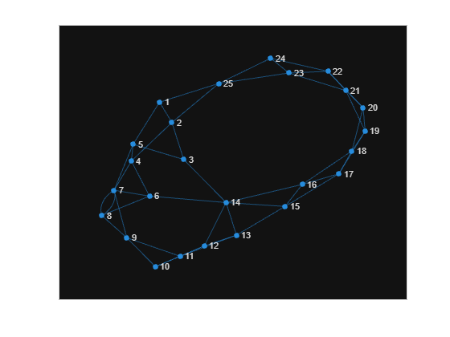
Figure 1: Example Small-World Network
Then, each student node gains a number of external social links, sampled randomly from a negative exponential distribution of mean 5. These are attached to a node in the network – randomly sampled, with weighting doubled for nodes within the same class. This assures a mean degree of around 13 when self-connections are eliminated, as is to be expected of the median age university student (Mossong J, 2008).
Thus, we have a large network of students interconnected by edges that represent regular prolonged contacts. The social links created here are most akin to a Erdős–Rényi network, where all possible links are equally likely to be present – which suggests high correlation with real-world data (Dimou, et al., 2022).
We then assign each ‘student’ node a state, to reflect their disease status. We assume there is no pre-assumed immunity in the population, and as such nearly all individuals begin in the Susceptible (S) state.
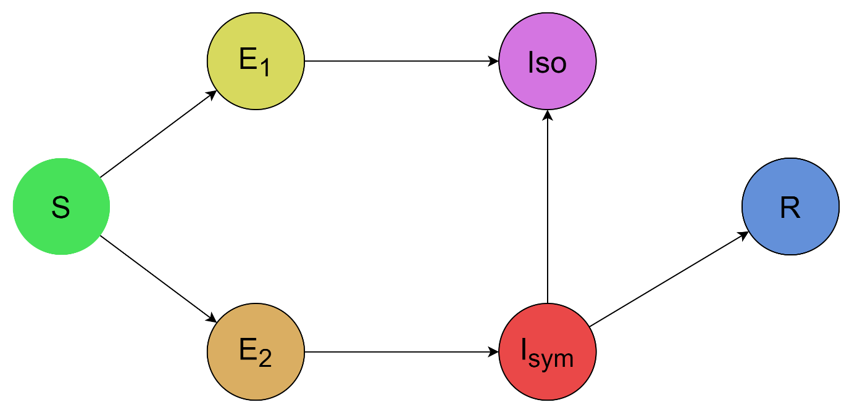
Figure 2: State Flow Diagram
If a susceptible student is then infected with the virus, then that student will be considered in the incubatory phase of the virus and moved to one of two Exposed compartments according to a p value – assumed to be 0.5 but may vary later – which corresponds to the proportion of the population which would isolate upon showing symptoms, whether via inability to return to the population or for prevention of spread.
The Exposed1 compartment (E₁) contains those who isolate and therefore only leads to the terminus Isolation (Iso) compartment. The Exposed2 (E₂) compartment contains those who will not isolate and therefore leads to the Infected - Symptomatic (I_{sym}) compartment – which will convey the majority of transmission of the virus in this model.
The I_{sym} compartment will in part lead to the Iso compartment for the reasons above as for the E₁ compartment, and will otherwise be directed to the other terminus compartment, the Recovered (R) endstate.
All nodes in the graph will flow through these states to simulate a human undergoing infection, until there are no infected individuals.
The transition between states happens discreetly and stochastically as an event, and these events are iterated until completion. An event can occur when either there is a connection between an infected node and a susceptible node, i.e. transmission of the disease, or where an already infected agent progresses through the stages of infection, e.g. onset of symptoms.
Each event has a different probability of occurring, due to the periods of time for each state and transition being different. We assign each unique event a rate parameter to model this, which are based off the epidemiological properties of our chosen base disease, COVID-19. These are generally derived from the inverse of the time taken for these events to occur:
Parameter | Value | Compartment  Interaction | Description | Source
β | 2.2 * ζ | [I] upon [S] | Symptomatic infection rate | (Qun Li, 2020)
β ₂ | Β * 0.05 | [E₁] & [E₂] upon [S] | Pre-symptomatic infection rate | (Wycliffe E. Wei, et al., 2020)
δ | 1 / 14 | [Iso] from [I_{sym}] | Isolation rate | Assumed
ε | 1 / 5.2 | [Iso] & [I_{sym}] from [E₁] & [E₂] | Rate of onset of symptoms | (Qun Li, 2020)
ζ | 1 / 11 | [R] from [I_{sym}] | Recovery rate | (Sudre, 2021)
p_{rewire} | 0.2 | [S] | Rewiring probability used to construct small-world network structures | Assumed
p_{seed} | 10 | [S₁] & [S₂] | Initial infected population | Assumed, values lower than 5 led to stochastic death
p_{iso} | 0.5 | [E₁] & [E₂] | Proportion of isolating individuals | Assumed
iso_thr | 1 / 48,  1 / 480 | [Iso] from [S] | Rate of pre-emptive isolation strategies | Assumed, given 10 min interviews per 8 hour work day for 1 person, 10 people
Figure 3: Rate Parameter Table, mean values used
Once we have the probability of each possible event occurring, we can randomly sample events, and update the state of the graph – then iterate this until no events can occur.
We simulate the time taken for each event using a negative log function acting upon a random variable between 0 and 1, divided by the total event rate for that state.

Isolation Strategies
We will introduce and test 3 different isolation strategies and their individual effectiveness. These strategies are assumed to all be put into place once the infection reaches a certain threshold, which we assume to be the size of a full class of people, e.g. 25 in the base case. They are also assumed to be performed at a constant rate.
The first strategy we will evaluate is the standard ‘Contact Tracing’ strategy, where an individual will be randomly sampled from the infected compartment, and then a directly connected susceptible node will be reassigned directly to the Iso compartment. This reflects the simple method used many times during the COVID-19 pandemic.
The second strategy we will use is the ‘And-One’ tracing strategy. Like the ConTra (contact tracing) strategy, we will sample a random infected node, and then connect to one of its direct contacts, then connect to one of that neighbor’s susceptible neighbors. This node is then moved directly to the Iso compartment. This strategy is probabilistically more likely to find higher degree nodes to isolate and should therefore cut off more disease pathways. It should also hopefully preempt presymptomatic middle links.
The third strategy is the ‘Degree-Based’ strategy, where a random node is sampled from the susceptible population, with probabilities proportional to their degree. This should limit the impact of the highly social contingent, however in a highly connected society, this may have a limited impact in the short term.
To test these, we will perform a simulation of each isolation strategy on the same network, then iterate this for 100 different created networks. Then, we can analyze key epidemiological metrics such as the peak mass of the infection, and its total duration.
This has been coded in MATLAB using inbuilt graph functionality and the code will be accessible in Appendix A at the end of the report.

Results
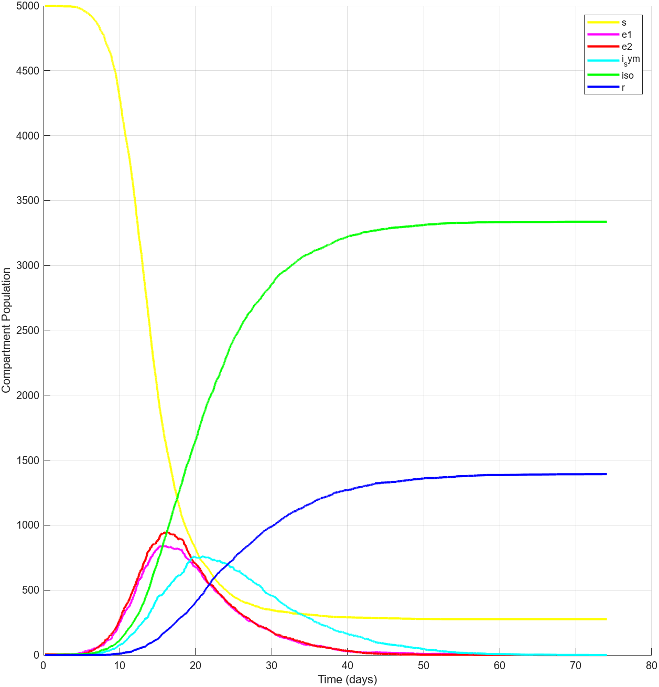
Figure 4: Plot of one simulation with no control measures.
This is a plot of one example time series showing the total population of each compartment through the whole non-isolation strategy infection simulation. It shows the general behavior of the model at large. A large peak of the exposed compartments, then a week later, a peak of the symptomatic compartment, then both peter out to 0 while the total susceptible population remains near constant, and the isolation compartment balloons before the recovered compartment grows at a lower rate. There is a period of pre-symptomatic spread, which balloons into symptomatic spread, and becomes a runaway infection before people isolate and recover, and it levels out. This shows the general trend of exponential growth until population becomes the rate limiting factor. Thus, we expect more effective measures to either slow the growth and flatten the curve, or increase the excluded population limit and raise the ending S population.

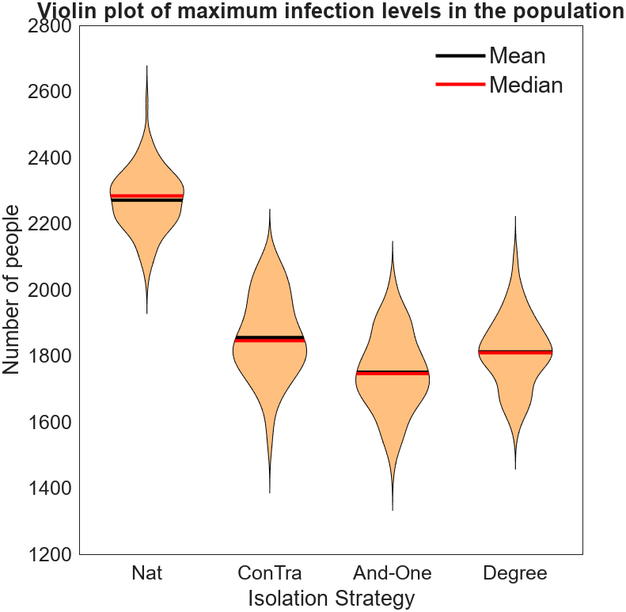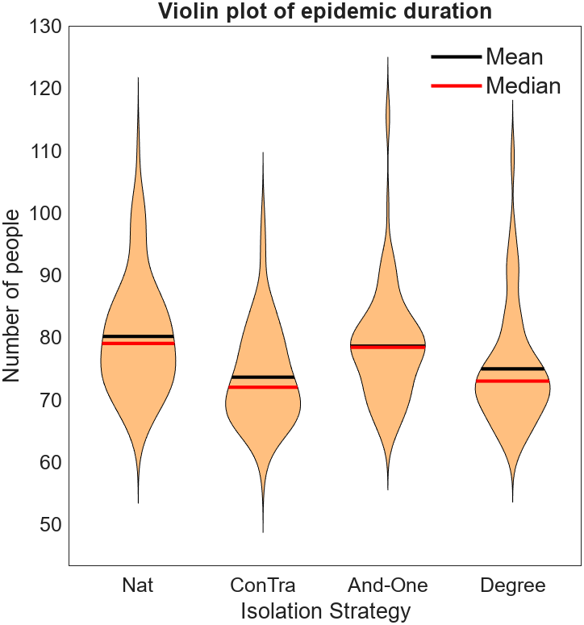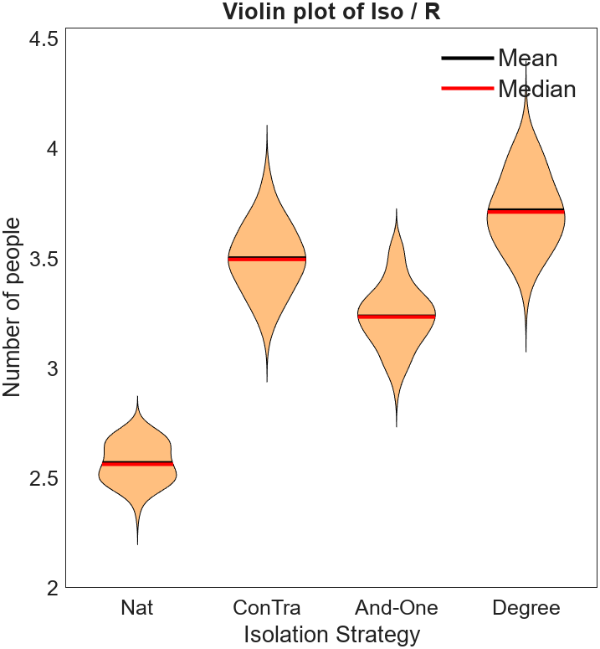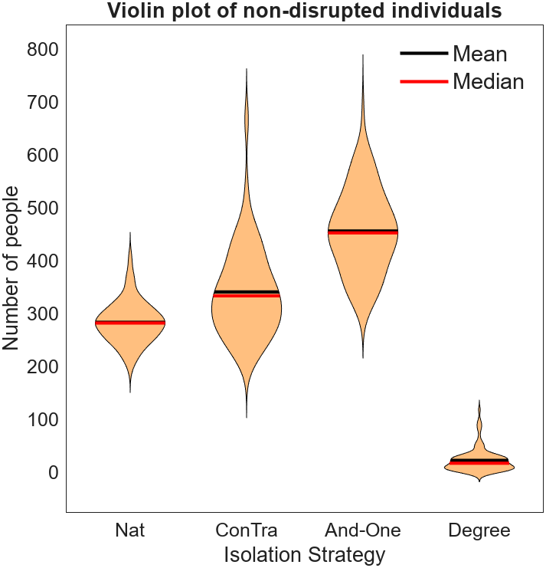
Figures 5,6, 7, 8 (top-left, top-right, bottom-left, bottom-right): Violin plots (Hoffmann, n.d.) showing collated data from 100 simulations of low isolation strategy efficiency, 200 classes of 25. Figure 5: Maximums of added E₁, E₂, and I values for each simulation. Figure 6: Total duration of epidemic until event rate reaches 0. Figure 7: Ratio of Iso to R compartment end populations. Figure 8: End population of S compartment.
The first set of tests use the assumed baseline variables of a smaller scale isolation strategy and more classes of a smaller size.
The violin plots show us that these metrics are all generally normally distributed, however the durations of epidemic seem to have positive skew. The main metric we will use to numerically analyze the impact will be the peak number infected at any point in the simulation, as this most generally describes the peak disruptive impact of the epidemic.

Isolation Measure | Natural | Contact Tracing | And-One | Degree
Mean | 2’271 | 1’856 | 1’751 | 1’812
SD | 90.19 | 122.66 | 116.13 | 105.64
Min | 2’038 | 1’535 | 1’467 | 1’582
10th Per. | 2’158 | 1’706 | 1’597 | 1’663
25th Per. | 2’215 | 1’776 | 1’680 | 1’754
50th Per. | 2’284 | 1’846 | 1’747 | 1’810
75th Per. | 2’331 | 1’956 | 1’827 | 1’880
90th Per. | 2’374 | 2’033 | 1’919 | 1’942
Max | 2’568 | 2’094 | 2’012 | 2’097
2-tailed t-test results for difference of means
w/ Nat | - | 8.09e-52 | 4.72e-56 | 9.91e-55
w/ CT | 8.09e-52 | - | 5.95e-08 | 0.0045
w/ A-O | 4.72e-56 | 5.95e-08 | - | 2.63e-04
w/ Deg | 9.91e-55 | 0.0045 | 2.63e-04 | -
Table A: Descriptive statistics of maximum infection levels for low efficiency isolation measures simulations
Statistically, the methods are all significantly different in magnitude to at least a 99% significance level. Thus, we can rank the measures from least to most effective with little contention – all statistics other than the maximum follow the same ordinality – the control test with no measures is by far the worst, as is to be expected. Ordinary contact tracing is the 3rd most effective, curbing the peak by 18%, and the most variable. Slightly more effective than that is degree-based tracing, which decreased the peak by 20%. The most effective method appears to be the ‘and-one’ method, which only reached mean maximum 77% as large as without any contact tracing whatsoever.
The no-isolation and ‘and-one’ methods both had higher epidemic durations than the contact tracing and degree-based methods, though likely due to different reasons – the former ran out of people to infect and the latter due to cornering the virus in the late stages of the epidemic.
The degree-based method ended up with the greatest proportion of people isolated as a ratio of those who fully spread the virus - ~3.7 compared to 3.5 for regular contact tracing, and ~3.3 for the ‘and-one’ strategy. It is expected that these must all be higher than the base ~2.7 of the control, but this means that degree-based is the most disruptive to the population at large. This can be further seen as the number of individuals remaining in the S compartment in the degree-based scenario nears 0 for almost every simulation, where the control had around 300, or 12% of the population. Regular contact tracing had around 350, and and-one had on average 500.
This suggests the degree-based system is rather indiscriminate and disruptive compared to the other contact tracing methods, and may be comparative to a lockdown.

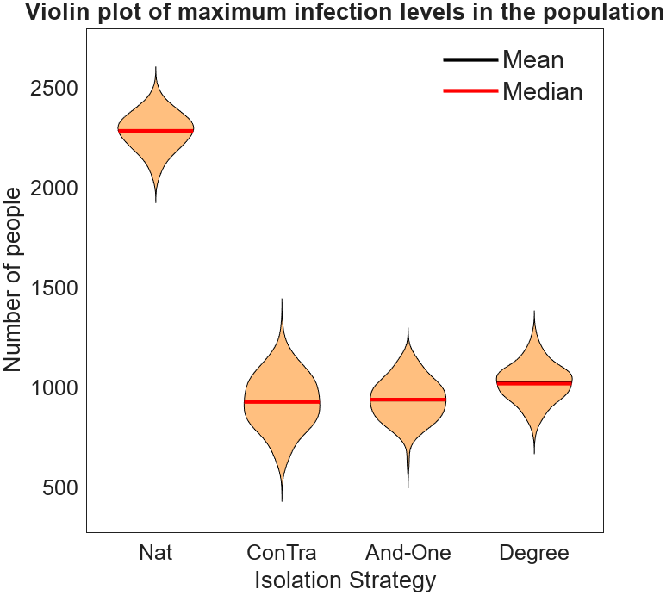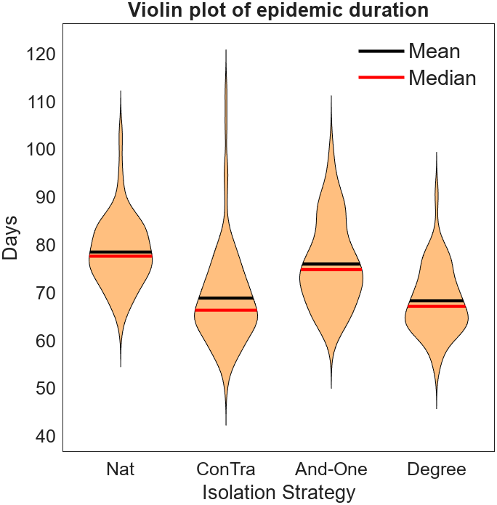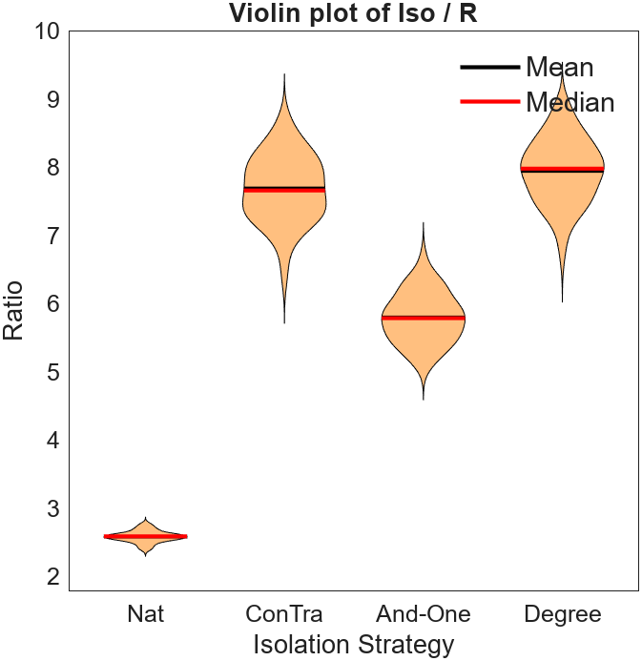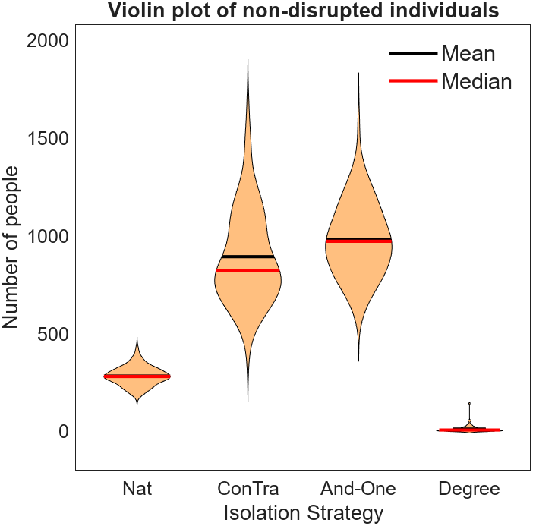
Figures 9, 10, 11, 12 (top-left, top-right, bottom-left, bottom-right): Violin plots (Hoffmann, n.d.) showing collated data from 100 simulations of high isolation strategy efficiency, 200 classes of 25. Figure 9: Maximums of added E₁, E₂, and I values for each simulation. Figure 10: Total duration of epidemic until event rate reaches 0. Figure 11: Ratio of Iso to R compartment end populations. Figure 12: End population of S compartment.
The second set of tests have an isolation rate 10 times that of the baseline, however the threshold remains the same. This is reflected in the much larger isolation ratio, and the much smaller maximum infection levels.

Isolation Measure | Natural | Contact Tracing | And-One | Degree
Mean | 2’281 | 930 | 940 | 1023
SD | 91.17 | 132.03 | 102.24 | 93.78
Min | 2’039 | 618 | 635 | 781
10th Per. | 2’158 | 759 | 821 | 896
25th Per. | 2’220 | 833 | 863 | 956
50th Per. | 2’284 | 928 | 940 | 1’020
75th Per. | 2’343 | 1’035 | 1’011 | 1’078
90th Per. | 2’396 | 1’099 | 1’083 | 1’146
Max | 2’489 | 1’257 | 1’126 | 1’272
2-tailed t-test results for difference of means
w/ Nat | - | 2.43e-96 | 5.60e-99 | 5.04e-98
w/ CT | 2.43e-96 | - | 0.5095 | 2.00e-07
w/ A-O | 5.60e-99 | 0.5095 | - | 3.03e-08
w/ Deg | 5.04e-98 | 2.00e-07 | 3.03e-08 | -
Table A: Descriptive statistics of maximum infection levels for high efficiency isolation measures simulations
Interestingly, the statistics suggest that the results from regular contact tracing, and the and-one method with high efficiency, have a mean that is not different in a statistically significant manner. They have joint reduced the peak to the lowest proportion, followed by degree-based isolation, and then no isolation whatsoever. However, the standard deviation of the standard contact tracing is rather high compared to the and-one method, which is less elevated with respect to the baseline. We see very similar results for the duration and isolation ratios however, compared to the low efficiency tests.
Whereas the peaks decreased by 400-500 in the low-efficiency model, when the efficiency parameter was increased tenfold, we saw the peaks only around halve in size, suggesting there may be significant diminishing returns in increasing the number of resources allocated to tracing and tracking.

Discussion

Conclusion

We used early data to simulate the spread of COVID-19 through a network of networks used to model a highly-connected university building. Here, we have varied the classical SEIR model due to changes in social and educational structures (Kim A. Weeden, n.d.) to create a unique model that accounts for greater general awareness of the spread of new diseases. We then applied this to a network carefully constructed to model the structure of a modern university center.
We looked at three measures of contact-tracing given perfect information about strong connections between individuals, and found that if resources permit, attempting to isolate contacts of contacts may do more to curb the transmission of highly contagious diseases with pre-symptomatic aspects than simple contact tracing as it is thought of currently. This method also seemed to be less disruptive population-wise, however it did not decrease the time taken for the disease to leave the system, as the other measures did.
We found that an indiscriminate degree-based isolation method – which may model a form of socially enforced lockdown – is not more effective than discriminating against identified infected nodes, however it does hamper the infection by a similar degree.
We find that even a small-scale contact-tracing outfit of 1 isolation event every 10 minutes may be able to decrease the peak of an average outbreak by up to 20%, however without regular testing or prior knowledge of an outbreak, even a very small transmissibility before symptoms arise may make an outbreak grow exponentially before large portions of a population are affected.
Aswell, we see that even large-scale containment measures do not have much impact on the length of time the disease will spread for if individuals are not released back into the general community. However, it will highly reduce the overall disruption of even a largely connected student area.
Our results are limited, as they assume an ‘infinite’ isolation, whereas other models have more accurately modelled this as a state that can be returned from to a susceptible state after a reasonable amount of time. It also does not account for the possibility of impermanent immunity to the disease, and thus the likelihood is more pathways will constantly be activated for the disease to jump through. However, this model gives insight into possible short-term strategies, and may be apropos if isolation is considered as the move to online learning.
These solutions also assume perfectly gathered knowledge about people and their physical links, and perfect adherence to tested isolation measures. This is unlikely, and would likely lead to a lower effectiveness of containment than is displayed here.
Overall, we recommend that future contact tracing efforts, in tandem with other reasonable measures, should opt to preempt infectious transmission between reported cases and their contacts, and thus apply an ‘and-one’ strategy.

References
Agency, H. E. S., 2023. Table 1 - HE student enrolments by HE provider 2014/15 to 2021/22. [Online]
Available at: https://www.hesa.ac.uk/data-and-analysis/students/table-1
Dimou, A., Maragakis, M. & Argyrakis, P., 2022. A network SIRX model for the spreading of COVID-19. Physica A: Statistical Mechanics and its Applications, Volume 590.
Hoffmann, H., n.d. Violin Plot, MATLAB Central File Exchange. [Online]
Available at: https://www.mathworks.com/matlabcentral/fileexchange/45134-violin-plot
[Accessed 9 April 2024].
Kim A. Weeden, B. C. B. P., n.d. Still a Small World? University Course Enrollment Networks before and during the COVID-19 Pandemic. Sociological Science, Volume 8, pp. 73-82.
Kucharski, A. J. e. a., 2020. Effectiveness of isolation, testing, contact tracing, and physical distancing on reducing transmission of SARS-CoV-2 in different settings: a mathematical modelling study. The Lancet: Infectious Diseases, 20(10).
Mossong J, H. N. J. M. B. P. A. K. M. R. e. a., 2008. Social Contacts and Mixing Patterns Relevant to the Spread of Infectious Diseases. PLoS Med, 5(3).
Qun Li, M. X. G. P. P. W. P. X. W. M. L. Z. M. Y. T. P. R. R. M. +., 2020. Early Transmission Dynamics in Wuhan, China, of Novel Coronavirus–Infected Pneumonia. New England Journal of Medicine, 382(13).
Sudre, C. M. B. V. T. e. a., 2021. Attributes and predictors of long COVID. Nat Med, Volume 27, pp. 626-631.
Wycliffe E. Wei, M. et al., 2020. Presymptomatic Transmission of SARS-CoV-2 — Singapore, January 23–March 16, 2020, s.l.: CDC.
Youzhong Wang, D. Z. Z. C. Y. W. H. S. &. X. Z., 2011. The Impact of Community Structure of Social Contact Network on Epidemic Outbreak and Effectiveness of Non-pharmaceutical Interventions. Pacific-Asia Workshop on Intelligence and Security Informatics , Volume 6749.

Appendix A: Code
cs = 25 ; % class size
cn = 200 ; % number of classes

resultmm = cell(100, 4) ; % cell to collect result vectors
degs = zeros(100, 1) ; % network statistics
gstds = zeros(100, 1) ;
meanccs = zeros(100, 1) ;

for loopno = 1:100 % loop 100 simulations

% creation of a single ring network
m = zeros(cs, cs) ;
l = [0; ones(2, 1); zeros(cs - 5, 1); ones(2, 1)] ;
for c1 = 1:cs
m(c1, :) = l ;
l = circshift(l, 1) ;
end
m = kron(eye(cn),m) ; % creation of adjacency matrix of many ring networks
ga = graph(m) ;

for it = 1:cn % loop through ring networks
itn = (it - 1) * cs ;
p = 0.2 ; % rewire nodes to make small world networks
r = randperm(cs, cs*p) + (itn * 2) ;
ep = ga.Edges.EndNodes(r, :) ;
ga = ga.rmedge(r) ;
for c2 = 1:(cs*p)
r2 = randi(2) ;
r3 = ep(c2, r2) ;
while r3 == ep(c2, 1) || r3 == ep(c2, 2)
r3 = randi(cs) + itn ;
end
if r2 == 1
ga = addedge(ga, ep(c2, 1), r3, 1) ;
else
ga = addedge(ga, r3, ep(c2, 2), 1) ;
end
end
end

sc = 5 ; % social links
a = [ones(cs, 1); zeros(cs * (cn - 1), 1)] + 1 ;
for n = 1:cn % for every node
for s = 1:cs
p = round(exprnd(sc)) ; % exponential random number
b = a ;
b(((n - 1) * cs) + s) = 0 ;
c = ones(p, 2) * ((n - 1) + s) ;
c(:, 2) = datasample(1:(cs*cn), p, 'Weights', b, 'Replace', false) ;
ga = addedge(ga, c(:,1), c(:,2), 1) ;
end
a = circshift(a, cs) ; % double the probability in every small-world network
end
ga = simplify(ga) ; % remove self-connections

degvec = degree(ga) ;

degs(loopno) = mean(degree(ga)) ;
gstds(loopno) = std(degree(ga)) ;

for iscount = 1:4 % change isolation strategy

tl = cs * cn ; % total population

delta = 1/14 ; % epidemic rate parameters
gamma = 1/11 ;
epsilon = 1/5.2 ;
beta = 2.2 / 11 ;
beta2 = 0.05.*beta ;

nettm = adjacency(ga) ;

pseed = 10 ; % seed starting infections
e1vec = zeros(1, tl) ;
e2vec = zeros(1, tl) ;
e1vec(randperm(tl, pseed./2)) = 1 ;
e2vec(randperm(tl, pseed./2)) = 1 ;

isovec = zeros(1, tl) ; % vectors for tracking nodes in each state
ivec = zeros(1, tl) ;
svec = ones(1, tl) - ivec ;
rvec = zeros(1, tl) ;

resultm = [] ;

t = 0 ;
tthr = 0 ;
isothr = 1/480 ;
while sum(ivec)+sum(e1vec)+sum(e2vec) > 0 % loop until no infection
% if t >= tthr
% figure()
% gap = plot(ga, 'layout', 'force', 'UseGravity', true) ;
% highlight(gap, nonzeros((1:tl) .* svec), 'NodeColor', 'green') ;
% highlight(gap, nonzeros((1:tl) .* rvec), 'NodeColor', 'blue') ;
% highlight(gap, nonzeros((1:tl) .* isovec), 'NodeColor', 'cyan') ;
% highlight(gap, nonzeros((1:tl) .* e1vec), 'NodeColor', 'yellow') ;
% highlight(gap, nonzeros((1:tl) .* e2vec), 'NodeColor', 'magenta') ;
% highlight(gap, nonzeros((1:tl) .* ivec), 'NodeColor', 'red') ;
% tthr = tthr + 1000 ;
% end

% calculate event rates
is = ( ivec * nettm ) .* svec ;
infrate = beta .* sum(is) ;
e1s = ( e1vec * nettm ) .* svec ;
e1rate = beta2 .* sum(e1s) ;
e2s = ( e2vec * nettm ) .* svec ;
e2rate = beta2 .* sum(e2s) ;

e1isorate = epsilon .* sum(e1vec) ;
e2isyrate = epsilon .* sum(e2vec) ;

isorate = delta .* sum(ivec) ;
recrate = gamma .* sum(ivec) ;

totrate = infrate + e1rate + e2rate + e1isorate + e2isyrate + isorate + recrate ;
% randomly select the event type
r = rand .* totrate ;
p = randsample([1, 2], 1) ;

if r >= (infrate + e1rate + e2rate + e1isorate + e2isyrate)
if r >= (totrate - recrate) % i_sym to rec
recec = randsample(1:tl, 1, true, ivec) ;
ivec(recec) = 0 ;
rvec(recec) = 1 ;
else % i_sym to iso
recec = randsample(1:tl, 1, true, ivec) ;
ivec(recec) = 0 ;
isovec(recec) = 1 ;
end
elseif r >= (infrate + e1rate + e2rate)
if r >= (infrate + e1rate + e2rate + e1isorate) % e2 to i_sym
recec = randsample(1:tl, 1, true, e2vec) ;
e2vec(recec) = 0 ;
ivec(recec) = 1 ;
else % e1 to iso
recec = randsample(1:tl, 1, true, e1vec) ; %
e1vec(recec) = 0 ;
isovec(recec) = 1 ;
end
else
if r >= (infrate + e1rate) % s to e1 or e2 at random via e2 interaction
recec = randsample(1:tl, 1, true, e2s) ;
svec(recec) = 0 ;
if p == 2
e2vec(recec) = 1 ;
else
e1vec(recec) = 1 ;
end
elseif r >= infrate % s to e1 or e2 at random via e1 interaction
recec = randsample(1:tl, 1, true, e1s) ;
svec(recec) = 0 ;
if p == 2
e2vec(recec) = 1 ;
else
e1vec(recec) = 1 ;
end
else % s to e1 or e2 at random via i interaction
recec = randsample(1:tl, 1, true, is) ;
svec(recec) = 0 ;
if p == 2
e2vec(recec) = 1 ;
else
e1vec(recec) = 1 ;
end
end
end

% isolation strategy
if ( sum(svec) < (tl - cs) ) && (t > tthr) && ( sum(is) ~= 0 ) % needs to be over the infection level threshold
tthr = t + isothr ;
switch iscount % switch isolation strategy
case 2 % ct
randct = randsample(1:tl, 1, true, is) ;
svec(randct) = 0 ;
isovec(randct) = 1 ;
case 3 % and one
randct = randsample(1:tl, 1, true, is) ;
r = zeros(1, tl) ;
r(randct) = 1 ;
rctvec = ( r * nettm ) .* svec ;
if sum(rctvec) ~= 0
randct = randsample(1:tl, 1, true, rctvec) ;
svec(randct) = 0 ;
isovec(randct) = 1 ;
end
case 4 % degree
randct = randsample(1:tl, 1, true, degvec' .* svec) ;
svec(randct) = 0 ;
isovec(randct) = 1 ;
end
end

t = t + (- log(rand) ./ totrate) ; % serial interval function

resultm = [resultm;t,sum(svec),sum(e1vec),sum(e2vec),sum(ivec),sum(isovec),sum(rvec)] ; % add to data table
end

resultmm{loopno, iscount} = resultm ;

end

% svec
% sum(svec)
% isovec
% sum(isovec)
% rvec
% sum(rvec)
% t

% figure()
% gap = plot(ga, 'layout', 'force', 'UseGravity', true) ;
% highlight(gap, nonzeros((1:tl) .* svec), 'NodeColor', 'green') ;
% highlight(gap, nonzeros((1:tl) .* rvec), 'NodeColor', 'blue') ;
% highlight(gap, nonzeros((1:tl) .* isovec), 'NodeColor', 'cyan') ;
% highlight(gap, nonzeros((1:tl) .* e1vec), 'NodeColor', 'yellow') ;
% highlight(gap, nonzeros((1:tl) .* e2vec), 'NodeColor', 'magenta') ;
% highlight(gap, nonzeros((1:tl) .* ivec), 'NodeColor', 'red') ;

if loopno > 99 % graph individual simulations to ensure success
figure
hold on
cola = [1, 1, 1, 0, 0, 0] ;
colb = [1, 0, 0, 1, 1, 0] ;
colc = [0, 1, 0, 1, 0, 1] ;
for c = 2:7
plot(resultmm{1}(:, 1), resultmm{1}(:, c), 'LineWidth', 2, 'Color', [cola(c-1), colb(c-1), colc(c-1)])
end
hold off
legend('s', 'e1', 'e2', 'i_sym', 'iso', 'r')

figure
hold on
cola = [1, 1, 1, 0, 0, 0] ;
colb = [1, 0, 0, 1, 1, 0] ;
colc = [0, 1, 0, 1, 0, 1] ;
for c = 2:7
plot(resultmm{2}(:, 1), resultmm{2}(:, c), 'LineWidth', 2, 'Color', [cola(c-1), colb(c-1), colc(c-1)])
end
hold off
legend('s', 'e1', 'e2', 'i_sym', 'iso', 'r')

figure
hold on
cola = [1, 1, 1, 0, 0, 0] ;
colb = [1, 0, 0, 1, 1, 0] ;
colc = [0, 1, 0, 1, 0, 1] ;
for c = 2:7
plot(resultmm{3}(:, 1), resultmm{3}(:, c), 'LineWidth', 2, 'Color', [cola(c-1), colb(c-1), colc(c-1)])
end
hold off
legend('s', 'e1', 'e2', 'i_sym', 'iso', 'r')

figure
hold on
cola = [1, 1, 1, 0, 0, 0] ;
colb = [1, 0, 0, 1, 1, 0] ;
colc = [0, 1, 0, 1, 0, 1] ;
for c = 2:7
plot(resultmm{4}(:, 1), resultmm{4}(:, c), 'LineWidth', 2, 'Color', [cola(c-1), colb(c-1), colc(c-1)])
end
hold off
legend('s', 'e1', 'e2', 'i_sym', 'iso', 'r')
end
end

resultmm ; % extract metrics out of data
maxinf = zeros(100, 4) ;
sleft = zeros(100, 4) ;
terad = zeros(100, 4) ;
conco = zeros(100, 4) ;
for col = 1:4
for row = 1:100
ts = resultmm{row, col} ;
tsinf = ts(:, 3) + ts(:, 4) + ts(:, 5) ;
maxinf(row, col) = max(tsinf) ;
sleft(row, col) = ts(end, 2) ;
terad(row, col) = ts(end, 1) ;
conco(row, col) = ts(end, 6) / ts(end, 7) ;
end
end

mean(maxinf, 1) % descriptive statistics about infection peaks
std(maxinf, 1)
prctile(maxinf, [0, 10, 25, 50, 75, 90, 100], 1)
[h,p] = ttest(maxinf(:, 1), maxinf(:, 2))
[h,p] = ttest(maxinf(:, 1), maxinf(:, 3))
[h,p] = ttest(maxinf(:, 1), maxinf(:, 4))
[h,p] = ttest(maxinf(:, 2), maxinf(:, 3))
[h,p] = ttest(maxinf(:, 2), maxinf(:, 4))
[h,p] = ttest(maxinf(:, 3), maxinf(:, 4))

figure % violin plots of descriptive statistics
violin(maxinf) ;
title('Violin plot of maximum infection levels in the population')
xticks(1:4)
xticklabels({'Nat', 'ConTra', 'And-One', 'Degree'})
axis('padded')
xlabel('Isolation Strategy')
ylabel('Number of people')

figure
violin(terad) ;
title('Violin plot of epidemic duration')
xticks(1:4)
xticklabels({'Nat', 'ConTra', 'And-One', 'Degree'})
axis('padded')
xlabel('Isolation Strategy')
ylabel('Days')

figure
violin(conco) ;
title('Violin plot of Iso / R')
xticks(1:4)
xticklabels({'Nat', 'ConTra', 'And-One', 'Degree'})
axis('padded')
xlabel('Isolation Strategy')
ylabel('Ratio')

figure
violin(sleft) ;
title('Violin plot of non-disrupted individuals')
xticks(1:4)
xticklabels({'Nat', 'ConTra', 'And-One', 'Degree'})
axis('padded')
xlabel('Isolation Strategy')
ylabel('Number of people')

resultmm2 ; % large scale isolation stats and graphs
maxinf2 = zeros(100, 4) ;
terad2 = zeros(100, 4) ;
conco2 = zeros(100, 4) ;
sleft2 = zeros(100, 4) ;
for col = 1:4
for row = 1:100
ts = resultmm2{row, col} ;
tsinf = ts(:, 3) + ts(:, 4) + ts(:, 5) ;
maxinf2(row, col) = max(tsinf) ;
terad2(row, col) = ts(end, 1) ;
conco2(row, col) = ts(end, 6) / ts(end, 7) ;
sleft2(row, col) = ts(end, 2) ;
end
end

figure
violin(maxinf2) ;
title('Violin plot of maximum infection levels in the population')
xticks(1:4)
xticklabels({'Nat', 'ConTra', 'And-One', 'Degree'})
axis('padded')
xlabel('Isolation Strategy')
ylabel('Number of people')

figure
violin(terad2) ;
title('Violin plot of epidemic duration')
xticks(1:4)
xticklabels({'Nat', 'ConTra', 'And-One', 'Degree'})
axis('padded')
xlabel('Isolation Strategy')
ylabel('Days')

figure
violin(conco2) ;
title('Violin plot of Iso / R')
xticks(1:4)
xticklabels({'Nat', 'ConTra', 'And-One', 'Degree'})
axis('padded')
xlabel('Isolation Strategy')
ylabel('Ratio')

figure
violin(sleft2) ;
title('Violin plot of non-disrupted individuals')
xticks(1:4)
xticklabels({'Nat', 'ConTra', 'And-One', 'Degree'})
axis('padded')
xlabel('Isolation Strategy')
ylabel('Number of people')

mean(maxinf2, 1)
std(maxinf2, 1)
prctile(maxinf2, [0, 10, 25, 50, 75, 90, 100], 1)
[h,p] = ttest(maxinf2(:, 1), maxinf2(:, 2))
[h,p] = ttest(maxinf2(:, 1), maxinf2(:, 3))
[h,p] = ttest(maxinf2(:, 1), maxinf2(:, 4))
[h,p] = ttest(maxinf2(:, 2), maxinf2(:, 3))
[h,p] = ttest(maxinf2(:, 2), maxinf2(:, 4))
[h,p] = ttest(maxinf2(:, 3), maxinf2(:, 4))
[h,p] = ttest(maxinf2(:, 1), maxinf(:, 1))
[h,p] = ttest(maxinf2(:, 1), maxinf(:, 2))
[h,p] = ttest(maxinf2(:, 1), maxinf(:, 3))
[h,p] = ttest(maxinf2(:, 1), maxinf(:, 4))
[h,p] = ttest(maxinf2(:, 2), maxinf(:, 1))
[h,p] = ttest(maxinf2(:, 2), maxinf(:, 2))
[h,p] = ttest(maxinf2(:, 2), maxinf(:, 3))
[h,p] = ttest(maxinf2(:, 2), maxinf(:, 4))
[h,p] = ttest(maxinf2(:, 3), maxinf(:, 1))
[h,p] = ttest(maxinf2(:, 3), maxinf(:, 2))
[h,p] = ttest(maxinf2(:, 3), maxinf(:, 3))
[h,p] = ttest(maxinf2(:, 3), maxinf(:, 4))
[h,p] = ttest(maxinf2(:, 4), maxinf(:, 1))
[h,p] = ttest(maxinf2(:, 4), maxinf(:, 2))
[h,p] = ttest(maxinf2(:, 4), maxinf(:, 3))
[h,p] = ttest(maxinf2(:, 4), maxinf(:, 4))

