Zibin Mei

10085722

Refactoring log:

Extract helper method: getPrimitives(), due to parent method too large

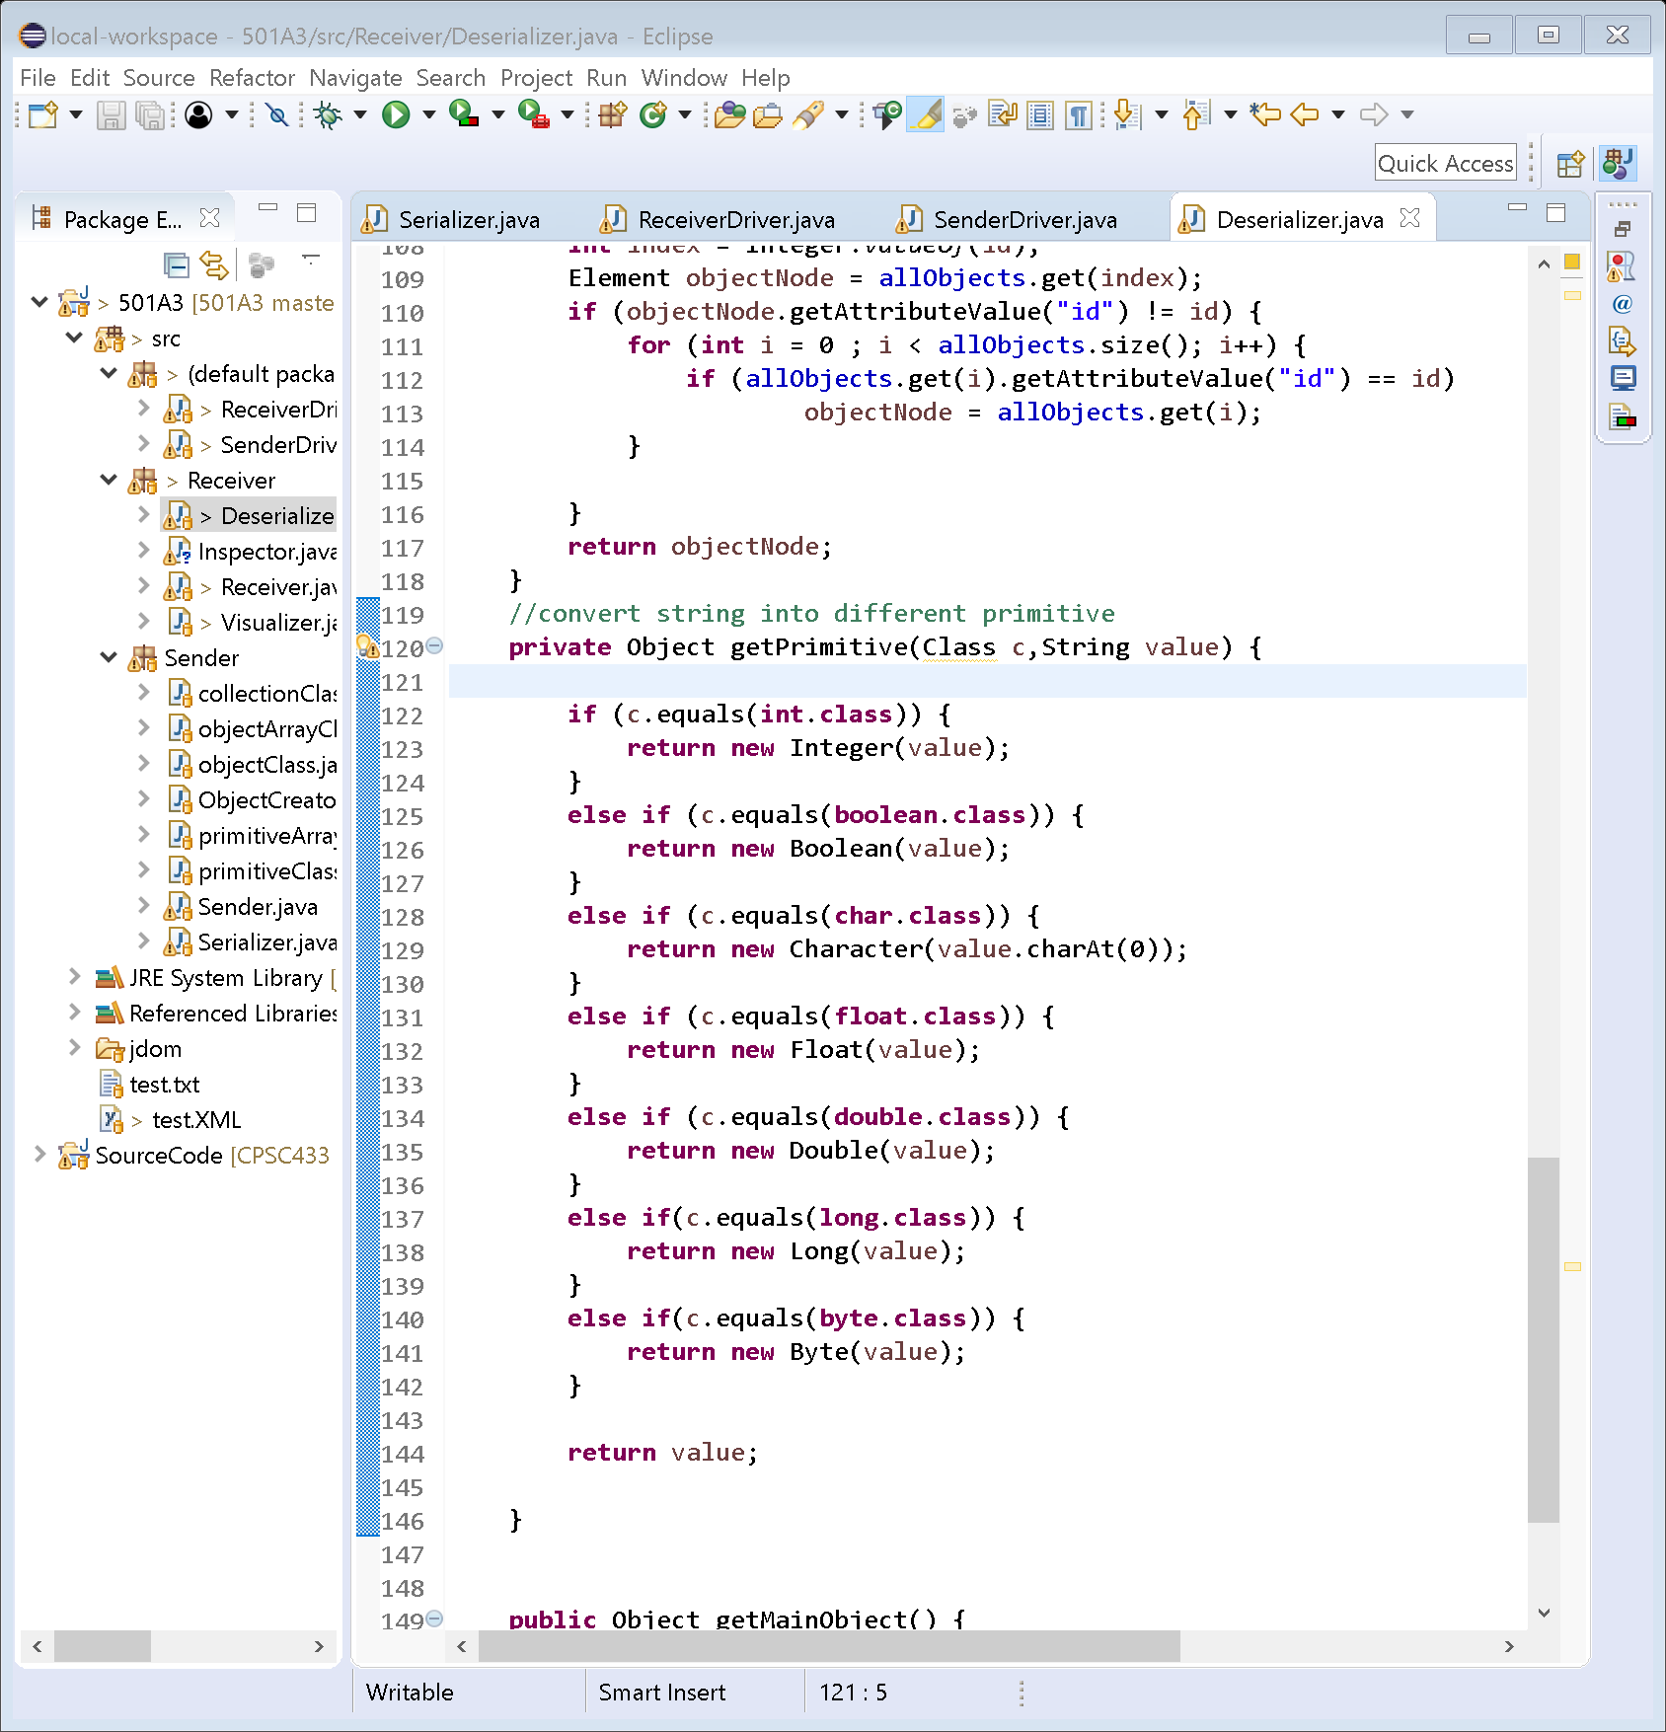

Extract helper method: getNodebyID() , due to redundant/duplicate

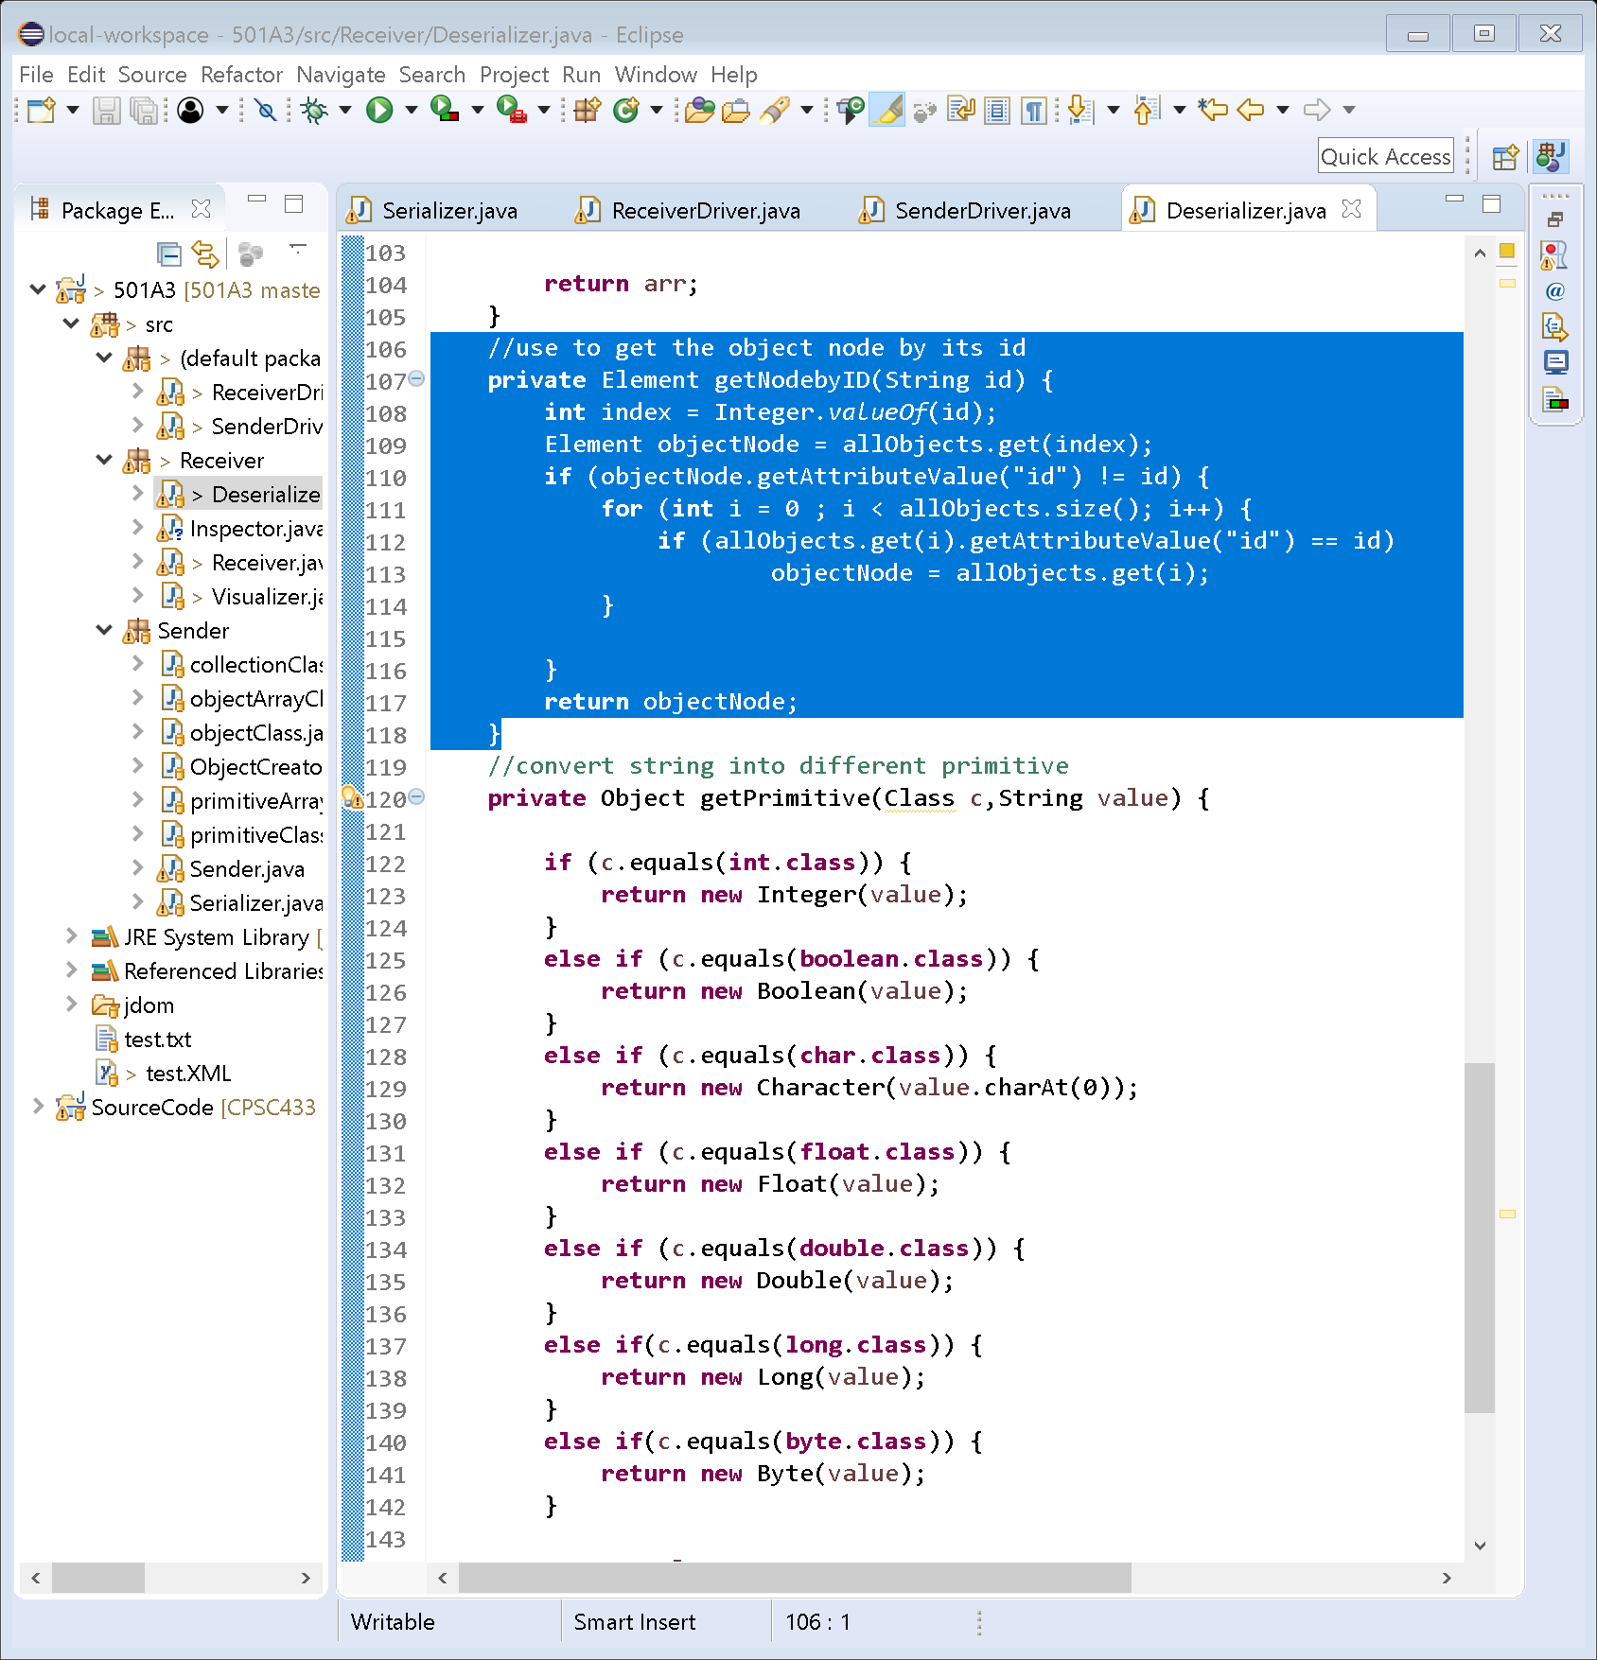

Extract class: Drivers, due to class is hard to find in the crowed package

There maybe some rename as well