1 First part of a script to update the position of a virtual item in relation to the RFID read from another script.

2 Closing and opening the top menu panel.

3 UI Interface.

4 Moving the virtual items through Lerp. Still some adjustments needed.

5 Displays the emergency button icon when the node reads the data. To reset the node, scripts need to call the ResetNode() script.

6 Started the panel to send orders.

7 Implemented Emg stop press recognition and reset recognition through reset+start button press.

8 Script to store information about an order from a drop down input that changes the part number.

9 Updated the display item panel to read data from the CurrentOrders script and update through a button click.

10 Created information panels with unique information.

11 UI Icon now shows time left.

12 Implemented new UI elements. A button to switch between AR and Twin, and a "Extra features" button on the bottom left with a tween animation to show the fire simulation button.

13 Created a fire simulation with indicators to the nearest exit.

14 Created a script to read cart data to match carrier and order id. This is used to highlight the correct cart when an item in the "current orders" panel is clicked.

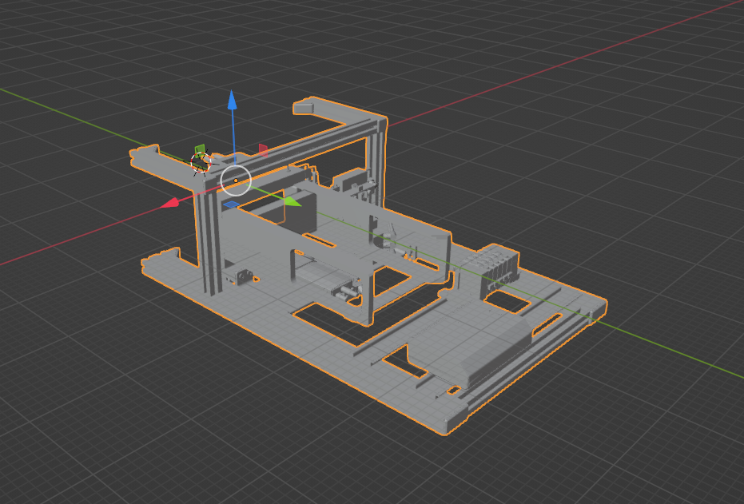

Credits:

https://assetstore.unity.com/packages/vfx/particles/fire-explosions/free-fire-vfx-urp-266226