Imported a Gorilla model from the Character Creator program and set it up for Unity. Added idle and jump animation, which are triggered by an Object with tag "Banana". Implemented AI navigation for roaming to random positions on a surface, and head tracking of a banana object.

Gorilla Manager script that checks if all gorillas have a banana.

Used a coroutine to make the gorilla move to a certain position when the human enters the scene.

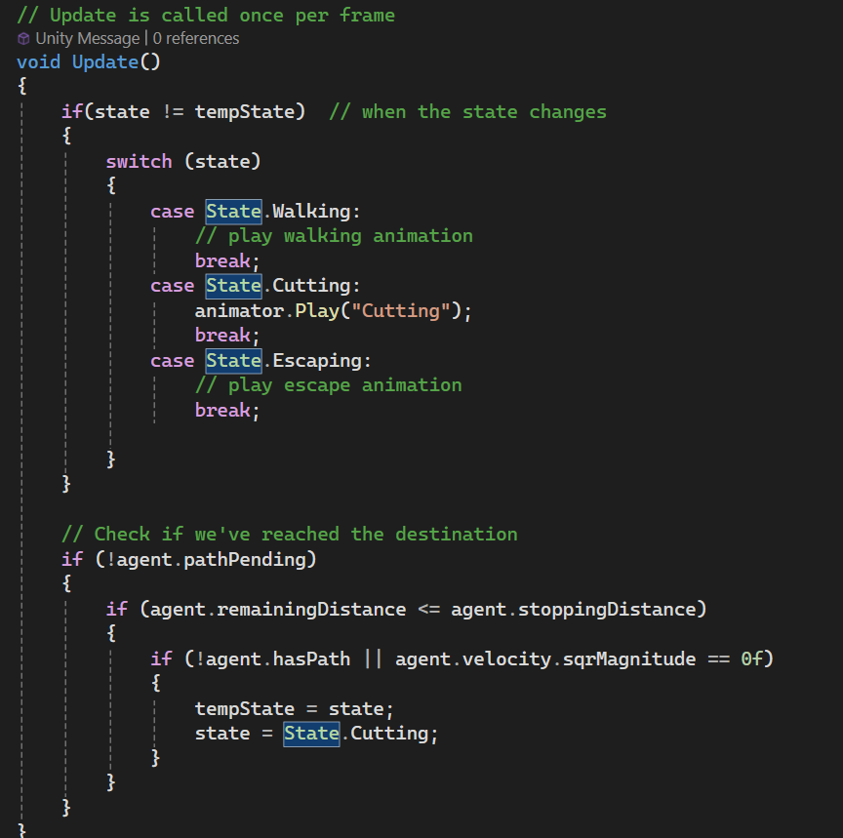

States for the Human.