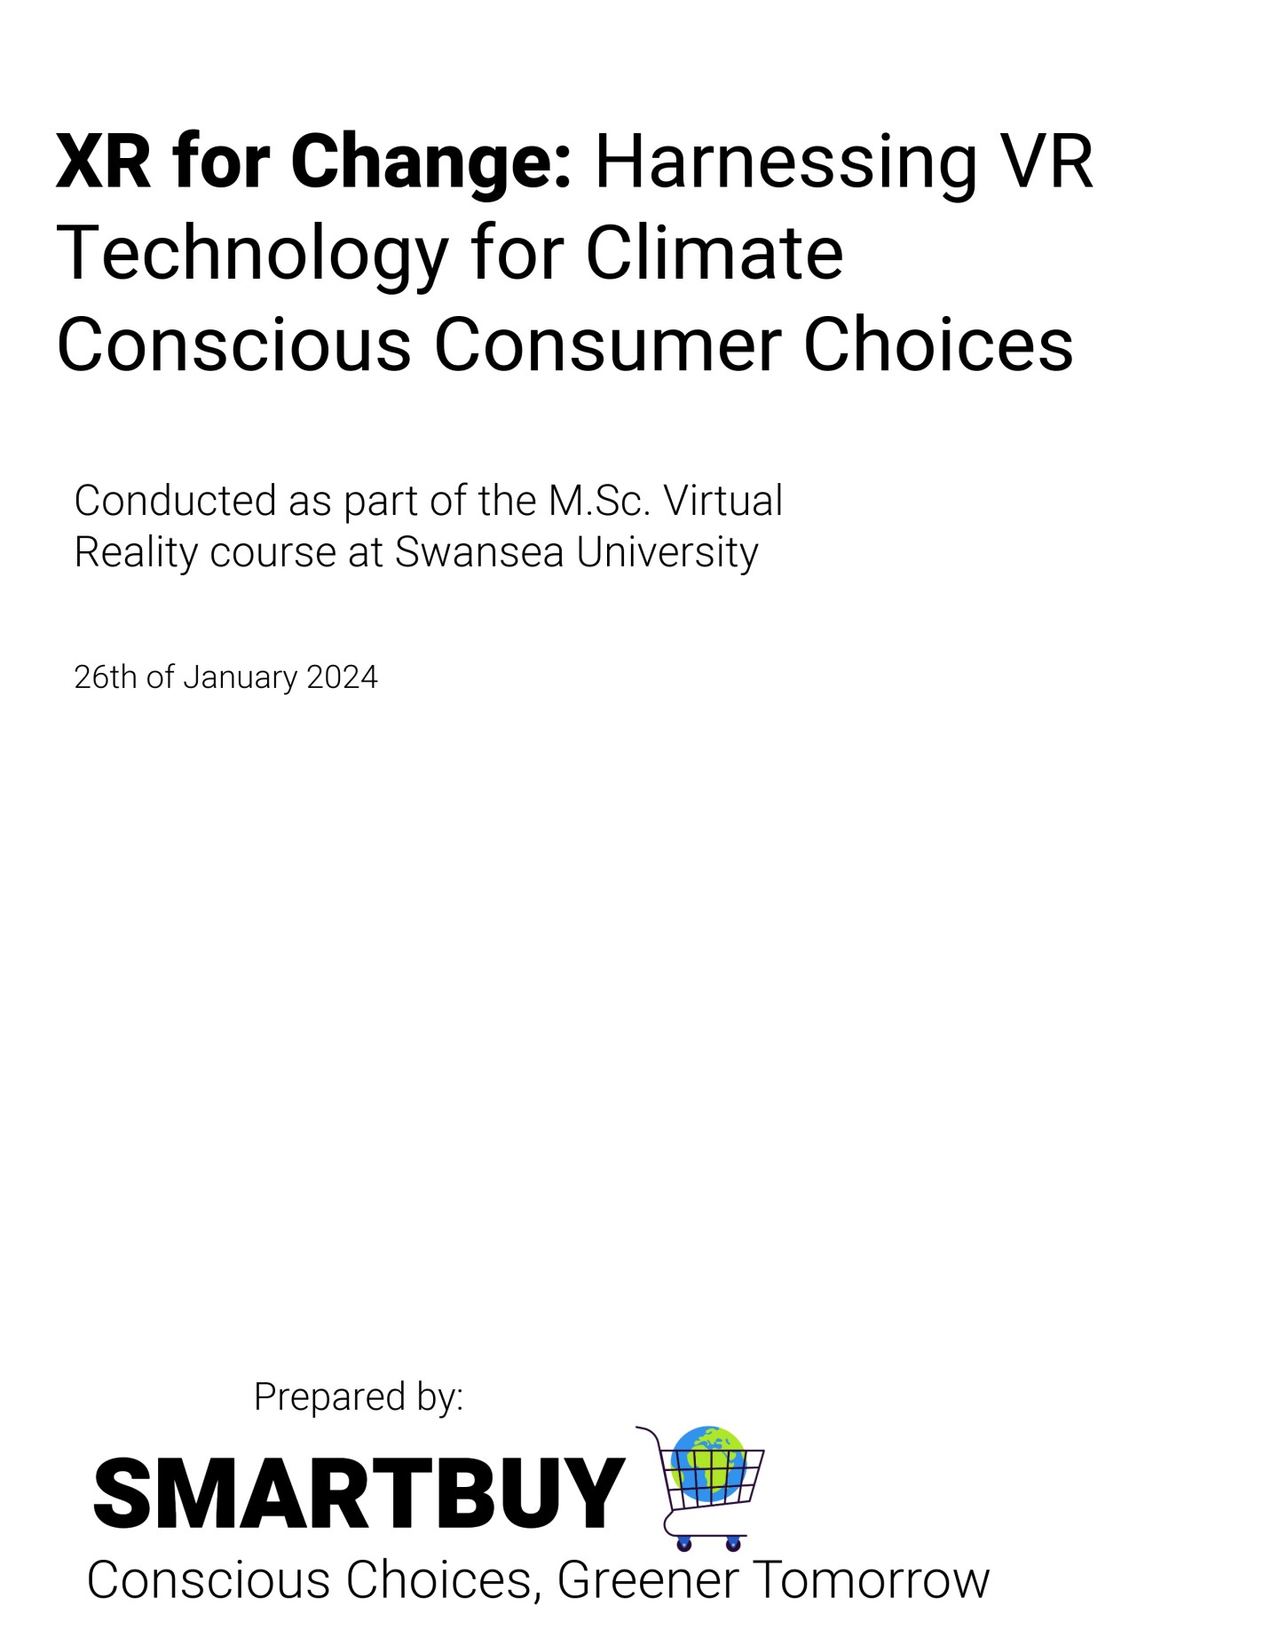
Introduction:

In a world increasingly impacted by climate change, it can be difficult to imagine the real-life consequences of our actions. Every choice people make now, have a significant impact on the future. VR Technology allows to step inside a problem and see the impact of climate change on the world around us. XR technology has become a perfect tool to create engaging and impactful experiences to target climate change (AlQallaf et al., 2022). This technology enables educators to develop new tools for multi-sensory teaching that promote learning through guided haptic and visuals (AlQallaf et al., 2022). The SmartBuy app promotes conscious purchasing practices to mitigate the impact of climate change. Certain products contribute significantly to the escalation of the carbon footprint, thereby exacerbating the deteriorating condition of our planet. According to various reports, between one third and one half of all globally produced food is wasted, resulting in a considerable global loss and contributing to the ongoing climate change crisis (Dhunnoo et al., 2023). The production of food products not only depletes water resources, but also generates greenhouse gas emissions (Beattie & McGuire, 2016). In addressing these environmental challenges, the SmartBuy app leverages VR technology. This innovative approach allows users to experience realistic simulations and immersive visualizations, fostering a profound understanding of the consequences of their consumption habits. By providing a tangible and engaging platform, SmartBuy aims to inspire individuals to alter their behaviour, cultivating a conscious and eco-friendly approach to consumer choices.

How does Extended Reality serve as a powerful tool for elevating awareness about climate change?

One of the primary challenges associated with climate change is that its effects are not immediately visible to the human eye; instead, they unfold gradually over an extended period (Dhunnoo et al., 2023). Consequently, it becomes challenging to visualize the long-term consequences. As a result, initiating behavioural change among people proves to be a complex task. Virtual Reality has a great potential to serve as a tool for increasing awareness about climate change by rendering the invisible visible (Marijn H. C. Meijers et al., 2023). For instance, VR enables the visualization of projected consequences of global warming, allowing individuals to vividly experience potential outcomes of a 50-year timeframe (Dhunnoo et al., 2023). Scenarios such as fires, floods, hunger, and conflicts represent some of the tangible consequences of global warming, already affecting certain cities or even whole countries (Cueto & Silva, 2019). Research indicates that without government intervention, major cities like Hong Kong could face severe air pollution by 2050, jeopardizing the availability of fresh air (Dhunnoo et al., 2023). Additionally, rising ocean temperatures pose a significant threat, potentially leading to the widespread destruction of coral reefs and the depletion of global fish stocks (Dhunnoo et al., 2023).
Through visualization, individuals can take immediate actions. For instance, if a city is projected to face coastal flooding in the future, people may choose to refrain from purchasing property in the affected area or start exploring alternative options (Cueto & Silva, 2019). Amsterdam, being low-lying, flat, and situated in proximity to the North Sea, is one such city exposed to this risk (Cueto & Silva, 2019). Utilizing VR technology to simulate a flooded Amsterdam allows individuals to firsthand experience the potential consequences. This immersive experience not only empowers individuals to make informed decisions about their choices but also prompts governments to take proactive measures in safeguarding the city (Cueto & Silva, 2019). Implementing systems such as dikes, barriers, levees, and floodgates becomes a tangible and urgent necessity to protect against the impending challenges posed by climate change (Cueto & Silva, 2019).
As technological advancements continue at a rapid pace, Extended Reality (XR) is poised to gain widespread acceptance (Statista, 2020). The trajectory of XR integration suggests a future in which children grow up immersed in a technologically driven environment (DavisFloyd, 2021). Early education on climate change for children has the potential to yield significant positive impacts on our planet, given the likelihood that they will play a pivotal role in implementing and driving change. However, the effectiveness of such education depends on various factors, including the quality of the educational programs, societal values, and individual actions (Davis-Floyd, 2021).

Examples of VR Projects Driving Climate Change Awareness:

Extended reality holds significant potential to inspire individuals to take action and personally sense the impacts of climate change (Rogers, 2020). Numerous organizations, charities, and schools are already embracing immersive media, such as virtual reality and augmented reality. For instance, National Geographic has developed an AR tool enabling users to witness the consequences of climate change globally, utilizing projected data from 2070 in 12 cities (Rogers, 2020).
Environmental charity Earthwatch Europe has also leveraged immersive technology to allow users to experience the effects of climate change. Their app empowers individuals to safeguard a city from the ramifications of global warming (Rogers, 2020). Maria Pontes, the director of programs, highlighted that AR provides an innovative, enjoyable, and captivating method of communication (Rogers, 2020). Therefore, XR technology emerges as an ideal tool to promote eco-friendly behaviour and educate individuals about the global crisis (Rogers, 2020).

Integrating VR Technology into the SmartBuy App:

SmartBuy was developed with the aim of providing fact-based information about the production of everyday food products, highlighting the often-unrecognized contributions to global warming associated with their purchase. The app seeks to inform consumers about these environmental impacts, encouraging them to make conscious choices while shopping for food. SmartBuy believes that small changes in consumer behaviour today can lead to significant positive changes in the future. The application employs Virtual Reality to create an immersive experience for users, taking them into a virtual grocery store where they can interactively learn about the environmental footprint of various products. As society continues to adopt VR technology, SmartBuy recognizes the lasting impact of experiences in this medium, as they evoke emotions and can leave a lasting impression on users. SmartBuy's VR experience begins in a virtual grocery store, educating users for example, about the substantial emissions produced during the transport of exotic fruits from Central and South America (Beattie & McGuire, 2016). The app uses a three-dimensional representation to illustrate the harmful emissions, such as a flying airplane emitting particles. This approach allows users to engage with the information in a way that surpasses traditional 2D videos or photographs (Rubio-Tamayo et al., 2017). Another crucial aspect of the SmartBuy application involves showcasing the palm oil production process, a significant contributor to the global warming crisis. Many users are unaware that palm oil is present in a wide range of products, from snacks and sweets to household detergents and body care items and the issue of "greenwashing," where products containing palm oil may use alternative names, such as Cetyl Palmitate (Teng et al., 2020). Furthermore, the SmartBuy app sheds light on the connection between palm oil production and deforestation, emphasizing the devastating consequences, such as uncontrolled fires that harm wildlife like Gorillas (Teng et al., 2020). Users are immersed in an adventure within the app, witnessing logging activities that contribute to deforestation. SmartBuy's approach is designed to be adaptable, allowing for continuous refinement and the incorporation of new products in the future. Through its immersive and educational experiences, SmartBuy aims to empower consumers to make informed choices that contribute to a more sustainable and environmentally conscious future. Additionally, SmartBuy incorporates advanced features like directional 3D audio, baked lighting, and non-player characters into the project. These elements are strategically integrated to enhance the user experience, providing a more immersive and realistic virtual environment (Rubio-Tamayo et al., 2017). Directional 3D audio contributes to a sense of spatial awareness, allowing users to perceive sounds as they would in the physical world (Rubio-Tamayo et al., 2017). Baked lighting enhances visual realism by simulating realistic lighting conditions, creating a more natural and engaging atmosphere within the virtual grocery store. The inclusion of NPCs adds a layer of interactivity, making the virtual experience more dynamic and responsive to user actions. These features collectively contribute to a more compelling and effective educational platform within the SmartBuy application (Marijn H. C. Meijers et al., 2023).

Conclusion:
Concluding, in a world increasingly shaped by the profound effects of climate change, the SmartBuy app emerges as a solution to bridge the gap between consumer choices and environmental impact. The immersive power of Virtual Reality technology has been harnessed to provide users with a transformative journey inside the complexities of climate change, encouraging a conscious and eco-friendly approach to daily consumption. Utilization of VR technology offers an engaging and educational experience, allowing users to witness and understand the environmental footprint. VR projects driving climate change awareness showcase the growing potential of Extended Reality technology in addressing global challenges. By leveraging VR technology, individuals can immerse themselves in realistic simulations that vividly depict the consequences of climate change, enabling people to better understand the urgency of environmental issues and encouraging them to take meaningful actions towards a more sustainable and eco-friendly lifestyle.

References
AlQallaf, N., Bhatti, S., Suett, R., Aly, S. G., Khalil, A. S. G., & Ghannam, R. (2022). Visualising Climate Change using Extended Reality: A Review. 2022 29th IEEE
International Conference on Electronics, Circuits and Systems (ICECS). https://doi.org/10.1109/icecs202256217.2022.9970808
Beattie, G., & McGuire, L. (2016). Consumption and climate change: Why we say one thing but do another in the face of our greatest threat. Semiotica, 2016(213). https://doi.org/10.1515/sem-2015-0109
Cueto, Y. R., & Silva, R. (2019). Identification of Areas Exposed to Storm Surge Flooding:
Topographic Factors and Ecosystem Changes. Journal of Coastal Research, 92(sp1),
68. https://doi.org/10.2112/si92-008.1
Davis-Floyd, R. (2021). Birthing Techno-Sapiens: Human-Technology Co-Evolution and the
Future of Reproduction (p. 322). Routledge. (Original work published 2021)
Dhunnoo, Y., Carter, A., O’Hare, D., Birt, J., & Skitmore, M. (2023). Improving Climate
Change Awareness through Immersive Virtual Reality Communication: A Case Study.
Sustainability, 15(17), 12969. https://doi.org/10.3390/su151712969
Marijn H. C. Meijers, Ragnheiður “Heather” Torfadóttir, Anke Wonneberger, & Masłowska,
E. (2023). Experiencing Climate Change Virtually: The Effects of Virtual Reality on Climate Change Related Cognitions, Emotions, and Behavior. Environmental
Communication, 17(6), 581–601. https://doi.org/10.1080/17524032.2023.2229043
Panu, P. (2020). Anxiety and the Ecological Crisis: An Analysis of Eco-Anxiety and Climate
Anxiety. Sustainability, 12(19), 7836. https://doi.org/10.3390/su12197836
Reis, C. M., & Andréa Cruz Câmara. (2023). Expanding Nature’s storytelling: extended reality and debiasing strategies for an eco-agency. PsyArXiv (OSF Preprints).
https://doi.org/10.31234/osf.io/btz9e
Rogers, S. (2020). How Extended Reality Can Bring Climate Change Front Of Mind. Forbes.
https://www.forbes.com/sites/solrogers/2020/04/21/how-extended-reality-can-bringclimate-change-front-of-mind/
Rubio-Tamayo, J., Gertrudix Barrio, M., & García García, F. (2017). Immersive
Environments and Virtual Reality: Systematic Review and Advances in
Communication, Interaction and Simulation. Multimodal Technologies and
Interaction, 1(4), 21. https://doi.org/10.3390/mti1040021
Said, I., Stanbury, A. J., Delhagen, E., & Hyung Sik Kang. (2023). Immersive Climate
Narratives: Using Extended Reality to Raise Climate Change Awareness. https://doi.org/10.1145/3611659.3617195
Statista. (2020, November). Global augmented/virtual reality market size 2016-2022 | Statistic. Statista; Statista. https://www.statista.com/statistics/591181/globalaugmented-virtual-reality-market-size/
Teng, S., Khong, K. W., & Che Ha, N. (2020). Palm oil and its environmental impacts: A big data analytics study. Journal of Cleaner Production, 274, 122901.
https://doi.org/10.1016/j.jclepro.2020.122901

