Using Putty to connect Amazon AWS

Firstly, download putty.exe,which allows you to connect to a virtual machine, on <https://www.chiark.greenend.org.uk/~sgtatham/putty/latest.html>

and you may also need to download WinSCP, which is a file transmitter for Windows system.

Here is the link for downloading WinSCP

<https://winscp.net/eng/download.php>

Step 1. Prepare your Key Pair

Firstly, after launching the AWS machine. You have to set up a Key Pair to access the virtual machine remotely.

Create a Key Pair

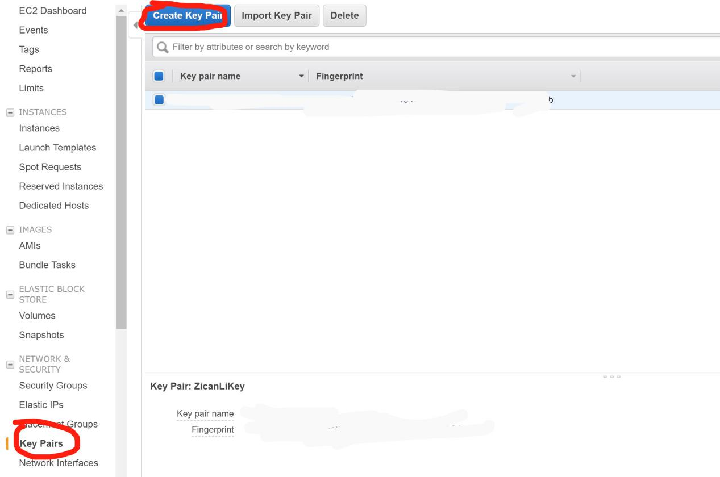

After Creating a Key Pair, there will be .pem file automatically downloaded to your local machine, which is the key to access AWS machine.

Then you can open WinSCP and click tools and click Run PuTTYgen

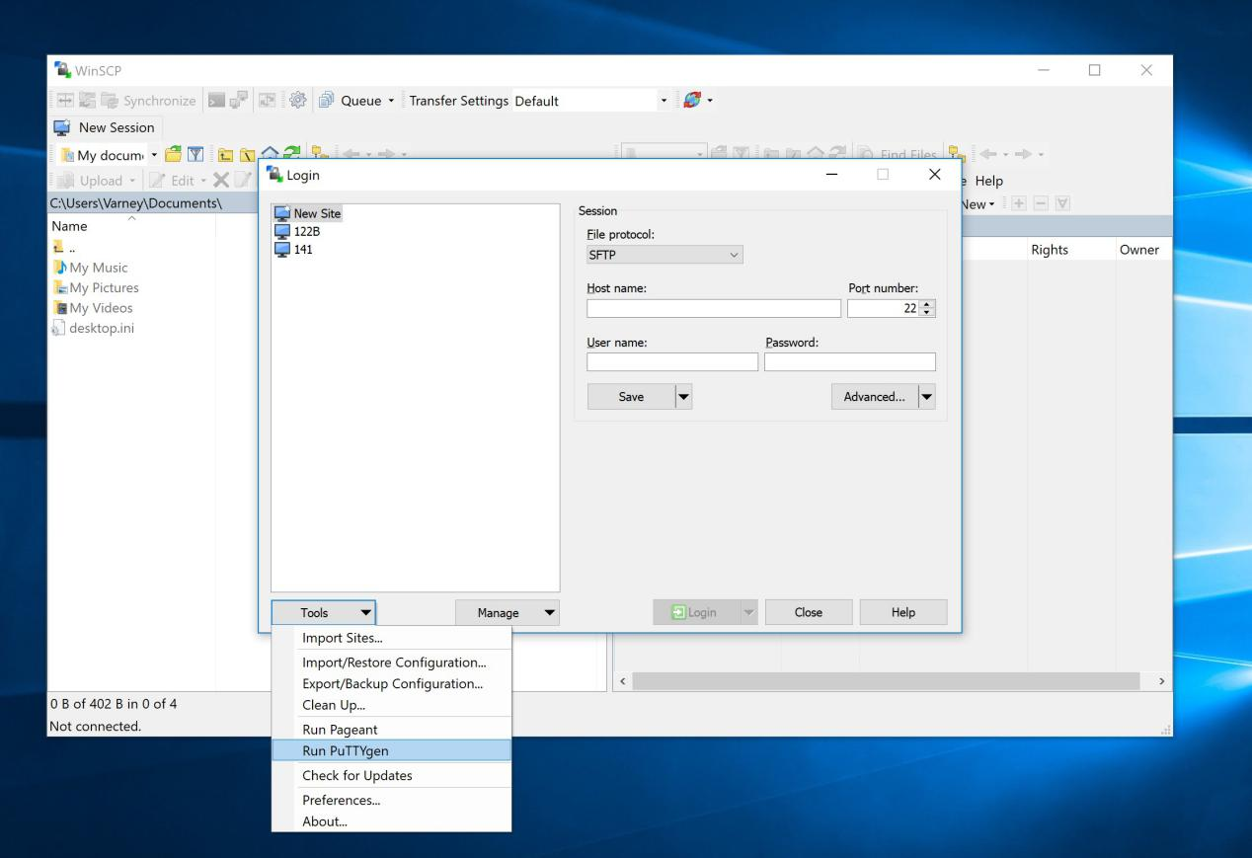

We are using PuTTYgen to convert the .pem file to a .ppk file. Click **Load** and select the .pem file you just downloaded.

If you follow the instruction correctly, you will see the screenshot below

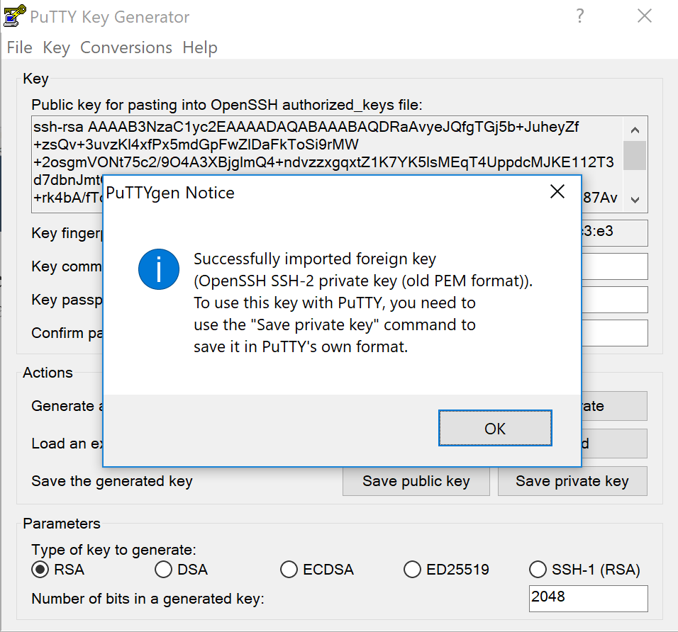

Then, Click Save private key, which saves a .ppk file on your local machine. You will rely this .ppk file to access the AWS machine.

Step 2. Login ubuntu on WinSCP

Make sure in the Security Group of your AWS console, you have opened the port 22 (for SSH)

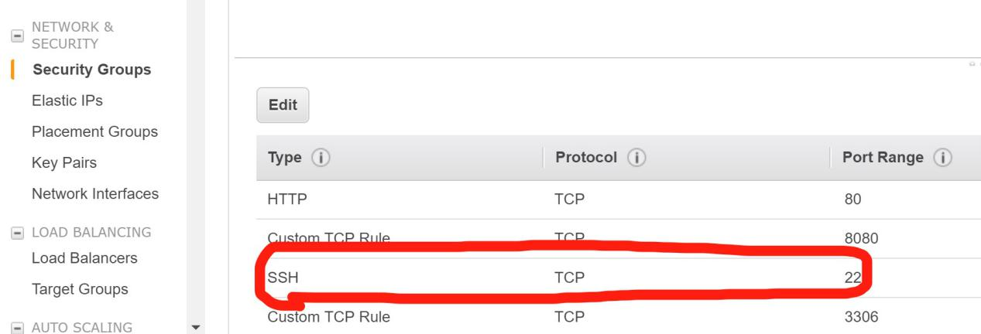

Copy the Public DNS, which you can find on the Instance of AWS, on WinSCP as **hostname**. Type **ubuntu** as username, and type your personal password. Then click **advanced** to specify the key file for connecting.

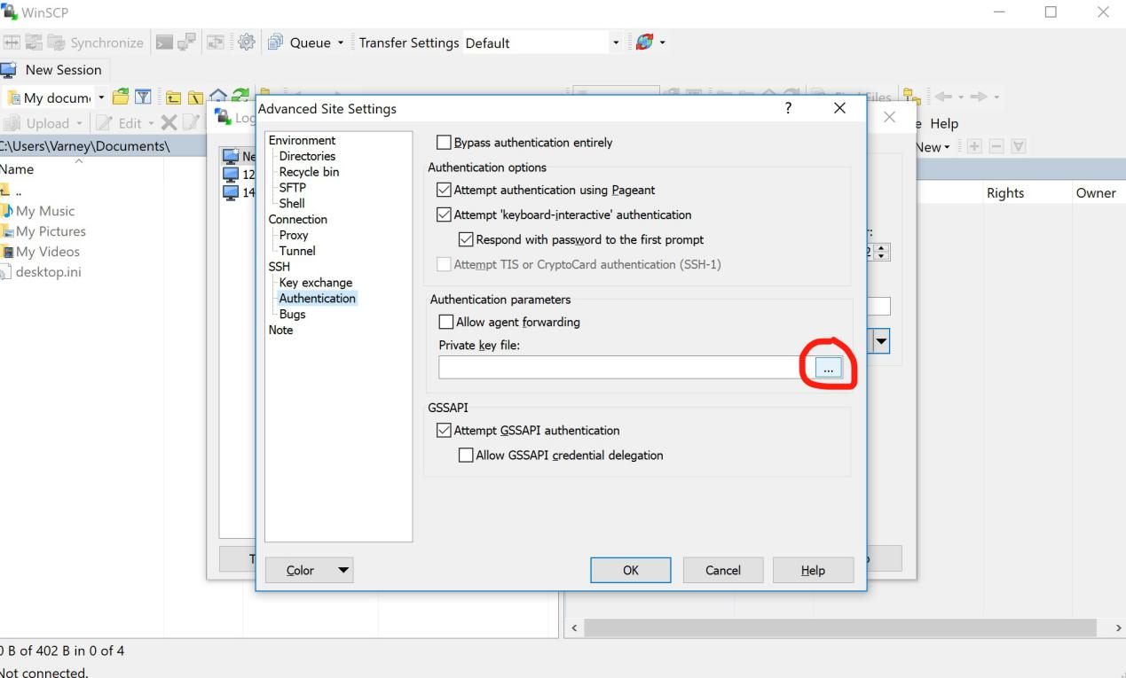

Go to **Authentication** and select the Private key file which is the .ppk file on your local machine. And then, Click OK. So far, you should be able to login ubuntu on WinSCP.

Step 3. Login ubuntu by Putty.exe

Open putty.exe and type **ubuntu@YOUR_PUBLIC_DNS** as the hostname

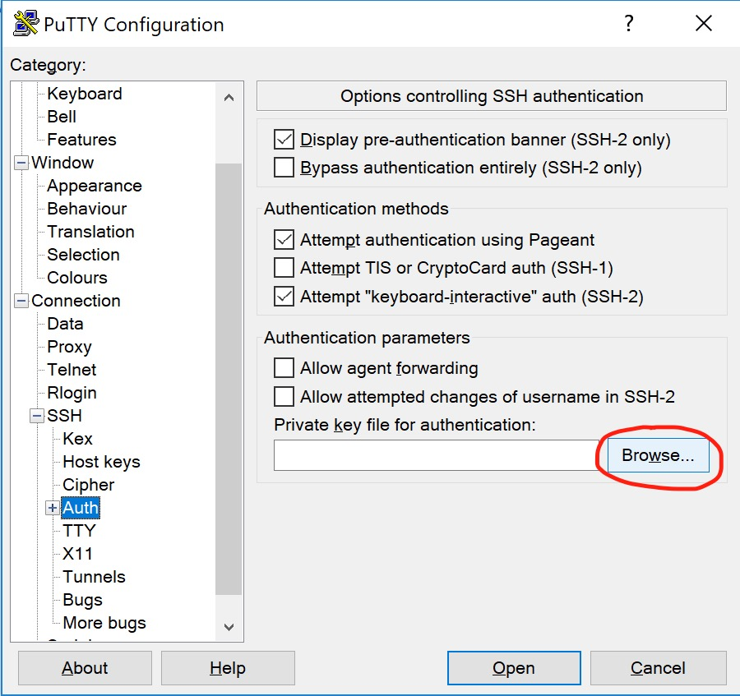

Then click SSH and Auth, choose the private key file (that .ppk file) as the private key file for authentication. Finally, click open. You will be able to connect to the AWS machine.

Tips: Go back to save the hostname and key on putty and you will not be asked to do all those stuff again next time you log in.