  
**ENGR1000J/VG100 Introduction to Engineering, Summer 2025**

**May 20, 202****5**

**Logo**

Project Title

**Group 0: TC team**

Provide 1 graphic that beautifully encompasses the technical concept of your project without words!

*The example figures/tables in this template are taken from ENGR1000J/VG100 project reports of previous year.*

Team Member1 (中文名)，*email@address*

Ting Sun1 (孙婷)，*[ting.sun@sjtu.edu.cn](mailto:ting.sun@sjtu.edu.cn)*

Different Institute Member2, *email@address*

# Abstract

This section includes information for those readers who will not read the entire document. Although this section appears first in the document, it is usually written last. It is one-paragraph long (not an introduction) and complete in itself (no reference numbers). It should indicate the general engineering background of your project and state the objectives. The design methodology, measurement techniques, observed facts, key understandings and conclusions must be stated in summary form. It should include a description of the project background, the project aim, the major tasks undertaken, the measurement techniques employed, key observations and physical understanding, conclusion and the significance of your findings. Word count is 200-400.

# Acknowledgments

Thank all the parties assisted this project, such as TAs, instructors, helpful companies, teammates, etc….

Table of Contents

**Abstract 2**

**Acknowledgments 2**

**I. Introduction 4**

**II. Project Management 4**

**III. System Design and Assembly 7**

**IV. Measurement Results and Discussion 9**

**V. Conclusions 9**

**VI. References 10**

**VII. Appendix 13**

**VIII. Supplementary 13**

# Introduction

This section gives the reader a flavor of the work or project presented: the context of the work, the objectives, scope. In another word, the problem, the need, and the solution. Normally it begins with more general background, then gradually narrows down to a particular problem. After clearly identify the problem, what is needed will be liberated followed by a solution (brief summary of what your prototype can offer). The main goal of this section is to establish the significance of your project--why is it needed. (page limit 2 pages)

Background is where you set the context for your work. You need to place your work in a context beyond the immediate engineering application. Current societal topics are a good place to start: security, energy, sustainability, productivity, etc. Spend some time discussing the broader engineering issues, then gradually narrow the discussion down to the technical side of your project. Background can include reasonable technical discussions on some fundamental theories related to your project. Please avoid your own personal opinion and keep all the discussions objective.

Proper citation is always required per academic ethic and HC. List and number all references at the end of the report. Reference citations in the text should be in numerical order. In order to convey the overall project design logic clearly, please extract out the statements for problem, need/s, and solution and include them below.

**Statements**

* Problem: clearly and concisely sums up what is the problem.
* Need/s: clearly and concisely sums up what is/are needed.
* Solution/s: clearly and concisely sums up the solution your project offers.

# Project Management

This section describes how your team managed this project. It should include a simple Gantt Chart, material budget, personnel information and contribution, and risk assessment. The tasks stated in the Gantt Chart correspond to the needs/solutions of this project.

A Gantt chart provides concise but accurate information on the expected timetable for the project. The time for completion of each task should correspond exactly to the tasks previously described. Keep your Gantt Charts simple; as this graphic is intended for external audience, do not include too many tasks or descriptions of each task.

Budget: State the proposed costs and budget of the project. Also include information on how you intend to manage the budget. One common way of showing the budget is according to the tasks as in Table 1.

In building a set-up or prototype, material costs are typically accounted for in a bill of materials (BOM). This typically takes the form of the example shown below in Table 2. State the costs of the project in an itemized form. Use a table, and make sure you list the total and any relevant sources for your purchases. If the purchasing link list is too long to fit in the main report body, you may include them as an appendix or a supplementary session.

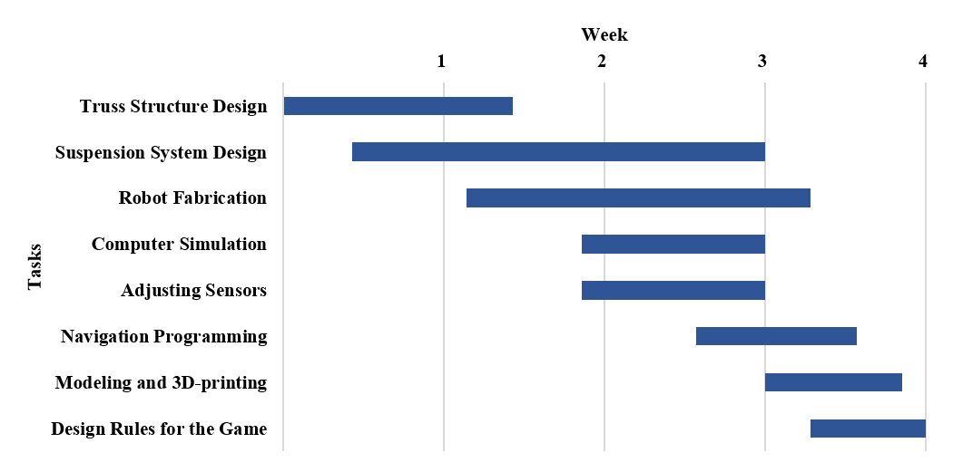**Fig. 1 Gantt chart for the project.**

**Table 1 Project estimated budget**

|  |  |  |
| --- | --- | --- |
| Task | Description of work | Anticipated costs, Yuan |
| 1 | 3D-printing container | 150.00 |
| 2 | Construction of suspension system | 100.00 |
| 3 | Realization of automatic navigation | 200.00 |
| 4 | Construction of jogging system | 200.00 |
| 5 | Realization of additional function | 200.00 |
| 6 | Tools | 150.00 |
|  | Total | 1000.00 |

Personnel: List the key personnel responsible for completion of the project, as well as other personnel involved in the project. Include brief summaries of their principal roles. These roles/contributions listed for each personnel shall be coherent with the tasks shown in Gantt Chart. The contributions of each team member are to be in agreement among the complete team, therefore, a signature is required from each member to endorse the content. (See Table 3).

Risk Assessment: What needs to be in place for your project to succeed? What are the major sources of risk and how will you attempt to mitigate them? What is your fallback plan? What might be safety concerns?

**Table 2 Bill of materials\***

|  |  |  |  |  |
| --- | --- | --- | --- | --- |
| Quantity | Part Description | Purchased From* | Part Number | Price (Each in RMB) |
| 8 | Wheel | Taobao Vendor |  | 5.70 |
| 6 | Motor | Taobao Vendor | GA12-N20 | 0.97 |
| 1 | Alien mask | Taobao Vendor |  | 37.50 |
| 4 | 20g tungsten | Taobao Vendor |  | 19.80 |
| 1 | Battery | Taobao Vendor |  | 58.00 |
| 4 | Spring | Taobao Vendor |  | 2.00 |
| 1 | Color sensor | Taobao Vendor | TCS3200 | 20.95 |
| 1 | Grayscale sensor | Taobao Vendor | S601 | 16.90 |
| 6 | Bearing | Taobao Vendor |  | 2.50 |
| 2 | Synchronous pulley (with belt) | Taobao Vendor |  | 32.50 |
| 1 | Pole | Taobao Vendor |  | 26.22 |
| 1 | Square stick | Taobao Vendor |  | 37.22 |
| 2 | L298n | Taobao Vendor |  | 10.00 |
| 1 | Storage box | Taobao Vendor |  | 58.00 |
| 3 | Laser sensor | Taobao Vendor |  | 4.20 |
| 1 | Laser pen | Taobao Vendor |  | 27.00 |
| 1 | Loudspeaker | Taobao Vendor |  | 16.89 |
| 1 | USB flash disk | Taobao Vendor |  | 19.90 |
| 1 | Speech module | Taobao Vendor | JQ8400-FL | 9.90 |
| 1 | 80-g A4 paper (500 pieces) | Taobao Vendor |  | 24.50 |
| 1 | Wooden materials | Taobao Vendor |  | 16.00 |
| 1 | Cap pistol | Taobao Vendor |  | 45.00 |
| 1 | Arduino Mega 2560 | Taobao Vendor |  | 143.40 |
| 1 | 3D-Printed part | Online Vendor |  | 270.00 |
|  |  |  | Total = | 1,078.60 |

*The links are shown in the appendix.

**Table 3 Key personnel responsible for the project and their contributions**

|  |  |  |
| --- | --- | --- |
| Member | Contributions | Signature |
| Ting Sun* |  | Sign here to acknowledge and agree with the content. |
| Xinyi Zhou |  |
| Yicheng Zhang |  |
| … |  |
| Member Name |  |

# System Design and Assembly

This section documents detailed design methodology and assembly procedure (concisely!) for your project. A schematic diagram of your overall system should be provided. The function and technical information about the key components should be explained in detail. You should present your step-by-step design procedure and the theory behind. Some photos, diagrams, and mathematical equations might be necessary. Readers should be able to re-create your system based on this section. You will be graded on the technical completeness of these descriptions.

An example layout:

* Overall structure design
* Key components and assembly
* Electrical/circuit design

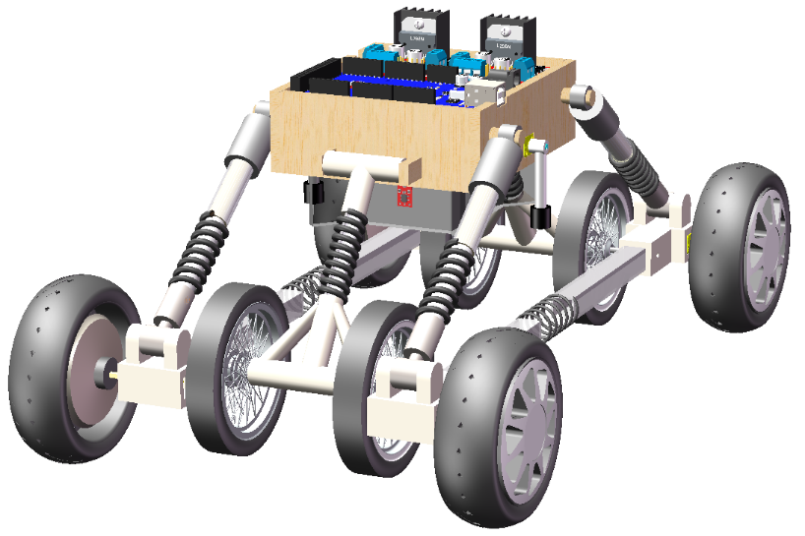

**Fig. 2 The overall design of the explorer.** (Generated by SOLIDWORKS 2019)

|  |  |  |  |
| --- | --- | --- | --- |
| 1. L298N Motor Driver | 1. MEGA 2560 | 1. 11.1 V RC Battery | 1. Upper Pin Connection |
| 1. Acrylic Round Bar | 1. Spring | 1. Lower Pin Connection | 1. Motor Container |
| 1. N20 Gear Motor | 1. Principal Wheel | 1. Horizontal Acrylic Bar | 1. Spring |
| 1. N20 Gear Motor | 1. Rolling Bar | 1. T-shape Connection | 1. Spring |
| 1. Acrylic Round Bar | 1. Auxiliary Wheel | 1. Stainless Steel Axle | 1. Trident Pin Connection |
| 1. Target Platform | 1. Laser Sensor | 1. Greyscale Sensor | 1. Container Box |

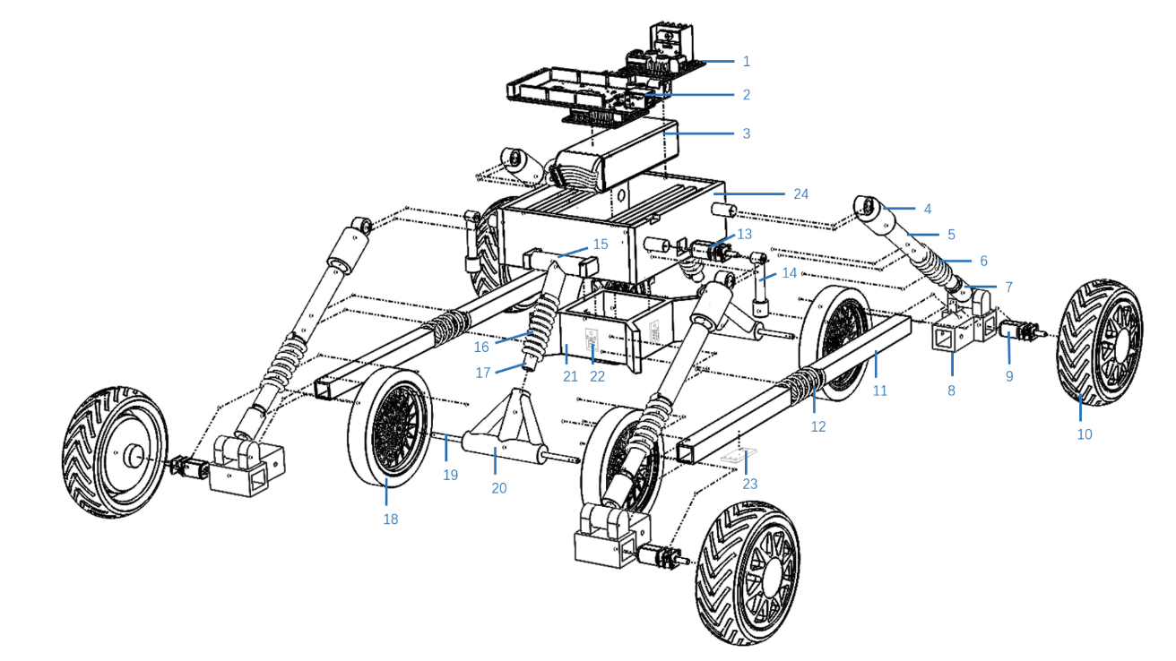

**Fig. 3 Exploded view of the explorer.** (Generated by SOLIDWORKS 2019)

# Measurement Results and Discussion

In this section you present your performance measurement results along with supporting text which ensures that the reader understands the data (description of post-processing or evaluation methods, analysis of uncertainties, exposition of tables/figures, correlations).

Next is the most important part of the report – you are expected to assess critically what your results mean, what design implication they might have to the engineering community, and whether they make sense according to what you learned from the engineering lectures. Do not simply repeat in words what is obvious from your figures and tables (this is, sadly, a common mistake).

Refer to a figure or a table by its number, not “figure below” or “table above.” When citing a figure in the text, use the abbreviation “Fig.” except at the beginning of a sentence. Do not abbreviate “Table”. Place a figure or a table close to (often immediately before or after) the “paragraph” of its first mention. By contrast, it is not necessary --- and so DO NOT place a figure or a table immediately after the “sentence” of the first mention; doing so inevitably breaks up a coherent paragraph (consisting of a topic sentence, several sentences of analysis and evidence, and a concluding remark) into several incoherent “paragraphs,” some made of a single sentence.

Figures should have no background, borders, or outlines. Captions are bold with a single tab (no hyphen or other character) between the figure number and figure description. Keep the lettering size and style uniform both within each figure and throughout all of your illustrations. An example Figure is shown in Fig. 4.



**Fig. 4 Magnetization as a function of applied fields.**

# Conclusions

Although a conclusion may review the main points of the report, do not replicate the abstract as the conclusion. Start with a concise summary of what you achieved in the project. You should cover the following points: What were the highlights of the project? How successfully did you meet your objectives? Where and why did you fail to meet objectives? How did your actual progress match your original plan? Was your estimating of time and resource accurate? With the benefit of hindsight, were there risks for which you failed to prepare adequately? Also discuss any problems which you encountered with e.g. equipment, shortage of resources (expertise/materials/etc.) or events/circumstances external to the project.

Finally, explain how you achieved the learning outcomes for the project, listed in the module description. You may also offer a concise summary of further opportunities created by your work. Discuss any lessons to be learned for the benefit of future students.

# References

The examples below illustrate different reference types following the AIAA journal article traditions. All references should be in 9-point font, with reference numbers in brackets. You are not required to indicate the type of reference; different types are shown here for illustrative purposes only.

The DOI (digital object identifier) should be incorporated in every reference for which it is available (see Ref. 1 sample); for more information on DOIs, visit [www.doi.org](http://www.doi.org) or [www.crossref.org](http://www.crossref.org).

Note: The subtitles in this reference guide (e.g., "Periodicals," "Books," etc.) are for instructional purposes only. They are NOT expected to show up in your final report.

*Periodicals*

[1] Vatistas, G. H., Lin, S., and Kwok, C. K., “Reverse Flow Radius in Vortex Chambers,” *AIAA Journal*, Vol. 24, No. 11, 1986, pp. 1872, 1873.

doi: 10.2514/3.13046

[2] Alyanak, E. J., and Pendleton, E., “Aeroelastic Tailoring and Active Aeroelastic Wing Impact on a Lambda Wing Configuration,” *Journal of Aircraft*, published online 10 Nov. 2016.

doi: 10.2514/1.C033040

[3] Dornheim, M. A., “Planetary Flight Surge Faces Budget Realities,” *Aviation Week and Space Technology*, Vol. 145, No. 24, 9 Dec. 1996, pp. 44–46.

[4] Terster, W., “NASA Considers Switch to Delta 2,” *Space News*, Vol. 8, No. 2, 13–19 Jan. 1997, pp. 1, 18.

All of the preceding information is required. The journal issue number (“No. 11” in Ref. 1) is preferred, but the month (Nov.) can be substituted if the issue number is not available. Use the complete date for daily and weekly publications. Transactions follow the same style as other journals.

*Books*

[5] Peyret, R., and Taylor, T. D., *Computational Methods in Fluid Flow*, 2nd ed., Springer-Verlag, New York, 1983, Chaps. 7, 14.

[6] Oates, G. C. (ed.), *Aerothermodynamics of Gas Turbine and Rocket Propulsion*, AIAA Education Series, AIAA, New York, 1984, pp. 19, 136.

[7] Volpe, R., “Techniques for Collision Prevention, Impact Stability, and Force Control by Space Manipulators,” *Teleoperation and Robotics in Space*, edited by S. B. Skaar and C. F. Ruoff, Progress in Astronautics and Aeronautics, AIAA, Washington, DC, 1994, pp. 175–212.

Publisher, place, and date of publication are required for all books. No state or country is required for major cities: New York, London, Moscow, etc. A differentiation must always be made between Cambridge, MA, and Cambridge, England, UK. Note that optional series titles are in Roman type.

*Proceedings*

[8] Thompson, C. M., “Spacecraft Thermal Control, Design, and Operation,” *AIAA Guidance, Navigation, and Control Conference*, CP849, Vol. 1, AIAA, Washington, DC, 1989, pp. 103–115

[9] Chi, Y. (ed.), *Fluid Mechanics Proceedings*, NASA SP-255, 1993.

[10] Morris, J. D., “Convective Heat Transfer in Radially Rotating Ducts,” *Proceedings of the Annual Heat Transfer Conference*, edited by B. Corbell, Vol. 1, Inst. of Mechanical Engineering, New York, 1992, pp. 227–234.

*Reports, Theses, and Individual Papers*

[11] Brandis, A. M., Johnston, C. O., and Cruden, B. A., “Nonequilibrium Radiation for Earth Entry,” AIAA Paper 2016-3690, June 2016.

[12] Steger, J. L., Jr., Nietubicz, C. J., and Heavey, J. E., “A General Curvilinear Grid Generation Program for Projectile Configurations,” U.S. Army Ballistic Research Lab., Rept. ARBRL-MR03142, Aberdeen Proving Ground, MD, Oct. 1981.

[13] Tseng, K., “Nonlinear Green’s Function Method for Transonic Potential Flow,” Ph.D. Dissertation, Aeronautics and Astronautics Dept., Boston Univ., Cambridge, MA, 1983.

Government agency reports do not require locations. For reports such as NASA TM-85940, neither insert nor delete dashes; leave them as provided. Place of publication *should* be given, although it is not mandatory, for military and company reports. Always include a city and state for universities. Papers need only the name of the sponsor; neither the sponsor’s location nor the conference name and location is required. *Do not confuse proceedings references with conference papers*.

*Electronic Publications*

Regularly issued electronic journals and other publications are permitted as references. Include the doi if provided; otherwise provide the full URL. Archived data sets also may be referenced as long as the material is openly accessible and the repository is committed to archiving the data indefinitely. References to electronic data available only from personal websites or commercial, academic, or government ones where there is no commitment to archiving the data are not permitted in the reference list.

[14] Atkins, C. P., and Scantelbury, J. D., “The Activity Coefficient of Sodium Chloride in a Simulated Pore Solution Environment,” *Journal of Corrosion Science and Engineering* [online journal], Vol. 1, No. 1, Paper 2, URL: <http://www.cp/umist.ac.uk/JCSE/vol1/vol1.html> [retrieved 13 April 1998].

[15] Vickers, A., “10-110 mm/hr Hypodermic Gravity Design A,” *Rainfall Simulation Database* [online database], URL: <http://www.geog.le.ac.uk/bgrg/lab.htm> [retrieved 15 March 2006].

Break website addresses after punctuation, and do not hyphenate at line breaks.

*Computer Software*

[16] TAPP, Thermochemical and Physical Properties, Software Package, Ver. 1.0, E. S. Microware, Hamilton, OH, 1992.

Include a version number and the company name and location of software packages.

*Patents*

Patents appear infrequently. Be sure to include the patent number and date.

[17] Scherrer, R., Overholster, D., and Watson, K., Lockheed Corp., Burbank, CA, U.S. Patent Application for a “Vehicle,” Docket No. P-01-1532, filed 11 Feb. 1979.

*Private Communications and Websites*

References to private communications and personal website addresses are not permitted. They may, however, be incorporated into the main text of a manuscript or may appear in footnotes.

*Unpublished Papers and Books*

Unpublished works can be used as references as long as they are being considered for publication or can be located by the reader (such as papers that are part of an archival collection). If a journal paper or a book is being considered for publication, choose the format that reflects the status of the work (depending upon whether it has been accepted for publication):

[18] Doe, J., “Title of Paper,” *Name of Journal* (to be published).

[19] Doe, J., “Title of Chapter,” *Name of Book*, edited by…, Publisher’s name and location (to be published).

[20] Doe, J., “Title of Work,” Name of Archive, Univ. (or organization), City, State, Year (unpublished).

Unpublished works in an archive *must* include the name of the archive and the name and location of the university or other organization where the archive is held. Also include any cataloging information that may be provided.

# Appendix

# Supplementary