basic syntax  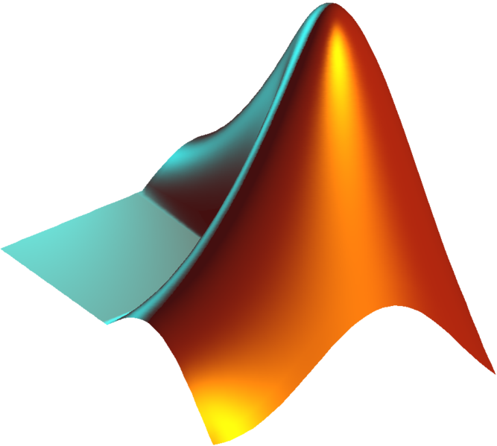
>>> x = 1  >>> y = [1,2,3,4,5] # list  >>>  >>> range(1,6,2)  [1,3,5]  >>>  >>> y[0] # zero-indexed  1 | >> x = 1;  >> y = [1 2 3 4 5]; % row vector  >> z = [1 2 3 4 5]'; % column vector  >> 1:2:6  ans =  1 3 5  >> y(1) % one-indexed  ans =  1

operators & numbers boolean operators
 | + | – | * | / | ** |  | : | % | # | = | 1j | np.nan | np.inf | == | < | > | <= | >= | != | and | or | not
 | + | – | .* | ./ | .^ | .\ | : | mod(x,n) | % | = | i | NaN | Inf | == | < | > | <= | >= | ~= | && | || | ~

special functions
from numpy import * # many of these functions also available in math
 | sin | cos | tan | sinh | cosh | tanh | arcsin | arcsinh | exp | expm1 | deg2rad | rad2deg | log | log10 | sqrt
 | sin | cos | tan | sinh | cosh | tanh | asin | asinh | exp | expm1 | deg2rad | rad2deg | log | log10 | sqrt
 | sind | cosd | tand |  |  |  | asind
from scipy.special import *
 | j0 | jn | jv | y0 | yn | yv | gamma | erf | erfc | hyp2f1 | binom | poch | airy
 | besselj |  |  | bessely |  |  | gamma | erf | erfc | hypergeom | nchoosek |  | airy | isprime | nthroot

arrays & operations NumPy also provides universal functions.
from numpy import *
 | array(((a,b,c),(d,e,f))) | eye(n) | zeros((m,n)) | ones((m,n)) | rand | empty((m,n)) | None
 | [a b c; d e f] | eye(n) | zeros(m,n) | ones(m,n) | rand |  | []

 | linspace | arange(a,b,d) | diag | vstack | hstack | meshgrid | reshape | ravel | tile
 | linspace | a:d:b | diag | vertcat | horzcat | meshgrid | reshape |  | repmat

plotting
import numpy as np  import scipy as sp  x = np.linspace(0,6,201)  y = sp.j0(x)  fig = plt.figure()  ax = fig.add_subplot(111)  ax.plot(x,y,'r-',lw=2,label='J_0(x)')  ax.set_title('Zeroth-Order Bessel  Function', fontsize=24, family='serif')  ax.set_ylabel('f(x)', fontsize=18)  ax.set_xlabel('x', fontsize=18)  ax.set_ylim((-1, 2))  ax.legend()  plt.show() | x = linspace(0,6,201);  y = besselj(0,x);  figure1 = figure;  axes1 = axes('Parent',figure1);  plot(x,y,'r-','DisplayName','J_0(x)',  'LineWidth',2);  title({'Zeroth-Order Bessel Function'});  xlabel('x');  ylabel('f(x)');  ylim([-1 2])  legend();
from numpy import *
from matplotlib.pyplot import *
 | plot |  |  | plot_surface |  |  | contour | legend | imread | imshow | imsave
 | plot | fplot | ezplot | surf | ezsurf | plot3 | contour | legend | imread | imshow | imwrite

linear algebra
from numpy import *
from scipy.linalg import *
 | dot | cross | A.T | inv | det | trace | inner | outer | matmul | eig | solve | qr | svd | lu | expm | logm | cholesky
 | dot | cross | A' | inv | det | trace | * |  | * | eig | \ | qr | svd | lu | expm | logm | chol
polynomials & curve fitting
from numpy import *
 | poly(v) | roots(p) | polyval(p,x) | polyder(p,m) | polyint(p,m) | polyfit(x,y,n)
 | poly(v) | roots(p) | polyval(p,x) | polyder(p,m) | polyint(p,m) | polyfit(x,y,n)
Polynomials are ordered in ascending manner (x⁰+x¹+x²) in Python and in descending order in MATLAB (x²+x¹+x⁰).
from scipy.interpolate import *
 | interp1d(xd,yd,mt) | griddata(xd,yd,(gx,gy),mt) | splrep(xd,yd) | bisplrep | splprep
 | interp1(xd,yd,x,mt) | interp2(xd,yd,x,gx,gy) | spline(xd,yd,x)

string operations
 | print | '%f'%np.pi | .find | in | .join | .split | + |  | .upper
 | disp | sprintf('%f',pi) | strfind | strcmp | strjoin | strsplit | strcat | strtok

advanced syntax
control statements |  | exception handling | loops
 | if expr1:  code1  elif expr2:  code2  else:  code3 | A = 1  try:  file = open('file.txt')  except IOError, exc:  print 'file cannot be opened'  except:  print 'non-IOError'  else:  print file.readlines()  finally:  file.close() | for v in arange(1.0,0.0,-0.2):  print v  n = 0  while n < 10:  print n  n -= 1
 | if expr1  code1  elseif expr2  code2  else  code3  end | A = rand(3);  B = ones(5);  try  C = [A; B];  catch err  error('Dimension mismatch');  end | for v = 1.0:-0.2:0.0  disp(v)  end  n = 0;  while n < 10  disp(n);  n = n - 1;  end

function definitions |  |  | anonymous functions
 | def foo(x):  y = x ** 2  return y | may be defined in any block  (including in nested blocks) | lambda x: x ** 2
 | function [y] = foo(x)  y = x .^ 2  end | must be in file named foo.m | @(x) x .^ 2;

using code & scripting |  |  |  | file input & output
 | import | eval | execfile | open | .read | .readline | .write | .close | np.loadtxt | np.savetxt
 | import | eval | run | open | fileread | fgetl | fprintf | fclose | load | save

interesting features
import this  from __future__ import division  @decorator  with x as y:  pass | tic; expr; toc % stopwatch timer  clc % clear display  format short % or long (change # disp)  echo on % or off (echo script cmds)  !cd dir % run shell commands
IPython makes an excellent default interpreter, as does the Jupyter notebook. | MATLAB has an extensive collection of Toolboxes.

