Lab Assignment #1
Access the online Python notebook server (Jupyter).
- For many of you, this will be your first time using Linux. In order to get started, please log in using your University NetID and locate the system task bar at the top of the screen.

If you cannot log in, please see the TA for a guest account
until your registration is processed.

- From the system task bar, select Applications and then System Tools. Among the applications you can launch is the Terminal. (In the future we will abbreviate this as Applications→System Tools→ Terminal.) Click Terminal to start it. (There is also a small black icon on the task bar you can use.)
The system will launch a window showing the command line.

- At the command line, type the following line. (This setup is only necessary once.)
/class/cs101/etc/setup101

- Then open a new Terminal and type the following two lines. (You will do this in every lab.)
jupyter notebook
An Internet browser will open and navigate to localhost:8888/tree (the number may be different from 8888). If it does not, open the browser at Applications→Internet→Firefox and navigate to the URL listed on the command line.
[I 18:47:46.131 NotebookApp] The Jupyter Notebook is running at: http://localhost:8888/
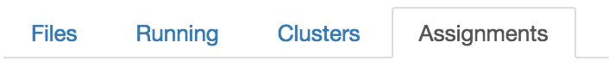
- Select the Assignments tab at right.

- Under Released assignments, Fetch the first lab assignment, lab1.
After a moment, a new entry appears under Downloaded assignments.

- Click on lab1 to open the lab assignment in a new browser tab or browser window.

- Complete the exercise in the browser.
- When you have completed the lab assignment, you can Validate and then Submit lab1 under the appropriate headers on the Assignments tab. This should have remained open in another tab—if it did not, navigate back to the original URL for the main page and it should reappear.
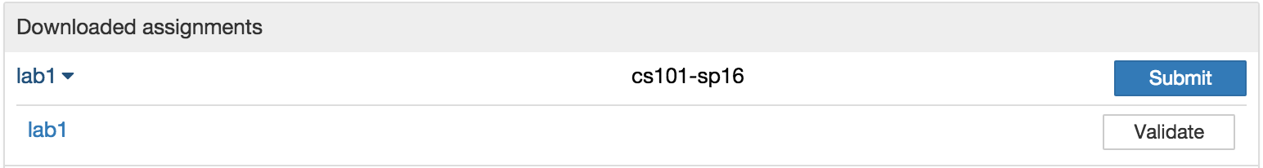
- Always submit your assignment by the end of your section’s lab period. A lab assignment does not have to validate as correct in order to be submitted. (Human-graded portions of an assignment will also not be verified, so even correct validation may not indicate a perfect grade.)

Please leave this sheet at your desk
for the use of the next student to sit here.

