Lab Assignment #1
❖ Objectives
Learn how to access the online Python notebook server and use a notebook.
Learn how course policies will be applied with respect to labs and assignments.
Familiarize yourself with Linux and the command line.

Access the online Python notebook server (Jupyter).
- Open your internet browser and navigate to cs101.studentspace.cs.illinois.edu. You may wish to bookmark or write down this URL, and it is linked from the main course web page as well.
- Log in using your Illinois NetID and password.
The server may take a moment to start a session.
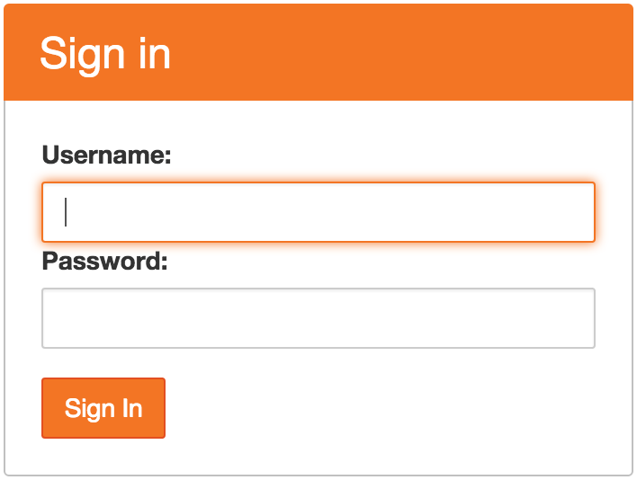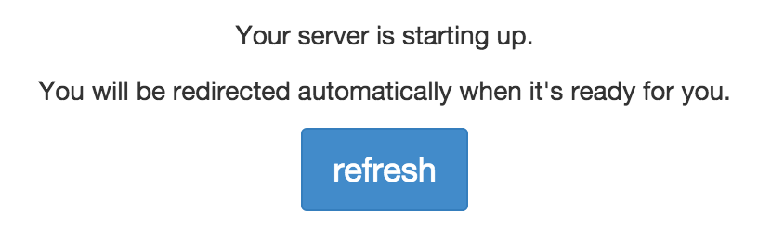
- Select the Assignments tab at right when the main page loads.
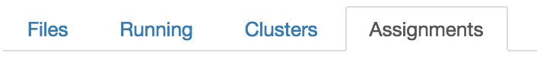
- Under Released assignments, Fetch the first lab assignment, lab1.
After a moment, a new entry appears under Downloaded assignments.
- Click on lab1 to open the lab assignment in a new browser tab or browser window.
- Complete the exercise in the browser as directed.
- When you have completed the lab assignment, you can Validate and Submit lab1 under the appropriate headers on the Assignments tab. This should remain open in another tab—if it did not, navigate back to the original URL for the page and it should reappear.
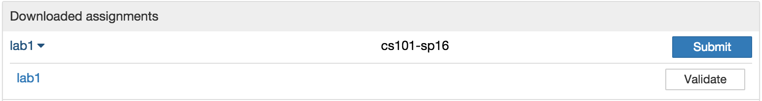
- Always submit your assignment by the end of your section’s lab period. A lab assignment does not have to validate as correct in order to be submitted. Obviously, human-graded portions of an assignment will also not be verified, so even correct validation may not indicate a perfect grade.

Please leave this sheet at your desk for the use of the next student to sit here.

- Although you can access this server and the notebooks you have created online throughout the semester, you may want to keep a copy of your completed lab assignments so that you have a record for future reference. In that case, you should select File→Download as→ and either IPython Notebook (.ipynb) or HTML (.html).

