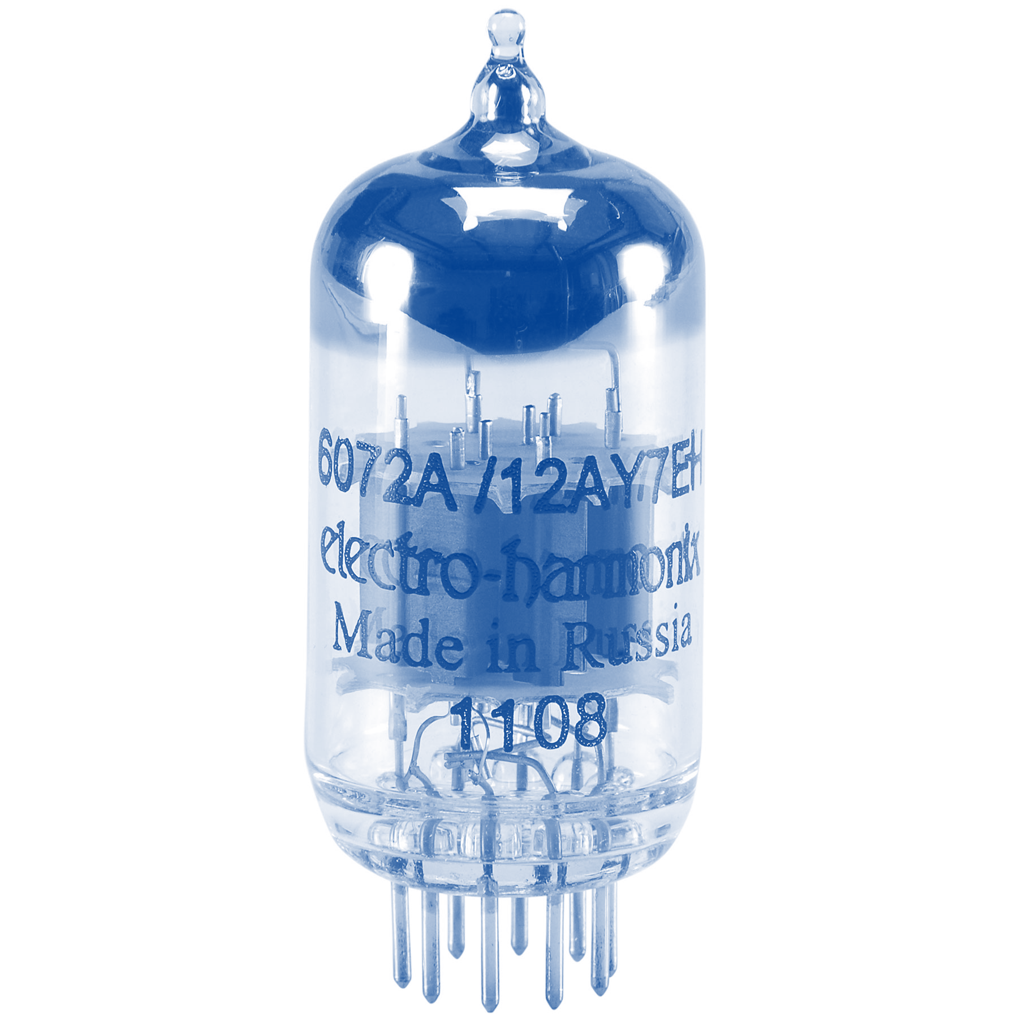
Name:________________________________ Section:__AY____
CS101
midterm2

Objectives
- Reflect on performance on the second midterm.

Reflections on Midterm
In order to help you analyze what went well and what didn’t work
in your preparation and performance on the first midterm, please fill
out and return this worksheet to your TA. Although not required,
serious completion is worth 25% of a lab in extra credit. (This
worksheet will be returned to you.)

- Approximately how much time did you spend preparing for this exam? ________
- What percentage of your test-preparation was spent in each of the following activities?
Reviewing course slides for the first time | Reviewing course slides (rereading) | Reviewing homework or lab exercises | Solving problems for practice | Reviewing your own notes | Studying outside sup-plementary materials | Other:  _________________________________
____% | ____% | ____% | ____% | ____% | ____% | ____%
- Now that you have looked over your graded exam, estimate the percentage of points you lost due to each of the following:
Trouble with syntax | Trouble with function behavior | Not under-standing the concept | Careless mistakes | Other:  ________________________________________________
____% | ____% | ____% | ____% | ____%
- What did you do differently from the first midterm’s study?

- Based on your responses to the questions above, name at least three things you plan to do differently in preparing for the next exam. For instance, will you spend more time studying, change a specific study habit or try a new one (if so, name it), make math more automatic so it does not get in the way of physics, try to sharpen some other skill (if so, name it), solve more practice problems, or something else?

- What can we do to help support your learning and your preparation for the final exam?

