A UN Report on the Relationship between GDP and Life Expectancy

Brianna Zichettella

2023-10-13

This report was prepared to the attention of the UN. It analyzes the relationship between a country’s GDP, its life expectancy, and CO2 emissions. Our goal is to determine to what degree a country’s economic strength or weakness is realated to its public heatlh status and impact on climate pollution. We hypothesize that obth life expectancy and CO2 emissions increase with the country’s GDP.

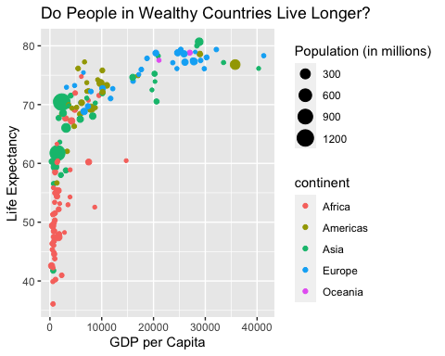

The above plot shows the relationship between GDP per capita and life expectancy for a total of 142 countries. For this set of countries, economic wealth ranged from a minimum of $312.2 to a maximum of $41283.2 per capita.

| Summary of data |  |
| --- | --- |
| Number of Countries | 142 |
| Minimum GDP per Capita | 312.2 |
| Maximum GDP per Capita | 41283.2 |

| country | pop | continent | lifeExp | gdpPercap |
| --- | --- | --- | --- | --- |
| Australia | 18565243 | Oceania | 78.83 | 26997.94 |
| New Zealand | 3676187 | Oceania | 77.55 | 21050.41 |

Exercise 1: Headers and Sub-Headers

# Header

## Subheader

Exercise 2:

Unnumbered list

* Programming language: **R**
* Function: *group_by*
* What’s next? ***multiple imputation***
* Guide: R Markdown cheat sheet <https://www.rstudio.org/links/r_markdown_cheat_sheet>

Numbered list

1. **R**
2. *piping*
3. ***multiple imputation***
4. Behold: [R Markdown cheat sheet](https://www.rstudio.org/links/r_markdown_cheat_sheet)
5. You can also make all of the numbered entries 1’s