1. 全文写作



1. 概括题目（走路是最好的运动方式，但当代人走路达不到基本标准
2. 为什么导致问题发生

现在大多数人们在办公室工作，缺少时间和机会去走路

人们缺少锻炼自己的意识，在空闲时间更喜欢去刷手机

1. 有哪些解决措施

政府和社会弘扬和宣传走路的重要性

工作单位内部可以购买一些运动器材和设施

1. 重申自己的观点

With people's concern for health issues, more and more health topics have become the focus of discussion. Many health experts believe that proper exercise is very important for people's health, but many people don't exercise enough. Here are my views and suggestions on this issue.

First of all, due to the quick pace of life in modern society, most people work in the office, so they spend most of their time sitting in chairs and they lack enough time to walk and exercise

Secondly, most people today lack the awareness to exercise themselves. People prefer to lie at home and watch their mobile phones rather than go to exercise, which is also a very important reason for this problem

So how can we solve this problem? First of all, the government and society should widely publicize the importance of exercise for maintaining health and create an exercise environment in the society. For the company, the company can buy some sports equipment and facilities to help employees exercise better

Generally speaking, people should exercise and exercise more for their own health.In this way, people can be healthier

1. 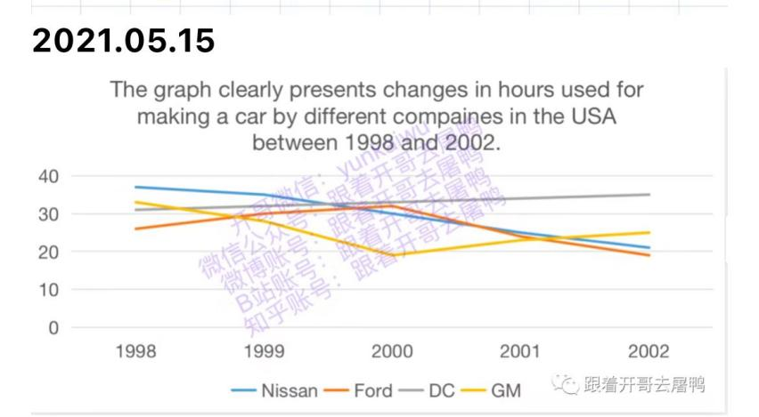
2. 简单介绍图表
3. 写明折线上升下降关系
4. 写结论，1998年最慢和最快的公司，以及2002年最慢和最快的公司

This chart shows the changes in the time when different companies in the United States make a car between 1998 and 2002.

First of all, there are four different companies, namely Nissan, Ford, DC and GM. Nissan's car making time has been slowly decreasing, from 38 hours in 1998 to 22 hours in 2002. In contrast, DC the time it takes to build cars has been slowly increasing. Ford's time to build a car has been increasing until 2000, from 26 hours in 1998 to 30 hours in 2000. However, after 2000, the time dropped rapidly from 30 hours to 20 hours in 2002. GM is the most unstable. In the first two years, the time decreased rapidly from 32 hours to 18 hours, but returned to 24 hours in the next two years.

It can be seen that in 1998, Ford was the fastest company to make cars, followed by DC. By 2002, Ford was still the fastest company to make cars, the next is Nissan.

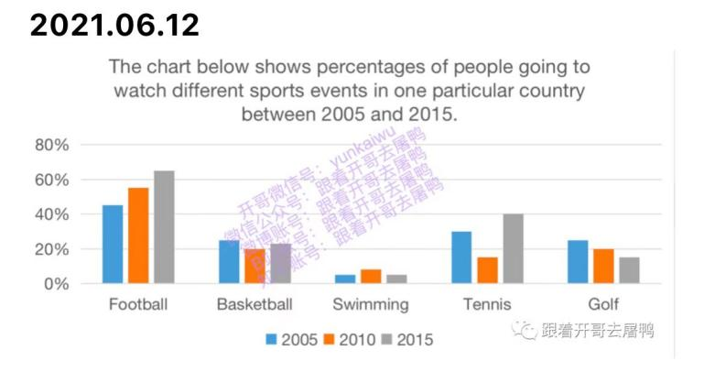

1. 简单介绍图表
2. 写明折线上升下降关系
3. 写结论，2005年最受欢迎的运动是，2015年最受欢迎的运动是

The chart below shows percentages of people going towatch different sports events in one particular country between 2005 and 2015.

First of all, we can see that the popularity of football is rising steadily, from 42% in 2005 to 62% in 2015. On the contrary, golf gradually decreased from 22% in 2005 to 18% in 2015.Basketball and swimming are relatively stable. Basketball is basically maintained at more than 20% and swimming is basically maintained at about 7%.The most unstable sport is tennis, which fell rapidly from 30% in 2005 to 15% in 2010, and then returned to 40% in 2015.

From the chart, we can see that the most popular events in 2005 and 2015 are football. On the contrary, the least popular events in 2005 and 2015 are swimming.