练习一：The graph below gives information on the number of participants for different activities at one social center in Melbourne, Australia for the period 2000 to 2020.

Summarize the information by selecting and reporting the main features, and make comparisons where relevant.

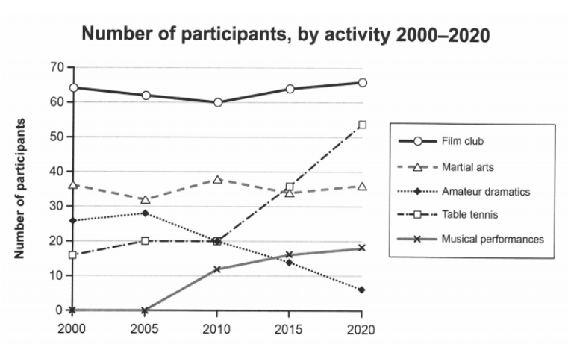

This figure of lines shows a description of participant numbers for different activities in two decades at a social center in Melbourne, Australia, where two axes represent years and the number of participants, respectively. It‘s worth noting that the film club had the most participants compared with other activities.

According to the figure, the number of film club participants slightly declined from 65 in 2000 to 60 in 2010, before increasing to more than 65 in 2020. The martial arts had a stable number of participants in these two decades, whereas a drop in amateur dramatics happened from 2005 to 2020.

The number of table tennis and musical performance participants both had a rising trend, where there was a significant growth from 20 in 2010 to about 54 in 2020 and from zero in 2005 to around 19 in 2020, respectively. Notably, the number of participants in table tennis surpassed both the activities of martial arts and amateur dramatics in 2020 at this social center in Melbourne.

练习二（范文3）：

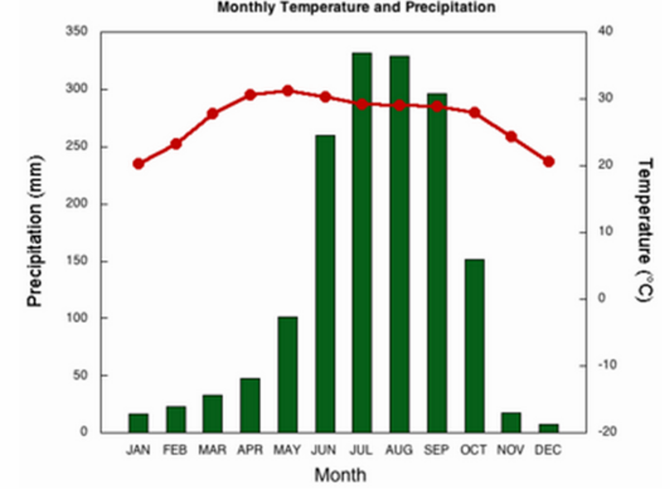

This figure shows the temperature and precipitation over the course of each month. It is worth noting that precipitation values were extremely fluctuating, whereas temperatures were stable this year. The monthly bar chart for precipitation reached its highest value in July of this year, while temperatures were highest in May.

The average temperatures of this city climb from the lowest value around 20’C to the highest value 30’C between January to May, before declining to the original annual point in December.

Overall, there was an annual change in temperatures in this city.

According to the figure, the extreme growth of precipitation was seen from less than 50mm in January to more than 300 mm in July, and then the high value of precipitation lasted about one month and decreased to close to 300 mm in September. Furthermore, it was rapidly falling to under 20 mm in December, which trends similar to the line of average temperatures.