练习一：The graph below gives information on the number of participants for different activities at one social center in Melbourne, Australia for the period 2000 to 2020.

Summarize the information by selecting and reporting the main features, and make comparisons where relevant.

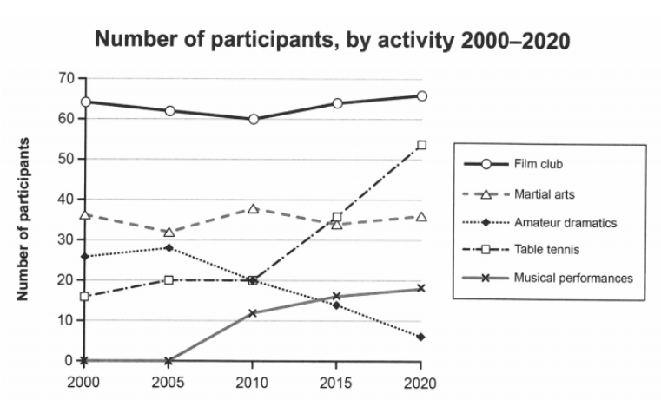

This figure of lines shows a description of participant numbers for different activities in two decades at a social center in Melbourne, Australia, where two axes represent years and the number of participants, respectively. It‘s worth noting that the film club had the most participants compared with other activities.

According to the figure, the number of film club participants slightly declined from 65 in 2000 to 60 in 2010, before increasing to more than 65 in 2020. The martial arts had a stable number of participants in these two decades, whereas a drop in amateur dramatics happened from 2005 to 2020.

The number of table tennis and musical performance participants both had a rising trend, where there was a significant growth from 20 in 2010 to about 54 in 2020 and from zero in 2005 to around 19 in 2020, respectively. Notably, the number of participants in table tennis surpassed both the activities of martial arts and amateur dramatics in 2020 at this social center in Melbourne.

练习二（范文3）：

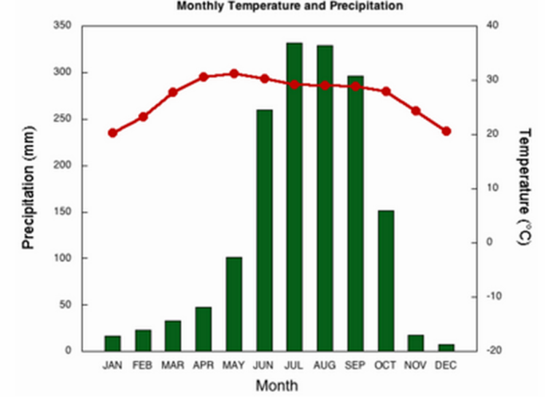

This figure shows the temperature and precipitation over the course of each month. It is worth noting that precipitation values were extremely fluctuating, whereas temperatures were stable this year. The monthly bar chart for precipitation reached its highest value in July of this year, while temperatures were highest in May.

The average temperatures of this city climb from the lowest value around 20’C to the highest value 30’C between January to May, before declining to the original annual point in December.

Overall, there was an annual change in temperatures in this city.

According to the figure, the extreme growth of precipitation was seen from less than 50mm in January to more than 300 mm in July, and then the high value of precipitation lasted about one month and decreased to close to 300 mm in September. Furthermore, it was rapidly falling to under 20 mm in December, which trends similar to the line of average temperatures.

练习3：（范文第6面）

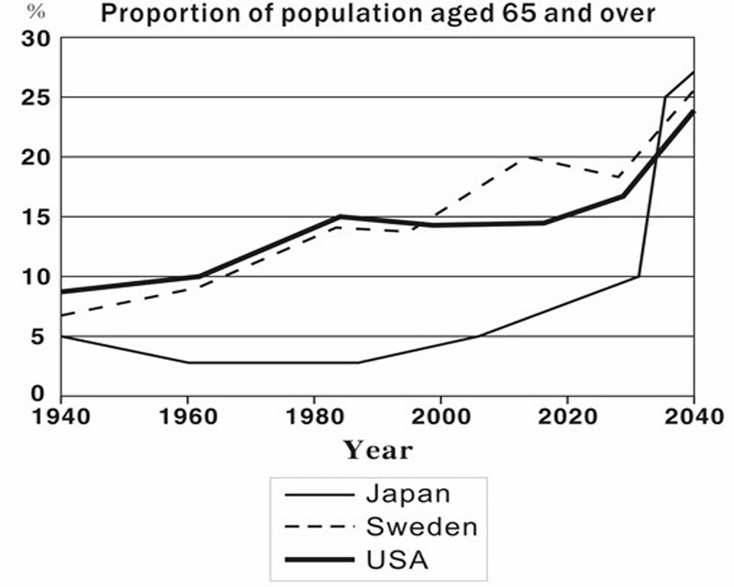

This figure introduces the proportion of the population in three counties whose ages include and are over 65, where the axes represent years and proportions, respectively.

Overall, among of three nations populations have been growing during the period of 10 decades.

According to the figure, there was a steady rise in the population in both Japan and Sweden during the past 80 years, where the old individual population rose from about 9% and 7% in 1940 to 16% and 18%, respectively, and then both lines will be predicted as a similar increasing trend by experts from 2020 to 2040.

The line of the USA elder population dropped slightly in the first decade (around 2%), before considerably climbing from 3% in 1960 to 7% in 2020.

Whereas a significant growth trend will be experienced from approximately 7% in 2020 to 27% in 2024, even the proportion of elderly will be higher than the other two in the future.

练习4：

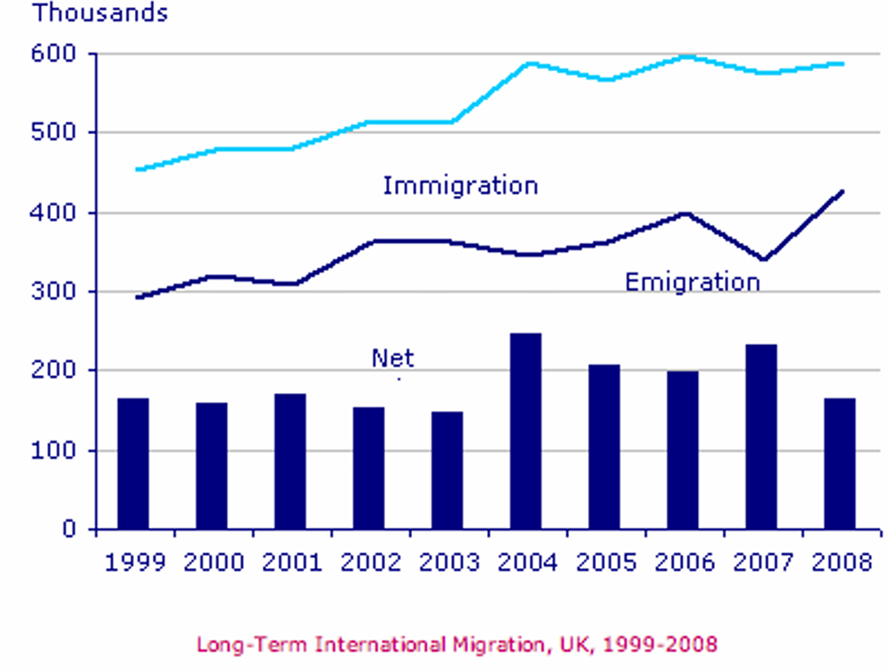

This figure shows the number of international migrants in the UK from 1999 to 2008, where two axes represent the time point for each year and the migration number, respectively.

Overall, all trends of immigration, emigration, and net were increasing in the past.

According to the figure, a stable rise could be seen in both immigration and emigration during the period of this decade, where the number of emigration and immigration grew approximately from 300K and 460K in 1999 to 420K and 590K in 2008, respectively.

It is worth noting that emigration experienced a significant fall from 400K in 2006 to 330K in 2007, after which rose again to 420K in 2008.

There was an inconsistent trend in the figure for the net which was around 150K from 1999 to 2003, before considerably climbing to 250K in 2004. And then, the last five years experienced a slight decrease from 250K in 2004 to around 150K in 2008, which means it went back to the original year of 1999 again.

Increase/climb/rise/grow/decrease/fall/decline/slide/growth/drop

Remain stable/constant at/steady/inconsistent/fluctuate

Slightly<considerably<significantly<extremely<rapidly

Approximately, around

Experienced/witnessed/ there was an opposite trend in the figure for resources

静态图：

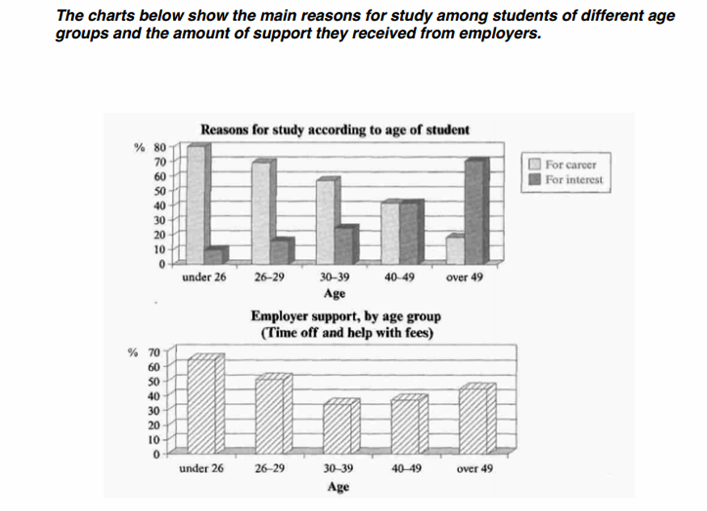

The bar charts demonstrate the resources for different age groups of students in terms of why they are studying and whether they are supported by employers, where the axes represent different ages and proportions in the two figures, respectively.

According to the first bar chart, the reason for studying to get a job opportunity is nearly 80% in the group which is under 26, while the reason for interest is under 10%. With the age increasing, students have a significant trend toward interest, where the reason for career and for interest was almost 70% and 15% in the age group of 26-29, and approximately 55% and 23% in the age group of 30-39, respectively. It is worth noting that the 40-49 group has a similar proportion of each reason that both are nearly 40%. For the elderly, the interest has a dominant situation (the proportion is 70%) compared with the reason for a career (the proportion is under 20%).

The proportion of employer support in the group under 26 age (over 60%) was much higher than in the group of 26-29 and 30-39 at 50% and 30%, respectively. And then, there is a slight rise for the older groups reaching over 40% for those aged 50 and more.

Increase/climb/rise/grow/decrease/fall/decline/slide/fluctuate/variable/inconsistent/steady/remain stable/sightly/considerably/significantly/extremely/rapidly/approximately/around/and then/before doing/after which/although/experience/witnessed

While/compared with/followed by/high/low/ took up/was taken up/

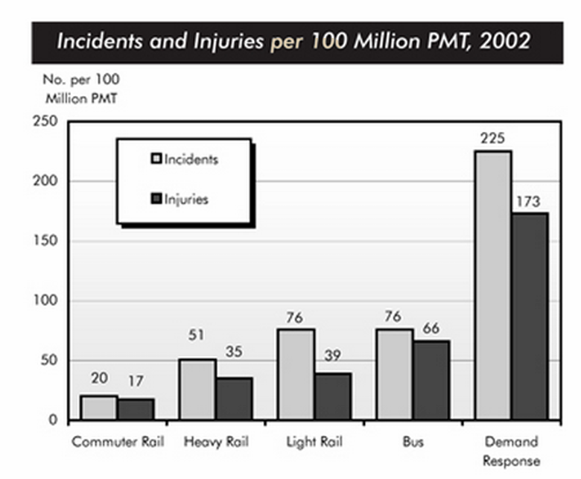

This bar chart demonstrates the number of incidents and injuries in every 100 Million passenger miles traveled (PMT), based on five different ways of transportation in 2002, where two axes represent the type of transport and the number per 100 Million PMT, respectively.

According to the figure, demand response transport services dominated a large segment of injuries and incidents compared to other transporting methods, which took up a total of 225 incidents and 173 injuries pre-100 Million PMT. By contrast, it is clear that the lowest number of incidents and injuries were conducted by commuter rail services, where the number of incidents and injuries was 20 and 17 pre-100 Million PMT, respectively.

Moreover, similar incidents were witnessed by both light rail and bus services which had 76 individuals in 2002, followed by the figure for injuries of the light rail and the bus (39 people and 66 people were injured). There was the second least number of incidents and injuries being taken up by the heavy rail, compared with the others, where the number of individuals was 51 for incidents and 35 for injuries.

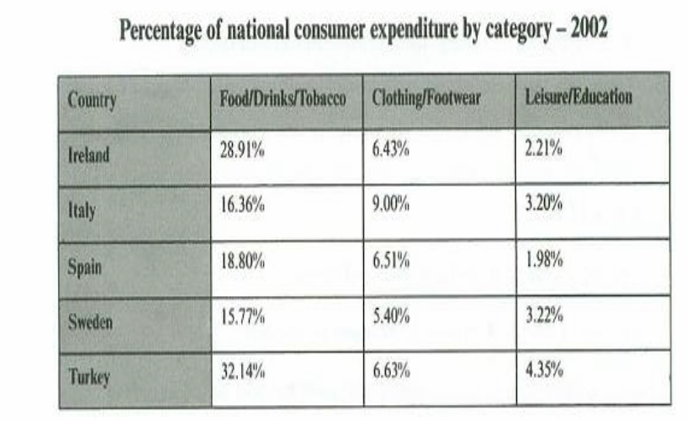

This chart demonstrates the percentage of local consumer expenditure in different countries by three categories in 2002, where the national areas include Ireland, Italy, Spain, Sweden, and Turkey. Overall, the category of food and drinks had a dominant situation for consumer spending in each country.

According to the figure, individuals in Ireland and Turkey spend a lot of money on their daily lives, such as food, drinks, and tobacco, where the proportion of the two countries was 28.91% and 32.14% in 2002, respectively. Whereas the proportion of Italy, Spain, and Sweden for food expenditure was lower than the proportion of the above two, which was conducted at 16.36%, 18.80%, and 15.77%, respectively.

Compared with other categories, the class of leisure and education had the lowest proportion in each state, which means all of them are under 5%. For the class of clothing and footwear, it is worth noting that the proportion of the spending in Italy was much higher than the figure for others at 9.00%, while the percentages of others in this class were all approximately 6%.