小作文修改

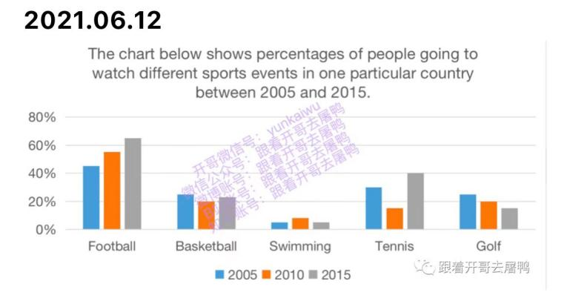

The chart indicates how the proportion of people going to watch different sports in one country between 2005 and 2015.

It is clear from the picture that The proportion of spectators of football and tennis was increased. The proportion of football has rapidly increased from 42% in 2005 to 62% in 2015. football has more proportion of people in watching events during the ten-year period.The proportion of tennis audience also increased from 30% in 2005 to 40% in 2015.

Golf, on the other hand, shows the opposite part.The change occurred in the proportion golf has decreased from 22% in 2005 to 18% in 2015.

On the other hand，The smallest change in specific gravity occurs in basketball and swimming. During this decade, the proportion of basketball viewing decreased slightly from 22% to 21%. Swimming is basically unchanged

In general，In terms of popularity, football and tennis attract more and more people，golf attracts fewer people every year, while basketball and swimming keep stable popularity.

大作文

2021.04.10  社会（健康）

Many people believe that bicycle is a healthy and environmentally friendly mode of transport. However, it is no longer the main form of transport. What are the reasons? What could be done to encourage the use of bicycles among the wider population?

1. 原因：人们缺乏对自行车的益处和保护环境的意识

其他交通工具的发展，地铁公交等现在通勤都很方便

1. 解决方法：政府加强相关方面的精神的宣传，营造氛围

多投放共享单车，实现共享单车全覆盖

Cycling is generally considered to be a healthy means of transportation, whether for the health of cyclists or the environment. However, for some reasons, it is not people's mainstream choice. In order to encourage more people to ride bicycles, I have some personal views

A reasonable reason why people may not ride to work is that people lack awareness of the advantages of cycling, and they think that if they ride a long-distance bike, it is very tiring and time-consuming. Indeed, cycling can make people very tired and consume a lot of energy, so people's image may be more frustrating.Another reason is the promotion of public transport. It includes convenient taxis to efficient buses and subway cars. These means of transportation are more convenient and fast, further reducing the choice of bicycles.

In order to encourage more people to ride bicycles, first of all, the government should carry out relevant publicity to help people establish awareness. We can shoot public service advertisements or put up posters. This method can help people better understand the advantages of bicycles. Another approach is that the government needs to take measures. For example, the government can introduce shared bicycles to make bicycles more accessible and affordable.

In a word, we need to let more people use bicycles, so that we can make ourselves and the environment healthier