# Operational Concept Description (OCD)

**LiveRiot Video Editing System and social networking enhancement**

**Team 04**

**Yang Li Project Manager, Life Cycle Planner**

**Haoyu Huang Feasibility Engineer, System Architect**

**Ye Tian Operational Concept Engineer, Prototyper**

**Zichuan Wang Operational Concept Engineer, Prototyper**

**Haishan Ye Requirement Engineer, Life Cycle Planner**

**Kaiqi Zhang Feasibility Engineer, System Architect**

**09/25/2013**

# Version History

| Date | Author | Version | Changes made | Rationale |
| --- | --- | --- | --- | --- |
| 08/20/12 | SK | 1.0 | * Original for CSCI477; Tailored from ICSM OCD Template | * To fit CS477 course content |

# Table of Contents

Operational Concept Description (OCD) i

Version History ii

Table of Contents iii

Table of Tables iv

Table of Figures v

1. Introduction 1

2. Shared Vision 2

2.1 Overview of the system 2

2.2 System Boundary and Environment 3

3. System Transformation 5

3.1 Information on Current System 5

3.2 System Objectives, Constraints and Priorities 6

3.3 Proposed New Operational Concept 8

3.4 Organizational and Operational Implications 12

# Table of Tables

Table 1: The Program Model 2

Table 2: The Program Model of California Science Center Volunteer Management Project - example **错误! 未定义书签。**

Table 3: Level of Service Goals 7

Table 4: Relation to Current System 8

# Table of Figures

Figure 1: System Boundary and Environment Diagram 4

Figure 2: System Boundary and Environment Diagram of Volunteer Management Project - example **错误! 未定义书签。**

Figure 3: Element Relationship Diagram of Transportation Grant Fund system 10

Figure 4: Element Relationship Diagram of the Los Angeles Community Garden Inventory and Locator 10

Figure 5: Element Relationship Diagram 11

Figure 6: Business Workflows Diagram 11

Figure 7: Business Workflow Diagram of Volunteer Tracking System - Example 12

### Introduction

#### Purpose of the ODC

This document provides, in detail, the shared visions and goals of the stakeholders of the LiveRiot Video Editing System and social networking enhancement. The success-critical stakeholders of the project are LiveRiot, as the project owner; musicians, fans and venues, as users; members of CSCI 577a Team 04, as developer.

#### ****Status of the ODC****

The status of the OCD is currently at the As-Built version number 9.4 in the development phase. The scope of the Volunteer Tracking System project has been re-evaluated to accommodate those challenges by removing the core capability of certificate generation. Vincent Tsan has been assigned to be the maintainer.

### Shared Vision

#### Overview of the system

Table : The Program Model

|  |  |  |  |
| --- | --- | --- | --- |
| **F**ans would like to upload, edit videos on LiveRiot, musicians would like to communicate on LiveRiot, venues and musicians would use LiverRiot to improve their business | | | |
| **Stakeholders** | **Initiatives** | **Value Propositions** | **Beneficiaries** |
| * Developers * LiveRiot * Venues * Fans * Musicians * Record labels | * Develop a system * High user traffic * Provide an assistance to monetize live shows * Create working campaign * Patterning with venues and record labels | * Create a platform for high quality videos * Increase explorer of unsigned artists * Decrease piracy * Maintain musicians’ control over their art * Create communicate between musicians and fans * Increase attendance to venues | * Musicians * Venues * Fans * Record labels |

#### Benefits Chain Diagram

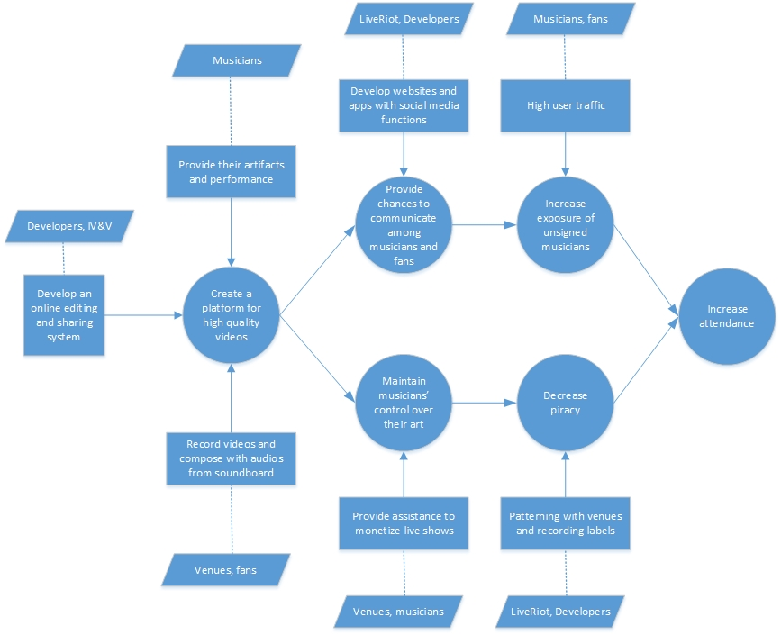

figure 1 Benefits Chain Diagram

#### System Boundary and Environment

* Audio/Video Record Service
* Audio and Video Synchronization Service
* Video Editing Service
* Social Media Service
* Musician/Venue Dashboard Service
* Video Purchase Service
* Internal Infrastructure:
* Ruby on Rails 3.0
* iOS 7 framework
* PostgreSQL

Figure 2: System Boundary and Environment Diagram

### System Transformation

#### Information on Current System

##### Infrastructure

1. Server side

1) Operating system: Linux version 3.8.11-ec2 (gcc version 4.4.3 (Ubuntu 4.4.3-

4ubuntu5.1) )

2) Database: PostgreSQL v 9.2.

3) Web Server: written in Ruby on Rails and run on Amazon utilizing EC2 and S3

4) Video Editor: Node.js and Express

5) Digital Signal Processing: Faust

2. Client side

1) Apps: video record app, audio record app

2) Operating System: iOS

3) Database: Sqlite

4) Development platform: Mac OS

##### Artifacts

1. User Manual

Teach and guide the user how to use the product

2. Functioning Software System

The video recording app and website.

3. System and Software Architecture Description

Object-oriented analysis and design (OOA&D) of the system being developed

4. Email notification system

Notify users when they create account and when new message come to them

5. Social video app template.

Third-party video app template.

##### Current Business Workflow

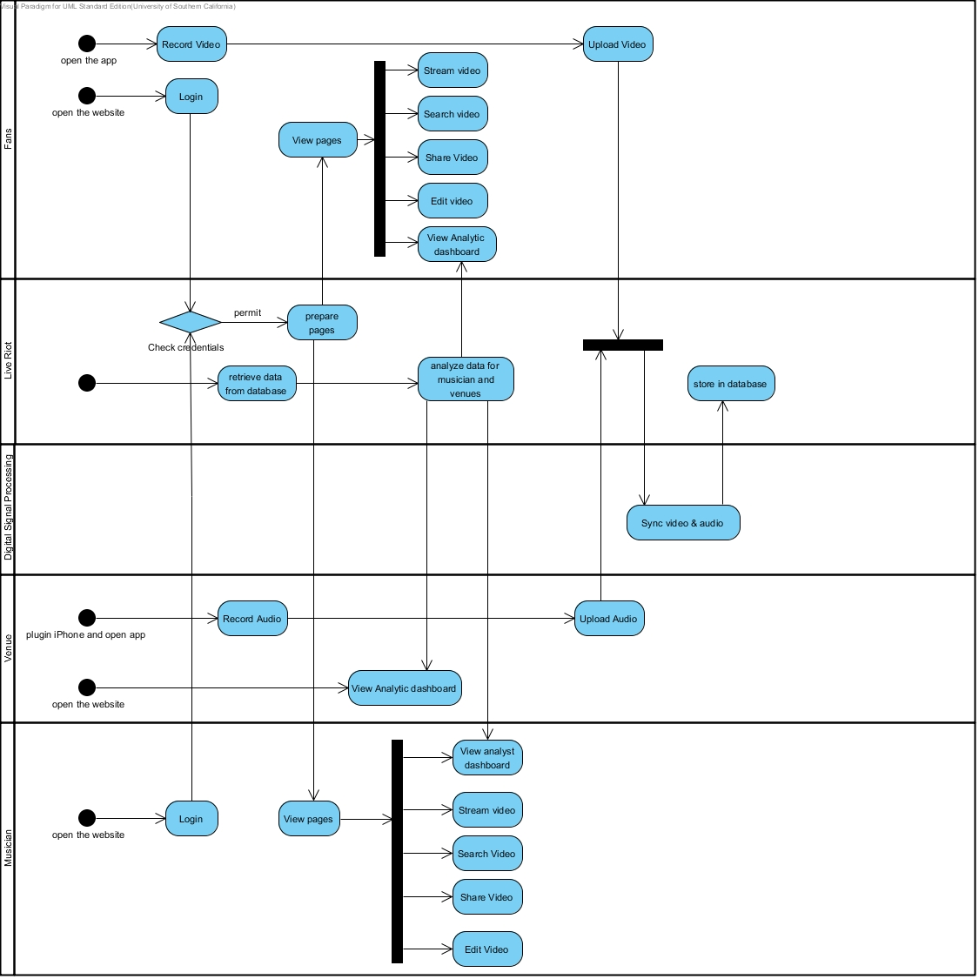

#### System Objectives, Constraints and Priorities

##### Capability Goals

<< Provide a brief enumeration of the most important operational capability goals. A “capability” is simply a function or set of functions that the system performs or enables users to perform. To facilitate traceability between capability goals listed in the OCD and references to them from other artifacts (WinWin Agreements, SSAD, LCP, and FED), assign each capability a unique designation (e.g. OC-1) and a short descriptive name.

|  |  |
| --- | --- |
| **Capability Goals** | **Priority Level** |
| **<< OC-1 Automated Report Generation:** The system is capable of generating the report in PDF format. >> | << Must have>> |
|  |  |
|  |  |
|  |  |

##### Level of Service Goals

<< Identify in a table the desired and acceptable goals for the proposed new system's important levels of service. Example can be found in ICSM EPG. >>

Table : Level of Service Goals

|  |  |  |
| --- | --- | --- |
| **Level of Service Goals** | **Priority Level** | **Referred WinWin Agreements** |
|  |  |  |
|  |  |  |
|  |  |  |
|  |  |  |

##### Organizational Goals

<< List briefly the broad, high-level objectives and aspirations of the sponsoring organization(s) and any organizations that will be using and maintaining the new system. The goals should be expressed in terms of (or referenced to) the Value Propositions, and should only include the goals that indicate what the organization wishes to achieve by having the proposed system (e.g., increase sales, profits, and customer satisfaction). Each goal in this section should relate to one or more of the Value Propositions.

Provide a brief enumerated list of goals. To facilitate traceability, assign each goal a unique number (e.g. OG-1).

For example:  
OG-1: Increase sales and profits via more efficient order processing.  
OG-2: Improve speed via faster order entry.

More examples can be found in ICSM EPG. >>

**OG-1:** <Goal>

##### Constraints

<< Identify constraints of the project. Constraints will be derived from your WinWin negotiation and/or client’s meeting. Constraint is a limitation condition that you have to satisfy for your development project. Examples of Constraints are:

**CO-1:** **Windows as an Operating System**: The new system must be able to run on Windows platform.

**CO-2: Zero Monetary Budget:** The selected NDI/NCS should be free or no monetary cost.

**CO-3: Java as a Development Language**: Java will be used as a development language. >>

##### Relation to Current System

<< Summarize the relations between the current and new systems in a table. Include key differences between the current and new roles, responsibilities, user interactions, infrastructure, stakeholder essentials, etc. Example of Relation to Current System can be found in ICSM EPG.>>

Table : Relation to Current System

|  |  |  |
| --- | --- | --- |
| **Capabilities** | **Current System** | **New System** |
| Roles and Responsibilities |  |  |
| User Interactions |  |  |
| Infrastructure |  |  |
| Stakeholder Essentials and Amenities |  |  |
| Future Capabilities |  |  |

#### Proposed New Operational Concept

<< This section contains information about the transformation of new operational concept that will be introduced to the system. >>

##### Element Relationship Diagram

<< The element relationship diagram summarizes the major relationships among the primary elements and external entities involved in the proposed new system. The entities include actors or users as well as external systems and components that interface with the system. The dashed box represents your proposed system, the boxes outside the dashed box represent external element that your system has to communicate with.

Note that the example is more in the style of a data flow diagram than in the style of Chen's ER diagram or of an EER diagram; any of these notations is fine, as the content is far more important than the style. The followings are an example and a template for Element Relationship diagram. >>

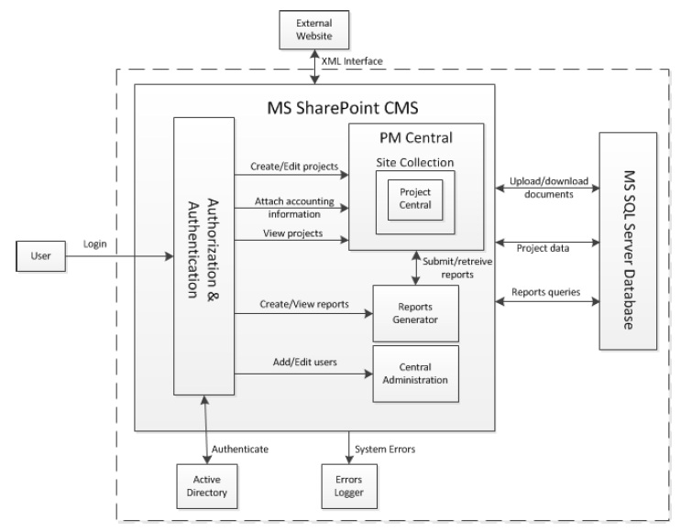

Figure : Element Relationship Diagram of Transportation Grant Fund system

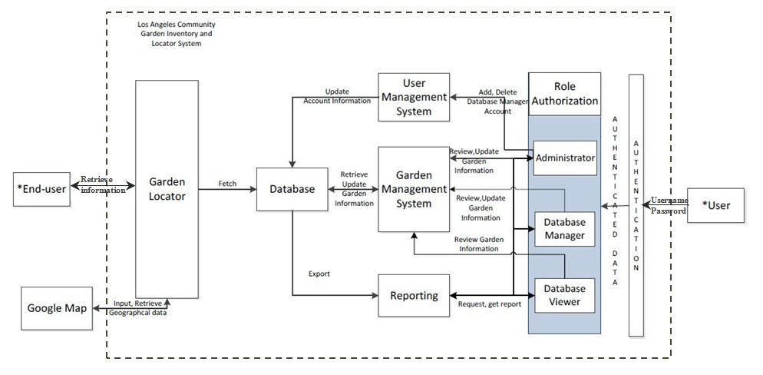

Figure : Element Relationship Diagram of   
the Los Angeles Community Garden Inventory and Locator

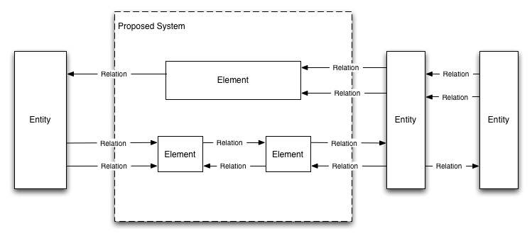

Figure : Element Relationship Diagram

##### Business Workflows

<< Characterize the new operational concept in terms of the flow of works through the proposed new system. The workflows will be illustrated in the form of business activity diagram(s). It will show the overview of the business activities flowing in proposed new system. As appropriate, indicate future capabilities of the new system or major differences from the current system as well. >>

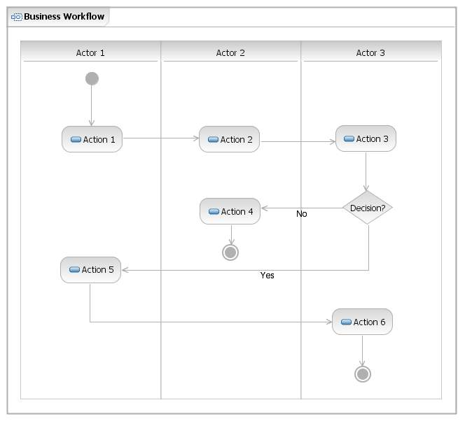

Figure : Business Workflows Diagram



Figure : Business Workflow Diagram of Volunteer Tracking System - Example

#### Organizational and Operational Implications

##### Organizational Transformations

<< Identify and describe any significant changes in organizational structure, authority, roles, and responsibilities that will result from transitioning to the new system. Identify the major operational stakeholders affected by the changes, and indicate their concurrence with the changes.

Examples of organizational transformations:

* The need to hire a new system maintainer to take care of the system
* The elimination of the need for current, time-consuming management approvals before initiating delivery actions >>

##### Operational Transformations

<< Identify any significant changes in operational procedures and workflows that will result from transitioning to the new system. Identify major operational stakeholders affected by the changes, and indicate their concurrence with the changes.

Examples of operational transformations:

* Having the financial, delivery, and administrative processing concurrently progress rather than sequentially to decrease response time, subject to the check for payment validity before shipping an order.
* The option for new potential volunteers to fill out the applications online, or on paper and submitted in person. >>