Feasibility Evidence Description (FED)

LiveRiot Video Editing System and social networking enhancement

Team 04

Yang Li Project Manager, Life Cycle Planner
Haoyu Huang Feasibility Engineer, System Architect
Ye Tian Operational Concept Engineer, Prototyper
Zichuan Wang Operational Concept Engineer, Prototyper
Haishan Ye Requirement Engineer, Life Cycle Planner
Kaiqi Zhang Feasibility Engineer, System Architect

09/25/2013

Version History
Date | Author |  |  | Version |  | Changes made |  | Rationale
08/20/12 |  | SK | 1.0 |  | - Original for CSCI477; Tailored from ICSM OCD Template |  | - To fit CS477 course content

Table of Contents
Feasibility Evidence Description (FED) i
Version History iii
Table of Contents iv
Table of Tables v
Table of Figures vi
1. Introduction 1
2. Business Case Analysis 2
2.1 Cost Analysis 2
2.2 Benefit Analysis 2
2.3 ROI Analysis 3
3. Risk Assessment 4
4. NDI/NCS Interoperability Analysis 5
4.1 Introduction 5
4.2 Evaluation Summary 5

Table of Tables
Table 1: Personnel Costs 2
Table 2: Hardware and Software Costs 2
Table 3: Benefits of xxx System 2
Table 4: ROI Analysis 3
Table 9: Risk Assessment 4
Table 10: NDI Products Listing 5
Table 11: NDI Evaluation 5

Table of Figures
Figure 1: ROI Analysis Graph 3

Introduction
<< Discuss the purpose of the FED>>
<< Discuss the status of the FED especially key differences from the previous version, for example
- The risk of possible components mismatch has been removed
- The client postponed the hardware acquisition to next fiscal year and business case analysis is updated accordingly. >>

Business Case Analysis

Cost Analysis
<< Identify all possible cost either in monetary term or non-monetary term, such as hours spent, qualitative benefits for the project. Please note that you do not include the effort cost spent by development team, include only cost spent by clients. >>

Personnel Costs
<< Identify all personnel-related cost from exploration phase to operation phase. Example can be found at ICSM EPG>Task: Analyze Business Case >>
Table 1: Personnel Costs
Activities | Time Spent (Hours)

Hardware and Software Costs
<< Identify all hardware and software-related cost from exploration phase to operation phase. Example can be found at ICSM EPG>Task: Analyze Business Case >>
Table 2: Hardware and Software Costs
Type | Cost | Rationale

Benefit Analysis
<< Analyze benefits from this project. Benefits could be in the quantitative form such as more revenue, saved effort, and qualitative form such as increase of reliability. Example can be found at ICSM EPG>Task: Analyze Business Case >>

Table 3: Benefits of xxx System
Current activities & resources used | % Reduce | Time Saved (Hours/Year)
Total

ROI Analysis
<< Calculate Return on Investment by using your cost and benefit analysis results and identify the breakeven point. Note, if you have hardware and software cost, it must be included in ROI calculation. For effort cost, if you use a salary as your calculation base, assume 10% annually increase. Example can be found at ICSM EPG>Task: Analyze Business Case>>
Table 4: ROI Analysis
Year | Cost | Benefit  (Effort Saved) | Cumulative Cost | Cumulative Benefit | ROI
Figure 1: ROI Analysis Graph
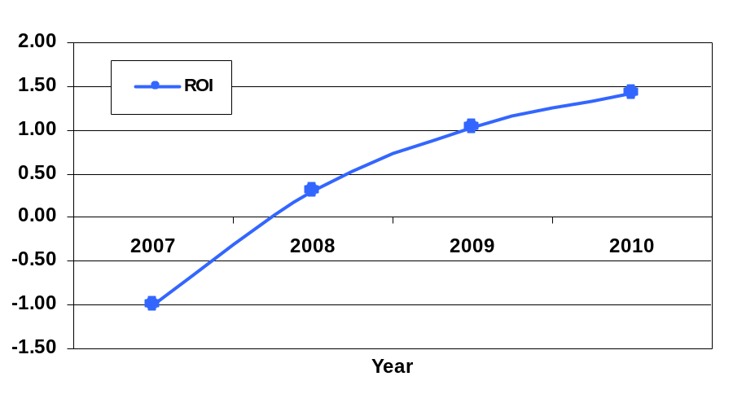

Risk Assessment
<< Identify our project risk, its exposure and its mitigation plan. Please note risk is a threat or probability that something will happen and possibly create loss or injury. So, if your threat or your incident is already happened, then it is a problem, not a risk. More example of risks can be found at ICSM EPG> Task: Assess and Plans to Mitigate Risks>>
Table 5: Risk Assessment
Risks | Risk Exposure |  |  | Risk Mitigations
Risks | Potential Magnitude | Probability Loss | Risk Exposure | Risk Mitigations
Cannot agree with Apple to sell music and videos on iTunes | 5 | 0.8 | 4 | Sell music and videos via in-app purchase
Facebook API does not support video preview | 2 | 0.8 | 1.6 | Just present a link to the video page
Open tagging library does not support | 9 | 0.2 | 1.8 | Research on library that is familiar with
Fail to collect statistics like shared times and steamed times | 5 | 0.2 | 1 | Use visitor counter from other parts to do the same job
Fail to clarify how to send gift email | 4 | 0.2 | 0.8 | Meeting with clients
Videos cannot be streamed by venue | 7 | 0.1 | 0.7 | Respect stakeholder’s interests and benifits
Fail to get a test database which contains required fields | 5 | 0.2 | 1 | Meeting with clients and negotiating
Fail to provide top 10 videos for users’ exploration | 5 | 0.2 | 1 | Use other suggestion methods
Cannot Editing videos on LiveRiot | 8 | 0.2 | 1.6 | Use well-developed open libraries

NDI/NCS Interoperability Analysis

Introduction
<< Identify the Non-Developmental Item (NDI) and Net-Centric Services (NCS) including open source software or libraries that you are using/ plan to use in your project and analyze their interoperability. >>

COTS / GOTS / ROTS / Open Source / NCS
<< Identify all candidate commercial off-the-shelf, government-off-the-shelf, research-off-the-shelf, open source software, libraries, and net-centric services component that you are using/ plan to use. Also identify the purpose of each component. >>
Table 6: NDI Products Listing
NDI/NCS Products | Purposes

Connectors
<< Identify the connector, for example
- “In this project, we use PHP/MySQL Connector to enable the PHP web application to retrieve and query data from the database”. >>

Legacy System
<< Identify the connector, for example
- “In this project, the development system has to be able to interoperate and works well with “BusinessWorks” version 5.2, which is a software system that the client is currently using.” >>

Evaluation Summary
<< Summarize the final selection of your interoperable NDI/NCS, its usage and its comment. Example can be found in ICSM EPG> Task: Analyze NDI Interoperability for NDI / NCS project. >>
Table 7: NDI Evaluation
NDI | Usages | Comments

