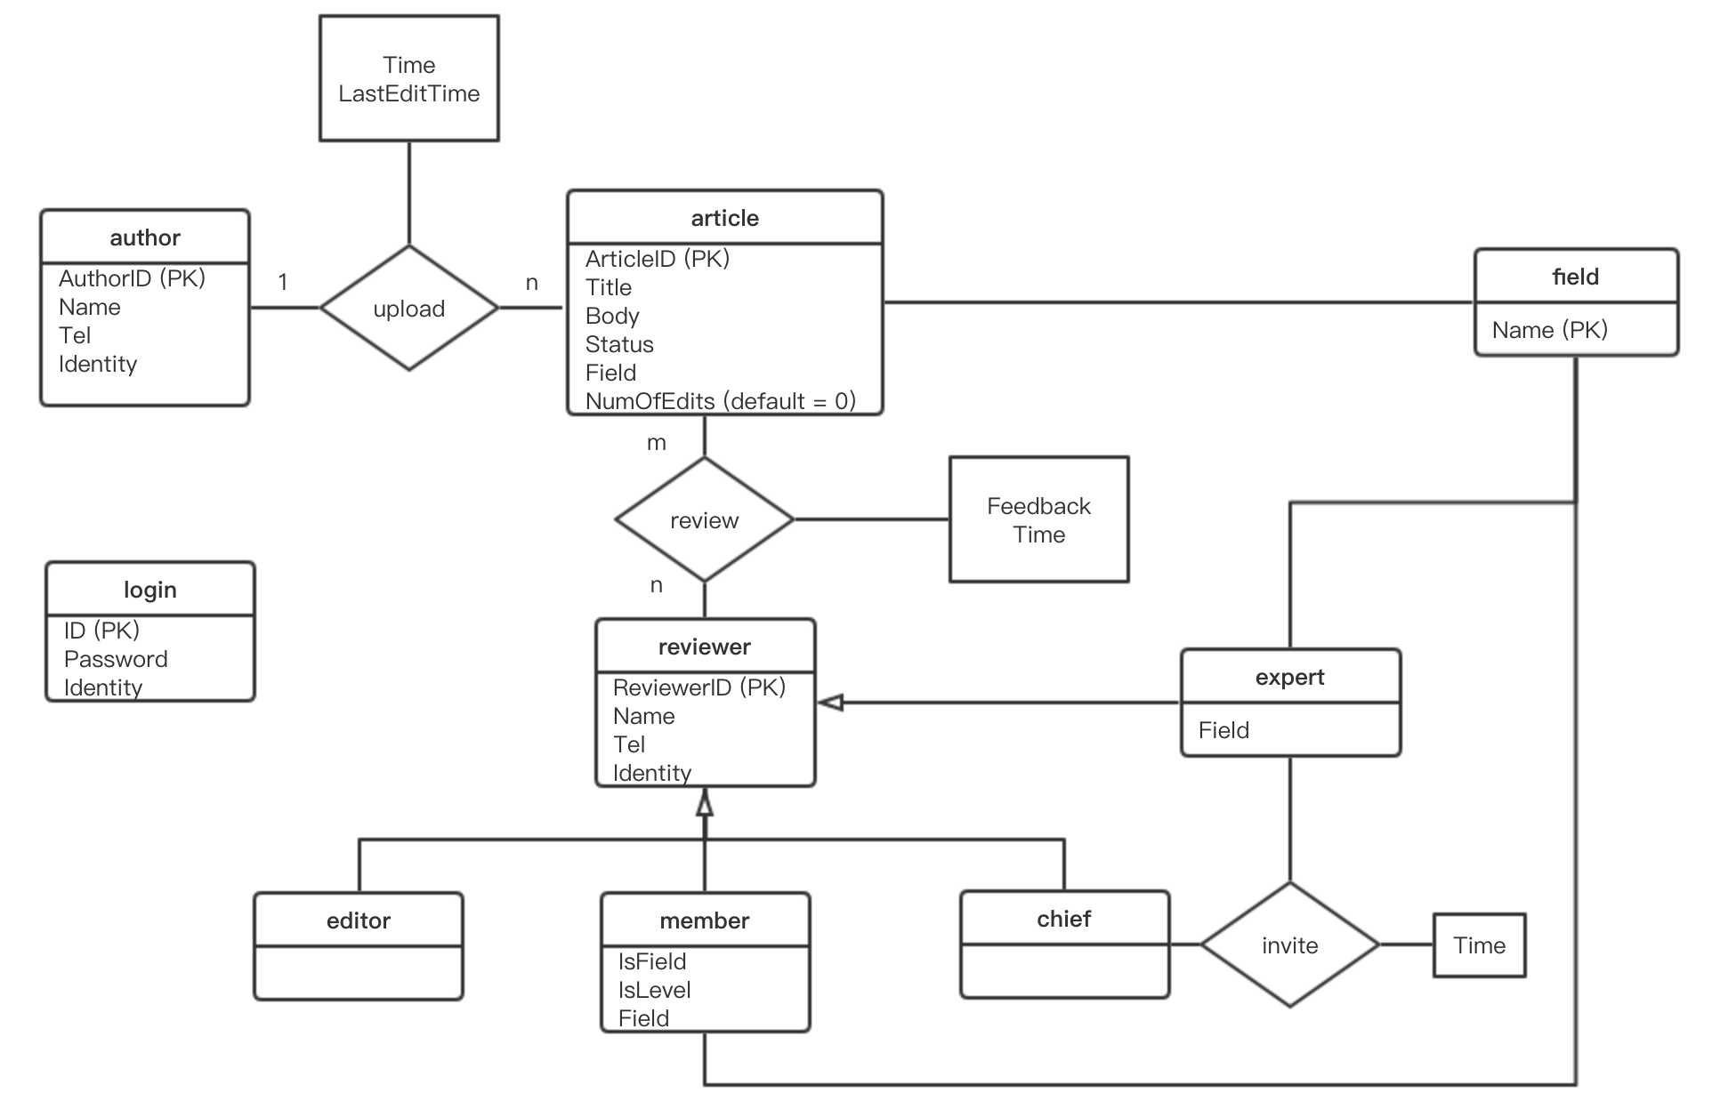

**关系模型：**

login (ID, Password, Identity)

author (AuthorID, Name, Tel, Identity)

upload (AuthorID, ArticleID, Time, LastEditTime)

article (ArticleID, Title, Body, Status, Field, NumOfEdits, AuthorID)

review_format (ArticleID, ReviewerID, Feedback, Time)

review_field (ArticleID, ReviewerID, Feedback, Time)

review_level (ArticleID, ReviewerID, Feedback, Time)

reviewer (ReviewerID, Name, Tel, Identity)

editor (EditorID)

member (MemberID, IsField, IsLevel, Field)

chief (ChiefID)

expert (ExpertID, Field)

invite (ReviewerID (ChiefID), ReviewerID (ExpertID), Time)

field (Name)