This application retrieves temperature information from two webservers. One of them is [www.weather.com](http://www.weather.com) and one is [www.weather.cnn.com](http://www.weather.cnn.com). The application allows you to retrieve information from the zip code you want. It will also always show the weather in our city from weather.cnn.com. There is a default zip code of our city that requires minimal time to load. If you choose a different zip code, you must press the go button again, to allow the application to get and parse the data. This code uses two runnables and two AsyncTasks to fetch the data from the two servers without locking up the UI.

This is the sequence diagram for this application:

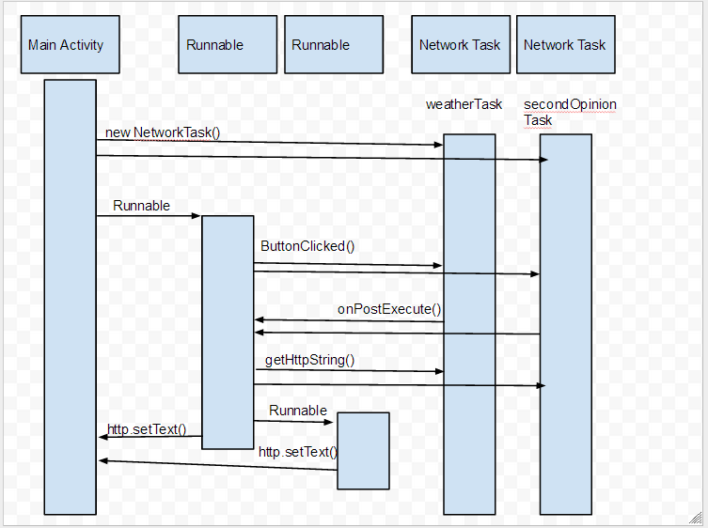

This is the class diagram for this application:

