SampleArcPyMappingScriptTools
Contact: jbarrette@esri.com
Version: ArcGIS 10.0 Final
Summary:
These tools were created as representative samples for how arcpy.mapping could be used to perform a variety of tasks. The script tools are divided into 3 categories: Cartography Tools, Export and Printing Tools, and MXD and LYR Management Tools. Most of these tools can be run from either ArcCatalog or ArcMap. There are several tools that can ONLY be run from ArcMap because they reference the map document that is currently loading within the ArcMap application.
The script tools also make use of validation scripts. Many of the script tools have parameters that are automatically self-populated based on the value of another parameter or the currently loaded map document. Validation scripts are a property of the tool and can be easily reviewed and edited. Take some time to understand these validation scripts because they can be very useful.
This package not only includes the script tools but also other support data, map documents, and layer files that allow you to practice using each tool in the appropriate context. The following pages in this README file will simply display each script tool’s dialog with the appropriate parameters that you can use for a demonstration with a few added comments. Note: these tools should work with any collection of data and map documents but for the purpose of a packaged demonstration, the data is provided.
For more specific information about each tool, look at the header information in each Python script or the look at the script tool dialog help.

Notes / known issues:
- Some of the scripts will automatically open the resulting map document (it makes an easier demo). The map document will not fully open until the GP tool has been closed. So click “Close” when the script tool is completed.
- The default file extension when specifying an output text file is .DBF.
- You can’t overwrite existing text files, you must save with a new name.
- You can’t add a layer into an empty data frame via CURRENT. See the Add Layer File into MXD (from ArcMap) sample.
- The script tool help needs to fixed. There are some issues with removing some old artifacts. For example when previewing the item description info via ArcCatalog, the are multiple bad images that are part of the metadata.

CARTOGRPAHY TOOLS
Adjust Layout Text Width (from ArcMap) – you must run this from within ArcMap. Open this script tool with the Cartography.mxd already opened in ArcMap.
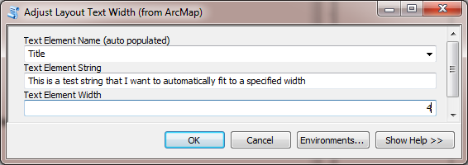
In the result you should see that the “Title” text element string has been fit to a width of approximately 4 inches. This script is good for demonstrating how text elements can be resized using format tags even though arcpy.mapping does not have a size property for text elements.

Find and Replace a Text String – The Cartography.mxd works well for this tool because you can play with the different settings to produce the desired results. The resulting output mxd will automatically open.
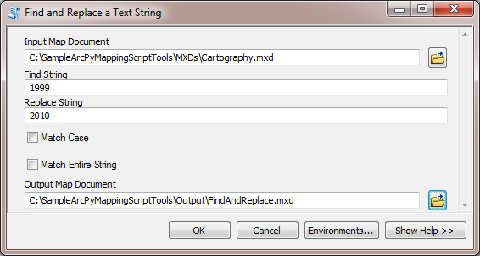
This is a very common operation. This script could be easily modified to loop through a directly of map documents to automate the changes to multiple mxds.

Page Layout Element Report – the resulting text file will automatically open.
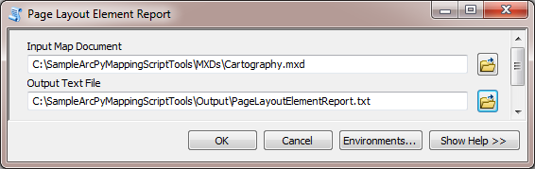
This tool is great for people that are designing their maps and want to know more about the properties of each element. It is also useful for people that are writing scripts that modify these elements.

Shift Page Layout Elements – the resulting output map document will automatically open. The X and Y shifts below are exaggerated to demonstrate the point.
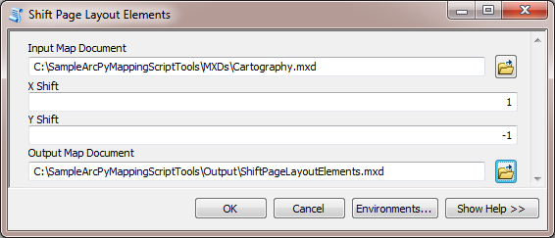
This tool is useful for situations where the layout doesn’t center well when printed. This tool allows someone to easily all shift elements so that they center better on a printed page.

UpdateSymbology – the resulting output map document will automatically open.
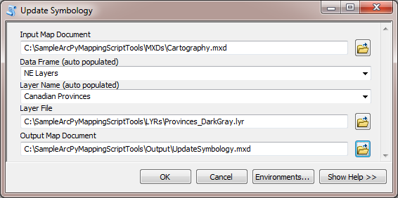
This tool demonstrates how you can transfer the symbology from an existing layer file to a layer in a map document.

EXPORT AND PRINTING TOOLS
Append PDF Documents – The resulting PDF will automatically open. The order that the pages are added is the order they appear in the multi-page output.
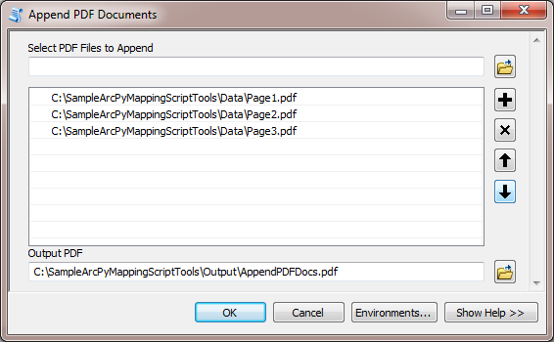
This tool is great for assembling map books by combining the results of data driven pages, different map document exports, misc PDFs, etc, into a multi-page PDF output.

Export Map Documents to PDF – The resulting PDF will automatically open. The order that the pages are added is the order they appear in the multi-page output.
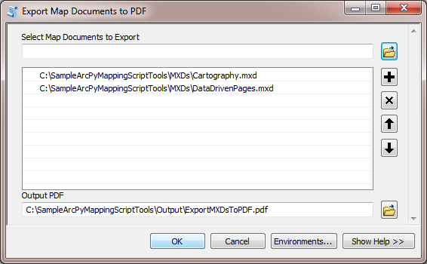
A simple tool to convert multiple map documents into a multi-page PDF document.

Print Map Document(s) – select one or many map documents.
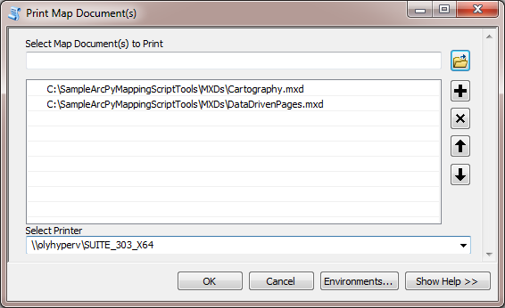
A simple tool for queuing up individual map documents that need to be printed.
Print Data Driven Page(s) – be sure to select a map document that is data driven page enabled.
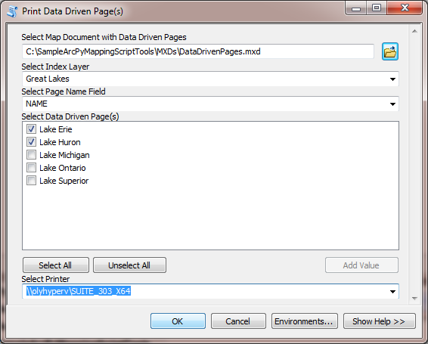
This is a nice tool for selected the individual pages that need to be printed.

MXD AND LYR MANAGEMENT TOOLS
Add Layer File into MXD (from ArcMap) – you must run this script tool from the catalog window in ArcMap because it will add a layer to the currently loaded map document.
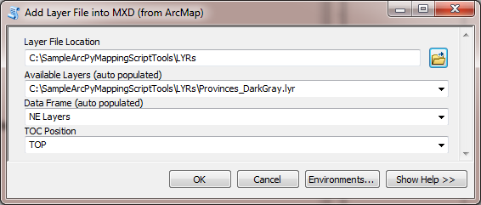
This demonstrates an example of how someone could create a custom “Add Data” utility for users to pick from a list of existing layer files. The layer file location could be hard coded to eliminate one extra parameter.
Find Broken Data Sources (Report) – The resulting text file will open automatically identifying broken MXD layers.
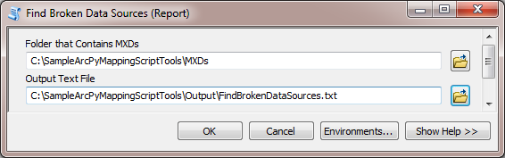
This is a perfect tool for data administrators that want to easily find broken layers and tables in MXDs. This tool loops through multiple MXDs in a folder.

Find Data Source (Report) – a txt file will automatically open showing the map documents that use a specified data source.
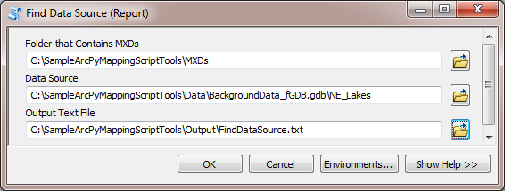
This is a great tool for a data administrator that wants to know which map documents contain a specific data source. This could also be easily applied to layer files.

Find Layers Projected on the Fly (Report) – a txt file will automatically open showing the layers in map documents that are being projected on the fly.
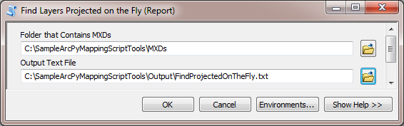

Multi Layer File Summary (Report) – a txt file will automatically open showing various information about each layer in each different layer file.
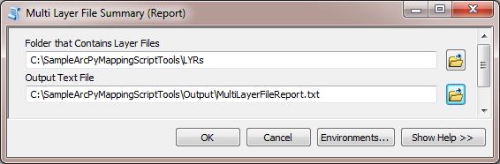

Multi MXD Summary (Report) – a txt file will automatically open showing various information about each map document, its data frames and layers.
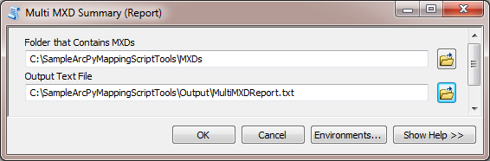

Replace Layer with Layer File – replaces the symbology for a layer in a map document with the symbology from a layer in a layer file.
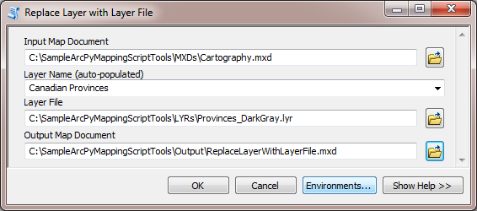
Replace Layer with Layer File (from ArcMap) – same as above but does it to “current” map document. This must be run from ArcMap.
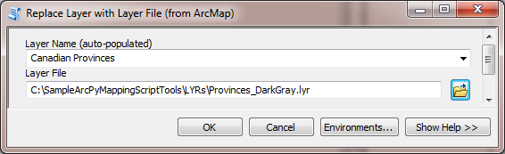

Update MXD from pGDB to fGDB – all layers in a map document pointing to a personal GDB are redirected to a file GDB. There is also an option to update SQL Expresssions. The square brackets are replaces with double quotes for the NE_State_Landlocked definition query.
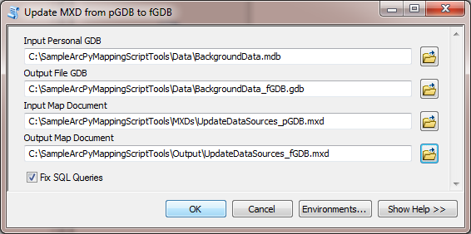

Update MXD Tags – takes each unique layer name and adds it to the map document tags property so that map documents that contain particular layers can be searched.
