Getting Started

Ubuntu Installation
http://unetbootin.sourceforge.net/
http://www.ubuntu.com/

SVN Client
Once you have installed latest Ubuntu on your computer, install a SVN Client.

RapidSVN
Rapid SVN is a easy SVN Client for Ubuntu
http://www.rapidsvn.org

To install RapidSVN:
sudo apt-get install rapidsvn

Using Rapid SVN to checkout the repository Educational Robots:

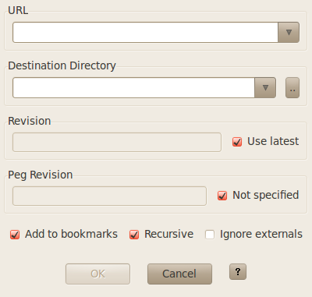

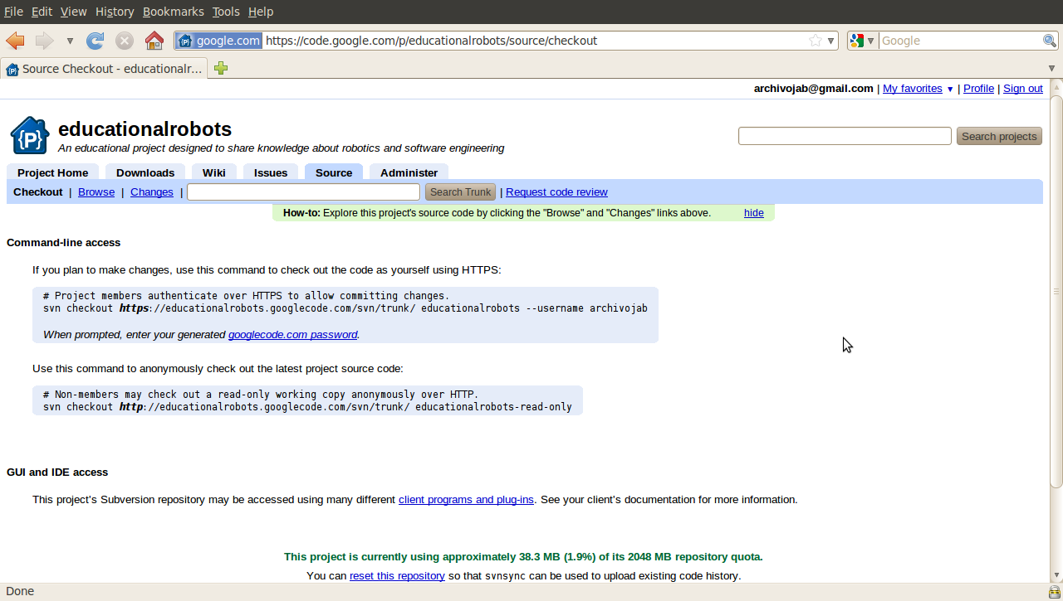
https://educationalrobots.googlecode.com/svn/trunk/

Toold to see differences between changes in a SVN

sudo apt-get install meld

http://amjith.blogspot.com/2007/07/visual-diff-tools-in-linux.html

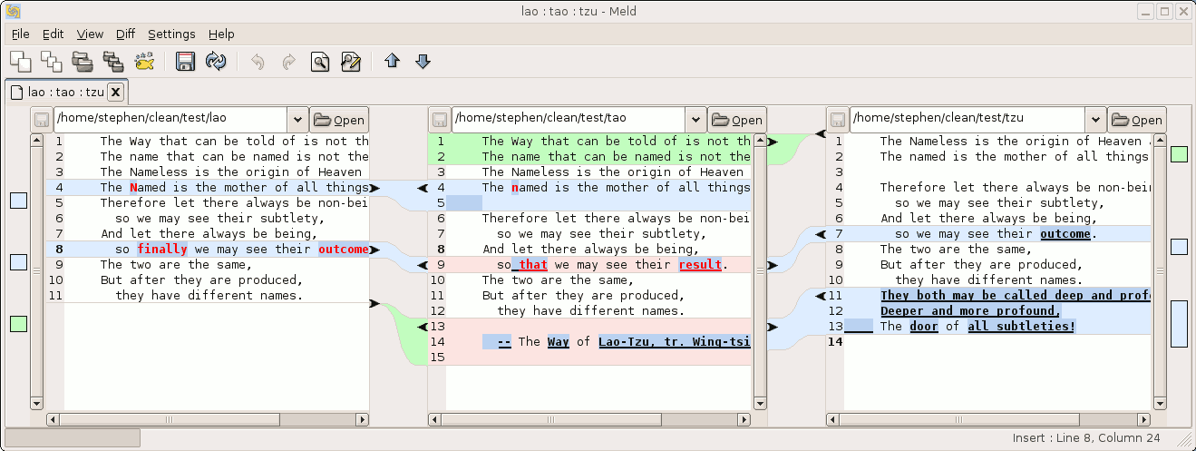

SVN Plugin for Eclipse

http://subclipse.tigris.org/
http://subclipse.tigris.org/update_1.6.x

http://www.veoh.com/browse/videos/category/educational/watch/v6319020ExkaHtJA
http://www.vogella.de/articles/Eclipse/article.html#updatemanager

Java installation

sudo apt-get install sun-java6-jdk
sudo apt-get install sun-java6-jre
sudo apt-get install sun-java6-plugin
sudo apt-get install sun-java6-fonts

sudo apt-get install openjdk-6

sudo add-apt-repository "deb http://archive.canonical.com/ lucid partner"
sudo aptitude update

sudo aptitude install sun-java6-jdk
sudo aptitude install sun-java6-jre
sudo aptitude install sun-java6-plugin
sudo aptitude install sun-java6-fonts
sudo update-alternatives --config java

http://www.greatwhiteit.com/web/guest/technology-blog/-/blogs/how-to-install-oracle-sun-java-jdk-and-jre-in-ubuntu-10-04-lucid-lynx

Install Windows XP from USB
http://www.geekets.com/2010/04/06/instalar-windows-xp-desde-un-pendrive/
http://www.wintoflash.com/download/es/
http://www.disk-tools.com/download/daemon

sudo apt-get install flashplugin-nonfree flashplugin-installer

Bluetooth

http://blueman-project.org

sudo apt-get install blueman

