**Predator Prey Pursuit**

We have collected some video clips to get some necessary data for our work. We have splited frames from those videos and extracted JSON files. These JSON files contain frame properties (Height & Width of a frame) as well as the co-ordinations of predator and prey. These co-ordinations has been extracted based on the time intervals from the starting point until the predator catches its' prey.

There are 5 folders which are named after the sample numbers accordingly. Each folder contains 3 sub-folders. One is named as **'VideoFootage'** which contains video clip(s). Another one is named as **'Frames'** which contains the frames - splited from the video. Last one is **'JSON_Files'** which contains the respected json files of each frames. In some **'VideoFootage'** folders, there are two videos. One is the full video and another one is the exact trimmed video. In a word, we have total 5 samples of dataset in our basket.

**The folder scaffolding has been provided below:-**

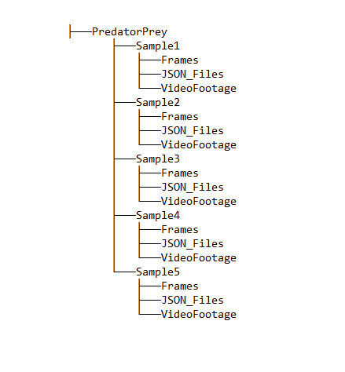

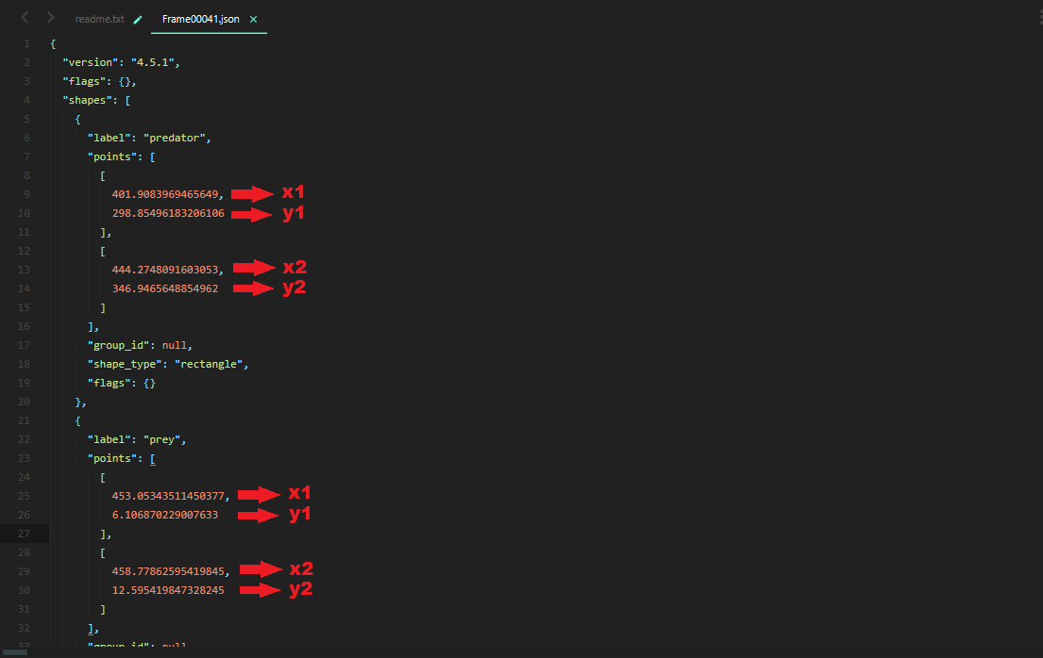

Fig 1: JSON_Sample_1.

In every JSON file, there are records of two objects. One is Predator and another is Prey. The label of **'Predator'** has been named as **'predator'** and the label of **'Prey'** has been named as **'prey'**. For each label, there are 2 co-ordinates. The **"points"** attribute contains an array. This array contains another 2 array. These array contains (x1,y1) and (x2,y2) as shown in Fig 1: JSON_Sample_1. Here, (x1,y1) refers the top left co-ordinate point of the rectangle and (x2,y2) refers the bottom right co-ordinate point of the rectangle.