Passing Data:

Angular Control:

Phân trang

Max-size: kích thước của 1 2 3 4 5 (chỗ phân trang)

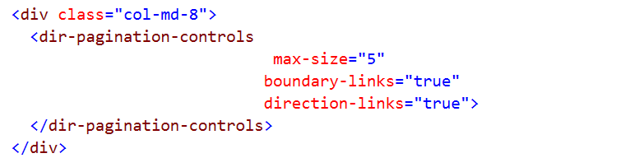

Remember Insert service ‘angularUtils.directives.dirPagination’

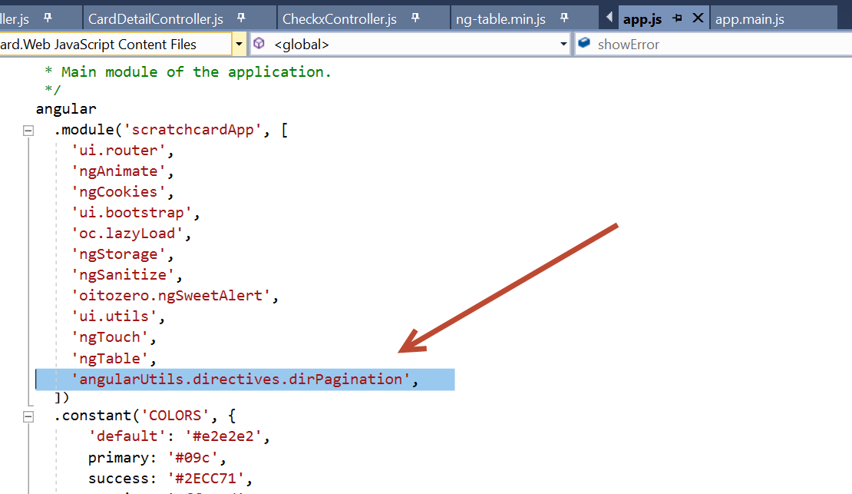

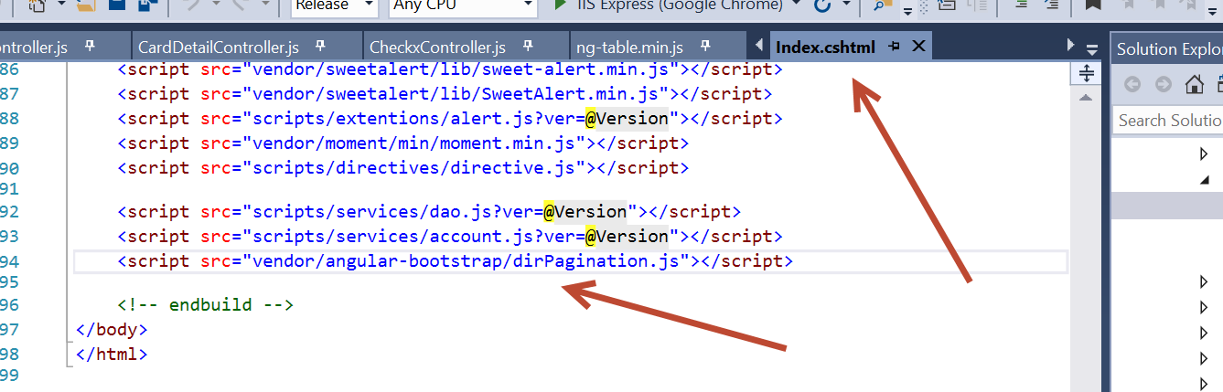



Reference:

<https://stackoverflow.com/questions/25027050/dirpagination-does-not-work-angular-js-pagination>