Mental Illness Detection with Java Programming

Berlian Rahmy Lidiawaty

Politeknik Negeri Malang PSDKU Kediri

Kediri, Indonesia

berlianerel@gmail.com

Ahmad Zidan Alfa Robby

Politeknik Negeri Malang PSDKU Kediri

Kediri, Indonesia

zidanrobby34@gmail.com

Felya Renanda Fergi Andarista

Politeknik Negeri Malang PSDKU Kediri

Kediri, Indonesia

felyarenanda10@gmail.com

Zanuba Shafa Adelia

Politeknik Negeri Malang PSDKU Kediri

Kediri, Indonesia

zanubashafa2@gmail.com

***Abstract- Some people don't know that they have a mental disorder and indirectly ignore it. If this continues to be ignored, it will have a negative impact on that person's life. We decided to create a program that aims to detect mental illness. The user can view a mental illness diagnosis based on the symptoms the user has selected. Users can also view brief solutions provided by the program after knowing the diagnosis of mental illness. With this program, users can determine their mental condition before consulting a psychiatrist.***

***Key Words- Mental illness, ental issues detector, Detection, Java, Symptoms.***

1. **INTRODUCTION**

Mental health is a condition in which a person realizes his own abilities, can cope with the pressures of normal life, can work productively and is able to contribute to his environment (WHO, 2016). Mental health is just as important as physical health. There is no health without mental health, as the definition of health put forward by WHO that "health as a state of complete physical, mental ad social well being is not merely the absence of disease or infirmity." Mental health problems or mental illness are defined as a person's inability to adapt to environmental demands and conditions resulting in certain disabilities (Kartono, 2000).

Mental illness is a response maladaptive to stressors from the inner / outer environment is indicated with thoughts, feelings, and behavior incompatible with local and cultural norms and interfere with social, work and physical functions individual (Townsend 1996).

Disorder mental is a symptom or pattern of visible psychological behavior clinically that occurs in someone from contact with a state of distress (painful symptoms) or inability (interference with one or more important function) that is increases the risk of death, pain, disability or loss of essential liberty and it is not uncommon for this response to occur accepted under certain conditions (American Psychiatric Association 1994).

Mental illness is a problem that many people are not aware of in the world. Based on the 2013 Basic Health Research (Riskesdas) data, the prevalence of mental emotional Disorders with depression and anxiety symptoms at the age of 15 reached 14 million people. This figure is equivalent to 6 percent of Indonesia's population. The cause of this mental illness comes from many factors, it could be stress, depression due texperiencing experiencing deep mental stress, or traumatic loss of something and someone. In Indonesia, many people do not know well about mental illness, because in Indonesia there are still many who are not accustomed to admitting about mental illness because they do not know whom to tell and are afraid that if they tell you they will be thought of being insane and getting worse.

Based on several sources, we take several types of mental illness that occur in Indonesia, namely bipolar, insomnia, schizophrenia, obsessive complusive disorder, psychopathy, anorexia nerves, multiple identity disorders, homosexuality, self harm / self injures, antisocial personality disorder, post traumatic stress disorder.

This paper aims to create a program that uses the Java programming language. making the learning process more attractive by utilizing technology.

Provided and to help diagnose a disease related to mental health without replacing the role of a psychiatrist. This program uses correlation measurement, with the inner product calculation method.

1. **METHOD**
2. Techniques of Collecting Data

In collecting our data we need several steps:

1. Determine the scope of mental illness that will be included in the program and we agree to determine several mental illnesses as shown below :

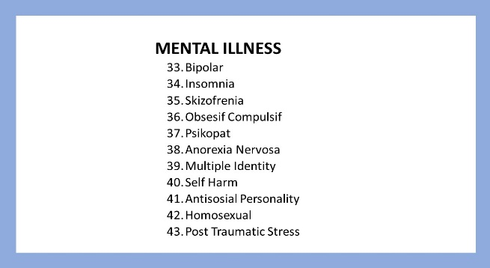

1. Determining the symptoms of mental illness, then we summarize them into more specific symptoms as shown below :

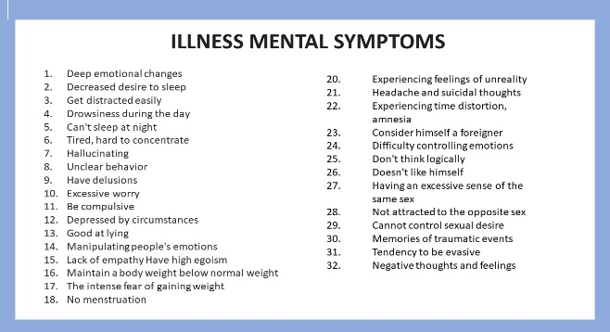

1. Focusing on the age criteria of users around 16 to 35 years old who will use the Mental Illness Detection application.
2. Correlation Measurement

Correlation is a statistical measure that expresses the extent to which two variables are linearly related (meaning they change together at a constant rate). It's a common tool for describing simple relationships without making a statement about cause and effect.

1. Make a mapping

To determine the mental illness experienced by the user, we make a map. Mapping is useful for classifying symptoms with mental illness. In making the mapping, the first thing to do is group the symptoms with the disease by making a tree diagram. these numbers are the code numbers of symptoms and diseases.

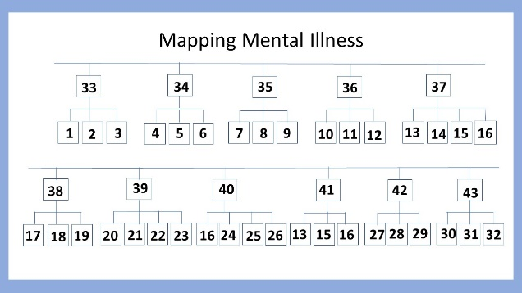

(c)

The data in the tree diagram is based on the numbers shown in figure (a) and figure (b).

1. Meta Data

After creating the mapping, proceed to create meta data in tabular form. To fill in the table using numbers 0 and 1, number 0 which means you do not have these symptoms, while number 1 which means you have these symptoms. In this program we determined 11 diseases with 32 symptoms which will be arranged in the following table :

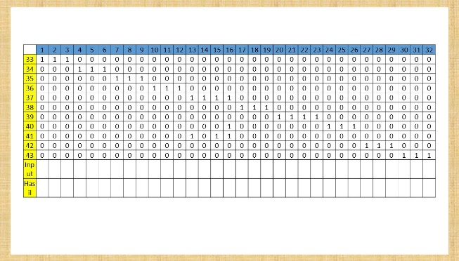

(d)

3. Correlation Computing

After classifying symptoms by mental illness, we computed the correlations of user input with user-selected symptoms. To compute the correlation we use the Inner-product method, by multiplying the result from the user input by the metadata we have constructed. The following is the Inner-product formula :

$$x.y \sum_{i=1}^{n}{xi.yi}$$

The result of the Inner-product formula will be added according to the row. After getting the result of addition, then we will create a function that will find the highest value of the sum. The highest value will be chosen when determining the disease. If there is more than one highest score, mental illness analysis will reveal several possible diseases.

1. How The Program Work

Mental illness detection program, functions to determine the possibility of mental illness suffered by the user. In order to make the program run optimally, it requires source code that is responsible for giving program commands. We created a function to multiply the input from the user by the metadata, as shown below.

private void correlationMeasurement(){

for(int i=0;i<hasilCormes.length;i++){

for(int j=0;j<hasilCormes[i].length;j++){

hasilCormes[i][j]= inputGejala[j]*metaDataPenyakit[i][j];

}

}

}

After making the functions above, we made a function to add up the results from the correlationMeasurement function. It can be seen as follows.

private void jumlahCormer(){

for(int i=0;i<hasilCormes.length;i++){

for(int j=0;j<hasilCormes[i].length;j++){

hasilJumlah[i] = hasilCormes[i][j] + hasilJumlah[i];

}

}

}

The purpose of making the function above is to get the final result which will later be used to determine the mental illness experienced by the user. After that we create a function that is useful for finding the highest score and the highest score is the disease experienced by the user. Here's the function to find the highest value.

private void nilaiMax(){

for(int i=0;i < hasilJumlah.length;i++){

if(hasilJumlah[i] > maxValue){

maxValue = hasilJumlah[i];

}

}

}

Then we create a function of determining the disease according to the meta data. You can see an example of the function of determining disease as follows.

private void mepekit(){

if(hasilJumlah[0]==maxValue){

namaPenyakit.add("\nFrom several symptoms that you choose "

+"\nThe system has analyzed the possibility that you have BIPOLAR Mental Disorder"

+ "\n");

}

}

Then we added a solution function for mental illness suffered by the user. This function uses an external library, namely Freetts, when the program is run, a solution will come out in the form of sound from the system. An example of a solution function can be seen as follows.

private void solusi(){

if(hasilJumlah[0]==maxValue){

voiceSolusi.allocate();

voiceSolusi.speak("Solution for bipolar illness is."

+ "\nYou may need to do interpersonal rhythm therapy. or change your lifestyle and communicate with other people more often.");

}

That's a very important function in the program. We made a jframe which is useful as a display application or Graphic User Interface. Here is a look at the application using jframe and how it works.

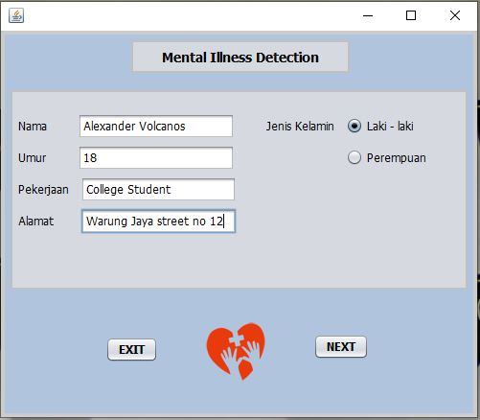

The picture above is the home display window of the Mental Illness Detection application. Users can write personal data in the initial window. Then if the user selects Next, the application will open a window describing symptoms and input from the user. In addition, if the user selects Exit, the user will exit the program. The following displays symptoms and user input.

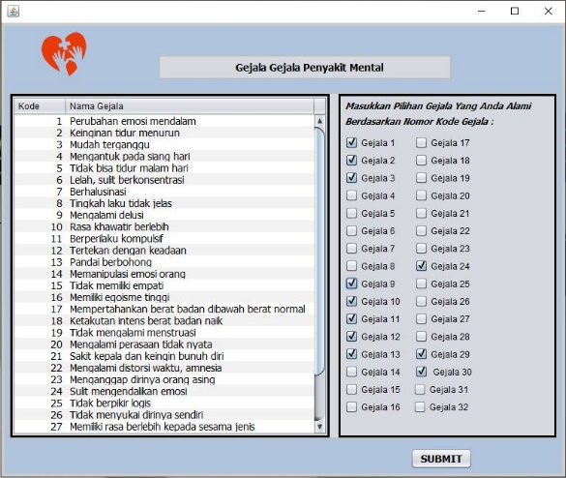

In this window the user will be given a description of the symptoms and the option to choose how much symptom suits the user's condition. When the user submits, there will be diseases that may be suffered by the user based on the choice of symptoms.

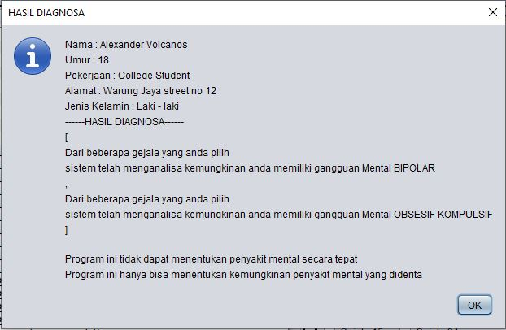

A message will appear containing the user's personal data and diagnostic results by the system. this program can only determine the likelihood of mental illness being experienced and cannot definitely determine mental illness. Then a question message will appear asking if the user wants to hear the solution to the mental illness.

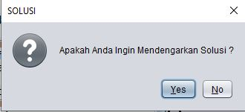

1. **RESULT & DISCUSSION**

Based on a meta-analysis of all symptoms that have been determined by the program, our results show that a mental illness can be detected through the symptoms selected by the user, so that the program can display mental illness diagnoses and can provide solutions according to the mental illness diagnosis.

Some people underestimate mental disorders that they experience such as stress and other mental disorders. The occurrence of mental disorders because people do not satisfy the various needs of their soul. Some examples of these needs include the first need for affiliation, namely the need for affection and acceptance by other people in the group. Second, the need for autonomy, which is to want to be free from the influence of others. Third, the need for achievement, which appears in the desire to succeed in doing something and others.

There is another opinion of Alfred Adler which states that mental disorders are caused by excessive pressure from feelings of inferiority (infioryty complex). The cause of inferiority complex is failure to achieve superiority in life. This constant failure will cause anxiety and emotional tension.

Psychologists differ on the causes of mental disorders. According to Sigmund Freud's opinion in Maslim (2002), mental disorders occur because the demands of the id (sexual instinctive impulses) cannot be played with the demands of the super ego (normal social demands). People want to do something that will give them self-satisfaction, but that action will get public reproach. This unresolved conflict between self-will and societal demands will eventually lead to mental disorders.

In fact, we think mental illness have a bad impact on a person's survival. In response to these problems, we try to minimize the bad impact on a person's life due to mental disorders by creating a program using the Java programming language.

This program can assist users in identifying mental illness experienced. As an existing problem, that many people find it difficult to admit that there is a mental illness in themselves, this program is a solution for those who find it difficult to express the symptoms they are experiencing.

1. **CONCLUSION**

Mental health problems or mental illness is defined as a person's inability to adapt to the demands and environmental conditions that result in certain disabilities (Kartono, 2000). Based on research Mentall illness is something that should not be ignored, mental health needs to be maintained as well as maintaining physical health. In Indonesia many people do not know well about mental illness, because in Indonesia there are still many who are not accustomed to admitting about mental illness because they do not know who to tell who they are and are afraid that if they tell you, they will be thought to be insane and get worse.

Mental illnes is also something you may not be aware of but being there in this program can help the users for detect what is experienced through the symptoms selected by the user. This program is an effort to minimize unwanted things that happen to people with mental disorders.

1. **REFERENCES**

[1] dr. Tjin Willy. Gangguan Mental. https://www.alodokter.com/kesehatan-mental.

[2] Badan Penelitian Dan Pengembangan Keksehatan Kementrian Kesehatan Ri. 2013. Riset Kesehatan Dasar.

<http://Www.Depkes.Go.Id/Resources/Download/General/Hasil%20riskesdas%202013.Pdf>

[3] Wilkson, Judith. M. 2012. Buku Saku Diagnosis Keperawatan. Buku Kedokteran EGC

[4] Herry Zan Pieter. Bethsaida Janiwarti.Marti Saragih. 2011. Pengantar Psikologi untuk Keperawatan. Jakarta:Kencana