Lesson 4: Randomized Experiments

Overview: This final lesson in the Data unit involves the carrying out of a randomized experiment, and then the consideration of what is a surprising result. After the randomized experiment is compete and data are gathered, students run a simulation so that they have a distribution of possible results to compare their sample to, in order to judge if it is surprising or not.

Student Goals for the Lesson:
- To apply the characteristics of a well-defined experiment.
- To experience the difference between an experiment and an observational study.
- To learn to recognize instances of confounding in an experiment.
- To learn that randomizing the assignment of treatments protects against confounding and makes cause and effect statements possible.
- To develop an informal idea of statistical inference, as the extent to which a result is surprising given a certain claim or theory.
- To become introduced to and familiar with the Simulation Process Model (SPM) as a way to represent data in a simulation.

Handouts:
- Coke/Pepsi Taste Test
- Simulation Process Model for Coke/Pepsi

Other Materials/Resources Needed:
- Dixie cups (6 per group)
- Coke & Pepsi
- Coin
- Sampling SIM (http://www.tc.umn.edu/~delma001/stat_tools/)

1. Opening Discussion/Questions:
Can you tell the difference between Coke and Pepsi? How can you tell if somebody really knows?
What constitutes good evidence? What are the elements of a good experiment? Who thinks they call tell the difference? Share your ideas with people in your small group.

2. Activity 1: Coke/Pepsi Taste Test

The taste test is generally conducted in the following way. Students are broken into small groups first (of about 4 students).

Assign Roles to Group Members
Taster - Those students who think they can tell the difference between Coke and Pepsi.
Runner - Those students who deliver cups of soda from the pourer to the taster.
Recorder - Those students who record and report the results of the taster.
Pourer - They determine the order of the soda and also pour the soda.

Experimental Protocol
Tasters, Runners, and Recorders will initially leave the room. Tasters get a Dixie Cup to fill with water. They are to cleanse their palette with a drink of water after each soda tasting. Recorders should bring a notebook and pencil with them to record the results of the test.

Pourers will use a coin to determine the pouring order of the five sodas. They will then pour the soda and prepare the five cups for distribution to their taster. After the Dixie cups of cola have been poured and laid out on the table by the pourers, the Runners are called to bring one cup at a time to their assigned subject. The Recorder writes down the results and reviews with pourer at end of test.

Instructor Notes: Using Sampling SIM

- Under the Population menu, set the level of measurement to Binomial.
- Select the 0.5 button.
- Open the Sampling Distribution window.
- Set the Sample Size to 5, and the Number of Samples to 1000.
- Discuss what that will have the program do. Our hypothetical student will taste five sodas, guessing each time. That student will repeat the experiment 1000 times. Sampling SIM displays the percentage, or proportion, of sodas that the student guessed correctly.
- We can also see how likely it would be for that student to guess 4 out of 5 sodas correctly. Under the Options menu, select One Slider and Proportion Above. Move the slider under the graph so that it encompasses the intended area (4)
An example of the graph that Sampling SIM produced is shown below:

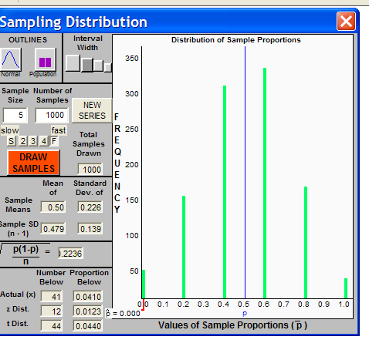

Instructor Notes: Next, a visual model of the simulation process, the Simulation Process Model is introduced. This model is used to help students understand and distinguish between the statistical model used to generate the simulation, the sample data generated, and the distribution of sample statistics for these samples. The SPM Model is also used to break down the process of comparing students’ experimental results to those generated by a particular model or theory (i.e., what if the student was just guessing).

Levels of Data | The Simulation of Samples (SOS) Model  Coke Pepsi Taste Test | The Sampling and Inference Process
Level 1:  Population | 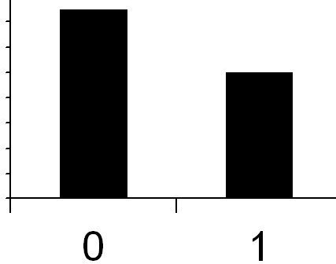  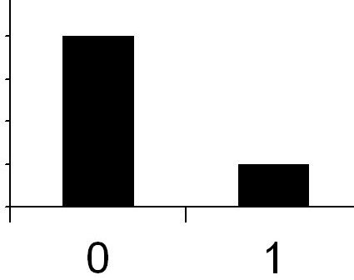  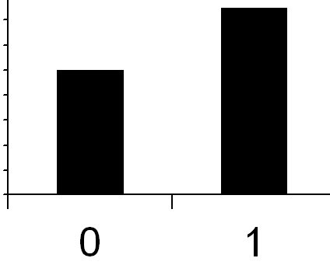  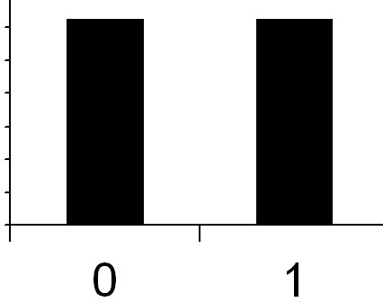  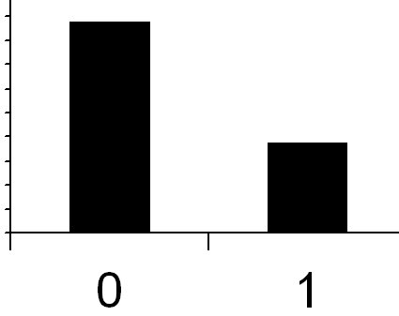  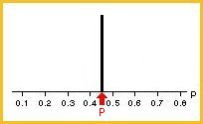  …  Sample 1:  Sample 2:  Sample 3:  Sample 4:  Sample 5:  Sample k: | 1. Assume no one can really tell the difference, and is just guessing each time they taste a soda.
Level 2:  Samples & sample statistics |  | 2. Generate data based the model that everyone is guessing and can’t really tell the difference. How many would they get right just by chance? How many would they get wrong?
Level 2:  Samples & sample statistics |  | 3. Compute the proportion of correct guesses for each sample of 5 guesses.
Level 3:  Distribution of sample statistics | 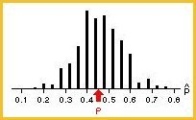  Sampling distribution | 4. Graph these proportions (show the distribution).
Level 3:  Distribution of sample statistics |  | 5. Show your result compared to the distribution of guesses. Does it seem likely that you were just guessing?

Whole Class Discussion: Was this an experiment or an observational study? Why? Did we have all three elements of a good experiment (randomization, control, and replication)? What things could have confounded our results? Did we protect against this? How? What did we control for?
Based on your result, do you believe you can tell the difference between Coke and Pepsi? Why or why not? What if I really couldn’t tell the difference between the two? How many would you expect me to get correct? What if I did the taste test 10 times. How many would you expect me to get? Write down 9 more results so that you have 10 total.
Pool your results with your group and create a dot plot. What does it look like? Now imagine I took the taste test over and over and over again. How many would I get right? What would the results look like?
Discuss the Simulation Of Samples Model (SOS) in the context of this Coke versus Pepsi test. Display overhead of SOS on the white board and customize the model to reflect Coke & Pepsi. For example, start off with “What if you could not tell the difference, then what would you expect the results to look like?” 50-50?

Wrap-up: What does the graph of the results look like? Where does your actual result fit in? Do we expect that result if you really couldn’t tell the difference? ‘So, based on your result should I believe that you can tell the difference between Coke and Pepsi?

Reference
Snell, L., Peterson, B., Moore, T., & Garfield, J. (1998). Teaching Chance: An instructor guide for teaching a chance course. Retrieved October 21, 2007, from http://www.dartmouth.edu/~chance/teaching_aids/teaching_aids.html

