Lesson 2: Modeling Random Variables

Overview:
This lesson engages students with modeling random variables using coins, cards, and dice. Students construct probability distributions to represent each of the scenarios and make predictions on probabilities of other events based on these histograms. They first generate data with concrete materials and then move to Fathom to simulate larger data sets and see the stable trend emerge.

Student Goals for the Lesson:
- Understand the use of models to represent random variables and simulate data
- Understand how to interpret visual representations for probability
- Use a simulation to generate data to estimate probabilities
- Gain an informal understanding of probability distributions as a distribution with shape, center and spread

Handouts:

- Coins, Cards, and Dice

Other Materials/Resources Needed:

- Fathom software

1. Opening Discussion/Questions:

Students are asked to think about different random devises they have encountered, such as coins, cards, and dice. Then they are asked to make conjectures about the expected number of:
- Heads on five tosses of a fair coin
- Hearts in five draws from a poker deck
- Twos in five rolls of a fair die
They are then asked to reason about what is the same and what is different about these three experiments. Next, students are led to define three random variables as follows:
X: Number of heads in five tosses
Y: Number of hearts in five cards dealt
Z: Number of 2’s in five rolls
They now create models of each variable to generate and then simulate data that can be graphed and summarized to compare the distributions for each random variable.
Students begin with the Coin variable. They toss a coin five times and count the number of heads and then repeat this 10 times, making a frequency distribution for the number of heads that show up on each toss of five coins. Each time they toss the five coins, they check the value of X (Number of heads in five tosses) in the table, then find the relative frequency probability for each value of X. Next, students open a Fathom file that generates data based on this model of equally likely outcomes as shown in Figure 1.
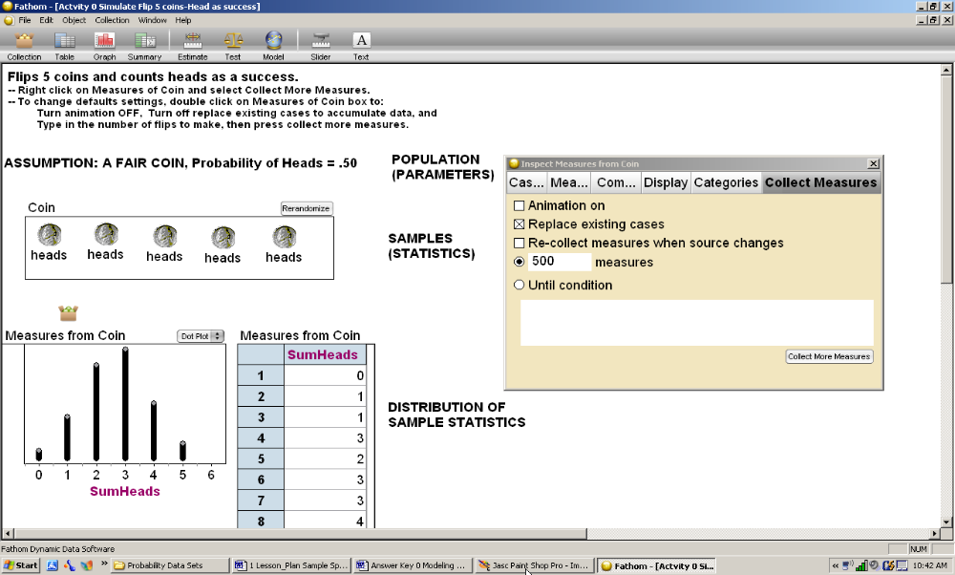
Figure 1: Simulating the number of heads in five tosses of a fair coin in Fathom.
Students are asked how the simulated data compare to the data they generated by physically tossing coins, and if they expect these results to be similar for all students in the class. This leads to a discussion on the idea of a random outcome that is unpredictable, but that you can predict patterns of outcomes for many repetitions of an experiment. The simulation is repeated for 500 trials and relative frequencies are found for the six possible outcomes (0 to 5 heads). Students again discuss whether they think the results will vary from student to student, and see that with the larger sample size there is much less variability. They graph the data and informally describe shape, center and spread. They see that the expected number of heads for five tosses would be 2 to 3 heads, but that results can vary from 0 to 5 heads. They can generate the mean and standard deviation and intercept these values for the distribution (see Figure 2).
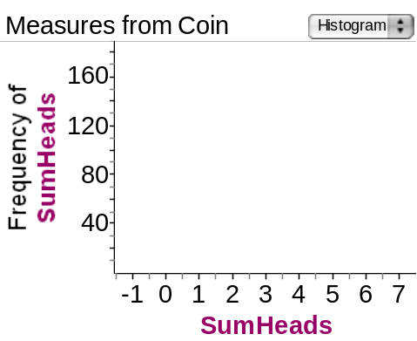  Center is about 2.5, and range is 0 to 5 | 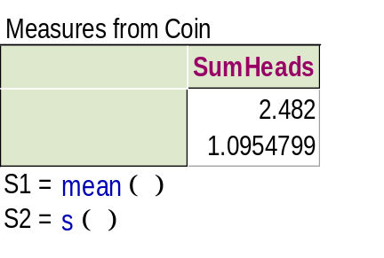
Figure 2: The results of simulating the number of heads in five tosses of a fair coin in Fathom.
The next part of the Coins, Cards, and Dice Activity has students take a deck of cards, shuffle, draw a card, replace it, draw, and replace, five times. They then count the number of hearts that showed up in sample of five draws with replacement. A discussion of the term “replacement” challenges students to reason about why they would replace the card drawn each time and how that would affect the results of the experiment so it is not similar to the coin tosses. This is an informal introduction to the idea of independent events without going into probability theory. Next, students, use Fathom to simulate this experiment. They discuss what the model will be, that it is no longer one of equally likely outcomes, but that the chance of getting one heart when randomly drawn from a deck is not one-fourth, and that is needed in the new model. They again run the simulation generating output, graph the results, and find measures of center and sprad, which are different form those in the Coin exapmple (Figure 3).
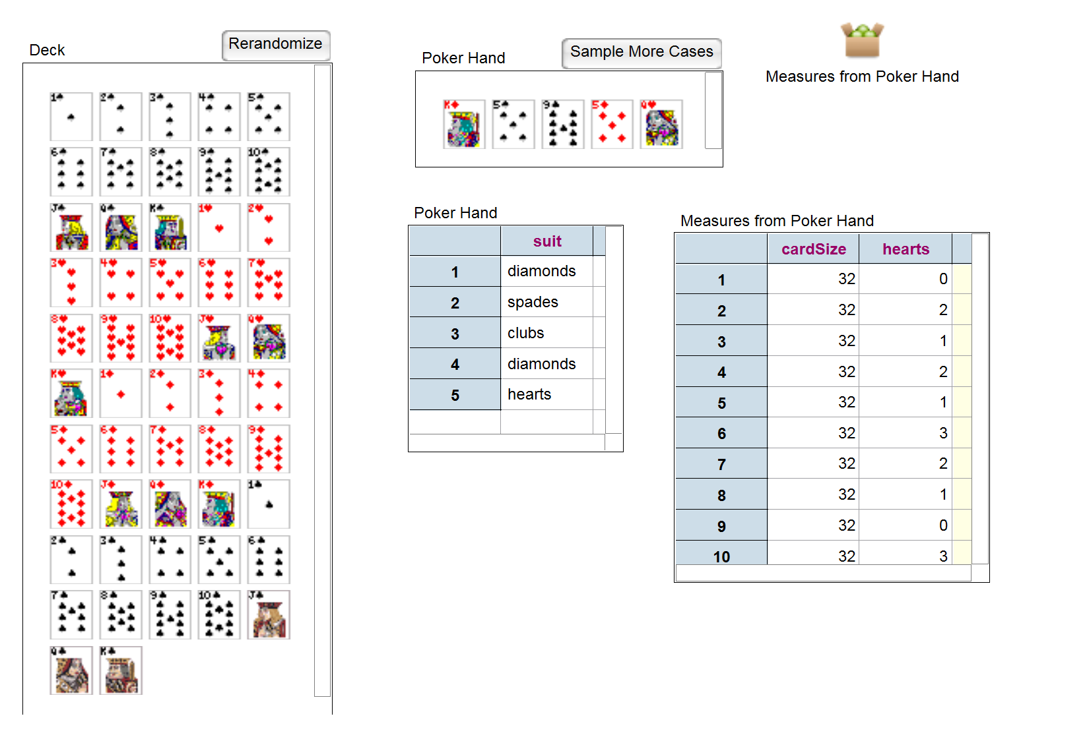
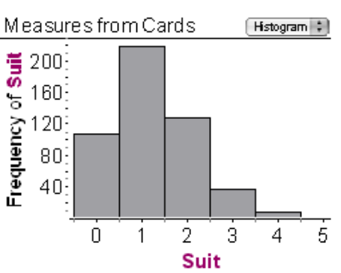
Figure 3: The Fathom simulation of the number of hearts in cards.
This activity is repeated a third time for the Dice example. First students roll a dice five times counting the number of 2’s that show up. They record the data and compare it with the class. Then they simulate the data on Fathom, first discussing how the model must be changed, based on the new probability of getting a two, which is one-sixth.
The results of the three experiments are compared. Students are asked to reason about what was the same and what was different across the three experiments, and how the differences in the experiments reveal themselves in the probability histograms. The expected value is also compared for each experiment, as well as where the same value (e.g., 4) appears in each histogram. This can lead to a discussion on how likely this outcome is (or is not) for each experiment, based on whether it is in the tail of the distribution, a precursor of the P-value concept.

Wrap Up:
How does the chance or likelihood of an outcome relate to where the value for that outcome is located in the probability distribution? What causes the likelihood of a particular value (e.g., five successes) to be different for different random variables?
Looking at where a particular value is located and how far it is in the tails is something we consider when making inferences, as we have done in previous lessons. This will relate to our future discussions of the p-value.

Reference
Garfield, J., Zieffler, A., & Lane-Getaz, S. (2005). EPSY 3264 Course Packet, University of Minnesota, Minneapolis, MN.

