Lesson 2: Exploring and Sorting Distributions

Overview: This lesson begins with a data set of body measurements gathered from a previous set of students that includes kneeling heights. After students make some predictions about this variable, they examine and describe various graphical representations of the class data on kneeling heights. The students are then led through a demonstration of how to transform a scatter of dots into a histogram, using TinkerPlots software. In the second activity students are asked to sort a set of histograms into different piles according to general shape, helping them to recognize and label typical shapes, seeing the distribution as an entity, rather than as a set of individual values. The third activity has students imagine different distributions and their shapes for a set of possible variables. In the fourth activity students match histograms to variable descriptions, reasoning about the connected characteristics of distributions as well as the variable contexts. In the fifth and final activity students compare different representations of the same data to see how various features are hidden or revealed by each type of graph. They further develop the idea of shape by changing bin widths on histograms using Fathom to see how the size of the bins affects the stability of the shape.

Student Goals for the Lesson:
- To understand how a distribution is represented by a histogram and that a histogram (or dot plot) allows us to describe shape, center and spread of a quantitative variable in contrast to a bar graph (bar chart).
- To understand the differences between graphs of individual data values (e.g., case value graphs) and graphs displaying distributions of data (e.g., histograms).
- To understand how graphical representations of data reveal the variability and shape of a data set.
- To recognize and label common models for shapes of distribution, using statistical names for these models (e.g., normal, skewed, bimodal and uniform).
- To understand that the different features of a graph may be hidden or revealed, depending on the graph used, so it is important to change characteristics of a graph (such as bin width) as well as view different graphs of the same data, in order to learn more about the data set and whether or not a particular model seems to fit the data.

Handouts:

- What is a Histogram?
- Sorting Histograms
- Matching Histograms to Variable Descriptions
- Creating Graphs for Variables without Data!
- Exploring Different Representations of the Same Data

Other Materials/Resources Needed:

- TinkerPlots data set Kneeling Heights
- Histograms Packet (one per group)
- Fathom Data File of Class Data
- Instructor’s Tinkerplots Demonstration Guide

Note: Although sample data files are available in Fathom and TinkerPlots, we encourage instructors to gather and use their own students’ data for these activities.

1. Opening Discussion Questions:
How many different ways have you seen data represented in a graph? Which of these do you think might allow us to determine the important characteristics of a distribution of numerical data (e.g., shape, center and spread)?

2. Activity 1: What is a Histogram?

This includes a demonstration using Tinkerplots software.

Please see the accompanying Instructor’s Tinkerplots Demonstration Guide for more information about how to perform this demonstration in class.

3. Activity 2: Sorting Histograms

Note this activity is from Garfield (2002a).
4. Whole Class Discussion I
Let’s compare the results obtained for the different groups of students: the categories and the terms used to describe them.
Then introduce the statistical terms for the graphs (uniform, normal, right- and left-skewed, bimodal). Graphs (uniform, normal) are described in terms of symmetry and shape (bell-shape or rectangular). Other distributions that do not fit these shapes can be described in terms of their characteristics (skewness, bimodality or unimodality, etc.). A discussion of which descriptors can and cannot go together may follow. For example, normal and skewed cannot go together.
During this discussion some important points are addressed:
- Ideal shapes: density curves vs. histograms (theoretical vs. empirical distributions)
- Different versions of ideal shapes
- Idea of models, characteristics of distributions
- Statistical words vs. informal descriptors
- Other ways to describe a distribution
- Why is it important to describe a distribution?
- Normal, skewed, uniform, bimodal, and symmetric: which can be used together?
- How well do they fit the graphs? Which fit best?

5. Activity 3: Matching Histograms to Variable Descriptions

Note this activity is adapted from Adapted from Workshop Statistics (Rossman, Chance and Lock, 2001) and Activity Based Statistics (Scheaffer et al., 2004a).

6. Activity 4: Creating Graphs for Variables without Data!

7. Activity 5: Exploring Different Representations of the Same Data

8. Whole class discussion II

How many ways could we display the same set of data in general?
How do we determine the best representation to answer a particular question?
How we display data depends on what we want to know. There are no fixed criteria for judging one data display as superior to another. Rather, the relative value of a plot depends on its intended purpose. Each representation is good for some purposes and not so good for others.

Why might one representation be better than another? It depends on what we want to use the data for and what we want to look for in the data set. So the question we are asking about the data leads to the choice of a graph, and often we look at more than one graph to answer our questions.
On the next page are two different graphs of the same data set of how far students live from school (present copies to students, or display on an overhead).

What is different about them? Which one gives the best idea of shape, center and spread? Why?

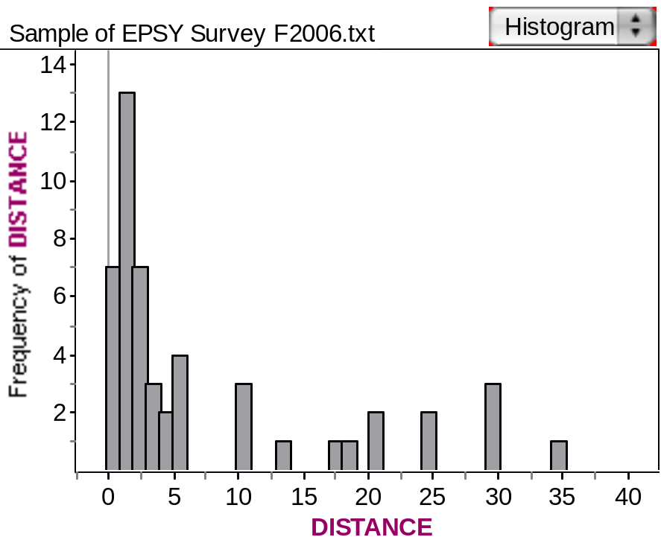

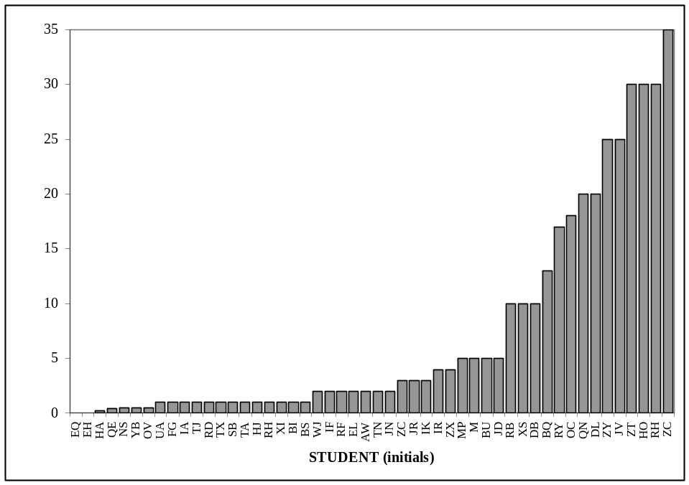

Here’s a graph from USA today. What kind of a graph do you think it is? Does it seem to be a good graph? Why or why not? What could have been done to make it a better graph of the data?

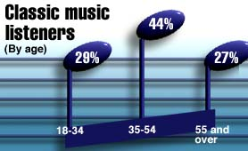

Wrap-up: Take away Message
You should now understand how a distribution is represented by a histogram and that a histogram (or dot plot) allows us to describe shape, center and spread of a quantitative variable in contrast to a bar graph (bar chart). Try to reminder the differences between graphs of individual data values (e.g., case value graphs) and graphs displaying distributions of data (e.g., histograms), and understand which types of graphs allow us to look at characteristics such as shape, center and spread.
You should now understand how only certain graphical representations of data reveal the variability and shape of a data set (e.g., a histogram).
You now know and should be able to use names for some common models for shapes of distribution (e.g., normal, skewed, bimodal and uniform).
Finally, these activities illustrated how different features of a graph may be hidden or revealed, depending on the graph used, so it is important to explore data in different graphs to reveal characteristics and patterns in the data.

References
Garfield, J. (2002a). Histogram Sorting. Statistics Teaching and Resource Library (STAR). Retrieved December 24, 2006, from http://www.causeweb.org/repository/StarLibrary/activities/
Garfield, J., Zieffler, A., & Lane-Getaz, S. (2005). EPSY 3264 Course Packet, University of Minnesota, Minneapolis, MN.

Rossman, A., Chance, B., & Lock, R. (2001). Workshop statistics: Discovery with data and Fathom. Emeryville, CA: Key College Publishing.

Scheaffer, R.L., Watkins, A. Witmer, J., & Gnanadesikan, M., (2004a). Activity-based statistics: Instructor resources (2nd edition, Revised by Tim Erickson). Key College Publishing.

